L-SIAMS: A Local IoT-Based Multi-Layer Secured Attendance Monitoring System with RFID and Biometric Authentication

A Manuscript Presented to the Faculty of the College of Computing Studies, Information and Communication Technology
Isabela State University – Echague Campus

In Partial Fulfilment of the Requirements for the Degree
Bachelor of Science in Information Technology

By:
Ched Nikko P. Pangilinan
Joshkirby Tyler M. Bote
Naph Yvan P. Villamar

March 2026

CHAPTER I
INTRODUCTION

1.1 Project Context
Top Achievers Private School Inc. (TAPS) currently uses an RFID-based system installed at the main school entrance. Students tap their RFID cards upon arrival, primarily serving as a notification mechanism for parents to monitor whether their child has entered or left the school premises. However, the system does not record or validate actual classroom attendance.
Based on observation, TAPS accommodates approximately 300–500 students daily, with attendance-related tapping occurring through a single RFID terminal at the gate. During peak hours, an average queue of 20–30 students forms at the RFID terminal, resulting in delays and congestion. In some cases, students bypass the RFID terminal to avoid long waiting times, reducing the reliability of attendance monitoring. Inside classrooms, teachers still conduct manual roll calls, consuming approximately 5–10 minutes of the 40-minute class period. The existing system also lacks classroom-level validation and teacher authentication mechanisms.
From a cybersecurity perspective, the current attendance setup lacks sufficient protection mechanisms for attendance data transmitted within the network. The absence of encrypted communication, device authentication, access control, and audit logging increases the risk of unauthorized access, data interception, and possible record tampering, which may compromise the confidentiality, integrity, and reliability of attendance information.
To address these issues, the researchers designed and developed L-SIAMS: A Local IoT-Based Multi-Layer Secured Attendance Monitoring System with RFID and Biometric Authentication. The developed system implements classroom-based RFID attendance recording combined with biometric teacher verification and multi-layer security mechanisms, improving attendance accuracy, reducing processing time, and strengthening the protection of attendance information within a controlled Local Area Network (LAN) environment. RFID readers are deployed at classroom entry points to record attendance at the point of instruction, and fingerprint authentication is used to verify teacher identity before an attendance session can be opened.
Practical constraints were considered throughout development, including the cost of hardware deployment per classroom, maintenance of devices such as RFID readers and fingerprint sensors, network reliability within the LAN, and deployment feasibility in terms of installation and power requirements.
The system uses IoT-based components suitable for classroom attendance monitoring and local network communication. Fingerprint authentication prevents proxy attendance, which cannot be addressed by RFID alone. A LAN-based architecture was adopted to provide faster communication, reduced latency, and improved security by limiting exposure to external networks.
Through this implementation, the study aims to improve attendance accuracy, reduce processing time, minimize congestion, and enhance the security and reliability of attendance data.
1.1.1 Background of the Study
Educational institutions continue to adopt digital systems to improve operational efficiency; however, existing attendance practices still present limitations in accuracy, validation, and security. At present, the RFID system implemented in schools is primarily used as a notification tool to inform parents whether their son or daughter has entered or left the school premises. It does not record or validate actual classroom attendance, resulting in a gap between entry monitoring and real student presence during instructional time.
Existing attendance systems continue to face challenges related to attendance validation, operational efficiency, and data security. Although RFID-based systems improve entry monitoring, many implementations still lack classroom-level verification, teacher authentication, and sufficient protection mechanisms for attendance information.
In addition, existing systems lack essential security mechanisms such as encryption, access control, and audit logging. This creates vulnerabilities in attendance data, allowing potential unauthorized access or modification, which compromises data integrity and accountability.
To address these issues, this study developed L-SIAMS: A Local IoT-Based Multi-Layer Secured Attendance Monitoring System with RFID and Biometric Authentication, which enables automated, classroom-level attendance recording. The system uses RFID technology to capture student attendance at the point of instruction and integrates biometric fingerprint authentication to ensure that only authorized teachers can initiate attendance sessions.
The development of the system involved the design and integration of IoT components using the ESP32 microcontroller within a Local Area Network (LAN) to support real-time data transmission.
The system also implements a fallback mechanism in which attendance data is retained on the terminal during connectivity interruptions and synchronized automatically once the network is restored. Each held record carries the timestamp taken at the moment of the tap together with an idempotency key, so that a replayed or retried transmission cannot produce a duplicate attendance record.
To ensure data security and reliability, the system incorporates multi-layer security mechanisms, including encrypted communication for data protection, role-based access control for user authorization, per-device request authentication, and audit logging for traceability of system activities.
Following development, the system will be evaluated based on ISO/IEC 25010 to assess system quality in terms of functionality, usability, and performance, and ISO/IEC 27001, guided by the CIA Triad, to evaluate security in terms of confidentiality, integrity, and availability.
Through this development and evaluation, the study provides a more accurate, efficient, and secure approach to attendance monitoring by addressing the limitations of entry-based systems, reducing time consumption, and ensuring the reliability and integrity of attendance records.
1.1.2 Statement of the Problem
The current attendance monitoring system of Top Achievers Private School Inc. (TAPS) presents several operational and security issues that affect the accuracy, efficiency, and reliability of attendance recording within the school.
Specifically, this study seeks to answer the following questions:
1. How can manual classroom attendance checking, which consumes 5–10 minutes per session, be minimized to improve instructional time?
2. How can the system ensure accurate classroom-level attendance recording?
3. How can congestion at the RFID gate, measured by queue length (20–30 students) and waiting time, be reduced?
4. How can teacher identity verification be integrated to ensure secure and authorized attendance recording?
5. How can multi-layer security mechanisms be implemented to protect attendance data and ensure confidentiality, integrity, and availability?
1.2 Objectives of the Project
General Objective
The main goal of this study is to design, implement, and evaluate L-SIAMS: A Local IoT-Based Multi-Layer Secured Attendance Monitoring System with RFID and Biometric Authentication that improves classroom-level attendance monitoring, reduces processing time, and ensures data security through the application of robust cybersecurity mechanisms.
Specific Objectives
1. Design and implement an IoT-based hardware system that:
1.1 Captures student attendance via RFID tapping at classroom entry points;
1.2 Verifies teacher identity using biometric fingerprint authentication before activating attendance sessions;
1.3 Automatically records student ID, date, and time for accurate and real-time attendance monitoring.
2. Develop a locally hosted system that:
2.1 Allows administrators to register users and IoT devices;
2.2 Stores attendance records in a centralized database for efficient retrieval;
2.3 Generates attendance reports and dashboards for monitoring and decision-making.
3. Implement selected security mechanisms to protect attendance data and system operations by:
3.1 Securing transmitted data against interception through encrypted communication;
3.2 Preventing unauthorized access through authentication and role-based access control;
3.3 Restricting unauthorized system interaction through controlled network access;
3.4 Improving accountability and monitoring through audit logging of system activities;
3.5 Applying application-level security measures to protect system operations and user information;
3.6 Implementing network security controls such as IP filtering, firewall configuration, encrypted communication, and device authentication to secure IoT-based attendance communication within the Local Area Network (LAN).
4. Evaluate and validate the system by:
4.1 Measuring processing time, queue length, and system efficiency during attendance recording;
4.2 Comparing system-recorded attendance with manual classroom attendance to assess accuracy;
4.3 Conducting controlled security evaluation through simulated unauthorized access attempts, data interception testing, and data modification scenarios to assess the effectiveness of implemented security mechanisms;
4.4 Assessing system usability, performance, reliability, and security using measurable indicators aligned with ISO/IEC 25010, and applying ISO/IEC 27001 guided by the CIA Triad to evaluate the effectiveness of implemented security controls.
Objectives 1 to 3 have been realized in the developed prototype presented in this manuscript, and the resulting system is documented in Chapter IV. Objective 4 will be addressed in the evaluation phase described in Chapter III, which will be conducted upon deployment of the prototype at Top Achievers Private School Inc.
1.3 Scope and Limitations
This study focuses on the design, development, and implementation of L-SIAMS: A Local IoT-Based Multi-Layer Secured Attendance Monitoring System with RFID and Biometric Authentication. The system records student attendance at the classroom level using RFID technology integrated with IoT devices. It includes biometric fingerprint authentication for teacher verification and a locally hosted web-based platform for managing attendance data.
The system implements multi-layer security mechanisms such as encrypted communication, per-device request authentication, Role-Based Access Control (RBAC), network access control, and audit logging. It will be evaluated using ISO/IEC 25010, ISO/IEC 27001, and the CIA Triad.
The system is limited to classroom-based attendance monitoring within TAPS and does not include gate-level tracking, learning management systems, grading systems, facial recognition, GPS tracking, or mobile application integration. Only teachers and administrators have system access.
The system operates within a Local Area Network (LAN) and is not integrated with cloud-based or external systems. As a result, it has no remote access, limited data sharing, and is not scalable across multiple campuses. In cases of network failure, data is retained on the terminal and transmitted once the connection is restored, which may cause delays in real-time monitoring. The system was developed as a prototype and will be tested only in selected classrooms, which may not fully reflect performance in large-scale deployment where increased users and devices may affect efficiency.
Security testing will be conducted through controlled procedures, including simulated attack scenarios; however, these may not cover all possible real-world attack variations. Evaluation results will be based on a limited number of respondents in a controlled environment, which may affect generalizability.
Additionally, the system requires hardware installation per classroom and ongoing maintenance, which may impact cost and long-term deployment.
1.4 Significance of the Study
School Administrators. Provides accurate and real-time classroom attendance data, improving monitoring and decision-making through secure access and audit logging.
Teachers. Reduces attendance recording time by minimizing manual roll calls and ensures a more efficient and authenticated attendance process.
Students. Improves attendance recording by making it faster, more organized, and less time-consuming during class sessions.
IT Administrators. Enhances system management and strengthens network and data security through the implementation of selected security mechanisms that help protect attendance records and sensitive user information from unauthorized access and modification.
Cybersecurity and Future Researchers. Provides a reference for the development of secured IoT-based systems by demonstrating how selected security mechanisms can be applied to protect sensitive attendance data and improve network security within educational environments.

CHAPTER II
REVIEW OF RELATED LITERATURE AND STUDIES

2.1 Introduction
This chapter presents the review of related literature and studies that provide the technological and security foundations for the development of the proposed Multi-Layer Secured IoT-Based Attendance Monitoring System. The discussion is organized using a thematic approach, grouping related concepts into key areas such as IoT-based attendance systems, identification technologies, and multi-layer security mechanisms. Existing literature shows that automated attendance systems help reduce manual work, speed up attendance recording, and improve data accuracy. However, many systems still lack strong security implementation, especially in terms of multi-layer protection and teacher-level validation. These gaps highlight the need for a more secure, accurate, and integrated attendance monitoring system.
2.2 Review of Related Literature
IoT-Based Attendance Systems
The Internet of Things (IoT) refers to a network of interconnected devices that collect, process, and exchange data through communication networks. In educational systems, IoT is used to automate attendance monitoring by allowing devices to record and send attendance data in real time.
IoT-based attendance systems use hardware components such as RFID readers and microcontrollers to capture attendance data and send it to a centralized server. These systems reduce manual attendance checking, shorten recording time, and allow real-time monitoring of student presence in classrooms (Shrivastava et al., 2023).
However, many IoT-based attendance systems focus mainly on functionality and data transmission. Some systems do not include strong security features such as encryption, device authentication, and monitoring. This makes them vulnerable to unauthorized access, data interception, and system misuse. Recent studies explain that IoT systems are exposed to security risks because devices constantly communicate and exchange data over networks (Ferrag et al., 2021; Neshenko et al., 2021).
Identification Technologies in Attendance Systems
Attendance monitoring systems commonly use RFID and biometric authentication technologies to improve attendance accuracy and reduce manual recording. RFID enables fast identification through contactless card scanning, while biometric authentication provides stronger identity verification using unique physiological characteristics such as fingerprints (Shrivastava et al., 2023).
RFID Technology for Student Attendance
RFID (Radio Frequency Identification) is commonly used in attendance systems because it is fast and easy to use. Students are given RFID cards, and attendance is recorded when the card is tapped on a reader. The system records the student's identity along with the date and time.
RFID systems reduce the time needed to record attendance and remove the need for manual roll calls. This allows faster and more efficient attendance tracking inside the classroom.
Although RFID technology improves attendance efficiency, it has limitations in identity verification because RFID cards may be shared or used by unauthorized individuals. This creates risks of proxy attendance and inaccurate attendance records in educational environments (Shrivastava et al., 2023).
Fingerprint-Based Teacher Authentication
Fingerprint authentication uses the unique pattern of a person's fingerprint to verify identity. In attendance systems, it ensures that only authorized individuals can access or activate the system.
Biometric authentication strengthens attendance reliability by ensuring that only registered individuals can access or activate the attendance system. Fingerprint authentication is widely recognized as a secure authentication mechanism because fingerprint patterns are unique and difficult to duplicate (Ahmad et al., 2022).
However, most systems use fingerprint authentication for student attendance only. There are few systems that use fingerprint verification to confirm the presence of the teacher before attendance recording. Without teacher validation, attendance can be recorded even if the teacher is not present.
Applying fingerprint authentication for teacher-level verification improves accountability and ensures that attendance sessions are initiated only by authorized personnel. This additional authentication layer enhances attendance validity and reduces opportunities for unauthorized attendance recording (Ahmad et al., 2022).
Security in IoT-Based Systems
Security is an important part of IoT-based systems because data is sent through networks where it can be accessed or attacked. IoT systems are exposed to risks such as unauthorized access, data interception, and device misuse because devices continuously communicate with each other (Ferrag et al., 2021; Neshenko et al., 2021).
Common security problems include lack of encryption, weak authentication, and no monitoring system. These issues can allow attackers to access, modify, or misuse attendance data. To prevent these risks, modern systems use security mechanisms such as encryption, authentication, access control, and monitoring. These measures help protect data and ensure that the system works correctly and securely (Ferrag et al., 2021).
Multi-Layer Security Frameworks
Multi-layer security, also known as defense-in-depth, uses multiple security mechanisms across different parts of a system. This approach ensures that if one layer fails, other layers still protect the system.
In attendance systems, multi-layer security includes encrypting data during transmission, verifying users and devices, controlling access through roles, and recording system activities through audit logs.
These layers work together to protect attendance data and system operations. Using multiple security layers reduces the chance of system compromise by addressing different types of security risks at different levels (Ferrag et al., 2021).
Network Security in IoT Systems
Network security protects communication between devices and controls which devices are allowed to access the system. In IoT systems, devices constantly exchange data, making them vulnerable if network protection is weak.
Security controls such as IP filtering, firewall configuration, and port restriction are used to limit access to authorized devices only. These controls are important in Local Area Network (LAN) environments.
These mechanisms help prevent unauthorized access, packet interception, and network intrusion in IoT systems (Neshenko et al., 2021). Without network security, attackers may access the system and cause data breaches or disruptions.
A LAN-based deployment also reduces the attack surface of the system by limiting exposure to external internet-based threats compared to cloud-dependent architectures. This approach strengthens internal network control, improves communication speed, and enhances monitoring of connected IoT devices.
Application Security and Data Protection
Application security protects the system from internal threats by ensuring that only valid inputs and authorized users can access system functions. This includes input validation, password hashing, and secure session management. These controls prevent invalid data and unauthorized access.
Audit logging is also important because it records system activities such as login attempts and attendance transactions. These logs help administrators track system usage, detect unusual behaviour, and ensure accountability. These mechanisms ensure that attendance data is not changed, accessed by unauthorized users, or lost during system operation (Ahmad et al., 2022; Whitman & Mattord, 2021).
Security Standards and Evaluation Models
Standard frameworks are used to ensure that the system is reliable and secure. The ISO/IEC 25010 model provides a widely accepted international framework for evaluating software quality based on functionality, usability, performance efficiency, and security (ISO/IEC, 2022). The CIA framework focuses on confidentiality, integrity, and availability, ensuring that data is protected, accurate, and accessible (Whitman & Mattord, 2021).
ISO/IEC 27001 provides guidelines for implementing security controls such as encryption, authentication, access control, and monitoring (International Organization for Standardization, 2022). These frameworks help ensure that the system is secure and performs properly.
2.3 Review of Related Studies
Foreign Related Studies
Studies such as those by Shrivastava et al. (2023) show that IoT-based attendance systems reduce manual work, improve accuracy, and allow real-time monitoring of attendance data.
However, many studies focus mainly on system functionality and do not include strong security features such as encryption, authentication, and monitoring. Some systems rely only on RFID, which makes them vulnerable to proxy attendance. Other systems use biometric authentication but focus only on student verification and do not confirm teacher presence. In addition, many systems do not implement multi-layer security, especially in network protection and audit logging.
Local Related Studies
Recent local and international implementations of digital attendance systems demonstrate improvements in attendance recording efficiency, data accessibility, and monitoring capabilities. However, many systems still focus mainly on automation and functionality while providing limited implementation of encryption, access control, audit logging, and network-level security protections.
2.4 Synthesis of the Reviewed Literature and Studies
The reviewed literature shows that modern attendance systems using IoT, RFID, and fingerprint technologies improve attendance recording by making it faster, more accurate, and easier to manage.
However, several gaps still exist. Many systems focus only on functionality and do not include strong security features. Most systems lack multi-layer security, including encryption, device authentication, network protection, and audit logging.
In addition, many systems use only one identification method. RFID systems can be misused through proxy attendance, while biometric systems are often limited to student verification only. Another major issue is the lack of teacher verification before attendance recording. Most systems do not ensure that attendance is recorded only when the teacher is present.
To address these gaps, this study proposes L-SIAMS: A Local IoT-Based Multi-Layer Secured Attendance Monitoring System with RFID and Biometric Authentication that combines RFID-based student attendance with fingerprint-based teacher authentication. The system applies multi-layer security, including encryption, authentication, access control, network protection, audit logging, and application security.
This approach improves attendance accuracy, ensures teacher validation, and provides better protection of attendance data.

CHAPTER III
RESEARCH METHODOLOGY

3.1 Research Design
This study employed a multi-method research design, integrating Design and Development Research, Experimental Research, and Survey Research to ensure a comprehensive and systematic approach in developing and evaluating L-SIAMS: A Local IoT-Based Multi-Layer Secured Attendance Monitoring System with RFID and Biometric Authentication.
Design and Development Research served as the primary framework of the study, guiding the systematic process of designing, developing, and testing the system based on the problems identified in Chapter I, including manual attendance checking, lack of classroom-level validation, absence of teacher authentication, congestion during attendance, and weak security mechanisms. This phase has been completed, and its output is the working prototype documented in Chapter IV.
Experimental Research will be used as a supporting method to compare the existing manual attendance system and the developed system using measurable variables such as processing time, waiting time, queue length, accuracy, efficiency, response time, and security effectiveness. These variables are directly derived from the study objectives and will allow quantitative evaluation of system performance.
Survey Research will be applied to gather user feedback using structured questionnaires such as the System Usability Scale (SUS) and Technology Acceptance Model (TAM), allowing the evaluation of usability and system acceptance.
Evaluation will be embedded within the study using ISO/IEC 25010 for system quality and ISO/IEC 27001, guided by the CIA framework (Confidentiality, Integrity, and Availability), to assess system security.
The methodological flow of the study follows this sequence: system design and development, system testing, experimental comparison, survey-based evaluation, and data analysis. As of this prototype presentation, system design and development have been completed and development-time testing has been performed. The experimental comparison, survey-based evaluation, and data analysis will be conducted upon deployment of the prototype at the partner school.
The study involved the development and evaluation of three main components: IoT-based hardware for attendance capture, software systems for data processing and management, and security mechanisms for data protection. These components were integrated and will be evaluated collectively.
Figure 1
Methodological Flow of the Study
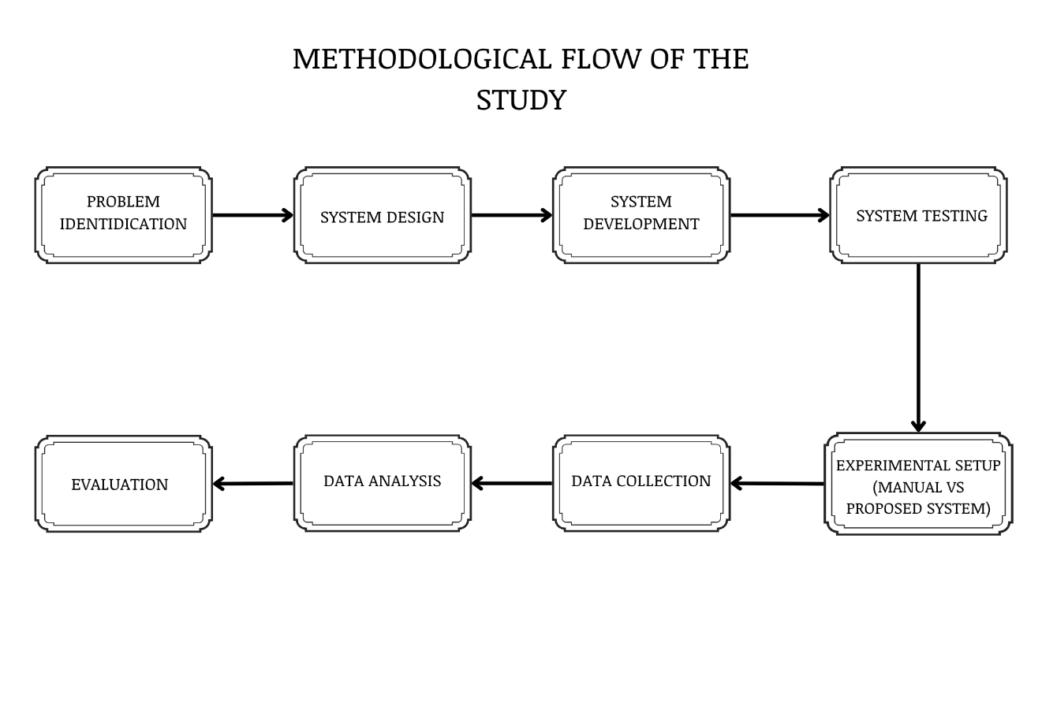
3.2 System Development Method
The study followed an Iterative Software Development Life Cycle (SDLC) model, in which the system was developed through repeated cycles of planning, design, development, testing, and refinement. This approach allowed continuous improvement based on testing results and user feedback. Security mechanisms were implemented consistently across all phases of development to ensure data protection and system integrity.
Figure 2
Iterative System Development Life Cycle Diagram
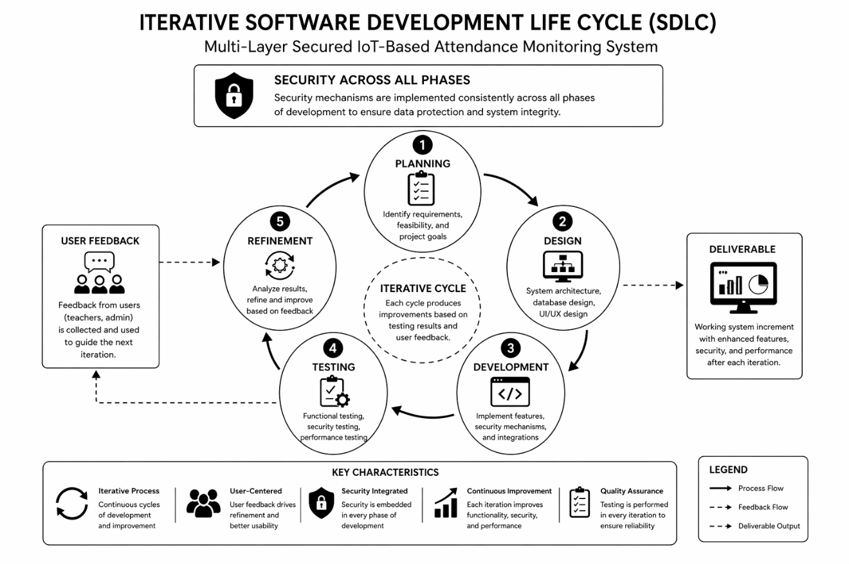
3.2.1 Requirement Analysis
In this phase, the researchers analyzed the existing attendance monitoring system and identified operational and security issues, including time-consuming manual attendance checking, lack of classroom-level validation, absence of teacher identity verification, congestion during attendance recording, and vulnerabilities in data security. To address these issues, the system introduced RFID-based attendance recording at classroom entry points and biometric fingerprint authentication for teacher verification, ensuring accurate attendance recording and authorized system usage. Multi-layer security mechanisms such as encrypted communication, authentication, access control, and audit logging were integrated to protect system data.
3.2.2 System Design
The system was designed to operate within a secure Local Area Network (LAN) to ensure fast, reliable, and low-latency communication. The design includes a database structure for managing users, students, attendance records, and logs; a web-based dashboard for monitoring and administration; and a controlled workflow in which attendance recording occurs only after successful teacher authentication.
The network security design includes network-level access control by address range, controlled port access, firewall configuration, per-device request authentication using signed requests, and encrypted communication using HTTPS/TLS to minimize unauthorized access and reduce network exposure.
Figure 3
System Design Diagram
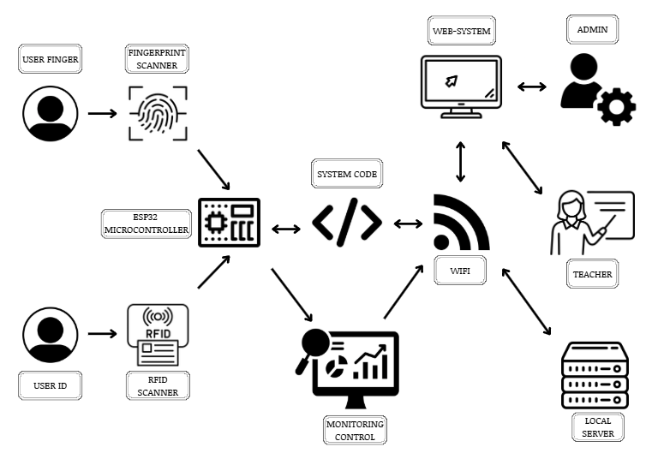
3.2.3 System Development
The system was developed using IoT-based hardware and software components, including the MFRC522 RFID reader module, an optical fingerprint sensor, and the ESP32 microcontroller, integrated with a web-based platform for monitoring and data management. The web application was implemented in PHP and backed by a MariaDB relational database, deployed on the school server within the LAN. Security features including encrypted communication, authentication, access control, and audit logging were implemented to ensure confidentiality, integrity, and availability of data.
User passwords are secured using bcrypt hashing at cost factor 12, and a distinct cryptographic credential is generated for each registered IoT device to authenticate and sign its communication with the server.
3.2.4 System Testing
Structured testing was carried out in two stages. Development-time verification was performed alongside implementation to confirm the correctness and security of the system as it was built. Evaluation-stage testing, described in the remainder of this chapter, will be conducted upon deployment of the prototype at the partner school.
Two automated test suites were developed and executed during implementation. A certificate and transport-security suite verifies the system’s TLS configuration, and returned 40 passing assertions covering encryption of the root key at rest, trust-chain validation, the certificate extensions that browsers and embedded TLS clients actually check, preservation of the root certificate across reissue so that deployed terminals continue to validate, and refusal of malformed hostname input. A concurrency and correctness suite exercises the live service layer against a real database to verify row locking, unique constraints, and deadlock retry behaviour when simultaneous taps are recorded. The output of the transport-security suite is presented in Chapter IV as evidence of the implemented transport protection.
Evaluation-stage testing will proceed as follows.
Functional testing will verify that all system components operate correctly, including attendance recording and authentication processes, with a success rate of at least 95 percent indicating acceptable functionality.
Performance testing will measure system response time and latency, with the system expected to respond within less than two seconds to support real-time operation.
All penetration testing activities will be limited strictly to owned and authorized LAN devices within a controlled academic environment to simulate common security threats and evaluate the effectiveness of implemented protection mechanisms without affecting external or real-world systems.
Security testing using Wireshark, Nmap, and Metasploit will be limited strictly to authorized and owned Local Area Network (LAN) devices for academic and evaluation purposes only. Wireshark will be used for packet inspection and verification of encrypted traffic to analyze communication between IoT devices and the server. Nmap will be used for port and service discovery to identify unnecessary open ports and evaluate network exposure within the LAN environment. Metasploit will be used to simulate controlled exploit scenarios to assess the effectiveness of implemented authentication and access control mechanisms against unauthorized access attempts. No external systems or unauthorized networks will be targeted during testing procedures.
Table 1
Security Plan Test
Threat | Tool | Test Procedure | Expected Result | Metric | Pass/Fail Basis
Unauthorized Access | Metasploit | Simulate unauthorized login attempt | Access blocked | Number of successful unauthorized attempts | No successful unauthorized access
Packet Interception | Wireshark | Monitor transmitted packets | Encrypted packets observed | Encrypted vs unencrypted packets | No readable sensitive data
Open Port Exposure | Nmap | Scan server ports | Only authorized ports open | Number of open ports | No unnecessary open ports
Device Spoofing | Request signature validation | Attempt unregistered device access | Device rejected | Rejected unauthorized requests | 100% rejection
Log Monitoring | Audit Logs | Perform login and attendance actions | Logs generated correctly | Audit log completeness | Complete logs generated

These tools were selected due to their effectiveness in analyzing network traffic, identifying vulnerabilities, and evaluating system security within a controlled academic environment. Usability testing will be conducted through actual user interaction using survey instruments. All testing will be conducted in a controlled environment without affecting real-world systems.
3.3 Participants/Respondents
The participants of the study will include students, faculty members, a school IT administrator, and school administrators from Top Achievers Private School Inc., selected using purposive sampling. A total of 41 participants will be involved to ensure sufficient data for system evaluation.
Specifically, 30 students will participate in system testing to evaluate attendance speed, waiting time, queue length, and overall system efficiency during actual usage. Eight faculty members will serve as primary respondents who will evaluate system usability, accuracy, and effectiveness in classroom attendance monitoring. One school IT administrator will assess system performance, network reliability, and the effectiveness of implemented security mechanisms. In addition, two school administrators will evaluate the system in terms of monitoring capability, data reliability, and decision-making support.
Purposive sampling will be used to select participants who have direct interaction with the system, ensuring that the collected data is relevant and based on actual system usage and evaluation.
3.4 Data Gathering Instruments
The study will use multiple instruments to collect quantitative and qualitative data for system evaluation. The selected instruments are directly aligned with the study objectives to ensure that each objective is measured using appropriate and measurable variables. System-generated data such as attendance logs, timestamps, response time records, and database entries will be used as primary instruments to measure processing time, response time, efficiency, and accuracy. Observation tools such as checklists and time recording devices will be used to measure queue length and waiting time during attendance procedures. Record comparison between manual attendance and system-generated attendance will be used to determine accuracy.
The instruments used in the study are categorized based on system components. For the IoT component, RFID logs, device timestamps, and response time measurements will be used to evaluate device performance and communication efficiency. For the software component, database records, system outputs, and user interaction data will be used to evaluate functionality, usability, and reliability. For the security component, tools such as Wireshark and Nmap will be used to identify vulnerabilities and evaluate the effectiveness of implemented security mechanisms. Survey instruments will include a 5-point Likert scale questionnaire to measure user perception, usability, efficiency, accuracy, and security.
Table 2
Likert Scale Interpretation
Scale | Description | Interpretation
5 | Strongly Agree | Very High
4 | Agree | High
3 | Neutral | Moderate
2 | Disagree | Low
1 | Strongly Disagree | Very Low

The System Usability Scale (SUS) will be used to evaluate system usability, while the Technology Acceptance Model (TAM) will be used to measure user acceptance. ISO/IEC 25010 will be used to assess system quality, and the CIA framework will be used to evaluate system security.
Prior to actual deployment, the survey questionnaire will undergo pilot testing to evaluate clarity, consistency, and reliability. Selected respondents outside the target participants will be asked to complete the questionnaire to identify unclear statements and improve the validity of the instrument.
Each objective of the study will be evaluated using corresponding metrics and instruments. The objective of reducing attendance time will be measured using processing time and waiting time obtained from system logs and observation tools. The objective of reducing congestion will be evaluated using queue length measurements. The objective of improving attendance accuracy will be measured through record comparison between manual and system-generated data. The objective of improving system efficiency will be evaluated through computed efficiency percentages. The objective of ensuring system security will be assessed through security testing tools by identifying vulnerability severity levels.
Teacher authentication effectiveness will be measured based on the successful authentication rate and the number of failed authentication attempts recorded during system usage. This will ensure that only authorized teachers are able to initiate attendance sessions.
Security effectiveness will be evaluated based on successful prevention of unauthorized access attempts, protection of transmitted attendance data, enforcement of authentication procedures, and completeness of recorded audit logs during controlled testing.
System reliability will also be evaluated by testing the fallback mechanism, in which attendance data is temporarily retained on the terminal during network interruptions and synchronized once the connection is restored.
Table 3
Instrument–Metric Mapping
Objective | Metric | Instrument
Reduce attendance time | Processing Time | System logs, stopwatch
Reduce congestion | Waiting Time | Observation, stopwatch
Reduce congestion | Queue Length | Observation checklist
Improve accuracy | Accuracy Rate | Record comparison
Improve efficiency | Efficiency (%) | Computation
Ensure security | Vulnerability severity | Wireshark, Nmap
Verify teacher identity | Authentication success rate | System logs
Ensure reliability | Data synchronization success | System logs

Table 4
SOP–Objectives–Metrics–Instrument Mapping
Statement of the Problem | Objective | Metric | Instrument | Success Criterion
How can manual classroom attendance checking be minimized? | Reduce attendance recording time | Processing Time | System logs, stopwatch | Reduced processing time
How can accurate classroom-level attendance recording be ensured? | Improve attendance accuracy | Accuracy Rate | Record comparison | ≥ 95%
How can congestion at the RFID gate be reduced? | Reduce waiting time and queue length | Waiting Time, Queue Length | Observation tools | Reduced congestion
How can teacher identity verification be integrated? | Verify authorized teacher access | Authentication Success Rate | System logs | ≥ 95%
How can multi-layer security mechanisms protect attendance data? | Implement network and application security | Vulnerability Severity, Unauthorized Access Attempts | Wireshark, Nmap, Metasploit | No High or Critical vulnerabilities

3.5 Evaluation Procedure
The evaluation process will follow a structured sequence: system deployment, functional and performance testing, user testing in actual attendance scenarios, experimental comparison between the manual and the developed system, survey distribution to respondents, and data collection and analysis.
Each instrument will follow a specific evaluation procedure. System logs will be collected during attendance sessions to measure processing time and response time. Observation tools will be used during actual attendance scenarios to record waiting time and queue length. Survey instruments such as SUS and TAM will be administered after system use to evaluate usability and acceptance. Security testing tools will be applied in controlled scenarios to identify vulnerabilities and assess system protection mechanisms. The collected data will then be analyzed based on predefined metrics and evaluation criteria.
Controlled simulation scenarios will be conducted to generate measurable evidence supporting system performance and security claims. These simulations will include attendance scenarios for performance testing, authentication testing for teacher verification, controlled attack scenarios for security evaluation, and network interruption scenarios to validate the fallback mechanism.
The evaluation of the system will be conducted across its major components, including the IoT layer (device performance), network layer (data transmission efficiency), application layer (system functionality and usability), and security layer (data protection and access control).
3.6 Experimental Design
The study will compare the existing manual attendance system and the developed system using measurable and quantitative criteria derived from the study objectives. Processing time will measure the reduction in attendance duration, waiting time and queue length will measure congestion levels, accuracy will evaluate the correctness of attendance records, efficiency will determine the improvement between manual and automated processes, response time will assess system performance, and security effectiveness will evaluate the strength of implemented security mechanisms.
Processing time will be computed as the total time required to complete attendance divided by the number of students, while waiting time will be calculated as the difference between arrival time and completion time. Accuracy will be measured as the percentage of correct records, and efficiency will be computed as the percentage improvement between manual and system performance.
In addition, authentication performance will be evaluated based on the rate of successful and failed fingerprint authentication attempts, while system reliability will be measured through the successful synchronization of retained data after simulated network interruptions. Security effectiveness will be analyzed based on the system’s ability to prevent unauthorized access, detect abnormal activities, and maintain data integrity during controlled testing scenarios.
All experiments will be conducted under the same class size, environment, time duration, and attendance procedures to ensure a fair and valid comparison.
The experimental process used to compare the manual attendance system and the developed system is illustrated in Figure 4. The diagram presents the sequence of steps including setup, execution, data collection, and result comparison.
Figure 4
Experimental Setup and Process Flow Diagram
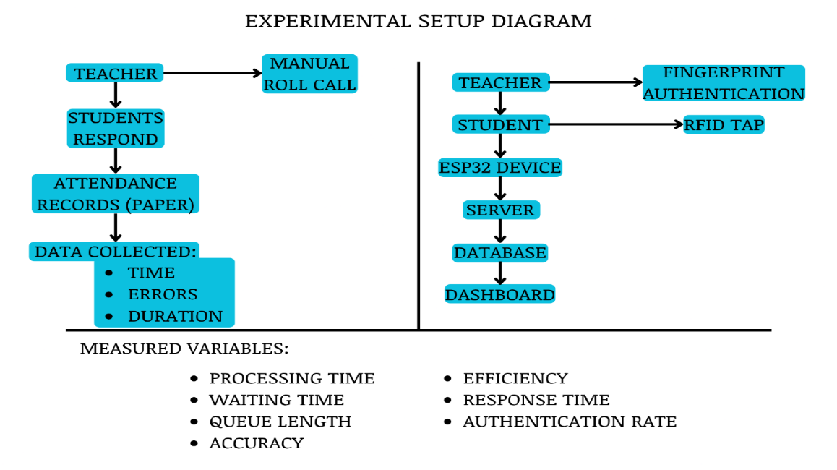
Null Hypothesis (H₀):
There is no significant difference between the manual attendance system and the developed system in terms of processing time, accuracy, and efficiency.
Alternative Hypothesis (H₁):
There is a significant difference between the manual attendance system and the developed system in terms of processing time, accuracy, and efficiency.
Statistical Test
To determine whether the observed differences between the manual attendance system and the developed system are statistically significant, the study will use a paired sample t-test. This test is appropriate because the same group of participants will be evaluated under two conditions: manual attendance and system-based attendance.
The paired t-test will analyze differences in processing time, accuracy, and efficiency for each participant or attendance session. A significance level of 0.05 will be used. If the computed p-value is less than 0.05, the null hypothesis will be rejected, indicating that the developed system provides a statistically significant improvement over the manual attendance system.
Mathematical Models
The study will use the following formulas to measure system performance:
Accuracy Rate: Accuracy (%) = (Number of Correct Attendance Records / Total Attendance Records) × 100
Processing Time: Processing Time = Total Time to Record Attendance / Number of Students
Efficiency: Efficiency (%) = ((Manual Attendance Time − System Attendance Time) / Manual Attendance Time) × 100
Waiting Time: Waiting Time = Time of Completion − Time of Arrival
3.7 Data Analysis Techniques
Data collected in the study will be analyzed using descriptive and comparative statistical methods. Mean, median, and standard deviation will be used to analyze survey responses and evaluate user perception, while comparative analysis will be used to determine differences between manual and system performance.
The results of the analysis will be interpreted based on predefined success criteria. For survey data, weighted mean and grand mean will be used to determine user perception levels. For experimental data, comparative analysis will be used to determine improvements between the manual and the developed system. The system will be considered acceptable if it meets the defined thresholds for usability, accuracy, performance, and security.
Table 5
Interpretation of Mean Scores
Mean Range | Interpretation
4.20–5.00 | Very High
3.40–4.19 | High
2.60–3.39 | Moderate
1.80–2.59 | Low
1.00–1.79 | Very Low

3.8 System Evaluation Criteria
Table 6
System Evaluation Criteria
Criteria | Indicator | Measurement | Success Criteria
Usability | SUS Score | Questionnaire | ≥ 70
Acceptance | TAM | Likert scale | Mean ≥ 3.0
Performance | Response Time | System logs | < 2 seconds
Accuracy | Attendance Records | Record comparison | ≥ 95%
Authentication | Success Rate | System logs | ≥ 95%
Reliability | Data Sync Success | System logs | ≥ 95%
Security | Vulnerability Severity | Security testing | No high-risk
Network Security | Open Ports | Nmap Scan | No unnecessary open ports
Access Control | Failed Unauthorized Requests | Security Testing | 100% rejection of unauthorized requests
Access Control | Encrypted Packets | Wireshark Analysis | No readable sensitive data
Monitoring | Audit Log Completeness | Audit Logs | Complete logs generated

Security performance will be evaluated based on the effectiveness of implemented protection mechanisms during controlled testing. High-risk vulnerabilities must not be present, medium-risk vulnerabilities must be minimized, and low-risk vulnerabilities will be acceptable within controlled limits.
The selected evaluation thresholds are based on acceptable standards commonly used in system performance, usability, and security evaluation studies. High accuracy, fast response time, and reliable authentication are necessary to ensure that the system can operate effectively within classroom environments.
3.9 Ethical Considerations
The study will comply with Republic Act No. 10173, or the Data Privacy Act of 2012. Informed consent will be obtained from all participants prior to data collection, and participation will be voluntary. All collected data will be treated with strict confidentiality and will be used solely for academic purposes. Sensitive information, including biometric and attendance data, will be securely stored and will only be accessed by authorized personnel.
In the developed system, fingerprint data is not stored as an image. The fingerprint sensor converts each enrolled fingerprint into a numeric template held in the sensor module, and the server stores only a reference to that template together with the identity it belongs to. This design limits the personal data held by the system and supports the confidentiality requirement of the Data Privacy Act.

CHAPTER IV
TECHNICAL BACKGROUND

4.1 Introduction
This chapter presents the technical design, system architecture, and implementation of L-SIAMS: A Local IoT-Based Multi-Layer Secured Attendance Monitoring System with RFID and Biometric Authentication for Top Achievers Private School Inc. (TAPS). The system integrates IoT-based hardware, a web-based application, and multi-layer security mechanisms to provide accurate, efficient, and secure attendance monitoring.
The system consists of three major components: the IoT device for attendance capture, the application system for data processing and management, and the security architecture for data protection. These components operate within a Local Area Network (LAN) to provide reliable communication, low latency, and reduced exposure to external threats.
Figure 5
Data Flow Diagram
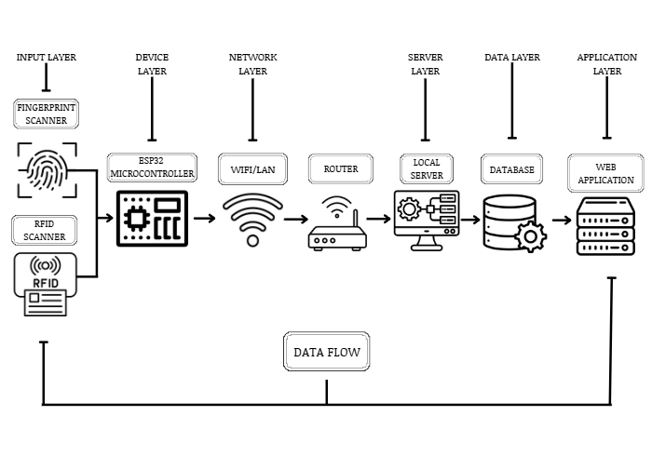
4.2 System Architecture Overview
The system adopts a multi-layer architecture composed of six main layers: the Device Layer, Network Layer, Transport Layer, Application Layer, Database Layer, and Monitoring Layer. Each layer performs a specific role while interacting with other layers to ensure overall system functionality.
The Device Layer captures attendance data using RFID readers and fingerprint sensors connected to the ESP32 microcontroller. The Network Layer manages secure communication between IoT devices and the server through the Local Area Network. The Transport Layer secures transmitted data using HTTPS/TLS encryption. The Application Layer processes attendance records, authentication requests, and system operations. The Database Layer manages secure storage of attendance records, user credentials, and audit logs. The Monitoring Layer handles activity logging, anomaly detection, and audit trail generation for accountability and security monitoring.
The architecture directly addresses the problems identified in Chapter I. Classroom-based RFID attendance reduces congestion at entry points, while automated recording minimizes manual attendance time. Biometric authentication provides teacher verification, and the integration of multi-layer security mechanisms protects attendance data from unauthorized access and modification.
The overall structure of the system is illustrated in Figure 6, showing the interaction between IoT devices, network components, application systems, and security layers.
Figure 6
System Architecture Diagram
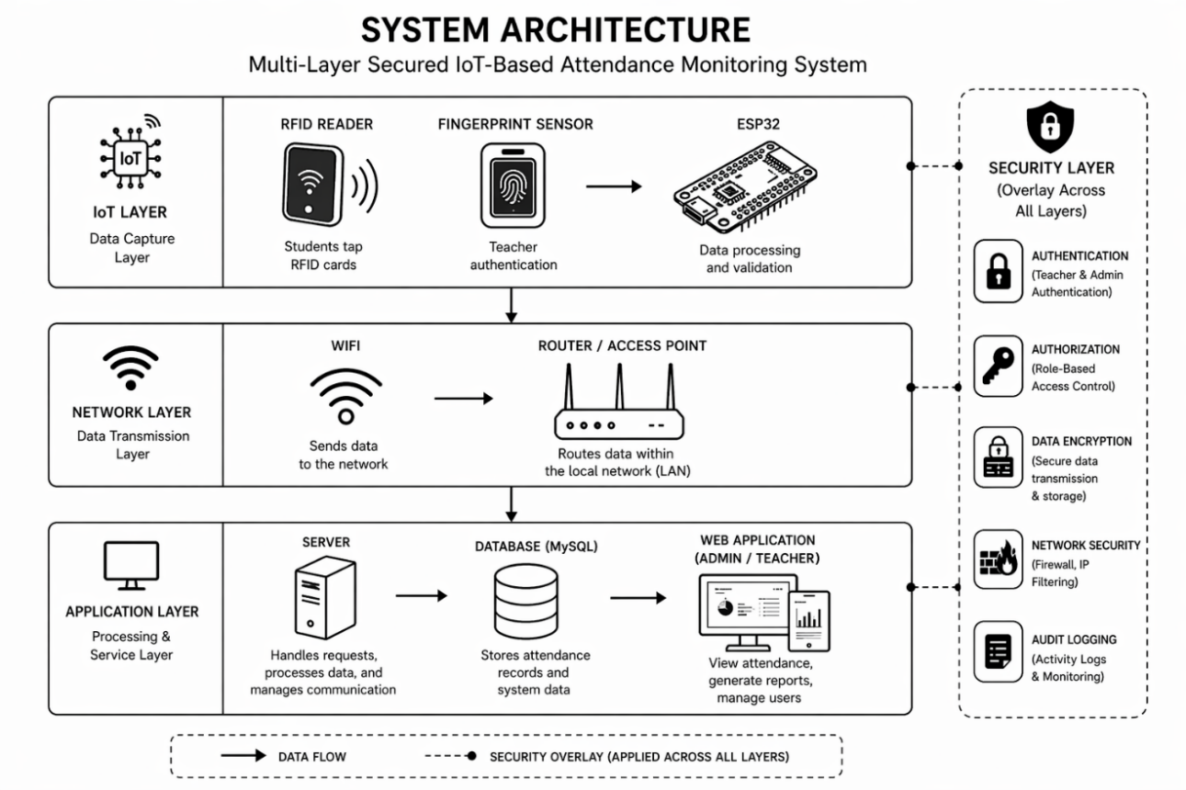
4.3 IoT Device Architecture
The IoT device is built using the ESP32 microcontroller, which serves as the central processing unit responsible for handling input, processing data, and transmitting information to the server. The ESP32 was selected for its cost efficiency, built-in Wi-Fi capability, and suitability for IoT applications.
The device integrates RFID technology to identify students and a biometric fingerprint sensor to verify teacher identity. RFID provides fast and contactless student identification, while fingerprint authentication prevents proxy attendance and ensures that only authorized teachers can initiate attendance sessions.
The system uses the MFRC522 RFID module for student identification due to its low cost, ease of integration, and compatibility with the ESP32 microcontroller. For biometric authentication, an optical fingerprint sensor of the AS608 or R307 family is used for its reliability, built-in template storage, and suitability for embedded systems. These components were selected to ensure affordability, efficiency, and ease of deployment in classroom environments.
Because a fingerprint reader can fail to read a legitimate teacher — through a wet, dry, or injured finger, or a sensor fault — the system provides a controlled failover in which an assigned teacher may open a session using their own account password instead. The failover is deliberately not silent: it is recorded as a distinct security event so that an administrator can see how often biometric verification is being bypassed and by whom.
The IoT device captures student and teacher data, processes the information, and transmits it to the server in a structured format through the network.
Figure 7
IoT Device Diagram
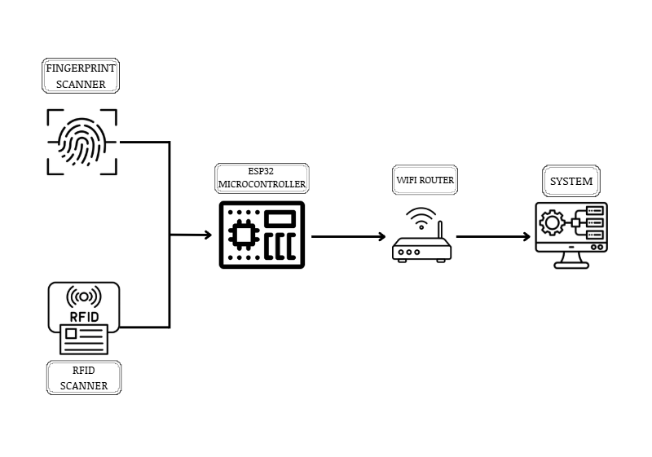
4.4 Network Architecture
The system operates within a Local Area Network (LAN) using a client-server model. The LAN-based setup was selected to provide faster communication, reduced latency, and enhanced security by limiting exposure to external networks.
Compared to cloud-based deployment, the LAN architecture reduces the system’s attack surface by restricting external internet exposure and allowing stricter internal network monitoring and access control.
The network connects IoT devices, the server, and client devices such as administrator and teacher computers. The Wi-Fi router acts as the central communication hub, enabling data transmission between devices.
Attendance data collected from IoT devices is transmitted to the server, where it is processed and stored. Client devices access the system through a web interface to view attendance records and generate reports.
Network access control is enforced at the application boundary in addition to the router. Every incoming request is checked against configured address ranges before any authentication is attempted: one range for browser access by staff, and a separate range for terminal traffic. A request originating outside its permitted range is refused and recorded as a security event, regardless of whether it carries valid credentials. This makes network position an independent condition of access rather than a consequence of the firewall alone.
Figure 8
Network Architecture
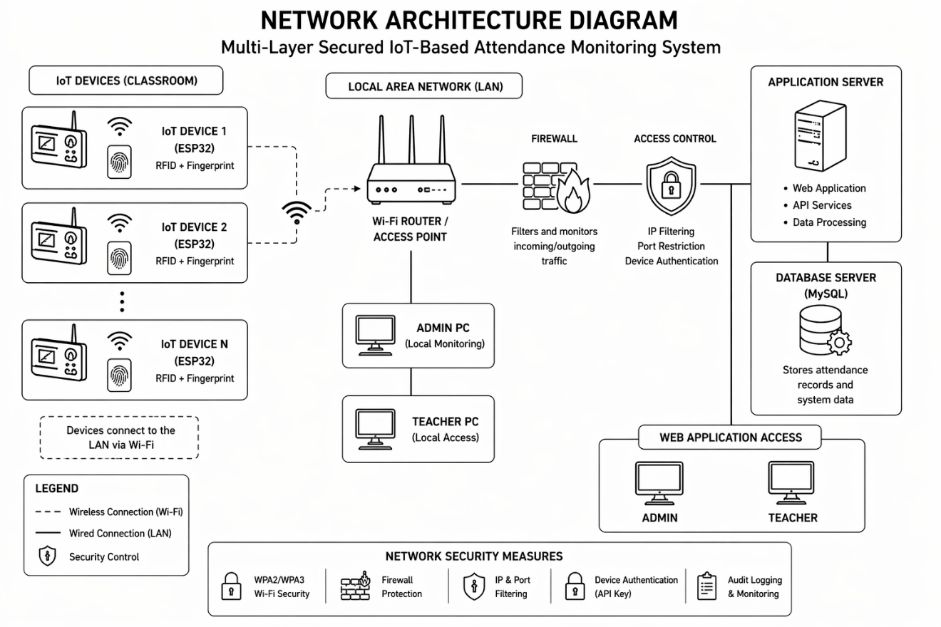
4.5 Application Architecture
The system follows a three-tier architecture consisting of the presentation layer, application layer, and data layer. The presentation layer serves as the user interface, allowing administrators and teachers to interact with the system. The application layer processes requests, applies system logic, and enforces rules such as authentication and validation. The data layer stores system data, including user information, attendance records, and audit logs.
The backend is implemented in PHP with a MariaDB relational database, selected for their compatibility, lightweight footprint, and suitability for LAN-based deployment on modest server hardware. The application runs without third-party runtime dependencies: the class autoloader, the spreadsheet and PDF report writers, the WebSocket server, the chart renderer, and the icon set are all implemented within the project. This decision follows directly from the deployment constraint, since the target network may have no route to the internet from which packages could be installed or updated.
Requests that change attendance state carry an idempotency key. If a terminal retries a transmission because it did not receive a response, the server recognizes the repeated key and returns the original outcome instead of recording a second attendance entry. This protects record integrity across an unreliable link without requiring the terminal to reason about what the server already received.
Monitoring screens receive updates over a WebSocket connection, with Server-Sent Events and long polling as automatic fallbacks when a client or network path does not support the primary transport. Each event carries a sequence number, so a client that reconnects after an interruption requests only the events it missed rather than losing them or reloading the entire view.
The system generates measurable data such as timestamps, response time, authentication logs, and attendance records, which will be used in the experimental evaluation described in Chapter III. These data outputs support the measurement of system performance, accuracy, and efficiency.
4.6 Database Design
The system database uses a relational structure to ensure efficient data storage, retrieval, and data integrity. It is implemented in MariaDB and consists of multiple interrelated tables that support attendance recording, user authentication, and system monitoring.
The main entities include the user table, which stores login credentials and user roles; the teacher table, which is linked to user accounts and stores biometric references; the class table, which organizes students and assigns teachers; and the student table, which contains student identity information along with RFID unique identifiers.
The attendance table records all attendance transactions, while the device table stores information about registered IoT devices and their corresponding credentials. The audit log table records system activities for monitoring and accountability purposes, and a separate security log table records security-relevant events for investigation.
The relationships between these entities are structured to ensure proper data linkage and consistency. A one-to-one relationship exists between the user and teacher entities, while a teacher can handle multiple classes. Each class contains multiple students, and each student can have multiple attendance records. Similarly, a device can send multiple attendance records, and a user can generate multiple audit logs. This relational design ensures traceability, consistency, and secure management of attendance data throughout the system.
Figure 9
Entity Relationship Diagram
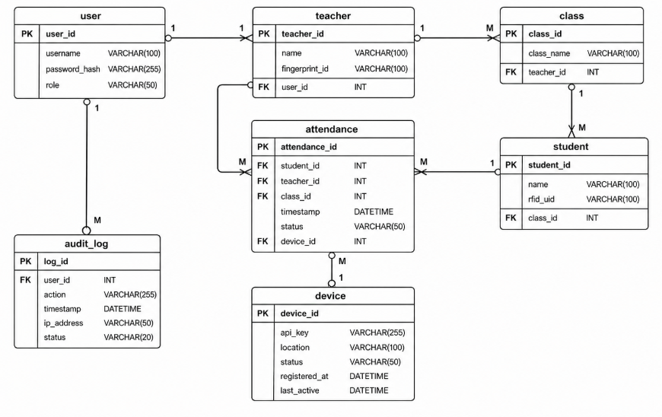
4.7 Data Flow Diagram
The Data Flow Diagram illustrates the internal processes of the system, including attendance capture, data validation, and storage. The process begins with teacher authentication, followed by student RFID scanning. The system validates the data and transmits it to the server, where it is processed and stored in the attendance database. The system also generates audit logs for monitoring and traceability, as shown in Figure 10.
Figure 10
Data Flow Diagram
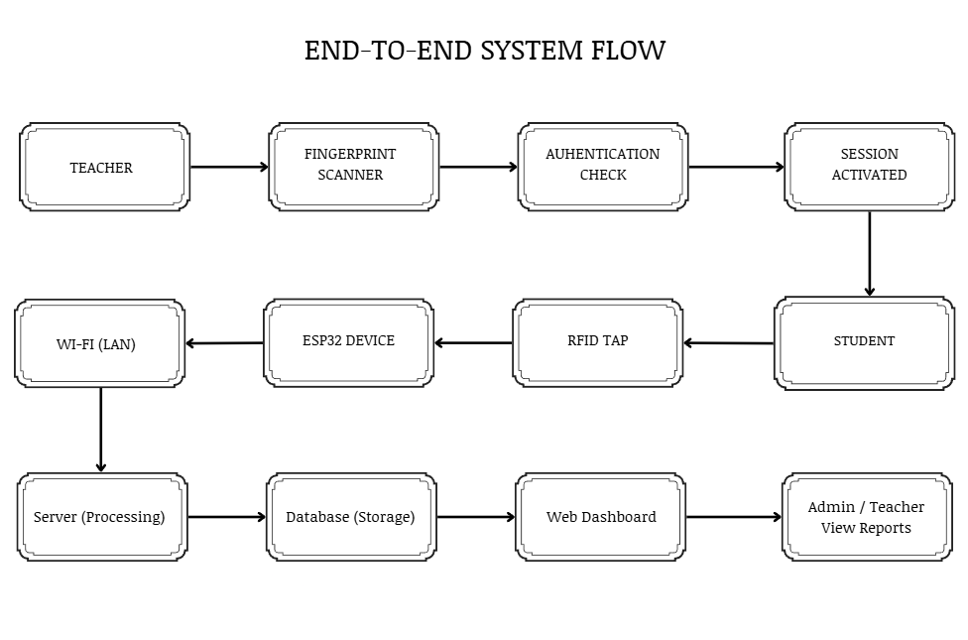
4.8 Security Architecture
The system implements a multi-layer security architecture to ensure data protection and system integrity. The security model comprises device authentication, network security, transport security, application security, database security, and monitoring mechanisms, as shown in Figure 11. Each layer is designed so that the failure of any single control does not by itself grant access to attendance data.
Device Layer Security
Each registered terminal holds two separate credentials: an API key that identifies it, and a 256-bit secret used to sign its requests. Identification and proof of identity are therefore distinct, so a key observed in transit or read from a device cannot by itself be used to impersonate that terminal. Every request from a terminal carries a signature computed over the request content using the device secret, together with a timestamp and a single-use value called a nonce.
The server validates every device request through a fixed six-step sequence, shown in Table 7. Each step has its own failure code, and every failure is written to the security log. The codes returned to the caller are deliberately coarse, so that a rejected request does not reveal which condition failed and therefore does not help an attacker map the system’s defences, while the log retains the precise reason for the administrator.
Table 7
Device Request Validation Sequence
Step | Condition checked | Failure code | Security purpose
1 | The device is registered and active | DEVICE_UNKNOWN | Rejects traffic from any terminal the school has not provisioned
2 | The API key is valid and unexpired | API_KEY_INVALID | Rejects revoked, expired, or fabricated credentials
3 | The request signature is valid | SIGNATURE_INVALID | Proves possession of the device secret; defeats key-only spoofing and detects tampering with the request body
4 | The timestamp is within ±30 seconds | TIMESTAMP_EXPIRED | Bounds the window in which any captured request could be reused
5 | The nonce has not been used before | REPLAY_DETECTED | Prevents a captured valid request from being replayed even inside the time window
6 | The device is bound to the classroom | DEVICE_CLASSROOM_MISMATCH | Prevents a terminal removed from one room from recording attendance for another

Credentials are managed over their whole life rather than issued once. Keys are generated during device registration, stored in protected form, validated on every request, and may be rotated, with a grace period during which the previous key remains valid so that rotation does not interrupt attendance capture. The system also revokes a device credential automatically when its behaviour indicates compromise: repeated signature failures, or use of the same key from several distinct network addresses within a short period.
Network Layer Security
Network security is enforced through controlled LAN access, including address-range filtering applied to every request before authentication, firewall configuration, and port restriction. Browser traffic and terminal traffic are governed by separate permitted ranges, so a compromised staff workstation does not inherit the network position of a classroom terminal. Requests arriving from outside the permitted range are refused and recorded, whether or not they carry valid credentials.
Transport Layer Security
HTTPS/TLS secures communication between the ESP32 terminals and the server within the LAN. Because the system is designed to run without internet access, it cannot obtain certificates from a public certificate authority. The system therefore operates its own internal certificate authority: it issues the server certificate, keeps the authority’s private key encrypted at rest, and provides the root certificate in a form the firmware compiles in, so that each terminal validates the server it connects to rather than trusting any host that answers. Reissuing the server certificate deliberately preserves the existing root, so that terminals already deployed in classrooms continue to validate without being reflashed.
The correctness of this arrangement was verified by an automated test suite during development. Its results are presented in Section 4.13 as Figure 20.
Application Layer Security
Application-level security combines several controls. User passwords are hashed with bcrypt at cost factor 12, a deliberately slow function chosen because human-chosen passwords are low in entropy and must be expensive to test. Password policy requires a minimum length of twelve characters with mixed character classes, rejects passwords appearing in a common-password blocklist, and prevents reuse of recent passwords. Repeated failed sign-in attempts lock an account for a fixed period.
Sessions are identified by cryptographically random tokens rather than predictable identifiers. Session cookies are restricted to the host, marked so that scripts cannot read them, and constrained so they are not sent with cross-site requests. A session expires both after a period of inactivity and at an absolute maximum age, and is additionally bound to the browser and network prefix it was created from, so that a stolen session identifier used from elsewhere is rejected. The number of concurrent sessions per user is capped.
State-changing requests require a cross-site request forgery token. Request rates are limited per terminal to contain a device stuck in a retry loop. Response headers restrict how the interface may be embedded, framed, or referenced, and a content security policy authorises the interface’s own scripts by nonce rather than permitting inline script execution generally, which closes the principal avenue for injected script.
Uploaded files are constrained by type and are stored in a location configured so that they cannot be executed by the web server, preventing an uploaded file from becoming a means of running code.
Database Layer Security
Database access is restricted to the application’s own account, which is granted only the privileges it requires. Passwords are stored as hashes and are never recoverable. Device signing secrets are stored encrypted rather than in plain text, so that read access to the database alone does not yield the ability to impersonate a terminal. All queries are parameterised, so that user-supplied values cannot alter the structure of a statement.
Attendance and audit records are treated as append-only history: corrections are recorded as new entries rather than overwriting earlier ones, so that the record of what was originally captured survives any later amendment.
Monitoring Layer Security
Monitoring is implemented through two complementary records. The audit log records ordinary administrative and attendance activity for accountability. The security log records events that carry a security meaning, each classified by severity and carried through a resolution workflow so that an administrator can mark an entry as investigating, resolved, or a false positive rather than merely observing it. The system records thirty-three distinct security event types, grouped in Table 8.
Table 8
Security Event Types Recorded by the System
Category | Recorded events
Device and request authentication | DEVICE_UNKNOWN, DEVICE_BLOCKED, DEVICE_SPOOFING, API_KEY_INVALID, API_KEY_EXPIRED, API_KEY_REVOKED_USE, API_KEY_IP_ANOMALY, SIGNATURE_INVALID, TIMESTAMP_EXPIRED, REPLAY_DETECTED, CLAIM_TOKEN_INVALID
Network access control | IP_NOT_ALLOWLISTED, BLOCKED_IP_ATTEMPT, RATE_LIMIT_EXCEEDED
Account and session security | LOGIN_FAILED, ACCOUNT_LOCKED, SESSION_HIJACK_SUSPECTED, UNAUTHORIZED_ACCESS, PERMISSION_VIOLATION
Application attack detection | CSRF_FAILURE, SQL_INJECTION_ATTEMPT, XSS_ATTEMPT, MALICIOUS_UPLOAD
Identity and biometric integrity | BIOMETRIC_OVERRIDE_USED, BIOMETRIC_OVERRIDE_REFUSED, FINGERPRINT_FAILURE_THRESHOLD, FINGERPRINT_SLOT_CROSS_DEVICE
Attendance and enrolment integrity | UNKNOWN_RFID, DEVICE_CLASSROOM_MISMATCH, SECTION_MISMATCH_REPEATED, GRADE_LEVEL_MISMATCH_BLOCKED, CROSS_DEPARTMENT_ASSIGNMENT_BLOCKED, UNAUTHORIZED_CHANNEL_SUBSCRIBE

These security mechanisms will be evaluated during the evaluation phase to determine their effectiveness in preventing unauthorized access, detecting system vulnerabilities, and ensuring data confidentiality, integrity, and availability.
Figure 11
Security Architecture Diagram
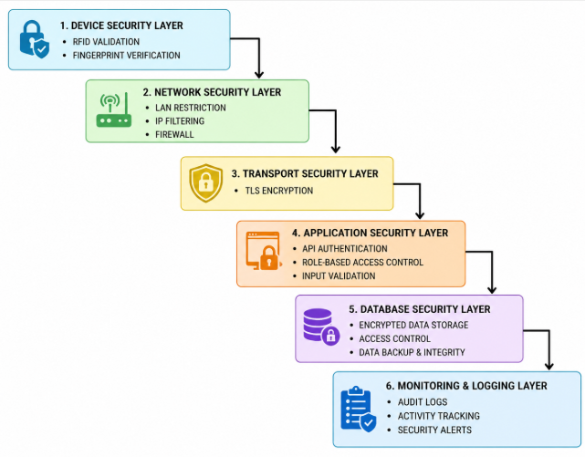
4.9 Threat Model and Security Considerations
The system adopts a structured STRIDE-based threat model to identify and address common security threats. Table 9 maps each threat category to the specific controls implemented in the system.
Table 9
Threat, Description and Mitigation
Threat | Description | Mitigation implemented
Spoofing | Unauthorized impersonation of users or devices | Fingerprint verification for teachers; per-request signature proving possession of the device secret; address-range restriction on terminal traffic
Tampering | Unauthorized modification of attendance data | Signature computed over the request content; parameterised queries; append-only attendance and audit history; idempotency keys on state-changing requests
Repudiation | Denial of performed actions | Audit log of administrative and attendance activity; separate security log with severity and resolution workflow; recorded biometric override events
Information Disclosure | Exposure of confidential data | HTTPS/TLS with an internal certificate authority; role-based access control; device secrets stored encrypted; passwords stored only as bcrypt hashes
Denial of Service | Disruption of system availability | Firewall rules and address-range restriction; per-terminal rate limiting; offline capture on the terminal with automatic resynchronisation
Elevation of Privilege | Unauthorized privilege escalation | Role-based access control with per-route permission checks; session binding and concurrent session limits; automatic revocation of device credentials showing signs of compromise

4.10 Security Testing Approach
Security testing will be conducted in a controlled environment using Wireshark, Nmap, and Metasploit. These tools will be used to analyze network traffic, discover exposed services, and simulate controlled attack scenarios.
Wireshark will be used for packet inspection and verification of encrypted traffic.
Nmap will be used for port and service discovery to evaluate network exposure.
Metasploit will be used to simulate controlled exploit scenarios for academic evaluation purposes only.
All testing procedures will be limited strictly to authorized and owned Local Area Network (LAN) devices to comply with ethical and legal cybersecurity standards.
The results of these tests will be used to classify vulnerabilities based on severity levels using the Common Vulnerability Scoring System (CVSS). Vulnerabilities classified as High Risk (CVSS 7.0 and above) must not be present for the system to be considered acceptable.
Table 10
CVSS Score Interpretation
CVSS Score | Severity
0.1–3.9 | Low
4.0–6.9 | Medium
7.0–8.9 | High
9.0–10.0 | Critical

In addition to this planned evaluation, transport-layer security was verified during development using an automated certificate test suite, the results of which are presented in Figure 20.
4.11 System Design Considerations
The system design considers efficiency, scalability, reliability, and security. The use of IoT technology enables real-time attendance recording, while the LAN-based setup provides stable communication. The integration of RFID and biometric authentication improves attendance accuracy and prevents unauthorized session initiation. The use of a structured database and web-based interface supports efficient data management and reporting.
The design also supports the collection of measurable data required for evaluation, including attendance timestamps, authentication logs, and system response times. These outputs will be used to validate system performance, accuracy, and efficiency based on the defined experimental metrics.
4.12 System Limitations
The system has several limitations. It depends on the stability of the Local Area Network, and any network interruption may affect real-time data transmission. RFID technology may experience misreads, while biometric authentication may fail to recognise a legitimate user under certain conditions, which is why the controlled password failover described in Section 4.3 exists.
The offline capture mechanism has a defined boundary that should be stated plainly. The terminal holds up to forty taps in the microcontroller’s real-time-clock memory while the server is unreachable, and replays them with their original timestamps once the link returns. That memory survives a reset or a watchdog reboot, but it does not survive a loss of power. If a classroom loses power before connectivity is restored, taps held at that moment are lost.
The system is limited to single-campus deployment and would require further development to support scalability across multiple campuses. The processing power, memory, and storage capacity of the ESP32 may affect performance when handling multiple simultaneous authentication and encryption operations.
Operating an internal certificate authority requires that certificates be renewed and that the root certificate be distributed to terminals when it changes, which adds administrative effort. Device credential rotation likewise adds maintenance as the number of registered terminals grows.
The system was developed as a prototype and will be tested in selected classrooms, which may not fully reflect large-scale deployment scenarios. Security testing will be conducted in controlled environments and may not cover all real-world attack variations.
4.13 Prototype Implementation and System Interface
This section presents the developed prototype as evidence of implementation. The screenshots that follow were captured from the running system operating against a populated database, and are grouped by the security function they demonstrate rather than by menu order, so that each figure supports a specific claim made earlier in this chapter.
4.13.1 Hardware Prototype
The classroom terminal integrates the ESP32 microcontroller, the MFRC522 RFID reader, and the optical fingerprint sensor in a single enclosure mounted at the classroom entry point.
Figure 12
Assembled L-SIAMS Classroom Terminal
[ INSERT PHOTOGRAPH ] Photograph of the completed terminal in its enclosure, front view.
Figure 13
Terminal Component Layout and Wiring
[ INSERT PHOTOGRAPH ] Photograph of the opened terminal showing the ESP32, MFRC522 reader and fingerprint sensor, and their connections.
Figure 14
Terminal in Classroom Use
[ INSERT PHOTOGRAPH ] Photograph of a student tapping an RFID card and, if available, a teacher presenting a fingerprint to open a session.
4.13.2 Authentication and Access Control
Access to the web application begins at a single authenticated entry point. The sign-in screen in Figure 15 is subject to the account lockout and password policy described in Section 4.8, and to the network address restriction described in Section 4.4, which is applied before credentials are examined.
Figure 15
System Sign-In Screen
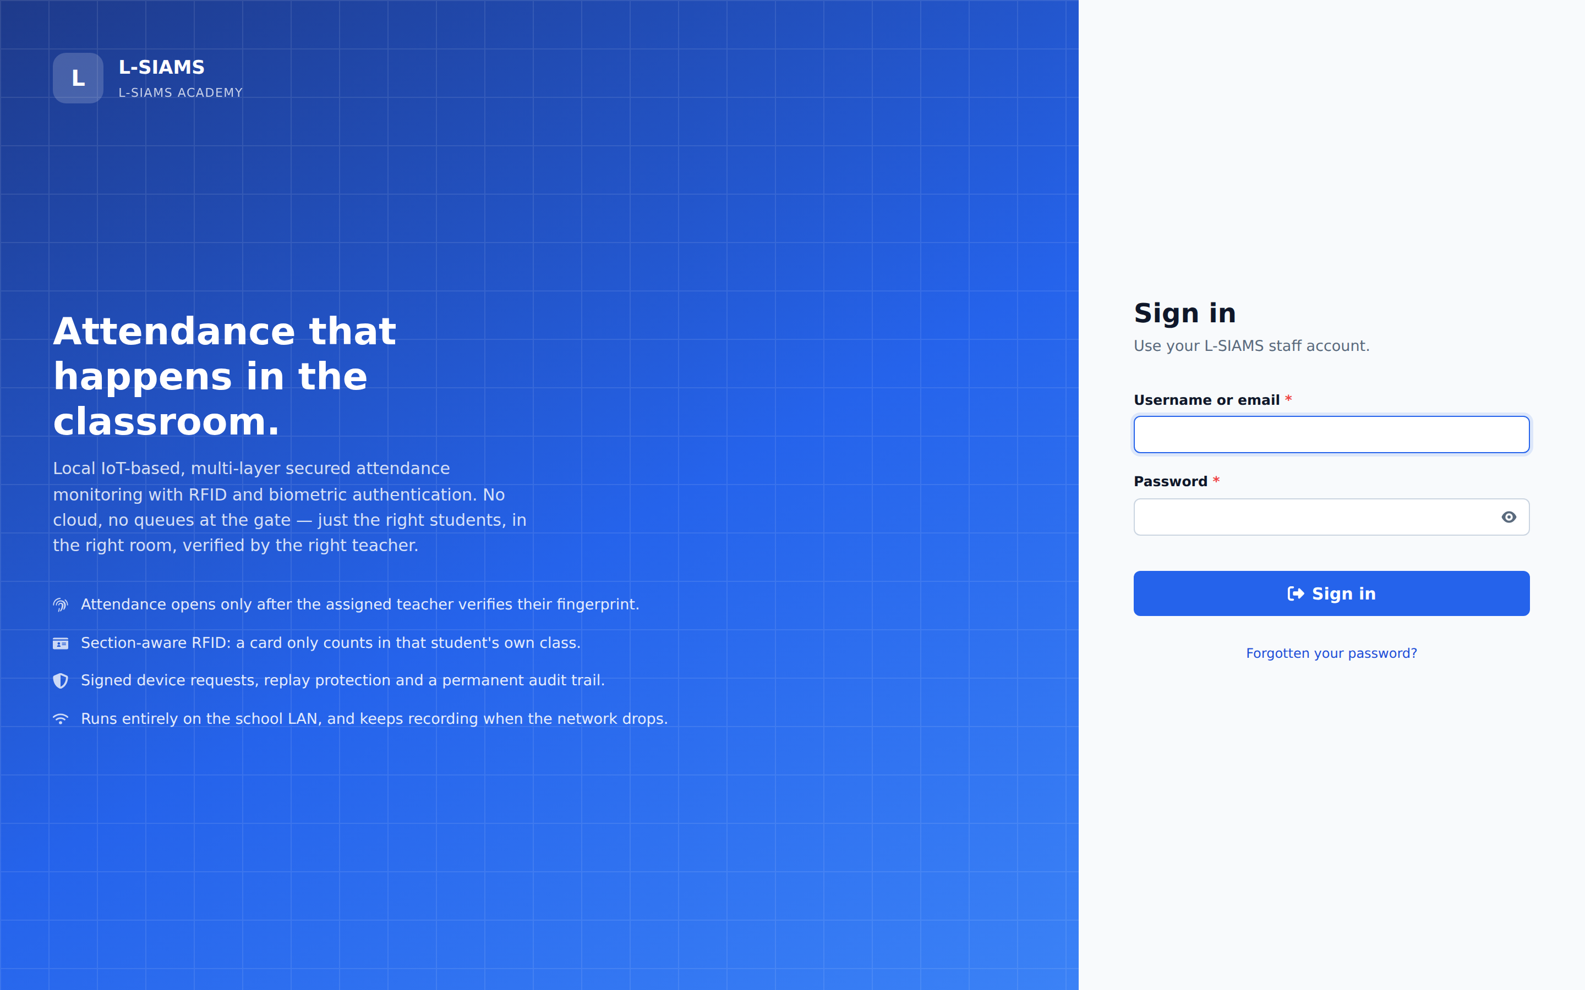
User accounts are governed by role-based access control. Figure 16 shows the account management interface, in which each account is bound to a role that determines the routes and operations available to it.
Figure 16
User Account and Role Management
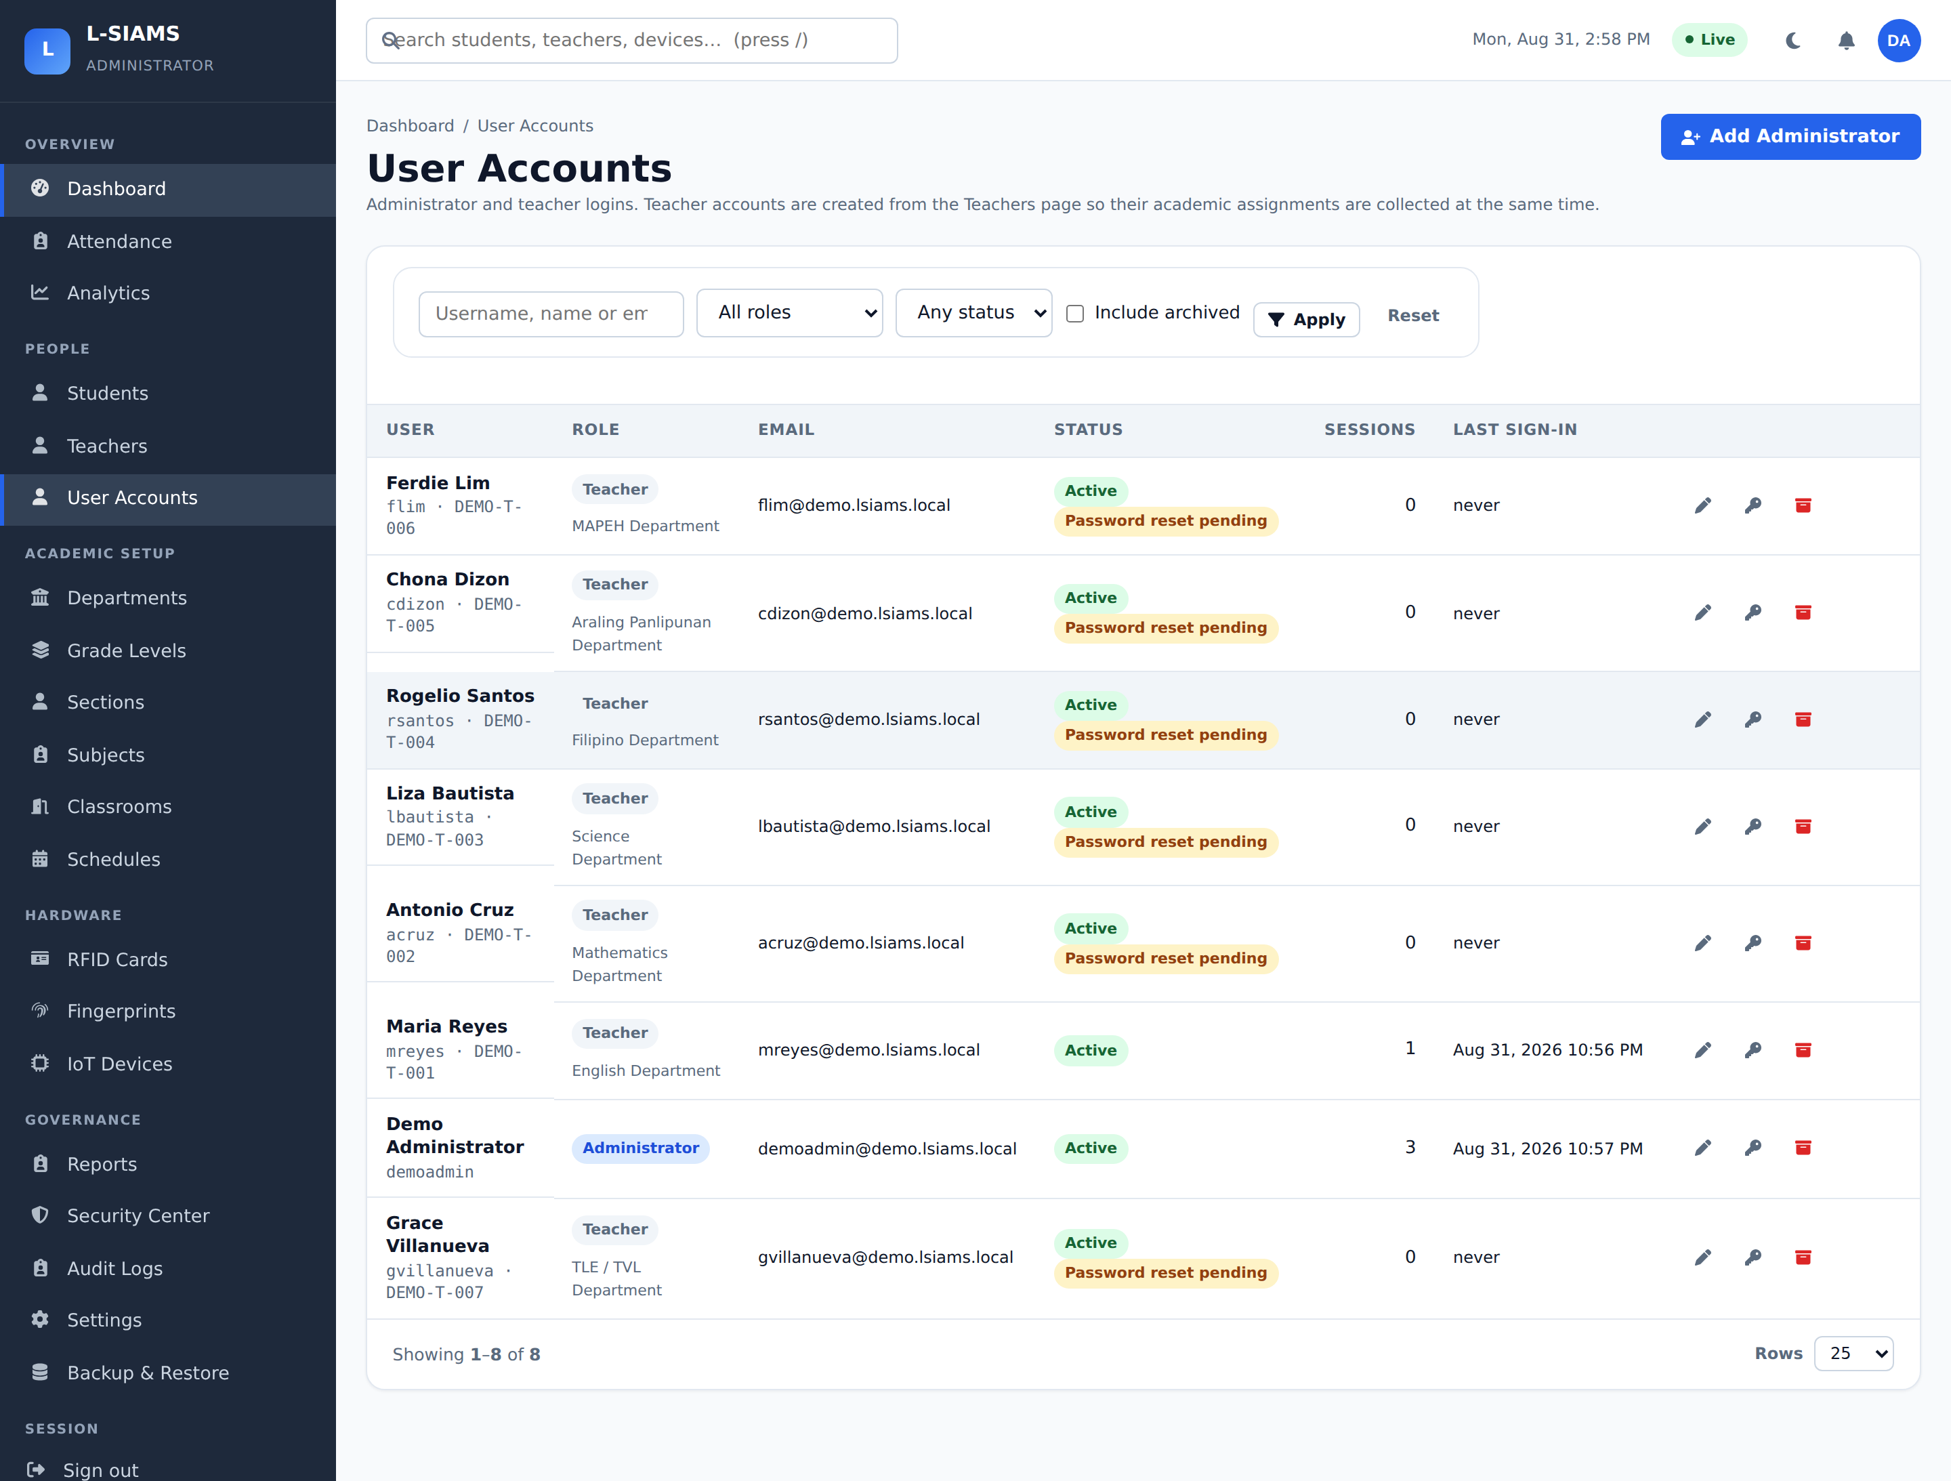
Active sessions are visible to the administrator and can be terminated individually or in bulk, as shown in Figure 17. This provides a direct response capability if a session is believed to be compromised, supporting the session controls described in Section 4.8.
Figure 17
Active Session Monitoring and Termination
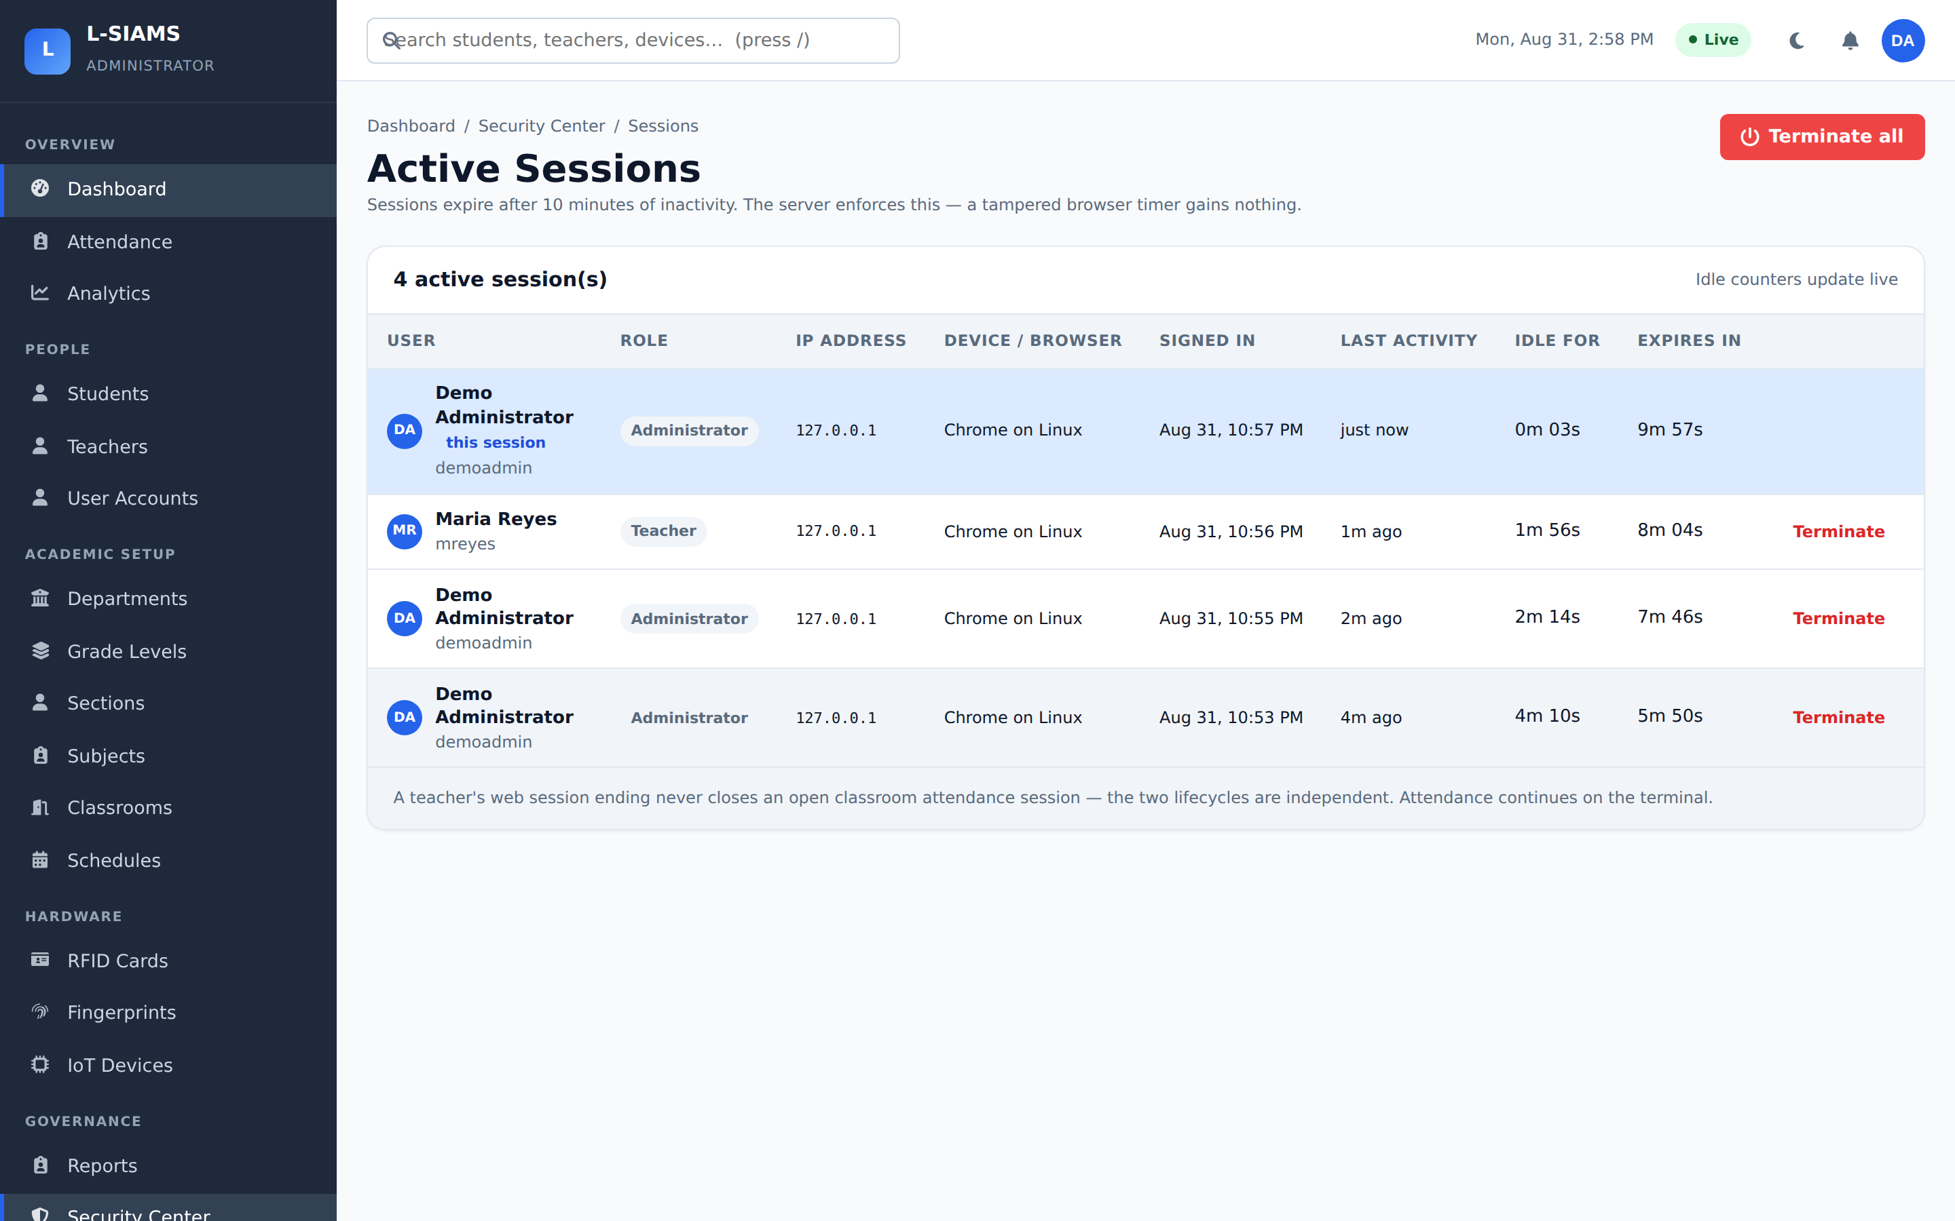
4.13.3 Device and Transport Security
Every classroom terminal must be registered before it can transmit attendance data. Figure 18 shows the device registry, including each terminal’s identifier, assigned classroom, and connection state.
Figure 18
Registered IoT Terminal Registry
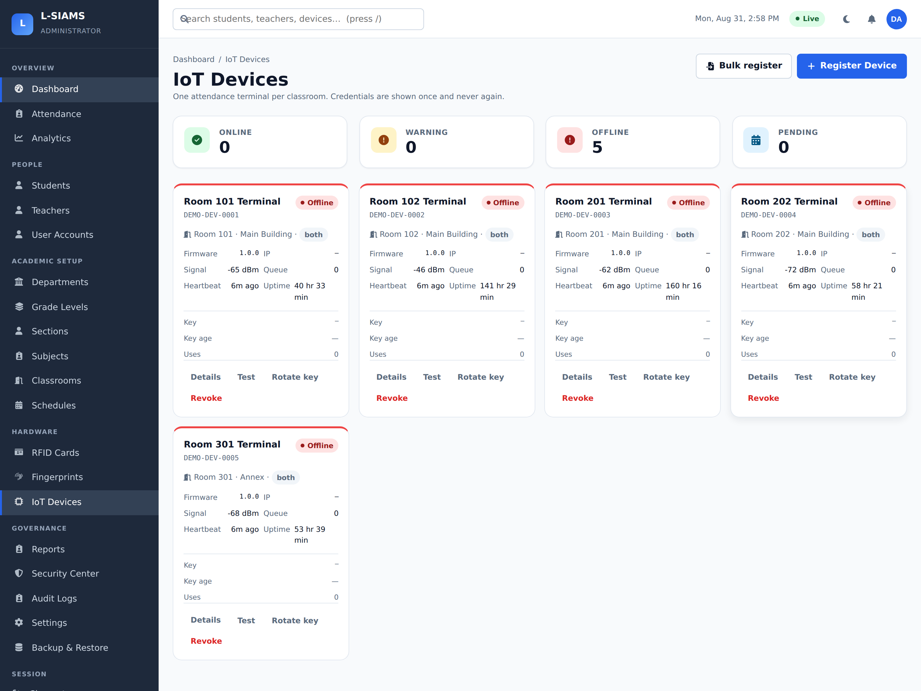
Figure 19 shows the detail view for an individual terminal, from which its credentials are issued, rotated, and revoked, and through which its recent activity and signature failures can be reviewed.
Figure 19
Terminal Detail and Credential Management
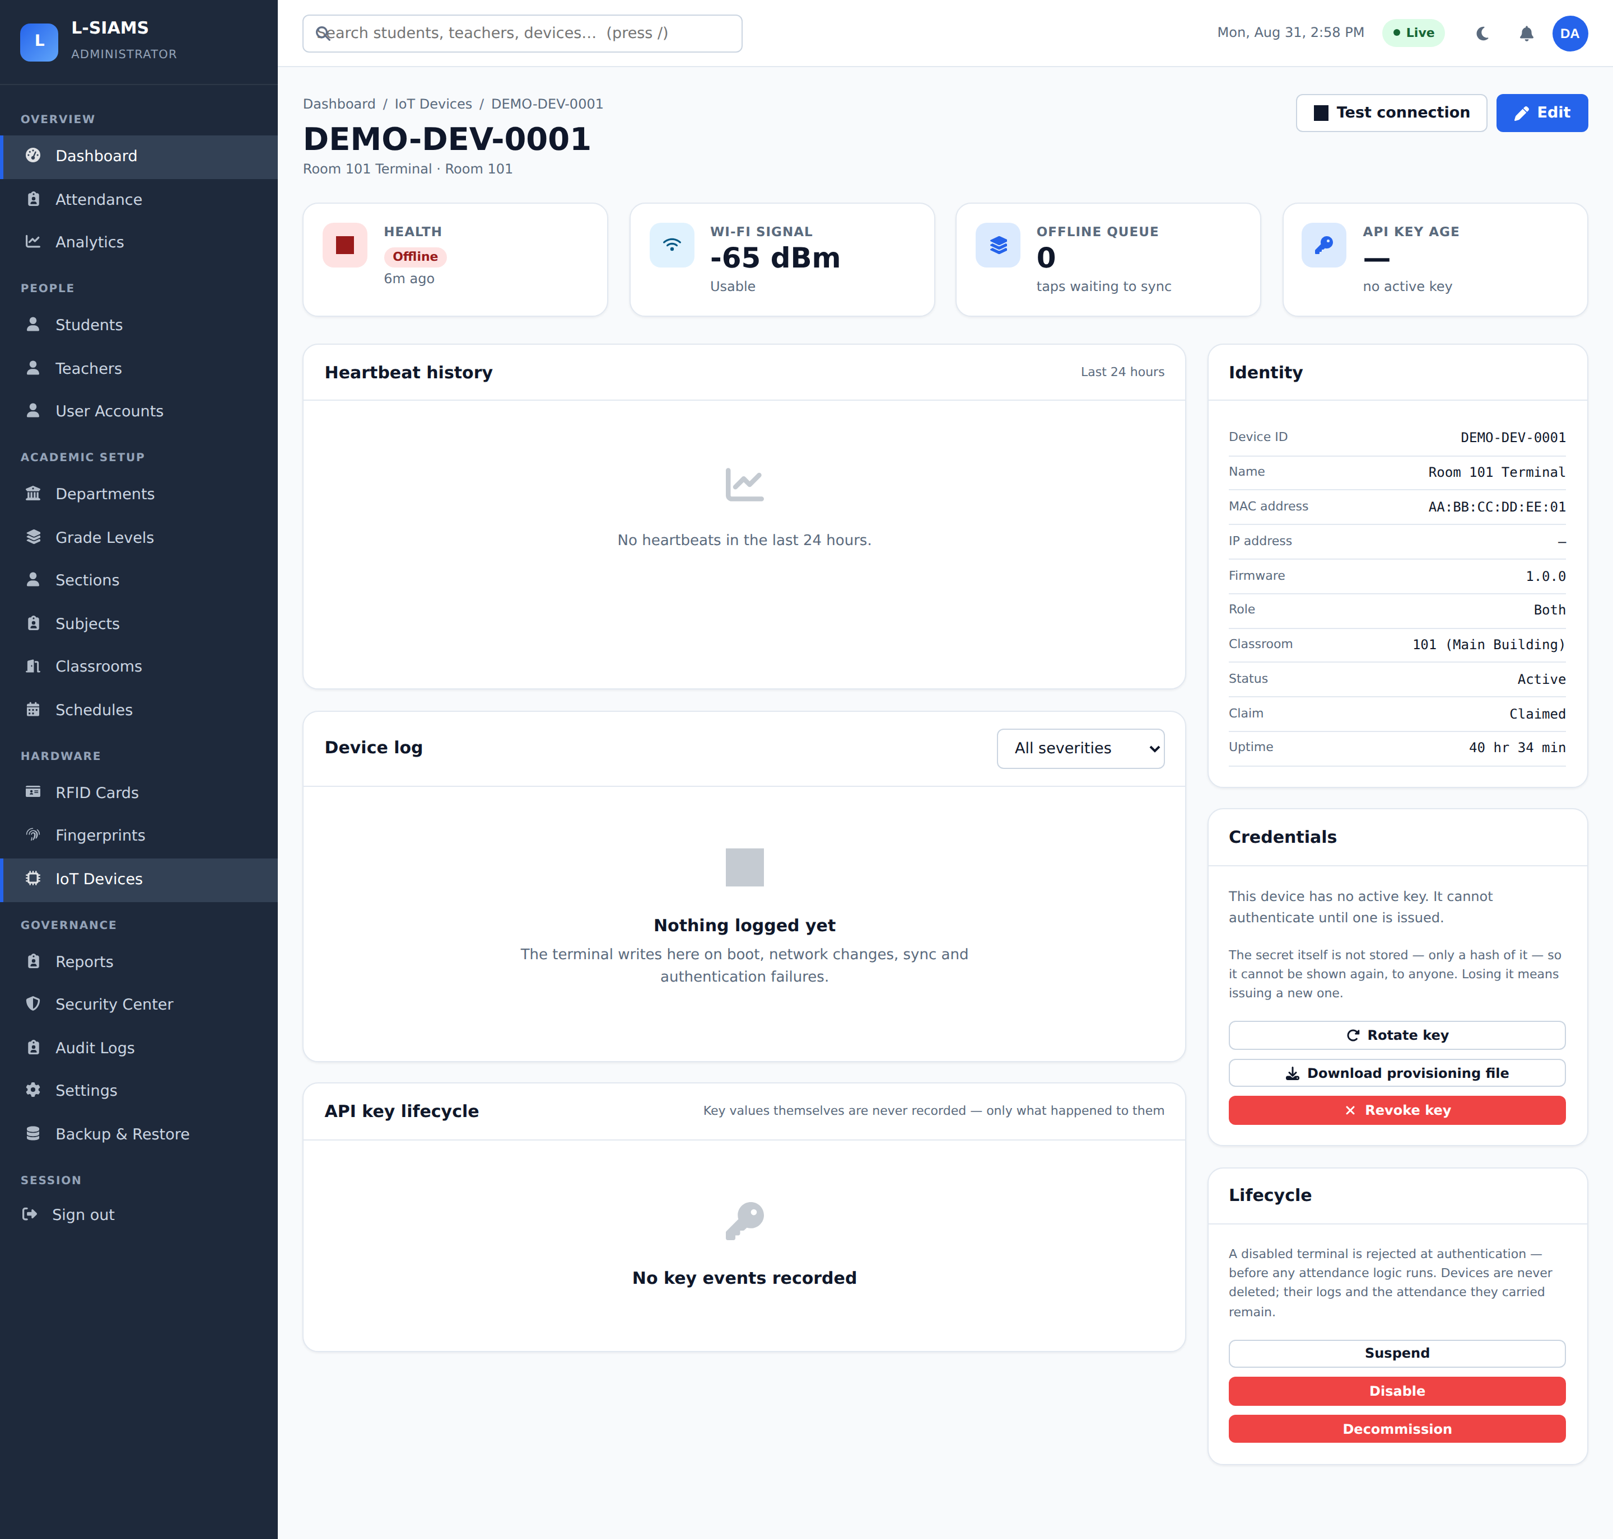
Figure 20 presents the output of the automated transport-security test suite described in Section 3.2.4, executed against the system’s certificate authority. All forty assertions passed, covering encryption of the authority’s private key at rest, trust-chain validation, the certificate extensions required by browsers and embedded TLS clients, preservation of the root across reissue, and rejection of malformed hostname input.
Figure 20
Transport Security Test Suite Results
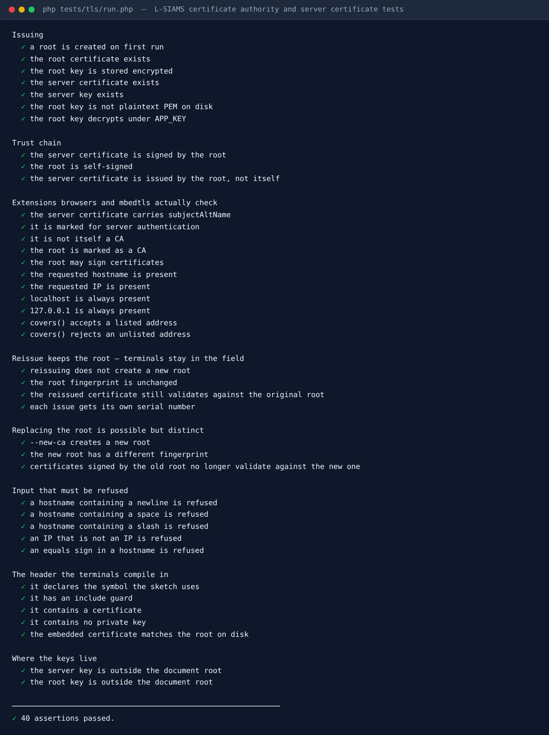
4.13.4 Monitoring, Audit and Incident Response
The security centre in Figure 21 summarises the system’s current security posture, including failed sign-ins, unknown cards presented, invalid device credentials, rejected signatures, and rate-limited requests over the preceding period.
Figure 21
Security Centre
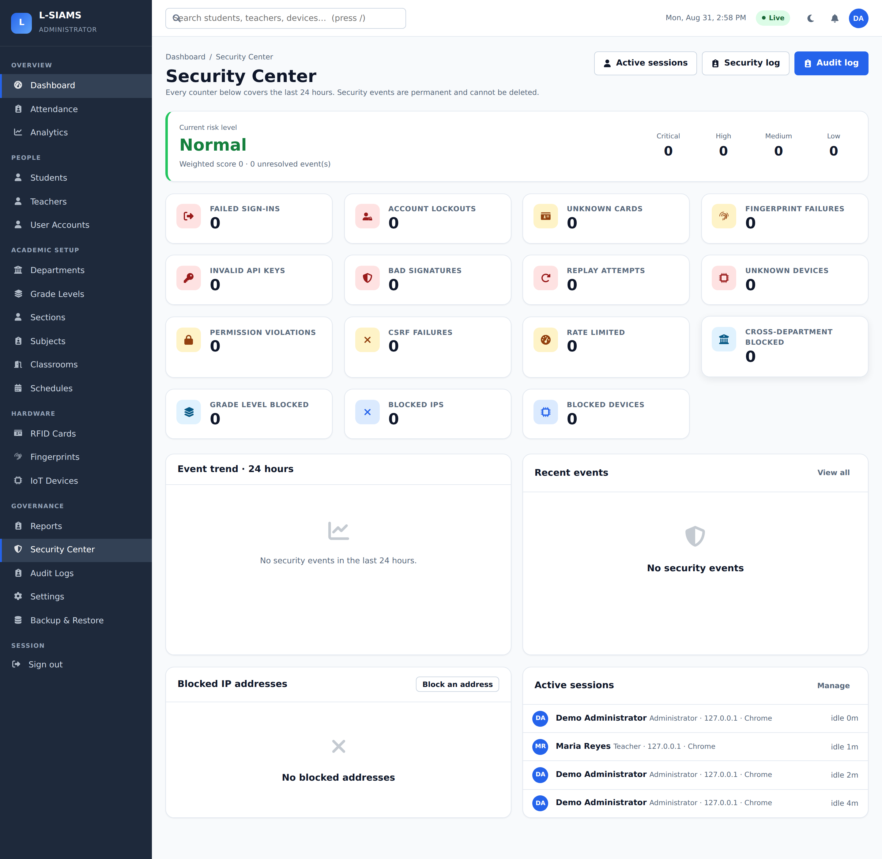
Figure 22 shows the security event log, in which each recorded event carries its type, severity, source address, and resolution state, implementing the monitoring layer described in Section 4.8 and Table 8.
Figure 22
Security Event Log
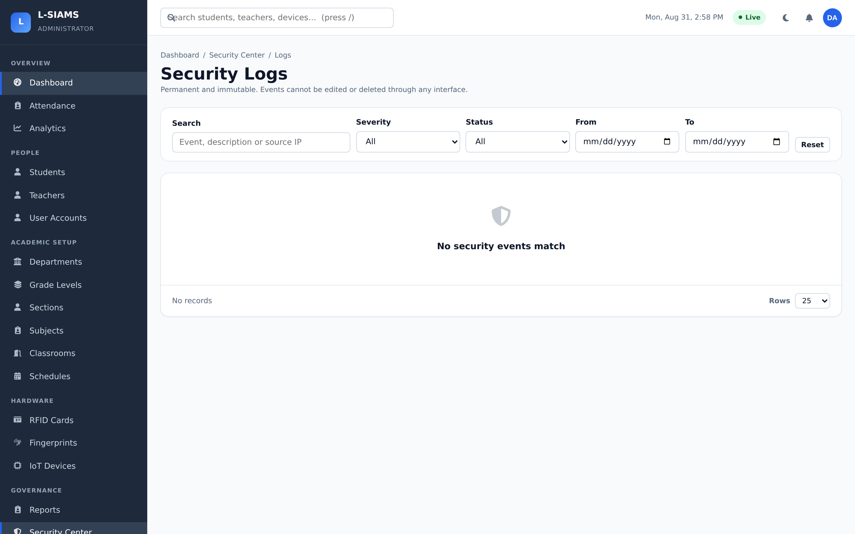
Figure 23 shows the audit trail, which records administrative and attendance activity for accountability and provides the non-repudiation control mapped in Table 9.
Figure 23
Audit Trail
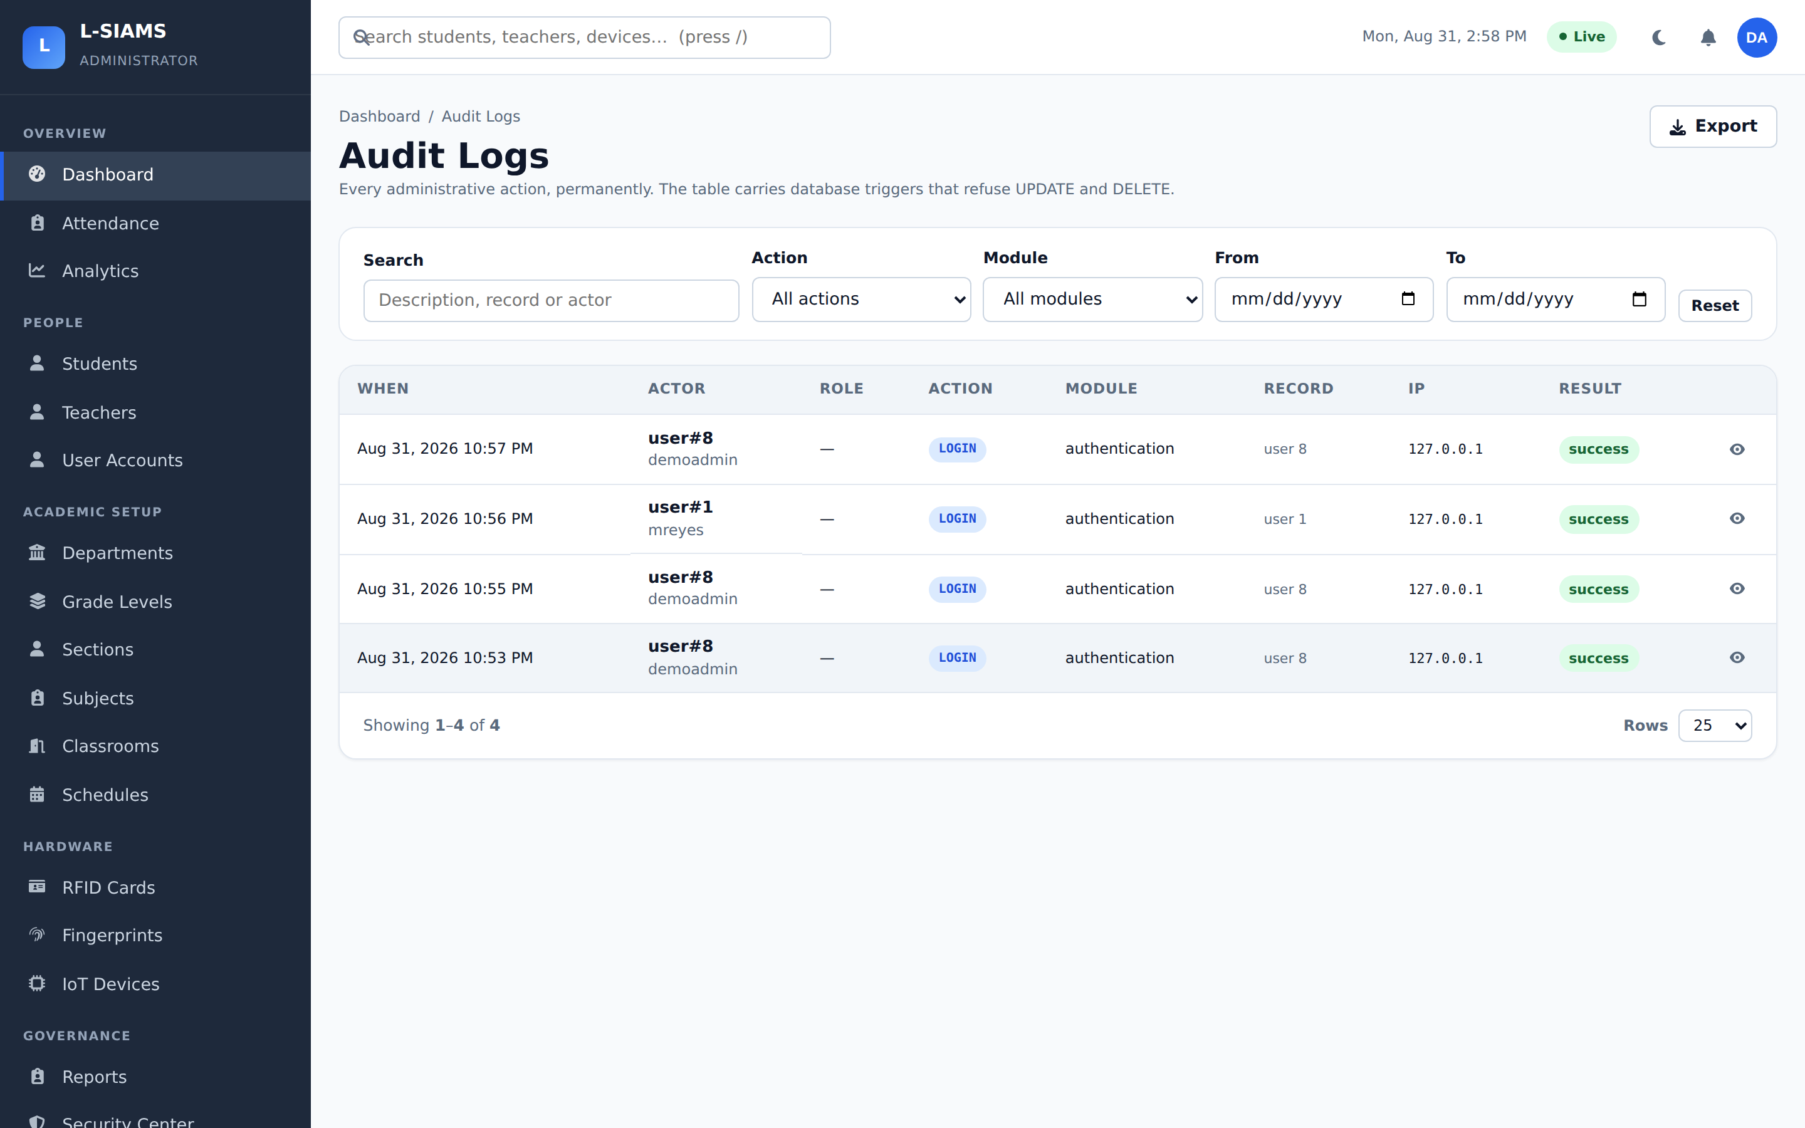
Figure 24 shows the register of unrecognised cards. A card belonging to no enrolled student is either an unfinished enrolment or an unknown card being presented at a reader; either case is surfaced to an administrator rather than silently discarded.
Figure 24
Unrecognised Card Detection
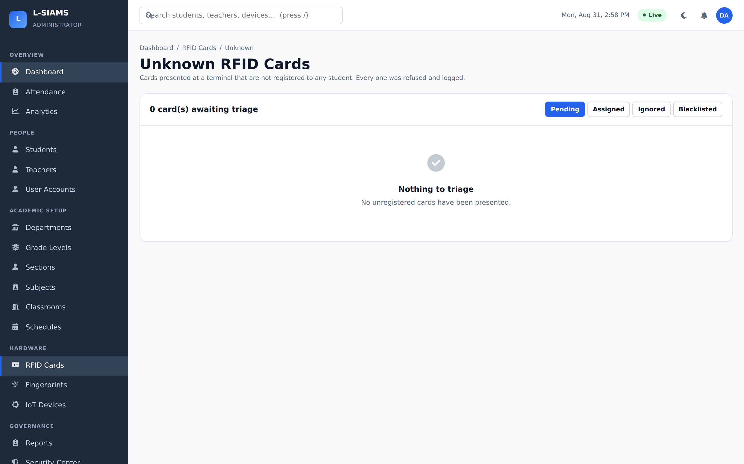
4.13.5 Identity Enrolment and Attendance Capture
Figure 25 shows fingerprint enrolment for teaching staff, which establishes the biometric reference used to authorise the opening of an attendance session.
Figure 25
Fingerprint Enrolment
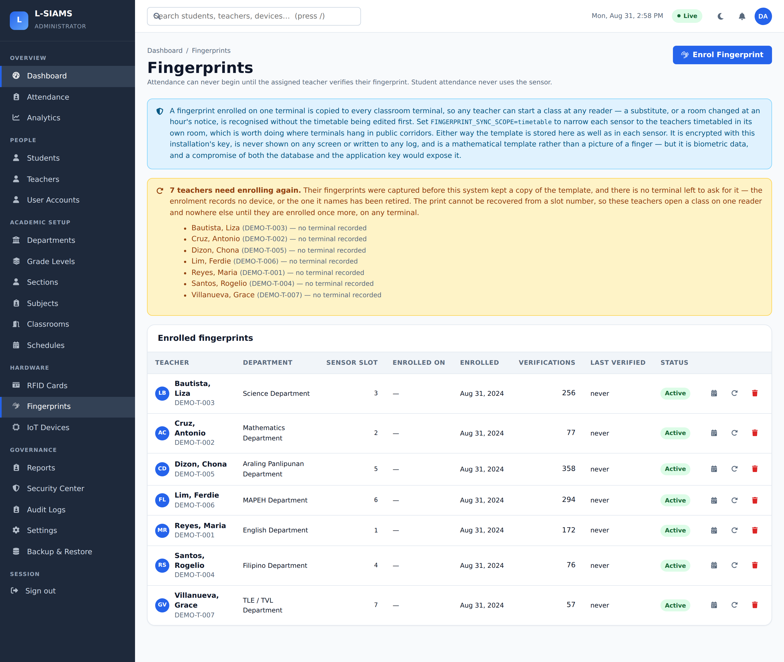
Figure 26 shows RFID card management, binding each card’s unique identifier to a single student record.
Figure 26
RFID Card Management
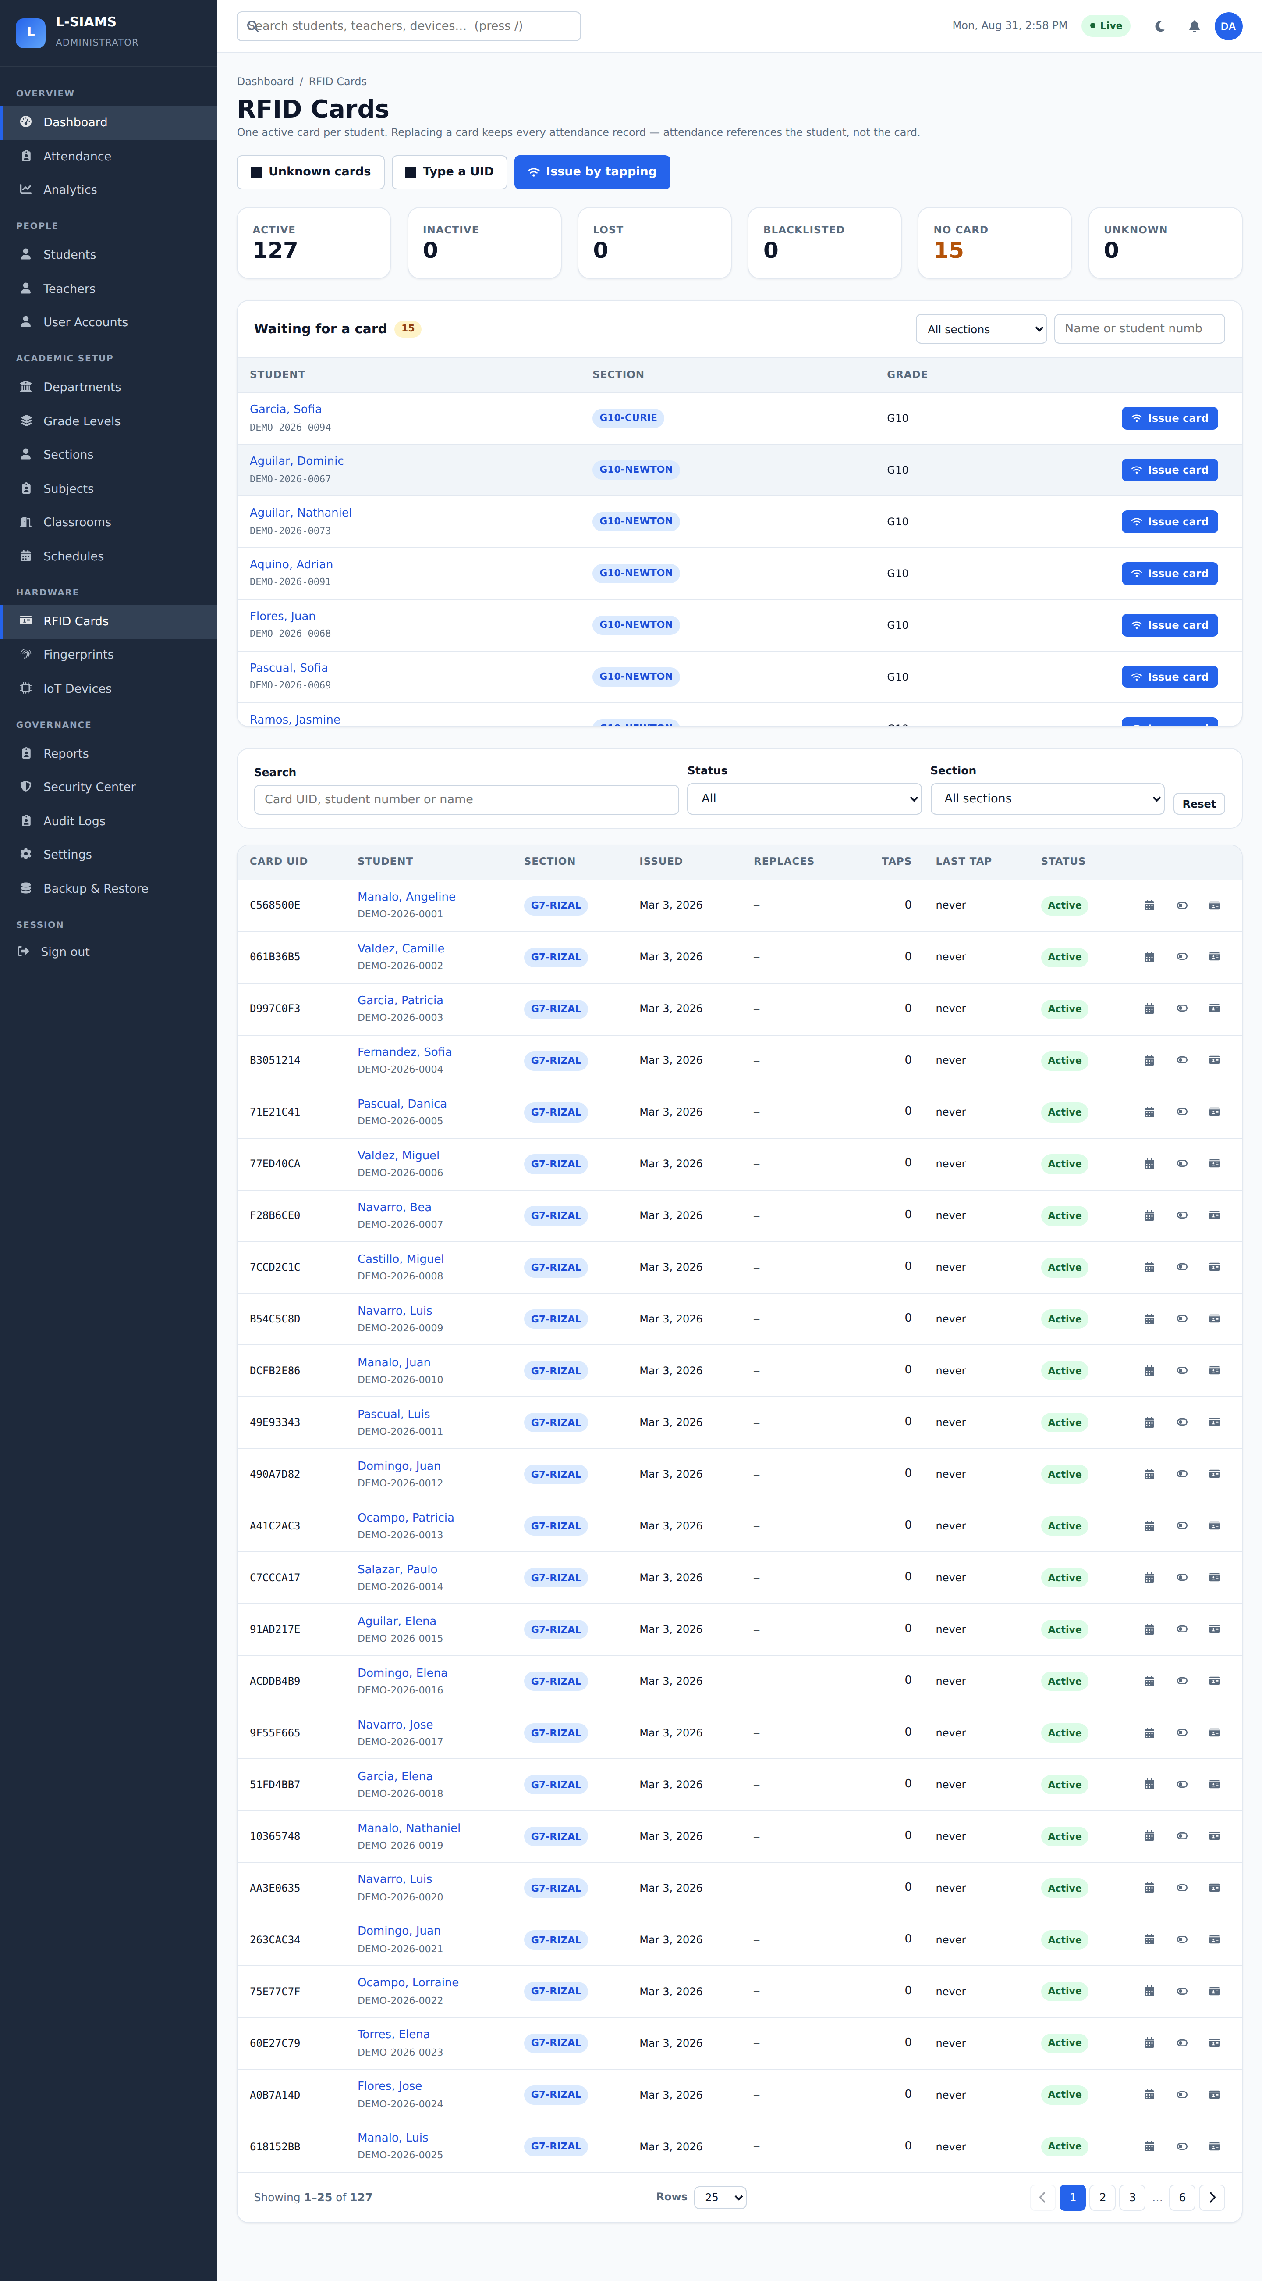
Figure 27 shows the administrator dashboard, which presents attendance trends, live tap activity, terminal connection status, and a security summary in a single view.
Figure 27
Administrator Dashboard
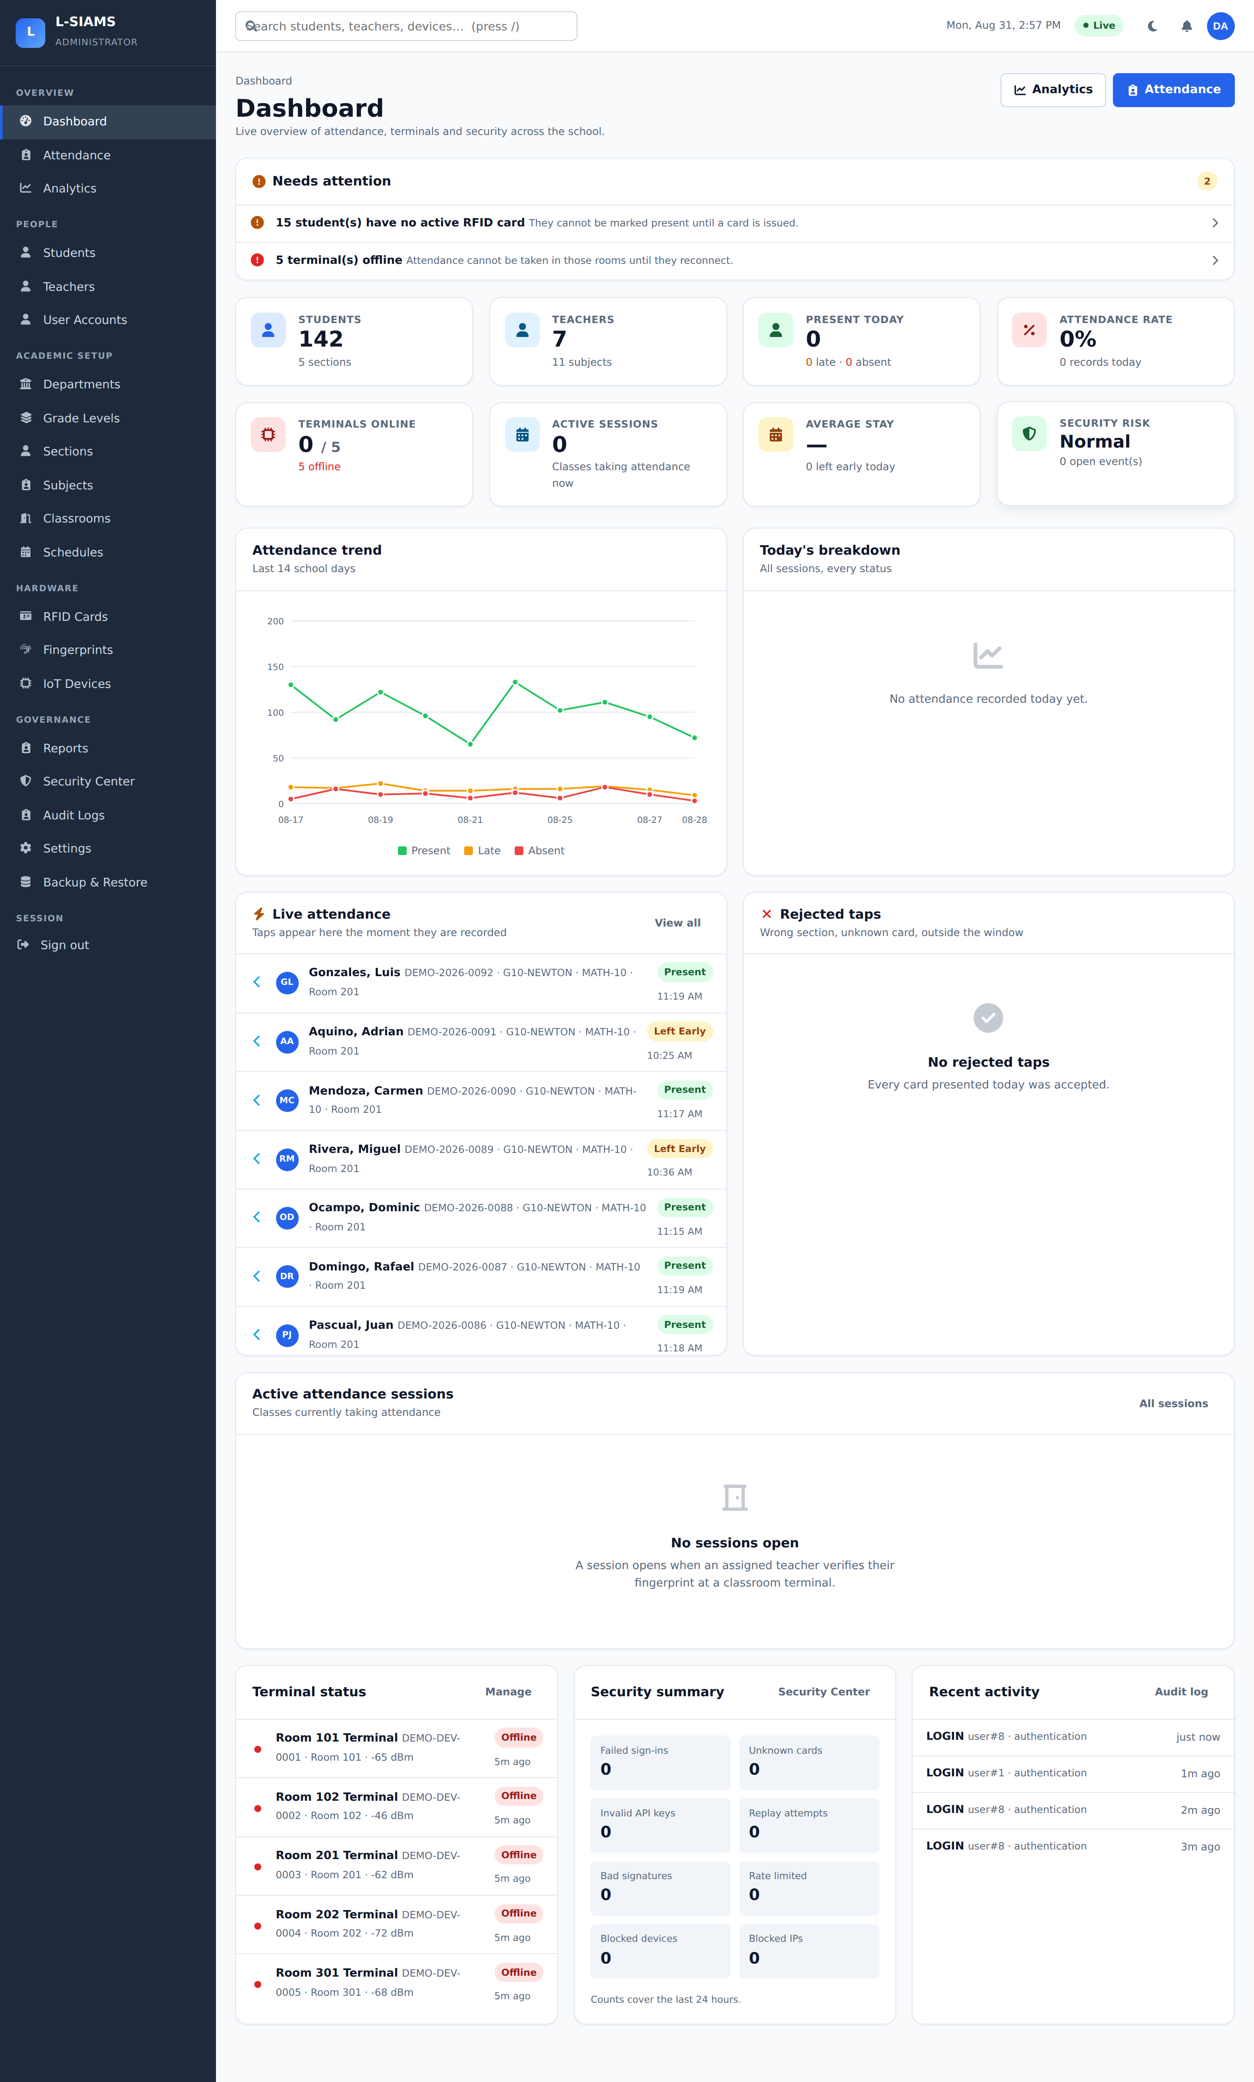
Figure 28 shows the attendance register, in which each record carries its arrival and departure status rather than a single ambiguous value.
Figure 28
Attendance Register
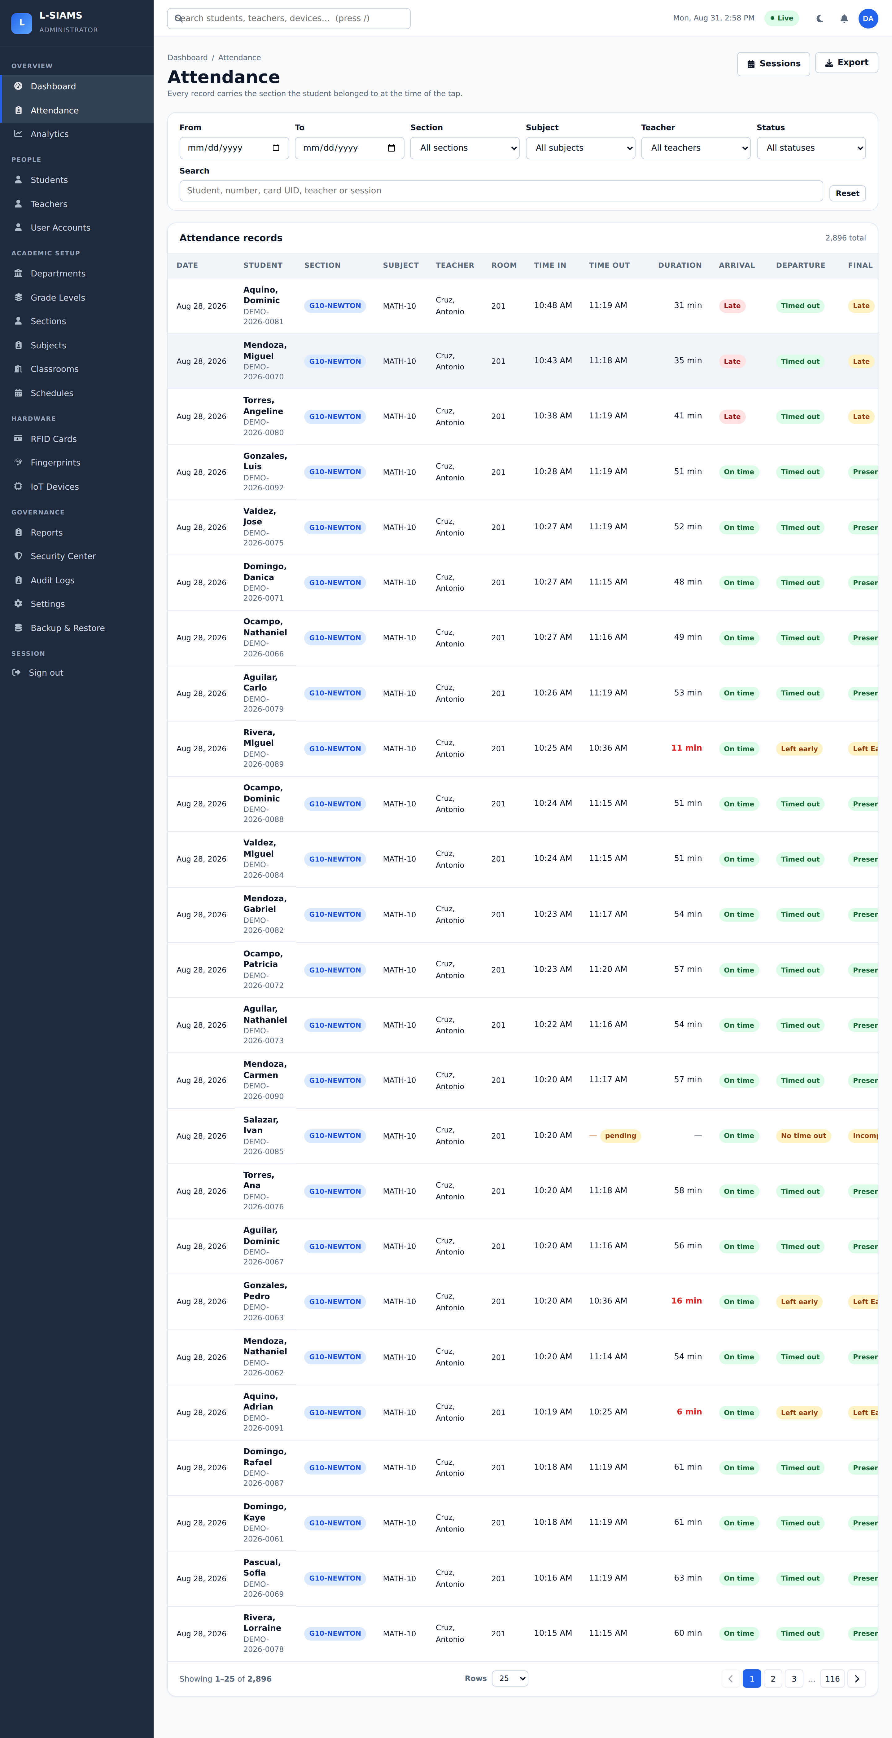
Figures 29 and 30 show the teacher portal, which is restricted by role to the classes a teacher is actually scheduled to teach.
Figure 29
Teacher Portal Dashboard
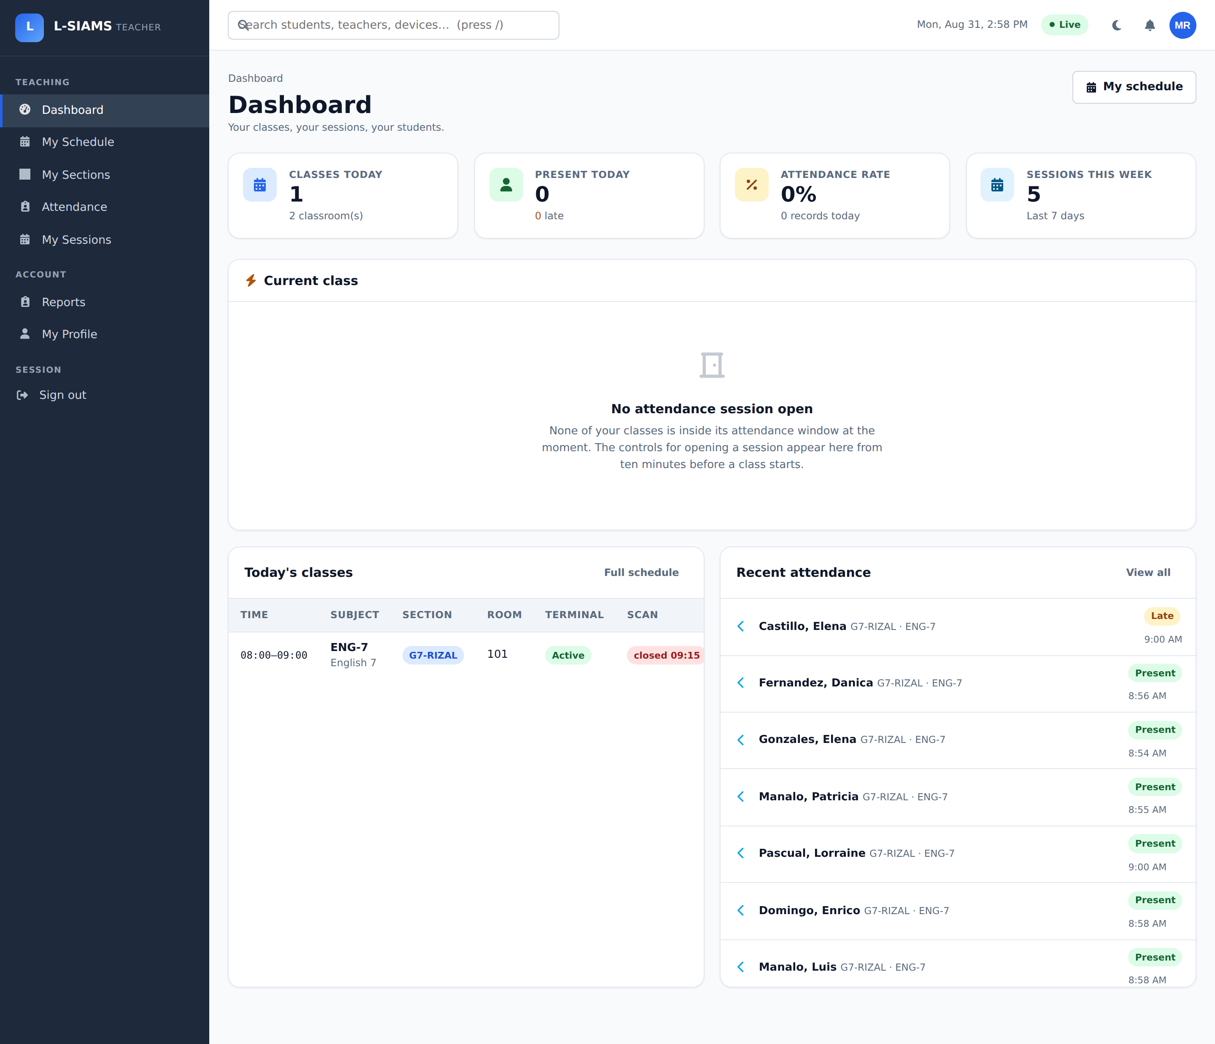
Figure 30
Teacher Attendance View
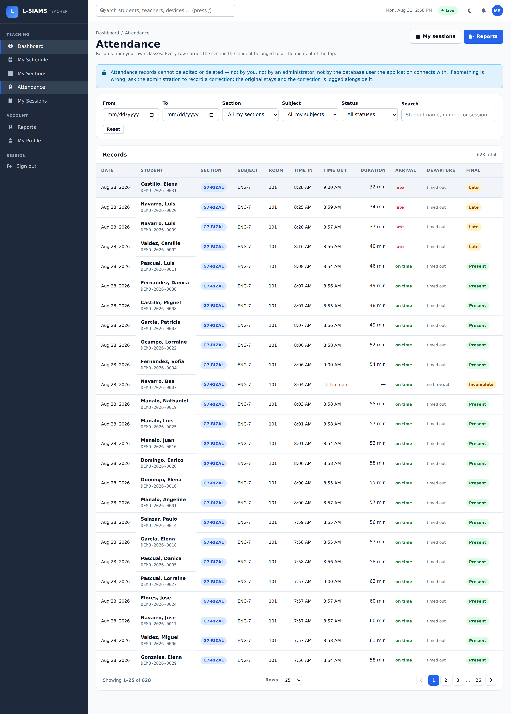
4.13.6 Administration, Reporting and Availability
Figures 31 and 32 show the student register and the class schedule configuration that determine which students are expected in which room at which time, and therefore which taps are valid.
Figure 31
Student Register
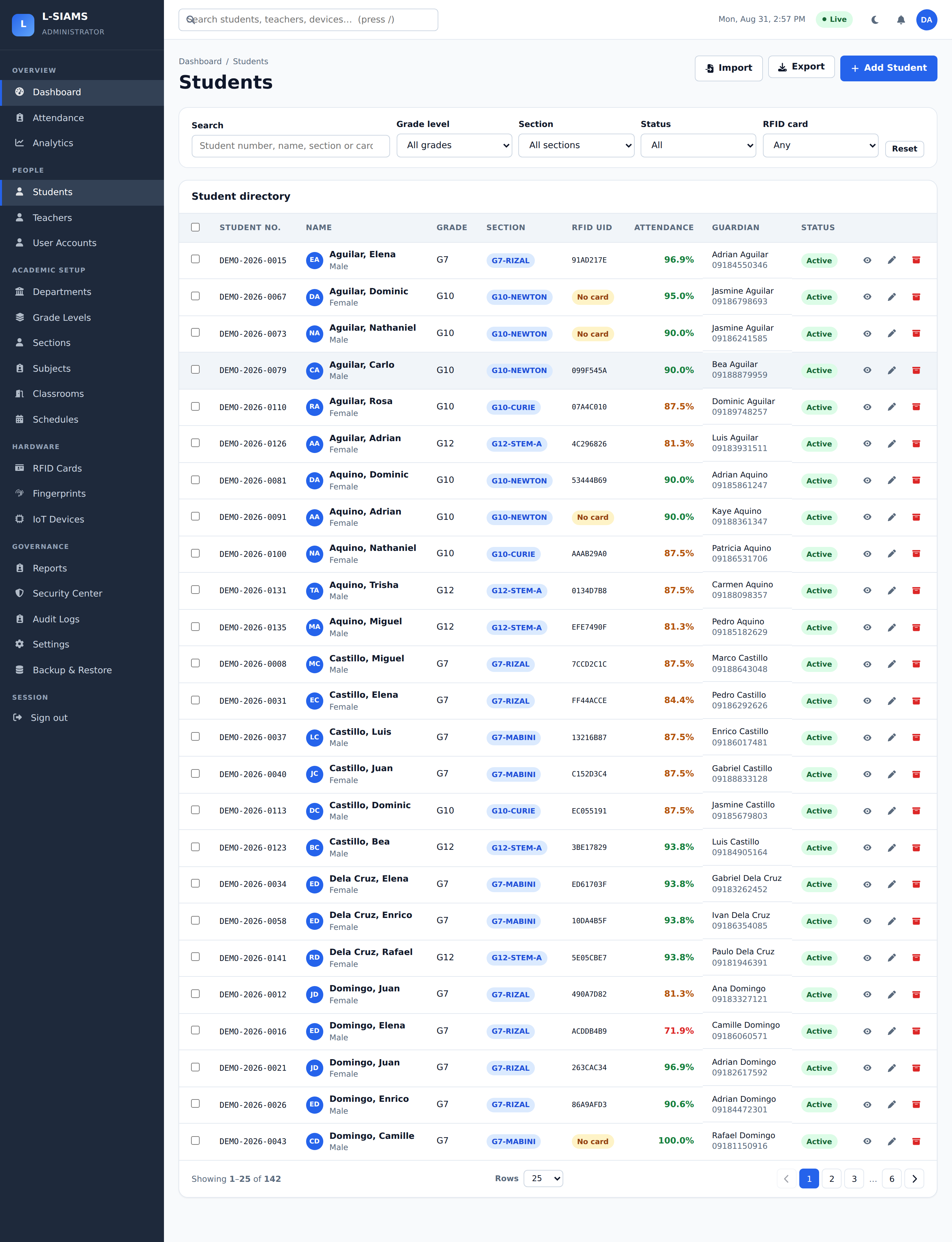
Figure 32
Class Schedule Configuration
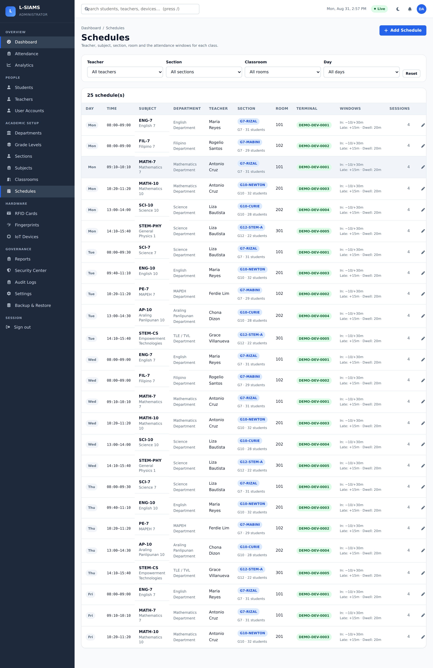
Figure 33 shows report generation, and Figure 34 the system security settings through which password policy, session timeouts, and attendance windows are configured.
Figure 33
Report Generation
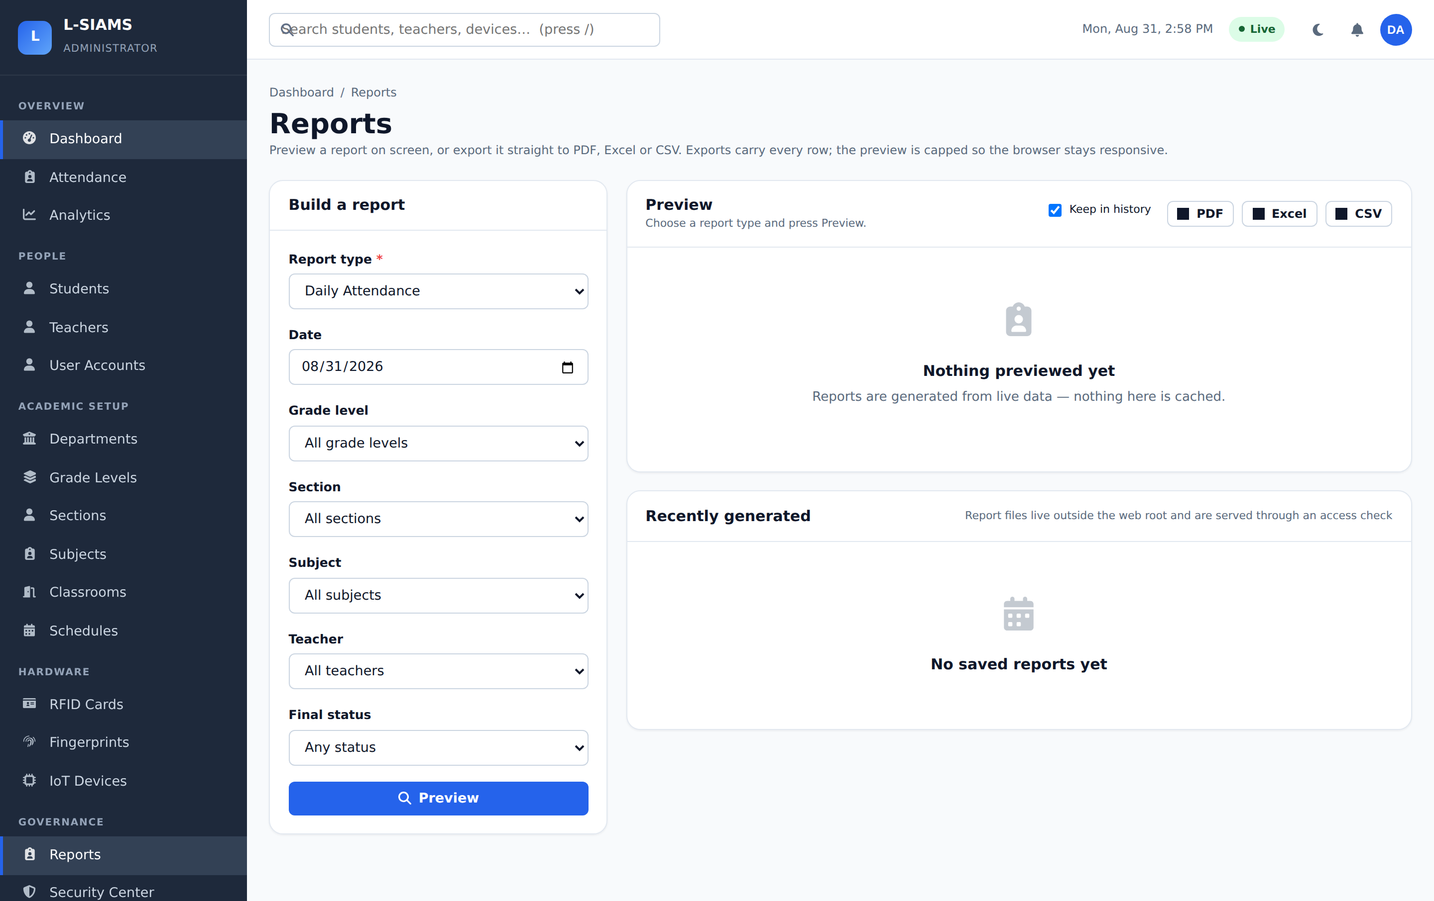
Figure 34
System Settings
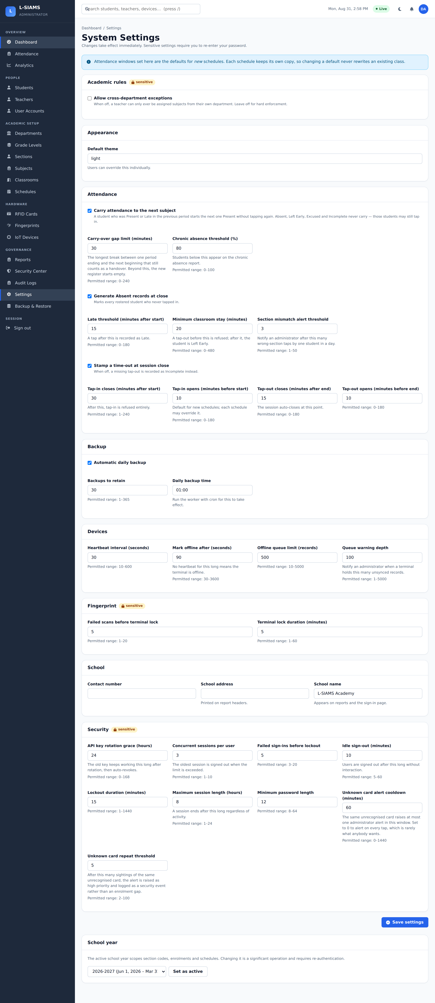
Figure 35 shows the backup and restore facility. Backups are encrypted, supporting the availability limb of the CIA triad by allowing the attendance record to be recovered after loss or corruption.
Figure 35
Backup and Restore
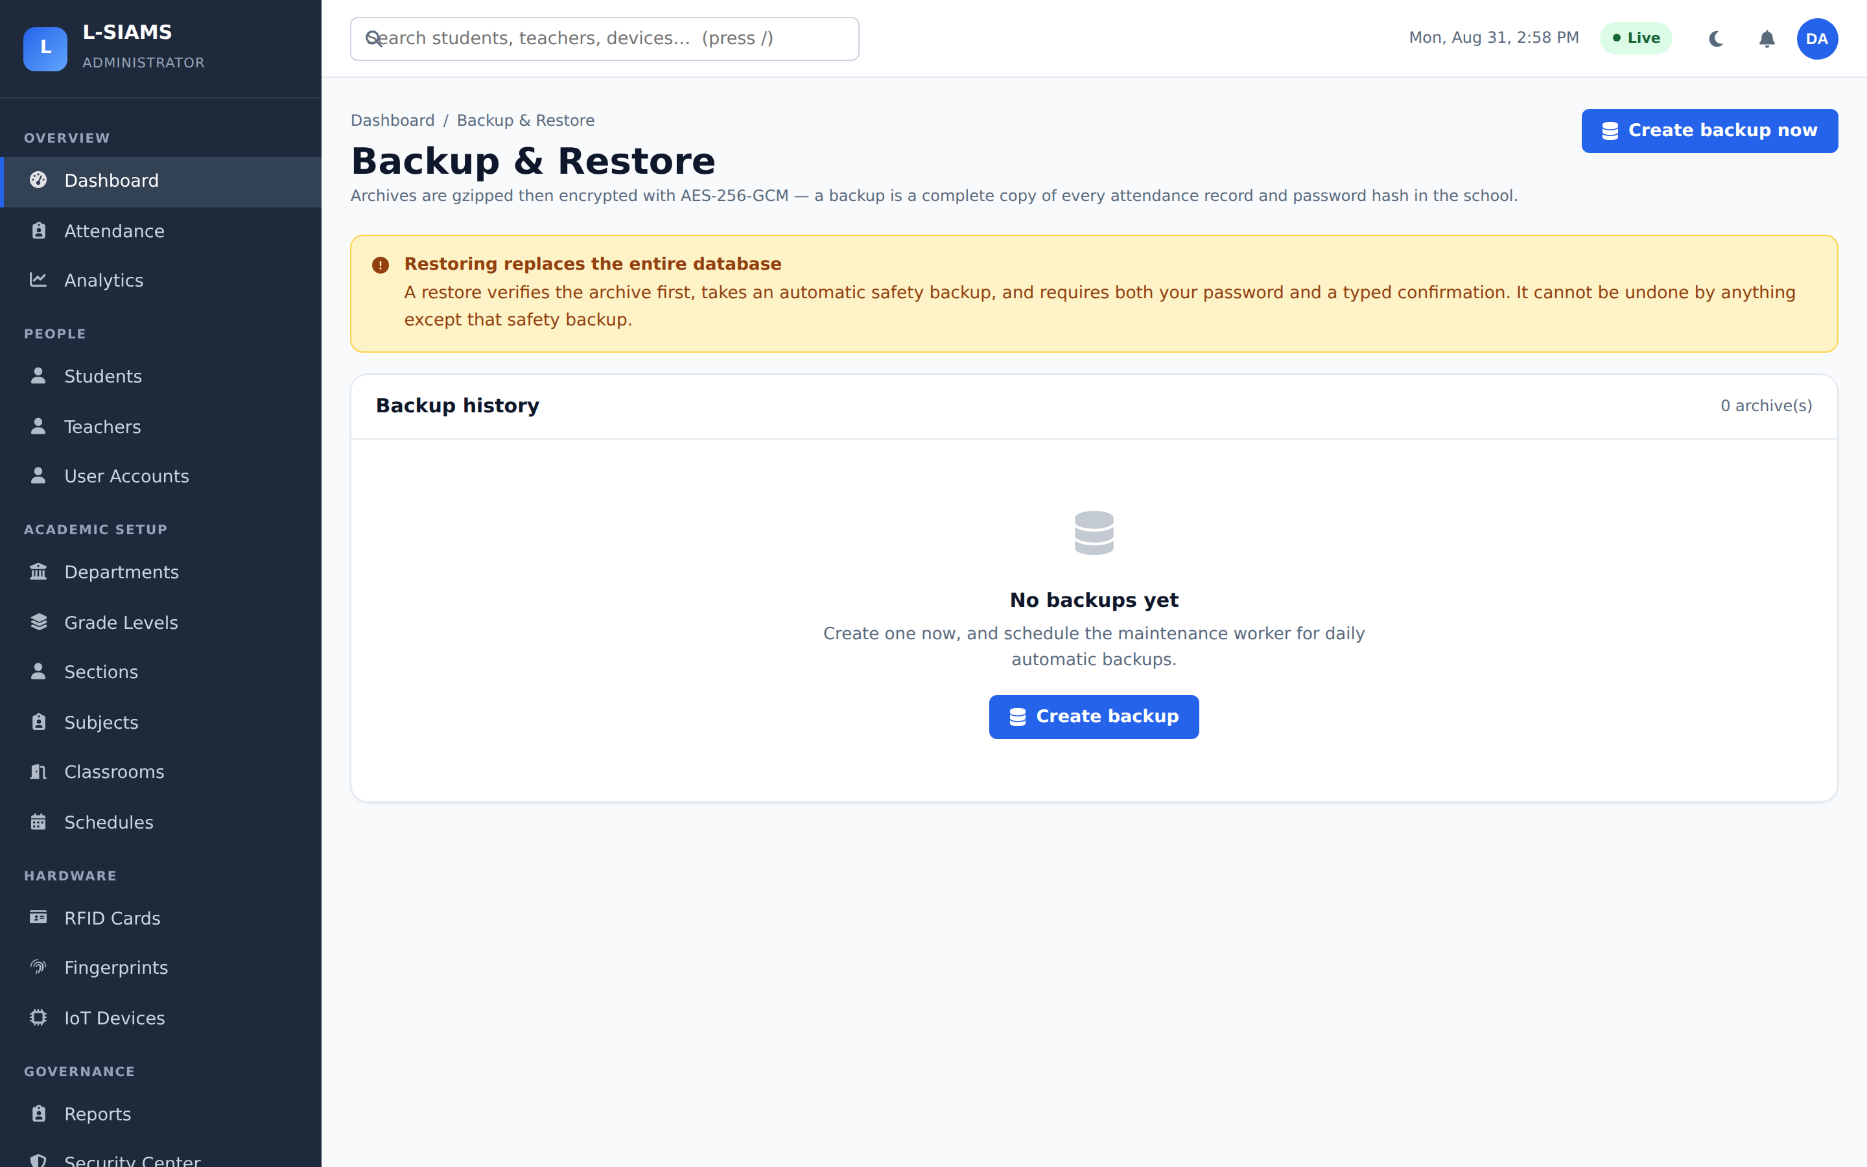

References

Ahmad, S., Qureshi, T., & Jameel, H. (2022). Security challenges in smart educational environments: A case for AES and role-based authentication in IoT systems. International Journal of Advanced Computer Science and Applications, 13(4), 511–519. https://doi.org/10.14569/IJACSA.2022.0130460
Ferrag, M. A., Friha, O., Hamouda, D., Maglaras, L., & Janicke, H. (2022). Edge-IIoTset: A new comprehensive realistic cyber security dataset of IoT and IIoT applications for centralized and federated learning. IEEE Access, 10, 40281–40306. https://doi.org/10.1109/ACCESS.2022.3165805
International Organization for Standardization. (2022). ISO/IEC 27001:2022 information security, cybersecurity and privacy protection—Information security management systems—Requirements. https://www.iso.org/standard/27001
ISO/IEC. (2022). ISO/IEC 25010 systems and software quality requirements and evaluation (SQuaRE): System and software quality models. https://iso25000.com/index.php/en/iso-25000-standards/iso-25010
Neshenko, N., Bou-Harb, E., Crichigno, J., Kaddoum, G., & Ghani, N. (2021). Demystifying IoT security: An exhaustive survey on IoT vulnerabilities and a first empirical look on internet-scale IoT exploitations. IEEE Communications Surveys & Tutorials, 23(1), 270–313. https://doi.org/10.1109/COMST.2020.3024599
Shrivastava, A., Sharma, P., & Gupta, R. (2023). IoT-based smart attendance monitoring system using RFID technology. International Journal of Innovative Research in Computer Science & Technology, 11(3), 45–50. https://doi.org/10.55524/ijircst.2023.11.3.9
Whitman, M. E., & Mattord, H. J. (2021). Principles of information security (7th ed.). Cengage Learning.

