WEEK 7: SYSTEM ENHANCEMENT AND TESTING

I. INTENDED LEARNING OUTCOME (ILO)
At the end of this laboratory activity, students should be able to:
Enhance the system prototype by implementing stakeholder recommendations, conduct systematic unit and integration testing, identify and resolve software defects, and document testing results and corrective actions to improve system quality and reliability.

III. PERFORMANCE TASK
Based on the recommendations gathered during the Prototype Presentation, your team shall improve the Alpha Version of the system and conduct comprehensive testing activities. The goal is to ensure that the prototype functions correctly, major defects are resolved, and the system is ready for deployment preparation.
The outputs of this activity will serve as evidence that the system has undergone quality assurance and enhancement before agency immersion and deployment.

III. WEEK 7 ACTIVITIES
Activity 1 – Enhancement Planning Review
Activity 2 – Implementation of Stakeholder Recommendations
Activity 3 – Unit Testing
Activity 4 – Integration Testing
Activity 5 – Debugging and Optimization
Activity 6 – Testing Documentation Preparation
Activity 7 – Adviser Validation

ACTIVITY 1
ENHANCEMENT PLANNING REVIEW
Purpose
To review the Enhancement Plan developed during Week 6 and identify enhancement priorities.
Procedure
- Review the approved Enhancement Plan.
- Identify high-priority recommendations.
- Assign enhancement tasks to team members.
- Establish enhancement timelines.
- Complete Form 1.

FORM 1
SYSTEM ENHANCEMENT IMPLEMENTATION PLAN
Directions
List all approved enhancements and assign responsibilities.
Enhancement Requirement | Priority | Assigned Member | Status
Persist the offline tap queue across a power loss, or document the residual risk in the user manual and the deployment checklist | High | Naph Yvan P. Villamar | In Progress
Expose biometric-override usage on the administrator dashboard so password failover is visible without opening the security log | High | Ched Nikko P. Pangilinan | Completed
Complete unit and integration testing across all modules and resolve every defect rated High before User Acceptance Testing | High | Naph Yvan P. Villamar / Ched Nikko P. Pangilinan | Completed
Make applied report filters explicit and colour the Status column in previews to match the dashboards | Medium | Ched Nikko P. Pangilinan | Completed
Prepare the user manual, installation guide and updated technical documentation for deployment | Medium | Joshkirby Tyler M. Bote | Not Started
Verify both classroom terminals under sustained load and confirm LED accept/refuse feedback in the actual rooms | Medium | Naph Yvan P. Villamar | Not Started
Incorporate the stakeholder recommendations returned on Form 3 that are not yet listed above

Expected Completion Date:

Prepared by:
Ched Nikko P. Pangilinan
Project Leader

ACTIVITY 2
IMPLEMENTATION OF STAKEHOLDER RECOMMENDATIONS

Purpose
To improve the prototype based on stakeholder feedback.

Procedure
- Implement approved enhancements.
- Verify system functionality after modification.
- Update repository.
- Record completed improvements.
- Complete Form 2.

FORM 2
ENHANCEMENT IMPLEMENTATION REPORT

Directions
Document all modifications completed.

Recommendation | Action Taken | Status
Taps held on a terminal are lost if the classroom loses power before the link returns (40 taps in ESP32 RTC memory, which survives a reset but not a power cut) | Every change to the held-tap queue is now also written to the ESP32 flash memory (NVS) and restored at start-up after a power loss. README and docs/FIRMWARE.md updated. Commit 747be8c. | In Progress
Use of the teacher password failover instead of the fingerprint is recorded but not visible at a glance | The Security tile on the administrator dashboard shows the number of fingerprint overrides this week and links to the BIOMETRIC_OVERRIDE_USED events. Needs attention lists them whenever there are any. Commit 1f26712. | Completed
The terminal has no display, so a student cannot read why a tap was refused | Onboard LED accept/refuse patterns implemented: 2 blinks accept, 5 blinks refuse, 160 ms. Commits 36a9077 to bbea6cf. | In Progress
It was not obvious on the reports screen which filters had actually been applied to a generated report | Filter state made explicit on the administrator and teacher report tabs, and the Status column in previews coloured to match the dashboards. Commits de750e1 and e1193ef. | Completed
Operating an internal certificate authority requires certificate renewal and root distribution to terminals | Renewal procedure documented in docs/HTTPS.md. Reissuing the server certificate keeps the existing root, so terminals are not reflashed. | Completed
Only two classroom terminals were constructed, which bounds the evaluation to two rooms | No technical action. Recorded as a scope constraint in Chapter I and Chapter III. | Completed
Complete unit and integration testing across all modules and resolve every defect rated High before User Acceptance Testing | Unit testing: 30 test cases, 377 automated checks. Integration testing: 23 test cases. 5 defects found and fixed, 3 of them rated High. Commits 414869a and 0ef270c. | Completed

Evidence Attached
☑ Before-and-After Screenshots
☑ Updated Source Code
☑ Repository Commit Logs

Summary of Improvements
Both High priority enhancements in the Week 6 System Enhancement Plan were implemented. Sessions opened by password instead of fingerprint are now counted on the administrator dashboard and listed under Needs attention. The classroom terminal now keeps held taps in flash memory as well as RTC memory, so a power cut no longer erases them. Unit and integration testing covered every module; the five defects found were fixed and re-tested.

ACTIVITY 3
UNIT TESTING

Purpose
To verify that individual modules perform according to specifications.

Procedure
- Test each major module independently.
- Execute test cases.
- Compare actual results with expected results.
- Record findings.
- Complete Form 3.

FORM 3
UNIT TESTING REPORT

Directions
Test each module individually and record results.

Module | Test Case | Expected Result | Actual Result | Status
Attendance capture (RFID) | UT-01 Two classrooms take attendance at the same time | Both sessions record independently | 3/3 checks passed | Pass
Attendance capture (RFID) | UT-02 One card tapped 50 times at once | Exactly one record | 4/4 passed, 1 row written | Pass
Attendance capture (RFID) | UT-03 One card tapped on two terminals at once | Only one terminal records it | 4/4 passed | Pass
Attendance capture (RFID) | UT-04 Student taps in the wrong section's class | Refused and not recorded | 5/5 passed | Pass
Attendance capture (RFID) | UT-05 Time-in and time-out sequence | First tap is time-in, second is time-out, third is refused | 6/6 passed | Pass
Attendance capture (RFID) | UT-06 Request retried after a network drop | Recorded exactly once | 2/2 passed | Pass
Offline sync | UT-07 Terminal sends taps held while offline | Each held tap recorded once and marked synced offline | 5/5 passed | Pass
Status resolution | UT-08 All arrival and departure combinations | All seven final statuses produced correctly | 3/3 passed | Pass
Session control | UT-09 Closing a session | Auto time-out, absences written, totals updated | 9/9 passed | Pass
Session control | UT-10 Only the scheduled teacher can open the class | Other teachers and wrong times refused | 7/7 passed | Pass
Session control | UT-11 Attendance carries into the next subject | Present students carried over, others not | 17/17 passed | Pass
Session control | UT-12 Teacher releases a student early | Early release recorded with the reason | 12/12 passed | Pass
Session control | UT-13 Class reopened after an early close | Students marked absent can still tap in | 5/5 passed | Pass
RFID card management | UT-14 Unknown card tapped | Refused, logged, administrator alerted | 11/11 passed | Pass
RFID card management | UT-15 Lost card replaced | New card works and history is kept | 12/12 passed | Pass
Reports | UT-16 Every report filter is applied | Rows match the chosen filters | 12/12 passed | Pass
Student import | UT-17 Import keeps every filled cell | No data dropped | 9/9 passed | Pass
Student import | UT-18 Excel (.xlsx) read and write | Workbooks read and written correctly | 30/30 passed | Pass
Device provisioning | UT-19 Issuing terminal credentials | All or nothing, no half-issued key | 13/13 passed | Pass
Authentication | UT-20 Five wrong passwords | Account locked for 15 minutes, then unlocks | 14/14 passed | Pass
Fingerprint sync | UT-21 Terminal receives the fingerprints it should hold | Correct templates queued for each terminal | 22/22 passed | Pass
Fingerprint sync | UT-22 Sensor returns templates, drifted sensor refilled, refused write retried | No teacher asked to enrol again | 41/41 passed | Pass
Fingerprint sync | UT-23 Synced template not flagged as intruder, refusal names both teachers | Correct and specific messages | 14/14 passed | Pass
Academic setup | UT-24 Archive and restore of sections, departments, subjects and classrooms, subject code rename | Reversible, blocked while in use | 49/49 passed | Pass
Installation checks | UT-25 Misconfigured installation and silent card reader | Specific cause reported | 18/18 passed | Pass
Realtime updates | UT-26 Event order and replay after reconnect | No event lost or duplicated | 4/4 passed | Pass
Performance | UT-27 Throughput and latency | 95% of taps processed under 800 ms | 112 taps per second, 95% under 11.2 ms | Pass
Security (TLS/HTTPS) | UT-28 Certificates, chain and key storage | Valid chain, keys outside the web root | 40/40 passed | Pass
Firmware (ESP32) | UT-29 Sketch type check | No errors or warnings | 0 errors, 0 warnings | Pass
Dashboard | UT-30 Sessions opened by password are counted | Counted for today and the week and listed under Needs attention | 3/3 passed | Pass

Unit Testing Summary
Item | Result
Total Test Cases Executed | 30
Passed | 30
Failed | 0

Tester: Naph Yvan P. Villamar, Ched Nikko P. Pangilinan
Date: September 28, 2026
ACTIVITY 4
INTEGRATION TESTING

Purpose
To verify that integrated modules interact correctly.

Procedure
- Execute end-to-end transactions.
- Verify system workflows.
- Test database interactions.
- Record results.
- Complete Form 4.

FORM 4
INTEGRATION TESTING REPORT

Directions
Evaluate integrated functionalities.

Integrated Components | Expected Result | Actual Result | Status
UI ↔ Authentication | Valid login opens the dashboard, wrong password is refused with a message, pages require sign-in, teachers are blocked from administrator pages | IT-01 Landed on /admin ("Dashboard · L-SIAMS")  IT-02 Stayed on /login; message: "Invalid username or password."  IT-03 Redirected to /login  IT-04 HTTP 403 at /admin/users | Pass
Authentication ↔ Database | Sign-in is recorded, 5 wrong passwords lock the account for 15 minutes, sign-out ends the session | IT-05 login_history +1; 1 active session(s)  IT-06 locked_until = now + 14 min; correct password refused  IT-07 terminated (logout); /teacher now, /login | Pass
UI ↔ Database | Add Student form saves the record, dashboard figures equal database counts | IT-08 Saved: 710 | Integration Tester | section 2  IT-09 Students UI 147 / DB 147; Teachers UI 7 / DB 7 | Pass
Reports ↔ Database | Report rows equal stored records, PDF and Excel export, saved report recorded | IT-10 Report 32 rows; database 32 records  IT-11 PDF 32 KB (%PDF), XLSX 5 KB (zip), generated_reports +1 | Pass
Terminal ↔ Server | Unsigned, tampered and replayed terminal requests are refused | IT-12 HTTP 401 DEVICE_UNKNOWN  IT-13 HTTP 401 SIGNATURE_INVALID  IT-20 first HTTP 200; replay HTTP 409 REPLAY_DETECTED | Pass
Terminal ↔ Database | Heartbeat stored, tap refused before the session opens, fingerprint opens the class, tap recorded once, wrong section refused, reopened class admits an absent student | IT-14 HTTP 200; heartbeat rows +1; last heartbeat 0s ago  IT-15 HTTP 409 SESSION_NOT_OPEN  IT-16 HTTP 201 SESSION_OPENED; ATT-2026-000101 | status open | roster 32  IT-17 HTTP 201: "Time in recorded for Ocampo, Pedro."; DB time_in 13:13:43 | late  IT-18 HTTP 201 TIME_IN_RECORDED; rows for student = 1  IT-19 HTTP 403 SECTION_MISMATCH; rows written 0  IT-22 close HTTP 200, student Absent; reopen HTTP 201 SESSION_OPENED; tap HTTP 201, Late at 13:13:45 | Pass
Terminal ↔ Teacher Dashboard | Tapped student appears on the teacher dashboard with the open session | IT-21 "Session open" shown: true; Ocampo listed: true | Pass
Password Failover ↔ Administrator Dashboard | Session opened by password is counted on the administrator dashboard and listed under Needs attention | IT-23 HTTP 200; opened_method=password; tile shows 1 override(s); Needs-attention entry: true | Pass

Integration Testing Summary
Item | Result
Total Test Cases | 23
Passed | 23
Failed | 0

Issues Encountered
1. A class closed early and reopened by the teacher's fingerprint refused the students who had been marked absent at close. Logged as BUG-001, fixed and re-tested.
2. On the demonstration data every teacher fingerprint scan was refused as FINGERPRINT_UNKNOWN because no terminal was recorded as holding the fingerprints. Logged as BUG-002, fixed and re-tested.
3. Running the automated test suite changed real records: a teacher's fingerprint, the students and schedules of a section, and leftover test rows. Logged as BUG-003, BUG-004 and BUG-005, fixed and re-tested.

ACTIVITY 5
DEBUGGING AND OPTIMIZATION

Purpose
To identify, correct, and document software defects.

Procedure
- Review failed test cases.
- Identify root causes.
- Correct identified defects.
- Re-test affected functionalities.
- Complete Form 5.

FORM 5
BUG RESOLUTION REPORT

Directions
Document all identified defects and corrective actions.
Bug ID | Description | Severity | Corrective Action | Status
BUG-001 | After a teacher closed a class early and reopened it by fingerprint, students marked Absent at close were refused with "Attendance already recorded for this session". | High | An Absent record with no time-in is now filled in as the student's arrival when they tap. Excused records are left unchanged. Regression test added. Commit 414869a. | Resolved
BUG-002 | On the demonstration data no teacher could open a class by fingerprint; every scan returned FINGERPRINT_UNKNOWN. | Medium | The demonstration data now records each teacher's fingerprint on every terminal. Commit 0ef270c. | Resolved
BUG-003 | The automated test suite deleted a real teacher's fingerprint enrolment and replaced it with a test one. | High | The test now creates its own temporary teacher. Commit 414869a. | Resolved
BUG-004 | The automated test suite deactivated the 32 students of a real section, disabled the section and archived 8 of its schedules. | High | The test now uses its own test section and department. Commit 414869a. | Resolved
BUG-005 | The automated test suite left 14 orphan fingerprint slot records and a renamed test subject behind. | Low | Clean-up now removes the test fingerprint slots and keeps the test prefix on the renamed subject. Commit 414869a. | Resolved
BUG-006 | The session panel replayed an old refusal message when the page loaded. | Medium | Old refusal no longer replayed on page load. Commit 914c974. | Resolved
BUG-007 | The card reader stopped reading after a fingerprint scan until the terminal was reset. | High | Firmware recovers the card reader after each fingerprint scan. Commit e2ba2cc. | Resolved
BUG-008 | The realtime server stopped on a failed database read, so dashboards stopped updating. | High | The realtime server keeps running through a failed read. Commit 4d639f1. | Resolved
BUG-009 | Browsers never reached Live when the realtime server used TLS. | Medium | TLS is negotiated inside the realtime event loop. Commit 71b2317. | Resolved
BUG-010 | The sign-in page shows a broken logo image because public/assets/img/lsiams-logo.png is not in the repository. | Low | Add the official logo file to public/assets/img/. | Pending

Optimization Activities
Optimization Implemented | Purpose
Automated test suite limited to its own test records | Tests can be run again on a copy of real data without changing any record
End-to-end integration tests that sign every terminal request the same way as the ESP32 | Repeatable check of the teacher scan, student tap, dashboard and report path after every change
Realtime server kept running through database errors and over TLS | Dashboards stay live
Card reader recovery without a reset | Terminal keeps working for a whole class without a manual restart
Tap processing measured under load | 112 taps per second sustained, 95% of taps processed within 11.2 ms

Re-Testing Results
☑ All Critical Bugs Resolved
☑ Major Functionalities Verified
☑ System Stability Improved

ACTIVITY 6
TESTING DOCUMENTATION PREPARATION

Purpose
To consolidate all testing evidence and prepare formal testing documentation.

Procedure
- Compile unit testing reports.
- Compile integration testing reports.
- Compile bug reports.
- Organize supporting screenshots.
- Complete Form 6.

FORM 6
TESTING DOCUMENTATION CHECKLIST

Directions
Verify all required testing documents are included.
Document | Included
Unit Testing Report | ☑
Integration Testing Report | ☑
Bug Resolution Report | ☑
Screenshots of Testing Activities | ☑
Test Cases Executed | ☑
Repository Update Evidence | ☑

Repository Information
Repository URL: https://github.com/Chedisss/L-SIAMS

Latest Commit ID: 747be8c

ACTIVITY 7
ADVISER VALIDATION

Purpose
To validate enhancement activities and testing results.

Procedure
- Demonstrate enhanced prototype.
- Present testing documentation.
- Present bug resolution report.
- Obtain adviser recommendations.
- Complete Form 7.

FORM 7
ADVISER VALIDATION RECORD

Evaluation Areas
Area | Status
Enhancement Implementation | Approved/For Revision
Unit Testing Documentation | Approved/For Revision
Integration Testing Documentation | Approved/For Revision
Bug Resolution Report | Approved/For Revision
Enhanced Prototype | Approved/For Revision

Adviser Recommendations

Required Revisions

Adviser Signature:
Date:

V. REQUIRED WEEK 7 SUBMISSION
- Form 1 – System Enhancement Implementation Plan
- Form 2 – Enhancement Implementation Report
- Form 3 – Unit Testing Report
- Form 4 – Integration Testing Report
- Form 5 – Bug Resolution Report
- Form 6 – Testing Documentation Checklist
- Form 7 – Adviser Validation Record
- Updated Source Code Repository
- Supporting Screenshots and Test Evidence

VI. WEEK 7 DELIVERABLES
✓ Enhanced Prototype
✓ Testing Documentation
✓ Bug Resolution Report
✓ Updated Source Code Repository
✓ Adviser-Validated System Improvements

VII. PERFORMANCE RUBRIC
Criteria | Weight
Implementation of Stakeholder Recommendations | 25%
Quality of Unit Testing | 20%
Quality of Integration Testing | 20%
Bug Resolution and Optimization | 20%
Testing Documentation | 10%
Repository Updates | 5%
Total | 100%

Note:
These outputs provide evidence that the system has undergone systematic quality assurance and refinement and is ready for Week 8 User Acceptance Testing (UAT) Preparation and Deployment Planning.

SUPPORTING SCREENSHOTS AND TEST EVIDENCE
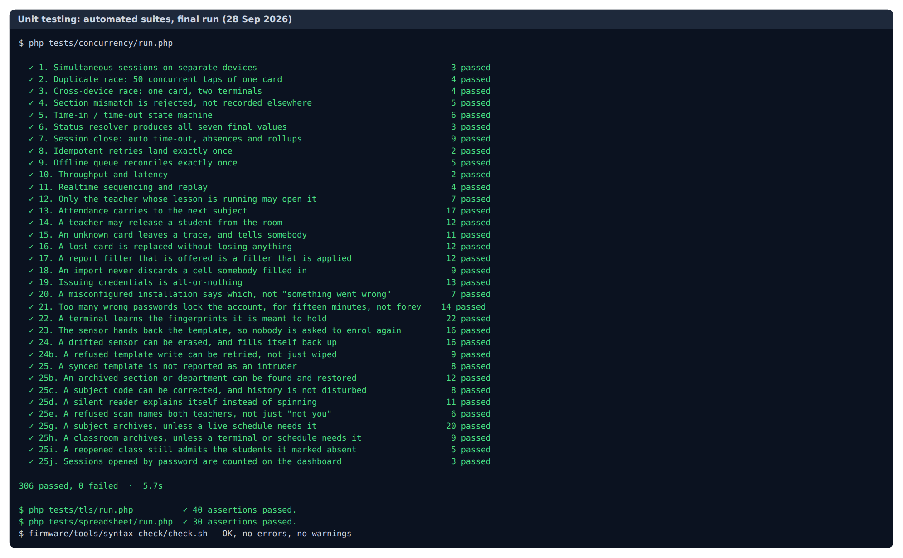
Figure 1. Unit testing, final run of all automated test suites

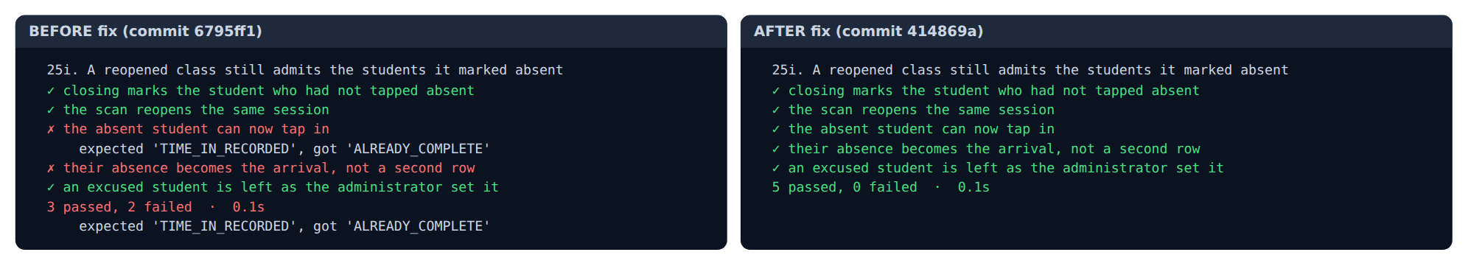
Figure 2. BUG-001 regression test before and after the fix

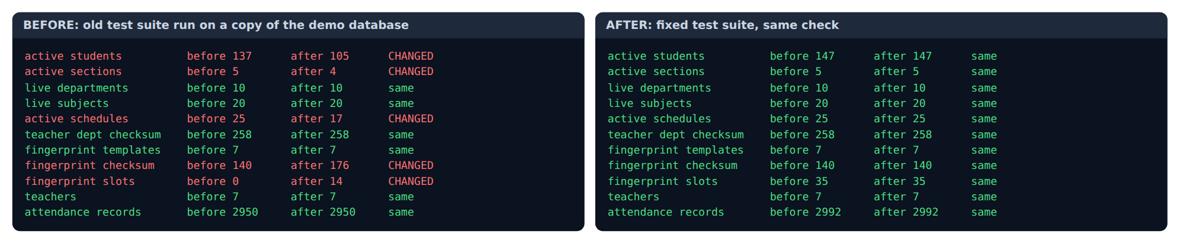
Figure 3. BUG-003, BUG-004 and BUG-005: real records before and after a full test suite run

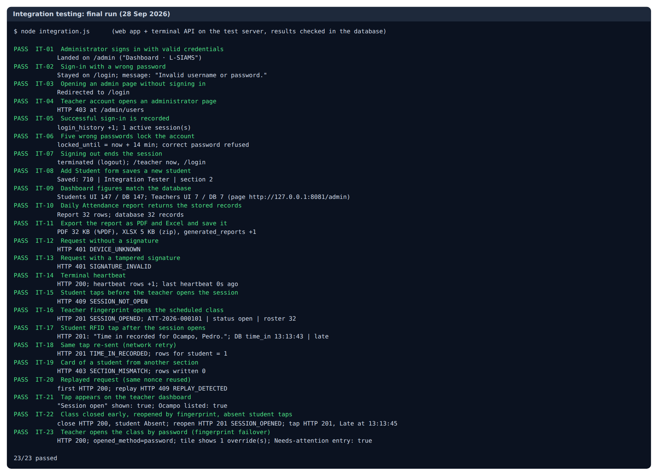
Figure 4. Integration testing, final run

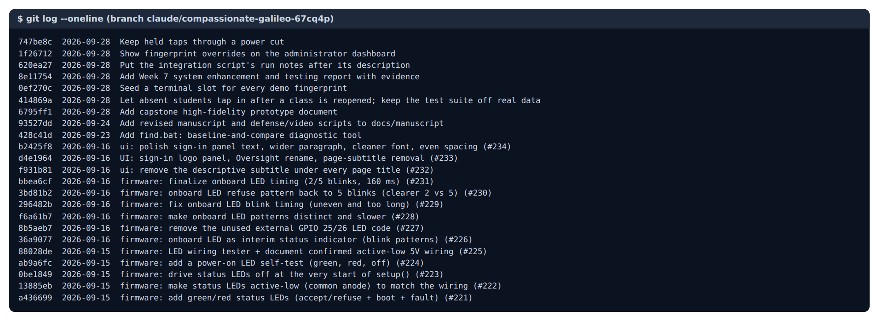
Figure 5. Repository commit log

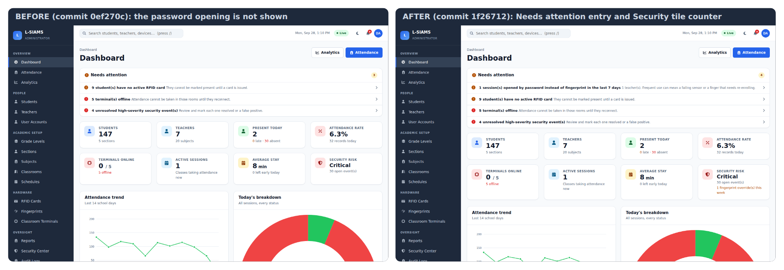
Figure 6. Fingerprint overrides on the administrator dashboard, before and after

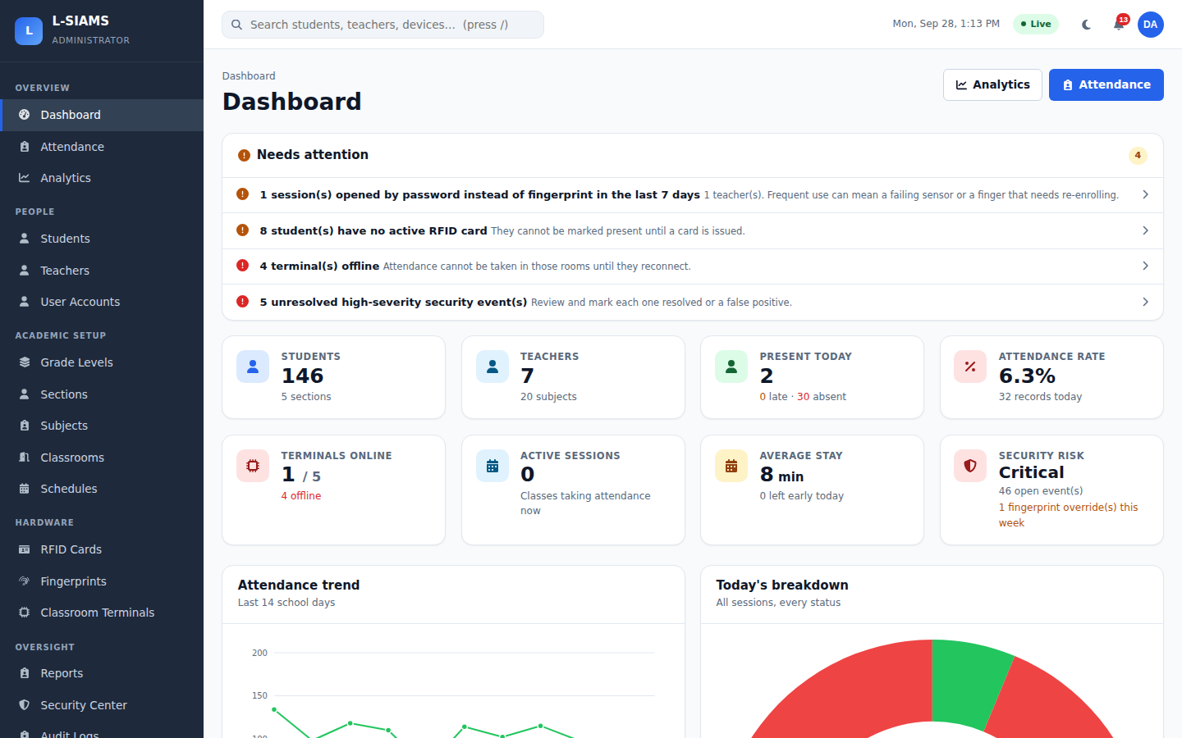
Figure 7. IT-01 Administrator signs in

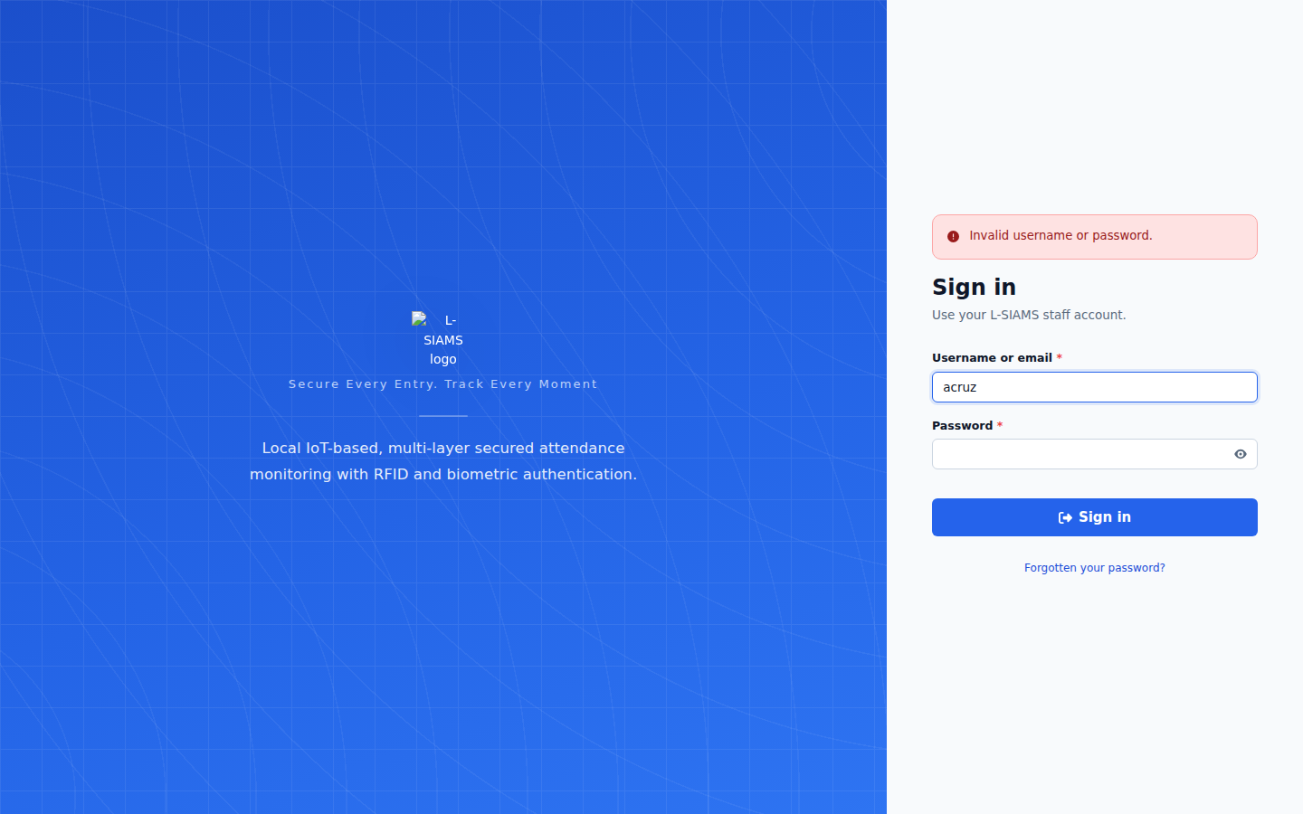
Figure 8. IT-02 Wrong password refused

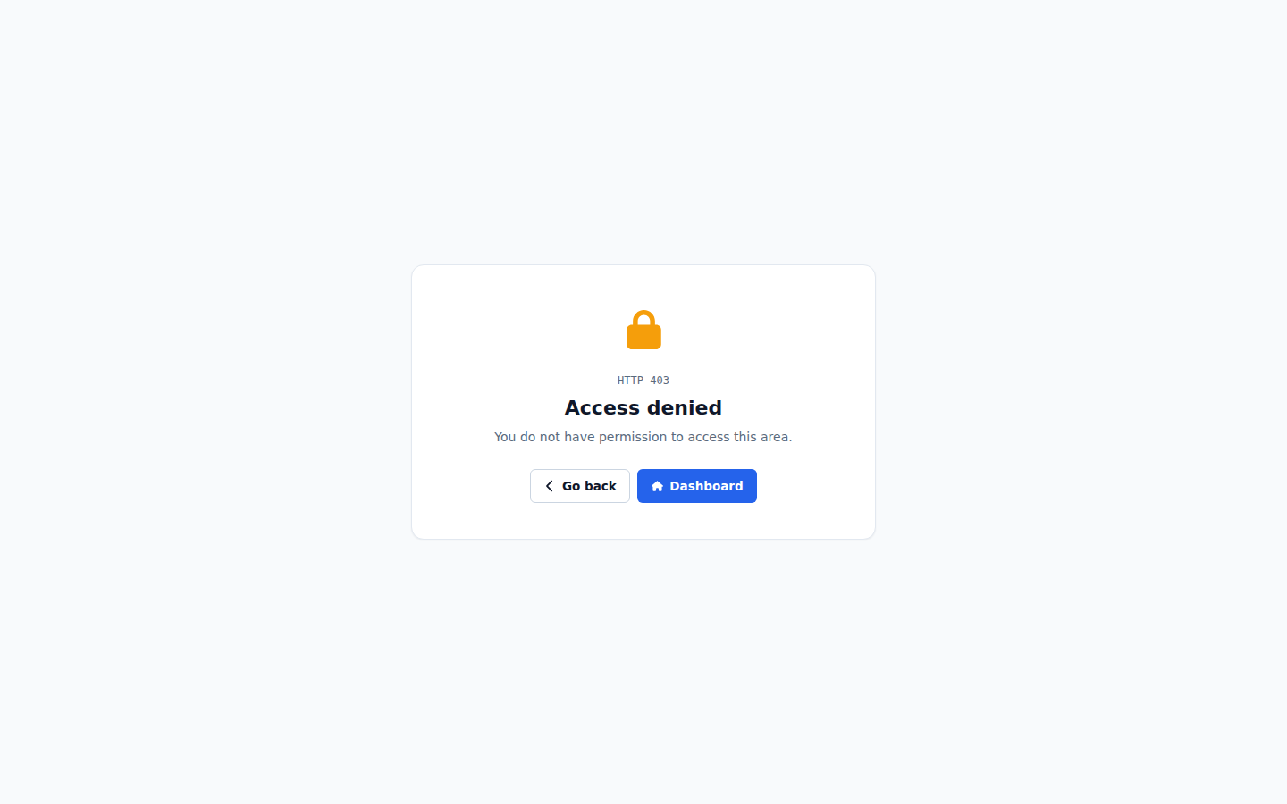
Figure 9. IT-04 Teacher account refused on an administrator page

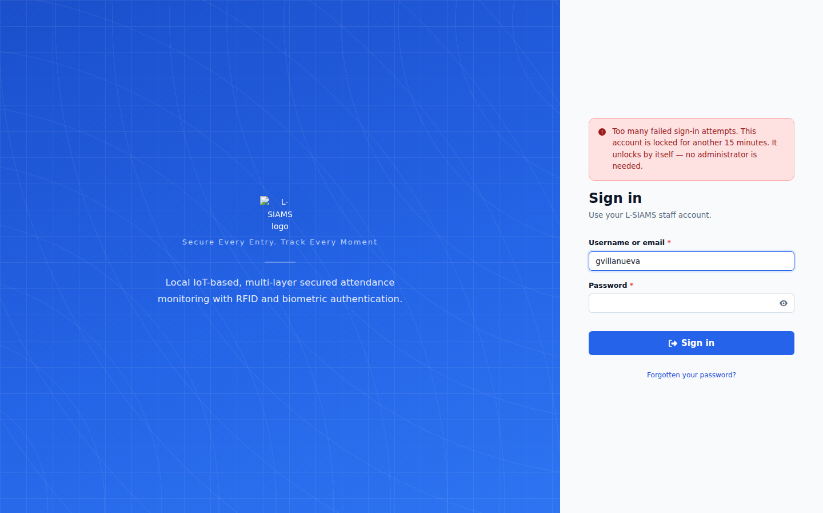
Figure 10. IT-06 Account locked after five wrong passwords

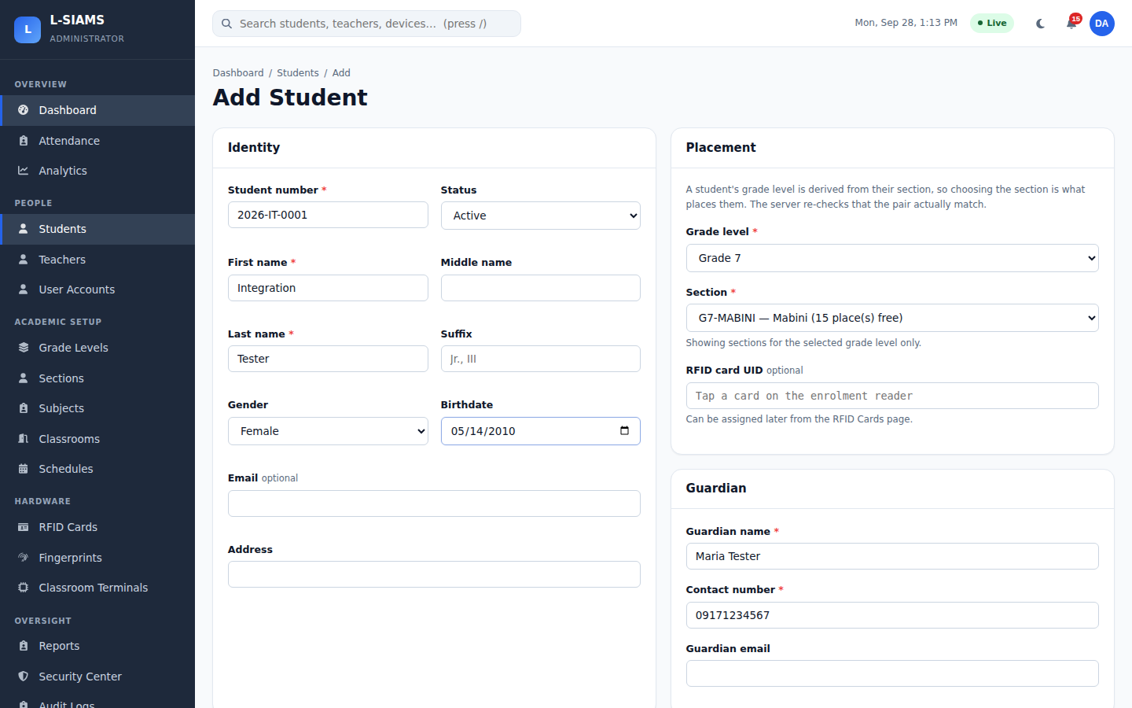
Figure 11. IT-08 Add Student form

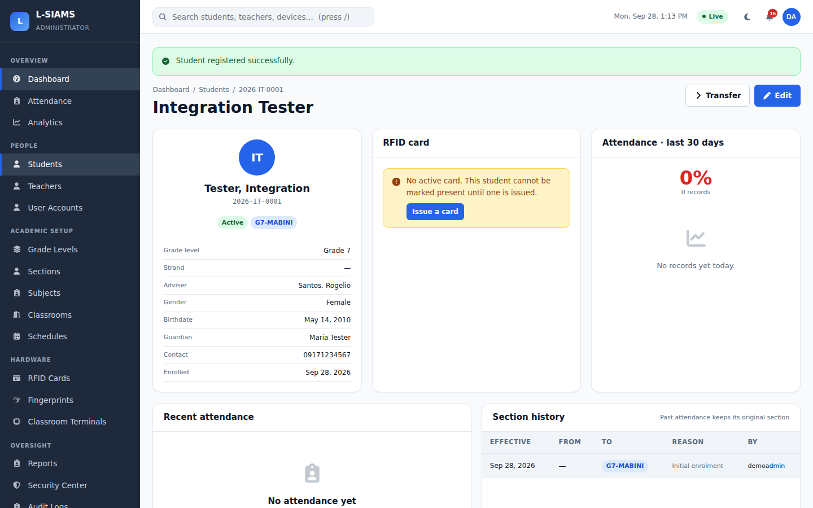
Figure 12. IT-08 Student saved

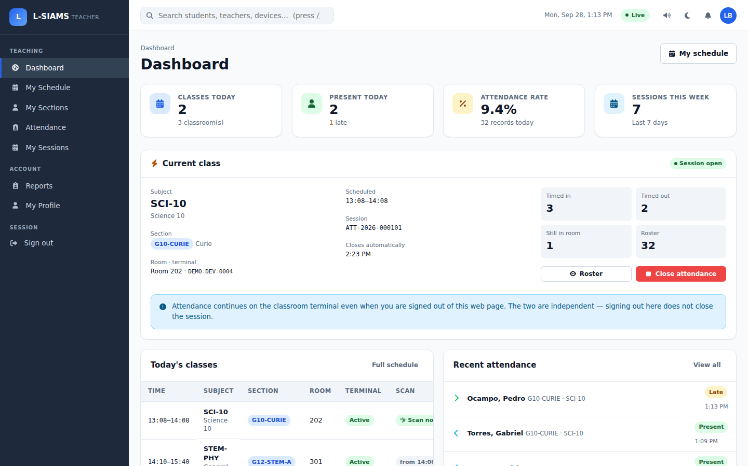
Figure 13. IT-21 RFID tap shown on the teacher dashboard

