CHAPTER V
RESULTS AND DISCUSSION
This chapter presents what was accomplished and found in the development, testing, deployment and evaluation of L-SIAMS at Top Achievers Private School Inc. The system was deployed on two classroom terminals for Grade 6 Gold and Grade 6 Diamond and evaluated on October 13–14, 2026. Of the 21 sessions opened in those two days, the first two were test sessions and are excluded, leaving 19 class sessions. The results are presented in the order of the requirements, design and development of the system (Sections 5.1–5.3), the testing results (Section 5.4), the evaluation results for Objectives 4.1, 4.2 and 4.4 (Section 5.5), and the deployment and user acceptance (Section 5.6), followed by a discussion.
5.1 Results of Requirements Analysis
The requirements identified in Chapter I were traced to the features implemented in the deployed system. Table 12 shows that every requirement under Objectives 1 to 3 was implemented and was exercised or evidenced during deployment.
Table 12
Requirements and Implemented Features
Requirement (Objective) | Implemented feature | Evidence
Capture attendance by RFID at classroom entry (1.1) | RFID terminal at each classroom door records tap-in and tap-out | 117 students tapped in during the 19 sessions (Table 19)
Verify teacher identity before a session opens (1.2) | Fingerprint verification opens a session only for the scheduled teacher; password failover | 18 of 18 enrolled-teacher sign-ins verified (Table 16)
Record student, date and time (1.3) | Each record stores the student, terminal, time-in, time-out and status | 562 complete records (Table 19)
Register users and devices (2.1) | Administration of users, teachers, students, RFID cards, fingerprints and terminals | Chapter IV, Section 4.13
Centralized database (2.2) | Single SQLite database on the school server | All records retrieved by the evaluation report
Reports and dashboards (2.3) | Dashboard, real-time monitoring, and reports exported as PDF, Excel and CSV | Chapter IV, Section 4.13
Encrypted communication (3.1) | HTTPS/TLS between terminals, browsers and server | TLS test suite; Table 14
Authentication and role-based access control (3.2) | Administrator and teacher roles; account lockout | 19 failed sign-ins refused (Table 15)
Controlled network access (3.3) | Network address allowlist; only required ports exposed | Table 14
Audit logging (3.4) | Audit trail and security event log | Every security event logged (Table 15)
Application-level security (3.5) | Cross-site request forgery protection, session timeout, session hijack detection | 2 session hijack attempts detected (Table 15)
Network and device security (3.6) | Per-device key, signed requests, timestamp and nonce checks | 4 invalid device claims and 27 replayed or expired requests rejected (Table 15)

5.2 Results of System Design
The finalized design is the one documented in Chapter IV: the layered architecture, the IoT terminal design, the network architecture, the application architecture, the database design, the data flow and the security architecture (Sections 4.2 to 4.8). Two aspects of the deployed form differ from the proposal and are reported here. First, the deployed edition, L-SIAMS-Lite, keeps its data in a single SQLite database file on the school server instead of a separate database server; the tables, the immutability of attendance and audit records, and the device API are unchanged. Second, the evaluation used two terminals, one per classroom, which bounds the scope of the results as stated in Chapter I.
5.3 Results of System Development
Table 13 lists the modules of the completed system, their status, and the evidence that each was developed and used.
Table 13
Module Development Status
Module | Status | Evidence
Classroom terminals (ESP32, MFRC522 RFID reader, AS608 fingerprint sensor) | Completed; 2 deployed | Chapter IV, Section 4.13.1
Session opening by fingerprint, with password failover | Completed | 10 sessions by fingerprint, 9 by password failover (Table 16)
Attendance recording: tap-in, tap-out, carry-over and automatic closing | Completed | 562 records (Table 19)
Administration of users, students, cards, fingerprints and terminals | Completed | Chapter IV, Section 4.13.2
Dashboard, real-time monitoring and reports | Completed | Chapter IV, Section 4.13.2
Security mechanisms: TLS, RBAC, device signing, network allowlist, audit and security logs, encrypted backups | Completed | Tables 14–15
Offline capture and synchronization | Implemented; not exercised during deployment | Section 5.6

5.4 Testing Results
During development, the transport-security test suite returned 40 passing assertions, and the concurrency and correctness suite verified that simultaneous taps of the same card produce a single record. The controlled security evaluation of Objective 4.3 was then carried out on the deployed system. Its results are presented in Table 14, and the security events that the system recorded during the two days of deployment are presented in Table 15 and Figure 28.
Table 14
Controlled Security Evaluation Results
Scenario | Method | Result | Status
Packet interception | Wireshark | [Insert observed result] (Figure 24) | [Pass/Fail]
Open port exposure | Nmap | [Insert open ports found] (Figure 25) | [Pass/Fail]
Unauthorized access | Metasploit | [Insert result] (Figure 26) | [Pass/Fail]
Unauthorized sign-in | Wrong passwords at the sign-in page | 19 failed sign-ins refused and logged | Pass
Device spoofing | Claim from an unregistered device | 4 invalid claims rejected and logged | Pass
Data modification (replay) | Resending captured terminal requests | 27 replayed or expired requests rejected and logged | Pass
Data modification (records) | Database privilege check | [Insert result] (Figure 27) | [Pass/Fail]
Session hijacking | Reusing a session from another client | 2 attempts detected and logged | Pass
Log monitoring | Audit and security logs | Every event above recorded with type, severity and source | Pass

Figures 24 to 27 present the evidence for the scenarios in Table 14 that were tested with external tools or commands. Figure 24 shows the Wireshark capture of the traffic between a classroom terminal and the server, Figure 25 shows the Nmap scan of the server, Figure 26 shows the Metasploit test against the sign-in page, and Figure 27 shows the result of the database privilege check.
Figure 24
Wireshark Capture of Terminal and Server Traffic
[Insert the Wireshark screenshot captured during testing]
Figure 25
Nmap Scan of the L-SIAMS Server
[Insert the Nmap screenshot captured during testing]
Figure 26
Metasploit Test Against the Sign-In Page
[Insert the Metasploit screenshot captured during testing]
Figure 27
Database Privilege Check (security:privileges)
[Insert the security:privileges screenshot]
Table 15
Security Events Recorded During Deployment (October 13–14, 2026)
Event | Severity | Count | Meaning
TIMESTAMP_EXPIRED | Medium | 27 | Request with an expired timestamp (replay) rejected
LOGIN_FAILED | Medium | 19 | Sign-in with a wrong password refused
BIOMETRIC_OVERRIDE_USED | Medium | 9 | Session opened by password failover instead of fingerprint
CLAIM_TOKEN_INVALID | High | 4 | Device claim with an invalid token rejected
SESSION_HIJACK_SUSPECTED | High | 2 | Session used from a different client detected
FINGERPRINT_FAILURE_THRESHOLD | High / Medium | 1 / 1 | Repeated unmatched fingerprints on a terminal flagged
Note. Severity is the level the system assigns to the event when it is logged; it is not a vulnerability rating. The events were produced mainly by the researchers’ controlled tests and by deliberate use of the password failover.

Figure 28
Security Events Recorded During Deployment
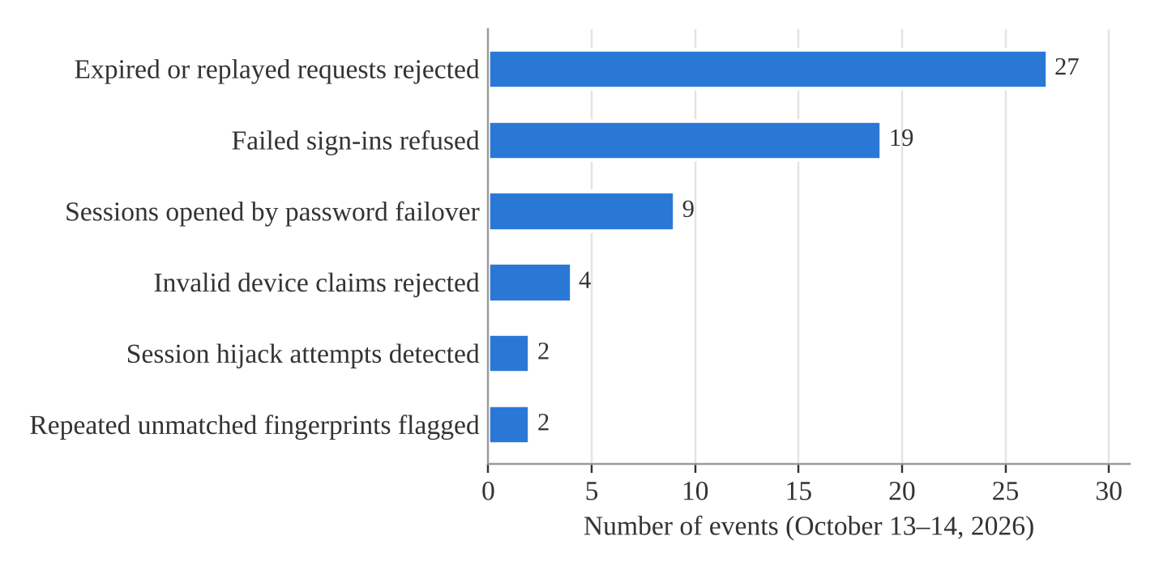
Figure 28 shows that expired or replayed requests (27) and failed sign-ins (19) were the most frequent events. Every one of them was refused by the system, and each was recorded with its type, severity and source.
Table 16
Teacher Identity Verification
Measure | Result
Class sessions opened | 19 (10 by fingerprint, 9 by password failover)
Fingerprint sign-in scans by enrolled teachers | 18 of 18 verified (100%)
Scans matching no active enrolment | 6, all refused
Verified teachers refused (class not theirs or not scheduled) | 10
Fingerprint enrolment attempts repeated | 2
Note. Fingerprint counts cover all scans on October 13–14, including enrolment and setup.

All scenarios with recorded results were blocked and logged, and no High or Critical vulnerability was identified among them. Each attack was stopped by a different control: signature, timestamp and nonce checks rejected forged and replayed terminal requests, account lockout and rate limiting refused password guessing, and session binding detected the reuse of a session from another client. Every fingerprint sign-in by an enrolled teacher was verified, meeting the 95% authentication criterion, while scans that matched no active enrolment and attempts to open a class a teacher was not scheduled to teach were refused. These results support Objective 4.3 within the scenarios tested; because the testing was controlled, they do not cover every real-world attack, as stated in the Scope and Limitations.
5.5 Evaluation Results
5.5.1 Processing Time, Queue Length and Efficiency
Table 17 presents the recording time of the five sessions in which a class queued at the terminal. Sessions with fewer than 10 taps were excluded because students arrived one at a time rather than in a queue.
Table 17
Recording Time in the Queue Sessions
Session | Date | Class | Students tapped | First to last tap (s) | Median interval (s)
ATT-2026-000003 | Oct 13 | G6 Diamond | 16 | 52 | 2.0
ATT-2026-000006 | Oct 14 | G6 Gold | 20 | 146 | 3.0
ATT-2026-000007 | Oct 14 | G6 Diamond | 14 | 89 | 6.0
ATT-2026-000012 | Oct 14 | G6 Diamond | 23 | 1,132* | 4.5
ATT-2026-000013 | Oct 14 | G6 Gold | 25 | 164 | 5.0
Mean |  |  |  |  | 4.10 (SD 1.60)
Note. *Includes students who arrived late after lunch; excluded from the whole-class time.

Figure 29
Time per Student in the Queue Sessions
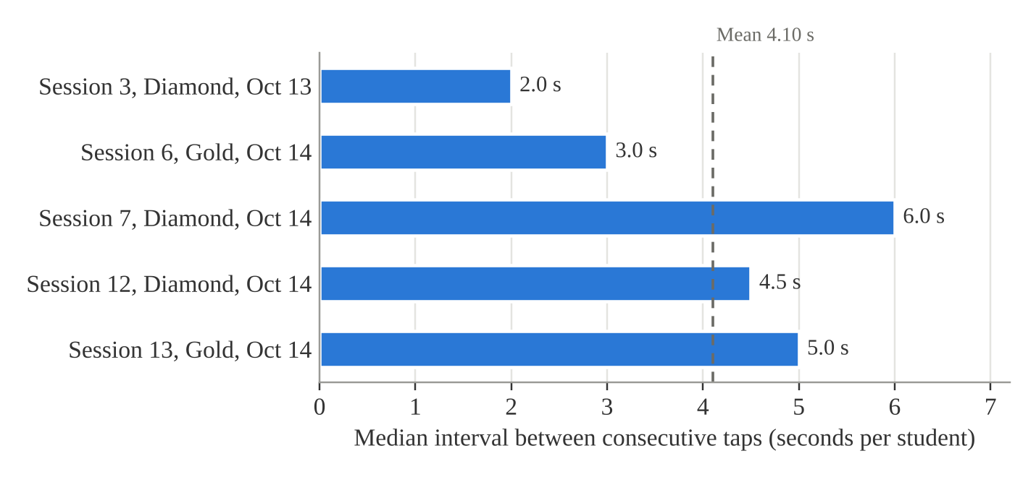
Figure 29 shows that the median interval between taps ranged from 2.0 to 6.0 seconds in the five queue sessions, around a mean of 4.10 seconds per student. Table 18 and Figure 30 compare this result with the manual roll call.
Table 18
Comparison of the Manual Roll Call and L-SIAMS
Measure | Manual roll call | L-SIAMS
Time per class | 4–5 min (240–300 s), 29–30 students called | 52–164 s for 14–25 students in the queue
Time per student | 8.1–10.2 s | 4.10 s
Efficiency | Not applicable | 49.6–59.7% (about 55%)
Where students queue | Single RFID gate (Chapter I) | Each classroom door
Queue length | 20–30 at the gate (Chapter I) | 20–30 per classroom door (observed October 14)

Figure 30
Time per Student of the Manual Roll Call and L-SIAMS
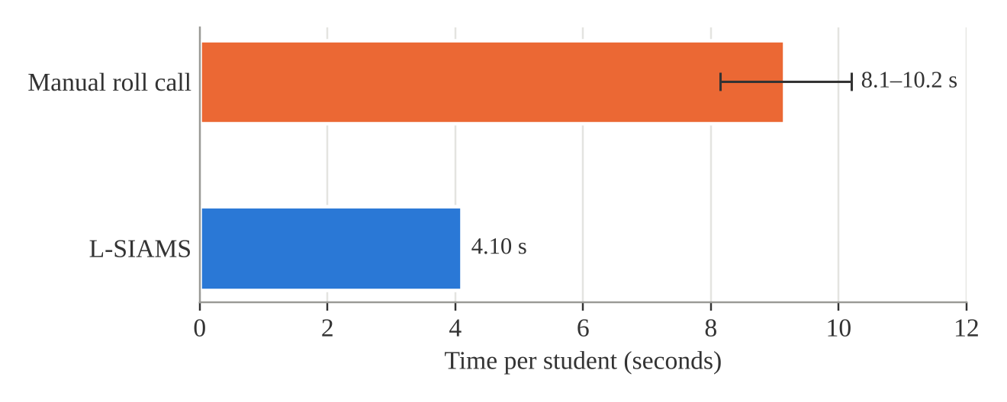
A whole class queuing at the door was recorded in 52 to 164 seconds, at a mean of 4.10 seconds per student, or about 15 students per minute. The manual roll call took 4 to 5 minutes for a class of 29 to 30 students, or 8.1 to 10.2 seconds per student, so the system recorded attendance about 50 to 60 percent faster per student. Because the manual time was recorded as a range, the comparison is descriptive and no paired t-test was performed. Congestion moved from the single school gate to the classroom doors: lines of 20 to 30 students still formed, but each line held only one class and cleared in under three minutes. The students’ ratings agree: tapping was rated faster than the roll call (Form 2, Q1, 4.45), while waiting in line received the lowest student rating (Q2, 3.65).
5.5.2 Accuracy of Attendance Records
Table 19
Attendance Records and Accuracy (19 Class Sessions)
Measure | Count | Percentage
Students who tapped in | 117 | 20.82%
Carried over from the previous period | 303 | 53.91%
Absent (no tap) | 142 | 25.27%
Total records | 562 | 100.00%
Records matching the manual roll call | 562 | 100.00%
Present students timed out by tapping out | 12 | 2.86% of 420
Present students released early by the teacher | 1 | 0.24% of 420
Present students closed automatically at session end | 407 | 96.90% of 420
Students recorded twice in one session | 0 | 0.00%

Figure 31
Attendance Records by Type
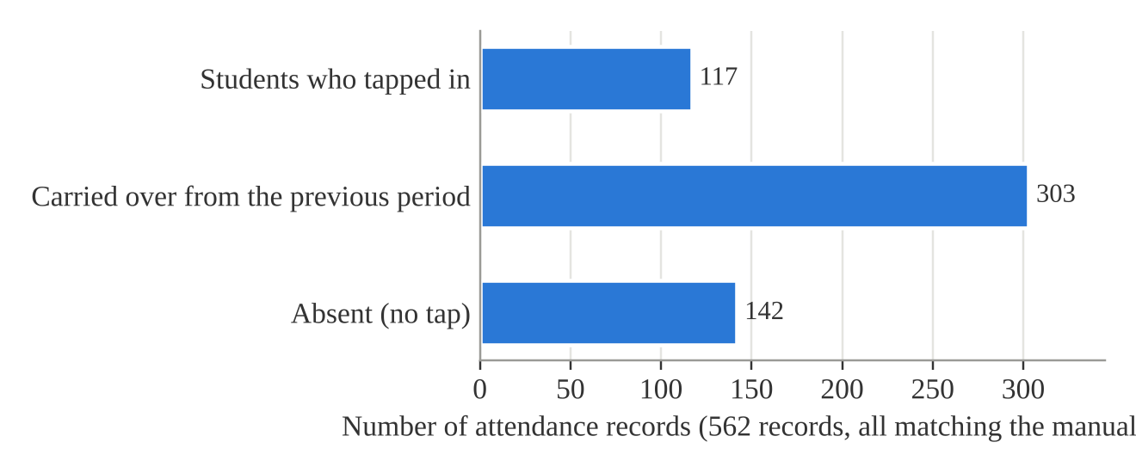
Figure 31 shows that more than half of the records (303) were carried over from the previous period, because students who stayed in the room for the next subject did not need to tap again; 117 were made by tapping in and 142 were absences.
All 562 attendance records of the 19 class sessions matched the teachers’ manual roll call, for an accuracy of 100 percent, exceeding the 95 percent criterion of Objective 4.2. No student was recorded twice: five repeat taps were ignored, and 34 taps made before a session was open were refused. Every present student received a time-out, but students rarely tapped out (12 of 420); departure was recorded mainly by the automatic closing of sessions.
5.5.3 Effectiveness of the Security Controls (ISO/IEC 27001, CIA Triad)
Table 20
Profile of Respondents
Respondent group | Frequency | Percentage
Students | 51 | 79.69%
Teachers | 10 | 15.63%
IT administrators | 2 | 3.13%
School administrator | 1 | 1.56%
Total | 64 | 100.00%

Table 21
Security Evaluation by CIA Dimension
Dimension | Respondents | Items | Mean | SD | Cronbach’s α | Interpretation
Confidentiality (Form 1, Part A) | 13 staff | 9 | 4.62 | 0.68 | 0.91 | Very High
Integrity (Form 1, Part B) | 13 staff | 9 | 4.67 | 0.63 | 0.92 | Very High
Availability (Form 1, Part C) | 13 staff | 9 | 4.56 | 0.65 | 0.85 | Very High
Staff security grand mean | 13 staff | 27 | 4.61 | 0.65 | 0.96 | Very High
Keeping attendance safe (Form 2, Part A) | 51 students | 6 | 4.25 | 0.92 | 0.62 | Very High

Figure 32
Security Evaluation by CIA Dimension
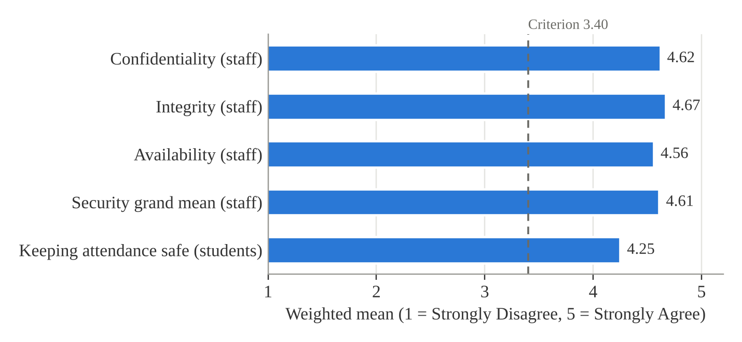
Figure 32 shows that every dimension, for both the staff and the students, lies well above the 3.40 criterion.
Table 22
Part D Technical Control Checklist
Measure | IT administrator 1 | IT administrator 2
Points earned (of 30) | 30 | 30
Compliance | 100% | 100%
Controls restating Table 7 criteria rated Yes | 6 of 6 | 6 of 6

The 13 staff rated all three dimensions Very High, with Integrity highest (4.67), Confidentiality next (4.62) and Availability lowest (4.56), for a security grand mean of 4.61; of their 351 ratings, 91.17 percent were Agree or Strongly Agree. The 51 students rated their part 4.25, also Very High. Both IT administrators rated all 15 technical controls Yes. Every result exceeds the 3.40 criterion, so the implemented controls are judged effective on all three dimensions of the CIA Triad (Objective 4.4). The highest-rated items were A1, only users with a valid account can sign in, and B8, terminal times match the school’s official time (both 4.92). The lowest were A5, account lockout, and B2, a tap is not recorded twice (both 4.31), and among students S3, the same protection against double taps (3.96), although the system logs show that no student was recorded twice. Internal consistency was acceptable for the staff dimensions (α 0.85 to 0.96) but below 0.70 for the student part (α 0.62), so the student result should be read with caution.
5.6 Deployment and User Acceptance
The system was deployed at Top Achievers Private School Inc. on October 13–14, 2026, with one terminal in each of the Grade 6 Gold and Grade 6 Diamond rooms. Teachers’ fingerprints and students’ RFID cards were enrolled before the class sessions; two sessions opened on October 13 served as tests. [Researchers: describe the orientation or training given to the teachers and students, and attach the attendance and photographs in Appendix I.] Twenty-one sessions were opened in the two days, 19 of them for classes, and 64 respondents took part in the evaluation.
The issues encountered and the actions taken were as follows. Two fingerprint enrolments failed because the two scans did not match or no usable image was captured, and were repeated. Six scans during setup matched sensor templates not linked to an active enrolment and were refused as designed. Nine sessions were opened through the password failover, each logged by the system. The terminals reported 15 lost connections, but no tap was made while a terminal was offline, so no attendance had to be synchronized later. Students rarely tapped out, so departure was recorded mainly by automatic closing.
Table 23
User Acceptance Test Results
Criterion | Mean | Interpretation | Rank
Ease of use | 5.00 | Very High | 1
User interface | 4.92 | Very High | 2
Accuracy | 4.85 | Very High | 3.5
Responsiveness | 4.85 | Very High | 3.5
Overall satisfaction | 4.83 | Very High | 5
Support for organizational requirements | 4.69 | Very High | 6
Grand mean (77 ratings) | 4.86 | Very High

Figure 33
User Acceptance Test Results
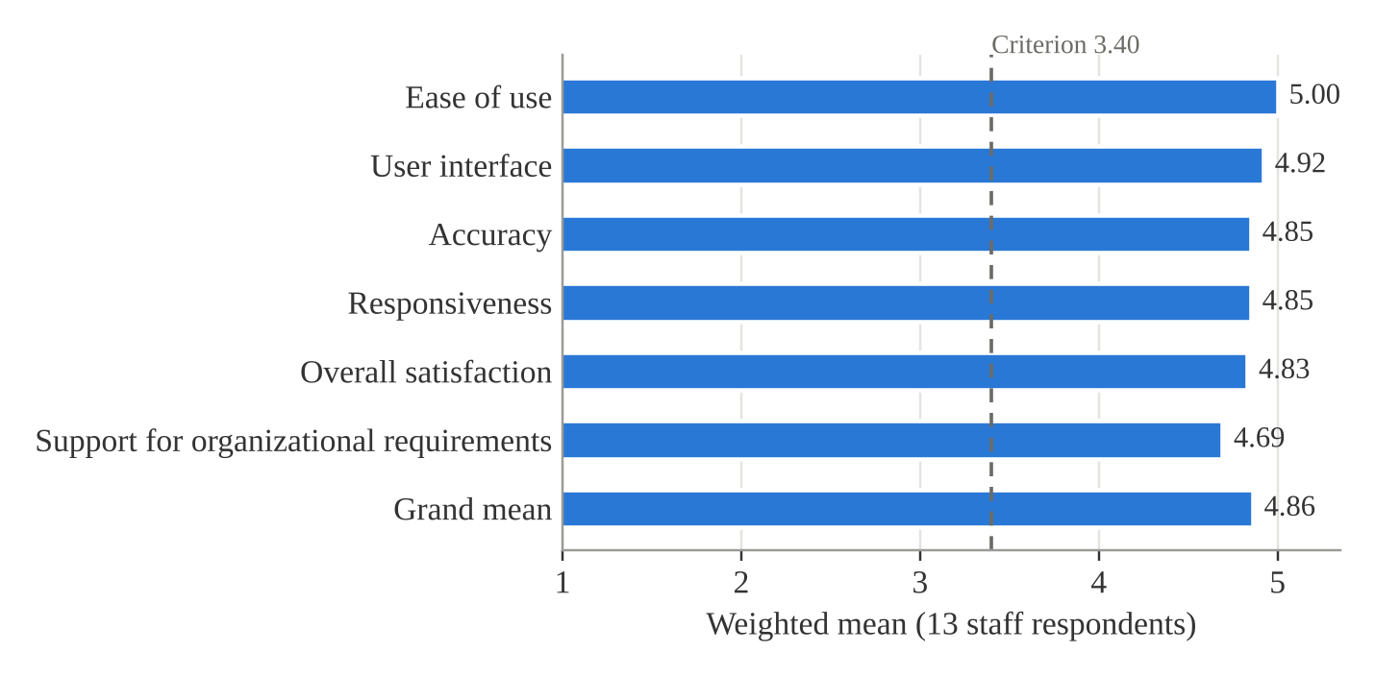
As Table 23 and Figure 33 show, the 13 staff accepted the system: every UAT criterion was rated Very High and the grand mean was 4.86, above the 3.40 criterion, with no rating below Agree. Teachers asked for a beep confirming that their fingerprint was recognized and for a quick user guide for faculty. In addition, the staff rated using L-SIAMS compared with the manual method at 4.96 (Form 1, Part E) and the students rated using the terminal at 4.26 (Form 2, Part B). [Researchers: state the current implementation status of the system at TAPS.]
Discussion
The results show that L-SIAMS met the criteria set for it at the partner school. Recording attendance at the classroom door took about half the time of the manual roll call per student and matched the manual record in all 562 cases, consistent with studies reviewed in Chapter II that found IoT-based attendance systems reduce manual work and improve accuracy (Shrivastava et al., 2023). The system went further than those studies in two respects that the literature identified as gaps: every session required the teacher to prove identity, by fingerprint or through the logged password failover, and the multi-layer security controls blocked every attack whose results were recorded.
The security results agree across three independent kinds of evidence: the controlled tests, the system’s own security logs, and the evaluation of the users and IT administrators. This supports the position of Ahmad et al. (2022) that encryption and role-based authentication are needed to protect IoT systems in educational environments, and it addresses the weaknesses of connected devices described by Neshenko et al. (2021). The lower ratings on double taps and lockout point to protections that work but are not visible to users, and the remaining line at the classroom door shows that one terminal per room still produces a short wait. Both findings are carried into the recommendations in Chapter VI.

CHAPTER VI
SUMMARY OF FINDINGS, CONCLUSION AND RECOMMENDATIONS
This chapter summarizes the findings of the study, presents the conclusions drawn from them for each objective, and gives recommendations for the school, the users of the system and future researchers.
6.1 Summary of Findings
The study developed and evaluated L-SIAMS, a secure IoT-based attendance monitoring system with RFID and fingerprint authentication, at Top Achievers Private School Inc. The system was deployed on two classroom terminals for Grade 6 Gold and Grade 6 Diamond on October 13–14, 2026. After two test sessions were excluded, 19 class sessions and 562 attendance records were evaluated, and 64 respondents (51 students, 10 teachers, 2 IT administrators and 1 school administrator) took part in the evaluation. The findings are summarized below by objective.
1. Design and implementation of the IoT hardware (Objective 1). Classroom terminals built on the ESP32 microcontroller, the MFRC522 RFID reader and the AS608 fingerprint sensor were completed and deployed. Students tapped in at the classroom door, and a session opened only after the scheduled teacher was verified. Of the 19 class sessions, 10 were opened by fingerprint and 9 by the logged password failover. All 18 fingerprint sign-ins by enrolled teachers were verified (100%), while 6 scans that matched no active enrolment and 10 attempts to open a class the teacher was not scheduled to teach were refused. Every record stored the student, terminal, time-in, time-out and status.
2. Development of the locally hosted system (Objective 2). The administration of users, teachers, students, RFID cards, fingerprints and terminals, the centralized SQLite database, the dashboard, real-time monitoring and the PDF, Excel and CSV reports were completed. All 562 records of the evaluation were retrieved from the database by the evaluation report.
3. Implementation of the security mechanisms (Objective 3). Encrypted communication over HTTPS/TLS, authentication with role-based access control and account lockout, the network address allowlist, audit and security logging, application-level protections and device authentication with signed requests were implemented. The transport-security test suite returned 40 passing assertions. During deployment the system refused and logged 19 failed sign-ins, 27 expired or replayed requests and 4 invalid device claims, and it detected 2 session hijack attempts (Tables 14 and 15).
4. Processing time, queue length and efficiency (Objective 4.1). A class queuing at the door was recorded in 52 to 164 seconds, at a mean of 4.10 seconds per student (SD 1.60), compared with 8.1 to 10.2 seconds per student for the manual roll call. The system was about 50 to 60 percent faster per student. Lines of 20 to 30 students still formed, but at each classroom door instead of the single school gate, and each line cleared in under three minutes.
5. Accuracy of attendance records (Objective 4.2). All 562 system records matched the teachers’ manual roll call, for an accuracy of 100 percent. No student was recorded twice; five repeat taps were ignored and 34 taps made before a session was open were refused. Students rarely tapped out (12 of 420 present students), so departure was recorded mainly by the automatic closing of sessions.
6. Security evaluation (Objectives 4.3 and 4.4). Every controlled scenario with a recorded result was blocked and logged, and no High or Critical vulnerability was found among them. The 13 staff rated Confidentiality 4.62, Integrity 4.67 and Availability 4.56, for a security grand mean of 4.61 (Very High, α 0.96), and the 51 students rated their part 4.25 (Very High, α 0.62). Both IT administrators rated all 15 technical controls in the Part D checklist Yes (100% compliance). The lowest-rated items concerned protection against double taps and account lockout.
7. User acceptance. The 13 staff rated every User Acceptance Testing (UAT) criterion Very High, with a grand mean of 4.86; ease of use was rated highest (5.00) and support for organizational requirements lowest (4.69). Teachers asked for a beep confirming that their fingerprint was recognized and for a quick user guide for faculty.
6.2 Conclusion
Based on the findings, the following conclusions were drawn:
1. The IoT hardware met Objective 1. Attendance can be captured at the classroom door by RFID, and no session can be opened without verifying the teacher, either by fingerprint or through a password failover that the system logs. The number of sessions opened by failover (9 of 19) shows that fingerprint sign-in, though fully accurate for enrolled teachers, still depends on careful enrolment.
2. The locally hosted system met Objective 2. Users and devices can be registered, records are kept in one centralized database, and reports and dashboards are available for monitoring.
3. The security mechanisms of Objective 3 work as designed. Each attack whose result was recorded was stopped by a different control and left a trace in the logs, which supports the multi-layer approach of the system.
4. L-SIAMS is more efficient than the manual roll call (Objective 4.1). It roughly halved the time needed to record each student and moved congestion from the school gate to shorter lines at each classroom door. Because the manual time was recorded as a range, this conclusion is descriptive rather than statistical.
5. L-SIAMS records attendance accurately (Objective 4.2). Its 100 percent agreement with the manual roll call exceeds the 95 percent criterion, and its safeguards against duplicate and early taps worked in every case.
6. The security controls are effective on all three dimensions of the CIA Triad as guided by ISO/IEC 27001 (Objectives 4.3 and 4.4), within the scenarios tested. Evidence from the controlled tests, the system’s own logs and the respondents’ ratings agree. The student result should be read with caution because of its lower internal consistency.
7. The intended users accept the system. All acceptance criteria were rated Very High, and the staff preferred L-SIAMS to the manual method.
Overall, L-SIAMS achieved its general objective: it provides secure, accurate and efficient classroom attendance monitoring at the partner school, within the two-classroom, two-day scope of the evaluation.
6.3 Recommendations
Based on the findings and conclusions, the following are recommended:
For the school and the users of the system:
1. Add an audible beep and a clear on-screen message when a teacher’s fingerprint is recognized, as the teachers requested, and when a student’s repeated tap is ignored, so that protections that already work, such as protection against double taps and account lockout, become visible to users.
2. Prepare a short quick user guide for faculty and hold a brief orientation for new teachers and students before each school year.
3. Re-enrol teachers’ fingerprints with several good-quality scans and review the password failover log regularly, to reduce the number of sessions opened without a fingerprint.
4. Install a second reader or terminal at the doors of large classes, or stagger arrival by class, to shorten the remaining line at the classroom door.
5. Keep the automatic closing of sessions as the main way of recording departure, or remind students to tap out where time-out is needed for reporting.
6. Back up the database regularly using the encrypted backup feature, and keep the server and terminals on the school’s protected local network.
For future researchers:
7. Deploy the system in more classrooms and grade levels over a longer period, including a test of offline capture and synchronization, which was implemented but not exercised during this deployment.
8. Time the manual roll call per student with a stopwatch under the same conditions as the system, so that a paired t-test or another inferential test can be used to compare the two methods.
9. Revise and pilot the student security items to raise their internal consistency to at least 0.70, and include more staff respondents.
10. Conduct a broader security assessment, such as an independent penetration test and tests of physical tampering with the terminals, to cover attack scenarios beyond those tested in this study.

