Statistical Analysis and Interpretation of System Evaluation Data

FORM 1
Research Question–Variable–Statistical Treatment Matrix

No. | Research Question/Objectives | Variable/Indicator | Data Type | Source of Data | Statistical Treatment | Expected Presentation
1 | Objective 4.1 – Measuring processing time, queue length, and system efficiency during attendance recording | Class recording time; time per student (median gap between taps); manual roll-call time; queue length; efficiency (%) | Quantitative – ratio (seconds; number of students) | System logs (report:evaluation, Oct 13–14, 2026); stopwatch (one roll call, Oct 13); queue observation (Oct 14) | Mean, SD; Efficiency = (Manual − System) ÷ Manual × 100; descriptive comparison (paired t-test not performed) | Comparison table and bar chart
2 | Objective 4.2 – Comparing system-recorded attendance with manual classroom attendance to assess accuracy | Accuracy rate (%) | Quantitative – ratio (%) | System attendance export compared with the teachers’ manual roll call | Accuracy = matching records ÷ total × 100; criterion ≥ 95% | Accuracy table; bar chart of records by type
3 | Objective 4.3 – Assessing usability, performance and reliability | Six UAT criteria; response time; offline sync success | Ordinal (Likert); ratio (ms, %) | UAT Form 4 (13 staff); system logs; offline test (Oct 11) | Weighted mean, grand mean (≥ 3.40); response time (< 2 s); sync rate (≥ 95%) | UAT table and bar chart
4 | Objective 4.3 – Evaluating security against ISO/IEC 27001 (CIA Triad) | Confidentiality, Integrity, Availability ratings; Part D control ratings | Ordinal (5-point Likert); categorical (Y/P/N) | Form 1 Parts A–C (13 staff); Form 2 Part A (51 students); Part D (2 IT administrators) | Weighted mean, SD, Cronbach’s α; Part D compliance (%); criterion mean ≥ 3.40 | Tables per CIA dimension; bar chart with 3.40 line
5 | Objective 5 – Penetration testing of the security controls | Outcome of each attack scenario; security events | Categorical; counts | Wireshark, Hydra, Nmap; security:privileges; security logs | Frequency count; pass/fail per scenario; vulnerability severity (no High or Critical) | Scenario results table


Prepared by:
Group Leader: Ched Nikko P. Pangilinan

Signature: _____________________________________
Date: October __, 2026

Adviser Verification:
Capstone Adviser: Dr. Romero Dante C. Salum

Signature: _____________________________________
Date: October __, 2026
Remarks:
FORM 2
Data Cleaning and Validation Checklist

Check | Yes | No | Remarks/Action Taken
All expected respondents are included | ☒ | ☐ | 64 of 64 present on the evaluation day: 13 staff (10 teachers, 1 school administrator, 2 IT administrators) and 51 students (Gold 29 of 29; Diamond 22 of 30, 8 absent)
Number of encoded responses matches completed questionnaires | ☒ | ☐ | 13 Form 1, 51 Form 2 and 13 UAT Form 4 rows encoded; Part D encoded for both IT administrators
No duplicate respondent records | ☒ | ☐ | Respondent codes T01–T10, A01, IT01–IT02 and S01–S51 are unique (0 duplicates)
No unexplained missing responses | ☒ | ☐ | None on Form 1 or Form 2; one UAT form left the satisfaction item blank (12 ratings for that item)
Coding is consistent | ☒ | ☐ | Ratings coded 5 to 1 as printed on the forms; Part D coded Y/P/N
Values are within the approved scale | ☒ | ☐ | Rating cells accept only whole numbers 1–5; observed range 1–5
Demographic categories are consistently encoded | ☒ | ☐ | Role encoded for all staff; grade and section encoded (Grade 6 Gold 29, Grade 6 Diamond 22)
No accidental text/numeric inconsistencies | ☒ | ☐ | All ratings stored as numbers
Original/raw dataset has been preserved | ☒ | ☐ | Paper questionnaires kept; original workbook kept unchanged beside the corrected copy
Confidentiality/anonymity has been maintained | ☒ | ☐ | Respondents identified by code only; no names in the dataset
Dataset is ready for analysis | ☒ | ☐ | Ready for analysis after the formula correction below

Data Cleaning Notes
Problems identified:
1. Form 2 Responses: the “Part A answered” column counted S1–Q6 (12 cells) instead of S1–S6, and row 43 used a shifted range, so the student Part A Cronbach’s alpha could not be computed.
2. Summary: the rank cells for Form 1 Parts A–C were empty.
3. Grade and section were not encoded for the student respondents.
4. One UAT form left the satisfaction item blank and did not mark the respondent’s role.
Actions taken:
1. The count formulas were corrected to S1–S6 (Part A) and Q1–Q6 (Part B) for every row; no rating was changed.
2. The rank formulas were restored.
3. All results were recomputed independently and match the workbook. Grade and section were encoded from the paper forms: Grade 6 Gold 29 and Grade 6 Diamond 22.
4. The blank was not imputed: satisfaction (4.83) uses 12 ratings and the UAT grand mean (4.86) uses 77; all six UAT means match the 13 paper forms.

Prepared by:
Group Leader: Ched Nikko P. Pangilinan

Signature: _____________________________________
Date: October __, 2026

Adviser Verification:
Capstone Adviser: Dr. Romero Dante C. Salum

Signature: _____________________________________
Date: October __, 2026

Adviser Remarks:
FORM 3
Respondent Profile Analysis

Profile Variable: Respondent group

Category | Frequency (f) | Percentage (%)
Students | 51 | 79.69
Teachers | 10 | 15.63
IT Administrators | 2 | 3.13
School Administrator | 1 | 1.56
Total | N = 64 | 100.00%

Interpretation
Sixty-four respondents took part. Students formed the largest group (51, or 79.69%); they answered Form 2, which covers tapping the RFID card at the classroom terminal. The 13 staff answered Form 1: 10 teachers (15.63%), who open sessions with their fingerprint, 2 IT administrators (3.13%), who also completed the Part D technical checklist, and 1 school administrator (1.56%). The students came from two sections: Grade 6 Gold (29, all present) and Grade 6 Diamond (22 of 30; 8 were absent on the evaluation day). Because the staff and students answered different items, their results are reported separately.

Prepared by:
Group Leader: Ched Nikko P. Pangilinan

Signature: _____________________________________
Date: October __, 2026

Checked by:
Capstone Adviser: Dr. Romero Dante C. Salum

Signature: _____________________________________
Date: October __, 2026
FORM 4
Frequency and Percentage Analysis

Research Question: SOP 5 – How do the staff rate the security of the system in terms of confidentiality, integrity and availability?
Variable/Indicator: All ratings on Form 1 Parts A–C (27 items × 13 respondents = 351 ratings)

Response/Category | Frequency | Percentage
5 – Strongly Agree | 247 | 70.37
4 – Agree | 73 | 20.80
3 – Neutral | 30 | 8.55
2 – Disagree | 1 | 0.28
1 – Strongly Disagree | 0 | 0.00
Total | N = 351 | 100.00%

Interpretation
Of the 351 security ratings given by the staff, 320 (91.17%) were Agree or Strongly Agree, with Strongly Agree alone accounting for 70.37%. Thirty ratings (8.55%) were Neutral, one (0.28%) was Disagree (item A9, network-only access), and none was Strongly Disagree. The staff therefore largely agree that the system’s security controls work as intended.

Prepared by:
Group Leader: Ched Nikko P. Pangilinan

Signature: _____________________________________
Date: October __, 2026

Checked/Verified by:
Capstone Adviser: Dr. Romero Dante C. Salum

Signature: _____________________________________
Date: October __, 2026
Remarks:
FORM 5
Weighted Mean Computation Sheet

Evaluation Dimension: Security – Confidentiality, Integrity and Availability (Form 1, Parts A–C)
Indicator: Security grand mean of the staff (27 items, 13 respondents)
Scale Used: 5-point Likert scale (5 Strongly Agree … 1 Strongly Disagree)

Response | Weight (X) | Frequency (f) | fX
Strongly Agree | 5 | 247 | 1235
Agree | 4 | 73 | 292
Neutral | 3 | 30 | 90
Disagree | 2 | 1 | 2
Strongly Disagree | 1 | 0 | 0
Total |  | N = 351 | ΣfX = 1,619

Computation:
Weighted Mean = ΣfX ÷ N = 1,619 ÷ 351 = 4.6125 ≈ 4.61

Weighted Mean: 4.61 (SD = 0.65)
Verbal Interpretation: Very High (4.20–5.00); meets the pass criterion of 3.40

Prepared by:
Group Leader: Ched Nikko P. Pangilinan

Signature: _____________________________________
Date: October __, 2026

Computation Verified by:
Capstone Adviser: Dr. Romero Dante C. Salum

Signature: _____________________________________
Date: October __, 2026
Adviser Remarks:
FORM 6
System Evaluation Results Summary

No. | Evaluation Dimension | Indicator | Weighted Mean | Verbal Interpretation | Rank
1 | Security – Confidentiality | Form 1 Part A (9 items, n = 13) | 4.62 | Very High | 2
2 | Security – Integrity | Form 1 Part B (9 items, n = 13) | 4.67 | Very High | 1
3 | Security – Availability | Form 1 Part C (9 items, n = 13) | 4.56 | Very High | 3
4 | Security – Students | Form 2 Part A, Keeping attendance safe (6 items, n = 51) | 4.25 | Very High | —
5 | Teacher verification (Obj. 1.2) | System logs: fingerprint sign-ins by enrolled teachers | 100% (18 of 18) | All verified; 6 test scans refused | —
6 | Recording time (Obj. 4.1) | System logs: median gap between taps, 5 queue sessions | 4.10 s per student | Class recorded in 52–164 s; 47.4% faster than the manual roll call (7.79 s) | —
7 | User acceptance (Obj. 4.3) | UAT Form 4 (6 items, n = 13) | 4.86 | Very High | —
8 | Technical controls | Part D checklist (15 controls, 2 IT administrators) | 100% | Fully compliant | —
9 | Accuracy (Obj. 4.2) | System records vs teachers’ manual roll call, 19 sessions | 100% (562 of 562) | Criterion ≥ 95% met | —
10 | Response time (Obj. 4.3) | System logs | 11.7 ms | Criterion < 2 s met | —
11 | Offline synchronization (Obj. 4.3) | Router unplugged, Terminal 1 (Grade 6 Diamond), Oct 11 | 100% (5 of 5) | Criterion ≥ 95% met; no loss or duplicate | —
Overall |  | Staff security grand mean (Parts A–C, 351 ratings) | 4.61 | Very High

Highest-Rated Indicator
Indicator: A1 “Only users with a valid L-SIAMS account can sign in” and B8 “Terminal times match the school’s official time” (tied)

Weighted Mean: 4.92 (Very High)
Lowest-Rated Indicator

Indicator: Staff: A5 “Repeated wrong passwords lock the account” and B2 “A tap is not recorded twice” (tied, 4.31). Students: Q2 “I do not wait long in line” (3.65, High)
Weighted Mean: 4.31 (Very High) – staff; 3.65 (High) – students
Overall Interpretation
Every rated result is Very High. The staff security grand mean is 4.61 and the student security mean is 4.25, both well above the 3.40 criterion, and both IT administrators rated all 15 technical controls Yes. Integrity ranked highest among the staff and Availability lowest, though all three lie within 0.11 of each other. Ranks compare only the three staff security dimensions, because the other rows come from different instruments. The system logs support the ratings: every fingerprint sign-in by an enrolled teacher was verified; classes were recorded at 4.10 s per student, 47.4% faster than the manual roll call (7.79 s); all 562 records matched the manual roll call; the response time was 11.7 ms; and all 5 taps held offline were synchronized without loss or duplication. The UAT grand mean of 4.86 shows the staff accept the system.

Prepared by:
Group Leader: Ched Nikko P. Pangilinan

Signature: _____________________________________
Date: October __, 2026

Adviser Verification:
Capstone Adviser: Dr. Romero Dante C. Salum

Signature: _____________________________________
Date: October __, 2026

Adviser Remarks:
FORM 7
Dimension-Level Statistical Summary

Evaluation Dimension | No. of Indicators | Mean/Composite Result | Verbal Interpretation | Rank
Integrity (Form 1 Part B) | 9 | 4.67 | Very High | 1
Confidentiality (Form 1 Part A) | 9 | 4.62 | Very High | 2
Availability (Form 1 Part C) | 9 | 4.56 | Very High | 3
Students – Keeping attendance safe (Form 2 Part A) | 6 | 4.25 | Very High | —
Overall | 27 | 4.61 (staff) | Very High

Key Observations
Highest-rated dimension:
Integrity (4.67): B8, terminal clock matching the school’s official time (4.92), and B1, correct student and time on each record (4.85).

Lowest-rated dimension:
Availability (4.56): C1, available whenever needed, C3, several terminals at once, and C8, problems resolved promptly (each 4.38).

Areas requiring improvement:
Staff: account lockout (A5, 4.31) and duplicate-tap prevention (B2, 4.31). Students: duplicate-tap prevention (S3, 3.96). Both groups rated duplicate-tap prevention lowest in its part, although the logs show no student was recorded twice; users do not see that a second tap is ignored.
Reliability: Cronbach’s α is 0.91 (Confidentiality), 0.92 (Integrity) and 0.85 (Availability), all acceptable; the student part (0.62) is below 0.70 and is reported with caution.

Prepared by:
Group Leader: Ched Nikko P. Pangilinan

Signature: _____________________________________
Date: October __, 2026

Reviewed by:
Capstone Adviser: Dr. Romero Dante C. Salum

Signature: _____________________________________
Date: October __, 2026
FORM 8
Data Visualization Planning and Verification

Figure No. | Variable/Result | Recommended Chart | Reason for Selecting Chart
Figure 1 | Respondent profile by group | Bar chart | Compares the size of four separate respondent groups
Figure 2 | Security means: staff Confidentiality, Integrity, Availability; student security | Horizontal bar chart with a reference line at 3.40 | Compares the security dimensions and shows each against the pass criterion
Figure 3 | Time per student in each queue session (median interval between taps; system logs, Obj. 4.1) | Vertical bar chart, one bar per session, with a line at the 4.10 s mean | Shows how fast each queue was recorded and how each session compares with the mean

Figures
Figure 1
Respondent Profile by Group (N = 64)
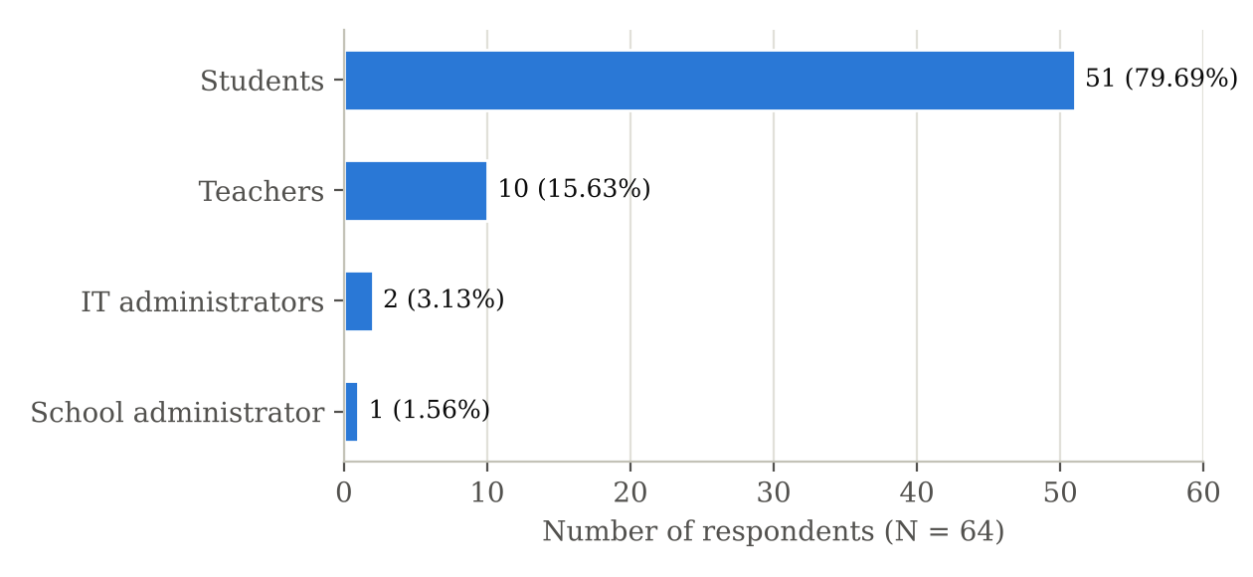
Note. Students answered Form 2; teachers, the school administrator and the IT administrators answered Form 1 and the UAT.
Figure 2
Security Evaluation by CIA Dimension (Weighted Mean)
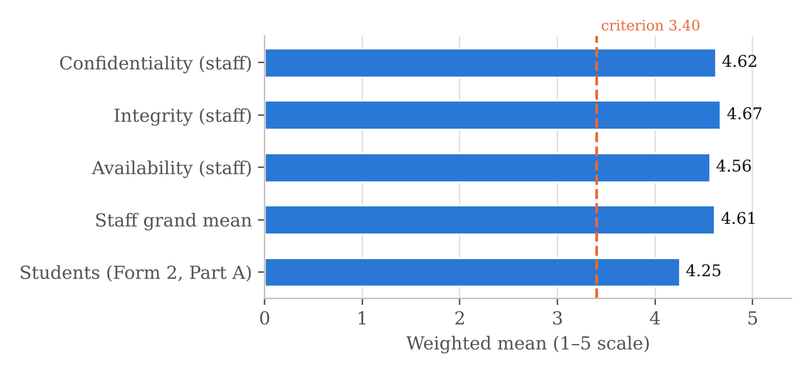
Note. Dashed line: success criterion of 3.40. Staff n = 13 (Form 1, Parts A–C); students n = 51 (Form 2, Part A).
Figure 3
Time per Student in the Five Queue Sessions
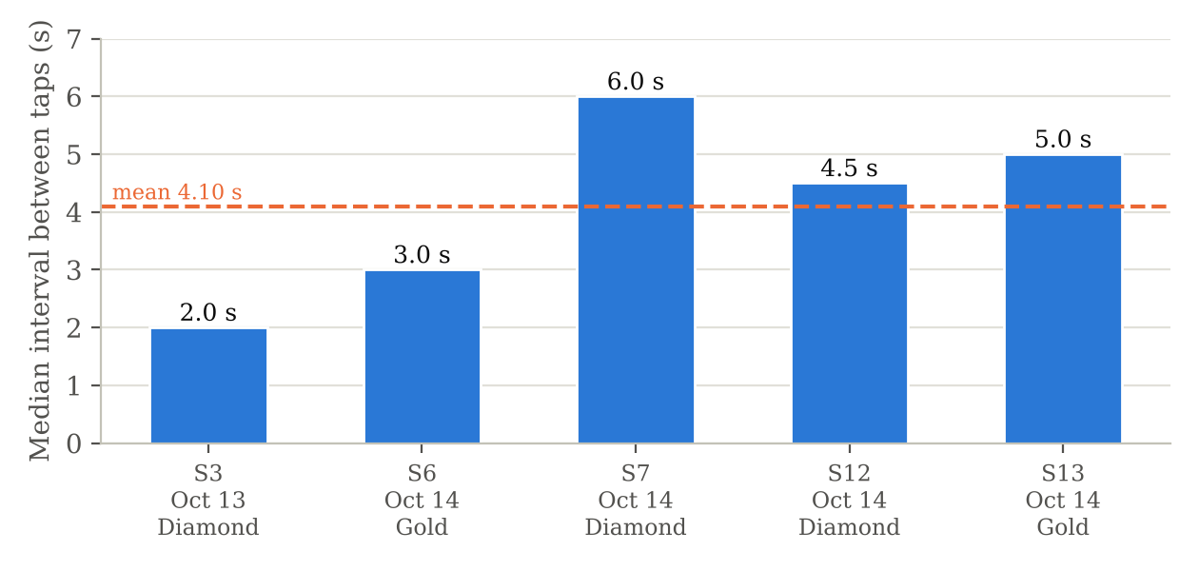
Note. Median interval between consecutive taps (report:evaluation, October 13–14, 2026). Mean 4.10 s (SD 1.60), compared with 7.79 s for the stopwatch-timed manual roll call.
Chart Verification
Criterion | Yes | No
Clear title | ☒ | ☐
Correct labels | ☒ | ☐
Accurate values | ☒ | ☐
Appropriate chart type | ☒ | ☐
Not misleading | ☒ | ☐
Figure number/caption included | ☒ | ☐

Prepared by:
Group Leader: Ched Nikko P. Pangilinan

Signature: _____________________________________
Date: October __, 2026

Verified by:
Capstone Adviser: Dr. Romero Dante C. Salum

Signature: _____________________________________
Date: October __, 2026
FORM 9
Statistical Interpretation Form

Research Question: Objective 4.3 – Evaluating system security against ISO/IEC 27001 guided by the CIA Triad
Table/Figure Number: Form 6 and Form 7 (security results); Figure 2 (Form 8)

Main Statistical Result
Staff security grand mean 4.61 (SD = 0.65), Very High, from 351 ratings; Integrity 4.67, Confidentiality 4.62, Availability 4.56; student security mean 4.25 (SD = 0.92), Very High; Part D compliance 100% for both IT administrators; Cronbach’s α for Parts A–C 0.85–0.92 (0.96 for all 27 items).

Highest Result
Integrity (4.67); items A1 (valid accounts only) and B8 (clock matches official time), both 4.92.

Lowest Result
Availability (4.56) among staff; item A5 (account lockout) and B2 (no duplicate taps), both 4.31. Among students, S3 (no duplicate taps), 3.96.

Meaning of the Result
Both staff and students agree that the system protects attendance data: only authorized users get in, records are accurate and cannot be altered without a trace, and the system is available when needed. The IT administrators’ checklist confirms the same controls from the technical side. The lower ratings on lockout and duplicate taps concern features users rarely trigger themselves, so they are less certain about them rather than reporting that they fail.

Relationship to the Research Objective
The results answer the security part of Objective 4.3: the implemented security controls are judged effective on all three CIA dimensions, and every mean exceeds the 3.40 criterion. The questionnaire results agree with the penetration testing (Objective 5), which found no High or Critical vulnerabilities, and with the history-protection check, in which every attempt to delete or rewrite attendance, audit, security and login history was refused.

Implication for the Developed System
The security design can go to deployment as built. The terminal should make its protections visible: for example, a distinct signal when a duplicate tap is ignored. Users should also be told how account lockout works.

Prepared by:
Group Leader: Ched Nikko P. Pangilinan

Signature: _____________________________________
Date: October __, 2026

Reviewed by:
Capstone Adviser: Dr. Romero Dante C. Salum

Signature: _____________________________________
Date: October __, 2026

Adviser Comments/Recommendations:
FORM 10
Key Findings and Areas for Improvement Matrix

No. | Statistical Finding | Evidence/Table | Interpretation | System Implication | Recommended Improvement
1 | Staff security grand mean 4.61 (C 4.62, I 4.67, A 4.56); α 0.85–0.92 | Forms 5–7 | Staff judge the security controls effective | Objective 4.3 (security) and the 3.40 criterion met | Deploy the security design as built
2 | Every simulated attack blocked and logged; 18 of 18 teacher sign-ins verified; every history guard held | Penetration tests; security logs; security:privileges | The controls work against the attacks tested | Objective 5 supported; replayed requests and history changes refused | Repeat the tests after each update
3 | Student security mean 4.25; lowest S3 “not recorded twice” 3.96, while the logs show 0 duplicates | Form 6; system logs | Protection works but is not visible to students | Users cannot see that a repeat tap is ignored | Give a distinct terminal signal when a repeat tap is ignored
4 | System 4.10 s vs manual 7.79 s per student; lines of 20–30 at each door (Oct 14); waiting rated 3.65 | System logs; stopwatch; observation; Form 2 Q2 | Recording is 47.4% faster, but a short line remains | Objective 4.1 met; congestion moved from the gate to each room | Consider a second terminal or staggered entry for large classes
5 | Cronbach’s α below 0.70 for the student part (0.62) | Summary sheet | Internal consistency of the student items is weak | Student means are less dependable than staff means | Report with caution; revise and pilot-test the student items before reuse
6 | UAT 4.86; response time 11.7 ms; 5 of 5 offline taps synced | UAT Form 4; system logs; offline test | Users accept the system | Objective 4.3 met | Add a fingerprint beep and a quick user guide

Prepared by:
Group Leader: Ched Nikko P. Pangilinan

Signature: _____________________________________
Date: October __, 2026

Reviewed and Validated by:
Capstone Adviser: Dr. Romero Dante C. Salum

Signature: _____________________________________
Date: October __, 2026

Adviser Remarks/Recommendations:
FORM 11
Chapter IV Statistical Analysis Preparation Sheet

A. Introduction to the Results
This chapter presents the evaluation of L-SIAMS at Top Achievers Private School Inc., deployed in the Grade 6 Gold and Grade 6 Diamond classrooms from October 12 to 15, 2026, with attendance recorded on October 13–14 and 64 respondents: 51 students, 10 teachers, 2 IT administrators and 1 school administrator. It reports processing time, queue length and efficiency (Objective 4.1), accuracy (Objective 4.2), usability, performance, reliability and security under ISO/IEC 27001 guided by the CIA Triad (Objective 4.3), and the penetration testing (Objective 5). Each result is interpreted against the success criteria in Table 8 of the manuscript.

B. Research Question/Objective 1
Research Question: Objective 4.1 – Measuring processing time, queue length, and system efficiency during attendance recording
Table Number: Tables 18–19 – Recording Time in the Queue Sessions; Comparison of the Manual Roll Call and L-SIAMS
Statistical Result:
Classes of 14–25 students in the queue recorded in 52–164 s; 4.10 s per student (SD 1.60, 5 sessions). Manual roll call 3 min 46 s for 29 students (7.79 s per student; stopwatch, Grade 6 Gold, Oct 13). Lines of 20–30 students formed at each classroom door (Oct 14).

Interpretation:
The system recorded attendance 47.4% faster per student than the roll call, and 100% faster in carried-over periods, which needed no tap or roll call. The comparison is descriptive because the roll call was timed for one class only. Congestion moved from the school gate to each classroom door.

C. Research Question/Objective 2
Research Question: Objective 4.2 – Comparing system-recorded attendance with manual classroom attendance to assess accuracy
Table Number: Table 20 – Attendance Records and Accuracy (19 Class Sessions)
Statistical Result:
562 records in 19 sessions (117 tapped in, 303 carried over, 142 absent); 562 matched the teachers’ manual roll call (100%); 0 students recorded twice; 5 repeat taps ignored; 34 taps before a session opened refused.

Interpretation:
The system recorded attendance as accurately as the manual roll call, above the 95% criterion, with no duplicate or incomplete records.

D. Research Question/Objective 3
Research Question: Objective 4.3 – Assessing system usability, performance and reliability, and evaluating system security against ISO/IEC 27001 guided by the CIA Triad
Table Number: Tables 21–24 – Profile of Respondents; Security Evaluation by CIA Dimension; Part D Checklist; User Acceptance Test Results
Statistical Result:
Staff security grand mean 4.61 (Integrity 4.67, Confidentiality 4.62, Availability 4.56); students 4.25; Part D compliance 100% for both IT administrators. UAT grand mean 4.86 (13 staff, 77 ratings). Response time 11.7 ms. Offline test: 5 of 5 taps held on the terminal were synchronized, with no loss or duplicate.

Interpretation:
The users accept the system, the performance and reliability criteria are met, and the security controls are judged effective on all three CIA dimensions; every mean exceeds 3.40.

E. Research Question/Objective 4
Research Question: Objective 5 – Conducting penetration testing to validate the effectiveness of the implemented security controls
Table Number: Tables 15–17 – Penetration Testing Results; Security Events Recorded; Teacher Identity Verification
Statistical Result:
Traffic encrypted (Wireshark); only the required ports open (Nmap); brute force blocked by lockout (Hydra); 4 forged device claims and 27 expired or replayed requests rejected; 10 wrong-class openings refused; every history guard held (security:privileges); no High or Critical vulnerabilities.
Interpretation:
Each simulated attack was blocked by a different control layer and logged, and stored history cannot be deleted or rewritten through SQL.

F. Overall Findings
L-SIAMS met every criterion in Table 8: security controls rated Very High by staff (4.61) and students (4.25) and fully in place according to both IT administrators; every simulated attack blocked and logged; all enrolled-teacher sign-ins verified; response time 11.7 ms; all 5 offline taps synchronized; UAT 4.86. Attendance was recorded 47.4% faster per student than the manual roll call (100% in carried-over periods), and all 562 records matched the manual roll call (100%).

Adviser Review
Comments/Recommendations:

Status:
☐ Approved for Chapter IV development
☐ For Revision
☐ Requires Further Analysis

Prepared by:
Group Leader: Ched Nikko P. Pangilinan

Signature: _____________________________________
Date: October __, 2026

Reviewed by:
Capstone Adviser: Dr. Romero Dante C. Salum

Signature: _____________________________________
Date: October __, 2026
FORM 12
Data Integrity and Ethical Compliance Declaration

We certify that the statistical analysis submitted for this laboratory activity:
☐ uses the actual collected research data;
☐ does not contain fabricated respondents or responses;
☐ does not intentionally alter data to obtain a desired result;
☐ preserves respondent confidentiality/anonymity where required;
☐ uses statistical treatments appropriate to the approved research methodology;
☐ reports results accurately;
☐ does not make conclusions beyond what the data support; and
☐ preserves the original/raw dataset for verification.

Student Certification
Name | Role | Signature | Date
Ched Nikko P. Pangilinan | Group Leader |  | October __, 2026
Naph Yvan P. Villamar | Member |  | October __, 2026
Joshkirby Tyler M. Bote | Member |  | October __, 2026

Adviser Verification
I have reviewed the group's statistical analysis activity and provided appropriate feedback regarding the accuracy, appropriateness, integrity, and interpretation of the submitted data.

Capstone Adviser: Dr. Romero Dante C. Salum

Signature: _____________________________________
Date: October __, 2026

Remarks:
FORM 13
Laboratory Activity 12 Submission and Adviser Monitoring Form

Project Title: L-SIAMS: A Local IoT-Based Multi-Layer Secured Attendance Monitoring System with RFID and Biometric Authentication
Group No.: __________
Section: ____________
Date: ______________

Required Output | Submitted | Adviser Checked
Form 1– Variable/Statistical Treatment Matrix | ☑ | ☐
Form 2 – Data Cleaning Checklist | ☑ | ☐
Form 3– Respondent Profile | ☑ | ☐
Form 4– Frequency/Percentage Analysis | ☑ | ☐
Form 5– Weighted Mean Computation | ☑ | ☐
Form 6– Evaluation Results Summary | ☑ | ☐
Form 7– Dimension-Level Summary | ☑ | ☐
Form 8– Data Visualization | ☑ | ☐
Form 9– Statistical Interpretation | ☑ | ☐
Form 10– Key Findings Matrix | ☑ | ☐
Form 11– Chapter IV Preparation Sheet | ☑ | ☐
Form 12– Data Integrity Declaration | ☑ | ☐
Cleaned Dataset | ☑ | ☐
Statistical Computation File | ☑ | ☐

Overall Adviser Assessment
Status:
☐ Completed – Satisfactory
☐ Completed – With Minor Revisions
☐ For Revision
☐ Requires Adviser Consultation

Adviser Comments

Signatures
Prepared by:
Group Leader: Ched Nikko P. Pangilinan

Signature: _____________________________________
Date: October __, 2026

Reviewed/Monitored by:
Capstone Adviser: Dr. Romero Dante C. Salum

Signature: _____________________________________
Date: October __, 2026

