ACTIVITY 1 – Review of Research Questions and Statistical Results
Review the research questions/objectives and corresponding statistical results from Week 12.

FORM 1
Research Question–Result–Chapter IV Mapping Form

No. | Research Question/Objective | Data/Variable | Statistical Treatment | Main Result | Table/Figure No. | Chapter IV Section
1 | Objective 4.1 – Measuring processing time, queue length, and system efficiency during attendance recording | System: class recording time (first to last tap) and time per student (median gap between taps), from the system logs. Manual: roll-call time by stopwatch (one class, Grade 6 Gold, October 13); queue length by observation (October 14) | Mean, SD; Efficiency = (Manual − System) ÷ Manual × 100; descriptive comparison (paired t-test not performed: the manual roll call was timed for one class only) | System: classes of 14–25 students in the queue recorded in 52–164 s; 4.10 s per student (SD 1.60, 5 sessions). Manual roll call 3 min 46 s for 29 students (7.79 s per student): system 47.4% faster, and 100% faster in carried-over periods. Queue (observed October 14): 20–30 students per line at each classroom door instead of the gate | Tables 18–19; Figures 31–32 | 5.5.1
2 | Objective 4.2 – Comparing system-recorded attendance with manual classroom attendance to assess accuracy | Attendance status of each student per session: system record vs teacher’s manual roll call | Accuracy = matching records ÷ total records × 100; criterion ≥ 95% | All 562 records in 19 sessions (117 tapped, 303 carried over, 142 absent) matched the teachers’ manual roll call: accuracy 100%. 0 students recorded twice; 5 repeat taps ignored | Table 20; Figure 33 | 5.5.2
3 | Objective 5 – Conducting penetration testing to validate the effectiveness of the implemented security controls | Outcome of each attack scenario; security events (Oct 13–14); database history protection | Frequency count; blocked/not blocked per scenario; vulnerability severity (criterion: no High or Critical) | Traffic encrypted; only required ports open; brute force blocked; 4 forged claims and 27 replayed requests rejected; 10 wrong-class openings refused; history cannot be deleted or rewritten (security:privileges); no High or Critical vulnerabilities | Tables 15–17; Figure 30; security:privileges screenshot | 5.4
4 | Objective 4.3 – Evaluating system security against ISO/IEC 27001 guided by the CIA Triad | Security Evaluation Questionnaire: Form 1 Parts A–C (13 staff), Form 2 Part A (51 students); Part D control checklist (2 IT administrators) | Weighted mean, SD, Cronbach’s α; Part D compliance (%); criterion: mean ≥ 3.40 | Staff 4.61 (Confidentiality 4.62, Integrity 4.67, Availability 4.56); students 4.25; all Very High. Part D: 100% compliance for both IT administrators | Tables 21–23; Figure 34 | 5.5.3
5 | Objective 4.3 – Assessing system usability, performance and reliability using measurable indicators | UAT Form 4 (13 staff, Oct 13–14); response time (system logs); offline test (5 cards, Oct 11) | Weighted mean, grand mean (≥ 3.40); response time (< 2 s); sync rate (≥ 95%) | UAT 4.86, every criterion Very High (77 ratings); response time 11.7 ms; 5 of 5 offline taps synced (100%) | Table 24; Figure 35 | 5.5.4; 5.6

Guide Questions
1. Does every research question/objective have corresponding evidence?
☒ Yes
☐ No
If No, explain:
Not applicable. Note: for Objective 4.1 the manual roll call was timed with a stopwatch for one class only (3 min 46 s for 29 students, Grade 6 Gold, October 13), so the comparison is descriptive and the paired t-test was not performed. Sessions 1 and 2 (October 13) were test sessions and are excluded from all results.

2. Are the statistical treatments consistent with Chapter III?
☒ Yes
☐ No

3. Are all reported values consistent with the Week 12 computations?
☒ Yes
☐ No
Note on question 2: Chapter III of the revised manuscript describes the instruments actually used (Security Evaluation Questionnaire, Part D checklist, UAT, system logs), the 64 respondents and the treatments applied (weighted mean, SD, Cronbach’s α, Part D compliance), and explains why the paired t-test was not performed. Two statements in it still have to be corrected: the offline-synchronization test was carried out (October 11, 5 of 5 taps synchronized), and the UAT forms are dated October 13–14, not October 15.


Prepared by:
Group Leader: Ched Nikko P. Pangilinan

Signature: _____________________________________
Date: October __, 2026

Adviser Verification:
Capstone Adviser: Dr. Romero Dante C. Salum

Signature: _____________________________________
Date: October __, 2026
Remarks:
ACTIVITY 2 – Organization of Chapter IV
Develop the structure of Chapter IV based on the approved research questions/objectives.

FORM 2
Chapter IV Organization Plan
CHAPTER IV – RESULTS AND DISCUSSION
Note. In the manuscript, Results and Discussion is Chapter V, because Chapter IV is the Technical Background. The section, table and figure numbers below follow the manuscript.

Proposed Sections
Section | Research Question/Objective Addressed | Table/Figure | Main Content
5.1–5.3 | Objectives 1–3: design, development and implemented security mechanisms | Table 13 – Requirements and Implemented Features; Table 14 – Module Development Status; Figures 13–23 – Screens of the deployed L-SIAMS-Lite | Requirements traced to implemented modules; finalized design; completed features with screenshots from the deployed system
5.4 | Objective 5 – Conducting penetration testing to validate the effectiveness of the implemented security controls | Table 15 – Penetration Testing Results; Table 16 – Security Events Recorded During Attendance Recording; Table 17 – Teacher Identity Verification; Figure 30 – Security Events Recorded During Deployment; security:privileges screenshot | Each scenario with its tool, outcome and pass/fail; security events; history-protection check; vulnerability severity
5.5.1 | Objective 4.1 – Measuring processing time, queue length, and system efficiency during attendance recording | Table 18 – Recording Time in the Queue Sessions; Table 19 – Comparison of the Manual Roll Call and L-SIAMS; Figure 31 – Time per Student in the Queue Sessions; Figure 32 – Time per Student of the Manual Roll Call and L-SIAMS | System timings from the logs; stopwatch-timed roll call (one class) and efficiency; carried-over periods; queue observation (October 14)
5.5.2 | Objective 4.2 – Comparing system-recorded attendance with manual classroom attendance to assess accuracy | Table 20 – Attendance Records and Accuracy (19 Class Sessions); Figure 33 – Attendance Records by Type | 562 records in 19 sessions compared with the manual roll call; accuracy rate; duplicate protection
5.5.3 | Objective 4.3 – Evaluating system security against ISO/IEC 27001 guided by the CIA Triad | Table 21 – Profile of Respondents; Table 22 – Security Evaluation by CIA Dimension; Table 23 – Part D Technical Control Checklist; Figure 34 – Security Evaluation by CIA Dimension | Weighted means, SD and Cronbach’s α per dimension, staff and students reported separately; Part D compliance
5.5.4; 5.6 | Objective 4.3 – Assessing system usability, performance and reliability using measurable indicators; deployment at Top Achievers Private School Inc. | Table 24 – User Acceptance Test Results; Figure 35 – User Acceptance Test Results | Response time; offline synchronization test; deployment period and users; UAT results; issues encountered and actions taken

Chapter IV Writing Sequence
For each research question/objective, follow:

1. Introduce the result
↓
2. Present the table/figure
↓
3. Describe the result
↓
4. Interpret the result
↓
5. Discuss its implication
↓
6. Relate it to the research objective

Prepared by:
Group Leader: Ched Nikko P. Pangilinan

Signature: _____________________________________
Date: October __, 2026

Reviewed by:
Capstone Adviser: Dr. Romero Dante C. Salum

Signature: _____________________________________
Date: October __, 2026

Adviser Remarks:
ACTIVITY 3 – Table and Figure Preparation
Review all tables and figures to ensure that they accurately represent the analyzed data.

FORM 3
Table and Figure Quality Checklist

Criterion | Yes | No | Remarks
Table/figure directly addresses a research question | ☒ | ☐
Table/figure number is provided | ☒ | ☐
Title is clear and informative | ☒ | ☐
Data are accurate | ☒ | ☐
Values match statistical computations | ☒ | ☐
Units/percentages are correctly presented | ☒ | ☐
Labels are understandable | ☒ | ☐
Decimal places are consistent | ☒ | ☐
No unnecessary data are included | ☒ | ☐
Table/figure is discussed in the text | ☒ | ☐
Table/figure is properly referenced in the discussion | ☒ | ☐

Tables/Figures Reviewed
No. | Table/Figure | Status | Revision Needed
1 | Tables 15–17 and Figure 30 – Penetration Testing, Security Events and Teacher Verification | ☒ Correct ☐ Revise | None
2 | Tables 18–19 and Figures 31–32 – Recording Time and Comparison with the Manual Roll Call | ☒ Correct ☐ Revise | None
3 | Table 20 and Figure 33 – Attendance Records and Accuracy | ☒ Correct ☐ Revise | None
4 | Tables 21–23 and Figure 34 – Security Evaluation by CIA Dimension | ☒ Correct ☐ Revise | None
5 | Table 24 and Figure 35 – User Acceptance Test Results | ☒ Correct ☐ Revise | None

Prepared by:
Group Leader: Ched Nikko P. Pangilinan

Signature: _____________________________________
Date: October __, 2026

Verified by:
Capstone Adviser: Dr. Romero Dante C. Salum

Signature: _____________________________________
Date: October __, 2026
ACTIVITY 4 – Results Presentation
Prepare the narrative presentation of the statistical results.

FORM 4
Results Presentation Worksheet

Research Question/Objective: Objective 4.3 – Evaluating system security against ISO/IEC 27001 guided by the CIA Triad

Table/Figure No.: Tables 22–23; Figure 34

Table/Figure Title: Security Evaluation of L-SIAMS by CIA Dimension

Statistical Result
Staff (Form 1, n = 13, 351 ratings). Confidentiality 4.62 (SD 0.68, α 0.91); Integrity 4.67 (SD 0.63, α 0.92); Availability 4.56 (SD 0.65, α 0.85); security grand mean 4.61 (SD 0.65, α 0.96). All Very High.
Students (Form 2 Part A, n = 51, 306 ratings). Mean 4.25 (SD 0.92, α 0.62), Very High.
Part D control checklist. IT01 30 of 30 points, IT02 30 of 30 points (100% compliance); all six controls restating Table 8 criteria rated Yes by both.

Important Numerical Findings
Highest result: Integrity, 4.67 (staff); items A1 and B8, 4.92

Lowest result: Availability, 4.56 (staff); items A5 and B2, 4.31; students’ S3, 3.96

Overall result: Staff 4.61 and students 4.25, both Very High; criterion of 3.40 met; Part D 100%

Objective Description of Result
Write what the data show without adding unsupported explanations.
Table 22 shows that the 13 staff rated all three security dimensions Very High: Integrity 4.67, Confidentiality 4.62 and Availability 4.56, for a security grand mean of 4.61. The 51 students rated their part of the system 4.25, also Very High. Of the 351 staff ratings, 91.17% were Agree or Strongly Agree and one was Disagree. Table 23 shows that both IT administrators rated all 15 technical controls Yes, including the six that restate the Table 8 criteria. Internal consistency was acceptable for the staff dimensions (α 0.85–0.92) and below 0.70 for the student part (α 0.62).

Prepared by:
Group Leader: Ched Nikko P. Pangilinan

Signature: _____________________________________
Date: October __, 2026

Adviser Review:
Capstone Adviser: Dr. Romero Dante C. Salum

Signature: _____________________________________
Date: October __, 2026

Remarks:
ACTIVITY 5 – Analysis and Interpretation
Students should explain the meaning of the results.

FORM 5
Analysis and Interpretation Worksheet

Research Question/Objective: Objective 4.3 – Evaluating system security against ISO/IEC 27001 guided by the CIA Triad

Result
What did the data show?
Staff rated Confidentiality 4.62, Integrity 4.67 and Availability 4.56 (grand mean 4.61); students rated their part 4.25; both IT administrators rated all 15 controls Yes. Every result exceeds the 3.40 criterion.

Analysis
What pattern, difference, ranking, or trend can be observed?
Integrity ranked highest and Availability lowest among staff, but the three lie within 0.11 of each other. Students rated lower than staff (4.25 vs 4.61) and were least sure that a double tap is not recorded twice (S3, 3.96); staff rated the same feature lowest in Integrity (B2, 4.31). Ratings on controls users rarely trigger themselves, such as account lockout (A5, 4.31), were also lower.

Interpretation
What does the result mean in relation to the research question?
The results answer the security part of Objective 4.3: users and IT administrators judge the implemented controls effective on all three CIA dimensions. The system logs agree: no student was recorded twice in any session, even though five repeat taps were made, and the history-protection check showed that stored attendance and log records cannot be deleted or rewritten. The lower ratings on duplicate taps and lockout reflect what users could see, not a failed control.

System Implication
What does the result indicate about the developed system?
The security controls of L-SIAMS are effective as implemented. The terminal should make its protections visible, for example with a distinct signal when a repeat tap is ignored, and users should be told how account lockout works. The student results should be read with caution because of their lower internal consistency (α 0.62).

Evidence Supporting the Interpretation
☒ Statistical result
☒ Respondent evaluation
☒ Testing result
☒ System observation
☐ UAT result
☐ Other: ___________________________

Prepared by:
Group Leader: Ched Nikko P. Pangilinan

Signature: _____________________________________
Date: October __, 2026

Adviser Review:
Capstone Adviser: Dr. Romero Dante C. Salum

Signature: _____________________________________
Date: October __, 2026

Adviser Comments:
ACTIVITY 6 – Results and Discussion Matrix
This form helps students distinguish the result from its interpretation and discussion.

FORM 6
Results–Interpretation–Discussion Matrix

Research Question | Result | Interpretation | Discussion/Implication | Evidence
4.1 – Processing time, queue length and efficiency | Class recorded in 52–164 s (4.10 s per student) vs 7.79 s per student for the stopwatch-timed roll call (3 min 46 s, 29 students); lines of 20–30 at each door | 47.4% faster per student, 100% faster in carried-over periods; congestion moved from the gate to each room | A short line still forms at the door but clears within 3 minutes | Tables 18–19; Figures 31–32; system logs; stopwatch; observation (Oct 14)
4.2 – Accuracy of attendance records | 562 of 562 records matched the manual roll call (100%); 0 recorded twice | The system records attendance as accurately as the manual method, with no duplicates | Meets the ≥ 95% criterion | Table 20; Figure 33; system logs; manual roll calls
5 – Penetration testing | All tested attacks blocked and logged; 27 replayed requests rejected; 10 wrong-class openings refused; every history guard held; no High or Critical vulnerabilities | Controls stop interception, unauthorized access, forged requests and changes to stored history | Attendance data is protected within the scenarios tested | Tables 15–17; Figures 24–30 (Wireshark, Hydra, Nmap); security:privileges
4.3 – Security controls (ISO/IEC 27001, CIA Triad) | Staff 4.61 (C 4.62, I 4.67, A 4.56); students 4.25; Part D 100% | Users and IT administrators judge the controls effective | Controls can be deployed as built; make duplicate-tap protection visible | Tables 21–23; Figure 34
4.3 – Usability, performance and reliability (UAT) | UAT grand mean 4.86, all six criteria Very High; response time 11.7 ms; 5 of 5 offline taps synchronized | Staff accept the system; performance and reliability criteria met | Ready for continued use; add the requested beep and quick guide | Table 24; Figure 35; UAT forms; system logs; offline test (Oct 11)

Important Reminder
Students should avoid writing statements such as:
"The system is excellent because the researchers believe it is excellent."
Instead, the discussion should be anchored in the actual evidence.
The basic pattern should be:
Evidence → Interpretation → Implication

Prepared by:
Group Leader: Ched Nikko P. Pangilinan

Signature: _____________________________________
Date: October __, 2026

Reviewed by:
Capstone Adviser: Dr. Romero Dante C. Salum

Signature: ____________________________________
Date: October __, 2026
ACTIVITY 7 – Findings Matrix
Identify the major findings emerging from the results.

FORM 7
Evidence-Based Findings Matrix

No. | Research Question | Major Result | Finding | Supporting Evidence | Implication
1 | 4.1 – Processing time, queue length and efficiency | 4.10 s vs 7.79 s per student | The system records attendance 47.4% faster than the roll call (100% in carried-over periods) | System logs; stopwatch (Tables 18–19) | Saves class time each period
2 | 4.2 – Accuracy of attendance records | 562 of 562 records matched (100%) | System records match the manual roll call | System logs; manual roll calls | Accuracy criterion met
3 | 5 – Penetration testing | Every simulated attack was blocked and logged | The security controls work against the attacks tested | Penetration tests; security logs; security:privileges | Repeat tests after each update
4 | 4.3 – Security controls (ISO/IEC 27001, CIA Triad) | Staff 4.61, students 4.25, Part D 100% | Security controls judged effective on C, I and A | Questionnaire; Part D checklist | Controls ready for deployment
5 | 4.3 – Usability, performance and reliability (UAT) | UAT 4.86; response time 11.7 ms; 5 of 5 offline taps synced | Users accept the system; performance and reliability criteria met | UAT Form 4; system logs; offline test | Proceed with deployment

Most Significant Finding
Every simulated attack – traffic interception, password guessing, port scanning, forged device claims and replayed requests – was blocked and logged, stored history could not be deleted or rewritten, and both staff (4.61) and IT administrators (100% of controls) rated the security controls effective. The multi-layer security, which is the study’s main contribution, is supported by three independent kinds of evidence: testing, logs and respondent evaluation.

Finding Requiring System Improvement
Visibility of the duplicate-tap protection and waiting at the door. Students rated “not recorded twice” lowest in their security part (S3, 3.96) although the logs show no duplicates, and rated “I do not wait long in line” 3.65. A distinct terminal signal for an ignored repeat tap is recommended, and lines of 20–30 students still form at each classroom door, although each clears within 3 minutes.

Prepared by:
Group Leader: Ched Nikko P. Pangilinan

Signature: _____________________________________
Date: October __, 2026

Validated/Reviewed by:
Capstone Adviser: Dr. Romero Dante C. Salum

Signature: ____________________________________
Date: October __, 2026

Adviser Remarks:
ACTIVITY 8 – Draft Chapter IV
Using Forms 1 to 7, prepare the initial Chapter IV.

FORM 8
Chapter IV Drafting Guide

CHAPTER IV
RESULTS AND DISCUSSION

Introduction
Briefly explain what the chapter presents.
This chapter presents the results of the development, testing, deployment and evaluation of L-SIAMS at Top Achievers Private School Inc. The system was deployed on two classroom terminals for Grade 6 – Gold and Grade 6 – Diamond from October 12 to 15, 2026; attendance was recorded on October 13–14, and 64 respondents took part: 51 students, 10 teachers, 2 IT administrators and 1 school administrator. The results are organized by objective: processing time, queue length and efficiency (4.1); accuracy (4.2); penetration testing (5); security under ISO/IEC 27001 guided by the CIA Triad (4.3); and usability, performance and reliability, with user acceptance (4.3).

Research Question/Objective 1

Research Question:
Objective 4.1 – Measuring processing time, queue length, and system efficiency during attendance recording
Table/Figure
Table/Figure No.: Tables 18–19; Figures 31–32

Title: Recording Time per Session and Comparison with the Manual Roll Call
Table 18
Recording Time in the Queue Sessions
Session | Date | Class | Students tapped | First to last tap (s) | Median interval (s)
ATT-2026-000003 | Oct 13 | G6 Diamond | 16 | 52 | 2.0
ATT-2026-000006 | Oct 14 | G6 Gold | 20 | 146 | 3.0
ATT-2026-000007 | Oct 14 | G6 Diamond | 14 | 89 | 6.0
ATT-2026-000012 | Oct 14 | G6 Diamond | 23 | 1,132* | 4.5
ATT-2026-000013 | Oct 14 | G6 Gold | 25 | 164 | 5.0
Mean |  |  |  |  | 4.10 (SD 1.60)
Note. *Includes students who arrived late after lunch; excluded from the whole-class time. Source: report:evaluation, October 13–14, 2026.
Table 19
Comparison of the Manual Roll Call and L-SIAMS
Measure | Manual roll call | L-SIAMS
Time per class | 3 min 46 s (226 s) for 29 students (stopwatch, Grade 6 Gold, Oct 13); 3–5 min (teachers’ estimate) | 52–164 s for 14–25 students in the queue
Time per student, periods with tap-in | 7.79 s | 4.10 s
Time per student, carried-over periods | 7.79 s (roll call repeated in every subject) | 0 s (attendance carried over)
Efficiency | — | 47.4% faster (tap-in periods); 100% (carried-over periods)
Where students queue | Single RFID gate | Each classroom door
Queue length | 20–30 at the gate | 20–30 per classroom door (observed Oct 14)

Figure 31
Time per Student in the Queue Sessions
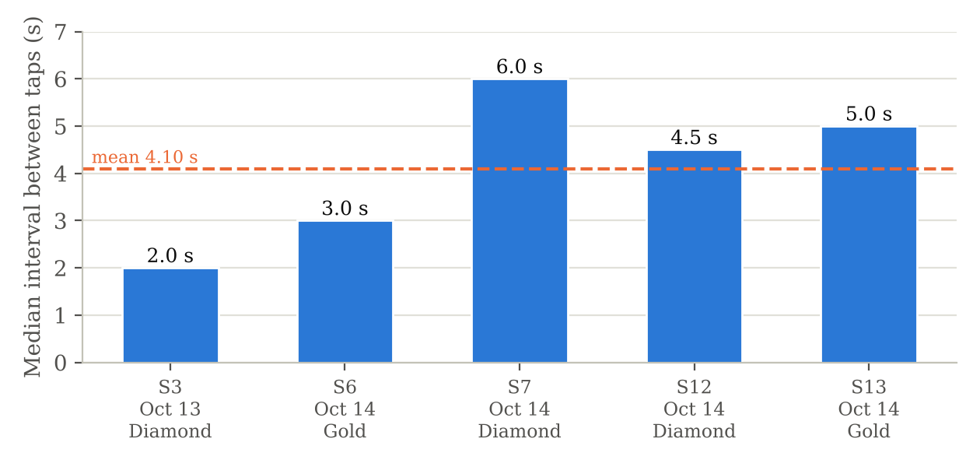

Figure 32
Time per Student of the Manual Roll Call and L-SIAMS
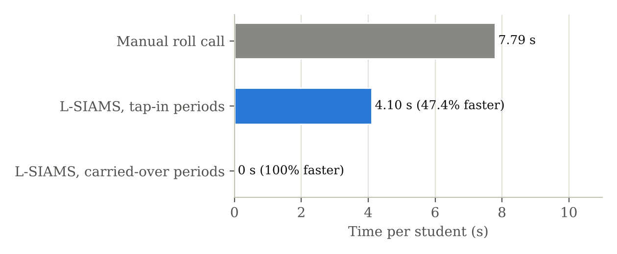

Results
Table 18 shows that in the five sessions where students queued at the terminal, classes of 14 to 25 students were recorded in 52 to 164 seconds, at a median of 2.0 to 6.0 seconds between taps (mean 4.10 s per student, SD 1.60). Sessions with fewer than 10 taps, and the two test sessions of October 13, were excluded because students arrived one at a time rather than in a queue.
Table 19 compares this with the manual roll call, which took 3 minutes and 46 seconds for 29 students of Grade 6 Gold (7.79 s per student) by stopwatch on October 13; the teachers estimated 3 to 5 minutes. Per student, the system was 47.4% faster. In the following periods, students who stayed in the room were carried over, so neither tapping nor a roll call was needed (100% faster). On October 14 the researchers observed lines of 20–30 students forming at each classroom door instead of at the school gate.

Analysis and Interpretation
The terminal records a class at about 15 students per minute. The time per student reflects the students’ own pace in the queue, because each tap carries the time it was made on the terminal.

Discussion and Implication
Students also rated tapping faster than the roll call (Q1, 4.45) but rated waiting in line lower (Q2, 3.65), which suggests that one terminal per room still produces a short queue. Because the manual roll call was timed for one class only, the comparison is descriptive and no paired t-test was performed.

Research Question/Objective 2
Research Question:
Objective 4.2 – Comparing system-recorded attendance with manual classroom attendance to assess accuracy
Table/Figure
Table/Figure No.: Table 20; Figure 33

Title: Accuracy of System-Recorded Attendance
Table 20
Attendance Records and Accuracy (19 Class Sessions)
Measure | Count | Percentage
Students who tapped in | 117 | 20.82%
Carried over from the previous period | 303 | 53.91%
Absent (no tap) | 142 | 25.27%
Total records | 562 | 100.00%
Records matching the manual roll call | 562 | 100.00%
Students recorded twice in one session | 0 | 0.00%

Figure 33
Attendance Records by Type
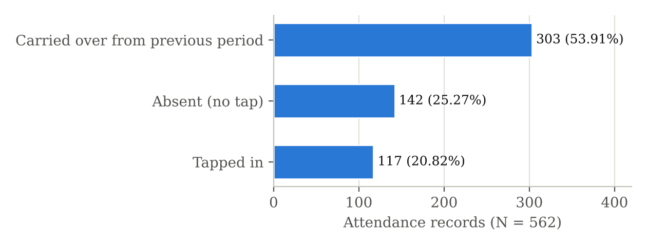

Results
Table 20 shows that all 562 attendance records in the 19 class sessions of October 13–14 – 117 students who tapped in, 303 carried over from the previous period and 142 absent – matched the teachers’ manual roll call, for an accuracy of 100%. No student was recorded twice; five repeat taps were ignored. Every present student received a time-out: 12 tapped out, 1 was released early by the teacher and 407 were closed automatically at the end of the session.

Analysis and Interpretation
The system recorded attendance as accurately as the manual method, exceeding the 95% criterion, and created no duplicate or incomplete records.

Discussion and Implication
Students rarely tapped out (12 of 420), so departure was recorded mainly by automatic closing. Tap-out should be explained to students, or treated as optional in the procedure.

Research Question/Objective 3
Research Question:
Objective 5 – Conducting penetration testing to validate the effectiveness of the implemented security controls
Table/Figure
Table/Figure No.: Tables 15–17; Figure 30; security:privileges screenshot

Title: Penetration Testing Results, Security Events Logged and Database History Protection
Table 15
Penetration Testing Results
Threat | Tool | Result | Status
Unauthorized access | Hydra (Kali Linux) | Sign-in blocked after the lockout threshold; no attempt succeeded | Pass
Packet interception | Wireshark | Only TLS-encrypted traffic; no readable sensitive data | Pass
Open port exposure | Nmap (Kali Linux) | Only the HTTPS and real-time ports open; database port not reachable | Pass
Device spoofing | Crafted HTTP requests | Unregistered and unsigned requests rejected and logged | Pass
Data modification | security:privileges | Deleting or rewriting stored history refused; every guard held | Pass
Log monitoring | Audit and security logs | Every test action recorded with type, severity and source | Pass
Note. Penetration tests performed on September 26 and October 15, 2026.
Table 16
Security Events Recorded During Attendance Recording (October 13–14, 2026)
Event | Severity | Count
TIMESTAMP_EXPIRED (replay rejected) | Medium | 27
LOGIN_FAILED | Medium | 19
BIOMETRIC_OVERRIDE_USED (password failover) | Medium | 9
CLAIM_TOKEN_INVALID | High | 4
SESSION_HIJACK_SUSPECTED | High | 2
FINGERPRINT_FAILURE_THRESHOLD | High / Medium | 1 / 1

Table 17
Teacher Identity Verification
Measure | Result
Class sessions opened | 19 (10 by fingerprint, 9 by password failover)
Fingerprint sign-ins by enrolled teachers | 18 of 18 verified (100%)
Scans matching no active enrolment | 6, all refused
Verified teachers refused (class not theirs) | 10

Figure 30
Security Events Recorded During Deployment
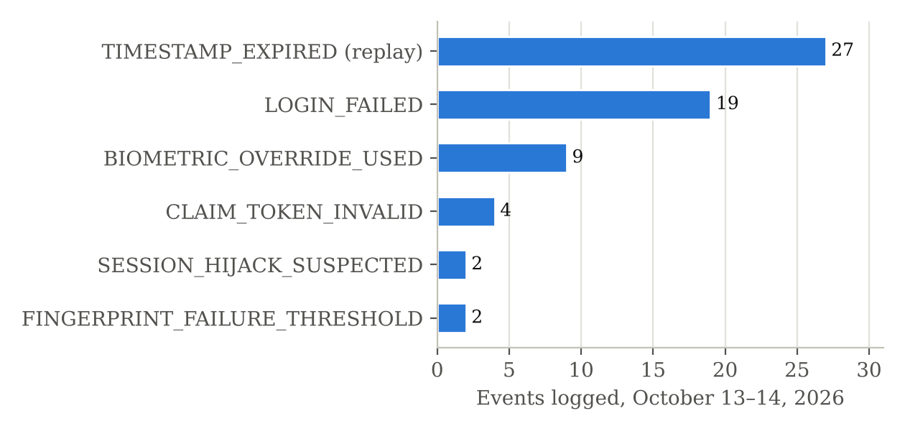

Database History-Protection Check (security:privileges)
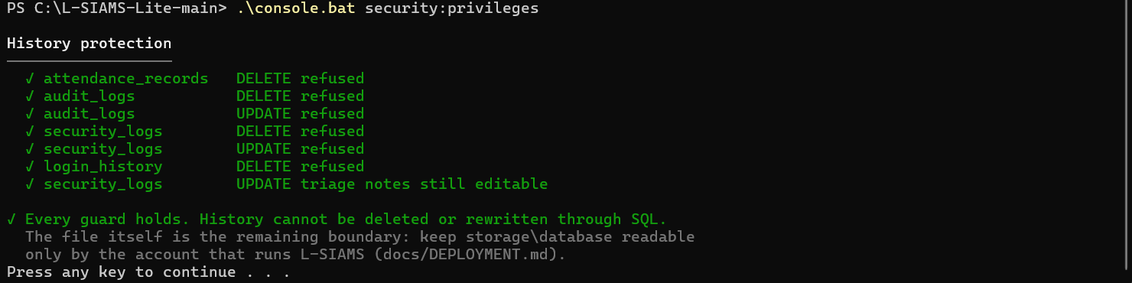
Note. Screenshot of the check run on the L-SIAMS-Lite server.

Results
Captured traffic between the terminals and the server contained only TLS ciphertext. Only the HTTPS and real-time ports were open. Brute-force login attempts were stopped by account lockout and rate limiting, and none succeeded. During deployment the system rejected and logged 4 forged device claims, 27 expired or replayed requests and 2 suspected session hijacks, and refused 10 attempts by verified teachers to open a class they were not scheduled to teach. All 18 fingerprint sign-ins by enrolled teachers were verified; 6 test scans with fingerprints not linked to an enrolment were refused. No High or Critical vulnerability was found.
The database history-protection check (security:privileges, run on the L-SIAMS-Lite server) refused every attempt to delete attendance records, audit logs, security logs and login history, and to rewrite audit and security logs, while leaving only the triage notes of security events editable. Stored history therefore cannot be deleted or rewritten through SQL; the remaining boundary is access to the database file itself.

Analysis and Interpretation
Each attack was stopped by a different control layer – encryption, lockout, port restriction, request signing, timestamp checks and database triggers – and every attempt was logged.

Discussion and Implication
Attendance data is protected against interception, unauthorized access and forged or replayed requests within the scenarios tested. Because testing was controlled, the results do not cover every real-world attack, as stated in the Scope and Limitations.

Research Question/Objective 4
Research Question:
Objective 4.3 – Evaluating system security against ISO/IEC 27001 guided by the CIA Triad
Table/Figure
Table/Figure No.: Tables 21–23; Figure 34

Title: Security Evaluation by CIA Dimension and Part D Control Compliance
Table 22
Security Evaluation by CIA Dimension
Dimension | Respondents | Items | Mean | SD | Cronbach’s α | Interpretation
Confidentiality (Form 1, Part A) | 13 staff | 9 | 4.62 | 0.68 | 0.91 | Very High
Integrity (Form 1, Part B) | 13 staff | 9 | 4.67 | 0.63 | 0.92 | Very High
Availability (Form 1, Part C) | 13 staff | 9 | 4.56 | 0.65 | 0.85 | Very High
Staff security grand mean | 13 staff | 27 | 4.61 | 0.65 | 0.96 | Very High
Keeping attendance safe (Form 2, Part A) | 51 students | 6 | 4.25 | 0.92 | 0.62 | Very High

Table 23
Part D Technical Control Checklist
Measure | IT administrator 1 | IT administrator 2
Points earned (of 30) | 30 | 30
Compliance | 100% | 100%
Controls restating Table 8 criteria rated Yes | 6 of 6 | 6 of 6

Figure 34
Security Evaluation by CIA Dimension
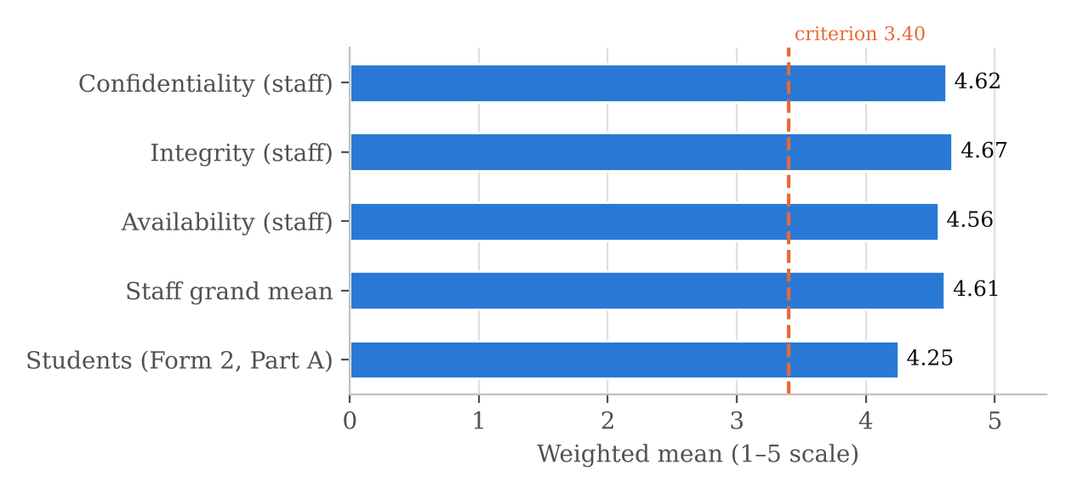

Results
Staff rated Confidentiality 4.62, Integrity 4.67 and Availability 4.56 (grand mean 4.61, Very High); students rated their part 4.25 (Very High). Both IT administrators rated all 15 controls Yes (100% compliance), including the six that restate the Table 8 criteria. Cronbach’s α was 0.85–0.92 for the staff dimensions and 0.62 for the student part.

Analysis and Interpretation
All results exceed the 3.40 criterion. Integrity ranked highest; the lowest items concern features users rarely trigger, such as lockout (A5) and duplicate taps (B2, S3).

Discussion and Implication
The implemented controls are judged effective on all three CIA dimensions, and the judgement agrees with the test results in Section 5.4. Making the protections visible to users is recommended. The student results should be read with caution because of their lower internal consistency.

Research Question/Objective 5
Research Question:
Objective 4.3 – Assessing system usability, performance and reliability using measurable indicators
Table/Figure
Table/Figure No.: Table 24; Figure 35

Title: User Acceptance Test Results, Response Time and Offline Synchronization
Table 24
User Acceptance Test Results
Criterion | Ratings | Mean | Interpretation | Rank
Ease of use | 13 | 5.00 | Very High | 1
User interface | 13 | 4.92 | Very High | 2
Accuracy | 13 | 4.85 | Very High | 3.5
Responsiveness | 13 | 4.85 | Very High | 3.5
Overall satisfaction | 12* | 4.83 | Very High | 5
Support for organizational requirements | 13 | 4.69 | Very High | 6
Grand mean | 77 | 4.86 | Very High
Note. *One form left this item blank; the blank was not imputed. UAT Form 4, 13 staff, October 13–14, 2026.
Table 24a
Performance and Reliability Indicators
Indicator | Result | Criterion | Status
Response time (system logs) | 11.7 ms | < 2 s | Met
Offline synchronization (router unplugged, Terminal 1, Grade 6 Diamond, Oct 11) | 5 of 5 taps synchronized; no loss or duplicate (100%) | ≥ 95% | Met
Completeness of session records | 562 of 562 records with a final status | Complete records | Met

Figure 35
User Acceptance Test Results
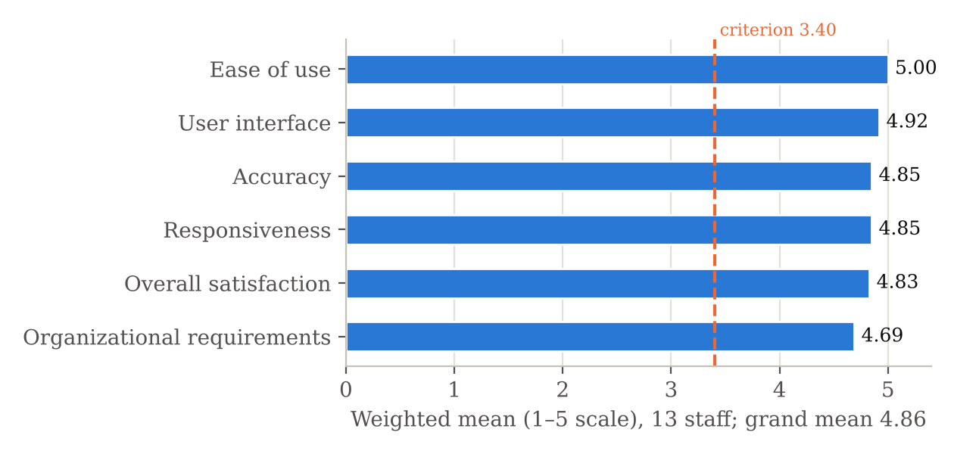

Results
The 13 staff rated all six UAT criteria Very High on October 13–14, with a grand mean of 4.86 from 77 ratings (one form left overall satisfaction blank): ease of use 5.00, user interface 4.92, accuracy 4.85, responsiveness 4.85, overall satisfaction 4.83 and support for organizational requirements 4.69. No rating fell below Agree. The measured response time was 11.7 ms, within the 2-second criterion. In the offline test on October 11, the router was unplugged and 5 cards were tapped on Terminal 1 (Grade 6 Diamond); all 5 taps were held on the terminal and synchronized when the network returned, with no loss or duplicate (100%, criterion ≥ 95%).

Analysis and Interpretation
Acceptance was consistent across respondents; the lowest criterion, support for organizational requirements, was still Very High. Performance and reliability met their criteria.

Discussion and Implication
The system was accepted by its users. Teachers asked for a beep confirming a recognized fingerprint and for a quick user guide for faculty, which are carried into the recommendations.

Overall Chapter IV Findings
L-SIAMS met every criterion in Table 8. All simulated attacks were blocked and logged with no High or Critical vulnerability, and stored history cannot be deleted or rewritten; the security controls were rated Very High by staff (4.61) and students (4.25) and fully in place according to both IT administrators; all enrolled-teacher fingerprint sign-ins were verified; no attendance was recorded twice; classes in the queue were recorded in under 3 minutes; the response time was 11.7 ms; all 5 offline taps were synchronized; and the UAT grand mean was 4.86. Attendance was recorded 47.4% faster per student than the manual roll call (100% in carried-over periods), and all 562 records matched the manual record (100%).

Prepared by:
Group Leader: Ched Nikko P. Pangilinan

Signature: _____________________________________
Date: October __, 2026

Reviewed by:
Capstone Adviser: Dr. Romero Dante C. Salum

Signature: _____________________________________
Date: October __, 2026
ACTIVITY 9 – Chapter IV Self-Evaluation

FORM 9
Chapter IV Quality Assurance Checklist

Criterion | Yes | No | For Revision
All research questions are addressed | ☑ | ☐ | ☐
Results are based on actual collected data | ☑ | ☐ | ☐
Statistical values are accurate | ☑ | ☐ | ☐
Tables are correctly numbered | ☑ | ☐ | ☐
Figures are correctly numbered | ☑ | ☐ | ☐
Tables/figures have appropriate titles | ☑ | ☐ | ☐
Results are objectively described | ☑ | ☐ | ☐
Interpretation is supported by data | ☑ | ☐ | ☐
Discussion relates to research objectives | ☑ | ☐ | ☐
Claims are supported by evidence | ☑ | ☐ | ☐
No fabricated or manipulated data | ☑ | ☐ | ☐
Chapter IV follows required manuscript format | ☑ | ☐ | ☐
References/citations are properly documented where required | ☑ | ☐ | ☐
Chapter IV is internally consistent with Chapters I–III | ☐ | ☐ | ☒

Group Self-Assessment
Overall status:
☐ Ready for adviser review
☒ Requires minor revision
☐ Requires major revision

Prepared by:
Group Leader: Ched Nikko P. Pangilinan

Signature: _____________________________________
Date: October __, 2026
ACTIVITY 10 – Adviser Review and Revision Record

FORM 10
Chapter IV Adviser Review Form
Project Title: L-SIAMS: A Local IoT-Based Multi-Layer Secured Attendance Monitoring System with RFID and Biometric Authentication
Group: Team ZIP
Date Reviewed: October __, 2026

Areas Reviewed
Area | Satisfactory | Needs Revision | Major Revision
Research question alignment | ☐ | ☐ | ☐
Statistical results | ☐ | ☐ | ☐
Tables and figures | ☐ | ☐ | ☐
Results presentation | ☐ | ☐ | ☐
Analysis | ☐ | ☐ | ☐
Interpretation | ☐ | ☐ | ☐
Discussion | ☐ | ☐ | ☐
Findings | ☐ | ☐ | ☐
Chapter organization | ☐ | ☐ | ☐
Consistency with Chapters I–III | ☐ | ☐ | ☐
 | ☐ | ☐ | ☐
Adviser Comments/Recommendations

Required Revisions

Revision Deadline
Date: __________________________

Adviser Decision
☐ Proceed to Chapter V preparation
☐ Revise and resubmit
☐ Further analysis required
☐ Further consultation required

Adviser Signature
Capstone Adviser: Dr. Romero Dante C. Salum

Signature: _____________________________________
Date: October __, 2026
ACTIVITY 11 – Revision Monitoring

FORM 11
Chapter IV Revision Tracking Form

No. | Adviser Comment/Required Revision | Action Taken | Revised By | Date | Adviser Verification
1 |  |  |  |  | ☐
2 |  |  |  |  | ☐
3 |  |  |  |  | ☐
4 |  |  |  |  | ☐
5 |  |  |  |  | ☐
6 |  |  |  |  | ☐

Student Certification
We certify that the revisions identified by the adviser have been addressed and incorporated into the revised Chapter IV draft.
Group Leader: Ched Nikko P. Pangilinan

Signature: _____________________________________
Date: October __, 2026

Adviser Verification
I have reviewed the revisions indicated above.
Capstone Adviser: Dr. Romero Dante C. Salum

Signature: _____________________________________
Date: October __, 2026
Status:
☐ Revisions satisfactorily addressed
☐ Additional revisions required

Remarks:
ACTIVITY 12 – Chapter IV Submission Form

FORM 12
Chapter IV Laboratory Submission and Adviser Monitoring Form

Required Output | Submitted | Adviser Checked
Form 1 – Research Question–Result Mapping | ☑ | ☐
Form 2– Chapter IV Organization Plan | ☑ | ☐
Form 3– Table/Figure Quality Checklist | ☑ | ☐
Form 4– Results Presentation | ☑ | ☐
Form 5– Analysis and Interpretation | ☑ | ☐
Form 6– Results–Interpretation–Discussion Matrix | ☑ | ☐
Form 7– Findings Matrix | ☑ | ☐
Form 8– Initial Chapter IV Draft | ☑ | ☐
Form 9– Chapter IV Self-Evaluation | ☑ | ☐
Form 10– Adviser Review Form | ☑ | ☐
Form 11– Revision Tracking Form | ☑ | ☐
Statistical tables/figures | ☑ | ☐
Supporting computation file | ☑ | ☐

Overall Status
☐ Completed – Satisfactory
☐ Completed – With Minor Revisions
☐ For Revision
☐ Requires Further Statistical Analysis
☐ Requires Adviser Consultation

Final Adviser Remarks

Signatures
Prepared by:
Group Leader: Ched Nikko P. Pangilinan

Signature: _____________________________________
Date: October __, 2026

Reviewed/Monitored by:
Capstone Adviser: Dr. Romero Dante C. Salum

Signature: _____________________________________
Date: October __, 2026

