ReefSafe
Evidence-Bounded Reef Screening for Sustainable Tourism
Malaysia Data Innovation Talent x DOSM Datathon 2026
Submission report

Executive summary
ReefSafe converts repeated reef observations into a transparent queue for field verification. It predicts the next observed annualised coral-cover change and pairs the result with source confidence, an empirical uncertainty range, and evidence to verify. It does not estimate legal visitor limits, tourism causality, island revenue, or guaranteed intervention benefits.

Four objectives
Objective | What the project delivers
1. Identify Associated Factors | Lagged associations for heat, water-quality indicators, and documented local disturbances; no causal attribution.
2. Compare Available Stressor Evidence | Side-by-side descriptive evidence while stating that tourism's causal percentage is not estimable.
3. Prioritise Field Verification | A ranked monitoring queue with uncertainty and evidence-matched inspection steps.
4. Frame Conservation with Economic Context | The published DMPM RM8.7 billion annual benchmark, with its original scope and components.

Headline model result
Gradient boosting achieved forward-test MAE 5.86 percentage points per year versus 5.99 for the mean baseline, a 2.2% improvement. Overall R2 is 0.070. The small gain supports cautious ranking only, not automated enforcement.

1. Data and provenance
Evidence | Role | Admission status
Reef Check Malaysia annual reports | Ecological condition and documented impact mentions | Verified input to scored model
Coordinates and marine-park labels | Location and grouping | Verified input; Labuan recorded as W.P. Labuan
NOAA Coral Reef Watch virtual stations | Regional heat context and descriptive diagnostics | Eligibility pending; excluded from scored model
Marine-park visitors | Historical aggregate context | Verified only for cited 2000-2009 scope; excluded from model
DMPM Total Economic Value booklet | Historical economic context | Verified context for six evaluated archipelagos
Local accommodation inventory | None | Excluded: reproducible source trail not available
NOAA variables are excluded from the scored model because written DOSM eligibility confirmation is not on file. Regional DHW remains visible only as supporting context for field questions.

Data quality boundaries
- Processed panel: 404 monitoring-unit/year observations, 56 unit labels, 2012-2025.
- First observations without an earlier survey have no next-change training target.
- Narrative flags indicate a report mention; no mention is not proof of absence.
- State totals and visitor aggregates are not allocated to individual reefs.
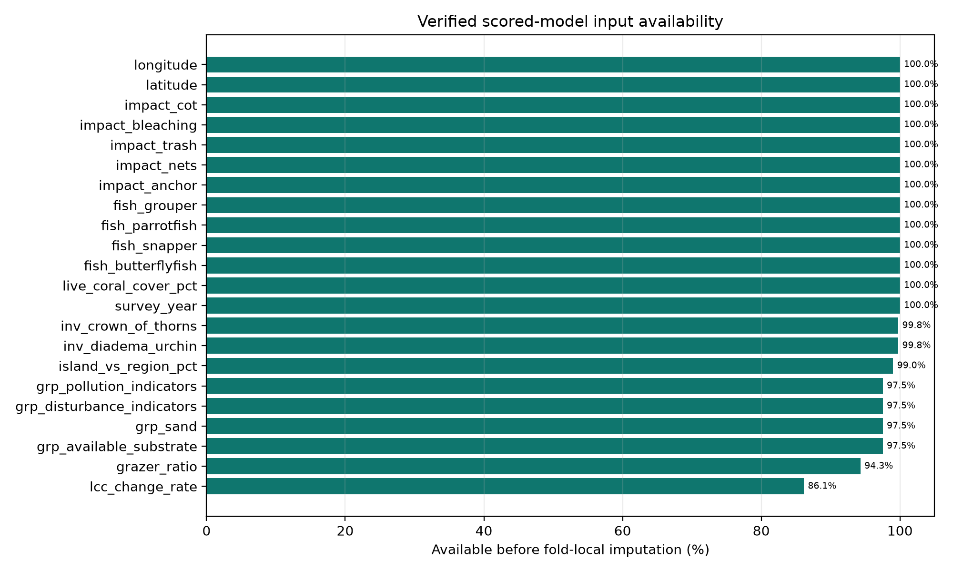
Figure 1. Availability of the verified features admitted to the scored model.

2. Observed trends and the tourism data gap
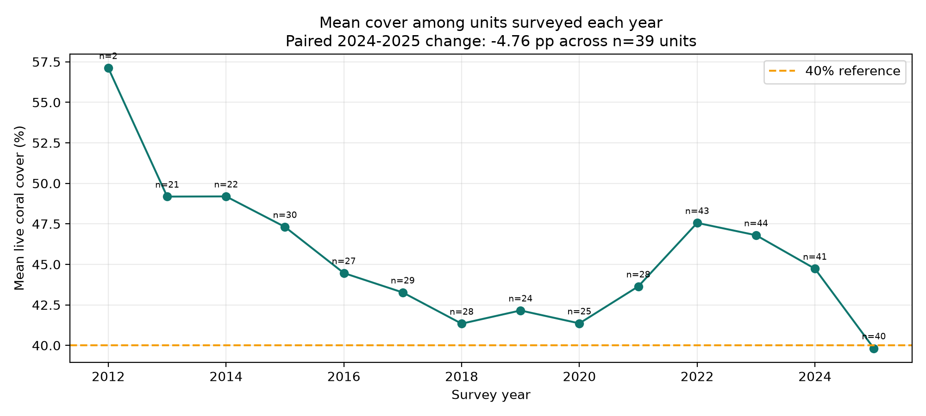
Figure 2. Unbalanced annual means with surveyed-unit counts and the paired 2024-2025 comparison.
The same 39 units averaged 44.98% live coral cover in 2024 and 40.22% in 2025, a change of -4.76 percentage points. This paired comparison is preferred to subtracting two changing annual samples.
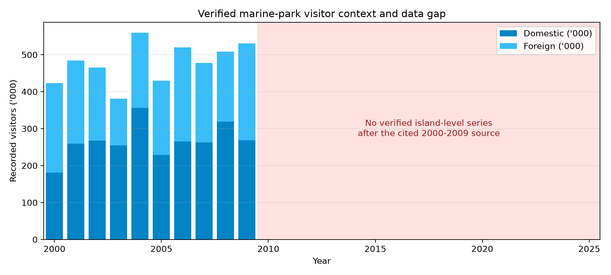
Figure 3. Verified 2000-2009 visitor context and the unresolved island-level exposure gap.
The available visitor totals cannot identify how many visitors, vessels, anchor drops, or wastewater loads reached a given monitoring unit. ReefSafe therefore does not estimate tourism's causal contribution to coral change.

3. Predictive method
For each monitoring unit, the pipeline orders surveys by year. Features at one observation predict the annualised live-coral-cover change at the next observation. Missing values are median-imputed inside each training fold. Evaluation uses expanding years: each target year is tested only with data from earlier target years.
Model | MAE | RMSE | R2
Baseline mean | 5.991 | 8.100 | -0.019
Ridge regression | 5.990 | 7.939 | 0.021
Gradient boosting | 5.859 | 7.739 | 0.070
Random forest | 6.074 | 8.017 | 0.002
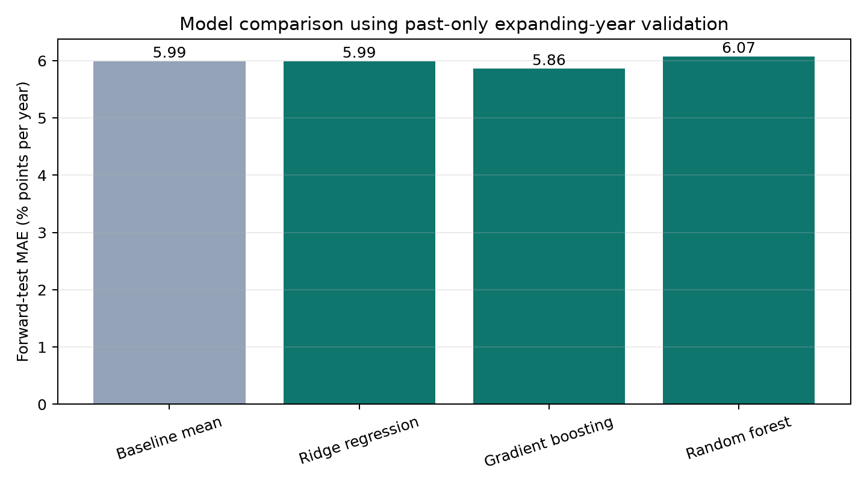
Figure 4. Past-only model comparison. Lower MAE is better.
XGBoost was not required to establish the result. Gradient boosting already provides the lowest measured forward-test MAE among the tested candidates; a more complex library would be justified only if it produced a material, repeatable improvement under the same validation.

4. Validation and uncertainty
Target year | n | MAE | RMSE | R2 | Bias
2021 | 24 | 5.70 | 7.58 | 0.11 | -2.40
2022 | 35 | 6.94 | 9.96 | 0.12 | -0.03
2023 | 43 | 5.76 | 7.24 | 0.18 | +0.87
2024 | 41 | 5.60 | 7.06 | -0.29 | +2.26
2025 | 40 | 5.38 | 6.74 | -0.65 | +4.45
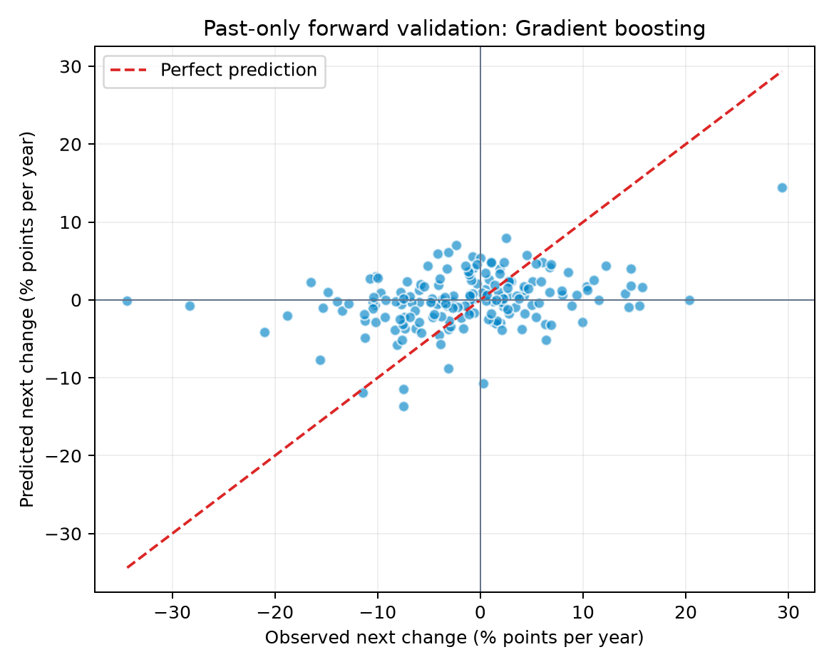
Figure 5. Held-forward observations and selected-model predictions.
Performance is unstable by year. In particular, negative R2 in 2024 and 2025 means the model did not explain those years better than their year-specific means. Predictions shrink towards the centre and miss extremes. The displayed bounds use pooled 2.5th and 97.5th percentiles of held-forward residuals; they are empirical screening ranges, not formal confidence intervals.

5. Associated factors
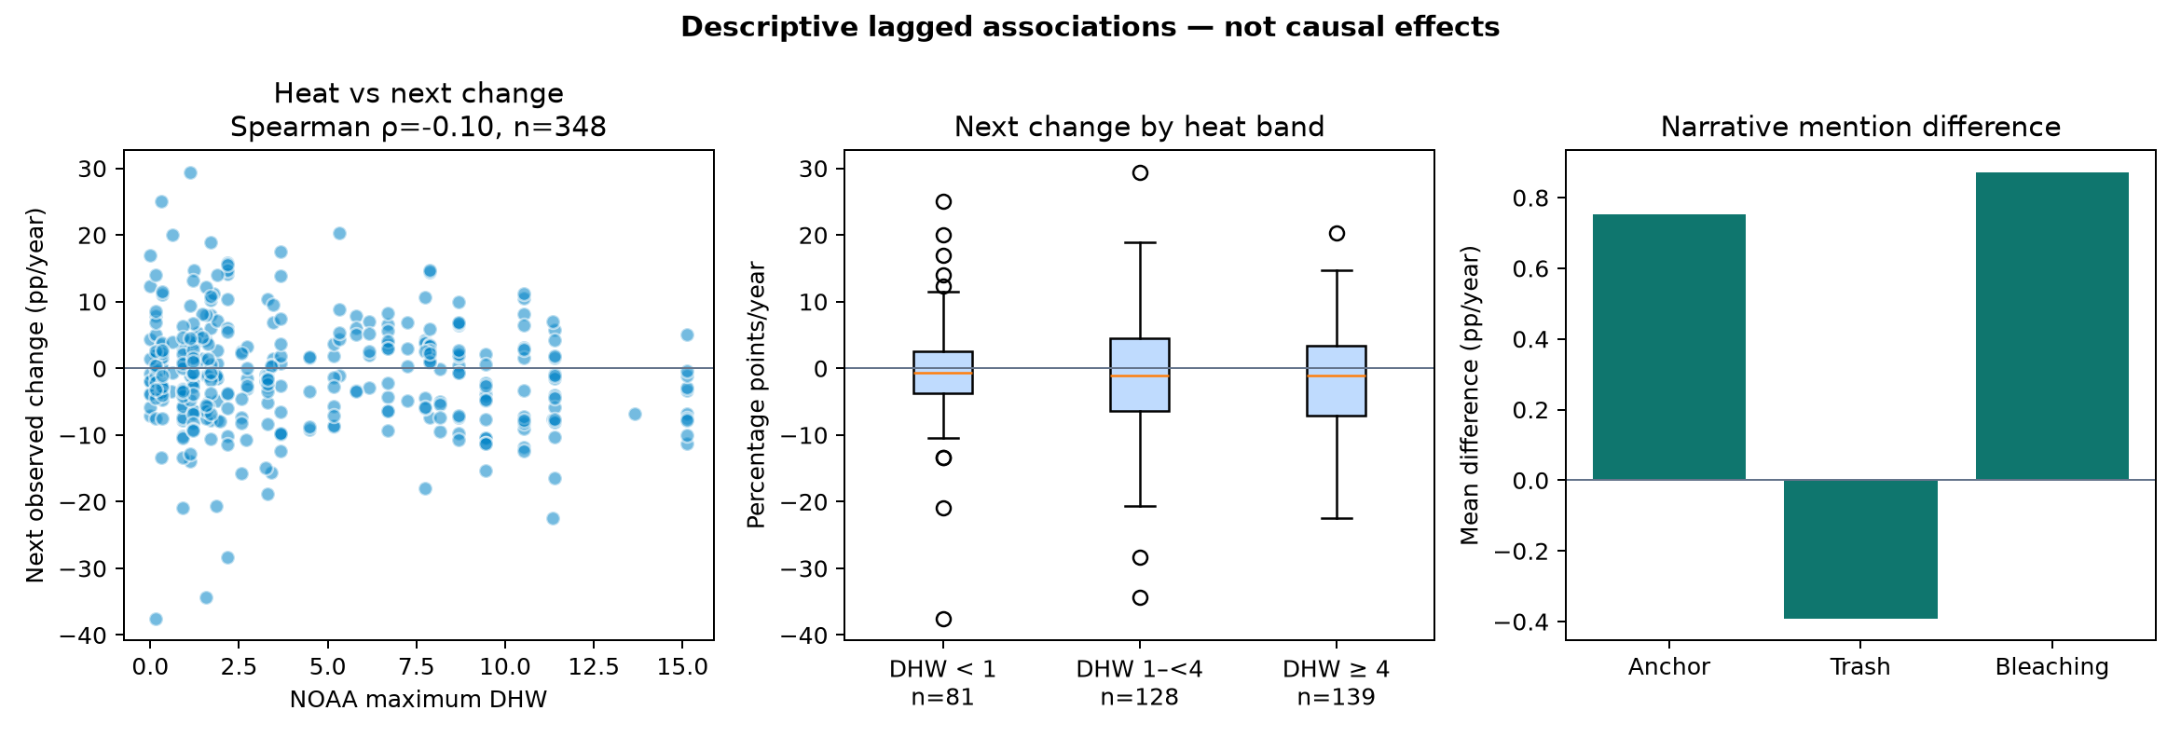
Figure 6. Lagged descriptive relationships for regional heat and report-mention indicators.
Regional maximum DHW has a weak negative Spearman association with the next observed change (rho -0.10, p=0.051, n=348). This supports a field-verification question, not a causal claim. Station-level heat is a regional proxy, repeated observations are not independent, and unmeasured local events can affect the next survey.
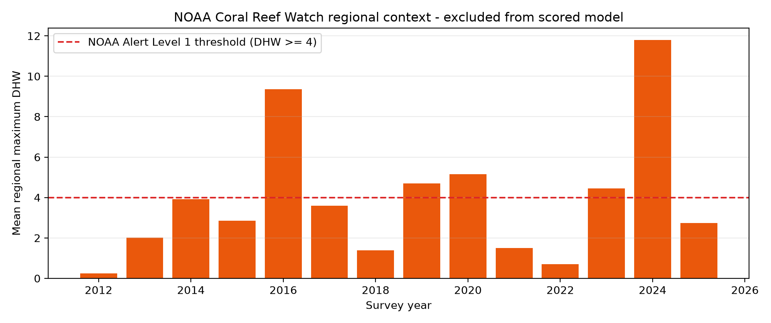
Figure 7. NOAA regional thermal context, explicitly outside the scored model.

Interpretation rule
Correlation is useful here only to show whether a proposed factor has a measured relationship worth investigating. It is not a prerequisite that proves causation, and it does not justify converting coefficients or feature importance into percentages of reef loss.

6. Economic context
The Department of Marine Park Malaysia booklet Total Economic Value of Marine Biodiversity: Malaysia Marine Parks reports a rounded annual Total Economic Value of RM8.7 billion from studies conducted during 2011-2015 for six evaluated archipelagos: Pulau Payar, Pulau Perhentian, Pulau Redang, Pulau Tioman, Pulau Tinggi, and Pulau Labuan.
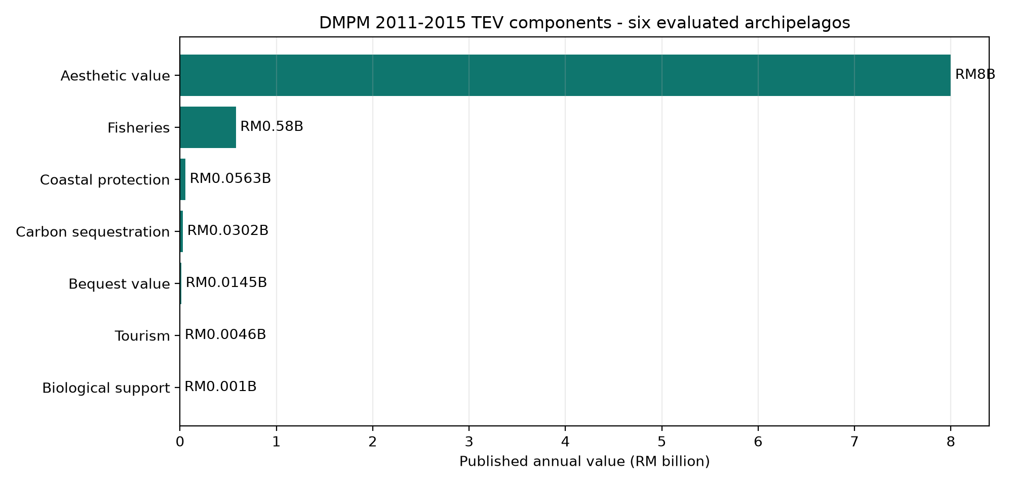
Figure 8. Source-transcribed DMPM component values. The calculated sum is RM8.68699 billion before headline rounding.
Component | Annual value | Source page
Aesthetic value | RM8,000.00 million | 9
Fisheries | RM580.40 million | 6
Coastal protection | RM56.25 million | 11
Carbon sequestration | RM30.24 million | 12
Bequest value | RM14.50 million | 13
Tourism | RM4.60 million | 7
Biological support | RM1.00 million | 10
This benchmark is historical context. It is not a current national reef total, ReefSafe revenue estimate, island allocation, avoided loss, or net present value.

7. Field-verification output
The final model scores the latest observation for each of 40 units. The top quartile is labelled High screening priority as a practical workload queue. Rank does not create a scientific threshold or regulatory instruction.
Rank | Unit | State | Estimate (pp/yr) | Empirical range | Next check
1 | Labuan | W.P. Labuan | -14.42 | -30.7 to -0.8 | Coordinate bleaching survey; do not attribute thermal loss to visitors
2 | Kapas | Terengganu | -5.75 | -22.0 to +7.9 | Prioritise field validation before imposing restrictions
3 | Seri Buat | Pahang | -5.15 | -21.4 to +8.5 | Inspect mooring availability and anchoring controls
4 | Mertang | Johor | -5.03 | -21.3 to +8.6 | Inspect mooring availability and anchoring controls
5 | Mensirip | Johor | -4.85 | -21.1 to +8.8 | Inspect waste and wastewater controls
6 | Tenggol | Terengganu | -4.64 | -20.9 to +9.0 | Inspect waste and wastewater controls
7 | Tinggi | Johor | -4.63 | -20.9 to +9.0 | Inspect mooring availability and anchoring controls
8 | Lima | Johor | -4.37 | -20.6 to +9.3 | Inspect mooring availability and anchoring controls
9 | Sibu | Johor | -4.34 | -20.6 to +9.3 | Inspect mooring availability and anchoring controls
10 | Lankayan | Sabah | -4.07 | -20.3 to +9.6 | Coordinate bleaching survey; do not attribute thermal loss to visitors

Operating cycle
Step | Owner | Action
1. Refresh | Analyst | Run preprocessing, model, notebook, and dashboard builders.
2. Review | Reef scientist | Check confidence, uncertainty, and source evidence.
3. Verify | Field team | Inspect the monitoring unit before any policy decision.
4. Record | Programme lead | Log findings and correct the evidence register.

8. Assumptions, conclusion, and references

Assumptions
- An island label is sufficiently comparable across survey years; site-composition changes remain possible.
- Annualised change summarises the interval between surveys; intermediate events are unobserved.
- Earlier patterns have limited relevance to later years; forward validation measures this assumption imperfectly.
- The top quartile is a workload queue, and all recommendations require field verification.
- DMPM's RM8.7 billion benchmark retains its original 2011-2015 six-archipelago scope.

Conclusion
ReefSafe's professional strength is restraint. The project presents what was observed, what the selected model estimates, how weak and uncertain that estimate is, which evidence should be checked next, and which tempting claims the available data cannot support.

References
- Reef Check Malaysia. Annual Survey Reports. https://reefcheck.org.my/annualsurveyreports/
- NOAA Coral Reef Watch. 5 km Virtual Stations. https://coralreefwatch.noaa.gov/product/vs/data.php
- Jabatan Taman Laut Malaysia / data.gov.my. Jumlah Pelawat Taman Laut Malaysia, 2000-2009. https://archive.data.gov.my/data/ms_MY/dataset/jumlah-pelawat-taman-laut-malaysia-dari-tahun-2000-hingga-2009-
- Department of Marine Park Malaysia. Total Economic Value of Marine Biodiversity: Malaysia Marine Parks. Studies 2011-2015. Archived PDF: https://wdpa.s3.amazonaws.com/Country_informations/MYS/TOTAL%20ECONOMIC%20VALUE%20OF%20MARINE%20BIODIVERSITY.pdf
- Burke, L., Reytar, K., and Spalding, M. (2012). Reefs at Risk Revisited in the Coral Triangle. World Resources Institute. ISBN 978-1-56973-791-0. Used for regional context, not the RM8.7 billion benchmark.
- Department of Statistics Malaysia. OpenDOSM data catalogue. https://open.dosm.gov.my/data-catalogue
Reproducible artifacts: notebooks/01_reproducible_pipeline.ipynb; data/provenance_manifest.csv; docs/assumptions.md; output/model_evaluation_metrics.json.

