Computer Vision Hw10 Report
R07921010 余奇安
1.Laplace mask1
[ [0,1,0],
[1,-4,1],
[0,1,0] ]

threshold at 15
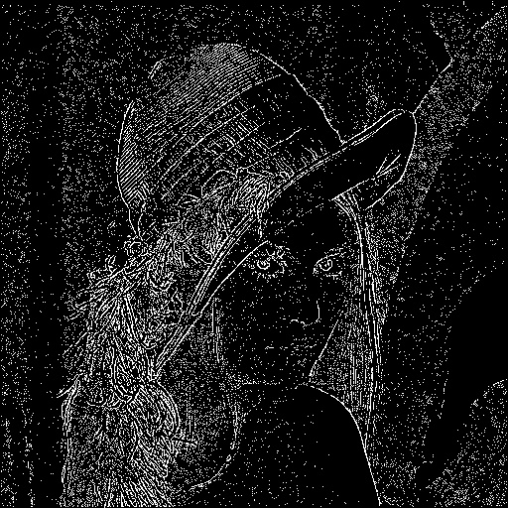

threshold at 18
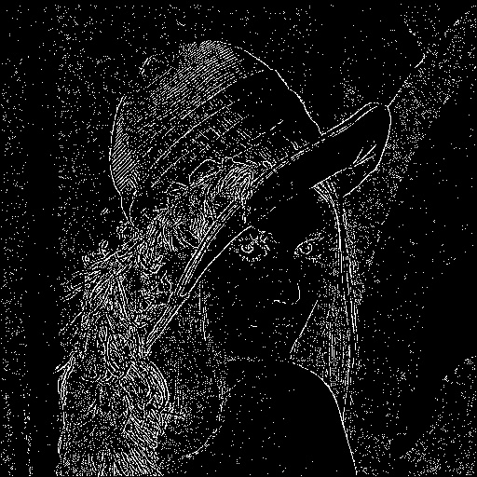

threshold at 20

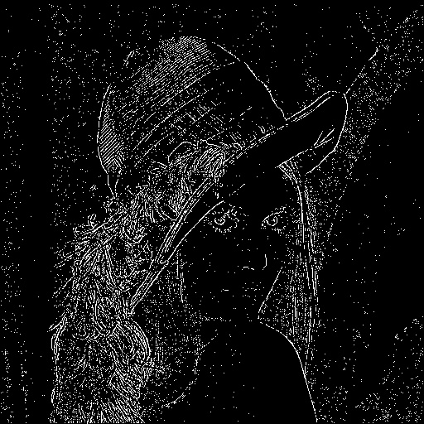

2.Laplace mask 2
mask=[[1.0/3,1.0/3,1.0/3],[1.0/3,-8.0/3,1.0/3],[1.0/3,1.0/3,1.0/3]]
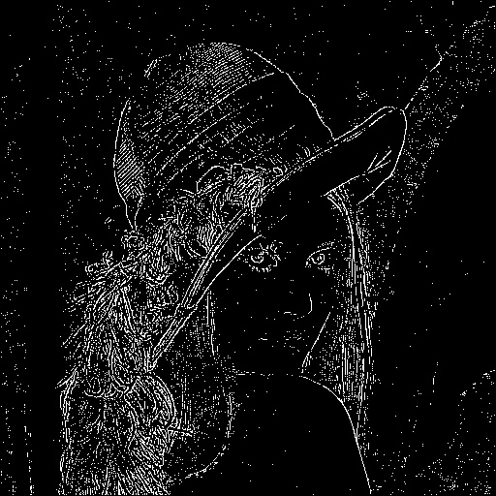
threshold at 15

threshold at 18
good for noise removed and clear contour
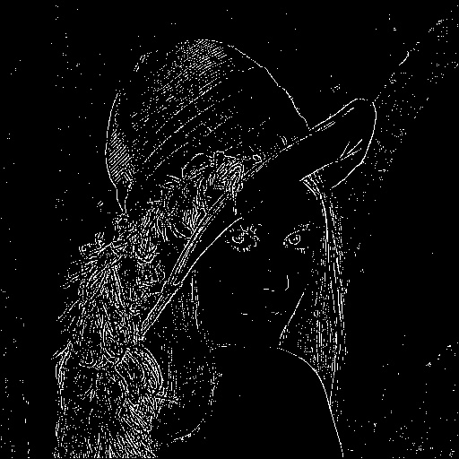

3.mini variance
mask=[[2.0/3,-1.0/3,2.0/3],[-1.0/3,-4.0/3,-1.0/3],[2.0/3,-1.0/3,2.0/3]]
threshold at 12
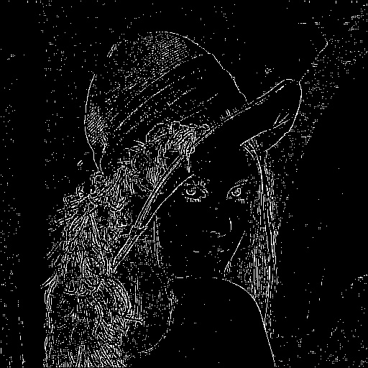

threshold at 15
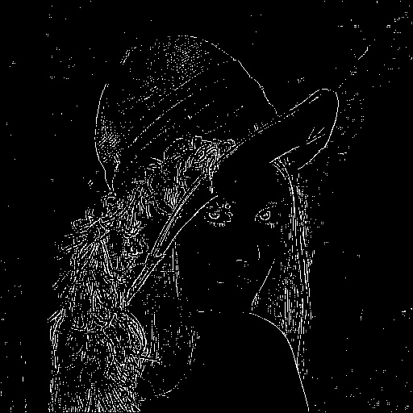

threshold at 20

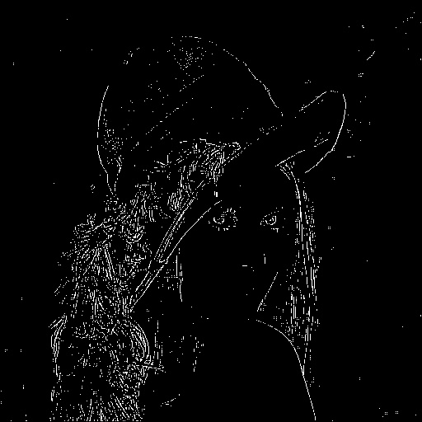

4. Laplace of Gaussion
mask=[[0,0,0,-1,-1,-2,-1,-1,0,0,0],
[0,0,-2,-4,-8,-9,-8,-4,-2,0,0],
[0,-2,-7,-15,-22,-23,-22,-15,-7,-2,0],
[-1,-4,-15,-24,-14,-1,-14,-24,-15,-4,-1],
[-1,-8,-22,-14,52,103,52,-14,-22,-8,-1],
[-2,-9,-23,-1,103,178,103,-1,-23,-9,-2],
[-1,-8,-22,-14,52,103,52,-14,-22,-8,-1],
[-1,-4,-15,-24,-14,-1,-14,-24,-15,-4,-1],
[0,-2,-7,-15,-22,-23,-22,-15,-7,-2,0],
[0,0,-2,-4,-8,-9,-8,-4,-2,0,0],
[0,0,0,-1,-1,-2,-1,-1,0,0,0]]

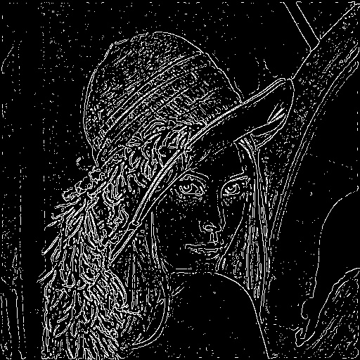
threshold at 1200

threshold at 1300
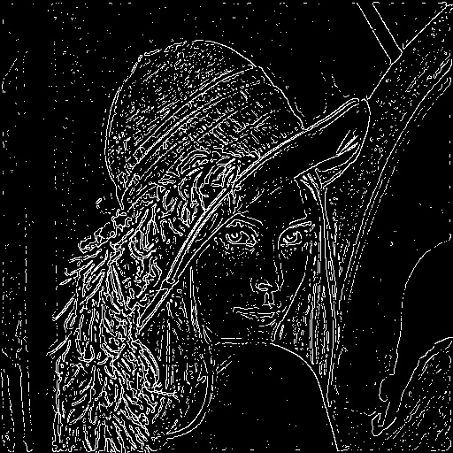

5. Difference Gaussian
I generate difference Gaussian mask by G(0,1)-G(0,3) in 11*11 mask
code:
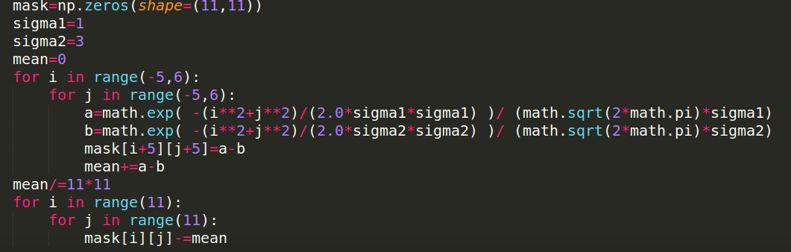

threshold at 1
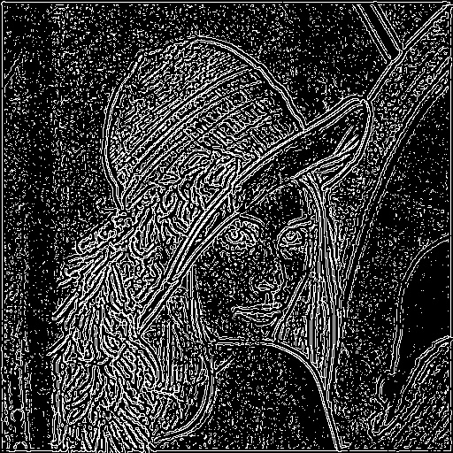

threshold at 2
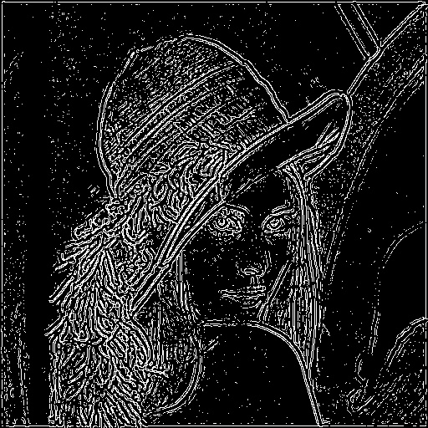

threshold at 3
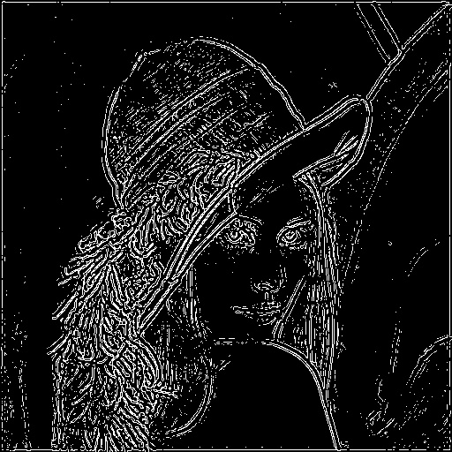

threshold at 4
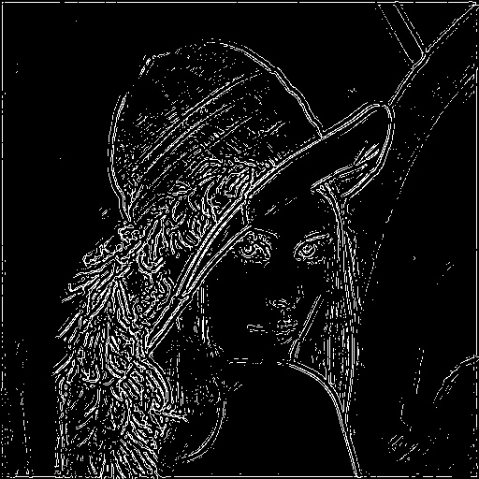

code:
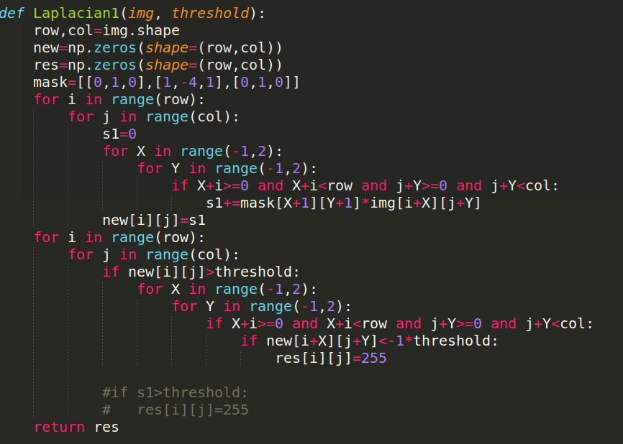

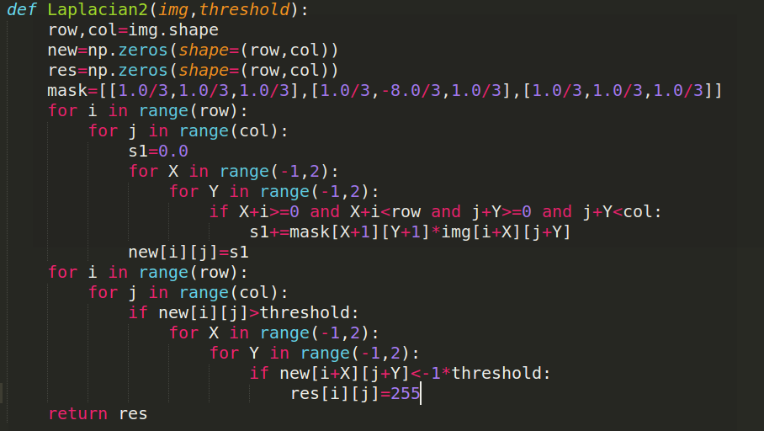

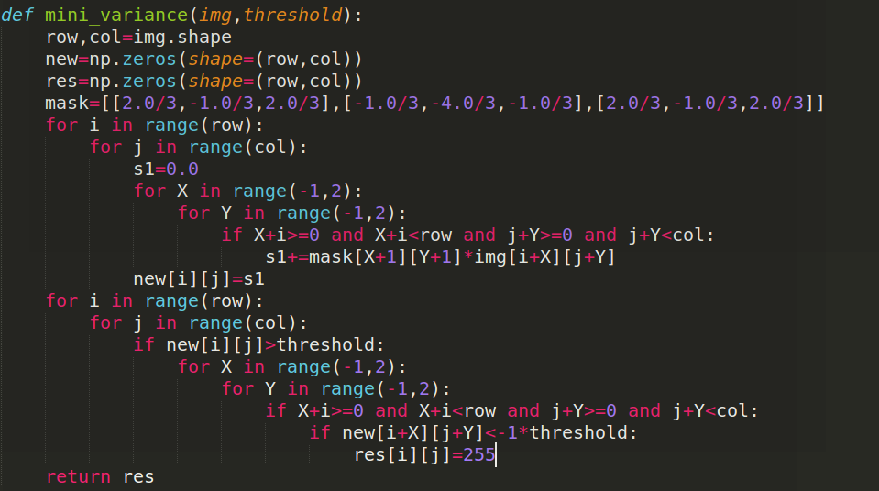

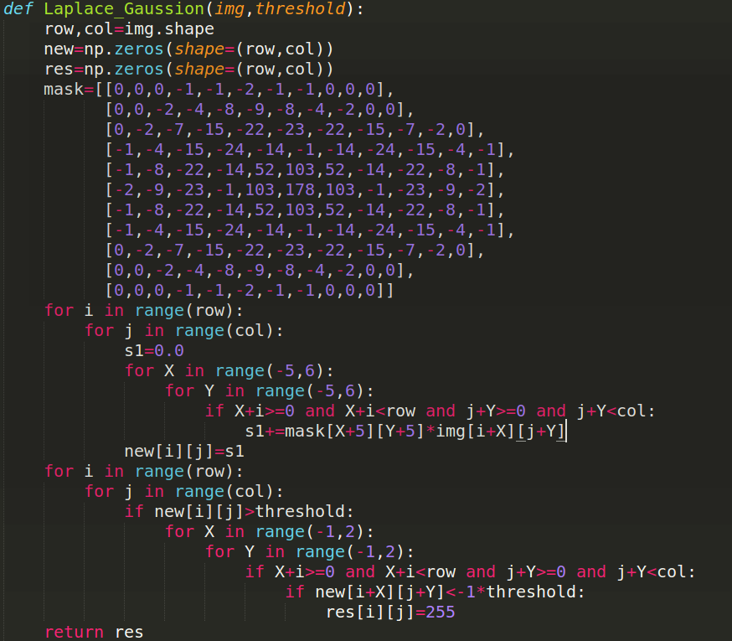

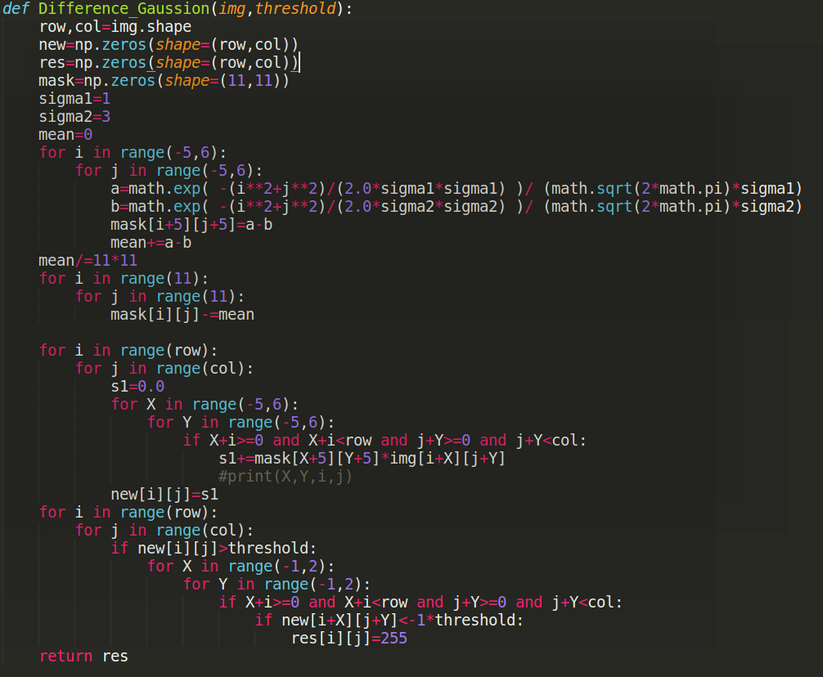
Discussion:
we can find that the bigger kernel has function not only on finding contour but also remove the noise. However, it’s also need more time to process the image.
I regard Laplace of Gaussian as the best performance.
I think this is because zero crossing check more constrains such as whether it’s neighbor is less than threshold, which increases the correctness of finding contour.
Besides, Gaussian distribution also a good model to describe the image pixels distribution.

