Computer Vision HW3
R07921010 余奇安

1.Histogram Equalization
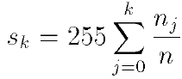

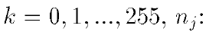
number of pixels with intensity j

n : total number of pixel

If pixel I(im,i,j)=k, after transform I(im, i,j)=S_{k}

Main code:
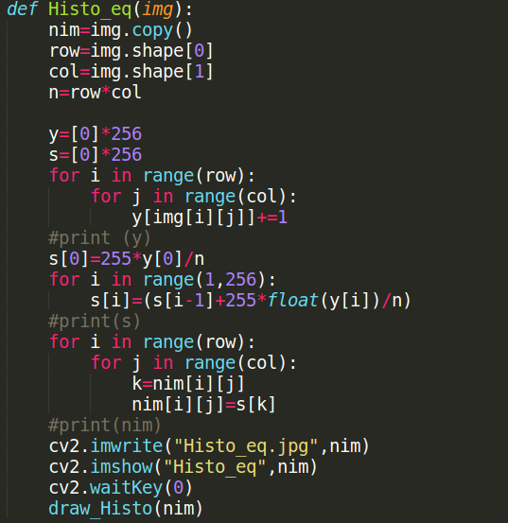

List y to calculate the numbers of pixel with intensity y[k],(k=0~255)
List s store the value after transform.

Original figure | Linear histogram equalization
 | 
Original histogram | Linear histogram equalization histogram
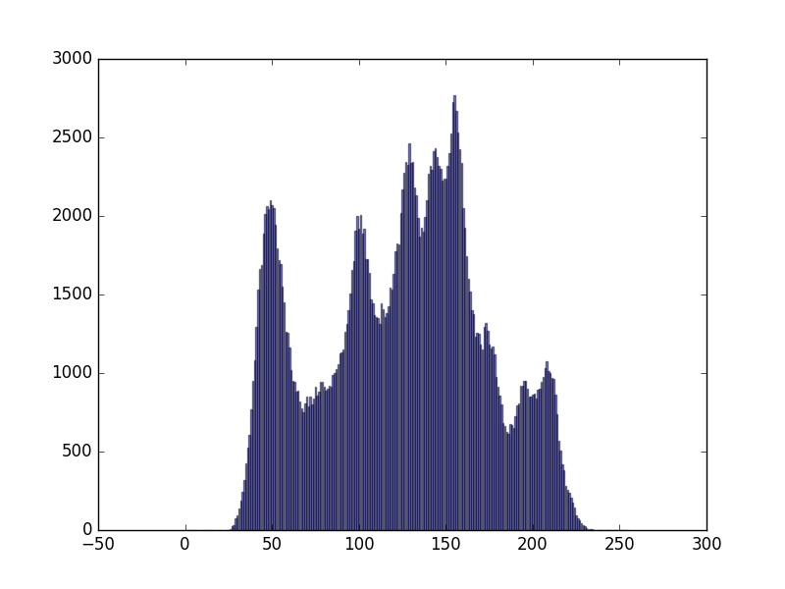 | 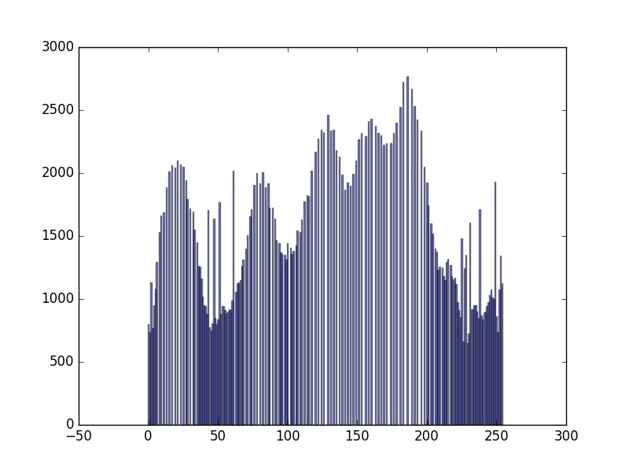

We can find that after histogram equalization, the contrast of image becomes more distinct, and the range of histogram becomes wider.

