Computer Vision Hw4
r07921010 余奇安
1.Binary morphological dilation
We choose 35553 as dilation kernel, and the input image is Lena.jpg thresholded at 128.
Binary image which is threshold at 128:


Dilation image:


We can find that the boundary of objects dilate after dilation, lots of black points disappear.
Code:
I define dil_kernel and dilation function to achieve the function.
The dil_kernal extend the flexibility or code so that I can change to different kind of kernals easily.
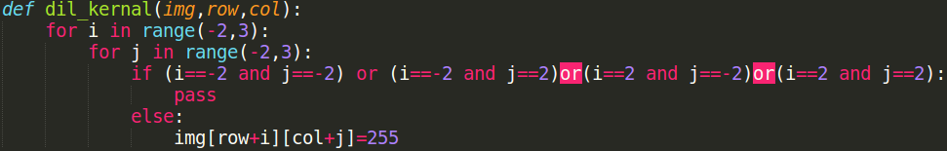
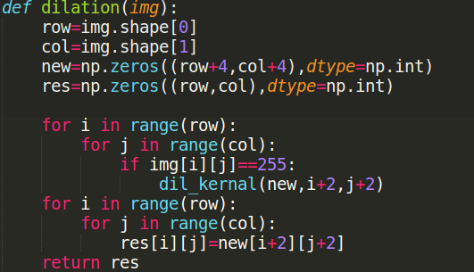

2.Erosion
Use 35553 kernel the same as dilation.
Erosion image:
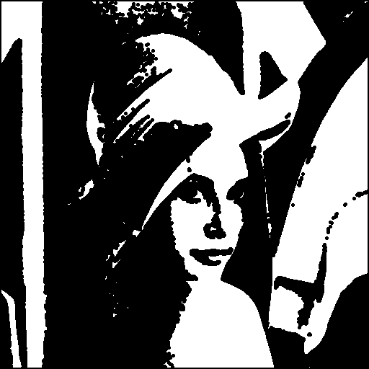

We can find that the boundary of objects contract after erosion.
Code:
I define ero_kernel and erosion function.
The reason to define ero_kernel is the same as dia_kernel.
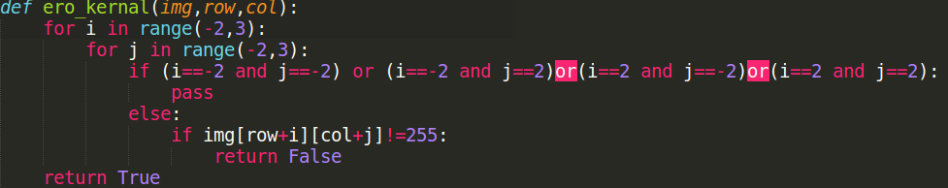
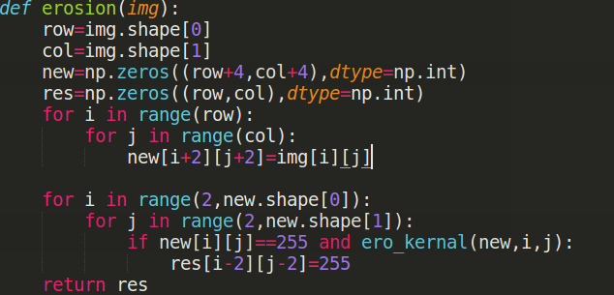

3.Opening
Opening morphological means that do the erosion fast then dilation.
Using the same 35553 kernel.
Image:


We can find that after opening operation, we can eliminate some small connection between objects.
Code:
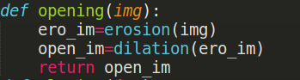

4.Closing
The closing operation do the dilation first and then do the erosion.
Image:
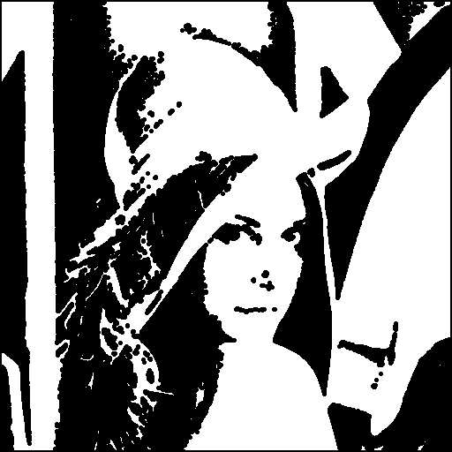
We can find that lots of small objects get connected after closing.

Code:

5.Hit and miss
We choose upside-down L shape kernel to detect the up right corner of objects.
Image:
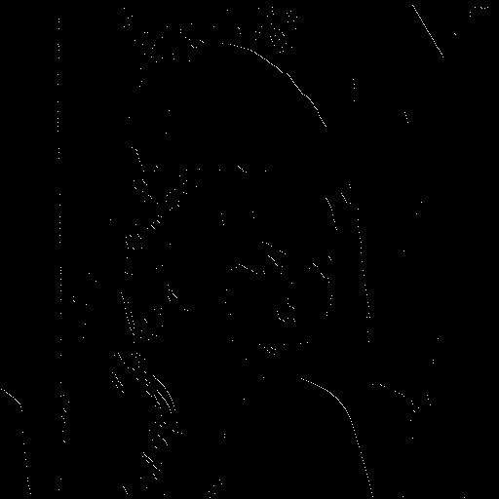

Code:
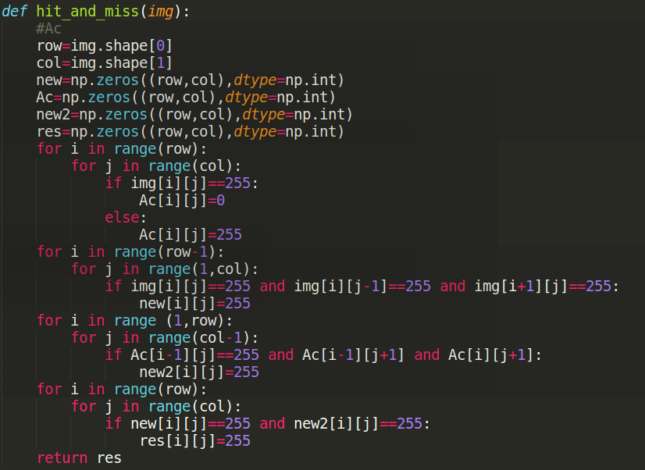

The L shape kernel is easy, so I just to write it in judgement, rather than other kernel function.
We can find that the up right corner is preserved after upside-down L shape kernel after hit and miss operation.

