Computer Vision Hw 5
R07921010 余奇安



Input image: grayscale Lena.jpg
1.Dilation
Use 35553 kernel. Every pixel value is the max value in kernel.
Image:


Code:
Define dilation function and dil_kernel
Create new np array with another 4 dimension in row and column respectively to deal with boundary detection.
Eventually, reduce the dimension to original image (res) .
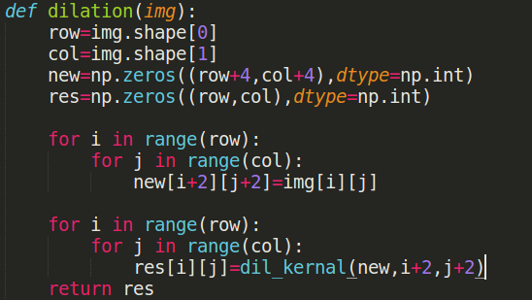

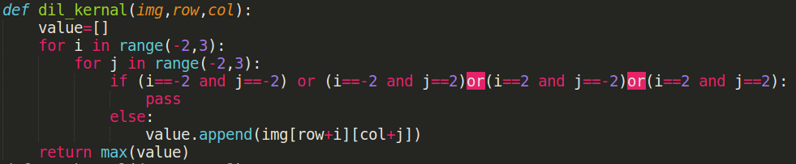
dil_kernel function is design to find the max value in kernel.

2.Erosion
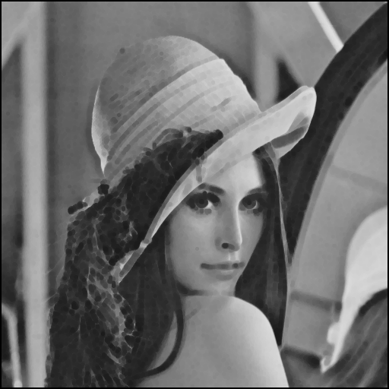
Use 35553 kernel. Every pixel value is the min value in kernel.

Code:
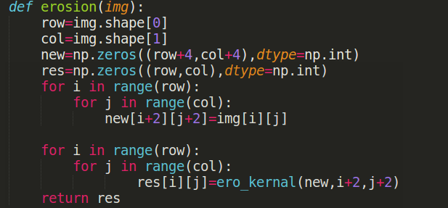
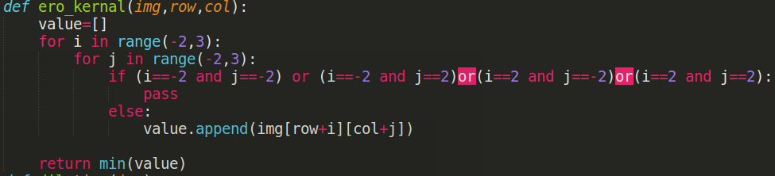

use ero_kernel to find the min value in kernel.
The meaning of variable is the same as dilation function.

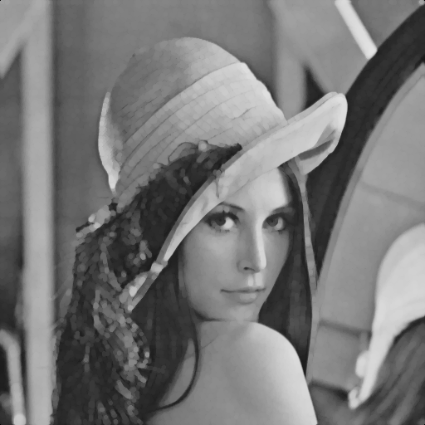
3.Opening

Opening operation means that do the erosion first and do the dilation.
After gray scale opening, the image becomes more smooth and vague, the dark pixel is reinforced.

Code:
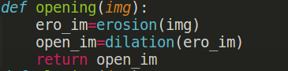

Based on the erosion and dilation function, we can do opening easily.

4.Closing
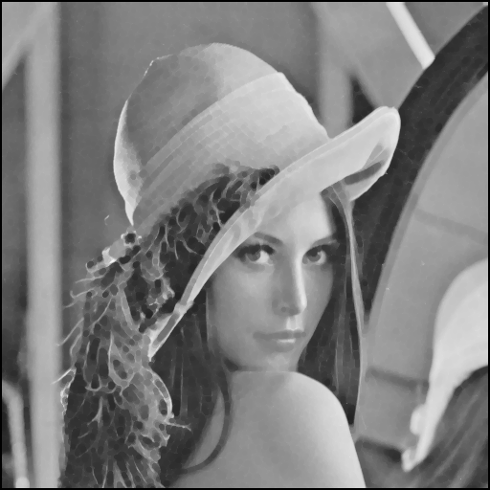

Code:
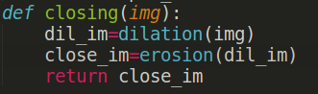

Closing operation means that do the dilation first and do the erosion.
After gray scale closing, the image becomes more smooth and vague, the bright pixel is reinforced.

