Computer vision Hw6
R07921010 余奇安
1.Yokoi connectivity number
Use Yokoi connectivity number to recognize the property of every pixel

1:edge label
2:connecting label
3:branching label
4:crossing label
5:interior label
0:isolated label
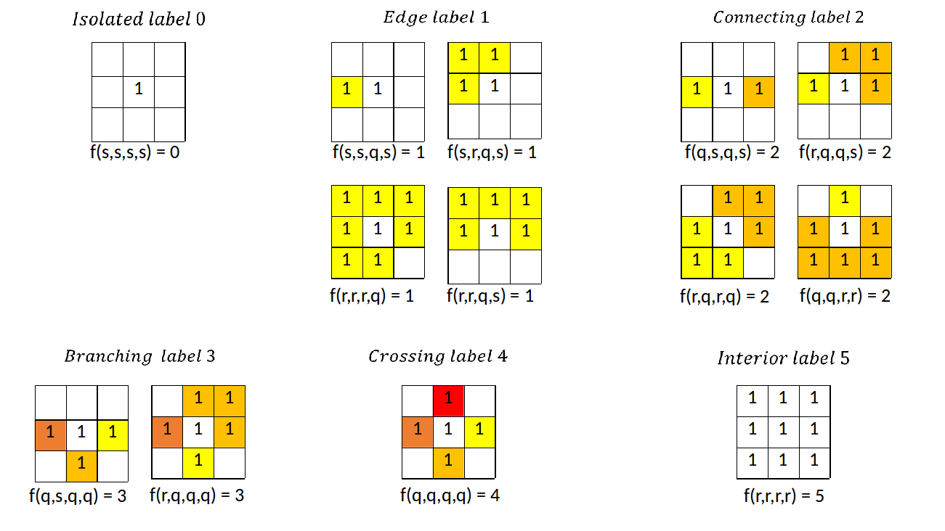
Step: Binary gray scale lena at 128
downside from 512x512 to 64x64 (choose the top left right pixel in 8x8 grid)
do the yokoi algorithm for 4 connectivity
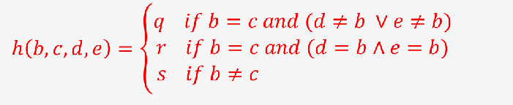
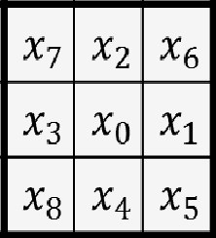
a1=h(b,c,d,e)=h(x0,x1,x6,x2)
a2=h(b,c,d,e)=h(x0,x2,x7,x3)
a3=h(b,c,d,e)=h(x0,x3,x8,x4)
a4=h(b,c,d,e)=h(x0,x4,x5,x1)

define f function:

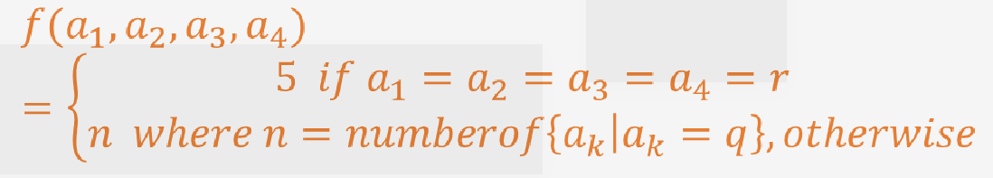
to determine the number of label.
Result:

Code:
follow the yokoi algorithm
define h function and f function first
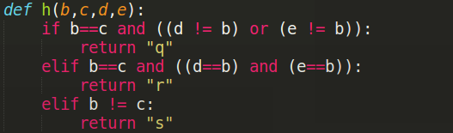
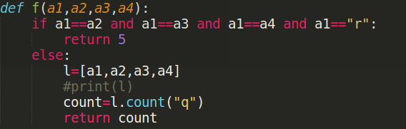
Second define yokoi function
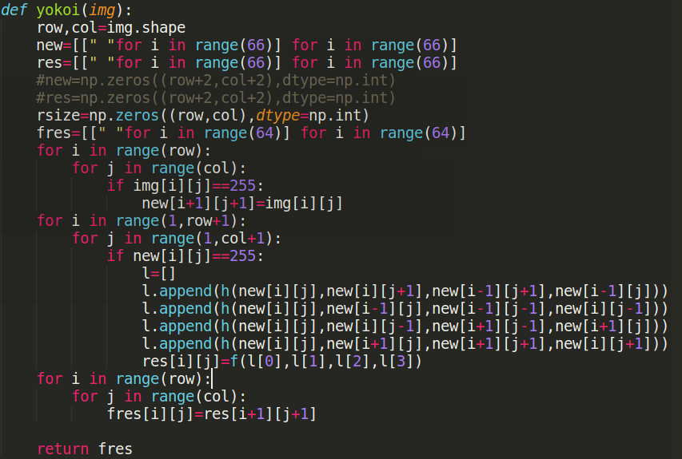
Finally, use pandas to output the matrix
