Computer Vision hw7 report
r07921010 余奇安
1.Thinning operator
Algorithm:
step1: mark-interior/border-pixel operator
step2: pair relationship operator
step3: marked-pixel connected shrink operator
Repeat step 1, 2, 3 until the output never change.

The input image is gray scale Lena.jpg downside from 512*512 to 64*64 and binary at 128.
Result:


Code:
Follow the slide to implement h, I, f, function for interior/border operator
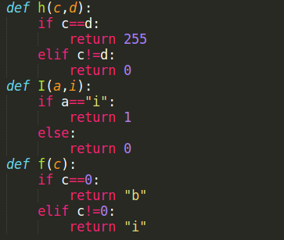

Interior/border operator work as IB function
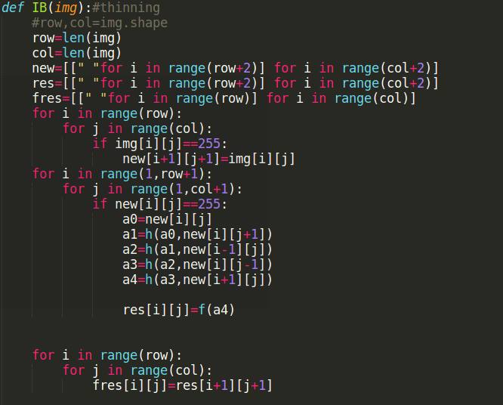

After define border and interior point, we should do the pair relation operator
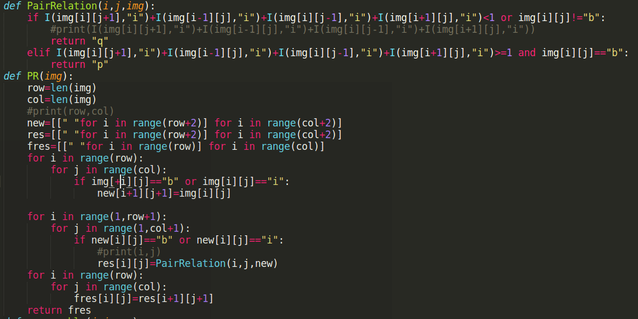
the pixel is removable if the pixel is marked as “p” and the value of f function return is exactly 1

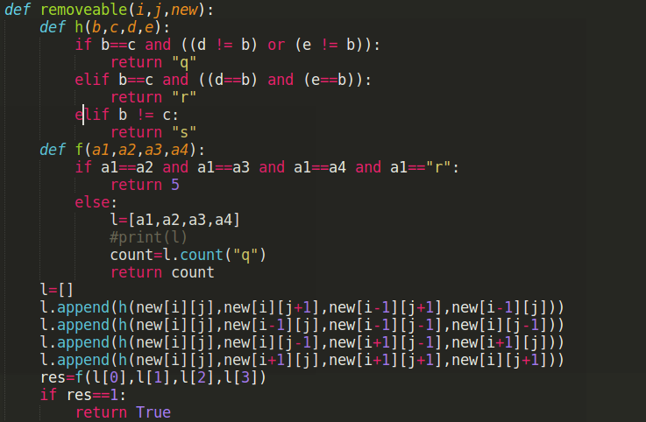
The thinning operator
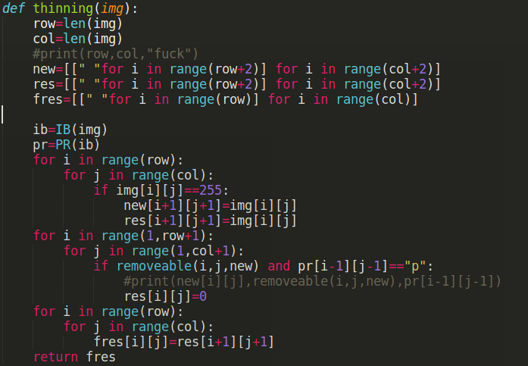
Use main function to repeat step 1,2,3 until the output never change
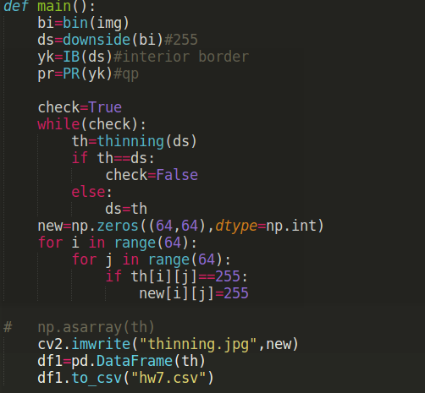
Discussion:
we can find that there is a line with two pixel width. I first regard it as not reasonable, but after I check the algorithm in slides, this is the correct result. It is because when the line is shrunk to two parallel pixel, they are both border which are marked q(no interior point), so the pixel will not be canceled.

