Computer Vision HW8
R07921010 余奇安
1.Add Gaussian noise
Gaussian noise with amp10 | Gaussian noise with amp30
 | 
SNR 13.61 | SNR 4.049

2.Add salt&pepper noise
Salt & Pepper with threshold 0.05 | Salt & Pepper with threshold 0.1
 | 
SNR 1.0278 | SNR -1.8038

3. 3x3 box filter to deal with 4 noise image
Gaussian noise with amp10 | Gaussian noise with amp30
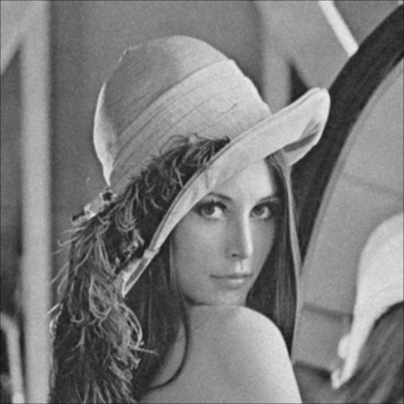 | 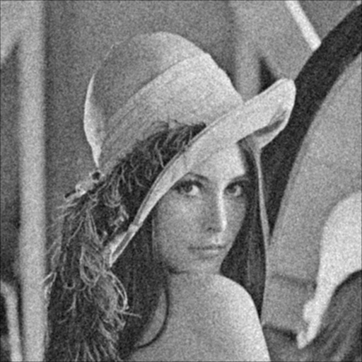
SNR 16.37 | SNR 12.07

Salt & Pepper with threshold 0.05 | Salt & Pepper with threshold 0.1
 | 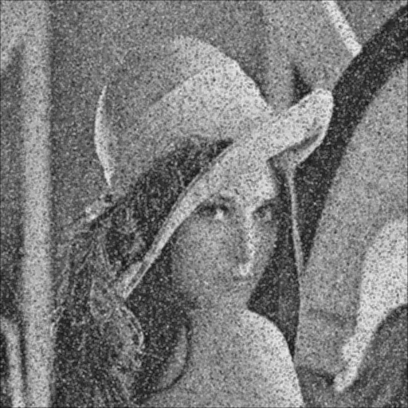
SNR 9.32 | SNR 6.5

3. 5x5 box filter to deal with each case
Gaussian noise with amp10 | Gaussian noise with amp30
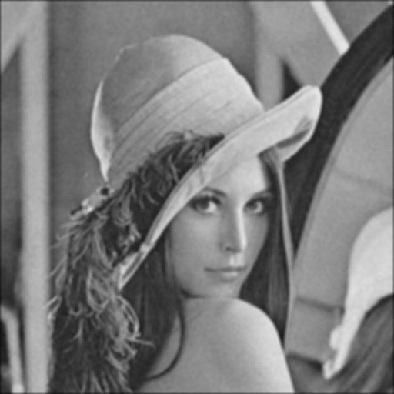 | 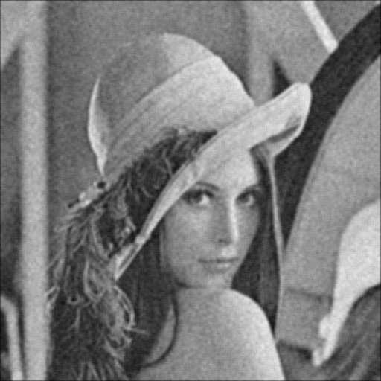
SNR 13.59 | 12.41

Salt & Pepper with threshold 0.05 | Salt & Pepper with threshold 0.1
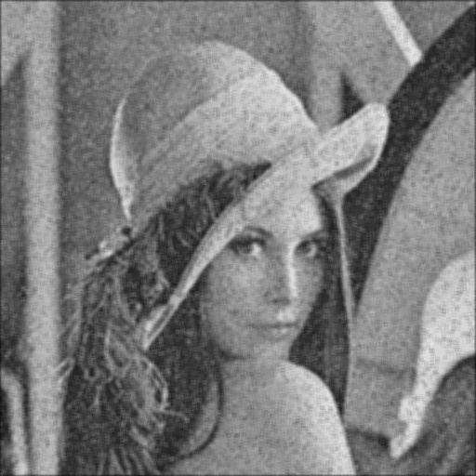 | 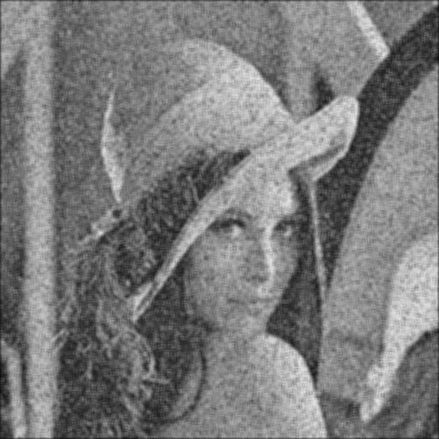
SNR 10.62 | SNR 8.40

4. 3x3 median filter
Gaussian noise with amp10 | Gaussian noise with amp30
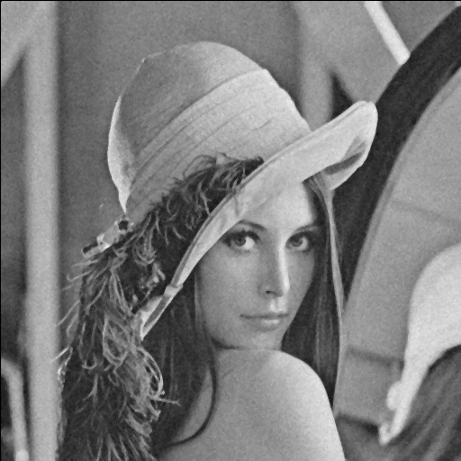 | 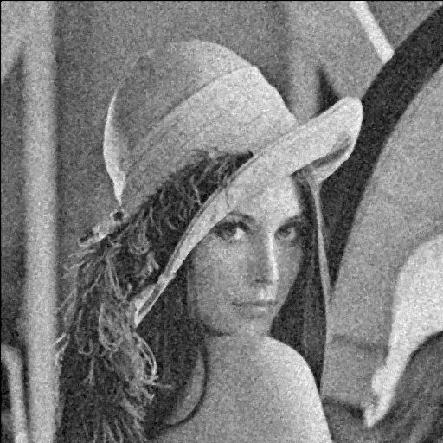
10.10 | 8.14

Salt & Pepper with threshold 0.05 | Salt & Pepper with threshold 0.1
 | 
10.17 | 9.47

5. 5x5 median filter

Gaussian noise with amp10 | Gaussian noise with amp30
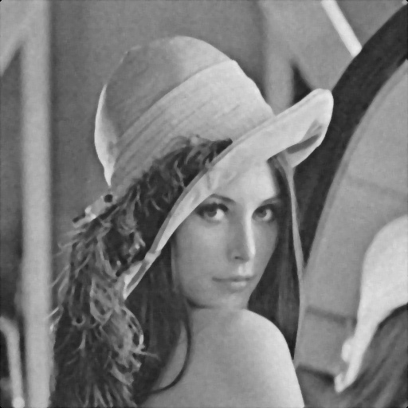 | 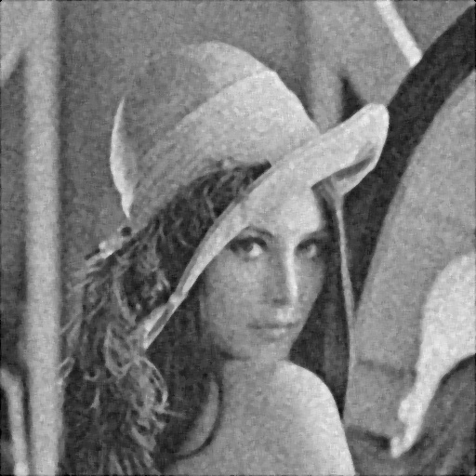
15.85 | 12.55

Salt & Pepper with threshold 0.05 | Salt & Pepper with threshold 0.1
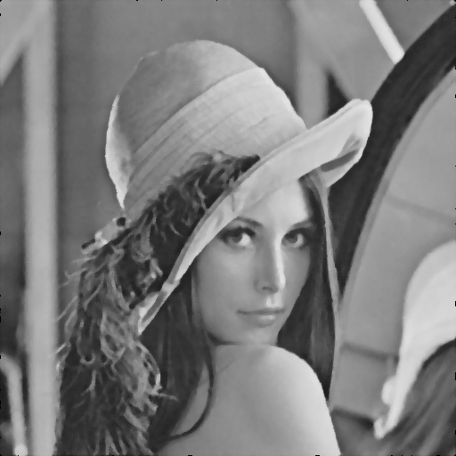 | 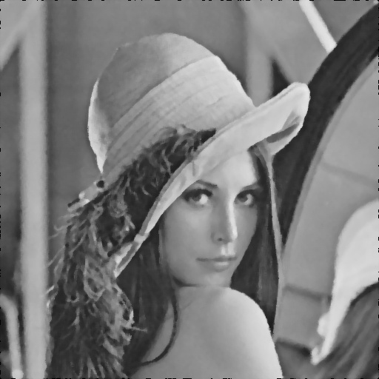
15.87 | 14.16

6.opening closing filter
Gaussian noise with amp10 | Gaussian noise with amp30
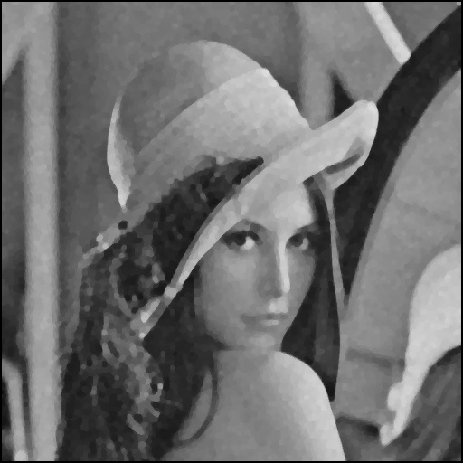 | 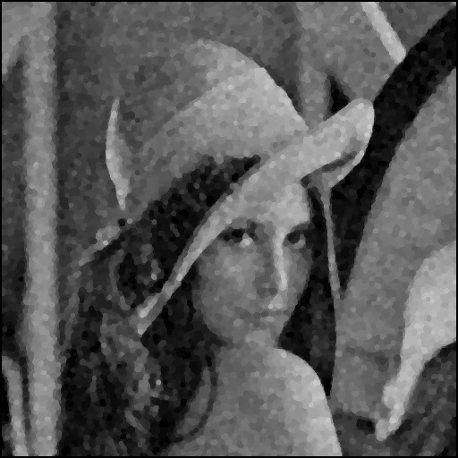
8.61 | 8.63

Salt & Pepper with threshold 0.05 | Salt & Pepper with threshold 0.1
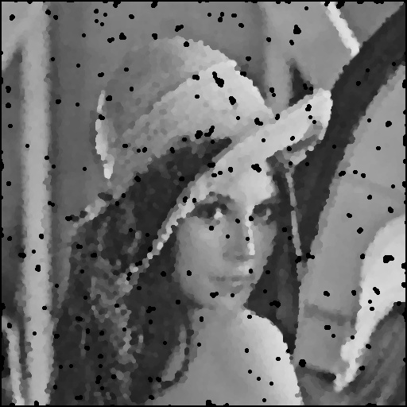 | 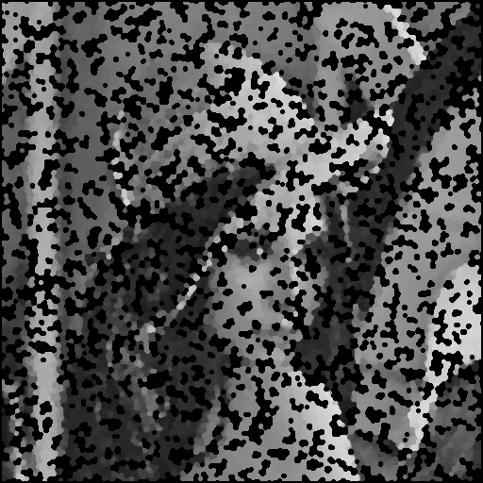
3.99 | -2.22

7. closing and opening filter
Gaussian noise with amp10 | Gaussian noise with amp30
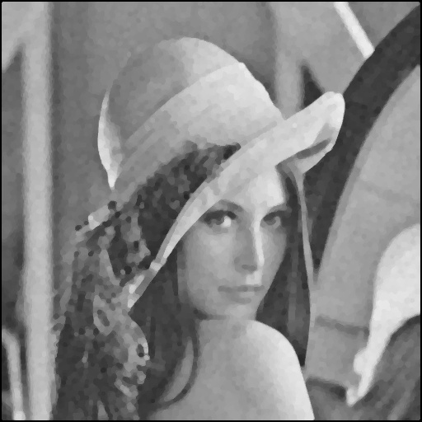 | 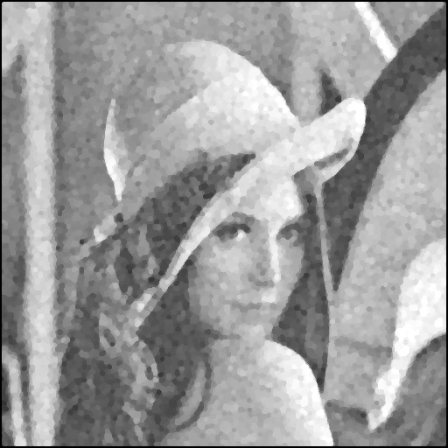
7.65 | 6.09

Salt & Pepper with threshold 0.05 | Salt & Pepper with threshold 0.1
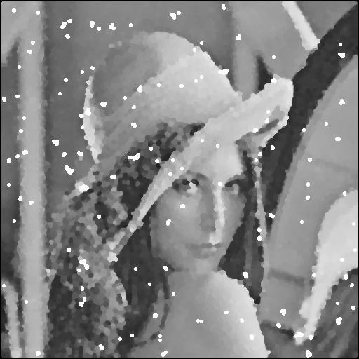 | 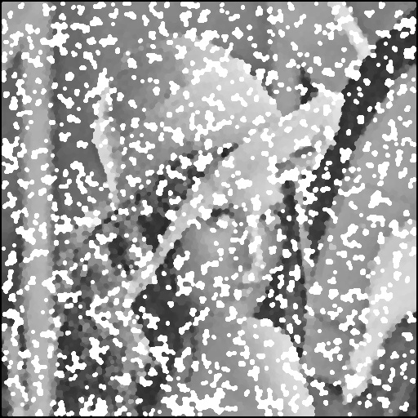
4.35 | -2.22

Discussion:
We can find that some SNR becomes negative value. It is because the noise bigger than signal.
Opening closing / Closing opening filter can deal with small noise both on SP and Gaussian, however, it will damage the image if the noise is too big.
Generally speaking, the 5x5 median filter can deal with the noise the best. It is because the median filter is good at dealing with the out peak value.

Code:
Use np.random.noraml to generate Gaussian noise
Use np.random.uniform to generate Salt&pepper noise
both with average 0 ,stand deviation 1
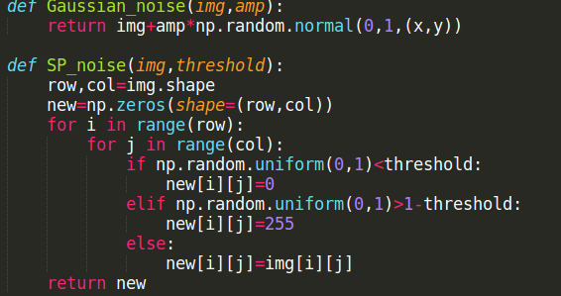
SNR function:
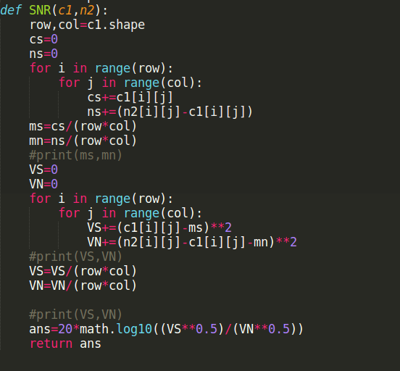

Filters
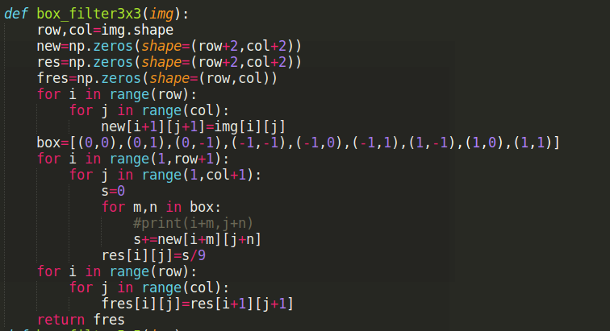

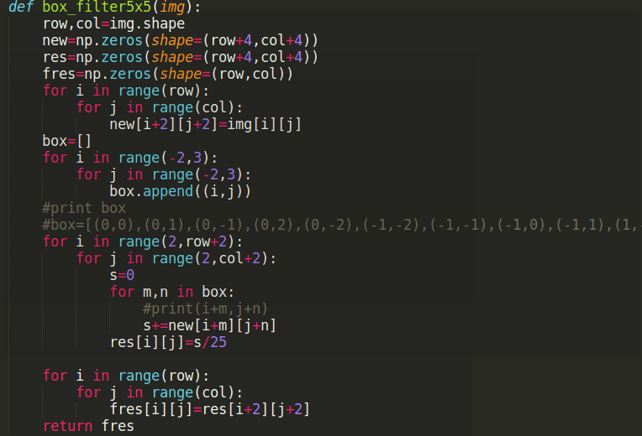

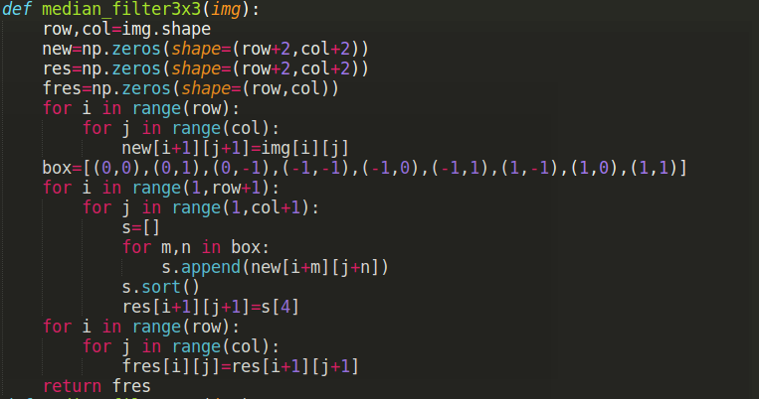
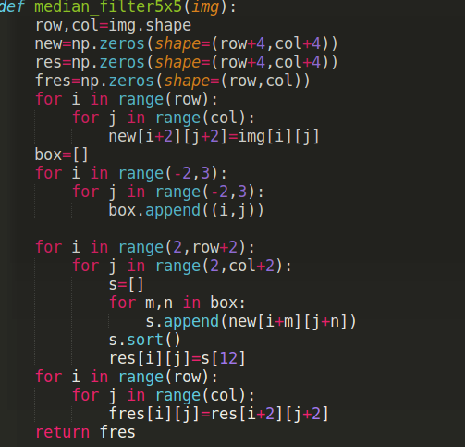

Base on dilation and erosion, implement the opening-closing / closing-opening filter
