Computer Vision hw9 Report
R07921010 余奇安
1.Robert’s operator, threshold at 12

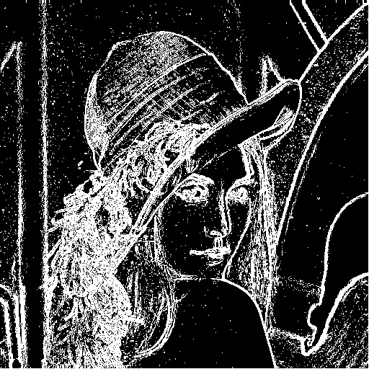
Code:
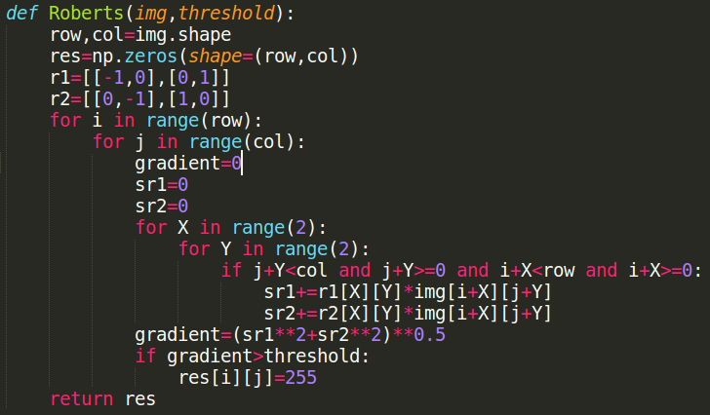
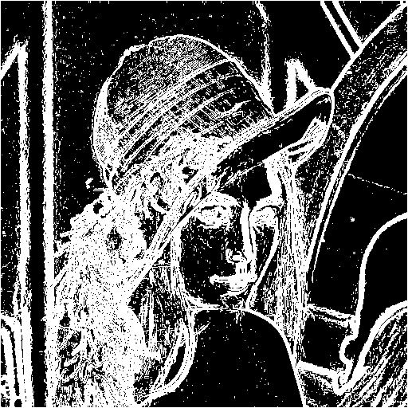
2.Prewitt’s edge detector threshold at 24

Code:
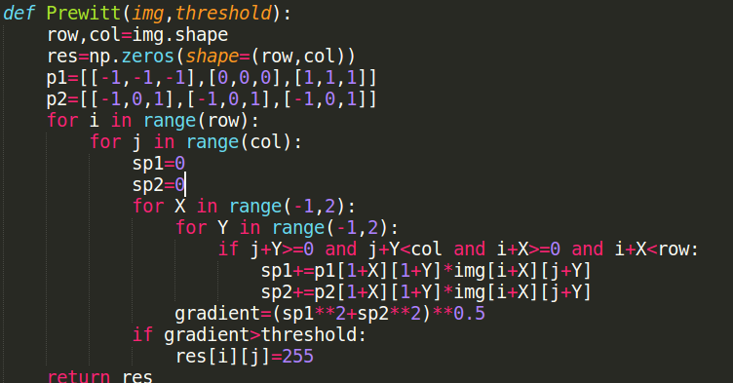

3.Sobel’s Edge Detector at 38
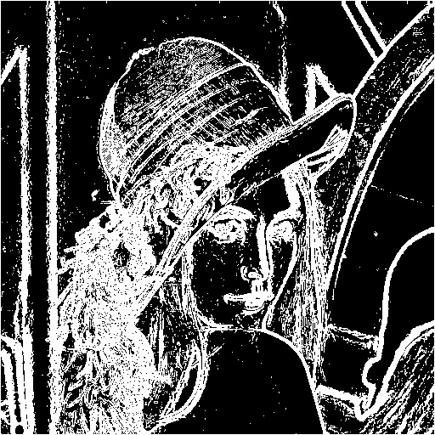
Code:
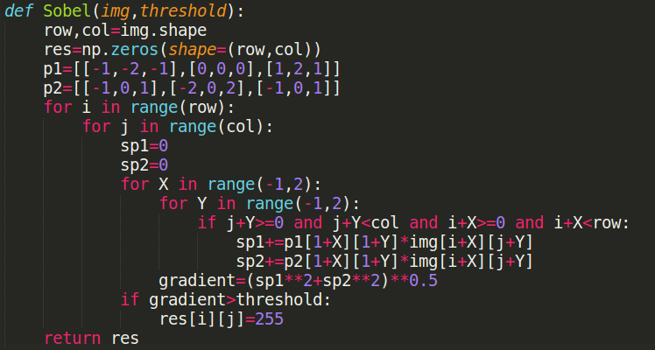

4.Frei and Chen’s Gradient Operator at 30
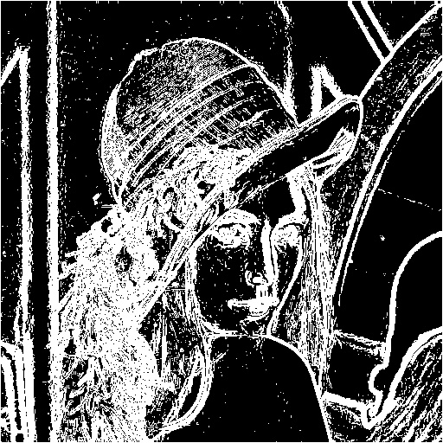
Code:
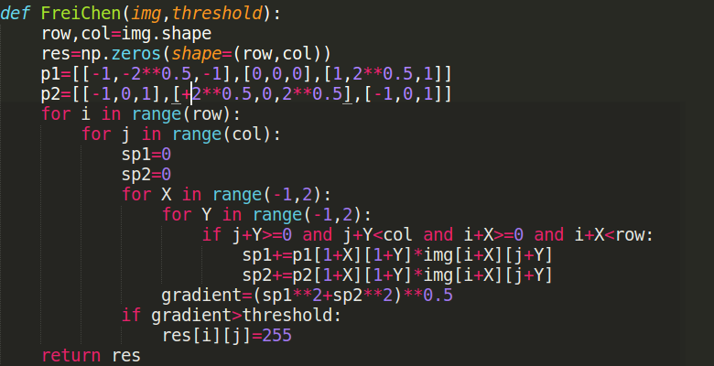

5.Kirsch’s Compass Operator at 135
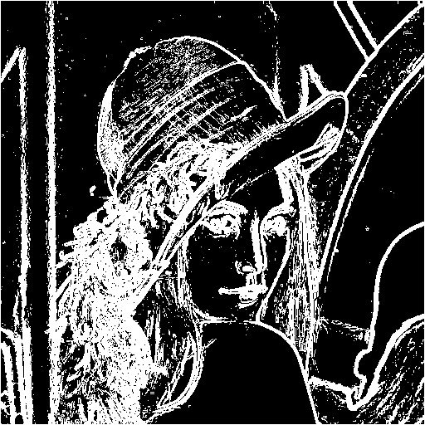
Code:
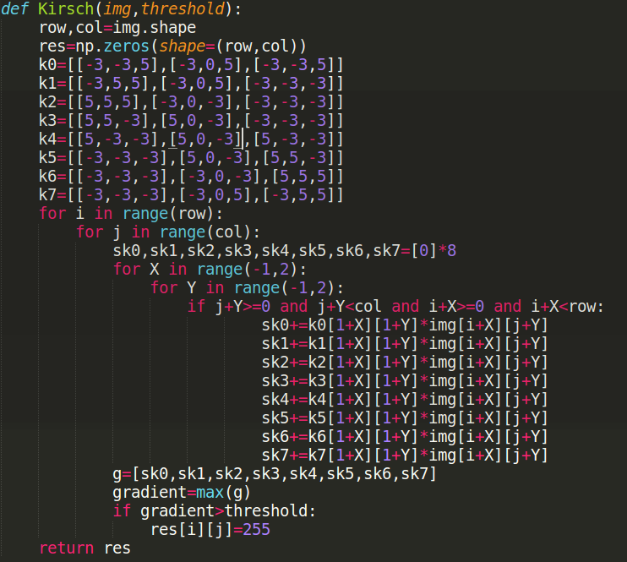

6.Robinson’s Compass Operator at 43
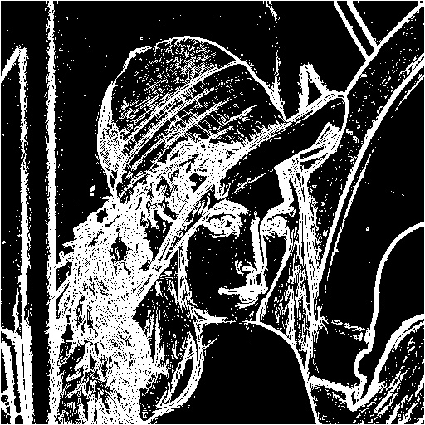
Code:
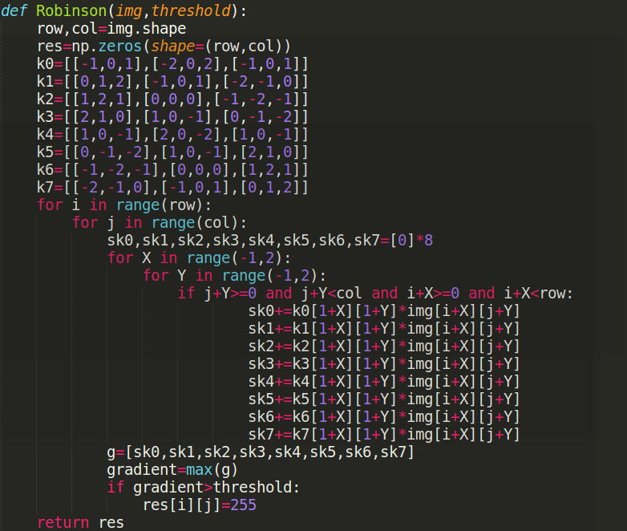
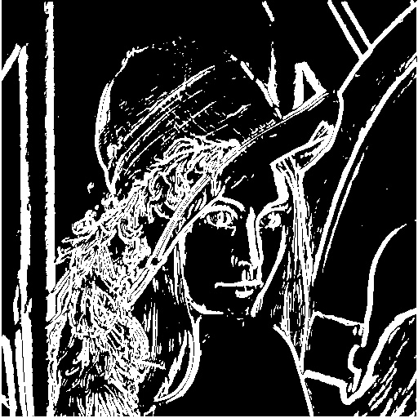
7. Nevatia-Babu 5x5 operator at 12500
Code:
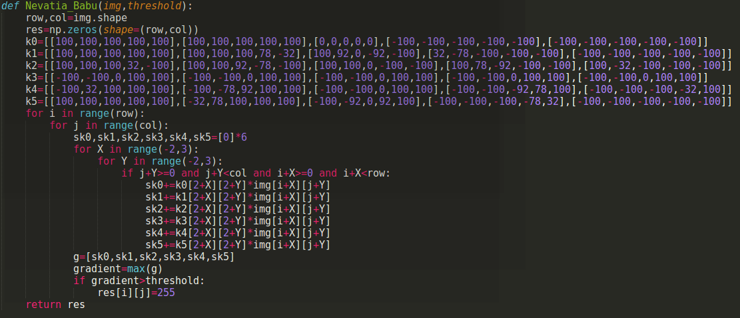
Discussion:
We can observe that the bigger the kernel of gradient edge detector, just like Nevatia-Babu 5x5, the better of noise removal performance, and the contour lines become more smooth and bold.

