Computer Vision hw1

r070921010 余奇安



Origin lena.jpg

**1.Use B_PIX to write a program to generate**

(a)upside-down lena.im

Define upside-down function,exchange the pixels symmetry to the center row of image.

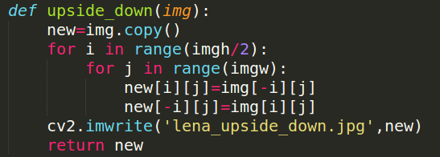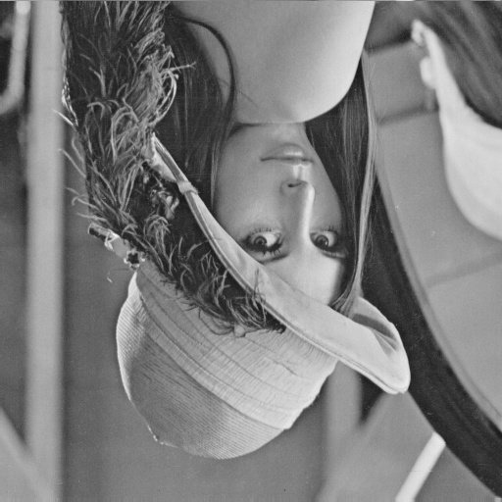

(b)right-side-left lena.im

Define left-right function, exchange the pixels symmetry to the center column of image.

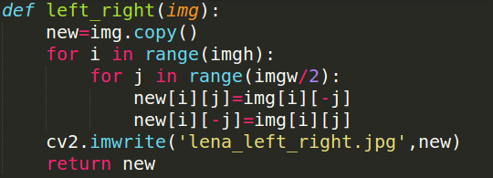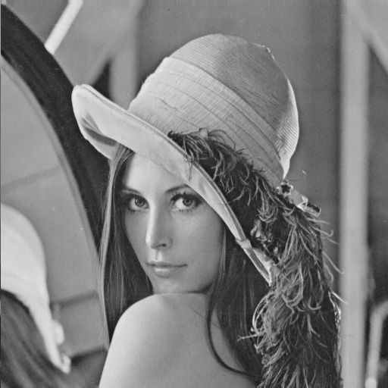

(c)diagonally mirrored lena.im

Define diag function, exchange pixels symmetry to the diagonal line of image.

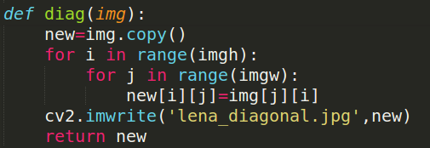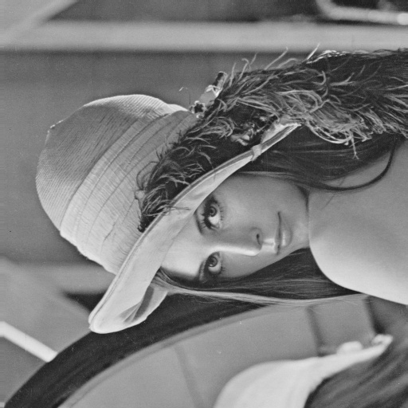

The program is written in python 2.7

Besides, the size of images have been rearranged for the typesetting of this report.

**2.Use photoshop to**

(a) rotate lena.im 45 degrees clockwise

method:

影像->影像旋轉->輸入45度選順時針



(b) shrink lena in a half

method: 影像->影像尺寸 長寬設為 9.03(原來18.06)



(c) binarize lena at 128 to get a binary image

method: 影像->調整->臨界值 設定臨界值為128

