<html>
<head>
<title>ShrishaTuladhar</title>
</head>
<body bgcolor="blue">

<h1> <font color="red" > THIS IS HEADING 1</font> </h1>
<h2> <font color="red" > THIS IS HEADING 2</font> </h2>
<h3> <font color="red" > THIS IS HEADING 3</font> </h3>
<h4> <font color="red" > THIS IS HEADING 4</font> </h4>
<h5> <font color="red" > THIS IS HEADING 5</font> </h5>
<h6> <font color="red" > THIS IS HEADING 6</font> </h6>

</body>
</html>
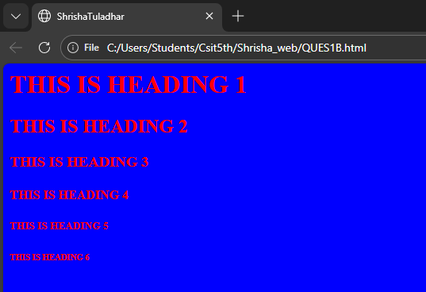
<html>
<head>
<title>ShrishaTuladhar</title>
</head>
<body >
<p align ="center">
<font color="green" ><b><font size="4"></font> Using the <i> <u><font size="7">font tag</u></i></font> </b></font>
</p>

</body>
</html>



<html>
<head>
<Title>
Shrisha
</Title>
<link rel="icon" type="image/x-icon" href="garlic.png">
</head>
</html>
<html>
<head>
<title>ShrishaTuladhar</title>
</head>
<body bgcolor="black">
<p align ="center">
<font color="white" ><b> "This is my<i> <u><font size="4">first webpage</u></i>"</font> </b></font>
</p>

</body>
</html>

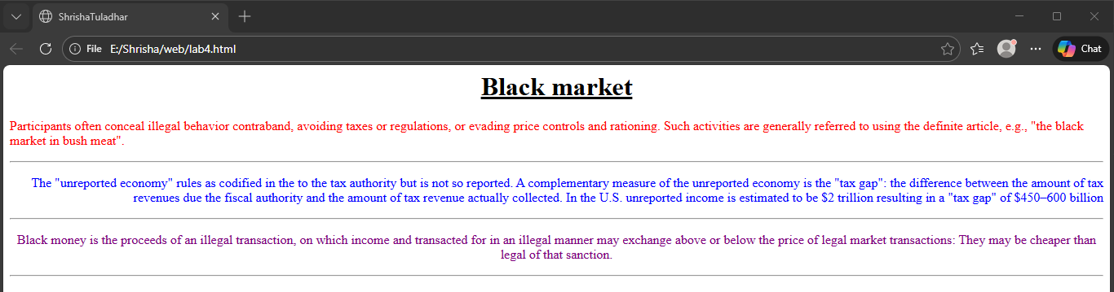

<html>
<head>
<title>ShrishaTuladhar</title>
</head>

<body>
<h1 align="center"><u>Black market</u></h1>
<p align="left">
<font color="red">
Participants often conceal illegal behavior contraband, avoiding taxes or regulations, or evading price controls and rationing. Such activities are generally referred to using the definite article, e.g., "the black market in bush meat".
</p></font><hr>
<p align="right">
<font color="blue">
The "unreported economy" rules as codified in the to the tax authority but is not so reported. A complementary measure of the unreported economy is the "tax gap": the difference between the amount of tax revenues due the fiscal authority and the amount of tax revenue actually collected. In the U.S. unreported income is estimated to be $2 trillion resulting in a "tax gap" of $450–600 billion
</p></font><hr>
<p align="center">
<font color="purple">
Black money is the proceeds of an illegal transaction, on which income and transacted for in an illegal manner may exchange above or below the price of legal market transactions:
They may be cheaper than legal of that sanction.
</p> </font> <hr>
</body>
</html>


<html>
<head>
<title>ShrishaTuladhar</title>
</head>
<body>
<pre>
<font size="4">
Name:<b>Shrisha</b>
Studies in Csit5<sup>th</sup>
Lives in <abbr title="Kathmandu">ktm</abbr>

Drinks H<sub>2</sub>O in a daily basis
<strong><i>A hardworking student</i></strong>
</font>
</pre>
</body>

