Software Requirements Specification - Warehouse Inventory & Reorder System(WrHM)

Project: Warehouse Inventory & Reorder System (WrHM) (WrHM)
Organization: Phenikaa University - School of Information Systems
Author:
Group 2:
1.Nguyen Đang Quang Anh - 24100455
2.To Kim Trung - 24100131
3.Cao Ba Son – 24100038
4.Nguyen Duong Ha My – 24100192
Version: 1.0 | Date: 2026-10-22
Standard reference: ISO/IEC/IEEE 29148:2018
Confidentiality: Business-sensitive stock and supplier data; RBAC with audit log
Group git link: https://github.com/Cheemsrussika/BTL_Warehouse_Management_-_Reorder_Sytem_Group2_YCPM

_This document consolidates 9 chapter document(s) (Chapters 1, 2, 3, 4, 5, 6, 7, 9, 11) into a single Software Requirements Specification with one continuous, consistent Table of Contents._

Table of Contents
1. Chapter 1 - Requirements Specification and Documentation 5
1.1 Objectives 5
1.2 Introduction 5
1.3 Purpose 5
1.4 Scope 5
1.5 Definitions, Acronyms and Abbreviations 6
1.6 References 6
1.7 Stakeholder Needs and Requirements 7
1.8 System / Business Overview 7
1.9 System Requirements 8
1.10 Functional Requirements 8
1.11 Non-functional (Quality) Requirements 12
1.12 Interface Requirements 13
1.13 Constraints 13
1.14 Verification and Validation Approach 13
1.15 Requirements Traceability 13
1.16 Assumptions and Dependencies 13
1.17 Appendices 14
1.18 Sizing and Effort Estimation (COCOMO II, simplified) 15
1.19 Specification Quality Evaluation 15
2. Chapter 2 - Requirements Validation and Verification 16
2.1 Objectives 16
2.2 Verification Method Distribution (Information) 16
2.3 Requirements Traceability Matrix 16
2.4 Traceability Coverage (Calculation) 17
2.5 Verification Effort Estimation 17
2.6 Test Case Register (Information) 18
2.7 Test Execution Summary (Calculation) 20
2.8 Validation Quality Evaluation 20

3. Chapter 3 - Managing Changing Requirements 20
3.1 Objectives 20
3.2 Change Request Log (Information) 21
3.3 Change Status Distribution 21
3.4 Change Impact Calculation 21
3.5 Change Volatility Evaluation 21
3.6 Change Volume Forecast (Estimation) 21
4. Chapter 4 - Non-functional Requirements 22
4.1 Objectives 22
4.2 Non-functional Requirements Register (Information) 22
4.3 Category Coverage (Calculation) 23
4.4 NFR Quality Evaluation 23
4.5 NFR Verification Effort Estimation 23
5. Chapter 5 - Collaborating with Stakeholders 23
5.1 Objectives 23
5.2 Stakeholder Register (Information) 23
5.3 Influence / Interest Matrix (Calculation) 24
5.4 Stakeholder Distribution by Organization 24
5.5 Engagement Readiness Evaluation 24
5.6 Stakeholder Engagement Effort Estimation 24
6. Chapter 6 - Use Case Modeling and Scenario Descriptions 24
6.1 Objectives 24
6.2 Actor Catalogue (Information) 25
6.3 Use Case Descriptions 25
6.4 Use Case Coverage Evaluation 45
6.5 Use Case Complexity and Effort Estimation 45
7. Chapter 7 - Modeling Techniques and Diagrammatic Notations 48
7.1 Objectives 48
7.2 Use Case Diagram (PlantUML, auto-generated) 49
7.3 Requirements Dependency Diagram (PlantUML, auto-generated) 52
7.4 State Machine Diagram 54
7.5 DFD Level-1 55
7.6 Notation Guidance 56
7.7 Model Completeness Evaluation 56
7.8 Model Complexity Metrics and Maintenance Effort Estimation 56
8. Chapter 9 - Tool Support for Requirements Engineering 56
8.1 Objectives 56
8.2 Tool Inventory (Information) 56
8.3 Tool Coverage by Category (Calculation) 57
8.4 Tooling Coverage Evaluation 58
8.5 Tool Onboarding Effort Estimation 58
9. Chapter 11 - Requirements Elicitation and Analysis Techniques 58
9.1 Objectives 58
9.2 Requirement Prioritization (Weighted Scoring, value/effort) 558

1. Chapter 1 - Requirements Specification and Documentation

1.1 Objectives
- Produce a complete Software Requirements Specification (SRS) compliant with the selected standard.
- Fill every clause of the standard's outline with substantive, dataset-derived content - not just section titles.
- Consolidate all functional and non-functional requirements into a single traceable document.
- Provide a quantitative overview (counts, priority mix, size/effort estimate) of the specification.

1.2 Introduction
This Software Requirements Specification (SRS) documents the requirements for Warehouse Inventory & Reorder System (WrHM) (WrHM), a system in the Warehouse Management & Inventory Reorder domain developed for Phenikaa University - School of Information Systems. It follows the outline defined by ISO/IEC/IEEE 29148:2018 and consolidates 36 functional requirements, 16 non-functional requirements, 7 stakeholder groups and 28 use cases into a single, traceable document.
Group git link: https://github.com/Cheemsrussika/BTL_Warehouse_Management_-_Reorder_Sytem_Group2_YCPM

1.3 Purpose
Warehouse Inventory & Reorder System (WrHM) is a web-based inventory management system for a small and mid-sized distribution warehouse. It gives External Auditor, External Stakeholder, Internal User, Order Service Interface, System Owner / Management and Technical Stakeholder a shared, agreed basis for design, implementation and verification.

1.4 Scope
In scope - capabilities realized by the use cases and functional requirements below, within the Warehouse Management & Inventory Reorder domain:
- User Login and Authentication (UC-101)
- Provision User Account and Manage Lifecycle (UC-102)
- Review System Audit Logs (UC-103)
- Manage Product and Supplier Catalog (UC-104)
- Configure SKU Inventory Parameters (UC-105)
- Manage Warehouse Storage Hierarchy (UC-106)
- Display item image icons in catalog and search (UC-107)
- Receive Goods (UC-201)
- Issue Goods (UC-202)
- Scan and Count Goods (UC-203)
- Handle Returned Goods (UC-204)
- Transfer Between Bins (UC-205)
- Validate a Transfer (UC-206)
- Recommend FIFO Batches (UC-207)
- Recommend FEFO Batches (UC-208)
- Initialize & Query Real-Time Stock Balances (UC-301)
- Reserve Order Stock & Deduct ATP (UC-302)
- Execute Reason-Based Stock Adjustment (UC-303)
- Verify Idempotent Adjustment Request (UC-304)
- Record & Inspect Immutable Transaction Ledger (UC-305)
- Generate Blind Cycle Count Sheet (UC-306)
- Submit Physical Count & Compute Discrepancy (UC-307)
- Reconcile Count Variance by Threshold (UC-308)
- Configure SKU Replenishment Policy (UC-401)
- Monitor Low-Stock Alerts and Dashboard (UC-402)
- Execute Automated Replenishment Cycle (UC-403)
- Review Reorder Suggestions and Create Purchase Orders (UC-404)
- Adjust or Dismiss a Reorder Suggestion (UC-405)
Out of scope - any capability not covered by an approved requirement in this document. Requests outside this scope should be raised as a Change Request (see Chapter 3).

1.5 Definitions, Acronyms and Abbreviations
Term | Definition
SRS | Software Requirements Specification
NFR | Non-functional (quality) Requirement
MoSCoW | Prioritization scale: Must / Should / Could / Won't have
RE | Requirements Engineering
V&V | Verification and Validation
COCOMO II | Constructive Cost Model II - parametric software cost/effort estimation model
KLOC | Thousands of Lines of Code - a software size measure
UML | Unified Modeling Language
CR | Change Request
ACT-01 | Actor: Warehouse Staff
ACT-02 | Actor: Inventory Controller
ACT-03 | Actor: Warehouse Manager
ACT-04 | Actor: IT Administrator
ACT-05 | Actor: Supplier (external)
ACT-06 | Actor: System Scheduler / Timer (external)
ACT-07 | Actor: System User
ACT-08 | Actor: Order Service

1.6 References
- ISO/IEC/IEEE 29148:2018 (primary reference for this document's structure)
- IEEE 830-1998 (alternative SRS outline, informative)
- ISO/IEC 27001 (information-security management, informative)
- Python 3 - Implement the requirement toolkit, simulators and the prototype server (standard library: http.server, sqlite3, csv, unittest).
- SQLite - Store users, SKUs, inventory, suppliers, transactions and audit logs in the prototype.
- PostgreSQL - Planned production store for the same schema once the prototype is validated.
- HTML/CSS/JavaScript - Browser UI for the stock list, dashboard and data-entry forms.
- matplotlib - Render the NFR simulation charts and coverage figures.
- openpyxl - Read and write WareHouse.xlsx so the workbook stays in sync with the CSV datasets.
- unittest - Run the requirement-consistency and safety-scenario test suites.
- Git + GitHub - Track changes and submit the project.
- VS Code - Edit, run and debug the scripts and datasets.
- LaTeX (pdflatex) - Produce the final report and the SRS PDF.
- Python requirements_toolkit - Generate requirements and coverage artifacts
- Microsoft Excel - Maintain FR, UC, test cases and traceability
- VS Code / Python - Run a local Module 2 demo and its unit tests

1.7 Stakeholder Needs and Requirements
ID | Stakeholder | Role | Needs (traced requirements)
STK-01 | Warehouse Manager | System Owner / Management | Bin and location hierarchy management; Confirm Goods Receipt; Check Transfer Permission
STK-02 | Warehouse Staff | Internal User | Item image icons in the stock list and search results; Create Draft Goods Receipt; Create Goods Issue Note; Confirm Goods Issue; Identify Product by QR/Barcode; Count Goods by Scanning; Create Return Note; Classify Returned Goods; Create Bin Transfer Note; Confirm Bin Transfer; Validate Transfer Stock and Capacity; Recommend FIFO Batch; Allocate FIFO Stock; Recommend FEFO Batch; Allocate FEFO Stock; Count Submission & Discrepancy Calculation
STK-03 | Inventory Controller | Internal User | Manage product and supplier catalog; Review and update SKU master data; Real-Time Stock Visibility; Reason-Based Stock Adjustment; Duplicate Transaction Prevention; Blind Count Sheet Generation; Threshold-Based Count Reconciliation; Configure SKU replenishment policy; Monitor available stock against the reorder point; Execute the automated replenishment cycle; Calculate the suggested order quantity from safety stock, lead time and MOQ; Review reorder suggestions and create purchase orders
STK-04 | IT Department | Technical Stakeholder | Account provisioning and login; Role-based access control (RBAC); Audit Trail & Compliance Logging
STK-05 | Supplier | External Stakeholder | _(no requirement explicitly sourced from this stakeholder yet)_
STK-06 | Order Service | Order Service Interface | Order Stock Reservation
STK-07 | Compliance Auditor | External Auditor | Stock Transaction History

1.8 System / Business Overview
Warehouse Inventory & Reorder System (WrHM) serves 8 actor(s) across 28 use case(s). Warehouse Inventory & Reorder System (WrHM) is a web-based inventory management system for a small and mid-sized distribution warehouse.
Actors:
ID | Name | Type | Description
ACT-01 | Warehouse Staff | Primary | Records stock-in/out by scanning SKUs; looks up stock levels
ACT-02 | Inventory Controller | Primary | Monitors stock, maintains SKU and catalog master data, generates reorder suggestions
ACT-03 | Warehouse Manager | Primary | Approves reorder requests and reviews inventory reports
ACT-04 | IT Administrator | Primary | Manages user accounts, configures role-based access permissions, and monitors system maintenance/audit logs.
ACT-05 | Supplier | External/Secondary | External entity that receives automated reorder notifications and purchase order details.
ACT-06 | System Scheduler / Timer | External/Secondary | Automated background cron/daemon service that triggers periodic low-stock evaluation,  Batch cycle-count generation, and notification dispatching.
ACT-07 | System User | Primary | Abstract base actor for every authenticated operational role (Warehouse Staff, Inventory Controller, Warehouse Manager, IT Administrator). Inherits the UC-101 login and authentication use case.
ACT-08 | Order Service | Primary | Requests stock allocations and releases

1.9 System Requirements
ID | Title | Type | Priority | Status | Source
FR-101 | Account provisioning and login | Functional | Must | Approved | STK-04
FR-102 | Role-based access control (RBAC) | Functional | Must | Approved | STK-04
FR-103 | Audit Trail & Compliance Logging | Functional | Should | Approved | STK-04
FR-104 | Manage product and supplier catalog | Functional | Must | Approved | STK-03
FR-105 | Review and update SKU master data | Functional | Must | Approved | STK-03
FR-106 | Bin and location hierarchy management | Functional | Must | Approved | STK-01
FR-107 | Item image icons in the stock list and search results | Functional | Could | Approved | STK-02
FR-201 | Create Draft Goods Receipt | Functional | Must | Approved | STK-02
FR-202 | Confirm Goods Receipt | Functional | Must | Approved | STK-01
FR-203 | Create Goods Issue Note | Functional | Must | Approved | STK-02
FR-204 | Confirm Goods Issue | Functional | Must | Approved | STK-02
FR-205 | Identify Product by QR/Barcode | Functional | Must | Approved | STK-02
FR-206 | Count Goods by Scanning | Functional | Must | Approved | STK-02
FR-207 | Create Return Note | Functional | Must | Approved | STK-02
FR-208 | Classify Returned Goods | Functional | Must | Approved | STK-02
FR-209 | Create Bin Transfer Note | Functional | Must | Approved | STK-02
FR-210 | Confirm Bin Transfer | Functional | Must | Approved | STK-02
FR-211 | Validate Transfer Stock and Capacity | Functional | Must | Approved | STK-02
FR-212 | Check Transfer Permission | Functional | Must | Approved | STK-01
FR-213 | Recommend FIFO Batch | Functional | Should | Approved | STK-02
FR-214 | Allocate FIFO Stock | Functional | Should | Approved | STK-02
FR-215 | Recommend FEFO Batch | Functional | Should | Approved | STK-02
FR-216 | Allocate FEFO Stock | Functional | Should | Approved | STK-02
FR-301 | Real-Time Stock Visibility | Functional | Must | Approved | STK-03
FR-302 | Order Stock Reservation | Functional | Must | Approved | STK-06
FR-303 | Reason-Based Stock Adjustment | Functional | Must | Approved | STK-03
FR-304 | Duplicate Transaction Prevention | Functional | Must | Approved | STK-03
FR-305 | Stock Transaction History | Functional | Should | Approved | STK-07
FR-306 | Blind Count Sheet Generation | Functional | Must | Approved | STK-03
FR-307 | Count Submission & Discrepancy Calculation | Functional | Must | Approved | STK-02
FR-308 | Threshold-Based Count Reconciliation | Functional | Must | Approved | STK-03
FR-401 | Configure SKU replenishment policy | Functional | Must | Approved | STK-03
FR-402 | Monitor available stock against the reorder point | Functional | Must | Approved | STK-03
FR-403 | Execute the automated replenishment cycle | Functional | Must | Approved | STK-03
FR-404 | Calculate the suggested order quantity from safety stock, lead time and MOQ | Functional | Must | Approved | STK-03
FR-405 | Review reorder suggestions and create purchase orders | Functional | Must | Approved | STK-03
Priority distribution (MoSCoW):
Priority | Count
Must | 29
Should | 6
Could | 1
Wont | 0

1.10 Functional Requirements
ID | Title | Description | Acceptance Criteria
FR-101 | Account provisioning and login | The system shall let authorized Managers or IT Department users create an account and assign a role. Warehouse Staff shall not self-register. Accounts shall be deactivated (soft delete), not deleted, so audit entries stay attributable; a deactivated account cannot log in. | Authorized user creates an account with valid email, temporary password, and assigned role; valid credentials authenticate within 2 s; invalid credentials reject with 401 error; self-registration blocked. Deactivation sets is_active = false, writes a DEACTIVATE_USER audit entry, and rejects subsequent logins with an account-suspended error.
FR-102 | Role-based access control (RBAC) | The system shall enforce role-specific permissions across all modules. Warehouse Staff are limited to operational tasks; Inventory Controllers manage stock adjustments and count verification. Unauthorized actions shall raise a permission error. | Warehouse staff blocked from adjustments/approvals with permission error; inventory controllers allowed adjustments; unauthorized URL/API calls blocked with 403 Forbidden.
FR-103 | Audit Trail & Compliance Logging | The system shall write an immutable, timestamped audit entry for every critical operation, capturing the user identity and the transaction timestamp. | System generates an immutable log entry with user ID, timestamp, action type, and old/new values within 1 s of any administrative, role, or master data change
FR-104 | Manage product and supplier catalog | The system shall let authorized users add, update and archive SKU records and supplier profiles. Captured attributes: product code, barcode, name, category, UOM, primary bin, requires_batch, requires_expiry and an optional image URL. Removal is a soft delete (status = ARCHIVED), blocked while on-hand stock > 0. | Authorized user can add/edit/disable SKU records with unique product code, barcode, UOM, and supplier ID; duplicate barcodes or codes rejected with error ; Flags are booleans; a product with requires_expiry=true cannot be received without a valid future expiry date. Archiving a SKU with on-hand stock > 0 is rejected with an explicit error and the record stays active.
FR-105 | Review and update SKU master data | The system shall let Inventory Controllers configure replenishment parameters per SKU: reorder point, minimum order quantity, default storage bin and allocation policy (FIFO or FEFO). | Inventory controller can update ROP, MOQ, and default location parameters per SKU; invalid negative thresholds or non-existent location are rejected. ; Only the two values FIFO and FEFO are available ; default is FIFO
FR-106 | Bin and location hierarchy management | The system shall let authorized users configure the warehouse topology as Zone -> Aisle -> Rack -> Shelf -> Bin and track the stock balance per bin. Each bin stores a capacity in units. | Authorized user can define hierarchical storage locations (Zone > Aisle > Rack > Shelf >Bin); system validates uniqueness of bin coordinate codes across warehouse. ; Capacity is a positive integer; a transfer that exceeds free capacity is rejected with no stock change.
FR-107 | Item image icons in the stock list and search results | The system shall display a thumbnail icon beside items in stock lists and search results when an image is associated, and a standard placeholder when none is. | Image thumbnail rendered within 500 ms in stock list and search results for SKUs with uploaded images; generic placeholder graphic displayed if image is missing.
FR-201 | Create Draft Goods Receipt | The system allows staff to create a draft goods receipt with SKU, quantity and location. The batch code and expiry date must be recorded for products tracked by batch or expiry. | A valid draft stores SKU, quantity, bin, lot and expiry when required; saving the draft does not increase inventory.
FR-202 | Confirm Goods Receipt | The system checks the related purchase order and allows receipt confirmation; the received quantity is recorded once. | The receipt is confirmed and the incoming quantity is recorded once.; The system shows an error and does not confirm the receipt.
FR-203 | Create Goods Issue Note | The system allows staff to create an issue note with product, quantity and destination. | An issue note is created successfully.
FR-204 | Confirm Goods Issue | The system checks available stock before confirming an issue and records the outgoing quantity. | The issue succeeds and stock decreases by the issued quantity.; The system warns of insufficient stock and does not issue goods.
FR-205 | Identify Product by QR/Barcode | When staff scans a registered SKU, barcode or lot code, the system shall identify the correct product. If a lot code belongs to more than one SKU, the system shall request an expected SKU instead of selecting an arbitrary product. | A unique code shows the correct SKU. Unknown codes show NOT_FOUND. An ambiguous lot code asks for the expected SKU; the scanned count does not increase.
FR-206 | Count Goods by Scanning | The system counts scanned items during the current operation and compares them with the related note. | The scanned count increases per scan; the transaction is not auto-confirmed.
FR-207 | Create Return Note | The system allows staff to create a return note and record the quantity and reason for return. | A return note is created.; An invalid quantity message is shown; no return is created.
FR-208 | Classify Returned Goods | The system allows returned goods to be classified as accepted or defective and prevents defective goods from becoming available stock. | The returned goods are quarantined and do not increase available stock.
FR-209 | Create Bin Transfer Note | The system allows staff to create a transfer note with source bin, destination bin, and quantity. | The transfer note is saved with the correct source and destination.
FR-210 | Confirm Bin Transfer | When a transfer is confirmed, the system decreases source-bin stock and increases destination-bin stock once. | Source stock decreases and destination stock increases equally; total stock stays unchanged.; No additional stock movement is recorded.
FR-211 | Validate Transfer Stock and Capacity | Before confirming a bin transfer, the system shall check the quantity in the source bin, that the destination bin is active, and that its free capacity is sufficient. | A transfer exceeding source stock or remaining bin capacity is rejected, with no stock change.
FR-212 | Check Transfer Permission | The system allows only authorized users to confirm transfers in an allowed status. | The transfer is confirmed (demo role check; not a secure login system).; The operation is rejected and stock remains unchanged.
FR-213 | Recommend FIFO Batch | Under FIFO, the system recommends the eligible batch with the earliest receiving date. | The earliest received eligible batch is recommended first.; Blocked batches are not included in the recommendation.
FR-214 | Allocate FIFO Stock | If one FIFO batch is insufficient, the system allocates the remaining quantity from the next eligible batch. | The system uses the oldest batch first, then the next one.
FR-215 | Recommend FEFO Batch | Under FEFO, the system recommends the eligible batch with the nearest expiration date. | The eligible batch with the nearest expiry date is recommended first.; Expired batches are excluded from the recommendation.
FR-216 | Allocate FEFO Stock | The system recommends eligible stock using FEFO. If batches expire on the same date, the batch received earlier shall be allocated first. | For equal expiry dates, allocate from the batch with the earlier receiving date first.
FR-301 | Real-Time Stock Visibility | Users shall be able to initialize and view real-time inventory balances (available, allocated, on-hand, and locked) for any product at a specific warehouse location. | System correctly displays all balance components in real-time.
FR-302 | Order Stock Reservation | The system shall reserve available stock upon receiving an order request and prevent reservations when available inventory is insufficient. | Allocated inventory increases and ATP decreases correctly; rejects when ATP is insufficient.
FR-303 | Reason-Based Stock Adjustment | Authorized staff shall be able to manually increase or decrease stock quantities with a valid business reason, provided the adjustment does not result in negative inventory. | Adjustment is recorded with a valid reason code; rejects negative inventory outcomes.
FR-304 | Duplicate Transaction Prevention | The system shall ensure that repeated submissions of the same stock adjustment request are processed only once to prevent double-counting. | Replaying identical idempotency_key returns cached result without double-counting.
FR-305 | Stock Transaction History | Every stock adjustment shall be permanently recorded in a historical log showing the user reason and the inventory balances before and after the change. | Immutable log record is created containing before/after balances and tx_id.
FR-306 | Blind Count Sheet Generation | During a physical inventory count, the system shall generate count sheets for warehouse clerks that hide the current system quantities to ensure an unbiased count. | Count sheet generated for clerk completely omits expected system quantity.
FR-307 | Count Submission & Discrepancy Calculation | Warehouse clerks shall be able to submit actual counted quantities, and the system shall automatically calculate the discrepancy against the expected system balance. | Variance is accurately computed as Counted Qty minus Expected Qty.
FR-308 | Threshold-Based Count Reconciliation | The system shall automatically update inventory balances if the count discrepancy is within an acceptable limit, or hold the count for supervisor review if it exceeds the limit. | Auto-adjusts if within threshold; sets status to pending_approval if exceeding threshold.
FR-401 | Configure SKU replenishment policy | The system shall allow Inventory Controllers to define, per SKU and supplier, the replenishment policy parameters: reorder point (ROP), safety stock, expected supplier lead time in days, minimum order quantity (MOQ) and order multiple (pack size). Values are validated (non-negative thresholds, lead time of at least one day, MOQ greater than zero, order multiple dividing the MOQ) and are consumed by the automated replenishment cycle. | Controller saves ROP = 50, safety stock = 30, lead time = 7 days, MOQ = 25 and order multiple = 25 for SKU-WIDGET-01; the values persist and are displayed unchanged when the policy is reopened. Negative ROP or safety stock, lead time below one day, MOQ <= 0 and an order multiple that does not divide the MOQ are rejected with a field-level validation error and no partial update is stored.
FR-402 | Monitor available stock against the reorder point | The system shall compare the available stock (on-hand minus reserved) of every active SKU with its configured ROP, flag every SKU whose available quantity is less than or equal to the ROP, and expose the result on a low-stock dashboard and alert list showing the shortage and the open suggestion, if any. | After a stock-out transaction drives available stock from 55 to 50 on a SKU with ROP 50, the SKU appears on the low-stock dashboard within 60 s with shortage = ROP - available = 0 and the alert is marked 'at threshold'. SKUs with available stock greater than ROP never appear. The flag clears once available stock rises above the ROP.
FR-403 | Execute the automated replenishment cycle | The system shall run a scheduled replenishment cycle at a configurable interval (default: daily at 01:00) that evaluates every active SKU, and an on-demand run that an Inventory Controller can trigger for one SKU, one supplier or the whole catalog. A cycle is idempotent: repeated runs while a suggestion is still open create no duplicate suggestions, and every run writes an execution record with start time, end time, SKUs evaluated and suggestions created. | With 200 active SKUs, 12 of which are at or below ROP and have no open suggestion or incoming purchase order, a cycle creates exactly 12 suggestions. Re-running the cycle without any stock movement creates 0 additional suggestions. The execution record lists start and end timestamps, 200 SKUs evaluated and 12 suggestions created.
FR-404 | Calculate the suggested order quantity from safety stock, lead time and MOQ | For every SKU selected by the replenishment cycle the system shall calculate the suggested order quantity as: suggested = max(MOQ, ceil(((average daily demand x lead time) + safety stock - available stock) / order multiple) x order multiple). When demand history is insufficient the system shall fall back to ROP minus available stock and flag the suggestion. Every suggestion shall expose its inputs so the result can be explained and audited. | Given average daily demand 10, lead time 7 days, safety stock 30, available stock 20, MOQ 25 and order multiple 25: (10 x 7) + 30 - 20 = 80, rounded up to 100; the suggestion shows quantity 100 together with all inputs and the formula trace. Identical inputs always produce an identical quantity. A SKU whose available stock stays above ROP is never suggested.
FR-405 | Review reorder suggestions and create purchase orders | The system shall present open reorder suggestions to Inventory Controllers with SKU, supplier, available stock, ROP, suggested quantity and estimated cost. The controller may accept, adjust (never below the MOQ and always in multiples of the order multiple) or dismiss a suggestion with a mandatory reason, and may convert accepted suggestions into draft purchase orders - one per supplier - with line items, agreed unit price and expected delivery date derived from the supplier lead time. | Selecting 3 suggestions from 2 suppliers creates 2 draft purchase orders; each line carries the accepted quantity and unit price; the PO total equals the sum of its line totals. A quantity of 10 against MOQ 25 is rejected, a quantity of 30 against order multiple 25 is rejected, and dismissing a suggestion without a reason is blocked.

1.11 Non-functional (Quality) Requirements
ID | Category | Metric | Target Value | Priority
NFR-101 | Performance | Response time | <= 2.0 s | Must
NFR-102 | Security | HTTP status code / Error type | 403 Forbidden / PermissionError | Must
NFR-103 | Reliability | Duplicate rejection rate | 100% rejection | Must
NFR-104 | Compliance | Allowed update/delete operations | 0 (append-only) | Should
NFR-201 | Performance | Normal search response | <= 2 seconds (proposed target) | Should
NFR-202 | Reliability | Extra stock updates after repeated confirmation | 0 extra updates | Must
NFR-301 | Performance | P99 response time | <= 100ms at 1,000 requests/sec | Must
NFR-302 | Reliability | Transaction isolation coverage | 0% race conditions or negative ATP under 100+ concurrent threads | Must
NFR-303 | Reliability | Retention window & lookup overhead | Retention TTL >= 72 hours; lookup overhead <= 10ms | Must
NFR-304 | Security | Ledger immutability compliance | 100% audit trail retention; 0 mutable ledger records | Must
NFR-305 | Security | Payload data exposure rate | 0 bytes of snapshot_expected_qty exposed in HTTP JSON payload | Must
NFR-401 | Performance | Cycle runtime for 20,000 active SKUs | <= 5 minutes | Must
NFR-402 | Performance | Event-to-alert latency | <= 60 s (p95) | Must
NFR-403 | Reliability | Deviation from the reference formula on the regression suite | 0 (100% match) | Must
NFR-404 | Reliability | Duplicate open suggestions per SKU after repeated cycles | 0 | Must
NFR-405 | Performance | Action response time | <= 2.0 s (p95) | Should

1.12 Interface Requirements
External systems / interfaces (secondary actors):
ID | Name | Description
ACT-05 | Supplier | External entity that receives automated reorder notifications and purchase order details.
ACT-06 | System Scheduler / Timer | Automated background cron/daemon service that triggers periodic low-stock evaluation,  Batch cycle-count generation, and notification dispatching.

1.13 Constraints
_No explicit constraint-type requirements captured. Add requirement entries with `type = Constraint` in the dataset (e.g. platform, regulatory, or organizational constraints) to populate this section._

1.14 Verification and Validation Approach
Verification Method | Requirement Count
Test | 34
Demonstration | 1
Inspection | 1
Every requirement in this document is expected to carry an assigned verification method (Inspection, Analysis, Demonstration or Test). See Chapter 2 for the full validation and verification report, including automated quality findings.

1.15 Requirements Traceability
Overall traceability coverage: 100.0%
Req. ID | Title | Use Case(s) | Covered
FR-101 | Account provisioning and login | UC-101, UC-102 | Yes
FR-102 | Role-based access control (RBAC) | UC-101, UC-102, UC-103 | Yes
FR-103 | Audit Trail & Compliance Logging | UC-102, UC-103, UC-105, UC-106 | Yes
FR-104 | Manage product and supplier catalog | UC-104 | Yes
FR-105 | Review and update SKU master data | UC-104, UC-105 | Yes
_...and 31 more row(s); see Chapter 2 for the complete traceability matrix._

1.16 Assumptions and Dependencies
Dependencies between requirements:
- FR-102 (Role-based access control (RBAC)) depends on: FR-101
- FR-103 (Audit Trail & Compliance Logging) depends on: FR-101
- FR-104 (Manage product and supplier catalog) depends on: FR-101
- FR-105 (Review and update SKU master data) depends on: FR-101, FR-104, FR-107
- FR-106 (Bin and location hierarchy management) depends on: FR-101
- FR-107 (Item image icons in the stock list and search results) depends on: FR-104
- FR-202 (Confirm Goods Receipt) depends on: FR-201
- FR-204 (Confirm Goods Issue) depends on: FR-203
- FR-206 (Count Goods by Scanning) depends on: FR-205
- FR-208 (Classify Returned Goods) depends on: FR-207
- FR-210 (Confirm Bin Transfer) depends on: FR-209, FR-211, FR-212
- FR-211 (Validate Transfer Stock and Capacity) depends on: FR-209
- FR-212 (Check Transfer Permission) depends on: FR-209
- FR-214 (Allocate FIFO Stock) depends on: FR-213
- FR-216 (Allocate FEFO Stock) depends on: FR-215
- FR-301 (Real-Time Stock Visibility) depends on: FR-104
- FR-302 (Order Stock Reservation) depends on: FR-104, FR-105
- FR-303 (Reason-Based Stock Adjustment) depends on: FR-301
- FR-304 (Duplicate Transaction Prevention) depends on: FR-303
- FR-305 (Stock Transaction History) depends on: FR-303
- FR-306 (Blind Count Sheet Generation) depends on: FR-106
- FR-307 (Count Submission & Discrepancy Calculation) depends on: FR-306
- FR-308 (Threshold-Based Count Reconciliation) depends on: FR-307
- FR-401 (Configure SKU replenishment policy) depends on: FR-104, FR-105
- FR-402 (Monitor available stock against the reorder point) depends on: FR-401
- FR-403 (Execute the automated replenishment cycle) depends on: FR-401, FR-402
- FR-404 (Calculate the suggested order quantity from safety stock, lead time and MOQ) depends on: FR-401, FR-403
- FR-405 (Review reorder suggestions and create purchase orders) depends on: FR-404, FR-104
General assumptions: stakeholder availability for review within the planned schedule; the operating environment described above remains stable for the duration of development; all elicitation findings in Chapter 11 accurately reflect stakeholder needs at the time of capture.

1.17 Appendices
Dataset entity | Count
Stakeholders | 7
Requirements | 36
Non-functional requirements | 16
Actors | 8
Use cases | 28
Change requests | 8
Hazards | 0
Elicitation sessions | 0
Tools | 13
Process activities | 0
Companion chapter documents: Chapter 2 (Validation & Verification), Chapter 3 (Change Management), Chapter 4 (Non-functional Requirements detail), Chapter 5 (Stakeholder Collaboration), Chapter 6 (Use Cases), Chapter 7 (Modeling Notations), Chapter 8 (Safety-Critical Requirements), Chapter 9 (Tool Support), Chapter 10 (RE Process), Chapter 11 (Elicitation and Analysis).

1.18 Sizing and Effort Estimation (COCOMO II, simplified)
- Estimated size proxy: **3.85 KLOC** (derived from requirement complexity weights)
- Estimated effort: **12.27 person-months**
- Estimated schedule: **7.98 months**
- Estimated average staff: **1.54 people**
- Estimated cost: **$15,463.44** (illustrative, blended daily rate)

1.19 Specification Quality Evaluation
- Requirements/NFRs evaluated: **264** quality checks
- Passed: **252** (95.5%)
Issues found:
Subject | Rule | Description
FR-101 | Q6 | Requirement is atomic (describes a single capability) — Consider splitting: contains ' and ' joining multiple clauses
FR-102 | Q6 | Requirement is atomic (describes a single capability) — Consider splitting: contains ' and ' joining multiple clauses
FR-104 | Q6 | Requirement is atomic (describes a single capability) — Consider splitting: contains ' and ' joining multiple clauses
FR-211 | Q2 | Requirement statement is unambiguous (no vague terms) — Ambiguous term(s): sufficient
FR-214 | Q2 | Requirement statement is unambiguous (no vague terms) — Ambiguous term(s): sufficient
FR-302 | Q2 | Requirement statement is unambiguous (no vague terms) — Ambiguous term(s): sufficient
FR-401 | Q6 | Requirement is atomic (describes a single capability) — Consider splitting: contains ' and ' joining multiple clauses
FR-402 | Q6 | Requirement is atomic (describes a single capability) — Consider splitting: contains ' and ' joining multiple clauses
FR-403 | Q6 | Requirement is atomic (describes a single capability) — Consider splitting: contains ' and ' joining multiple clauses
FR-404 | Q2 | Requirement statement is unambiguous (no vague terms) — Ambiguous term(s): sufficient
FR-404 | Q6 | Requirement is atomic (describes a single capability) — Consider splitting: contains ' and ' joining multiple clauses
FR-405 | Q6 | Requirement is atomic (describes a single capability) — Consider splitting: contains ' and ' joining multiple clauses

2. Chapter 2 - Requirements Validation and Verification

2.1 Objectives
- Assign a verification method to every requirement and confirm feasibility of verification.
- Compute a requirements-to-use-case/test traceability coverage figure.
- Estimate the verification effort implied by the chosen method mix.
- Track test case execution status and requirement-to-test-case coverage.
- Report requirement quality issues detected automatically (ambiguity, missing acceptance criteria).

2.2 Verification Method Distribution (Information)
Every requirement is assigned exactly one of four verification methods (Inspection, Analysis, Demonstration, Test). The current mix across 36 requirement(s) is:
Method | Count
Test | 34
Demonstration | 1
Inspection | 1

2.3 Requirements Traceability Matrix
Req. ID | Title | Use Case(s) | Verification Method | Covered
FR-101 | Account provisioning and login | UC-101, UC-102 | Test | Yes
FR-102 | Role-based access control (RBAC) | UC-101, UC-102, UC-103 | Test | Yes
FR-103 | Audit Trail & Compliance Logging | UC-102, UC-103, UC-105, UC-106 | Test | Yes
FR-104 | Manage product and supplier catalog | UC-104 | Test | Yes
FR-105 | Review and update SKU master data | UC-104, UC-105 | Test | Yes
FR-106 | Bin and location hierarchy management | UC-106 | Test | Yes
FR-107 | Item image icons in the stock list and search results | UC-104, UC-107 | Demonstration | Yes
FR-201 | Create Draft Goods Receipt | UC-201 | Test | Yes
FR-202 | Confirm Goods Receipt | UC-201 | Test | Yes
FR-203 | Create Goods Issue Note | UC-202 | Test | Yes
FR-204 | Confirm Goods Issue | UC-202 | Test | Yes
FR-205 | Identify Product by QR/Barcode | UC-203 | Test | Yes
FR-206 | Count Goods by Scanning | UC-203 | Test | Yes
FR-207 | Create Return Note | UC-204 | Test | Yes
FR-208 | Classify Returned Goods | UC-204 | Test | Yes
FR-209 | Create Bin Transfer Note | UC-205 | Test | Yes
FR-210 | Confirm Bin Transfer | UC-205 | Test | Yes
FR-211 | Validate Transfer Stock and Capacity | UC-206 | Test | Yes
FR-212 | Check Transfer Permission | UC-206 | Test | Yes
FR-213 | Recommend FIFO Batch | UC-207 | Test | Yes
FR-214 | Allocate FIFO Stock | UC-207 | Test | Yes
FR-215 | Recommend FEFO Batch | UC-208 | Test | Yes
FR-216 | Allocate FEFO Stock | UC-208 | Test | Yes
FR-301 | Real-Time Stock Visibility | UC-301 | Test | Yes
FR-302 | Order Stock Reservation | UC-302 | Test | Yes
FR-303 | Reason-Based Stock Adjustment | UC-303 | Test | Yes
FR-304 | Duplicate Transaction Prevention | UC-304 | Test | Yes
FR-305 | Stock Transaction History | UC-305 | Inspection | Yes
FR-306 | Blind Count Sheet Generation | UC-306 | Test | Yes
FR-307 | Count Submission & Discrepancy Calculation | UC-307 | Test | Yes
FR-308 | Threshold-Based Count Reconciliation | UC-308 | Test | Yes
FR-401 | Configure SKU replenishment policy | UC-401 | Test | Yes
FR-402 | Monitor available stock against the reorder point | UC-402 | Test | Yes
FR-403 | Execute the automated replenishment cycle | UC-402, UC-403 | Test | Yes
FR-404 | Calculate the suggested order quantity from safety stock, lead time and MOQ | UC-403, UC-404 | Test | Yes
FR-405 | Review reorder suggestions and create purchase orders | UC-404, UC-405 | Test | Yes

2.4 Traceability Coverage (Calculation)
Traceability coverage: 100.0% (36 of 36 requirements linked to a use case or acceptance criterion). A requirement counts as covered when it is exercised by at least one use case or carries an explicit acceptance criterion that a test can be written against.

2.5 Verification Effort Estimation
Using illustrative per-method effort weights (Inspection 0.5d, Analysis 1.0d, Demonstration 1.5d, Test 2.0d per requirement):
Method | Estimated Effort (person-days)
Test | 68
Demonstration | 1.5
Inspection | 0.5
Total estimated verification effort: 70 person-days.

2.6 Test Case Register (Information)
68 test case(s) are defined against this baseline:
ID | Title | Requirement(s) | Type | Priority | Status
TC-101 | Valid User Authentication | FR-101, NFR-101 | Functional | High | Passed
TC-102 | Rejection of login attempt with incorrect credentials | FR-101 | Functional | High | Passed
TC-103 | Verify unauthorized operational users cannot perform administrative actions | FR-102, NFR-102 | Functional | High | Passed
TC-104 | Verify user provisioning by administrator creates immutable audit record | FR-101, FR-102, FR-103 | Functional | Medium | Passed
TC-105 | System prevents registering duplicate barcodes across SKUs | FR-104, NFR-103 | Functional | High | Passed
TC-107 | Verify system rejects negative values for Reorder Point and non-positive MOQ | FR-105 | Functional | High | Passed
TC-108 | Storage Hierarchy Duplicate Coordinate Validation | FR-106 | Functional | High | Passed
TC-109 | Verify deactivation of user account and subsequent login rejection | FR-101, FR-102, FR-103 | Functional | Medium | Passed
TC-110 | Verify system prevents archiving a SKU with active on-hand inventory | FR-104 | Functional | High | Passed
TC-111 | Product tracking flags are persisted | FR-104 | Functional | Medium | Passed
TC-112 | Bin capacity is a positive integer with derived free capacity | FR-106 | Functional | Medium | Passed
TC-113 | Audit log entries are append-only | FR-103, NFR-104 | Functional | High | Passed
TC-114 | Item Image Placeholder Fallback Display | FR-107 | Functional | Low | Passed
TC-201 | Create a Valid Receipt | FR-201 | Functional | Must | Passed
TC-202 | Confirm a Receipt | FR-202, NFR-202 | Functional | Must | Passed
TC-203 | Reject Excess Receiving | FR-202 | Functional | Must | Passed
TC-204 | Create a Valid Issue Note | FR-203 | Functional | Must | Passed
TC-205 | Confirm Issue with Sufficient Stock | FR-204 | Functional | Must | Passed
TC-206 | Reject Issue Above Available Stock | FR-204 | Functional | Must | Passed
TC-207 | Scan a Valid Product Code | FR-205 | Functional | Must | Passed
TC-208 | Reject Unknown or Ambiguous Scan | FR-205 | Functional | Must | Passed
TC-209 | Count Items by Scanning | FR-206 | Functional | Must | Passed
TC-210 | Create a Return Note | FR-207 | Functional | Must | Passed
TC-211 | Reject Zero-Quantity Return | FR-207 | Functional | Must | Passed
TC-212 | Quarantine Returned Goods | FR-208 | Functional | Must | Passed
TC-213 | Create a Bin Transfer Note | FR-209 | Functional | Must | Passed
TC-214 | Confirm a Bin Transfer | FR-210 | Functional | Must | Passed
TC-215 | Prevent Duplicate Transfer | FR-210, NFR-202 | Functional | Must | Passed
TC-216 | Reject Transfer When Destination Bin Is Full | FR-211 | Functional | Must | Passed
TC-217 | Allow Warehouse Role to Confirm Transfer | FR-212 | Functional | Must | Passed
TC-218 | Reject Guest Role for Transfer | FR-212 | Functional | Must | Passed
TC-219 | FIFO Recommends the Oldest Batch | FR-213 | Functional | Should | Passed
TC-220 | FIFO Skips Blocked Batches | FR-213 | Functional | Should | Passed
TC-221 | FIFO Allocates Across Batches | FR-214 | Functional | Should | Passed
TC-222 | FEFO Recommends the Nearest Expiry | FR-215 | Functional | Should | Passed
TC-223 | FEFO Skips Expired Batches | FR-215 | Functional | Should | Passed
TC-224 | FEFO Handles Equal Expiry Dates | FR-216 | Functional | Should | Passed
TC-225 | Search Inventory Within 2 Seconds | NFR-201 | Non-functional | Should | Not Run
TC-301 | Verify Initialize & Query Real-time Stock Balances | FR-301 | Functional | High | Passed
TC-302 | Verify Allocate Stock & Deduct ATP | FR-302 | Functional | High | Passed
TC-303 | Verify Record Stock Adjustments with Reason Codes | FR-303 | Functional | High | Passed
TC-304 | Verify Enforce Transaction Idempotency on Duplicate Request | FR-304 | Functional | High | Passed
TC-305 | Verify Append-Only Immutable Transaction Ledger Record | FR-305 | Functional | High | Passed
TC-306 | Verify Create Blind Cycle Count & Mask System Quantity | FR-306 | Functional | High | Passed
TC-307 | Verify Submit Physical Count & Calculate Variance | FR-307 | Functional | High | Passed
TC-308 | Verify Auto-Reconcile or Hold Based on Threshold | FR-308 | Functional | High | Passed
TC-309 | Verify Real-Time ATP Query & Allocation Latency (P99 <= 100ms) | NFR-301, FR-301, FR-302 | Non-functional | High | Passed
TC-310 | Verify Concurrency & Locking Prevents Negative ATP | NFR-302, FR-302, FR-303 | Non-functional | High | Passed
TC-311 | Verify Idempotency Key Retention (>= 72h) & Fast Lookup (<= 10ms) | NFR-303, FR-304 | Non-functional | High | Passed
TC-312 | Verify Immutable Audit Ledger Blocks UPDATE and DELETE | NFR-304, FR-305 | Non-functional | High | Passed
TC-313 | Verify Backend Blind Count Serializer Strips snapshot_expected_qty | NFR-305, FR-306 | Non-functional | High | Passed
TC-314 | Verify Supervisor Review & Rejection of High-Variance Session | FR-308 | Regression | Medium | Passed
TC-315 | Verify Rejection of Zero-Quantity Adjustment | FR-303, FR-305 | Regression | High | Passed
TC-401 | Configure a valid SKU replenishment policy | FR-401 | Functional | Must | Passed
TC-402 | Reject invalid replenishment policy values | FR-401 | Functional | Must | Passed
TC-403 | Low-stock alert raised at the ROP boundary | FR-402 | Functional | Must | Passed
TC-404 | No alert is raised while stock stays above the ROP | FR-402 | Functional | Should | Passed
TC-405 | Automated cycle creates one suggestion per uncovered SKU | FR-403 | Functional | Must | Passed
TC-406 | Suggested quantity follows the lead-time, safety-stock and MOQ formula | FR-404 | Functional | Must | Passed
TC-407 | MOQ acts as the floor when the net requirement is lower | FR-404 | Functional | Should | Passed
TC-408 | Fallback to ROP minus available when demand history is missing | FR-404 | Functional | Should | Passed
TC-409 | Reject suggestion quantities below MOQ or outside the order multiple | FR-405 | Functional | Must | Passed
TC-410 | Accepted suggestions become one purchase order per supplier | FR-405 | Functional | Must | Passed
TC-411 | Dismissal of a suggestion requires a written reason | FR-405 | Functional | Should | Passed
TC-412 | Replenishment cycle is idempotent | NFR-404 | Non-functional | Must | Passed
TC-413 | Replenishment cycle processes the full catalog within the window | NFR-401 | Non-functional | Should | Passed
TC-414 | Low-stock alert is raised within the latency target | NFR-402 | Non-functional | Should | Passed
TC-415 | Suggestion workflow responds within the interactive target | NFR-405 | Non-functional | Could | Passed

2.7 Test Execution Summary (Calculation)
Status | Count
Passed | 67
Not Run | 1
- Execution progress: **67/68 (98.5%)** test cases executed.
- Pass rate (of executed): **100.0%** (67/67 passed).
- Requirement-to-test-case coverage: **100.0%** of requirements have at least one test case.

2.8 Validation Quality Evaluation
Overall requirement quality score: 95.5% (252/264 checks passed). See Chapter 1 for the itemized issue list. A low score here (below ~90%) typically means several requirements are not yet verifiable (missing acceptance criteria) and should be revised before verification activities begin.

3. Chapter 3 - Managing Changing Requirements

3.1 Objectives
- Maintain a single change-request log with status and impact analysis.
- Quantify the cumulative cost and schedule impact of approved changes.
- Identify which baseline requirements are affected by each change.

3.2 Change Request Log (Information)
ID | Title | Status | Requested By | Date | Affected Requirements
CR-01 | Add thumbnail preview for items from stock and search list | Approved | STK-02 | 2026-10-19 | -
CR-201 | Include batch and expiry fields in receiving | Submitted | Module 2 draft review |  | FR-201
CR-202 | Check destination-bin capacity for transfers | Submitted | Module 2 draft review |  | FR-211
CR-203 | Prevent wrong SKU selection when a lot code is shared by multiple products | Submitted | Module 2 draft review |  | FR-205
CR-301 | Add | Approved | STK-03 | 2026-09-20 | FR-308, FR-307
CR-302 | Delete | Approved | STK-06 | 2026-09-21 | FR-301
CR-401 | Show the quantity calculation trace in the suggestion list | Approved | STK-03 | 2026-10-14 | FR-404
CR-402 | Bulk dismissal of low-stock alerts with a shared reason | Submitted | STK-03 | 2026-10-16 | FR-402, FR-405

3.3 Change Status Distribution
Status | Count
Approved | 4
Submitted | 4

3.4 Change Impact Calculation
- Total requested cost impact (all CRs): **12.0 person-days**
- Total requested schedule impact (all CRs): **12.5 days**
- Cost impact of approved/implemented CRs only: **9.0 person-days**
- Schedule impact of approved/implemented CRs only: **10.0 days**

3.5 Change Volatility Evaluation
8 of 36 requirements (22.2%) have been touched by at least one change request. A volatility above ~20% typically warrants a review of the elicitation process (see Chapter 11).

3.6 Change Volume Forecast (Estimation)
- Observed change rate: **8.0 change request(s) per elicitation session** (8 CR(s) across 1 recorded session(s)).
- If elicitation continues at the same pace for a comparable number of future sessions, expect roughly **8.0 additional change request(s)** in the next phase.
- This is a simple linear projection intended to size change-control-board capacity, not a guarantee of future volume.

4. Chapter 4 - Non-functional Requirements

4.1 Objectives
- Specify measurable non-functional (quality) requirements grouped by ISO/IEC 25010-style category.
- Verify that every NFR carries a quantifiable target value and a verification method.
- Report the category coverage of non-functional requirements across the project.
- Estimate the effort needed to verify all non-functional requirements.

4.2 Non-functional Requirements Register (Information)
ID | Title | Category | Metric | Target Value | Priority | Verification
NFR-101 | Master Data Query and Auth Latency | Performance | Response time | <= 2.0 s | Must | Test
NFR-102 | Role-Based Access Security | Security | HTTP status code / Error type | 403 Forbidden / PermissionError | Must | Test
NFR-103 | Identifier Uniqueness and Consistency | Reliability | Duplicate rejection rate | 100% rejection | Must | Test
NFR-104 | Audit Trail Immutability | Compliance | Allowed update/delete operations | 0 (append-only) | Should | Test
NFR-201 | Inventory search response time | Performance | Normal search response | <= 2 seconds (proposed target) | Should | Analysis
NFR-202 | No duplicate stock updates | Reliability | Extra stock updates after repeated confirmation | 0 extra updates | Must | Test
NFR-301 | Real-Time ATP Latency | Performance | P99 response time | <= 100ms at 1,000 requests/sec | Must | Test
NFR-302 | Concurrency & Locking | Reliability | Transaction isolation coverage | 0% race conditions or negative ATP under 100+ concurrent threads | Must | Test
NFR-303 | Idempotency Key Retention | Reliability | Retention window & lookup overhead | Retention TTL >= 72 hours; lookup overhead <= 10ms | Must | Analysis
NFR-304 | Immutable Audit Ledger | Security | Ledger immutability compliance | 100% audit trail retention; 0 mutable ledger records | Must | Inspection
NFR-305 | Backend Blind Count Masking | Security | Payload data exposure rate | 0 bytes of snapshot_expected_qty exposed in HTTP JSON payload | Must | Demonstration
NFR-401 | Replenishment cycle throughput | Performance | Cycle runtime for 20,000 active SKUs | <= 5 minutes | Must | Test
NFR-402 | Low-stock alert latency | Performance | Event-to-alert latency | <= 60 s (p95) | Must | Test
NFR-403 | Reorder quantity correctness | Reliability | Deviation from the reference formula on the regression suite | 0 (100% match) | Must | Test
NFR-404 | Cycle idempotency | Reliability | Duplicate open suggestions per SKU after repeated cycles | 0 | Must | Test
NFR-405 | Suggestion workflow responsiveness | Performance | Action response time | <= 2.0 s (p95) | Should | Test

4.3 Category Coverage (Calculation)
Category | Count
Performance | 6
Security | 3
Reliability | 6
Compliance | 1

4.4 NFR Quality Evaluation
Measurability: 16/16 (100.0%) of NFRs have an explicit, quantifiable target value.

4.5 NFR Verification Effort Estimation
Using the same illustrative per-method weights as Chapter 2 (Inspection 0.5d, Analysis 1.0d, Demonstration 1.5d, Test 2.0d):
Method | Estimated Effort (person-days)
Test | 24
Analysis | 2
Inspection | 0.5
Demonstration | 1.5
Total estimated NFR verification effort: 28 person-days (e.g. performance/load testing, security review, availability analysis).

5. Chapter 5 - Collaborating with Stakeholders

5.1 Objectives
- Maintain a complete stakeholder register with roles, influence and interest levels.
- Classify stakeholders into an influence/interest engagement matrix.
- Identify high-influence / high-interest stakeholders requiring the closest engagement.
- Estimate the engagement effort (touchpoints) implied by each stakeholder's quadrant.

5.2 Stakeholder Register (Information)
ID | Name | Role | Organization | Influence | Interest | Contact
STK-01 | Warehouse Manager | System Owner / Management | Warehouse Operations | High | High | manager@wrhm.vn
STK-02 | Warehouse Staff | Internal User | Warehouse Operations | Medium | High | staff@wrhm.vn
STK-03 | Inventory Controller | Internal User | Warehouse Operations | High | High | controllers@wrhm.vn
STK-04 | IT Department | Technical Stakeholder | IT Department | High | Medium | it@wrhm.vn
STK-05 | Supplier | External Stakeholder | External | Low | Medium | supplier@partner.vn
STK-06 | Order Service | Order Service Interface | IT Systems Division | High | Medium | orderbot@enterprise.example.com
STK-07 | Compliance Auditor | External Auditor | Ministry of Industry & Trade | Medium | Low | anna@compliance.example.gov

5.3 Influence / Interest Matrix (Calculation)
Quadrant | Stakeholders
Manage Closely | Warehouse Manager, Inventory Controller
Keep Satisfied | IT Department, Order Service
Keep Informed | Warehouse Staff
Monitor | Supplier, Compliance Auditor

5.4 Stakeholder Distribution by Organization
Organization | Count
Warehouse Operations | 3
IT Department | 1
External | 1
IT Systems Division | 1
Ministry of Industry & Trade | 1

5.5 Engagement Readiness Evaluation
7/7 (100.0%) of stakeholders have contact information on file, and 2 require active, close management.

5.6 Stakeholder Engagement Effort Estimation
Assuming a weekly cadence for 'Manage Closely', biweekly for 'Keep Satisfied', monthly for 'Keep Informed', and ad hoc for 'Monitor' over a 3-month phase:
Quadrant | Stakeholders | Touchpoints/Quarter (each) | Total Touchpoints
Manage Closely | 2 | 13 | 26
Keep Satisfied | 2 | 6 | 12
Keep Informed | 1 | 3 | 3
Monitor | 2 | 1 | 2
Estimated total engagement touchpoints for the phase: 43.

6. Chapter 6 - Use Case Modeling and Scenario Descriptions

6.1 Objectives
- Document the actor catalogue and their relationship to the system.
- Produce full use-case descriptions (goal, preconditions, main flow, postconditions).
- Link each use case to the requirements it realizes.
- Estimate the realization effort of each use case from its main-flow complexity.

6.2 Actor Catalogue (Information)
ID | Name | Type | Description
ACT-01 | Warehouse Staff | Primary | Records stock-in/out by scanning SKUs; looks up stock levels
ACT-02 | Inventory Controller | Primary | Monitors stock, maintains SKU and catalog master data, generates reorder suggestions
ACT-03 | Warehouse Manager | Primary | Approves reorder requests and reviews inventory reports
ACT-04 | IT Administrator | Primary | Manages user accounts, configures role-based access permissions, and monitors system maintenance/audit logs.
ACT-05 | Supplier | Secondary | External entity that receives automated reorder notifications and purchase order details.
ACT-06 | System Scheduler / Timer | Secondary | Automated background cron/daemon service that triggers periodic low-stock evaluation,  Batch cycle-count generation, and notification dispatching.
ACT-07 | System User | Primary | Abstract base actor for every authenticated operational role (Warehouse Staff, Inventory Controller, Warehouse Manager, IT Administrator). Inherits the UC-101 login and authentication use case.
ACT-08 | Order Service | Primary | Requests stock allocations and releases

6.3 Use Case Descriptions

UC-101 - User Login and Authentication
- **Primary actor:** Warehouse Staff
- **Goal:** Authenticate and establish a secure active session within the system.
- **Trigger:** The user accesses the web application while unauthenticated.
- **Frequency:** Very high
- **Preconditions:** The user account has been pre-provisioned by an administrator and is in active status.
Use Case Diagram (PlantUML, auto-generated)
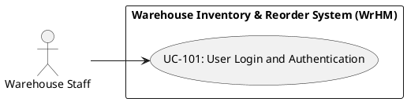
Main Flow
- 1.The user navigates to the login screen.
2.The user inputs their provided username/email and password.
3.The system validates the credentials
4.The system loads the user's role and associated permissions.
5.The system grants access and redirects to the role-specific dashboard within 2 seconds.
Alternative Flows: 3a. Invalid credentials: The system rejects the attempt with an error message and logs the failed attempt.
3b. Deactivated/Suspended account: The system displays a permission error message directing the user to contact the administrator
Postconditions: A secure session token is established, and user access rights are enforced
Related requirements: FR-101, FR-102

UC-102 - Provision User Account and Manage Lifecycle
- **Primary actor:** IT Administrator
- **Goal:** Create a new user profile, assign an operational role, and deactivate accounts that must no longer access the system
- **Trigger:** Onboarding of new warehouse personnel or personnel role change
- **Frequency:** Low
- **Preconditions:** The administrator is logged in with authorized administrative privileges.
Use Case Diagram (PlantUML, auto-generated)
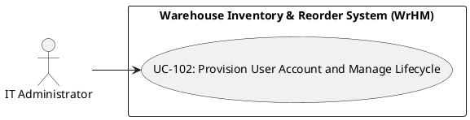
Main Flow
- 1.The administrator navigates to the User Management console.
2.The administrator selects "Create User" and enters the employee's name, email/username, and temporary password.
3.The administrator assigns a system role (e.g., Warehouse Staff, Inventory Controller, Warehouse Manager).
4.The administrator confirms and submits the account form.
5.The system verifies username/email uniqueness and creates the account record.
6.The system writes an entry to the immutable audit log recording account creation and role assignment.
Alternative Flows: 1a. Deactivate account: The administrator selects an active user profile and triggers Deactivate Account. The system sets is_active = False, writes a DEACTIVATE_USER entry to the audit log, and rejects subsequent login attempts by that user.
5a. Duplicate username/email: The system blocks creation and prompts for a unique identifier.
5b. Missing required fields: The system displays inline validation errors highlighting required fields.
Postconditions: A new user account is registered in the database with role permissions mapped.
Related requirements: FR-101, FR-102, FR-103

UC-103 - Review System Audit Logs
- **Primary actor:** Warehouse Manager
- **Goal:** Inspect historical system actions to investigate operational discrepancies or verify compliance
- **Trigger:** Periodic operational compliance review or discrepancy investigation.
- **Frequency:** Medium
- **Preconditions:** The user is authenticated with Manager or Administrator access.
Use Case Diagram (PlantUML, auto-generated)
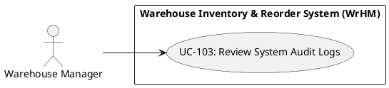
Main Flow
- 1.The manager navigates to the Audit & Compliance log viewer.
2.The system retrieves and displays the chronologically sorted log entries showing timestamp, user ID, event type, and details.
3.The manager applies filters by date range, specific user, or operation category (e.g., account provision, stock adjustments).
4.The system returns filtered, read-only audit records
Alternative Flows: 4a. No records match criteria: The system displays a message indicating no matching records found.
Postconditions: Audit records remain strictly immutable and read-only.
Related requirements: FR-102, FR-103

UC-104 - Manage Product and Supplier Catalog
- **Primary actor:** Inventory Controller
- **Goal:** Create, update, or archive product SKU profiles and supplier records
- **Trigger:** Introduction of new warehouse inventory, packaging adjustments, or vendor contract changes.
- **Frequency:** High (daily)
- **Preconditions:** The inventory controller is logged in with catalog editing permissions.
Use Case Diagram (PlantUML, auto-generated)
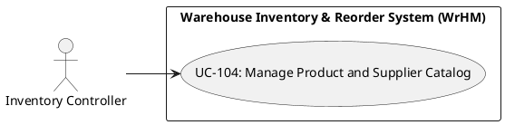
Main Flow
- 1.The controller navigates to the Catalog Management view.
2.The controller selects to add a new SKU or edit an existing one.
3.The controller inputs SKU details: product code, barcode, descriptive name, category, unit of measure (UOM), supplier, and the tracking flags requires_batch and requires_expiry.
4.The controller optionally uploads an image thumbnail for the item.
5.The controller submits the catalog form.
6.The system validates uniqueness of SKU code and barcode, confirms both tracking flags are boolean values, then saves the profile.
Alternative Flows: 2a. Archive SKU: The controller selects an existing SKU and triggers Archive SKU. The system verifies that the on-hand stock equals zero, sets status = ARCHIVED, and logs the event; if on-hand stock is greater than zero the system rejects the operation.
4a. No image provided: The system links a generic placeholder icon to the SKU profile.
6a. Duplicate SKU or barcode: The system alerts the user that the code exists and rejects creation.
6b. Non-boolean tracking flag: The system rejects the value and leaves the stored flag unchanged.
Postconditions: The product catalog record is updated and immediately available for warehouse lookup and inbound receiving.
Related requirements: FR-104, FR-105, FR-107

UC-105 - Configure SKU Inventory Parameters
- **Primary actor:** Inventory Controller
- **Goal:** Configure operational thresholds and location mappings per SKU.
- **Trigger:** Quarterly demand policy reviews, supplier lead time changes, or inventory restocking audits
- **Frequency:** Low
- **Preconditions:** The target SKU exists within the master catalog.
Use Case Diagram (PlantUML, auto-generated)
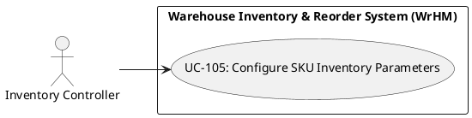
Main Flow
- 1.The controller searches for and selects an existing SKU.
2.The system presents the current threshold configuration and allocation policy.
3.The controller inputs or modifies the Reorder Point (ROP), Minimum Order Quantity (MOQ), default storage bin assignment, and allocation policy (FIFO or FEFO).
4.The controller saves the configuration.
5.The system validates that numeric threshold values are non-negative, that the selected bin exists and is active, and that the allocation policy is FIFO or FEFO.
6.The system updates the parameters and records an audit log entry.
Alternative Flows: 5a. Non-existent bin specified: The system prompts an error stating the bin location is invalid.
5b. ROP set higher than bin physical capacity: The system displays a warning regarding over-capacity risk.
5c. Allocation policy other than FIFO or FEFO: The system rejects the value and lists the two permitted options.
Postconditions: SKU operational parameters are updated and consumed by replenishment calculation runs
Related requirements: FR-103, FR-105

UC-106 - Manage Warehouse Storage Hierarchy
- **Primary actor:** Warehouse Manager
- **Goal:** Define, expand, or modify the physical warehouse storage topology down to the bin level.
- **Trigger:** Warehouse layout reconfiguration, facility expansion, or bin re-labeling.
- **Frequency:** Low
- **Preconditions:** The user is logged in with Warehouse Manager privileges.
Use Case Diagram (PlantUML, auto-generated)
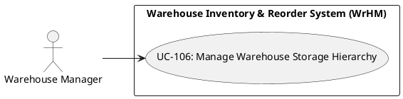
Main Flow
- 1.The manager accesses the Storage Hierarchy and Bin Configuration screen.
2.The manager views the hierarchical storage tree (Zone > Aisle > Rack > Shelf > Bin).
3.The manager defines a new storage node or edits an existing location's properties (e.g., storage type, capacity).
4.The manager confirms the layout changes.
5.The system verifies that the coordinate code (e.g., Z1-A02-R03-S1-B04) is globally unique within the facility and that the bin capacity is a positive integer.
6.The system stores the location node and enables it for stock placement.
Alternative Flows: 3a. Deactivating/Deleting a bin with on-hand inventory: The system blocks deletion and displays an error requiring stock relocation prior to removal.
5a. Coordinate conflict detected: The system displays a duplicate coordinate error.
5b. Capacity not a positive integer: The system rejects the node and requires a capacity greater than zero.
Postconditions: The warehouse topology is updated and ready to support put-away and picking routes.
Related requirements: FR-103, FR-106

UC-107 - Display item image icons in catalog and search
- **Primary actor:** Inventory Controller
- **Goal:** Display thumbnail icons or placeholder for items in stock lists and search results
- **Trigger:** User browses stock list or performs item lookup
- **Frequency:** Low
- **Preconditions:** SKU exists in catalog
Use Case Diagram (PlantUML, auto-generated)
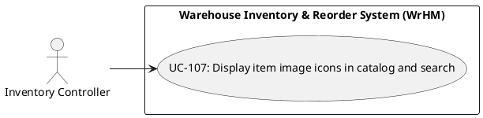
Main Flow
- 1.The controller or user views the stock list or search results.
2.The system loads the SKU image if associated.
3.The system renders the thumbnail or generic placeholder.
4.The system displays results within acceptable time.
Alternative Flows: 3a. No image associated: The system displays the standard placeholder icon.
Postconditions: Item list/search results display an icon (thumbnail or placeholder) for each SKU.
Related requirements: FR-107

UC-201 - Receive Goods
- **Primary actor:** Warehouse Staff
- **Goal:** Receive purchased goods into the warehouse
- **Trigger:** Goods arrive at the warehouse
- **Frequency:** High (daily)
- **Preconditions:** Warehouse staff is using an approved purchase order; SKU and bin exist.
Use Case Diagram (PlantUML, auto-generated)
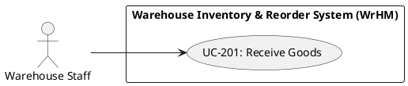
Main Flow
- 1. Open Goods Receiving.
- 2. Choose a purchase order and enter received goods.
- 3. Check batch/expiry information when needed.
- 4. Confirm the receipt.
Alternative Flows: Missing purchase order, invalid quantity, full bin or an expired item → show an error; do not confirm.
Postconditions: Confirmed receipt is recorded once; draft alone does not affect stock.
Related requirements: FR-201, FR-202

UC-202 - Issue Goods
- **Primary actor:** Warehouse Staff
- **Goal:** Issue goods against available inventory
- **Trigger:** Staff needs to dispatch goods
- **Frequency:** High (daily)
- **Preconditions:** Warehouse staff is working with available stock.
Use Case Diagram (PlantUML, auto-generated)
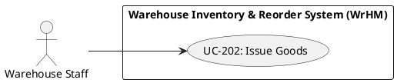
Main Flow
- 1. Open Goods Issuing.
- 2. Select products and enter an issue quantity.
- 3. Check available stock.
- 4. Confirm the issue.
Alternative Flows: Insufficient or ineligible stock → refuse confirmation; do not deduct inventory.
Postconditions: Confirmed issue reduces eligible stock once.
Related requirements: FR-203, FR-204

UC-203 - Scan and Count Goods
- **Primary actor:** Warehouse Staff
- **Goal:** Identify and count products by scanning
- **Trigger:** Staff needs to identify goods during an operation
- **Frequency:** Very high
- **Preconditions:** A registered barcode or SKU may be scanned using a keyboard/scanner device.
Use Case Diagram (PlantUML, auto-generated)
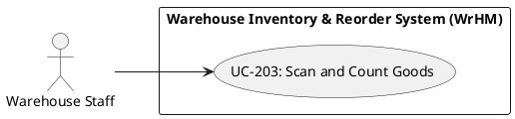
Main Flow
- 1. Open a receiving or issue note.
- 2. Scan the product QR code or barcode.
- 3. Review the product and scanned count.
Alternative Flows: Unknown, mismatched or ambiguous lot code → show an error or request the expected SKU; do not increase the count.
Postconditions: Product and count are identified; no automatic confirmation.
Related requirements: FR-205, FR-206

UC-204 - Handle Returned Goods
- **Primary actor:** Warehouse Staff
- **Goal:** Record and classify returned goods
- **Trigger:** A product is returned
- **Frequency:** Medium
- **Preconditions:** Warehouse staff can record a return for a registered SKU.
Use Case Diagram (PlantUML, auto-generated)
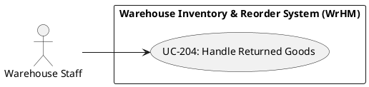
Main Flow
- 1. Open Returns.
- 2. Enter product, quantity, and return reason.
- 3. Inspect and classify the returned goods.
- 4. Save the result.
Alternative Flows: Invalid quantity or full bin → reject; damaged goods are quarantined.
Postconditions: Goods are recorded as accepted or quarantined.
Related requirements: FR-207, FR-208

UC-205 - Transfer Between Bins
- **Primary actor:** Warehouse Staff
- **Goal:** Move stock between storage bins
- **Trigger:** Goods must be moved to another bin
- **Frequency:** High (daily)
- **Preconditions:** Source/destination bins and the SKU exist.
Use Case Diagram (PlantUML, auto-generated)
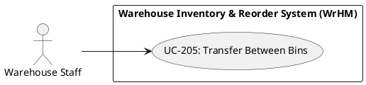
Main Flow
- 1. Open Bin Transfer.
- 2. Select source, destination, and quantity.
- 3. Save and confirm the transfer.
- 4. Check the bin quantities afterward.
Alternative Flows: Same bins, insufficient stock or full destination → refuse confirmation.
Postconditions: Source and destination bin balances change equally on confirmation.
Related requirements: FR-209, FR-210

UC-206 - Validate a Transfer
- **Primary actor:** Inventory Controller
- **Goal:** Validate stock, capacity and authorization
- **Trigger:** A bin transfer needs approval
- **Frequency:** High (daily)
- **Preconditions:** A draft stock transfer is present.
Use Case Diagram (PlantUML, auto-generated)
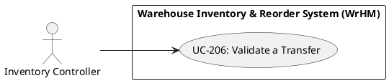
Main Flow
- 1. Choose a pending transfer.
- 2. Check source stock and destination location.
- 3. Check the user permission.
- 4. Approve or reject the transfer.
Alternative Flows: Unauthorized role or already confirmed transfer → reject.
Postconditions: Invalid or unauthorized transfers are rejected without stock movement.
Related requirements: FR-211, FR-212

UC-207 - Recommend FIFO Batches
- **Primary actor:** Inventory Controller
- **Goal:** Select batches according to FIFO
- **Trigger:** Staff selects FIFO for a goods issue
- **Frequency:** High (daily)
- **Preconditions:** A SKU has eligible inventory across one or more batches.
Use Case Diagram (PlantUML, auto-generated)
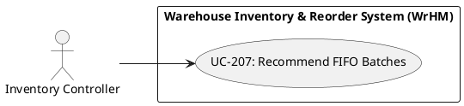
Main Flow
- 1. Open Goods Issuing.
- 2. Select FIFO and enter the required quantity.
- 3. Review recommended batches and allocation.
- 4. Confirm the selection.
Alternative Flows: Not enough eligible stock → no allocation; show an error.
Postconditions: Eligible batches are recommended in receiving-date order.
Related requirements: FR-213, FR-214

UC-208 - Recommend FEFO Batches
- **Primary actor:** Inventory Controller
- **Goal:** Select batches according to FEFO
- **Trigger:** Staff selects FEFO for a goods issue
- **Frequency:** High (daily)
- **Preconditions:** An expiry-controlled SKU has batches with known expiry dates.
Use Case Diagram (PlantUML, auto-generated)
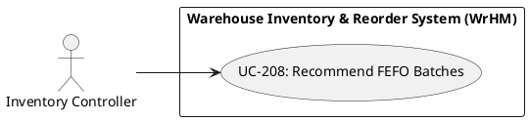
Main Flow
- 1. Open Goods Issuing.
- 2. Select FEFO and enter the required quantity.
- 3. Review the batches ordered by expiry date.
- 4. Select the recommended batches.
Alternative Flows: Expired batch, missing expiry or insufficient eligible stock → skip/reject.
Postconditions: Eligible batches are recommended in expiry-date order.
Related requirements: FR-215, FR-216

UC-301 - Initialize & Query Real-Time Stock Balances
- **Primary actor:** Order Service
- **Goal:** Initialize and retrieve real-time On-hand, Allocated, Locked, and ATP quantities for a SKU at a bin location.
- **Trigger:** Checkout or inventory inquiry request
- **Frequency:** Very high (continuous)
- **Preconditions:** SKU and warehouse bin location exist in master data.
Use Case Diagram (PlantUML, auto-generated)
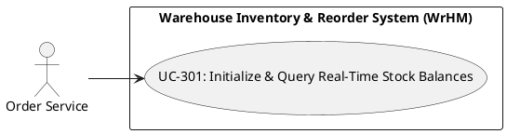
Main Flow
- Order Service sends stock initialization or balance query request
- System retrieves on_hand, allocated, and locked quantities
- System computes real-time ATP
- System returns stock balance payload
Alternative Flows: If SKU or bin does not exist, system returns KeyNotFoundError
Postconditions: Real-time stock balance is initialized or returned accurately.
Related requirements: FR-301

UC-302 - Reserve Order Stock & Deduct ATP
- **Primary actor:** Order Service
- **Goal:** Reserve available stock for an incoming customer order and deduct ATP immediately.
- **Trigger:** Customer places an order
- **Frequency:** High (daily)
- **Preconditions:** SKU is initialized at the bin location with real-time ATP.
Use Case Diagram (PlantUML, auto-generated)
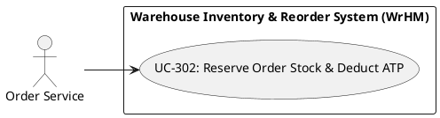
Main Flow
- Order Service submits reservation request with requested_qty
- System verifies ATP >= requested_qty
- System increases allocated by requested_qty
- System recalculates and deducts ATP while keeping on_hand unchanged
Alternative Flows: If ATP < requested_qty, system rejects reservation and raises InsufficientStockError
Postconditions: Allocated quantity increases and ATP decreases accordingly.
Related requirements: FR-302

UC-303 - Execute Reason-Based Stock Adjustment
- **Primary actor:** Inventory Controller
- **Goal:** Manually increase or decrease on-hand stock with a mandatory business reason code.
- **Trigger:** Physical damage, expiry, or stock discrepancy found
- **Frequency:** Medium (daily)
- **Preconditions:** Inventory Controller is authenticated; SKU exists in bin.
Use Case Diagram (PlantUML, auto-generated)
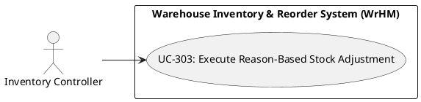
Main Flow
- Controller submits adjustment with sku, qty_delta, and reason_code
- System validates reason_code (DAMAGED, EXPIRED, LOST, FOUND, CYCLE_COUNT_SYNC)
- System verifies resulting on_hand >= 0 and ATP >= 0
- System updates on_hand and recalculates ATP
Alternative Flows: If adjustment results in negative on_hand or invalid reason_code, system rejects with NegativeStockError
Postconditions: On-hand and ATP balances are updated accurately.
Related requirements: FR-303

UC-304 - Verify Idempotent Adjustment Request
- **Primary actor:** Inventory Controller
- **Goal:** Prevent duplicate stock adjustments when network retries replay the same request.
- **Trigger:** Duplicate HTTP submission or network retry
- **Frequency:** Medium
- **Preconditions:** Adjustment request carries a unique idempotency_key.
Use Case Diagram (PlantUML, auto-generated)
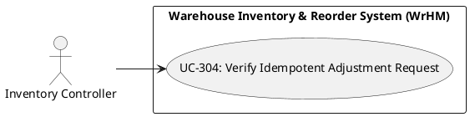
Main Flow
- Actor submits stock adjustment with idempotency_key
- System checks idempotency cache for existing key
- System processes new adjustment and caches response with TTL
- System returns transaction result
Alternative Flows: If idempotency_key already exists with identical payload, system returns cached transaction (is_replay=True) without double-counting
Postconditions: Adjustment is applied exactly once regardless of network retries.
Related requirements: FR-304

UC-305 - Record & Inspect Immutable Transaction Ledger
- **Primary actor:** Inventory Controller
- **Goal:** Permanently log every stock adjustment in an append-only audit ledger.
- **Trigger:** Completion of any stock adjustment
- **Frequency:** High (per transaction)
- **Preconditions:** A valid stock adjustment transaction has been executed.
Use Case Diagram (PlantUML, auto-generated)
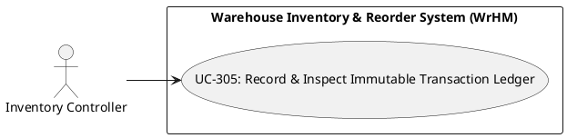
Main Flow
- System captures tx_id, sku, qty_delta, reason_code, on_hand_before, on_hand_after, and atp_after
- System appends immutable record to transaction ledger
- Auditor or Controller queries historical ledger entries
Alternative Flows: If any actor attempts UPDATE or DELETE on existing ledger records, system blocks with ImmutableLedgerError
Postconditions: Immutable audit trail entry is persisted permanently.
Related requirements: FR-305

UC-306 - Generate Blind Cycle Count Sheet
- **Primary actor:** Inventory Controller
- **Goal:** Initiate a cycle count session and generate a blind count sheet that masks system quantities.
- **Trigger:** Scheduled periodic inventory audit
- **Frequency:** Medium (weekly)
- **Preconditions:** SKU has active inventory in the target bin location.
Use Case Diagram (PlantUML, auto-generated)
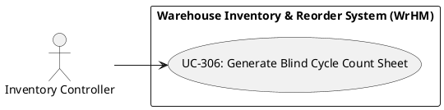
Main Flow
- Controller initiates blind cycle count session for SKU and bin
- System snapshots current on_hand as snapshot_expected_qty
- Warehouse Clerk requests count sheet
- System strips snapshot_expected_qty and returns blind sheet
Alternative Flows: If unauthorized clerk requests expected quantity field, API serializer strips all restricted bytes
Postconditions: Blind count session is created and expected quantity is hidden from clerk.
Related requirements: FR-306

UC-307 - Submit Physical Count & Compute Discrepancy
- **Primary actor:** Warehouse Staff
- **Goal:** Submit physical counted quantity and automatically compute count variance.
- **Trigger:** Clerk finishes physical bin count
- **Frequency:** Medium (weekly)
- **Preconditions:** Blind cycle count session is in_progress.
Use Case Diagram (PlantUML, auto-generated)
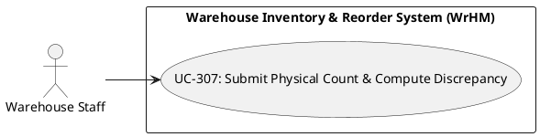
Main Flow
- Warehouse Clerk physically counts items in bin
- Clerk submits counted_qty >= 0 for session_id
- System retrieves hidden snapshot_expected_qty
- System computes Variance = counted_qty - snapshot_expected_qty
Alternative Flows: If counted_qty < 0, system rejects submission with InvalidQuantityError
Postconditions: Physical count and exact variance are recorded on the session.
Related requirements: FR-307

UC-308 - Reconcile Count Variance by Threshold
- **Primary actor:** Inventory Controller
- **Goal:** Automatically reconcile minor count variances or hold major variances for supervisor review.
- **Trigger:** Variance calculation completed
- **Frequency:** Medium (weekly)
- **Preconditions:** Physical count has been submitted and variance calculated.
Use Case Diagram (PlantUML, auto-generated)
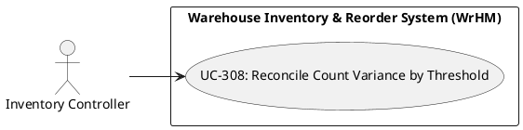
Main Flow
- System evaluates absolute variance against configured threshold
- If |Variance| <= threshold, system auto-invokes stock adjustment and marks session completed
- Supervisor reviews any held sessions
Alternative Flows: If |Variance| > threshold, system sets status to pending_approval and awaits supervisor approval or rejection
Postconditions: Inventory balance is reconciled or held for supervisor sign-off.
Related requirements: FR-308

UC-401 - Configure SKU Replenishment Policy
- **Primary actor:** Inventory Controller
- **Goal:** Set the ROP, safety stock, supplier lead time, MOQ and order multiple that the replenishment engine uses for a SKU.
- **Trigger:** Controller changes a replenishment parameter during a periodic policy review.
- **Frequency:** Quarterly per SKU, or whenever a supplier lead time changes.
- **Preconditions:** The user is logged in with Inventory Controller privileges. The SKU and its primary supplier exist and are active in the catalog.
Use Case Diagram (PlantUML, auto-generated)
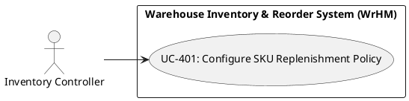
Main Flow
- 1.The controller opens the replenishment policy screen and searches for SKU-WIDGET-01.
2.The system displays the current ROP, safety stock, lead time, MOQ and order multiple.
3.The controller edits the values (ROP 50, safety stock 30, lead time 7 days, MOQ 25, order multiple 25) and saves.
4.The system validates that ROP and safety stock are non-negative, lead time is at least one day, MOQ and order multiple are positive and the order multiple divides the MOQ.
5.The system stores the policy and refreshes the low-stock flag for the SKU on the next cycle or on demand.
Alternative Flows: 3a. SKU has no supplier assigned: the system blocks saving and links to supplier assignment.
4a. A validation rule fails: the system highlights the offending field and stores nothing.
4b. MOQ is not a multiple of the order multiple: the system rounds the MOQ up and asks the controller to confirm.
Postconditions: The SKU policy is stored and consumed by the next replenishment cycle and by the low-stock evaluation.
Related requirements: FR-401

UC-402 - Monitor Low-Stock Alerts and Dashboard
- **Primary actor:** Inventory Controller
- **Goal:** See every SKU at or below its reorder point and decide whether to raise an order or dismiss the alert.
- **Trigger:** Stock-out posting, a replenishment cycle execution, or dashboard access.
- **Frequency:** Continuous monitoring; reviewed at least once per shift.
- **Preconditions:** The user is logged in as Inventory Controller and active SKUs have a configured ROP.
Use Case Diagram (PlantUML, auto-generated)
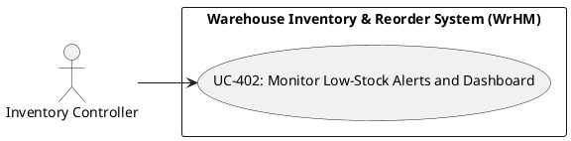
Main Flow
- 1.The controller opens the low-stock dashboard.
2.The system lists every active SKU whose available stock is at or below the ROP, with available quantity, ROP, shortage and open suggestion status.
3.The controller filters by supplier, category or shortage severity and opens a SKU row.
4.The system shows the stock ledger, reservations and the calculation basis of the suggestion.
5.The controller drills into the suggestion or dismisses the alert with a reason.
Alternative Flows: 2a. No SKU is below its ROP: the dashboard shows an empty state with the last evaluation timestamp.
4a. Ledger data is older than the alert latency target: the system shows a staleness warning with the last refresh time.
Postconditions: Every alert has an auditable decision - an open suggestion or a dismissal with a recorded reason.
Related requirements: FR-402, FR-403

UC-403 - Execute Automated Replenishment Cycle
- **Primary actor:** System Scheduler / Timer
- **Goal:** Evaluate the whole active catalog, calculate suggested quantities and persist one suggestion per uncovered SKU at or below its ROP.
- **Trigger:** Scheduled timer, or an on-demand run initiated by an Inventory Controller.
- **Frequency:** Daily by default; on demand after bulk stock movements.
- **Preconditions:** The scheduler service is running, SKUs have replenishment policies and at least one active supplier exists.
Use Case Diagram (PlantUML, auto-generated)
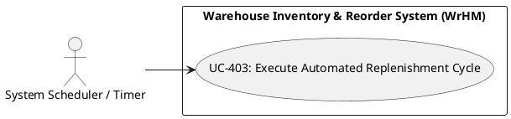
Main Flow
- 1.The scheduler triggers the cycle at the configured time (default 01:00).
2.The system loads every active SKU with its policy, available stock, reservations and demand history.
3.The system computes the suggested quantity for each SKU at or below its ROP.
4.The system creates or refreshes one open suggestion per SKU and supplier, skipping SKUs already covered by an open suggestion or an incoming order.
5.The system writes an execution record with timestamps, SKUs evaluated and suggestions created.
6.The system publishes the counts to the dashboard and sends a summary notification to the controller.
Alternative Flows: 1a. The scheduled window was missed: the system runs the cycle once at startup and marks the execution as RECOVERED.
2a. Demand history is missing: the system falls back to ROP minus available stock and flags the suggestion as FALLBACK.
3a. A SKU has no supplier: the system skips it and records a configuration error.
4a. The cycle is interrupted: it is marked FAILED, partial suggestions are kept and flagged for review.
Postconditions: Open suggestions exist for every uncovered SKU at or below ROP and an execution record is stored.
Related requirements: FR-403, FR-404

UC-404 - Review Reorder Suggestions and Create Purchase Orders
- **Primary actor:** Inventory Controller
- **Goal:** Turn accepted replenishment suggestions into draft purchase orders grouped by supplier.
- **Trigger:** Suggestion review after the nightly replenishment cycle.
- **Frequency:** Daily.
- **Preconditions:** At least one open suggestion exists, the controller is logged in and supplier prices are on file.
Use Case Diagram (PlantUML, auto-generated)
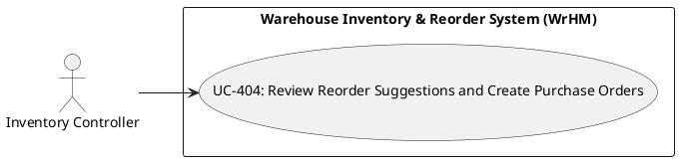
Main Flow
- 1.The controller opens the suggestion queue grouped by supplier.
2.The system displays SKU, supplier, available stock, ROP, suggested quantity, inputs and unit price.
3.The controller selects the suggestions to order and, if needed, adjusts quantities (never below MOQ, always a multiple of the order multiple).
4.The controller chooses 'Create purchase orders'.
5.The system groups the selection by supplier, creates one draft purchase order per supplier with line items, unit price and expected delivery date, and links each suggestion to its order line.
6.The system recalculates the order totals and removes the converted suggestions from the open queue.
Alternative Flows: 3a. Quantity below MOQ or not a multiple of the order multiple: rejected with an explicit error.
4a. A suggestion was already converted: the system excludes it and warns the controller.
5a. The supplier is inactive or has no price on file: conversion is blocked for that supplier and the suggestion stays open.
Postconditions: Draft purchase orders exist, suggestions are linked and no longer appear in the open queue.
Related requirements: FR-404, FR-405

UC-405 - Adjust or Dismiss a Reorder Suggestion
- **Primary actor:** Inventory Controller
- **Goal:** Override the engine's proposed quantity or dismiss an alert with a documented reason.
- **Trigger:** A controller disagrees with a suggested quantity or knows that a shortage is already covered.
- **Frequency:** Several times per week.
- **Preconditions:** The controller is logged in and at least one suggestion is open.
Use Case Diagram (PlantUML, auto-generated)
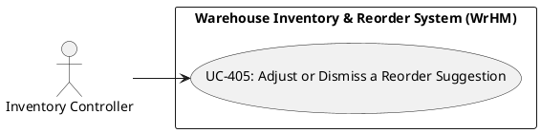
Main Flow
- 1.The controller opens an open suggestion.
2.The controller enters a new quantity or chooses Dismiss.
3.The system validates the quantity against the MOQ and the order multiple, or requires a dismissal reason.
4.The system records the adjustment or dismissal and the actor.
5.The suggestion leaves the open queue (converted or dismissed) and the low-stock alert is updated accordingly.
Alternative Flows: 2a. Quantity is below the MOQ: the system rejects the value and states the minimum.
2b. Quantity is not a multiple of the order multiple: the system rejects the value and lists the valid quantities.
2c. Dismissal without a reason: the system blocks the action.
3a. The suggestion was already converted: the system rejects the change and refreshes the queue.
Postconditions: The suggestion is adjusted with a validated quantity, or dismissed with a recorded reason; the queue reflects the decision.
Related requirements: FR-405

6.4 Use Case Coverage Evaluation
28/28 (100.0%) of use cases are linked to at least one requirement.

6.5 Use Case Complexity and Effort Estimation
Complexity proxy: 0.5 person-day per main-flow step, plus 0.5 day if an alternative flow is documented (covers design, implementation and unit-level test of that use case):
Use Case ID | Main Flow Steps | Alt. Flows? | Estimated Effort (days)
UC-101 | 1 | 1 | 1
UC-102 | 1 | 1 | 1
UC-103 | 1 | 1 | 1
UC-104 | 1 | 1 | 1
UC-105 | 1 | 1 | 1
UC-106 | 1 | 1 | 1
UC-107 | 1 | 1 | 1
UC-201 | 4 | 1 | 2.5
UC-202 | 4 | 1 | 2.5
UC-203 | 3 | 1 | 2
UC-204 | 4 | 1 | 2.5
UC-205 | 4 | 1 | 2.5
UC-206 | 4 | 1 | 2.5
UC-207 | 4 | 1 | 2.5
UC-208 | 4 | 1 | 2.5
UC-301 | 4 | 1 | 2.5
UC-302 | 4 | 1 | 2.5
UC-303 | 4 | 1 | 2.5
UC-304 | 4 | 1 | 2.5
UC-305 | 3 | 1 | 2
UC-306 | 4 | 1 | 2.5
UC-307 | 4 | 1 | 2.5
UC-308 | 3 | 1 | 2
UC-401 | 1 | 1 | 1
UC-402 | 1 | 1 | 1
UC-403 | 1 | 1 | 1
UC-404 | 1 | 1 | 1
UC-405 | 1 | 1 | 1
Total estimated realization effort across all use cases: 50.5 person-days.

7. Chapter 7 - Modeling Techniques and Diagrammatic Notations

7.1 Objectives
- Generate use-case and requirements-dependency diagrams from the actor, use-case, and requirement data.
- Add a cycle-count state machine and a system-wide DFD Level-1 to document lifecycle states and data exchanges.
- Provide PlantUML and Graphviz source files so the diagrams can be rendered again after model changes.
- Quantify model complexity and estimate the effort needed to maintain the diagrams.

7.2 Use Case Diagram (PlantUML, auto-generated)
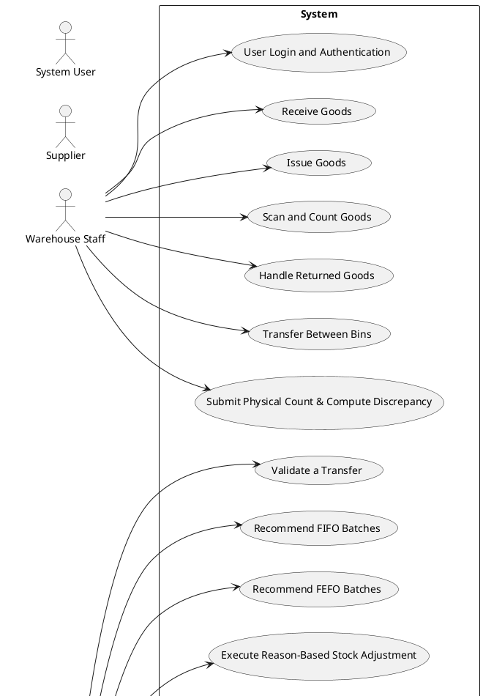
Diagram continued (2 of 3)
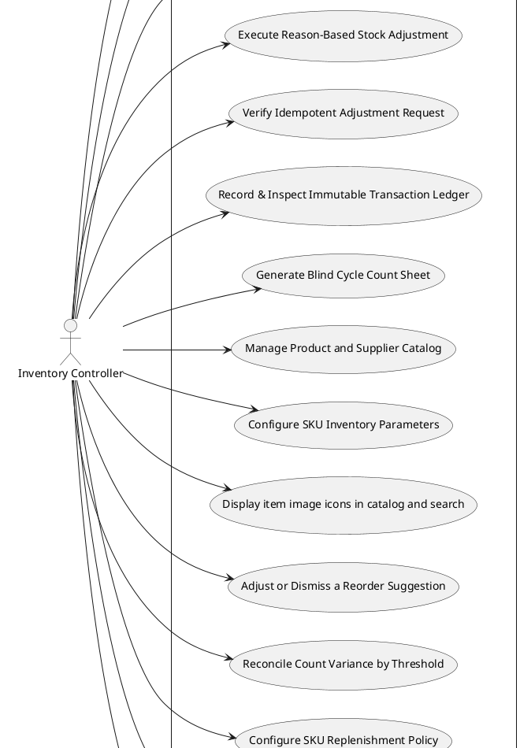
Diagram continued (3 of 3)
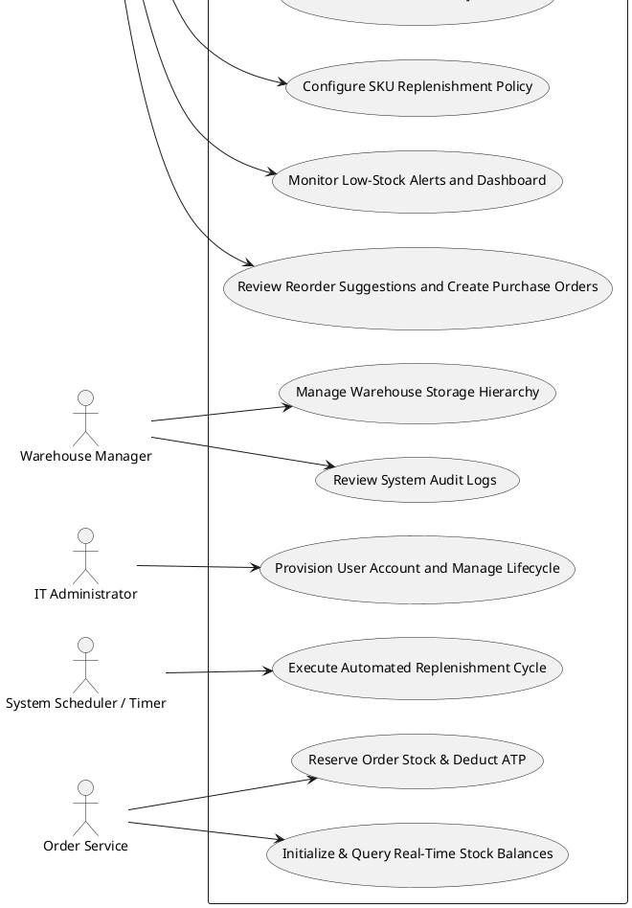

7.3 Requirements Dependency Diagram (PlantUML, auto-generated)

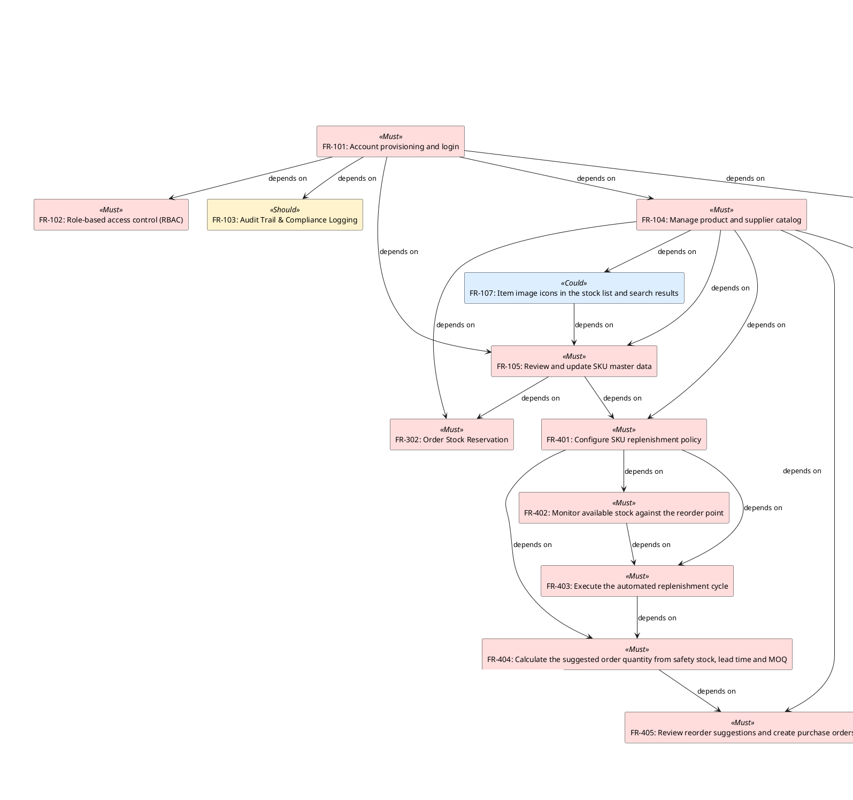

Diagram continued (2 of 2)

7.4 State Machine Diagram
This state machine follows FR-306–FR-308 and UC-306–UC-308. A session begins with a blind count, records the submitted quantity and variance, then either reconciles automatically within the configured threshold or moves to pending_approval. UC-308 states that a supervisor approves or rejects held sessions but does not define the resulting inventory or session status; the model ends at that decision boundary.
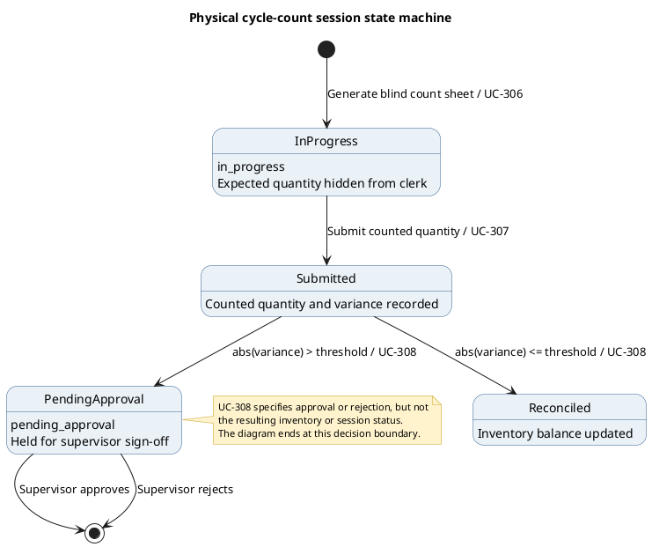
Figure 7.4.1. Cycle-count session state machine.

7.5 DFD Level-1
This system-wide DFD decomposes WrHM into four processes and shows its external entities, logical data stores, and labeled exchanges for access and master-data management, stock movements and cycle counts, replenishment, and reporting.
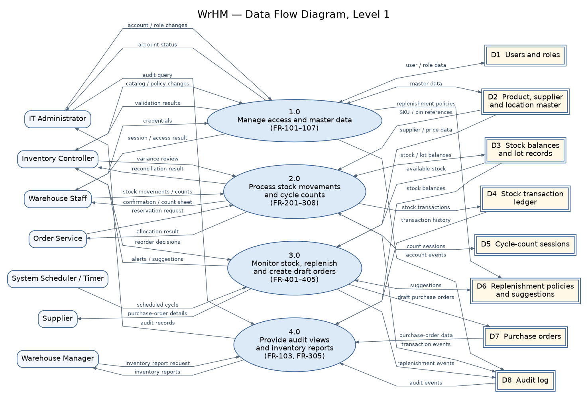
Figure 7.5.1. System-wide DFD Level-1 for WrHM.

7.6 Notation Guidance
- Use-case diagrams capture actor-to-goal relationships using UML 2.5 notation.
- Requirements-dependency diagrams use the documented simplified rectangle notation, colour-coded by MoSCoW priority.
- The cycle-count state machine uses UML state notation. It covers FR-306–FR-308 and UC-306–UC-308; the outcome after supervisor approval or rejection is not specified in the SRS.
- The DFD Level-1 uses numbered processes, external-entity boxes, double-line data-store symbols, and labeled directional data flows.
- PlantUML and Graphviz source files are included with the SRS diagrams and can be rendered with their respective tools.

7.7 Model Completeness Evaluation
- 28/28 (100.0%) of use cases have their primary actor resolved in the diagram (unresolved actors indicate a naming mismatch between the actors and use_cases datasets).
- The state machine covers the cycle-count states and transitions specified by FR-306–FR-308 and UC-306–UC-308, ending at the documented supervisor decision boundary.
- The DFD Level-1 contains 7 external entities, 4 processes, 8 logical data stores, and 38 connectors representing 43 directional data flows.

7.8 Model Complexity Metrics and Maintenance Effort Estimation
Diagram | Elements | Relationships
Use Case Diagram | 36 | 28
Requirements Dependency Diagram | 36 | 37
Cycle-count State Machine | 6 | 6
DFD Level-1 | 19 | 43
Across the use-case and dependency diagrams, the baseline remains 72 modeled elements and 65 relationships. The state machine adds 6 elements and 6 transitions; the DFD Level-1 adds 19 elements and 43 directed data flows. The updated total is 97 modeled elements and 114 relationships. At the illustrative rate of 0.1 person-day per element or relationship, estimated maintenance effort is 21.1 person-days.

8. Chapter 9 - Tool Support for Requirements Engineering

8.1 Objectives
- Catalogue the tools used to support requirements elicitation, management, and modeling.
- Summarize tool coverage by category (RM tool, modeling tool, collaboration tool, etc.).
- Highlight gaps where a requirements-engineering activity has no supporting tool.
- Estimate the one-time onboarding effort for the current tool set.

8.2 Tool Inventory (Information)
ID | Name | Category | Purpose | Strengths | Limitations
TL-01 | Python 3 | Language / runtime | Implement the requirement toolkit, simulators and the prototype server (standard library: http.server, sqlite3, csv, unittest). | One language across tooling and prototype; no external runtime needed. | The standard-library HTTP server is basic and is not a production web framework.
TL-02 | SQLite | Database (prototype) | Store users, SKUs, inventory, suppliers, transactions and audit logs in the prototype. | Zero-configuration and file-based; ships with Python. | Single-writer; prototype-only, not intended for concurrent production load.
TL-03 | PostgreSQL | Database (target) | Planned production store for the same schema once the prototype is validated. | Strong concurrency, transactional integrity and mature tooling. | Requires a database server and driver; not used in the prototype.
TL-04 | HTML/CSS/JavaScript | Frontend | Browser UI for the stock list, dashboard and data-entry forms. | Universal and needs no build step. | Hand-written DOM code without a component framework.
TL-05 | matplotlib | Charting | Render the NFR simulation charts and coverage figures. | Integrates directly with the Python data pipeline. | Produces static images only; not interactive.
TL-06 | openpyxl | Spreadsheet I/O | Read and write WareHouse.xlsx so the workbook stays in sync with the CSV datasets. | Keeps the workbook and canonical CSVs consistent. | xlsx-specific and slower on very large workbooks.
TL-07 | unittest | Testing | Run the requirement-consistency and safety-scenario test suites. | Built into Python and runs headless in the pipeline. | Verbose output; no features beyond the standard library.
TL-08 | Git + GitHub | Version control | Track changes and submit the project. | Distributed, widely used and free hosting. | Merge conflicts must be resolved manually.
TL-09 | VS Code | IDE | Edit, run and debug the scripts and datasets. | Extensible with strong Python support. | Not required at runtime.
TL-10 | LaTeX (pdflatex) | Typesetting | Produce the final report and the SRS PDF. | Professional output with dynamic cross-references. | Steeper syntax and an extra toolchain to install.
TL-11 | Python requirements_toolkit | RE tool | Generate requirements and coverage artifacts | Uses structured requirements data | Local tool; integration output should be reviewed.
TL-12 | Microsoft Excel | Documentation | Maintain FR, UC, test cases and traceability | Easy to share with group | Manual synchronization may cause mismatches.
TL-13 | VS Code / Python | Development | Run a local Module 2 demo and its unit tests | Quick local checks | Demo does not validate the integrated four-module system.

8.3 Tool Coverage by Category (Calculation)
Category | Count
Language / runtime | 1
Database (prototype) | 1
Database (target) | 1
Frontend | 1
Charting | 1
Spreadsheet I/O | 1
Testing | 1
Version control | 1
IDE | 1
Typesetting | 1
RE tool | 1
Documentation | 1
Development | 1

8.4 Tooling Coverage Evaluation
Category gaps identified: RM tool, Modeling tool, Collaboration tool, Traceability tool, Test management tool — consider adding tool support for these RE activities.

8.5 Tool Onboarding Effort Estimation
Assuming 2 person-days per tool for initial training and configuration (an illustrative planning constant), onboarding the current 13 tool(s) is estimated at 26 person-days in total.

9. Chapter 11 - Requirements Elicitation and Analysis Techniques

9.1 Objectives
- Log every elicitation session (technique, participants, objective, findings).
- Trace which requirements were derived from which elicitation session.
- Compute a value/effort prioritization ranking (weighted scoring) over the elicited requirements.
- Estimate the total facilitator/participant effort already invested in elicitation.

9.2 Requirement Prioritization (Weighted Scoring, value/effort)
Rank | ID | Title | Priority | Complexity (effort proxy) | Value/Effort Ratio
1 | FR-101 | Account provisioning and login | Must | 2 | 2.0
2 | FR-104 | Manage product and supplier catalog | Must | 2 | 2.0
3 | FR-105 | Review and update SKU master data | Must | 2 | 2.0
4 | FR-107 | Item image icons in the stock list and search results | Could | 1 | 2.0
5 | FR-201 | Create Draft Goods Receipt | Must | 2 | 2.0
6 | FR-203 | Create Goods Issue Note | Must | 2 | 2.0
7 | FR-204 | Confirm Goods Issue | Must | 2 | 2.0
8 | FR-205 | Identify Product by QR/Barcode | Must | 2 | 2.0
9 | FR-206 | Count Goods by Scanning | Must | 2 | 2.0
10 | FR-207 | Create Return Note | Must | 2 | 2.0
11 | FR-208 | Classify Returned Goods | Must | 2 | 2.0
12 | FR-209 | Create Bin Transfer Note | Must | 2 | 2.0
13 | FR-212 | Check Transfer Permission | Must | 2 | 2.0
14 | FR-301 | Real-Time Stock Visibility | Must | 2 | 2.0
15 | FR-307 | Count Submission & Discrepancy Calculation | Must | 2 | 2.0
16 | FR-401 | Configure SKU replenishment policy | Must | 2 | 2.0
17 | FR-402 | Monitor available stock against the reorder point | Must | 2 | 2.0
18 | FR-103 | Audit Trail & Compliance Logging | Should | 2 | 1.5
19 | FR-305 | Stock Transaction History | Should | 2 | 1.5
20 | FR-102 | Role-based access control (RBAC) | Must | 3 | 1.333
21 | FR-106 | Bin and location hierarchy management | Must | 3 | 1.333
22 | FR-202 | Confirm Goods Receipt | Must | 3 | 1.333
23 | FR-210 | Confirm Bin Transfer | Must | 3 | 1.333
24 | FR-211 | Validate Transfer Stock and Capacity | Must | 3 | 1.333
25 | FR-302 | Order Stock Reservation | Must | 3 | 1.333
26 | FR-303 | Reason-Based Stock Adjustment | Must | 3 | 1.333
27 | FR-304 | Duplicate Transaction Prevention | Must | 3 | 1.333
28 | FR-306 | Blind Count Sheet Generation | Must | 3 | 1.333
29 | FR-403 | Execute the automated replenishment cycle | Must | 3 | 1.333
30 | FR-404 | Calculate the suggested order quantity from safety stock, lead time and MOQ | Must | 3 | 1.333

