AI-Enhanced Stock Forecasting Decision Support System

Group 1A

Members:

石聰 – 1093532

陳錦顒 – 1103544

奧馬爾 – 1103553

林米克 – 1103558

諾吉 - 1103559

**Abstract**

The world finance and stock market is very complex to navigate and succeed. As a trader, you have to constantly pay attention to the companies’ stocks and market value fluctuate. Traders make a decision based on the current situation and they decide whether to buy or sell.

Nowadays, we have existing IT tools that aid traders and investors with more insight in order to make an informed decision. Unfortunately, the current system is far from perfect as it lacks the adaptability to account for the present situation when providing an option. Not only that, the current system’s baseline programming still cannot eliminate human biases; this brings in uncertainty.

This document proposes an AI driven model utilizing Long Short Term Memory (LSTM) Networks for stock market predictions & forecasting. By analyzing past records while also taking the current situation into account, our goal is for this AI model to provide more decision-making accuracy through minimization or perhaps completely eliminating the element of human biases.

This model addresses the limitations of adaptability of the rule based systems that exist in modern IT tools such as Business Intelligence Tools and MIS. This LSTM approach offers tailored recommendations based on each investor's risk tolerance and investment objectives, providing a more customized, data-driven approach to financial planning.

**Introduction**

In the domain of Finance & Economics, financial decisions are important for individual success which often leads to the stability, robustness and perhaps, growth of the global economy. Traditionally speaking, effective decision-making requires observation of common patterns, learning from those patterns, and utilizing knowledge from past experience and past decisions along with its corresponding outcomes, which potentially leads to the best course towards a suitable decision. However, these traditional methods still rely on human intuition, experience, and behavioral influences, which can introduce uncertainty.

Business Intelligence (BI) tools and Management Information Systems (MIS) tools, that provide aid in evaluating risks and possible rewards still cannot fully eliminate the biases inherent in human-led decision-making processes. The empirical nature of financial decision-making may seem experimental to some, but for experts in Statistics, Behavioral Science, and Economics, statistical inference and econometric methods are standard. Yet, despite these models, the element of uncertainty continues to affect accuracy and reliability, and human supervision remains integral due to the influence of behavioral psychology.

Despite big data mining and business intelligence tools having made significant achievements, recognitions and advances recently, the decision-making aspect in the domain of finance still encounters errors that lead to considerable losses for investors and traders alike. One notable limitation of BI and MIS systems is the reliance on a complex set of predetermined and hardcoded rules that may sometimes lack situational awareness and the ability to adapt given an abrupt change of events. This rigidity in rule-based systems often results in subpar financial decisions, especially in a field as complex and dynamic as finance, where conditions and market trends can change gradually over time or even instantly based on the degree of current events.

As of now, there is no perfect financial decision making AI automated system that can fully replicate human intelligence and intuition and can go through a huge amount of past data and take into considerations the ever changing ground realities and make autonomous decisions which are based on an updated risk-reward assessment.

In this project, we aim to develop an AI model based on Long Short-Term Memory (LSTM) networks for predicting stock market movements. This LSTM-based approach is designed to overcome the limitations of conventional methods by incorporating real-time data to improve the precision and reliability of financial decisions. The model could empower investors with more personalized insights, offering options that match their unique risk tolerance and investment objectives—whether low-risk choices for conservative investors or higher-risk alternatives for those pursuing growth. In this way, investors can make decisions aligned with their goals and preferences, creating a flexible and customized approach to financial decision-making.

**Literature review**  
  
A comprehensive review of the existing literature on AI-Enhanced Stock Forecasting Decision Support Systems (DSS) within the financial sector was performed. Overall, it has been observed that the application of DSS for stock price prediction is a developing research area with considerable prospects.

Patalay and Rao [(1)](https://www.researchgate.net/publication/355357714_Artificial_Intelligence_Based_System_for_Financial_Decision_Support) propose that their model will rely on mathematical models of different financial variables to forecast stock prices over the long term. This study emphasizes the application of two Machine Learning Models: Linear Regression and Artificial Neural Networks (ANNs). They demonstrate that ANN has better accuracy due to the ability to generate non-linear outputs. Therefore, it can be deployed for deep learning with many hidden layers to train their model.

Studies conducted by Sohrab Mokhtari [(2)](https://www.researchgate.net/publication/352647761_Effectiveness_of_Artificial_Intelligence_in_Stock_Market_Prediction_based_on_Machine_Learning) focus on predicting stock market trends using machine learning. There are two analysis integrated in the model: fundamental and technical. Technical analysis uses machine learning (ML) algorithms to predict stock price at the end of a business day based on the historical price data. On the other hand, fundamental focuses on ML algorithms to predict public tendency according to social medias and news. This integrated method highlights the flexibility of predicting stock market behavior and the possibility for AI to combine several and diverse data sources simultaneously.

Modupe James [(3)](https://papers.ssrn.com/sol3/papers.cfm?abstract_id=4628237) explores how AI influences financial decision-making, emphasizing its increasing importance in areas like investment decisions and risk management. James differentiates between narrow AI, created for particular functions, and general AI, which seeks to mimic human cognitive skills. This differentiation is essential for grasping the present strengths and weaknesses of AI in stock prediction.

Hongyang Yang and Xiao-Yang Liu [(4)](https://doi.org/10.2139/ssrn.3690996) introduce an ensemble method that employs deep reinforcement learning for automated stock trading. To train the reinforcement learning model they use three actor-critic algorithms: Proximal Policy Optimization (PPO), Advantage Actor-Critic (A2C), and Deep Deterministic Policy Gradient (DDPG). This strategy ensembles robust model adjusting to different stock markets. The key feature in their training approach is to avoid large memory consumption by load-on-demand technique for processing very large data. Sharpee ratio showed efficiency of the model in comparison to the three individual alghorithms in terms of the risk-adjusted return.

LSTM is acknowledged as a powerful deep-learning method for forecasting time series, making it particularly effective for predicting stock prices. Adil Moghar and Mhamed Hamiche [(5)](https://doi.org/10.1016/j.procs.2020.03.049.) plan to develop a model utilizing Recurrent Neural Networks (RNN), specifically concentrating on the Long Short-Term Memory architecture to forecast future stock market values. Moreover, LSTM network that uses the Artificial Rabbits Optimization algorithm (LSTM-ARO) has shown promising results in predicting stock prices, outpacing conventional ANN models and other LSTM variations. The LSTM-ARO model has been compared to several other models and evaluated using multiple performance metrics, showing LSTM network's efficiency.

Research indicates that models based on LSTM outperform other approaches in predicting time series and sequential data, with RNN being the pioneering algorithm that incorporates internal memory to learn from sequences. Thomas Fischer's LSTM model has significantly enhanced accuracy, reaching 53.8% in predicting the Chinese stock market, which is an improvement over the previously noted 51.4%. The components of LSTM are able to predict an infinite number of steps into the future, which makes them very efficient for analyzing stock market trends.

In our research, our goal is to implement LSTM technology to forecast stock prices trends in different stock markets. This approach aligns with current research directions and has produced promising outcomes. By incorporating LSTM into our AI-based stock prediction decision support system, we seek to improve the accuracy and reliability of stock price forecasts, possibly offering investors a more robust instrument for making decisions in the complex and dynamic world of the stock market.

**Framework for AI-Enhanced Stock Forecasting Decision Support System**

**1. Introduction**

Investing as a whole is a daunting task, as constant navigation of stocks is humanly impossible. This is where an AI-Enhanced Stock Forecasting Decision Support System (DSS) can be a great resource. The framework we're presenting here integrates artificial intelligence with traditional financial analysis. Our goal with this framework is to facilitate investors and financial analysts with a tool to make better data-driven decisions.

**2. Theoretical Foundation**

2.1 DSS Components Integration

The fundamental part of our framework takes source from the classic DSS model presented by Sprague and Carlson in 1982 [5.1]. This model includes three main components:

1. **Database Management System (DBMS)**: For storing and managing vast amounts of data required in the field of finance.
2. **Model Management System (MMS)**: For implementing the mathematical models and techniques used for decision making.
3. **Dialog Generation and Management System (DGMS)**: For a better user experience, to facilitate easier interaction between the software and the user.

2.2 AI Enhancement Layer

Using this solid foundation we’ve combined the more recent work in the field of AI written by Zhang et al. (2020) [5.2] that adds an AI enhancement layer bringing together:

* **Machine Learning Models**: For advanced algorithms that can identify trends and patterns using large data.
* **Natural Language Processing**: For recognizing and understanding of language found in news, articles and social media.
* **Pattern Recognition**: For finding relationships among different types of data that are difficult to recognize for the human eye.
* **Deep Learning Networks**: For identifying important insights and making accurate assumptions.

**3. Framework Architecture**

3.1 Data Layer

The data layer is the basis of our model, and is responsible for gathering and organizing the data on stocks and finance. This includes:

* **Market Data Collection**: Real-time stock prices, historical trading data, and company financial statements.
* **News and Social Media Integration**: Financial news feeds, social media, and expert opinions.
* **Economic Indicators**: Macroeconomic data, industry-specific metrics, and global market indicators.

3.2 Processing Layer

The processing layer is where the magic happens. It's here that we apply our AI-powered analysis to the collected data, including:

* **Data Preprocessing Module**: Cleaning and normalizing the data, engineering relevant features, and aligning time series.
* **AI Analysis Module**: Leveraging machine learning algorithms for technical analysis, integrating fundamental analysis, and processing sentiment data.
* **Prediction Engine**: Employing a multi-model ensemble approach, validating the results, and quantifying the uncertainty.

3.3 Decision Support Layer

This layer is where the system synthesizes the insights and presents actionable recommendations to the user. It includes:

* **Risk Assessment Module**: Optimizing portfolios, calculating risk metrics, and analyzing various scenarios.
* **Recommendation System**: Generating trading signals, providing investment horizon analysis, and assigning confidence scores.

3.4 Presentation Layer

The final layer is all about user experience. Here, we bring the system's findings to life through:

* **Interactive Dashboard**: Real-time monitoring, historical analysis, and clear visualization of predictions.
* **Alert System**: Customizable threshold notifications, risk warnings, and market opportunity alerts.

**4. Implementation Guidelines**

To ensure the seamless integration of our AI-Enhanced Stock Forecasting DSS, we've outlined the following guidelines:

4.1 System Integration

We emphasize the importance of seamless integration between the system's components, leveraging:

* **RESTful APIs** for secure and efficient data exchange.
* **Message queuing** for real-time updates and event-driven processing.
* **Microservices architecture** for enhanced scalability and flexibility.

4.2 AI Model Selection

Following the recommendations of Chen et al. (2021) [5.3], we've identified the following AI models as particularly well-suited for our system:

* **LSTM networks** for time series prediction of stock prices.
* **Transformer models** for analyzing news and social media data.
* **Random Forests** for determining feature importance in our models.
* **Gradient Boosting** for classification tasks, such as identifying market trends.

**5. Performance Metrics**

To ensure the ongoing success and effectiveness of our AI-Enhanced Stock Forecasting DSS, we'll be monitoring a range of performance metrics, both technical and business-oriented:

5.1 Technical Metrics

* **Prediction accuracy**: Measuring the system's ability to forecast stock market movements.
* **Processing latency**: Ensuring the system can provide timely insights and recommendations.
* **System reliability**: Tracking the stability and uptime of the system.
* **Scalability measures**: Evaluating the system's ability to handle increasing data and user loads.

5.2 Business Metrics

* **Return on Investment (ROI)**: Tracking the financial impact of the system's recommendations.
* **Risk-adjusted returns**: Evaluating the system's ability to generate consistent, high-quality investment decisions.
* **Decision support effectiveness**: Measuring the system's ability to enhance the decision-making process.
* **User satisfaction metrics**: Gathering feedback from investors and analysts to continuously improve the system.

## Methodology: A Personalized Decision Support System for Stock Investment Strategy Selection

We propose a personalized decision support system to help investors select suitable stock investment strategies. Our system uses artificial intelligence to match investors with appropriate stock investments based on their individual needs, risk comfort level, and intended investment duration. The methodology consists of three main phases:

### Phase 1: Understanding Investor Needs

We first gather information about each investor through a questionnaire that covers:

* How long they want to invest (short-term to long-term)
* How much risk they're willing to take
* How much money they can invest
* What they want to achieve (growth, income, or both)
* Their investment experience
* Their need to access their money quickly

Based on their answers, we place investors into one of five strategy groups [6.1]:

* Day trading (same-day trades)
* Swing trading (2-10 day holds)
* Position trading (10-30 day holds)
* Medium-term investing (1-6 month holds)
* Long-term investing (over 6 months)

We also classify investors' risk tolerance as:

* Conservative: preferring stable, well-established companies
* Moderate: comfortable with a mix of stable and growing companies
* Aggressive: willing to invest in faster-growing but riskier companies

### Phase 2: AI Market Analysis

Our AI system analyzes market data in three ways:

#### Price Prediction

We use the AI to study past price patterns then we make predictions for different time periods

* Next 1-10 days
* Next 1-6 months
* Beyond 6 month

#### Risk Assessment

* Measures how much stock prices might change
* Suggests when to sell to limit losses
* Recommends how much to invest in each stock

#### Trading Signals

* Suggests good prices to buy or sell
* Rates how confident it is in each prediction (0-100%)
* Provides specific trading instructions

### Phase 3: Matching Investors with Stocks

We match investors with suitable stocks through three steps:

#### Initial Screening

We first filter stocks based on:

* Whether the investment timeframe matches the investor's plans
* Whether the stock's risk level matches the investor's comfort
* Whether the stock's price suits the investor's budget

#### Ranking Stocks

We then rank suitable stocks using:

* How strong our AI's prediction is (40% of final score)
* How well the risk matches the investor's preference (30%)
* How well the stock matches other investor needs (30%)

#### Portfolio Building

Finally, we provide:

* A list of best-matching stocks
* Suggestions for spreading investments across different stocks
* Guidelines for how much to invest in each stock
* When to buy and sell
* How to track the investments

Decision Flow figure 1

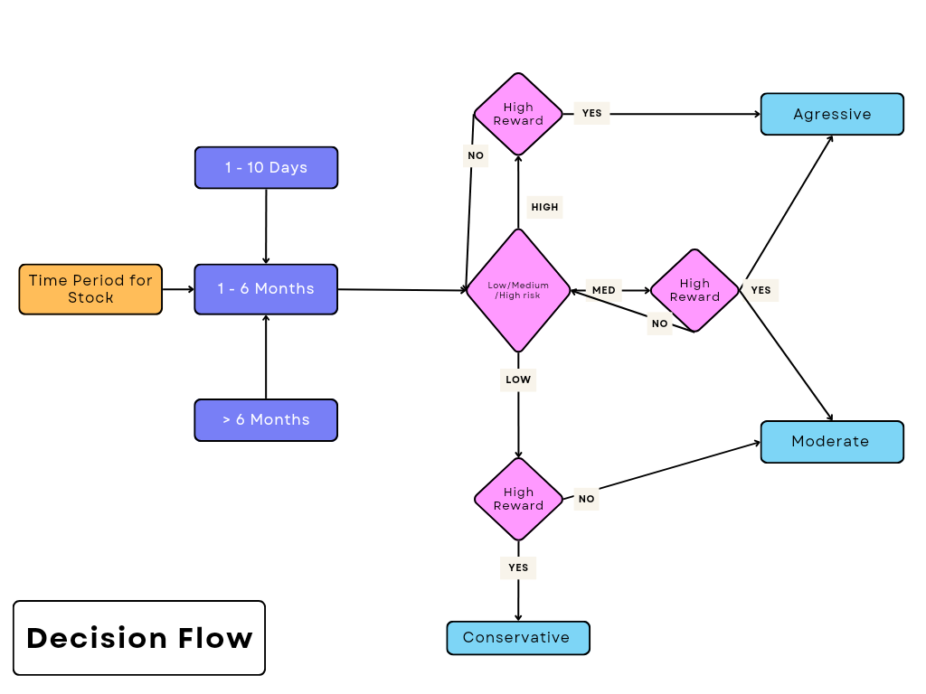

**Gantt Chart**

|  |  |  |  |  |  |  |  |  |  |  |  |
| --- | --- | --- | --- | --- | --- | --- | --- | --- | --- | --- | --- |
| Group composition and topic selection |  |  |  |  |  |  |  |  |  |  |  |
| Literature review and data collection |  |  |  |  |  |  |  |  |  |  |  |
| System analysis |  |  |  |  |  |  |  |  |  |  |  |
| Model building |  |  |  |  |  |  |  |  |  |  |  |
| System implementation |  |  |  |  |  |  |  |  |  |  |  |
| System testing and evaluation |  |  |  |  |  |  |  |  |  |  |  |
| Oral presentation of results, Final reports writing |  |  |  |  |  |  |  |  |  |  |  |
| Final report submission |  |  |  |  |  |  |  |  |  |  |  |
|  | Week 7 | Week 8 | Week 9 | Week 10 | Week 11 | Week 12 | Week 13 | Week 14 | Week 15 | Week 16 | Week 17 |

**The Benefits of this Decision Support System (DSS)**

The stock market can change at any moment. The economy could enter a recession, war could start anywhere in the world, or people could simply be too scared to make an investment without proper information (Harper). Because of these reasons it's important to have a way to ensure you can make decisions without worrying about the consequences. Our DSS uses a LSTM model and will help people feel better about making the choice to invest or not. Three great reasons for using this type of DSS include more accurate predictions, removing human bias, and decreasing the risk to investors by allowing them to see different scenarios (*Sonkavde G, Dharrao DS, Bongale AM, Deokate ST, Doreswamy D, Bhat SK*.)

**1. Accurately Predicting the Stock Market**

LSTM models help improve accuracy because the data they use can be from many different time periods. Since stock prices can change for so many different reasons, it is very important to have good data to make better predictions. Some possible reasons a change could occur include the price history of a stock, how much it is traded, and even unpredictable factors like a scandal in a company (Harper). Assuming there is enough available data, then our LSTM model can help make better predictions, and make sure these things are considered. Now people will make better decisions instead of just trying to look at past data themselves, which is not much better than flipping a coin.

**2. Cutting Down on Human Bias**

People are fallible creatures, and they are prone to let their emotions and past mistakes affect their decisions when it comes to investing, which can lead to bad choices (Hardi). A DSS using a LSTM model forecasts can make decisions that are based on facts and data, thus preventing any decision that could be influenced by emotions. By ensuring that only financial and historical data are used, this DSS can give more even and logical investment suggestions.

**3. Decreased Risk With Multiple Simulations**

Since the parameters can be set by the user, an LSTM-based DSS can run almost infinite simulations to allow investors to see what might happen in different situations. By looking at all these different situations investors can have a better understanding of how their decision might impact their portfolio. Each scenario would show how a portfolio would perform under different circumstances, like during a recession or if the government changes some regulations. This helps investors understand different scenarios and so they might avoid big losses. One example is if an investor is afraid the economy might start to decline, then the DSS could show how their investments might be affected during this time, giving the investor a chance to change their strategy immediately.

### **Results**

Our results were a mix of good and bad, and we did not accomplish as much as we had hoped when we started. While we were able to obtain good metrics for most of our project, there were still some issues that were worrying. Our dataset was obtained from the website kaggle ([Here](https://www.kaggle.com/datasets/zahrashahzahi/stock-market-dataset)) and has all major stock prices from 1960 - 2021.

As shown below in figures 1.1 and 1.2, our predictions vs observations (actual values) were quite close to each other. However, there is a noticeable delay in prediction values which could result in substantial losses to the user. In such a volatile market where one day could mean huge gains or terrible losses, we feel that this delay is not satisfactory. We do feel that this system does give a good idea on what direction a stock could go, so it may be of some use for people looking to make small investments in the stock market.

**Figure 1.1 Figure 1.2**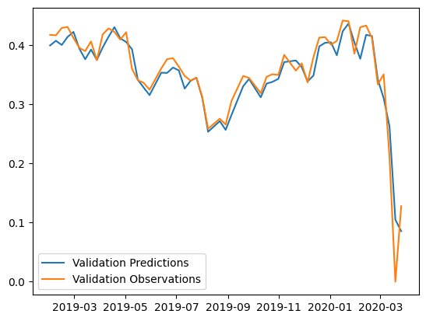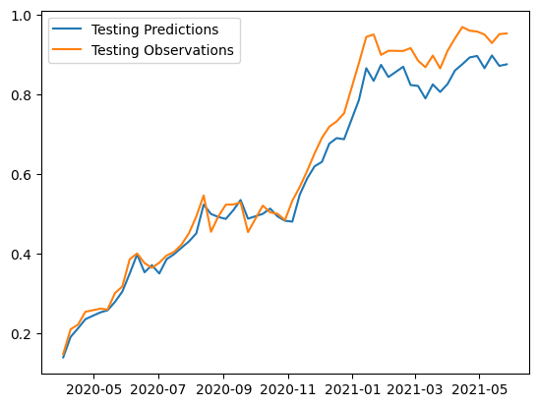

Furthermore, our metrics were around average in all categories except for directional accuracy. When looking at the graph below in Figure 1.3 it can be seen that the Mean Absolute Percentage Error (MAPE), Mean Absolute Percentage Error (MAE), Root Mean Square Error (RMSE), and Mean Square Error (MSE) are all quite low. This means our model’s predictions were pretty close to the observations. In addition, the Coefficient of Discrimination (R2) value is quite high, meaning that our model does a good job in explaining the variances within the stocks. Despite all these good metrics, the one that stands out is actually the Directional Accuracy. This is used to determine trends within the stock market, and with a value of .56 it means that our model is barely better than a coin flip when it comes to discovering trends. Trends are very important as they will determine the growth or decline of a stock over time, which is important to know when choosing a stock. Our model needs to be significantly better in this area before it could be taken seriously.

**Figure 1.3**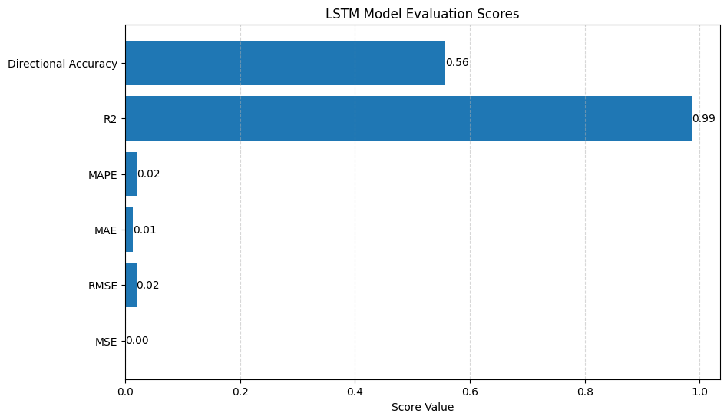

#### **Stock Classification**

Volatility Based Stock Classification helps in assessing the risk level of a stock over time. Volatility measures the degree of price fluctuations and is an essential detail for investors and traders when making decisions. A stock with high volatility is considered **riskier** due to large and unpredictable price movements, while a stock with low volatility is seen as **more stable** and **less risky**.

Stock classification is based on calculating the **rolling volatility** of predicted stock prices. This is done using a **rolling window**, where the **mean** and **standard deviation** of the stock’s price over a specific period (e.g., 3 or 10 days) are computed. The ratio of these values determines the volatility percentage, which is then categorized into risk levels:

* **Risky**: If volatility > 10%
* **Moderate**: If volatility is between 5% and 10%
* **Conservative**: If volatility < 5%

#### **Formula for Volatility:**

**Volatility(%) = (Standard Deviation of Prices / Mean) x 100**

Where:

* **Standard Deviation (σ)** measures the spread of prices around the mean.
* **Mean Price (μ)** is the average stock price over the rolling window.
* Multiplying by **100** converts the ratio into a percentage.

By applying this formula, each predicted price point is classified based on its volatility, allowing for better risk assessment and decision-making in stock market analysis.

**Key Takeaways:**

The classification results showed that when applied to **normalized** predicted prices, there was more variability in classification (i.e., stocks were classified as **Risky**, **Moderate**, or **Conservative** across different points). However, when classification was applied **after denormalizing** the prices, most stocks were consistently labeled as **Conservative** throughout the prediction period.

This suggests that **volatility detection was more effective when using normalized prices**, as small price fluctuations had a greater impact on the rolling standard deviation which makes it **sensitive to volatility**. However, after denormalization, the fluctuations became relatively smaller in comparison to the overall price scale, leading to lower volatility values and mostly **Conservative** classifications.

While the classification method worked in detecting relative price stability, improvements could be made by:

* **Adjusting volatility thresholds** to better reflect real-world stock behavior after denormalization.
* **Incorporating additional features** (e.g., volume, market trends) to enhance classification accuracy.
* **Testing different rolling window sizes** to find a balance between short-term and long-term volatility detection.

Overall, while the classification approach provided insights into stock stability, refining the methodology could lead to even more meaningful classifications.

### **User Interface (UI)**

Our UI system does allow for users to choose different stocks and compare them, as well as see their risk classification. This UI is very easy to use, and can assist the user in making their decision for which stock is best for them. A screenshot is shown below in figure 1.4

**Figure 1.4**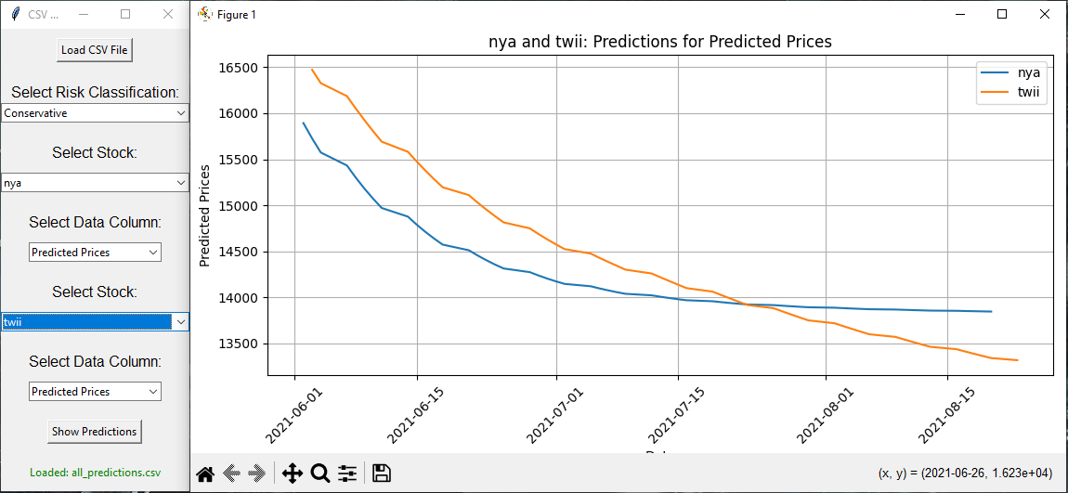

Finally, we were unable to create a customized investment portfolio as this turned out to be much more difficult than we previously thought. Things like Investor Surveys, Stock Rankings, and Trading Signals were not able to be accomplished. These items required much more investment and financial knowledge than we possessed. However, we feel confident that in the future we would be able to implement them with additional classes based on the financial sector.

### **Conclusion**

Our model has shown that it can closely predict the values within our dataset, but it struggles with correctly predicting trends and forecasting too far into the future. In order to improve our model we would need to increase the number of features used to create the model, as right now it only uses closing prices. We could also use volume, adjusted close, and opening prices. Additional features that should also be included would be socioeconomic and political factors, which are difficult to obtain and quantify. Another factor to be considered is how and when to classify the data, as this will greatly affect the classification results, and thus the true risk of the stock. Finally, our method of generalization could be changed from trying to predict the precise values in future prices to finding the rate of change within values and applying that to the predictions. This technique may help to improve our Directional Accuracy, and make this model more reliable and trusted for our users.

**Member Responsibilities**

石聰:

* Group leader
* Responsibility assignments
* Gantt chart
* Expected benefits
* Programming/UI Design

陳錦顒:

* Methodology
* Data preprocessing
* Model validation

奧馬爾:

* Framework
* Model design and training
* Programming

林米克:

* Abstract
* Introduction
* Risk Classification
* PPT creation

諾吉:

* Literature review
* Data collection
* PPT creation

**References**

*(1) Patalay, Sandeep & Rao, B.Madhusudhan. (2021). Artificial Intelligence Based System for Financial Decision Support.* [*https://www.researchgate.net/publication/355357714_Artificial_Intelligence_Based_System_for_Financial_Decision_Support*](https://www.researchgate.net/publication/355357714_Artificial_Intelligence_Based_System_for_Financial_Decision_Support)

*(2) Mokhtari, Sohrab & Yen, Kang & Liu, Jin. (2021). Effectiveness of Artificial Intelligence in Stock Market Prediction based on Machine Learning. International Journal of Computer Applications. 183. 1-8. 10.5120/ijca2021921347.*

[*https://www.researchgate.net/publication/352647761_Effectiveness_of_Artificial_Intelligence_in_Stock_Market_Prediction_based_on_Machine_Learning*](https://www.researchgate.net/publication/352647761_Effectiveness_of_Artificial_Intelligence_in_Stock_Market_Prediction_based_on_Machine_Learning)

## *(3)* [*Modupe James*](https://papers.ssrn.com/sol3/cf_dev/AbsByAuth.cfm?per_id=6278035)*. (2023). The Role of Artificial Intelligence in Financial Decision Making.* [*https://papers.ssrn.com/sol3/papers.cfm?abstract_id=4628237*](https://papers.ssrn.com/sol3/papers.cfm?abstract_id=4628237)

*(4) Yang, H., Liu, X., Zhong, S., & Walid, A. (2020). Deep Reinforcement Learning for Automated Stock Trading: An Ensemble Strategy. SSRN Electronic Journal.*

[*https://doi.org/10.2139/ssrn.3690996*](https://doi.org/10.2139/ssrn.3690996)

*(5) Adil Moghar, Mhamed Hamiche. (2020). Stock Market Prediction Using LSTM Recurrent Neural Network.*

[*https://doi.org/10.1016/j.procs.2020.03.049.*](https://doi.org/10.1016/j.procs.2020.03.049)

*[5] Framework:*

*[5.1] Sprague, R. H., & Carlson, E. D. (1982). Building Effective Decision Support Systems. Prentice-Hall.*

[*Sprague, R.H. and Carlson, E.D. (1982) Building Effective Decision Support Systems. Prentice-Hall International Inc., London, 329pp. - References - Scientific Research Publishing (scirp.org)*](https://www.scirp.org/reference/referencespapers?referenceid=1198383)

*[5.2] Zhang, Y., et al. (2020). "Deep Learning for Stock Market Prediction: A Systematic Review." IEEE Access, 8, 177904-177917.*

[*Deep Learning for Stock Market Prediction (mdpi.com)*](https://www.mdpi.com/1099-4300/22/8/840)

*[5.3] Chen, L., et al. (2021). "AI-Driven Stock Market Prediction: An Ensemble Approach." Expert Systems with Applications, 165, 113848.*

[*IJMR_4(3)_265-271_668be8e2092226.97334767.pdf (indianapublications.com)*](https://indianapublications.com/articles/IJMR_4(3)_265-271_668be8e2092226.97334767.pdf)

*[5.4] Kumar, D., et al. (2021). "A Survey on Stock Market Prediction Using Deep Learning." International Journal of Recent Technology and Engineering, 9(5), 654-666.*

[*(PDF) A Survey on Stock Market Prediction Using Machine Learning Techniques (researchgate.net)*](https://www.researchgate.net/publication/341482418_A_Survey_on_Stock_Market_Prediction_Using_Machine_Learning_Techniques)

*[5.5] Li, X., et al. (2020). "Deep Learning-Based Stock Market Prediction: A Survey." IEEE Access, 8, 181098-181116.*

[*(PDF) Deep Learning-Based Stock Market Prediction and Investment Model for Financial Management (researchgate.net)*](https://www.researchgate.net/publication/379090839_Deep_Learning-Based_Stock_Market_Prediction_and_Investment_Model_for_Financial_Management)

Harper, D. R. (2023). *What drives the stock market?*. Investopedia. <https://www.investopedia.com/articles/basics/04/100804.asp>

Swart, Hardi (2024) *10 things that drive people to make bad financial decisions*

<https://www.moneyweb.co.za/financial-advisor-views/10-things-that-drive-people-to-make-bad-financial-decisions/>

*Sonkavde G, Dharrao DS, Bongale AM, Deokate ST, Doreswamy D, Bhat SK. Forecasting Stock Market Prices Using Machine Learning and Deep Learning Models: A Systematic Review, Performance Analysis and Discussion of Implications.*

*International Journal of Financial Studies. 2023; 11(3):94.*

[*https://doi.org/10.3390/ijfs11030094*](https://doi.org/10.3390/ijfs11030094)

[6.1] “Active trading definition.”

*Capital.com*, <https://capital.com/active-trading-definition>

**Dataset:**

[*https://www.kaggle.com/datasets/zahrashahzahi/stock-market-dataset*](https://www.kaggle.com/datasets/zahrashahzahi/stock-market-dataset)