🤖 4X Advanced AI Tester Blueprint |

Agenda
- LLL -> Life Long LEANER
- Action Plan for the 12+ Weeks
- How to access the courses ? (Recordings)
- How to Ask the Doubts, Get the Task and Discuss my problem?
- Sequence to follow.
- Required Access SDETCLUB.com
- No Knowledge for Playwright / Selenium is required for this.
- Laptop Configuration
  - Personal - (8-16) GB RAM, 256 GB SSD/HDD - Yes
  - Office Laptop Issues Configuration
- Local LLM Setup
- Cloud AI - Groq Setup
- IDE Setup
  - VS Code with github co pilot
  - Antigravity
  - Cursor / Windsurf
- Github Account Setup
- LangFlow & n8n Setup
﻿

﻿
Question - ﻿forms.gle/q1jDgjAJM7bNeYwE6
﻿
MasterClass - How to setup CommandCode AI and OpenCode AI(Only Zoom) - Monday - 9 PM IST -

﻿
Task #1 - ﻿app.thetestingacademy.com/
﻿
Roadmap - Action Plan for the 12+ Weeks
﻿
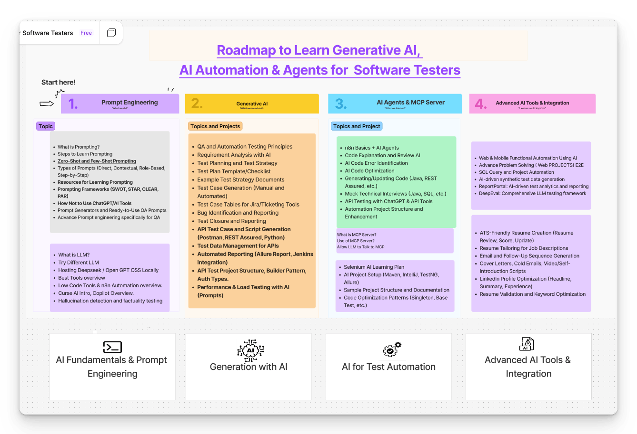
﻿﻿www.figma.com/board/0aAIi9aiWQDQJQ0rnTdkx0/Learn-Generative-AI---AI-Agents-for--Software-Testers?node-id=22-46&t=vnGZCA4abRpwPVXh-1

Task # 1 -
- Create an Account - ﻿app.thetestingacademy.com/
- (with Google Option)
﻿
What is the app.thetingacademy.com?
- Curriculum, Roadmap, AI Agent list, AI Testing Tools List, LIVE Test
- My progress.

﻿

How to access the courses ? (Recordings)
- Make sure that the you have a reset password -
﻿﻿courses.thetestingacademy.com/password/reset
﻿
- Access the all the courses here - ﻿courses.thetestingacademy.com/mycourses
- Bonus will be also available here in the ﻿course.thetestingacademy.com
- All Recordings 24x7 ->, Lifetime access
- AI Tester Blueorint 4x ( Date)
- PS. -> Finish all the videos within 4-5 months.
- You can do Binge Watchng - -Wathcing videos back to back.
﻿

﻿

How to Ask the Doubts, Get the Task and Discuss my problem?
- Private - ﻿www.sdetclub.com/c/ai-tester-4x-only - Invitation Based -
- Email from us - Invite you to SDETCLUB
- All the memebrs are for the same batch.
- Task , Doubts - Datewise
- LIVE Class - Sat/ Sun - 8.30 AM IST, 10.30 AM IST + 1 Extra (Bi Weekly) -> Friday/ Tue Evening - 8 PM IST or 9 PM IST (Optional, I would recommand), Extra AI concepts.
- LIVE Test - Wed at 9 am IST ( LIVE Test) Which you can give. - M ( Give the TEST -> EOD)
  - ﻿﻿app.thetestingacademy.com/student/live-test
- Email ID - ﻿contact@thetestingacademy.com - Max 1 hour
- Meeti, Dipak From my TEAM -

﻿

How to see the recording
﻿﻿https://www.loom.com/share/f52b39bc9095470ea0902075fe169e26?sid=564ed0c2-74ee-45c8-9acb-a6477b9669eb
- ﻿﻿courses.thetestingacademy.com/
- Today's AI Tester Blueprint 4x

﻿

Sequence to follow
- LLM Basics
- Prompt Eng
- Generative AI
  - Github Copilot
  - Claude Code
  - Command Code/ OpenCode AI
- AI Agents (RAG)
  - Vibe Code
  - n8n
  - Langflow
  - Crew AI / LangChain(Python Basics)
  - LangGraph - AI Agents(Multi Agents) QA
- RAG
  - 10 + TYPES
  - Langlfow
  - n8n
  - Vibe Code
- MCP
  - Use
  - Create Own MCP - FastMCP
  - Debug MCP
  - Automation + AI
- LLM Eval
  - Basic LLM Eval
  - DeepEval
  - PromptFoo
  - OpenEvAL, RAGAs
- AI Testing tools
  - 3-4 AI Testing
  - CI/CD + Automation via AI.
- Projects -
  - 35+ AI Projects( AI Agents, MCP, RAG, LLM EvaL)+. AI Testing Tool).

﻿

Required Access
﻿﻿https://forms.gle/L47EKJns4ZPobLUH6
﻿
- Bonus ✅ SDET Masterclass | Friday Master Class
- ✅ Gen AI Course
- ✅ n8n Basic → Advanced
- ✅ SDET Club (Doubts & Assignments)
- ✅ Job Assistance (QaJobBoard)

﻿
﻿
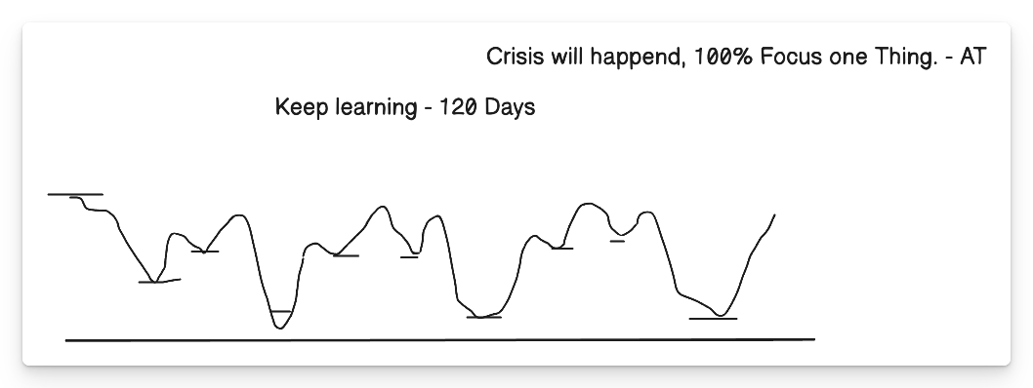
﻿

Rules of Life
- 100% Focus on One Thing -> AI Ready Tester -> All of the 100% efforts.
- 5% (Execution) and 95% (Plan) -> 5% Plan -> 95% -> Try and Fail -> Try Again ->Success.
- 50-70% is Perfect -> 100% is Failure - 25K + companies
  - 40-70% Ready -> Interviews
  - Unlimited Oppor. -> Delhi, NCR, Bangalore, Chennai, Pune, -> 25K companies.
  - ﻿
- New Actions -> Whatever worked in past, will not work in future. New Skills - G

﻿
- Discipline
- Consistnecy
- Focus
- Practice
5+ Week Per-month

﻿
the only reason right now I am learning is because if I do not learn, somebody is going to learn and implement, and I will leave behind I will get replace
﻿
Financial Knowledge
- Emergency Fund -> monthly - 50k x 6 months -> 3L ( FD, Bank) - Save Job Security.
- 20K per Month -> 1.2 L in your ACC, don't touch it, until emergency
- Health Insurance
- Term Insurance
- 4.SIP - MF - Investing (5-10%) per month, - without -> index Nifty
﻿
﻿

﻿
20-30 Pages per day
﻿

﻿

Task #2

Github Account Setup
﻿﻿github.com/signup
﻿

Task #3

NodeJS (latest version)
﻿﻿nodejs.org/en/download
﻿
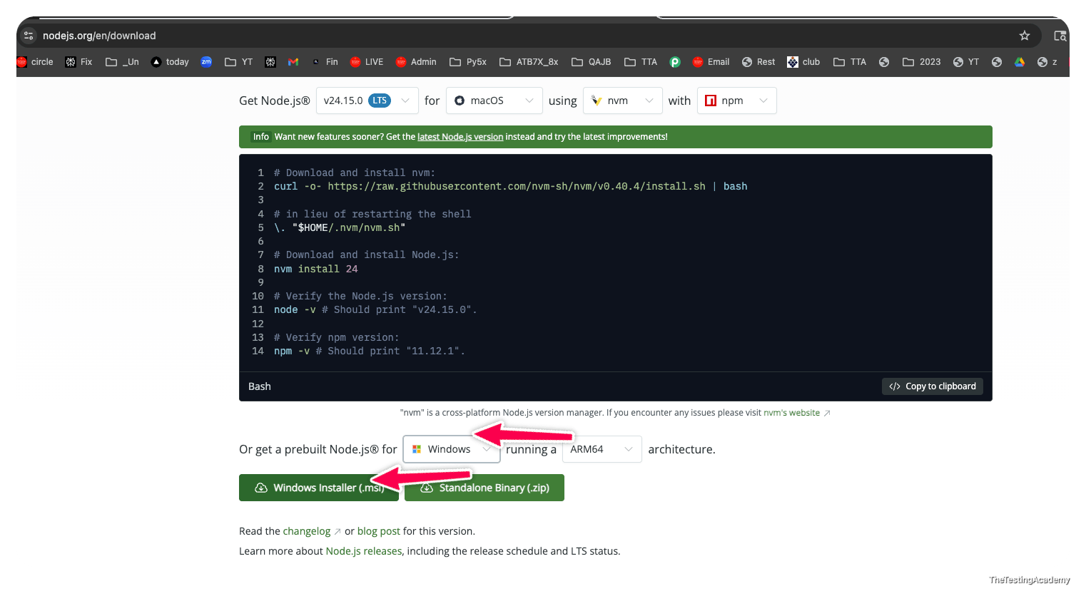

Visual Studio Code (Office Laptop)
﻿﻿code.visualstudio.com/download
﻿

Advance AI IDE ( Personal Laptop)
- Google Antrigravity -> ﻿antigravity.google/
- Cursor
- Windwruf
- KIRO /KILO
﻿

﻿
Person Laptop - PERSONAL
Office Laptop -> Office -> Personal If possible(invest 25-30k BUY OLD VERSION mac or windows)
﻿
﻿﻿🤖 4X Advanced AI Tester Blueprint |

﻿

🤖 AI Tester Blueprint
﻿

Foundation Models
🧠 What Changed After 2020 – The Era of Scale
Before 2020, AI models were like smart calculators – good at one thing. After 2020, AI models became like super interns – they can write, read, code, explain, summarize, and even reason.
2020-2022 - Playground ->. I had
2022 -> Sam Altman -> ChatGPT - on twitter.com
﻿

Real-World Example
- Old AI: A spam filter on
- New AI: Can read the email, explain why it is spam, rewrite it professionally, and suggest a reply.
﻿

Two Major Consequences of Scale
- Capability Explosion
  - Models can now perform many tasks well
  - New applications became possible (coding, writing, planning, vision)
- Model-as-a-Service Emergence
  - Training large models is expensive and centralized
  - A few organizations build models
  - Everyone else consumes them via APIs
﻿
➡️ Result: AI application demand increased while entry barriers dropped.
﻿
AI
- LLM
- llm Eval
- MCP
- RAG
- NLP
- Langchain
- n8n
- Prompt Eng.
- Gen AI
- Multi Agent
- RAGAS
- LangFlow
- Agentic AI
- DeepEval
- Github Copilot
- Context Eng
- Harness Eng
- Loop Enf
- Agent Orches
- VIBE Coding
- AI Testing Tools
- Claude
- Prompt Foo
- GauradRails
- Model Drift, Theft
- Cursor
- Skills
- Deep Learning
- MD Files
- Chuncking
- Sematic Search BM25
- Hallucinations
- KIRO, Amazon Q, Cursor,.
- Neutral Network.
- Tokemics
- Vector dB
- huGGINCE face
- Codex, Claude
﻿

🤖 What Is AI Engineering?
AI Engineering = Building applications on top of existing foundation models.
﻿
ML , DL , -> AI Eng
⚠️ Using powerful pre-built AI brains to solve real problems == AI Engineering.
﻿
You are not training the brain from scratch.
﻿
You are:
- Giving it instructions
- Giving it context
- Checking its answers
- Connecting it to real systems
﻿

Why AI Engineering Is Growing Fast
- Powerful models already exist
- APIs make usage simple
- Minimal infrastructure required
- Even non-engineers can build AI apps.

﻿
Traditional Machine Learner Engineer:
- Collects 1M records
- Labels data
- Trains a model
- Tunes hyperparameters
﻿
AI Engineer:
- Chooses GPT / Claude / Gemini - Brain
- Writes prompts
- Adds documents via RAG
- Evaluates responses
- Deploys fast
- Solve Real Problems
- LLM Eval
﻿
This is why AI Engineering feels faster and more creative.

﻿
LLM -> Brain
AI Agent -> Brain + Memory + Tools ( Workflows)

﻿
ChatGPT -> Chat application which is using a private LLM - GPT 5.6
Claude.ai -> chat application Sonu 4.6, Opus 4.6
Gemini - 3.1 ->. ﻿aistudio.google.com/prompts/new_chat
LLM -> Open source / Closed source
﻿

﻿
Claude Code, Kimi Code, Codex, Amazon Q, , - Github Copilot -> ? LLM? ( This is a AI Coding assistant) (AI Agent)
﻿
﻿
Notepad -> Program
IDE -> Integrated Development Environment -> IntelliJ
Eclipse
PyCharm
Sublime Text
Visual Studio Code

﻿
Antigravity, Cursor , Windsurf, KILO/kiro IDE, -> ADE -> agent-driven development environment (ADE), VS Code with GHCP (ADE) , GitHub Copilot (GHCP)
IDE + Agent
﻿
﻿
﻿
Perplexity ->. Curation of multiple models, it uses a algo(AI Agent). which select which model you can use for the which purpose. .
﻿

﻿
From Language Models to Large Language Models (LLMs)
﻿
﻿
What Is a Language Model?
A language model is like autocomplete on steroids.
the cat will sit on _
﻿

A language model:
- Learns statistical patterns of language.
- Predicts the next token given context
- Giving the Attention
﻿
Link to the Paper -> ﻿proceedings.neurips.cc/paper_files/paper/2017/file/3f5ee243547dee91fbd053c1c4a845aa-Paper.pdf
﻿
﻿﻿app.thetestingacademy.com/ai/llm-vs-aiagent
﻿
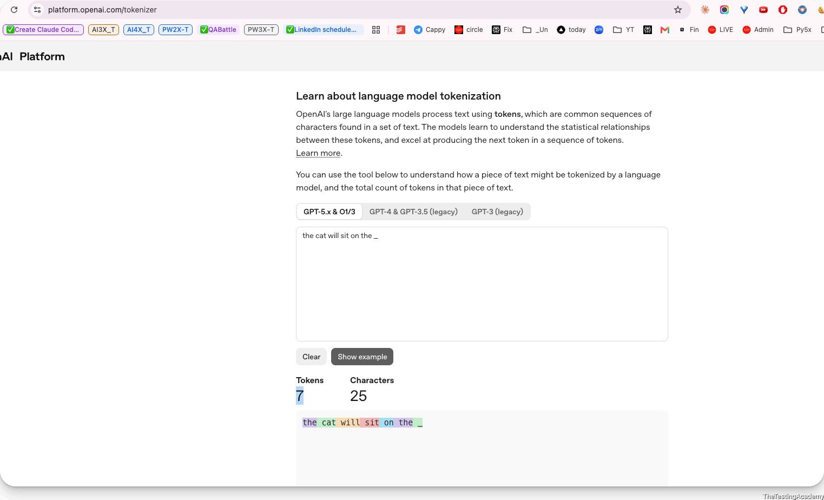

﻿

What is the Context?
- Information
- Reference, Objective.
- Some information what we are discussing
- background information
﻿
"My favorite color is ___"
﻿
Trained ->

﻿

Tokens (Very Important)
- Token = basic unit (word, sub-word, or character)
- Models don’t see words, they see tokens.
﻿
Why tokens?
- Capture meaning better than characters
- Smaller vocabulary than words
- Handle unknown/new words.
﻿
Ask - Give me the source code for the hello world in javascript.
﻿
Paper - ﻿arxiv.org/html/1706.03762v7
Attention is all you need ( ~2014)
﻿
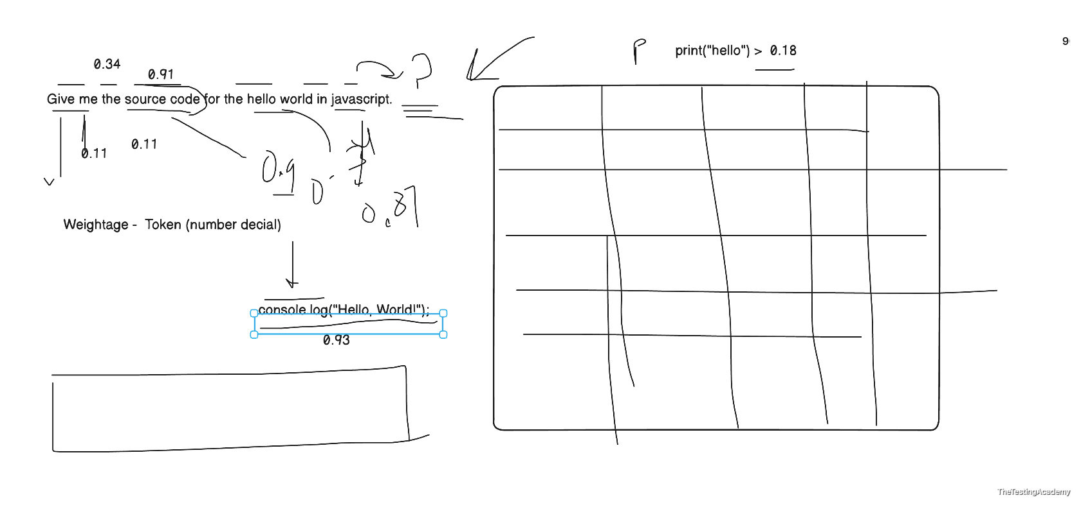
GPT 2 - Was trained - ﻿Reddit.com Forum where people discuss topics and problems.
﻿
Prompt
the cat will sit on the _, Can you please show me properly how exactly the transformer transforms it and how the large language model R is able to predict exactly in the tabular format? Explain to me step by step in a very simple manner so that I can know how the output is made in the end.
﻿
Text → Tokens → Token IDs → Vectors → Attention → Transformer layers → Vocabulary scores → Probabilities → Selected next token
﻿

Input sentence
“The cat will sit on the ___.”
The model’s job is to predict the next token after “the”.
A transformer does not directly understand the sentence like a human. It converts words into numbers, processes relationships between them, and produces probabilities for possible next words.
The numerical values below are simplified examples. Real language models use thousands of dimensions, billions of parameters, and many transformer layers.

﻿

Complete process at a glance
Step | Transformer operation | Simplified result
1 | Tokenization | ﻿The, cat, will, sit, on, the
2 | Token IDs | ﻿[791, 8415, 690, 2503, 389, 279]
3 | Embeddings | Each token becomes a vector of numbers
4 | Positional information | The model learns each token’s location
5 | Self-attention | Tokens examine other relevant tokens
6 | Feed-forward network | The model processes the combined meaning
7 | Repeat transformer layers | The representation becomes more contextual
8 | Generate logits | Every vocabulary token receives a raw score
9 | Softmax | Scores become probabilities
10 | Select a token | For example: mat
11 | Continue generation | “The cat will sit on the mat.”

﻿

Step 1: Tokenization
The tokenizer breaks the sentence into smaller units called tokens.
Position | Text | Token
1 | The | ﻿The
2 | cat | ﻿cat
3 | will | ﻿will
4 | sit | ﻿sit
5 | on | ﻿on
6 | the | ﻿the
7 | Missing | Model must predict this
The model receives:
[The] [cat] [will] [sit] [on] [the]
Tokens are not always complete words. For example, a tokenizer might split:
unbelievable → un + believ + able

﻿

Step 2: Tokens become token IDs
Every token has an integer ID in the model’s vocabulary.
Token | Example token ID
﻿The | 791
﻿cat | 8415
﻿will | 690
﻿sit | 2503
﻿on | 389
﻿the | 279
The sentence is now represented as:
[791, 8415, 690, 2503, 389, 279]
These IDs are only labels. The number 8415 does not itself contain the meaning of “cat”.

﻿

Step 3: Token IDs become embeddings
The model looks up an embedding for each token.
An embedding is a list of numbers representing learned features of a token.
Here is a highly simplified four-dimensional example:
Token | Animal-related | Action-related | Location-related | Grammar-related
﻿The | 0.05 | 0.02 | 0.04 | 0.92
﻿cat | 0.94 | 0.15 | 0.10 | 0.32
﻿will | 0.03 | 0.40 | 0.01 | 0.88
﻿sit | 0.15 | 0.96 | 0.35 | 0.25
﻿on | 0.02 | 0.08 | 0.95 | 0.61
﻿the | 0.05 | 0.02 | 0.04 | 0.92
In a real model, an embedding may contain thousands of numbers:
cat → [0.018, -0.246, 0.774, ..., -0.091]
These dimensions are learned during training. They do not normally have simple human-readable labels such as “animal-related”.

﻿

Step 4: Add positional information
A transformer must know the order of the tokens.
Compare:
The cat chased the dog.
The dog chased the cat.
The words are similar, but their positions change the meaning.
The model combines:
Token embedding + Position information
Position | Token | What position tells the model
1 | ﻿The | Beginning of the sentence
2 | ﻿cat | Subject position
3 | ﻿will | Comes after the subject
4 | ﻿sit | Main action
5 | ﻿on | Introduces a location or surface
6 | ﻿the | A noun probably comes next
After this step, the model knows both:
- what each token represents;
- where each token appears.

﻿

Step 5: Create Query, Key, and Value vectors
For every token, the transformer creates three new vectors:
Vector | Simple meaning
Query — Q | What information am I looking for?
Key — K | What type of information do I contain?
Value — V | What information should I pass forward?
They are calculated using learned matrices:
Q = Embedding × WQ
K = Embedding × WK
V = Embedding × WV
For the final token the, the query might behave conceptually like:
“I need information that will help identify the noun that should come next.”
The keys from previous words indicate what information they contain.
Previous token | Simplified information in its key
﻿The | Sentence beginning and grammar
﻿cat | Subject: an animal
﻿will | Future construction
﻿sit | Sitting action
﻿on | Surface/location relationship
﻿the | A noun phrase has started

﻿

Step 6: Self-attention calculates relevance
The final position examines earlier tokens and assigns attention weights.
The basic attention calculation is:
Attention(Q, K, V) =
softmax(QKᵀ / √d) × V
In simple language:
- Compare the current query with every key.
- Produce relevance scores.
- Convert those scores into percentages.
- Collect information from the corresponding value vectors.
For the last token, the attention might look like this:
Token being examined | Simplified attention weight | Why it matters
﻿The | 3% | Provides general sentence structure
﻿cat | 19% | Identifies who will sit
﻿will | 5% | Indicates future tense
﻿sit | 31% | Strongly defines the action
﻿on | 34% | Indicates that a surface/location follows
﻿the | 8% | Indicates that a noun should come next
Total | 100% | ﻿
This allows the model to form a contextual idea similar to:
An animal is going to sit on a particular surface or object.
The attention weights are not manually programmed. They are learned from training data.

﻿

Step 7: Multi-head attention
A transformer does not normally use just one attention calculation. It uses several attention heads.
Different heads may learn to examine different relationships.
Attention head | What it may focus on
Head 1 | ﻿cat is the subject
Head 2 | ﻿sit is the action
Head 3 | ﻿on expects a surface or location
Head 4 | ﻿the expects a noun
Head 5 | Common phrase patterns
Head 6 | Long-range grammatical relationships
A simplified view:
Head | Most important tokens | Information extracted
Grammar head | ﻿will, the | A noun should follow
Action head | ﻿sit | The noun should be compatible with sitting
Relationship head | ﻿on | The noun is likely a surface
Subject head | ﻿cat | The surface should be suitable for a cat
Phrase head | ﻿sit on the | Common continuation patterns
The outputs of the heads are combined into one richer representation.

﻿

Step 8: Feed-forward neural network
After attention, each token representation goes through a feed-forward neural network.
Its simplified job is to transform and refine the information:
Attention result
↓
Linear transformation
↓
Activation function
↓
Linear transformation
↓
Improved contextual representation
For the final position, the representation may now contain information similar to:
Learned condition | Strength
Next token should probably be a noun | Very high
Noun should describe a surface or place | High
Noun should be compatible with sitting | High
Noun should be plausible for a cat | High
Future tense is being used | Medium

﻿

Step 9: Residual connections and normalization
Transformers also use:
- Residual connections
- Layer normalization
A residual connection adds the earlier information back:
New representation = Old representation + Processed information
This helps prevent useful information from being lost.
Layer normalization keeps numerical values stable so that the network can process them effectively.
A simplified transformer block looks like:
Input
↓
Multi-head self-attention
↓
Add and normalize
↓
Feed-forward network
↓
Add and normalize
↓
Output

﻿

Step 10: Repeat through many transformer layers
This process happens repeatedly.
Layer stage | Simplified understanding
Early layers | Recognize tokens and basic grammar
Middle layers | Identify subject, action, and relationships
Later layers | Build sentence-level meaning and continuation possibilities
Final layer | Prepare scores for the next token
A model may have dozens or even hundreds of transformer layers.
By the final layer, the last-position representation approximately expresses:
Predict a noun describing something a cat can sit on.
It is important to understand that this meaning is stored as numbers, not as an English sentence inside the model.

﻿

Step 11: Convert the final representation into logits
The final vector is multiplied by an output matrix.
This produces one score for every token in the vocabulary.
These raw scores are called logits.
Suppose the model considers these candidate tokens:
Candidate token | Raw score or logit
﻿mat | 8.2
﻿floor | 7.6
﻿chair | 6.9
﻿sofa | 6.5
﻿bed | 6.1
﻿table | 4.8
﻿moon | 0.7
﻿banana | -0.5
﻿running | -1.2
A higher logit means the model considers that token more suitable.
Logits are not yet probabilities.

﻿

Step 12: Softmax converts logits into probabilities
The softmax function transforms the raw scores into probabilities that add up to 100%.
Probability(token i) =
e^(logit i) / sum of e^(all logits)
A simplified output may look like:
Candidate next token | Probability
﻿mat | 36%
﻿floor | 20%
﻿chair | 10%
﻿sofa | 7%
﻿bed | 5%
﻿table | 1%
Thousands of other tokens | 21%
Total | 100%
The model does not know with certainty that mat is correct.
It predicts:
“mat is the most probable next token based on this context.”

﻿

Step 13: Select the next token
The application chooses a token using a decoding strategy.

Greedy decoding
Always choose the highest-probability token:
mat → 36%
Output:
The cat will sit on the mat

Sampling
Randomly choose according to the probabilities.
Possible output:
The cat will sit on the sofa
Even though sofa has a lower probability, it is still plausible.

Temperature
Temperature changes how predictable or creative the selection is.
Temperature | Effect
0 or very low | Usually selects the highest-probability token
0.7 | Balanced output
1.0 | More variation
Above 1 | More randomness and less predictability

﻿

Step 14: Generate the following token
After selecting mat, the model receives a new input:
The cat will sit on the mat
It runs the complete process again to predict the next token.
For example:
Candidate | Probability
﻿. | 65%
﻿and | 9%
﻿near | 5%
﻿because | 2%
Other tokens | 19%
It may select the period:
The cat will sit on the mat.
Generation happens one token at a time.

﻿

Final simplified table
Stage | Input | Operation | Output
Tokenization | Sentence | Split text into tokens | ﻿The, cat, will, sit, on, the
Token IDs | Tokens | Vocabulary lookup | ﻿[791, 8415, 690, 2503, 389, 279]
Embeddings | Token IDs | Convert IDs to vectors | Numerical representations
Position encoding | Embeddings | Add token order | Position-aware vectors
Q, K, V | Position-aware vectors | Learned matrix multiplication | Query, key, value vectors
Attention | Q, K, V | Find relevant relationships | Focus on cat, sit, on, the
Multi-head attention | Attention outputs | Capture several relationships | Rich contextual representation
Feed-forward network | Contextual vectors | Refine learned features | Improved representation
Transformer layers | Previous layer output | Repeat processing | Deep contextual understanding
Output projection | Final vector | Score vocabulary tokens | Logits
Softmax | Logits | Convert scores to probabilities | ﻿mat: 36%, floor: 20%, etc.
Decoding | Probabilities | Select one token | ﻿mat
Next cycle | Updated sentence | Repeat everything | ﻿.

The key idea
Text
→ Tokens
→ Token IDs
→ Vectors
→ Attention
→ Transformer layers
→ Vocabulary scores
→ Probabilities
→ Selected next token
The transformer does not retrieve a fixed answer from a database. During training, it learned statistical and structural patterns such as:
“cat” + “sit on the” → mat, floor, chair, sofa, bed...
It then calculates which continuation is most probable for the current context.
﻿

﻿
4th Aug Tue - 8 PM IST -> Session - Doubts Class + CommandCode Part 2(Part 1 again)
7th Aug Friday 8 PM IST -> Mastering Claude Code (with Claude 101) ExamCo
﻿﻿anthropic.skilljar.com/claude-101
﻿
﻿
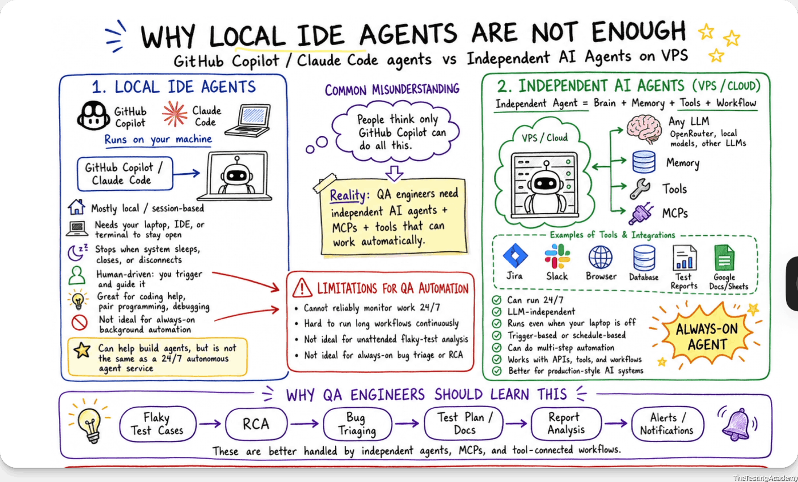
﻿
﻿
Office Laptop X - Try to use Personal If possible
﻿
Local TestCase

﻿
2th Aug 2026
﻿

What Is a Language Model? A language model is like autocomplete on steroids.
﻿

A language model:
- Learns statistical patterns of language.
- Predicts the next token given context
﻿
﻿
4th Aug -> Tue - 8 PM -> CommandCode AI revisit, Doubts (1.5 hour)
7th Aug Friday -> 8 PM -> MASTER Claude Code($20)( 25+ Commands) + Claude 101 Certification ((1.5 hour)
﻿

Two Types of Language Models
﻿

1. Masked Language Models (BERT-style) -> my - color is black
Bidirectional Encoder Representations from Transformers
Masked Model (BERT) = Fill in the blanks in an exam paper
- Predict missing tokens anywhere
- Uses left + right context
- Best for understanding tasks
Examples:
- Sentiment analysis
- Classification
- Code understanding
﻿﻿https://www.geeksforgeeks.org/nlp/masked-language-models/
my Fav color is black
﻿
“Playwright is a [MASK] automation tool.”
﻿
“Playwright is a browser/web automation tool.”
﻿

2. Autoregressive Language Models (GPT-style)
Autoregressive Model (GPT) = Write an essay one word at a time
Generative Pre-trained Transformer
- Predict next token only
- Generate text sequentially
- Best for generation
  - text
  - code
  - image
  - video
  - .....anythhing.
﻿
Examples:
- ChatGPT
- Code generation
- Writing, summarization
﻿
➡️ We mainly focuses on autoregressive models
My eye color is _Black, Brown ,Grey
﻿
GPT -> Generative Pre Trained Transformer.
﻿
Read It and Give a Task - ﻿app.thetestingacademy.com/ai/ml-ai-dl-engineer#tab1
﻿
- LLM -> large language model that predicts and generates text token-based
- Transformer -> It is an attention-based neural architecture used by most modern large language models
- Paramaters

﻿

Paramaters
Parameters in Large Language Models are the internal weights and biases that the model learns during training.
More Parameter have you better. LLM
﻿
﻿
﻿
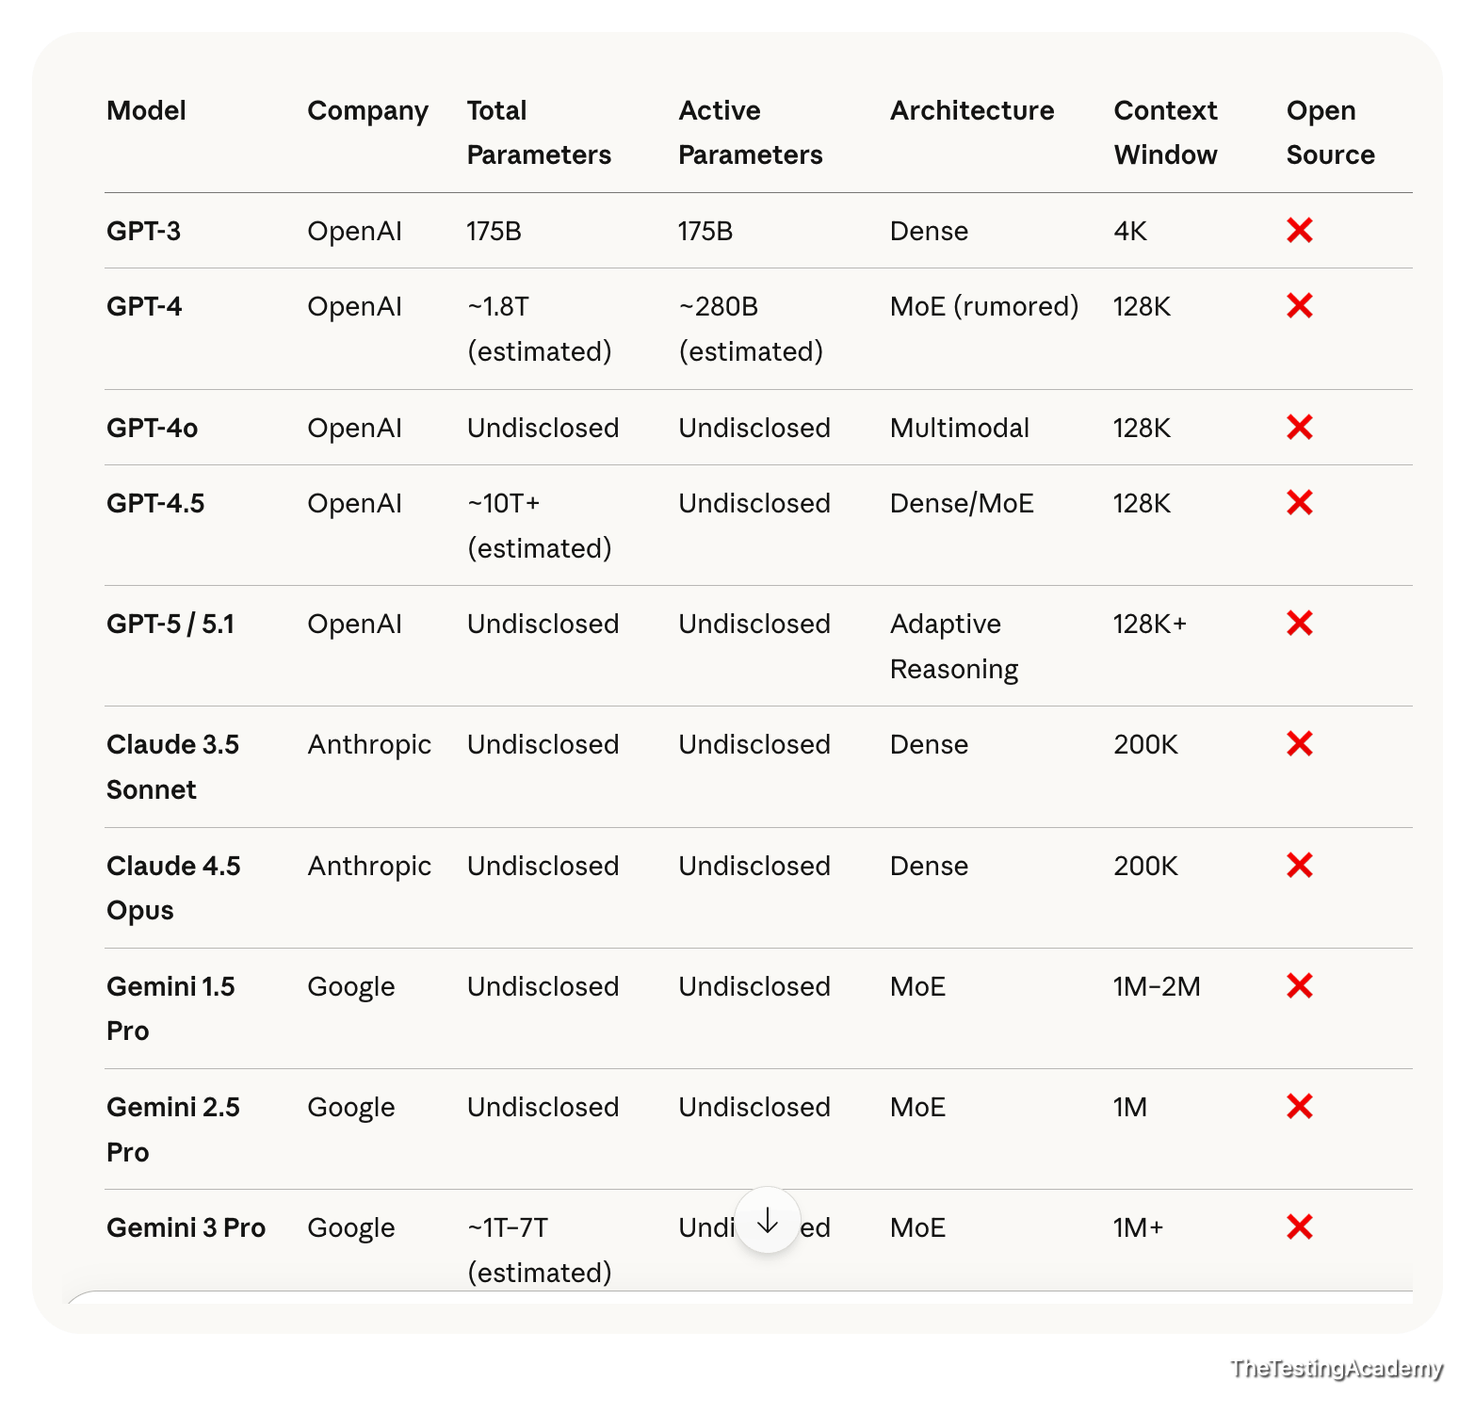
﻿
﻿
﻿
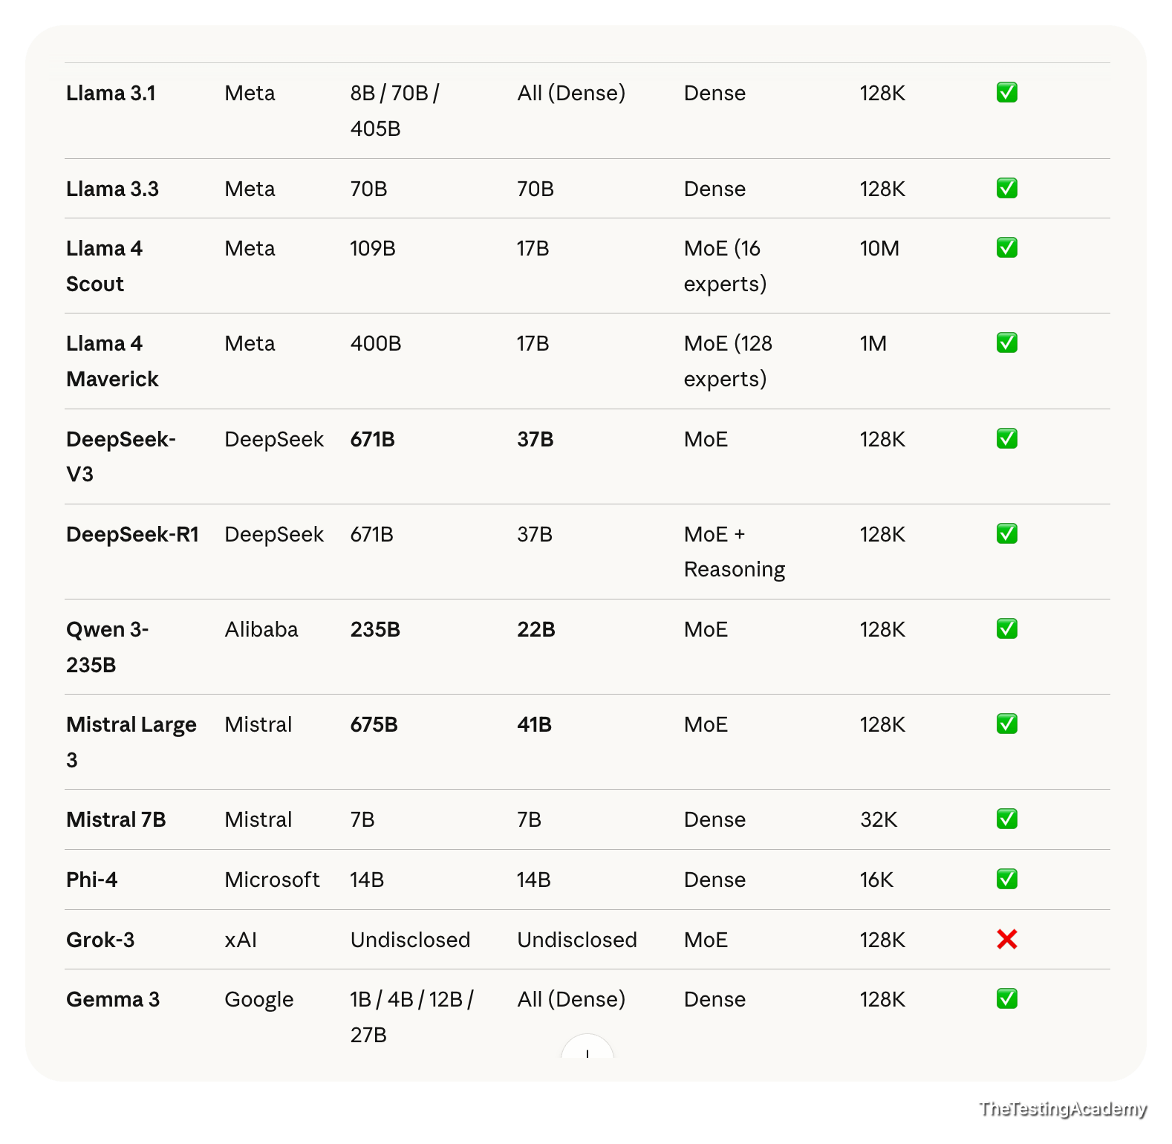
Large Language Model > 1B Large
Small Language Model < 1B (SLM)
﻿
Closed Source LLM
- GPT 5.6
﻿
Open Source LLM
- Mistral 4
- DeepSeek v4 Flash
﻿
﻿﻿huggingface.co/deepseek-ai/DeepSeek-V4-Flash-0731/tree/main
Hugging face is like a GitHub for the models, where you can host your model, you can download a model, and you can deploy and use it or test it also in this case.
﻿

﻿
- Office Laptop - Yes
- Personal. - P

﻿
Command Code | Command Code AI
- Visual Studio - ﻿code.visualstudio.com/download?_exp_download=fb315fc982
- Command Code AI -
  - ﻿﻿nodejs.org/en/download
  - ﻿﻿commandcode.ai/pricing
﻿
Rich -> $20 Claude / Codex
Budget - $1 CommandCode AI
Cursor, WindSurf - No
﻿

﻿
- Claude 101 - is optional to buy the - not mandatory to buy $20 (good to have)
﻿

﻿

Hallucinations (LLMs “Making Things Up”)

Definition
A hallucination occurs when an AI model produces confident but factually incorrect or completely fabricated output, even though the information does not exist in the system, logs, API, or requirements.
The key danger: the answer sounds correct.
﻿

QA Example 1 : Bug Report Hallucination
Prompt to AI
“Analyze this screenshot and generate a Jira bug report.”
AI Output (Hallucinated)
- Error Code: AUTH_403_INVALID_TOKEN
- Root Cause: Token expiry after 15 minutes
- Affected API: /auth/refresh
﻿
Reality
- Screenshot only shows “Something went wrong”
- No error code visible
- No token logic involved
﻿
Why this is a hallucination
- AI invented technical details
- No evidence in input
- Over-confident explanation
﻿

QA Example 2 – Test Case Hallucination
Prompt
“Generate test cases for VWO dashboard.”
AI Output
- Test case: Verify Dark Mode toggle
- Test case: Validate Export to CSV
﻿
Reality
- No Dark Mode
- No Export feature in product
﻿
﻿
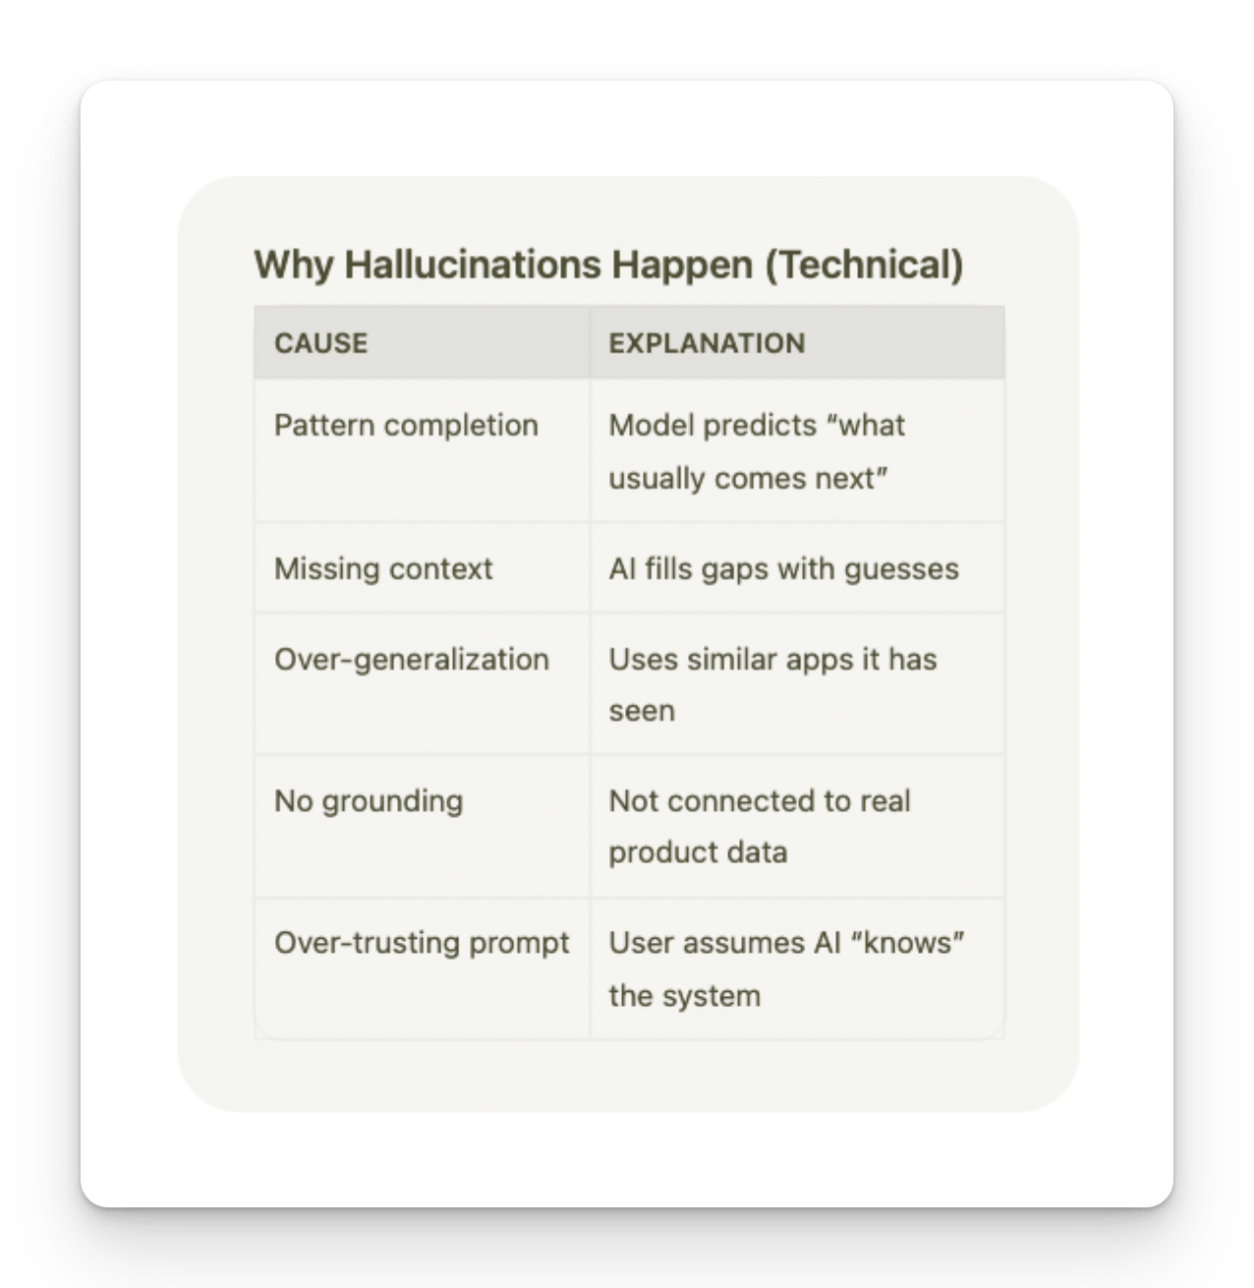

QA Red Flags for Hallucinations
- Mentions features not in PRD
- Invents error codes
- Claims logs show X (without logs)
- Gives exact numbers without evidence
Sounds too certain without sources

﻿
You never ask the AI. You always tell the AI what to do.
﻿

Anti-Hallucination Rules
ROLE: You are a QA assistant operating under strict verification rules. SCOPE OF KNOWLEDGE
You may ONLY use information explicitly provided in: PRD API documentation Logs Screenshots Test data User input
﻿
STRICT RULES (MANDATORY) DO NOT invent features, APIs, error codes, UI elements, or behavior. DO NOT assume default or "typical" system behavior. If information is missing or unclear, respond with: "Insufficient information to determine." Every assertion must be traceable to provided input. If a detail is inferred, label it explicitly as: "Inference (low confidence)". Output must be deterministic and repeatable.
PROCESS YOU MUST FOLLOW Step 1: Extract verifiable facts from the input. Step 2: List unknown or missing information. Step 3: Generate output ONLY from Step 1 facts. Step 4: Perform a self-check for hallucinations or contradictions. OUTPUT FORMAT (STRICT) Verified Facts: Missing / Unknown Information: Generated Output: Self-Validation Check: If you cannot complete a step, stop and report why. >> Instructions
﻿
﻿
﻿
﻿
﻿
﻿
﻿
- Local LLM with Ollama, LM Studio
- What is Prompt?, Skill?
- Prompt vs Skill File vs AI Agents
- Skill File (Office) - md -> that you can shared. (
  - Folder skill which can do many things.
﻿

﻿

Task 1. - Using the anti-hallucination rule to get the maximum output from the large language model
﻿
Req - ﻿docs.google.com/document/d/1GsT57ocl4HaUCxNhBGVmwvLYh7R24gjVB_RDteltkF4/edit?usp=sharing
﻿
Bad EXAMPLE
﻿﻿chatgpt.com/share/69a3c1a9-3ed0-8009-969c-9dd3a7cce824
﻿
Good Example
PRD - ﻿docs.google.com/document/d/1GsT57ocl4HaUCxNhBGVmwvLYh7R24gjVB_RDteltkF4/edit?usp=sharing
﻿﻿chatgpt.com/share/69a3c2d9-1f40-8009-98ed-6e04598199b4
﻿

﻿
Anti HALLCINATIONS Rule
﻿﻿github.com/PramodDutta/AI-Tester-Blueprint/blob/main/chapter_01_foundation_model/rules_checklists/ch_01_anti_hallucination.md
﻿

﻿
Prompt vs Skill
﻿
Prompt -> It is a set of instructions which are given.
Skill -> skill is nothing but a set of instructions which are properly structured to get a desired output
﻿
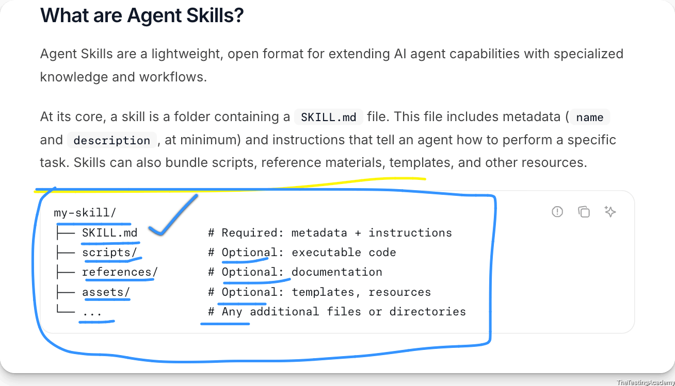
﻿
AI Agents - Brain + Memory + Tool (Workflow) -> They can do the studd 24x7, autononous
﻿

﻿
8th Aug 2026

Prompting Engineering
- What is Prompting
- Types of Prompts
- Advanced Prompting
  - QA-Specific Frameworks
    - Write your first QA-style prompt, Chain-of-Thought
    - Prompt frameworks: STAR, CLEAR, CRISP
    - Context creation via Templates (.md files)
    - RICE POT Framework (QA)
- What is Prompt Engineering and why we need to learn it
  - Steps to follow for Effective Prompt Engineering
  - Role-based prompting for QA, Zero Shot vs Precise Prompting

﻿

🧠 What is Prompting and how to learn?
﻿
- Better Mechanism to Ask from the LLM
- Ask -> Tell
﻿
Ask - you will get only 20% of things LLM
Tell - 80% ->
﻿
you will never ask from the LLM. You will always tell the LLM
Telling of the LLM, the right thing is called prompting.
﻿
LLM - (100%)
- Prompt Eng (Skill, AI Agents)
- RAG
- Fine tuning
﻿
- Prompting refers to the practice of providing specific instructions or input to an artificial intelligence (AI) model to obtain desired responses.
- In the context of AI and language models like GPT-4, prompting involves crafting queries or statements that guide the model to generate useful and relevant outputs.
﻿
Prompt Engineering is the practice of designing and refining inputs (prompts) to effectively communicate with Large Language Models (LLMs) to achieve desired outputs.
﻿
﻿
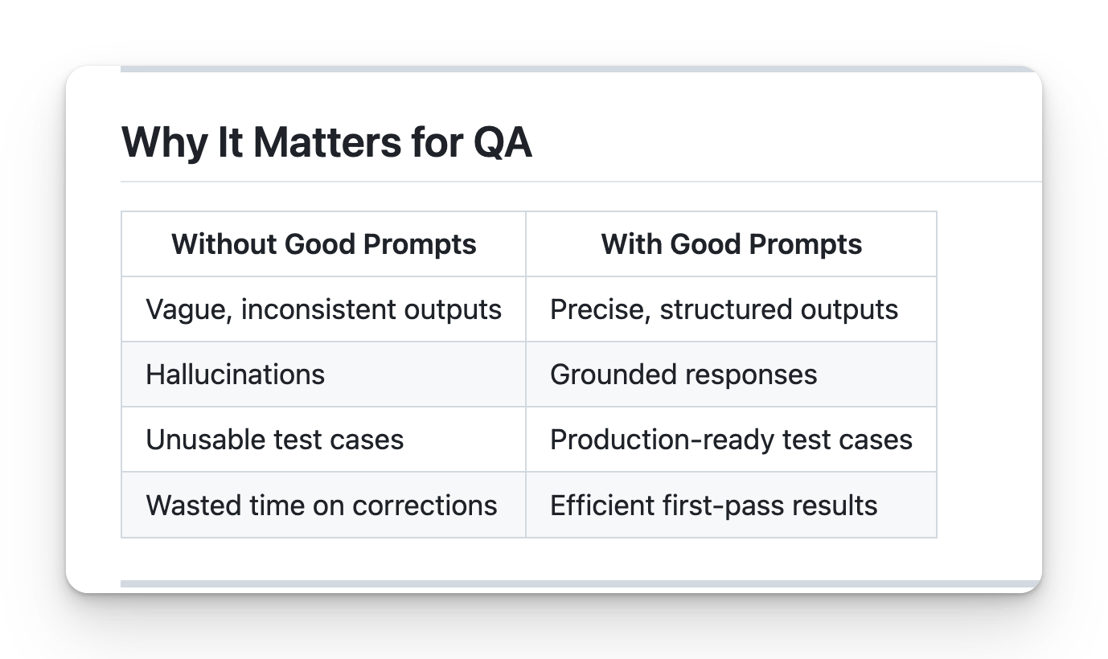
﻿
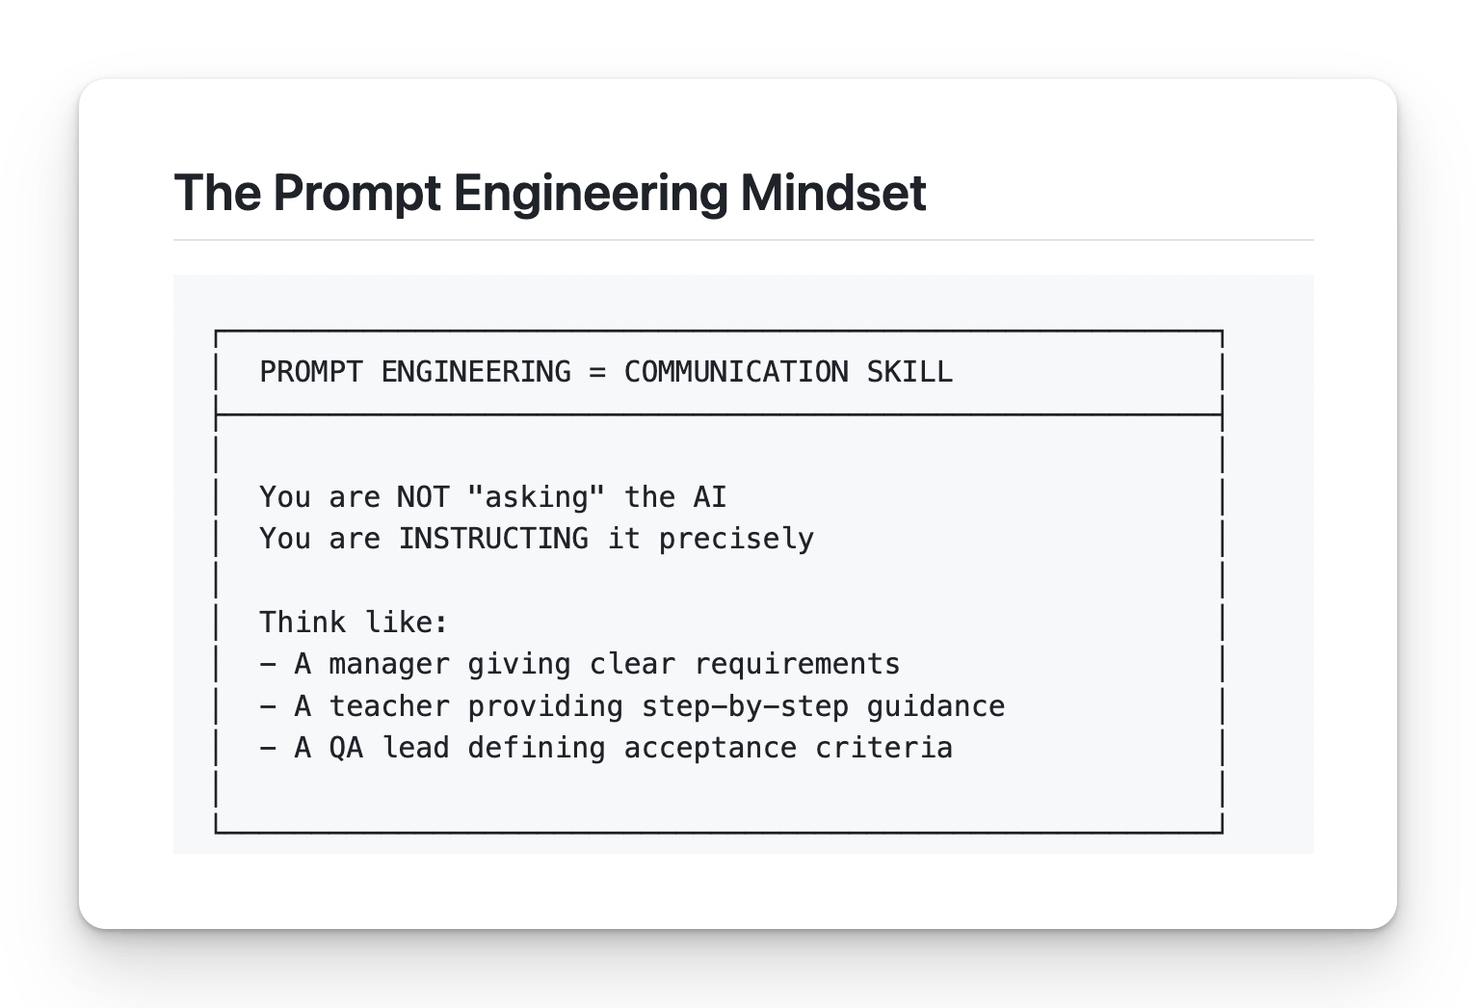
﻿

Core Principles
﻿

1. Be Specific
❌ Bad: "Write test cases for login"
﻿
✅ Good: "Write 5 functional test cases for email/password login, covering valid login, invalid email, invalid password, empty fields, and SQL injection attempt. Use the Proper JIRA format: Test ID, Description, Steps, Expected Result."
﻿
﻿

2. Provide Context
❌ Bad: "Test the API"
✅ Good: "Given this API endpoint documentation: [paste docs], write test cases covering happy path, error scenarios, and edge cases."
﻿

3. Define Output Format
❌ Bad: "Generate bug report"
✅ Good: "Generate a bug report using JIRA format: Title, Environment, Steps to Reproduce, Expected Result, Actual Result, Severity, Attachments."
﻿

4. Set Constraints
❌ Bad: "Help me test"
✅ Good: "Using ONLY the PRD provided, generate test cases. Do NOT assume any features not mentioned. If information is missing, state 'Not specified in PRD'."
﻿
﻿
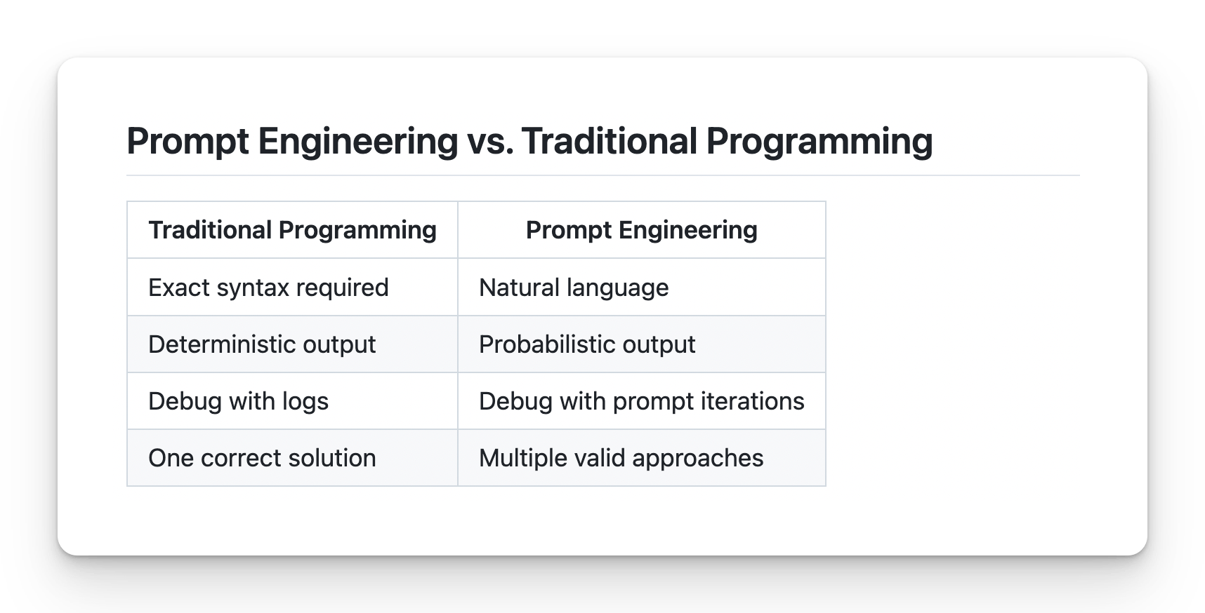

Steps to Follow for Effective Prompt Engineering
- │ Define the Goal │
- │ Gather Context │
- │ Choose Prompting Strategy │
- │ Structure the Prompt │
- │ Add Constraints │
- │ Test and Iterate │
- │ Document and Reuse │
﻿
Create testcase for app.vwo.com
﻿

Step 1: Define the Goal
Ask yourself:
- What exactly do I need?
- What will I do with the output?
- What does success look like?
❌ Vague: "Help me with testing" ✅ Clear: "Generate 10 test cases for login validation"
﻿
Objective : I want to generate only 10 test cases for the login on app.bw.com. I can see that on app.legend.com, there are:
- email ID
- password
- submit
- forget password
- a way to create a new account
I want to tell you that I have almost 15 years of experience, so please create the test case in such a way that it is production-ready and at an enterprise-grade level in this case
﻿
Plan -> Generate (AI) - - RULE 1- (95% Plan , 5% Action)
﻿
BLAST Framework > which will make sure that you know what you are building - AI
﻿
﻿

Step 2: Gather Context
Collect all relevant information:
- PRD / Requirements document
- API documentation
- Screenshots / UI mockups
- Error logs
- Previous test cases
- Constraints / Limitations
- JIRA ID, Stories , Epic, BRD, Conflueces, Wireframes, figma, Artch. Miro..
Rule: More context = Better output
﻿

Step 3: Choose Prompting Strategy
Zero-Shot -> No example
﻿
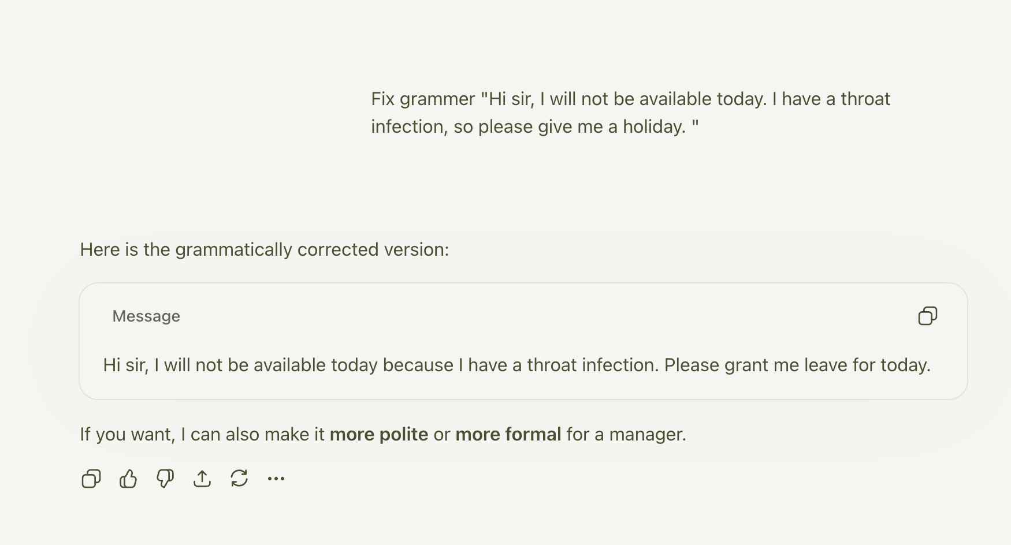
﻿
﻿

Few Shot : when you give one or more examples along with the prompt, what you wanted to achieve this
﻿
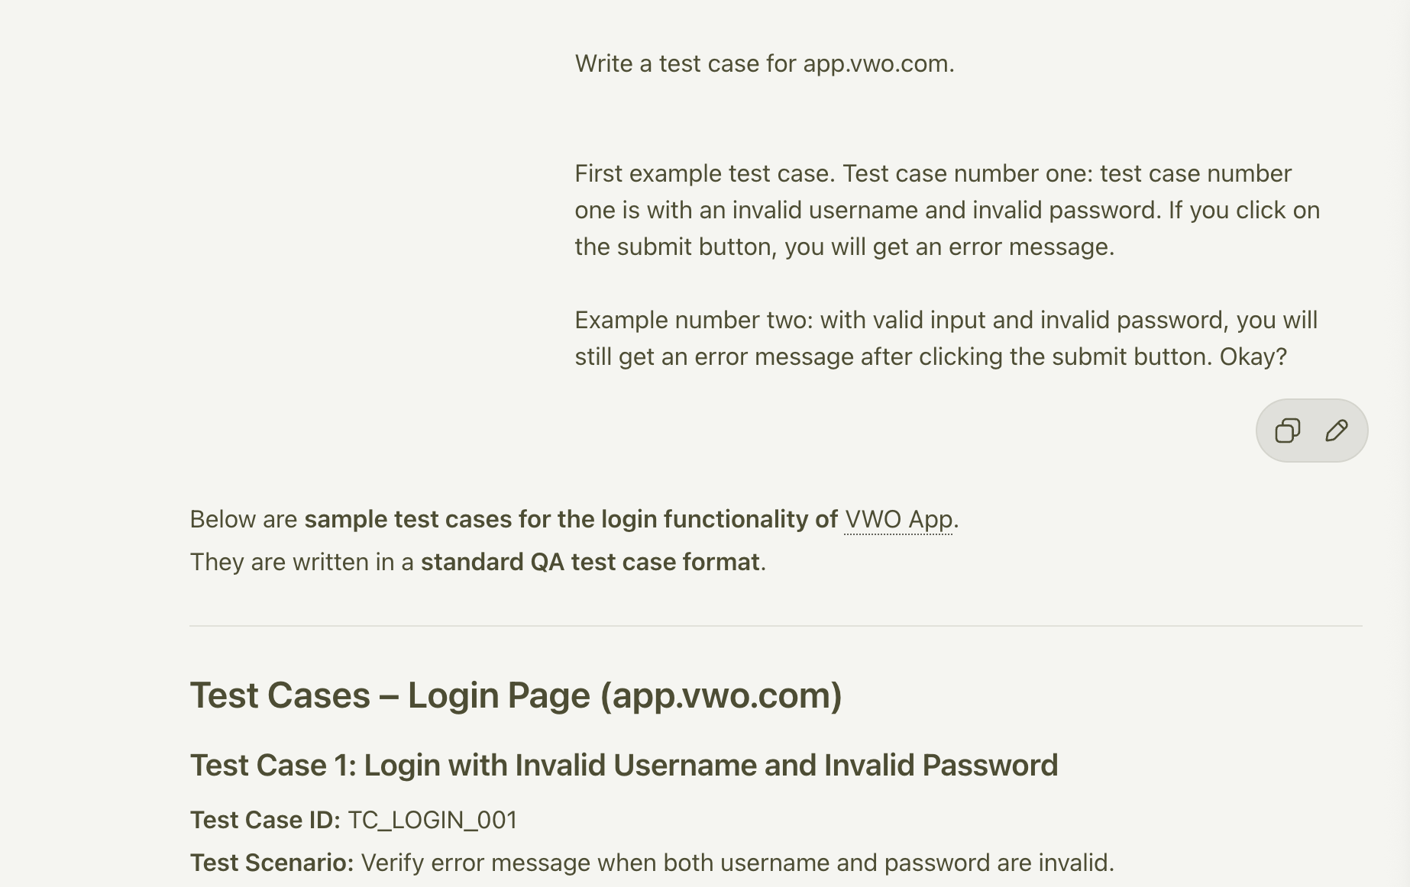
﻿
﻿
Chain of Thought : asking a continuous discussion question so that you can give feedback also, so that it gives a better answer in this case
﻿
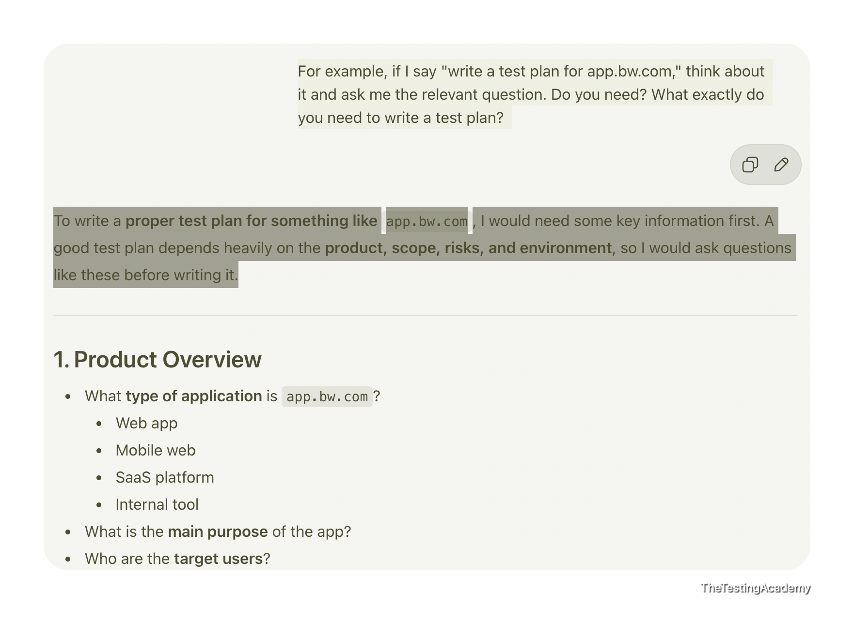
Situation | Strategy | ﻿
Simple, standard task | Zero-Shot | No Example
Custom format needed | Few-Shot | 2-3 examples
Complex analysis | Chain-of-Thought | Ask him to think about it
Domain expertise needed | Role-Based | Act as QA
﻿

Step 4: Structure the Prompt
Use a framework (RICE POT recommended):
﻿
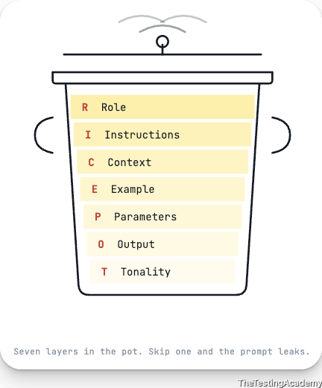
﻿
ROLE: [Expertise]
Instructions: [Purpose]
CONTEXT: [Background info]
EXPECTED: [Success criteria]
PARAMETERS: [Constraints]
OUTPUT: [Format]
TONE: [Specific instruction]
﻿
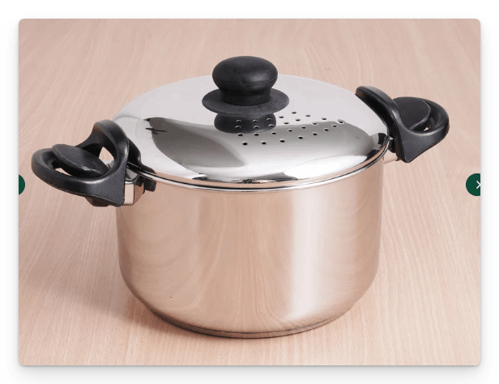
RICE POT to create the Selenium Code for the Salesforce Login.
﻿
Role -> You are a QA automation tester with 15 years of experience, You have a very good understanding of IT, CRM projects like ﻿salesforce.com. You need to create a framework with Selenium, Java, Maven, TestNG, and it should be enterprise-level framework that we need to create.
﻿
I -> Instructions
- Generate a Complete Selenium with Java automation script following the standard of enterprise level standards.
- Automate and verify the results of the login page ﻿login.salesforce.com/?locale=in, ensure that UI is thoroughly tested with valid and invalid testcases.
- [Critical] - Apply the TestNG annotations, @Test, @BeforeTest and others and and necessary setup/teardown logic.
- [Critical] Implement robust exception handling within both Page Object model and test scripts using structured try–catch blocks or explicit exception signatures.
- [Mandatory] Use Page Object Model with PageFactory, including @FindBy, constructor initialization, and reusable action methods.
- [Mandatory] - It is important that you use only the xpath not the css selectors.
- [Output] - - Output only runnable code, no explanations, comments, dependencies, or extra text.
- [Don't] - Don't use the css selectors, ID, name and others things.
- [Don't] - Don't add comments, Thread.sleep and other bad coding practice.
- [Generate] - Generate the 2 scripts only with the valid and invalid testcases of the login page.
- [Don't Use] Thread.sleep() anywhere; rely on WebDriverWait or implicit waits.
- Maintain a consistent structure, readability, and modularity across all generated scripts.
﻿
﻿
C -> Context You are creating a login page scripts with proper framework for the sales force login, which is a AB Testing website with valid and invalid login page where in the login page you have the email, password and submit button with remember me functionality.
﻿
E -> Example Example structure for PageFactory:
public class LoginPage { @FindBy(xpath = "//input[@id='username']") WebElement username;
﻿
@FindBy(xpath = "//input[@id='password']") WebElement password; @FindBy(xpath = "//input[@id='Login']") WebElement loginButton; public LoginPage(WebDriver driver) { PageFactory.initElements(driver, this); } public void doLogin(String user, String pass) { username.sendKeys(user); password.sendKeys(pass); loginButton.click(); }
﻿
﻿
P -> PARAMETERS with production level automation script expert with pin point accuracy and almost zero bad coding practice.
- I have external URLs, external staging URLs. I will give you the external username and password as well
﻿
O -> Output Provide only:
- 1 Page Object file
- 2 TestNG test scripts
- Maven project
- No explanations or additional content.
﻿
T -> Tone Technical, precisely, enterprise-grade, code-one.

﻿
﻿
Using this framework, can you generate a Playwright framework as well.
Using this framework, can you generate API,BDD automation code as well?
Using this framework, can you generate Test Plan, Testcase or STLC as well?
﻿
- │ Add Constraints │
- │ Test and Iterate │
- │ Document and Reuse │
﻿
# Understanding the RICE POT Prompt - Plan

Here's what I extract from this prompt before I build the plan:

**The RICE POT template** is a structured prompting framework for generating enterprise-grade code with zero ambiguity. This specific instance asks for a **Salesforce login page automation framework** using:

| Layer | What it Demands |
|---|---|
| **Role** | QA architect with 15yr CRM/Salesforce domain expertise |
| **Instructions** | Enterprise Selenium + Java + Maven + TestNG framework; valid + invalid login tests |
| **Context** | `login.salesforce.com/?locale=in` — email, password, submit, "remember me" |
| **Example** | PageFactory with `@FindBy`, xpath-only selectors, `doLogin()` action method |
| **Parameters** | External URLs + credentials provided separately; production-grade precision |
| **Output** | Exactly 3 files: 1 Page Object, 2 TestNG scripts, Maven `pom.xml` |
| **Tone** | Technical, precise, no comments, no `Thread.sleep`, no CSS/ID/name selectors |

The key constraints: **xpath-only**, **no CSS/ID/name**, **no comments**, **no Thread.sleep**, **PageFactory + @FindBy**, **TestNG annotations**, **robust exception handling**.

---

Now let me explore the existing project to understand what's already scaffolded, then build the plan.

Read [](file:///Users/promode/Documents/AITesterBlueprin4x/chapter_02_Prompt_Eng/02_RICE_POT.example.md)

Read [](file:///Users/promode/Documents/AITesterBlueprin4x/chapter_02_Prompt_Eng/01_RICE_POT_Template.md)

Read [](file:///Users/promode/Documents/AITesterBlueprin4x/chapter_02_Prompt_Eng/00_Task1.md)

Read [](file:///Users/promode/Documents/AITesterBlueprin4x/README.md)

Good. Now let me check the chapter_01 folder for any additional context about project conventions.

Read [](file:///Users/promode/Documents/AITesterBlueprin4x/chapter_01_LLM_BASICS)

Now I have the full picture. Before I finalize the plan, I need to clarify a few things.

Analyzing your answers...

Got it. Let me now fetch the live Salesforce login page to extract real xpaths before building the plan.

Fetched https://login.salesforce.com/?locale=in

Now I have all the context I need. Let me build the comprehensive plan.

Created memory file [](file:///Users/promode/Library/Application%20Support/Code/User/workspaceStorage/d4b8876e02373f67587248f5c4564d1c/GitHub.copilot-chat/memory-tool/memories/N2M1OTQ0OGQtOGE4Zi00MTRjLWJlY2ItNGYzM2NlMmVlNDM5/plan.md)

---

## What I Understand From This RICE POT Prompt

This is a **structured code-generation prompt** using the RICE POT framework. Here's the decoded intent:

| Component | What It's Asking For |
|---|---|
| **R**ole | Senior QA architect persona (15yr, CRM/Salesforce domain) — this biases output toward production patterns |
| **I**nstructions | Enterprise Selenium + Java + Maven + TestNG framework; valid + invalid login tests; TestNG annotations; exception handling; PageFactory + `@FindBy`; xpath **only** |
| **C**ontext | Target: `login.salesforce.com/?locale=in` (Indian locale, may serve different HTML). Login has username, password, submit, remember-me |
| **E**xample | Shows the exact code pattern expected — `@FindBy(xpath = "...")`, `PageFactory.initElements()`, action methods like `doLogin()` |
| **P**arameters | External credentials provided separately; production-grade precision demanded |
| **O**utput | Exactly 3 code files + Maven project. No explanations, no comments, no fluff |
| **T**one | Terse, precise, enterprise-grade. No `Thread.sleep`, no bad practices |

**The core tension**: "Enterprise-level framework" implies many files (base classes, utilities, config), but "Output: 1 Page Object, 2 TestNG scripts, Maven project" caps the deliverable count. My plan resolves this by building a full enterprise scaffold but keeping the user-facing deliverable focused on the 3 core files + `pom.xml`.

---

## Plan: Salesforce Login Selenium Framework (RICE POT)

**TL;DR** — Build inside `chapter_02/RICE_POT_SeleniumAdvanceFramework/`. Deliver: 1 Page Object (xpath-only `@FindBy`), 2 TestNG scripts (valid + invalid login), Maven `pom.xml`, plus enterprise scaffold (BaseTest, ConfigReader, WaitUtils). Live DOM fetched first.

### Phase 1: Scaffolding

| Step | What | Depends On |
|---|---|---|
| 1 | **Fetch live DOM** from `login.salesforce.com/?locale=in` to extract real xpaths | — |
| 2 | Create Maven directory structure under `chapter_02/RICE_POT_SeleniumAdvanceFramework/` | — |
| 3 | Create `pom.xml` (Selenium 4.x, TestNG 7.x, WebDriverManager 5.x, Maven Surefire) | Step 2 |

### Phase 2: Utilities & Config

| Step | What |
|---|---|
| 4 | `config.properties` — `base.url`, `valid.username=PLACEHOLDER`, `browser=chrome`, wait timeouts |
| 5 | `ConfigReader.java` — singleton, loads from classpath |
| 6 | `WaitUtils.java` — `WebDriverWait` wrapper; zero `Thread.sleep` |

### Phase 3: Base Test

| Step | What |
|---|---|
| 7 | `BaseTest.java` — `@BeforeTest` (WebDriverManager init, maximize, navigate), `@AfterTest` (quit), protected `driver` + `loginPage` fields |

### Phase 4: Page Object

| Step | What |
|---|---|
| 8 | `LoginPage.java` — `@FindBy(xpath="...")` for all elements; `PageFactory.initElements()`; action methods (`enterUsername`, `enterPassword`, `clickLogin`, `doLogin`, `getErrorMessageText`, `isErrorMessageDisplayed`, `checkRememberMe`); all wrapped in try-catch |

### Phase 5: Test Scripts

| Step | What | Tests |
|---|---|---|
| 9 | `ValidLoginTest.java` (extends BaseTest) | 3 tests: valid credentials, remember-me checked, UI elements rendered |
| 10 | `InvalidLoginTest.java` (extends BaseTest) | 5 tests: wrong password, empty username, empty password, both empty, invalid email format |

### Phase 6: Suite Config

| Step | What |
|---|---|
| 11 | `testng.xml` at project root — suite referencing both test classes |

### Phase 7: Verification

| Step | What |
|---|---|
| 12 | `mvn compile` — zero errors |
| 13 | `mvn test` with placeholders — validates xpaths, browser launches, no NPE |
| 14 | Grep checks: no `By.id/name/cssSelector/className`, no `Thread.sleep`, no comments in Java files |

### Key Decisions

- **xpath with `@id` allowed** — `//input[@id='username']` is valid xpath. "Don't use ID" means no `By.id()` strategy.
- **`config.properties` with placeholders** — credentials filled in when provided; no hardcoding.
- **Live DOM fetch is Step 1** — Salesforce can serve different HTML to the Indian locale; fetched DOM is authoritative.
- **8 total test cases** — 3 valid + 5 invalid, covering happy path and edge cases.

### Further Considerations

1. **CAPTCHA/SSO risk**: If the target Salesforce org has CAPTCHA or SSO, automated login will fail. This is a known limitation.
2. **Headless mode**: Add `headless=true/false` config flag for CI/CD readiness (not in initial deliverable but easy to add).
3. **Cross-browser**: Structure supports it; add `FirefoxDriver`/`EdgeDriver` branches in BaseTest when needed.

---

This is the plan. Does it look right? Any adjustments before we move to implementation?

﻿

Quick Checklist for Good Prompt
- Goal is clearly defined
- All relevant context is included
- Appropriate strategy chosen
- Prompt is well-structured
- Anti-hallucination constraints added
- Output format specified
- Task instruction is specific
﻿

Common Mistakes to Avoid
﻿
Blindly accepting the AI output
﻿
﻿
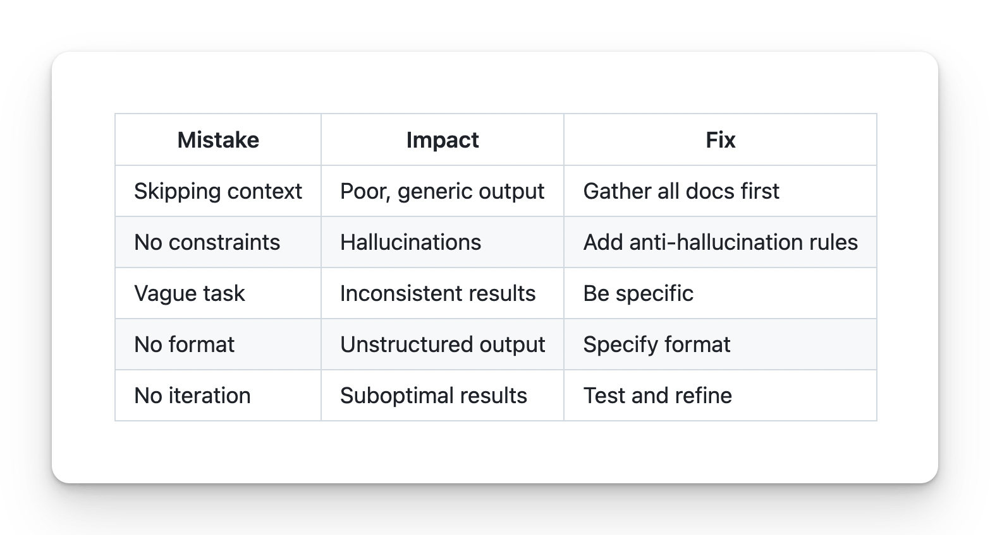

﻿

Prompt Frameworks: STAR, CLEAR, CRISP for QA
﻿

CRAP / CRISP Framework
C -> Context R -> Role A -> Action P -> Parameters
I -> Instructions (optional)
﻿

2. RACE
R — Role A — Action C — Context E — Expectation
R — Role A — Action C — Context E — Expectation Task - Bug Report for the invalid login at the app.vwo.com
﻿﻿chatgpt.com/share/69b4e6b0-c704-8001-adce-cad61b921623
﻿
3. COAST
C — Context O — Objective A — Action S — Style T — Tone
﻿
﻿

4. CLASSIC “Role Model Prompting”
“You are X, behave like Y, produce Z.” Feels like assigning an actor their script 🎭.
﻿
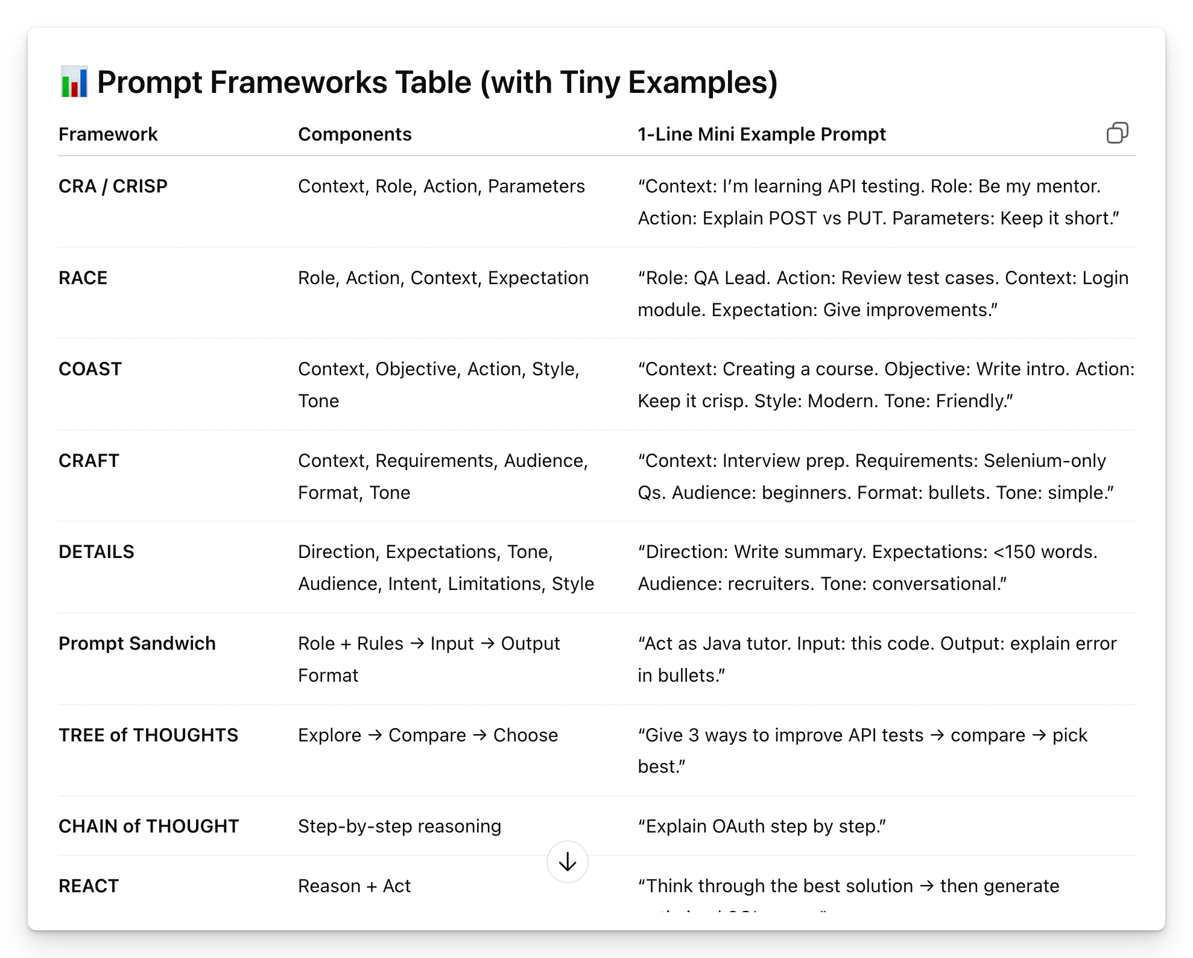
﻿
﻿
RICE POT Framework (95%, Plan, 5% Execution)
﻿

Checklist: Is Your Prompt Complete?
- Role defined
- Context provided
- Task is specific and quantified
- Constraints prevent hallucinations, conditions
- Output format specified
- Terminology defined if needed
﻿﻿chatgpt.com/share/697efcef-7c50-8009-b5e6-db0a4fab6f82
﻿

﻿
- FREE Course - ﻿learnprompting.org/courses/chatgpt-for-everyone
- Claude 101 ->.
- Codex Masterclass - Future
- Cursor Masterclass
- Claude Code Master - QA( Done)

﻿

Prompts Templates (templates/)
Purpose: Ready-to-use prompt templates for STLC
Chapter: 2 - Prompt Engineering
﻿

Template 1: Basic Test Case Generation ( RTCFR)
ROLE - You are a Senior QA Engineer.
TASK - Generate [NUMBER] test cases for [FEATURE].
number is your educated guess , here you context
CONSTRAINTS
- Use ONLY the provided requirements
- Do NOT assume undocumented behavior
- If information is missing, state "Not specified"
﻿
FORMAT: | Test ID | Description | Pre-conditions | Steps | Expected Result | Priority |
﻿
REQUIREMENTS: [PASTE REQUIREMENTS HERE]
﻿
+ ANTI Hallucinations RULES
﻿

Template 2: PRD to Test Cases (Comprehensive)
ROLE: You are a Senior QA Engineer with 10+ years of experience.
TASK: Generate comprehensive test cases from this PRD.
COVERAGE AREAS:
- Functional (happy path)
- Negative scenarios
- Boundary values
- Edge cases
CONSTRAINTS:
- Use ONLY PRD content
- No assumptions about unmentioned features
- Mark unclear items as "Needs clarification"
- Do NOT invent error messages or codes
FORMAT: | TID | Category | Description | Pre-conditions | Steps | Expected | Priority |
﻿
PRD / SRS / REQ / BRD / DRD / JIRA ID / confluece page(content) / HLD : <<< [PASTE PRD HERE] >>
﻿

﻿

Template 3: API Test Case Generation
ROLE: You are an API Testing Specialist.

TASK: Generate test cases for this API endpoint.

COVERAGE:
- Happy path (valid requests) | functionality
- Invalid inputs (validation errors)
- Authentication/Authorization
- Error handling
- Boundary conditions

CONSTRAINTS:
- Use ONLY the API documentation provided
- Include exact status codes from docs
- Do NOT assume undocumented behavior

FORMAT:
| Test ID | Endpoint | Method | Request Body | Expected Status | Expected Response |

API DOCUMENTATION:
<<<
[PASTE API DOCS HERE] - ﻿documenter.getpostman.com/view/3967924/RW1dExDv
>>>

﻿

Template 4: Negative Test Cases Only
﻿
ROLE: You are a QA Engineer focused on negative testing.

TASK: Generate negative test cases for [FEATURE].

FOCUS AREAS:
- Invalid inputs
- Boundary violations
- Missing required fields
- Unauthorized access
- Malformed data

CONSTRAINTS:
- Do NOT include happy path scenarios
- Each test must validate error handling
- Include expected error message if documented

FORMAT:
| Test ID | Invalid Scenario | Input | Expected Error |

FEATURE REQUIREMENTS:
[PASTE REQUIREMENTS] |. does not matter what you have here. You can mention Jira ID, SRS, BRD, PRD, Sprint Ticket, Jira ID, Test

﻿

RTCFR AND RICE POT.

Template 6: Regression Test Suite
ROLE: You are a QA Lead planning regression testing.

TASK: Generate a regression test suite for [MODULE].

PRIORITIES:
1. Critical business flows
2. Previously failed areas
3. High-risk integrations
4. Core functionality

CONSTRAINTS:
- Focus on end-to-end scenarios
- Include data setup requirements
- Estimate execution time per test

FORMAT:
| Test ID | Scenario | Data Setup | Steps | Est. Time | Priority |

MODULE DOCUMENTATION:
[PASTE DOCS]

﻿

Template 1: Basic Bug Report from Evidence
ROLE: You are a QA Engineer writing a bug report. TASK: Generate a bug report based ONLY on the evidence provided. CONSTRAINTS: - Use ONLY information from screenshots/logs - Do NOT assume root cause - Do NOT invent error codes - Mark unknown information as "[UNKNOWN]" FORMAT: Title: [Brief description] Environment: [From evidence or UNKNOWN] Severity: [Based on impact] Steps to Reproduce: [From evidence] Expected Result: [From requirements or UNKNOWN] Actual Result: [From evidence] Evidence: [List attachments] EVIDENCE: <<< [PASTE SCREENSHOT DESCRIPTION / LOGS] >>>
﻿﻿chatgpt.com/share/69b62739-0654-8001-9d70-a469cb0c7a48

﻿

Template 2: Bug Classification
ROLE: You are a QA Lead classifying bugs.

TASK: Classify this bug by severity and priority.

SEVERITY DEFINITIONS:
- Critical: System crash, data loss, security breach
- High: Major feature broken, no workaround
- Medium: Feature impaired, workaround exists
- Low: Minor issue, cosmetic

CONSTRAINTS:
- Base classification ONLY on provided information
- If impact is unclear, state "Needs more information"

FORMAT:
Severity: [Level]
Priority: [Level]
Justification: [Based on evidence]
Missing Information: [What's needed]

BUG DESCRIPTION:
<<<
[PASTE BUG DESCRIPTION]
>>>

Template 3: Bug Analysis (Chain-of-Thought)
ROLE: You are a Senior QA Engineer analyzing a bug.

TASK: Analyze this bug report step by step.

ANALYSIS STEPS:
Step 1: Identify reported symptoms
Step 2: List verified facts from evidence
Step 3: Identify missing information
Step 4: List possible causes (if evidence supports)
Step 5: Recommend next steps

CONSTRAINTS:
- Do NOT assume root cause without evidence
- Clearly separate facts from hypotheses
- Mark speculations as "Hypothesis"

BUG REPORT:
<<<
[PASTE BUG REPORT]
>>>
﻿﻿chatgpt.com/share/697f0a3c-7214-8009-8681-fb215f2b78cf
﻿

﻿

Template 5: Convert Notes to Bug Report
ROLE: You are a QA Engineer writing a formal bug report.
TASK: Convert these informal notes into a proper bug report.
CONSTRAINTS:
- Use ONLY information from the notes
- Mark gaps as "[NEEDS CLARIFICATION]"
- Do NOT invent details
- Ask for missing information
FORMAT: Title: Environment: Severity: Steps to Reproduce: 1. 2. 3. Expected Result: Actual Result: Evidence Required:
NOTES: <<< [PASTE INFORMAL NOTES]
﻿

﻿

Anti-Hallucination Reminder
⚠️ IMPORTANT: When generating bug reports: ✅ DO: - Use only provided evidence - Mark unknowns explicitly - Request clarification for gaps ❌ DO NOT: - Assume root cause - Invent error messages - Guess system behavior - Fill gaps with assumptions
﻿

﻿

API Testing Prompts
Purpose: Generate API test cases and scenarios
Chapter: 2 - Prompt Engineering
﻿

Template 1: REST API Test Suite
ROLE: You are an API Testing Specialist.
TASK: Generate a comprehensive test suite for this REST API endpoint.
COVERAGE AREAS:
- Happy path (valid requests)
- Input validation (invalid data)
- Authentication/Authorization
- HTTP methods (allowed vs not allowed)
- Response validation
- Error handling
CONSTRAINTS:
- Use ONLY the API documentation provided
- Use exact status codes from documentation
- Do NOT assume undocumented behavior
- Include request/response examples
FORMAT: | Test ID | Category | Method | Endpoint | Request | Expected Status | Expected Response |
API DOCUMENTATION: <<< [PASTE API DOCS]
﻿

﻿

Template 2: API Validation Tests
ROLE: You are an API QA Engineer.
TASK: Generate input validation test cases for this API endpoint.
VALIDATION SCENARIOS:
- Required fields missing
- Invalid data types
- Boundary values (min/max)
- Invalid formats (email, phone, date)
- Special characters
- Empty strings vs null
CONSTRAINTS:
- Use field constraints from API spec
- Include expected error messages if documented
- Do NOT invent validation rules
FORMAT: | Test ID | Field | Invalid Input | Expected Error Code | Expected Message |
API SPECIFICATION: <<< [PASTE SPEC]

Template 3: API Authentication Tests
ROLE: You are a Security-focused API Tester.
TASK: Generate authentication and authorization test cases.
SCENARIOS:
- No token/credentials
- Invalid token
- Expired token
- Wrong user permissions
- Token tampering
- Rate limiting
CONSTRAINTS:
- Use authentication method from docs
- Do NOT include actual tokens in tests
- Focus on security boundaries
FORMAT: | Test ID | Auth Scenario | Request Setup | Expected Status | Security Validation |
AUTH DOCUMENTATION: <<< [PASTE AUTH DOCS]

Template 4: API Contract Testing
ROLE: You are an API Contract Testing Specialist.
TASK: Generate contract tests to validate API response structure.
VALIDATIONS:
- Response schema matches spec
- Required fields present
- Data types correct
- Nullable fields handled
- Array bounds respected
CONSTRAINTS:
- Use exact schema from documentation
- Include positive and negative cases
- Validate both success and error responses
FORMAT: | Test ID | Response Type | Field | Expected Type | Required | Validation |
API SCHEMA: <<< [PASTE JSON SCHEMA OR OPENAPI SPEC]
﻿

﻿

Template 5: API Performance Test Scenarios
ROLE: You are a Performance Test Engineer.

TASK: Design performance test scenarios for this API.

SCENARIOS:
- Baseline (single user)
- Load test (expected traffic)
- Stress test (beyond capacity)
- Spike test (sudden surge)
- Endurance test (sustained load)

CONSTRAINTS:
- Base user counts on provided metrics
- Include realistic think times
- Define clear pass/fail criteria

FORMAT:
| Scenario | Users | Duration | Ramp-up | Pass Criteria |

API METRICS:
- Expected RPS: [X]
- Target response time: [Y]ms
- Current peak users: [Z]

ENDPOINT:
<<<
[PASTE ENDPOINT INFO]
>>>

Template 6: API Error Handling Tests
ROLE: You are an API QA Engineer.
TASK: Generate error handling test cases.
ERROR CATEGORIES:
- Client errors (4xx)
- Server errors (5xx)
- Timeout handling
- Malformed requests
- Service unavailable
CONSTRAINTS:
- Use error codes from documentation
- Include error response format
- Verify error messages are safe (no stack traces)
FORMAT: | Test ID | Error Scenario | Trigger | Expected Code | Expected Response Format |
ERROR SPEC: <<< [PASTE ERROR DOCUMENTATION]
﻿

﻿
﻿
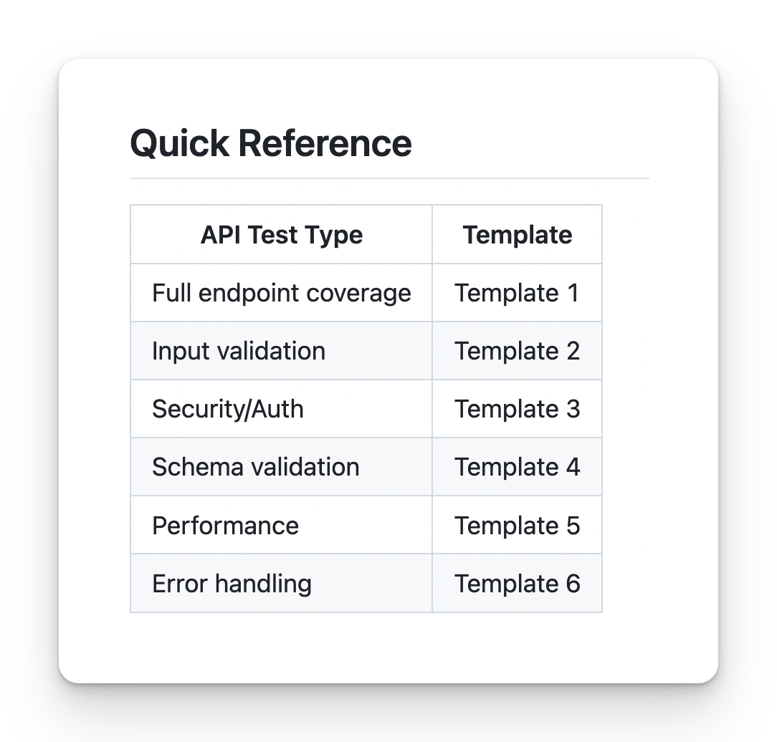
﻿

How to push the code to Github to our Repo?
﻿﻿github.com/new

How to get the person Token ? (Github)
﻿﻿github.com/settings/tokens
﻿
﻿
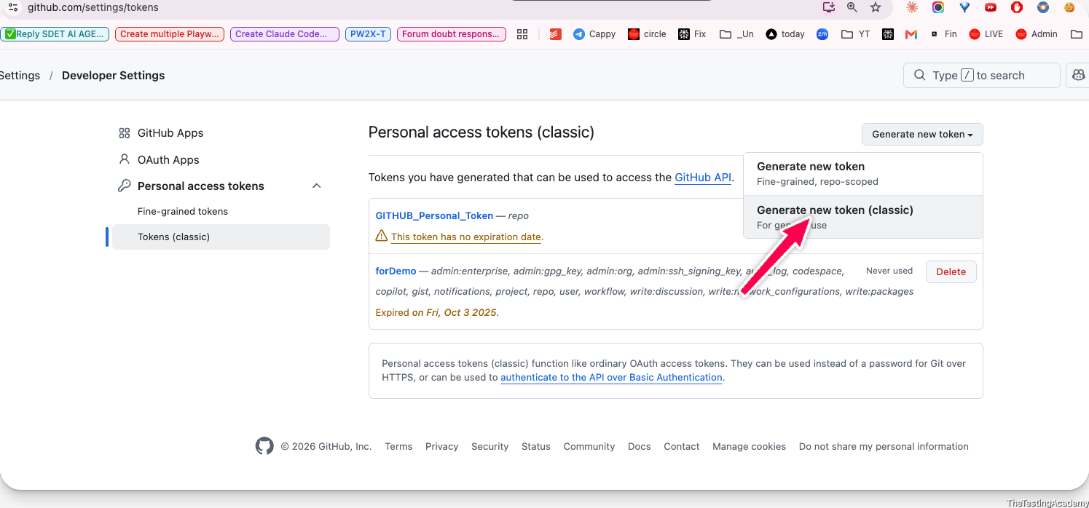
﻿
﻿
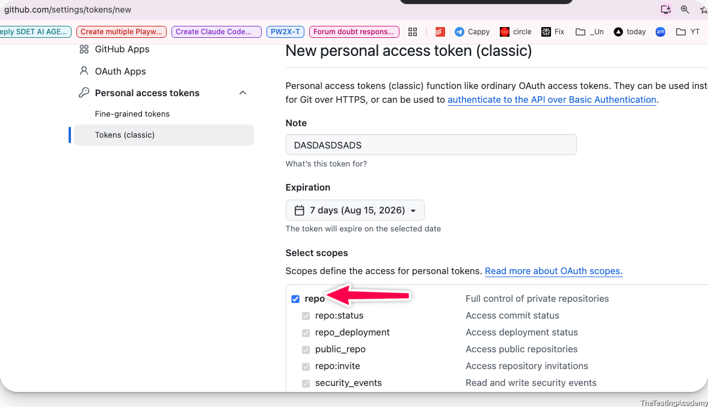
﻿
﻿
﻿
﻿

Try by yourself to push the code like this
﻿﻿github.com/PramodDutta/AITesterBlueprint4x/tree/main/chapter_02_Prompt_Eng
﻿
Please push to your
﻿﻿github.com/YourName/AITesterBlueprint4x/tree/main/chapter_02_Prompt_Eng
﻿
﻿
﻿﻿id.atlassian.com/manage-profile/security/api-tokens.

BLAST Framework
- (To create a Best Test Plan, Testcase Gen Local LLM )
- (You don't create the AI SLOP(Garbage)

﻿
9th Aug 2026
﻿
Finish by EOD
- Test Plan and Test case using the RICE POT framework.
  - Test Plan
  - Test Case
  - Bug Report
- Templates - folder
﻿

﻿
Open source Models + BLAST Framework
﻿
- Open Source Models
- Prompt - Test Plan -> Local Test Case Generator
- BLAST Framework
- ﻿﻿GROQ.com , Openrouter.ai - Cloud LLM Brain
﻿

﻿

Open Source Models
- Close source models never tell what data or weights that they have or created.
- they provide you transparency and less vendor dependency.
- Yes, you do not depend only on the US or any company or any country because of that.
- Open source means other people can also contribute to this.
- Weights -> Text -> WEIGHTS (maths) [ 0.0034,-.342322]... cat
﻿
﻿
Examples of popular model families include:
- Qwen - Alibaba
- Llama - Zuck
- Gemma - Google
- Mistral (EU)
- DeepSeek
- Kimi K3
﻿
﻿
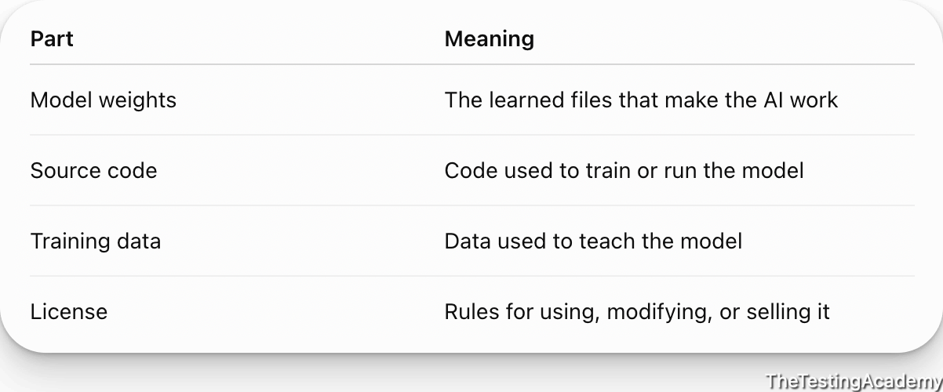
﻿

﻿

How to use the Open Source Model?
- Local Run OS
  - ollama (local, cloud both)
  - lm studio
  - llama.cpp
- Cloud Service
﻿

How to run the Local LLM into own system?
- 100% Open source
- 100% private, Data is not shared anywhere
- 100% can run without internet.
- Full control on the model
- You can fine tune also if required for your project. (teaching aksill), customize
- Offline, Zero after the setup
- 1 time cost for hardware.
  - 128GM Mac studio
- LLM Text Extraction -
- Automation + AI - OS or cheap models.
- LLM Response Validation
- Scale LLM Working
﻿
Disadvantage
- Slow
- Require heavy Infra, RAM and cost
- Limited Knowledge and sometimes OS LLM are not frequently update..
﻿

﻿
Office Laptop - P.S get a approval before installing
﻿
16 GB RAM -> my friend your computer will hang in this demo or project
8GB -> RAM -> my friend your computer will hang in this demo or project
4GB -> My you can watch this demo :), I will tell alternate.(Cloud LLM brain)
﻿
Local LLM(In your Computer)
﻿
﻿
- ﻿ollama.com/download
- anymode < 1-3b parameter.
- ﻿﻿ollama.com/library/llama3.2
- ﻿﻿ollama.com/library/gemma3:1b
- ﻿﻿ollama.com/library/deepseek-r1:1.5b
﻿
Alterante (Ollama is not working)
﻿﻿lmstudio.ai/
﻿
﻿

﻿
﻿
Cloud Based model (Cheap, and easy to use), Pay as you go.
- openrouter.ai
- ollama cloud
- ﻿﻿groq.com (FREE 1M per day )
﻿

﻿

Local TestCase Generator
﻿
Objective:
- Generate the TC from the Requirement use the opensource Model(ollama)
- Fetch the requirement from the JIRA and create TC around it.
  - Web application - BLAST Framework
    - Local LLM
    - Cloud LLM (Groq.com)
﻿
Pre- Req ->
- Requirment Doc
- JIRA Access -
  - API Token
  - Email ID
  - URL of the project.
﻿
﻿
﻿
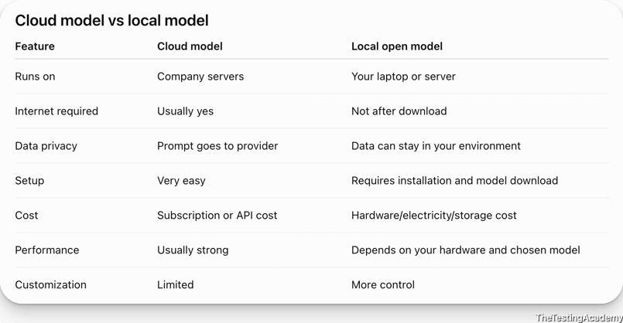
Requirement -﻿docs.google.com/document/d/1GsT57ocl4HaUCxNhBGVmwvLYh7R24gjVB_RDteltkF4/edit?usp=sharing
﻿
﻿

Task #1
Generate the TC from the Requirement use the opensource Model(ollama)
Requirement -﻿docs.google.com/document/d/1GsT57ocl4HaUCxNhBGVmwvLYh7R24gjVB_RDteltkF4/edit?usp=sharing
﻿
Generate TC 25 tc BY USING THE Local gemma3:1b
﻿

Task# 2
- Fetch the requirement from the JIRA and create TC around it.
  - Web application - BLAST Framework
    - Local LLM
    - Cloud LLM (Groq.com)
﻿
﻿
Control we have, more we can achieve -> ROVO, GHCP to achieve this, Codex, Claude to this, you have los the battle already.
Vendor Lockin ->
﻿
- JIRA Connection
  - ﻿﻿www.loom.com/share/47e8ed337bce40b285364c8aab349701
  - 30 Days FREE trial
    - Custom JIRA for learning purpose.
- JIRA URL - ﻿bugzz.atlassian.net/
- Token ? -> ﻿id.atlassian.com/manage-profile/security/api-tokens.
  - ATATT3xFfGF0T0OrEmD-fV9WhMeR51rlKcgM940gFeVpBiJML_nglNpJpAMt0L0J-XcMAHmCwCbn6X3FOe5xEYrCxwC7pwmp-2EPJIlUlfd2cizN0537qECKq4uEmE0L-1rkbbbVelwe1qdHnQujyjYNV5JXFN7P7Km_B2yXeGgf_po9wfrYGDc=9BEB16FD
- Email : thetestingacademy+jira@gmail.com
﻿

﻿

Prompt - VIBE Coded solution (in the Python)
- Fetch the JIRA
- Read the Testcase Temaplates
- Create the Testcase using the
  - Local Ollama Model.
  - ﻿﻿Groq.com ( gpt-oss20 modle) (FREE) cost
﻿
﻿
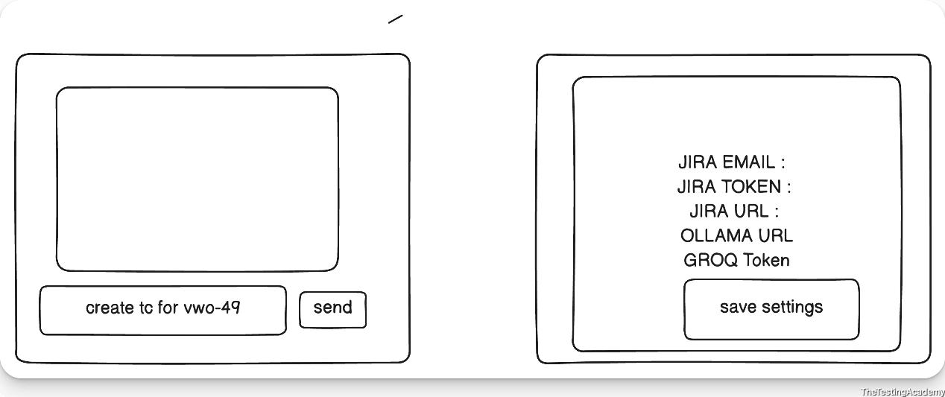
﻿

Create a free account on ﻿groq.com (1m FREE token per day) and get the key.
﻿﻿console.groq.com/keys
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
﻿

Proper Prompt Used

RICE-POT Prompt -> Jira Test Case Generator App

Role
You are a senior Python full-stack engineer and AI application architect, experienced in building lightweight internal tools with Streamlit, integrating REST APIs (Jira Cloud/Server), and orchestrating LLM backends across local (Ollama) and hosted (Groq) providers with automatic fallback logic.

Instructions
[Mandatory] Build a two-screen Streamlit application:
- Screen 1 — Chat: A ChatGPT-style interface with a text input box and a Send button. The user types natural-language requests such as "create test cases for JIRA-102" and clicks Send.
- Screen 2 — Settings: A configuration screen to input and persist: Jira URL, Jira email ID, Jira API token, LLM provider choice (Ollama / Groq), and Groq API key.
[Critical] Default LLM backend is Ollama, running locally, model gemma3:1b, connecting to the existing local Ollama server (http://localhost:11434). Do not re-pull or re-download the model — assume it is already present.
[Mandatory] Provide a fallback to Groq (groq.com) when Ollama is unavailable or the user explicitly opts out. The Groq API key is read from the Settings screen, never hardcoded.
[Mandatory] End-to-end flow when the user requests test cases for a Jira ID:
- Parse the Jira ticket key from the chat message.
- Fetch ticket details (summary, description, acceptance criteria) via the Jira REST API using the stored credentials.
- Load the test case template from a local /templates folder.
- Generate test cases with the selected LLM, using the fetched ticket content merged into the template structure.
- Render the generated test cases back in the chat pane.
[Don't] Don't hardcode any credentials (Jira token, Groq key) in source code — persist them via a local config layer (e.g. JSON file or SQLite), excluded from version control.
[Don't] Don't call Groq unless Ollama is unavailable or the user has explicitly selected it as the provider.
[Output] Plan first. Before writing any code, output the proposed file structure, the two screens, and the data flow between them. Wait for my approval. Only then build step by step, one module at a time.

Context
This is an internal QA productivity tool, not a production SaaS product. It exists to take a single Jira ticket and turn it into a test case draft, using either a small local model or a hosted fallback, with minimal setup and no unnecessary abstraction.

Example
Sample interaction:
User types: create test cases for QA-102 → clicks Send App fetches ticket QA-102 from Jira → merges its description/acceptance criteria into the template from /templates → sends the combined prompt to Ollama (or Groq, if selected) → renders the structured test cases in the chat pane, the same way a ChatGPT response would appear.

Parameters
- Jira base URL, Jira email ID, Jira API token — provided separately, entered/saved via the Settings screen
- Ollama endpoint (http://localhost:11434 ) and model tag (gemma3:1b ) — already running locally
- Groq API key — provided separately, entered/saved via the Settings screen, used only as fallback

Output
Deliver exactly:
- ﻿app.py — main chat screen
- ﻿pages/settings.py (or equivalent Streamlit multipage settings screen)
- ﻿config_store.py — handles reading/writing persisted settings (Jira + Groq credentials, provider choice)
- ﻿jira_client.py — fetches ticket details from Jira REST API
- ﻿llm_client.py — handles both Ollama and Groq calls, with fallback logic between them
- ﻿templates/ — folder with at least one sample test case template
- ﻿requirements.txt

Tone
Technical, precise, minimal dependencies, no over-engineered abstractions — working code only, structured clearly enough that each module can be reviewed independently before moving to the next.
﻿
﻿

﻿

﻿

How to deploy this?
- VPS
- Local Machine
﻿

How it is created, I want to properly track what are the Tech used? ( AI crearted, I didn't understand) ?
- Frontend?
- Backend?
- Track, Finding, Progress, context ?
﻿

BLAST Framework
it will make sure that whatever you are creating and whatever you are doing in the past, you will track:
- your findings
- your task
- your plan
- your code
- your progress
- your context
- your memory
- everything

﻿

B.L.A.S.T Framework
Blast framework will make sure that you do not create an AI blob or a code or a thing that you do not understand
- Blueprint
- Link (links and information) frontend, backend
- Architect
- Stylise(UI)
- Trigger and Deploy
  - vercel (Free deploy that you can showcase)
﻿

﻿
- Tuesday 8 PM - Claude101 (Part2) -IST
- Thursday - SKILL MASTERCLASS - 8 PM IST ( 4X)
  - Prompt -> SKILL (mandatory)
- 15th Aug - Holiday Enjoy
﻿
Tues -> 25th 8 PM IST -> AI Fluency: Framework & Foundations - Part 1
Thursday -> 27th 8 PM IST ->AI Fluency: Framework & Foundations - Part 2

22nd Aug 2026

✅ Fixing Job Applications process with AI.

Job Assistant AI

L0 : Primary Problem
Resume Rejections
Getting Low Calls
JD is not per Resume.
Recruiter Ghosting.
ATS Ready. (Application or Applicant Tracking System)

L1 : Secondary Problem
Notice Period 3 Month
Lack of Skills
Salary Negotiation.
Package Mismatch
Career Gap
X -> Break

L2 : Third Problem
Interview Prep (Coding Problem)
Over Experience , Under Exp
Communications.
ATS - Application Tracking System / Applicants Tracking System. (HR)
﻿greenhouse
leveljobs....ATS.
....overleaf, workday, cutshorts, lever, fondit, iCIMs,

ATS system -> Immedialty reject the resume in less than 1 min

ATS core Logic ->
Keywords
Description
Frequency KW.
Duplicate.
Freshness

1 Resume that you apply to all the job Portal - 2026 Aug -> This will not work

Job Description 1 <-> 1 Resume
10 Daily, -> 10 Resume

Step 1 - Jobalytics - Resume Keyword Analyzer
﻿chromewebstore.google.com/detail/jobalytics-resume-keyword/fkiljfkkceaopbpfgfmjdnkiejaifkgd?hl=en

Step 2 - Keywords and Create a Resume tailored with the JoB Description.
Keyword matches: testing test automation rest python pipeline show more
What's missing: test infrastructure test development software engineer risk assessment prompt engineering linux information system gpu generative ai devops decision making continuous improvement computer science clustering c++ automation solutions

Prompt
Provide a detailed review in the following format:\n\n" "1. Overall Result: [Score out of 10]\n" "2. Effectivity: [Score out of 10] with feedback on how effectively the resume presents the applicant's skills and experiences.\n" "3. Layout and Design: [Score out of 10] with comments on the visual appeal and organization of the resume.\n" "4. Content Relevance: [Score out of 10] with insights on the relevance and adequacy of the information provided.\n" "5. Grammar and Syntax: [Score out of 10] with observations on the language quality and readability.\n" "6. Impact: [Score out of 10] with thoughts on how the resume stands out or catches attention.\n\n" "Use symbols like ✅ for positive aspects and 🙈 for areas of improvement.

P.S : make sure that all the points are greater than seven > 7

How to prepare a Resume
Information with github, linked
Skills
3 Projects
With Number Added
Start all the bullet points 3 per project with Power Keyword. - ﻿www.indeed.com/career-advice/resumes-cover-letters/resume-power-words

Prompt 2
First, analyze the job description to extract essential skills, requirements, and frequently mentioned keywords. Cross-reference these with the existing content of the resume. Identify areas in the resume where these skills and keywords can be incorporated or emphasized, ensuring they match the individual's true experience and qualifications. Modify the resume by including these keywords in a way that enhances its relevance to the job description. Ensure the final resume remains coherent, professional, and accurately reflects the individual's capabilities. Provide the updated resume with highlighted changes that align closely with the tailored job description.

Example -

Prompt used.
First, analyze the job description to extract essential skills, requirements, and frequently mentioned keywords. Cross-reference these with the existing content of the resume. Identify areas in the resume where these skills and keywords can be incorporated or emphasized, ensuring they match the individual's true experience and qualifications. Modify the resume by including these keywords in a way that enhances its relevance to the job description. Ensure the final resume remains coherent, professional, and accurately reflects the individual's capabilities. Provide the updated resume with highlighted changes that align closely with the tailored job description.

JD description attached
As a Test Lead you will play a crucial role in ensuring the quality and reliability of our data analytics solutions. With your expertise in Snowflake TIBCO Spotfire and Power BI you will lead testing efforts to optimize performance and accuracy. Your contributions will drive innovation in Research and Development enhancing our capabilities and impact on society. Responsibilities
Lead the testing strategy for data analytics solutions ensuring robust performance and accuracy.
Oversee the development and execution of test plans for Snowflake TIBCO Spotfire and Power BI platforms.
Provide guidance to the testing team fostering a collaborative environment to achieve testing goals.
Coordinate with cross-functional teams to ensure seamless integration of testing processes.
Analyze test results to identify areas for improvement and implement corrective actions.
Develop automated testing frameworks to enhance efficiency and reduce manual testing efforts.
Monitor testing progress and report findings to stakeholders ensuring transparency and accountability.
Collaborate with developers to resolve issues and optimize system performance.
Ensure compliance with industry standards and best practices in testing methodologies.
Drive continuous improvement initiatives to enhance testing processes and outcomes.
Utilize domain expertise in Research and Development to tailor testing strategies to specific project needs.
Facilitate knowledge sharing and training sessions to upskill team members on testing tools and techniques.
Contribute to the companys purpose by ensuring high-quality data solutions that impact societal advancements.
Qualifications
Possess strong expertise in Snowflake TIBCO Spotfire and Power BI with a proven track record in testing.
Demonstrate experience in Research and Development domain applying insights to testing strategies.
Exhibit excellent analytical skills to interpret test results and drive improvements.
Show proficiency in developing automated testing frameworks and tools.
Display strong communication skills to effectively collaborate with cross-functional teams.
Have a minimum of 7 years of experience in testing roles with leadership capabilities.
Adapt to hybrid work model balancing remote and on-site collaboration effectively.

Paid - Websites
﻿novoresume.com/
﻿www.kickresume.com/en/
﻿www.jobscan.co/

FREE Version
qajobfit.com
﻿www.overleaf.com/
﻿enhancv.com/
flowCV
canva
TealHQ
Zety

My RESUME - ﻿sdet.live/resume old
New One -﻿drive.google.com/file/d/16LXqyWu8Y8EQpKQdNVWm9S-PpV-pyTNv/view?usp=drive_link
All Selected students resume, (just for reference)
﻿drive.google.com/drive/folders/1iFCiB_2DhVBti1EpPr_J2VuCzay8dMnr?usp=sharing

DON'T COPY THEM 100% , it doesn't work

Fixing the Resume with the help of Claude.ai
Jobscan.co and Resume from Kick Resume / Novaresume.
You have to invest a little amount of money to make sure your resume gets selected

Importnat Point
Keyword, Description. and Freshness - ﻿Nauktri.com - Daily update
﻿Linkedin.com -> update your at least 2 times per week.

Chatgpt - $20 Plan
Codex -> $20

Mandatory things to do in a resume:
A professional photo
All of your personal information, GitHub, and LinkedIn

How many times have you followed up with the interviewer or recruiter?
➡️ Feedback Request Email
Develop an email requesting feedback on a recent product or service experience / interview . The email should emphasize the importance of the customer's opinion, describe how the feedback will be used to improve the product or service, and express appreciation for their input. Include a straightforward and accessible link or method to submit the feedback. The tone should be appreciative and respectful of the recipient's time and opinion.

Hi [First name],
Thank you for choosing [product/service] — we're glad you're with us.
We'd like to ask a small favour. Your experience over the past [few weeks] tells us something we can't learn any other way, and we'd value hearing it honestly, including the parts that didn't work.
👉 Share your feedback — takes about 2 minutes
Here's what happens to what you tell us. Every response goes to the team that owns the relevant part of [product/service], and we review them together at the start of each [month]. Recent changes that came directly from customer feedback include [specific change #1] and [specific change #2] — both were raised by customers exactly like you.
If something fell short, we'd genuinely rather hear it than not. Critical feedback is the kind that changes our roadmap.
And if the form isn't convenient, simply replying to this email works just as well — it comes straight to me.
Thank you for the time. We know it's yours to spend, and we appreciate you spending a little of it on us.
Best regards, [Your name] [Title], [Company] [Email] · [Phone]
P.S. Prefer not to receive these? Opt out here — no hard feelings, and it won't affect your account.

➡️ Follow up series
Prompt to Keep Emailing the HR for next 4-5 days, telling about yourself.

1. Job Description: ${jd}
2. Resume Details: ${resume}
Your task is to analyze the provided job description and resume thoroughly. Then, create a series of five cold emails where each email serves a specific purpose:
- Email 1: Introduction and Expression of Interest - Introduce the candidate, express their interest in the position, and briefly mention how their skills align with the job requirements.
- Email 2: Highlighting Relevant Experience - Focus on one or two key experiences from the resume that directly relate to the job description, explaining how these experiences make the candidate a great fit.
- Email 3: Discussing Skills and Achievements - Elaborate on the candidate's skills and significant achievements, especially those that are relevant to the job description.
- Email 4: Addressing Company Values and Culture - Explain why the candidate is attracted to the company's culture and values, and how they see themselves contributing.
- Email 5: Closing and Call to Action - Summarize the key points, reiterate interest in the position, and propose a follow-up action, like a meeting or phone call.
Please ensure that each email is professionally written, concise, and tailored to both the resume and the job description and short. Use a friendly yet professional tone."

how to find an HR email ID
﻿hunter.io/try/search/browserstack.com?locale=en
to create the account at the hunter ﻿temp-mail.io/en
via the AI
﻿websets.exa.ai/websets/01m0kvhs6mjstyg3ak951vc1jf
﻿www.perplexity.ai/search/ad7d5ff1-d1b9-4292-9ab2-0a2d5c86a199
how to find the email ID of an HR
﻿hunter.io/try/search/physicswallah.org?locale=en
﻿www.perplexity.ai/search/physicswallah-read-the-hr-emai-GsqEeVZGRyiT2OfI4VHu7w
﻿www.signalhire.com/companies/search?q=PhysicsWallah

➡️ Scripts for Tell me About yourself
Write an engaging script for introducing yourself in a professional setting like a job interview or a networking event, focusing on your background, relevant experience, and unique qualities that make you stand out.
Links
﻿claude.ai/share/27bb5d36-59cd-4e28-8496-bda020f9d53c
https://aistudio.google.com/app/prompts?state=%7B%22ids%22:%5B%221NET3OfPDZhRRZsvzFIBHwEs_3H6rOsIf%22%5D,%22action%22:%22open%22,%22userId%22:%22104755920778477387077%22,%22resourceKeys%22:%7B%7D%7D&usp=sharing, https://drive.google.com/file/d/1cv6m-NkxdGz4UVYsMV8DTaCj-hDUNceC/view?usp=sharing
➡️ Cover Letter
Write a cover letter for a job application using the following details:
1. Job Description: ${jd}
2. Resume Details: ${resume}
Your task is to analyze the job description and the resume provided thoroughly. Then, craft a cover letter that:
- Begins with a professional greeting.
- Introduces the candidate and explains their interest in the specific position and the company.
- Elaborates on how their previous work experience and skills make them a suitable candidate for the role, with specific examples linking their background to the job description.
- Highlights one or two significant achievements from their career that are relevant to the job requirements.
- Discusses how the candidate aligns with the company’s values and culture.
- Concludes with a strong closing statement, expressing eagerness for an interview and thanking the reader for considering the application.
Ensure that the cover letter is professionally formatted, engaging, and no longer than one page. It should be tailored to the job description and the candidate's resume, showcasing why they are the ideal fit for the position."

How to find the email ID of HR ?
Good Product based companies list
﻿www.qajobsboard.com/top-100-software-companies-to-work-for-in-2025
﻿websets.exa.ai/websets/01kgy1bm667xfyc7k5vkv4tba2
﻿websets.exa.ai/websets/01km7apvg8xwtkgrq53heqasvn?utm_campaign=ws_sh

you can now tailor your resume and job description directly from Chrome or on LinkedIn if you use Claude with Chrome. Here is a

Job Tracker AI
Build a Job Tracker Kanban Board — React + Vite + IndexedDB

﻿docs.google.com/spreadsheets/d/1PCGrbGvhXGhRF3dLIP_-lHsqHi3Pn0z1xA5ofB15-Oo/edit?usp=sharing

Prompt to Create your own Job Tracker AI (localhost)
Create a local-first Job Tracker as a single-page React application scaffolded with Vite. All data must persist in the browser using IndexedDB (use the idb library for a cleaner async API). No backend or authentication is needed.
Data Model — Each job card stores:
Company name (text, required)
Job title / role (text, required)
LinkedIn job URL (URL, clickable)
Resume used (text / dropdown of previously used resume names, e.g., "SDE_Resume_v3", "QA_Lead_Resume")
Date applied (auto-set on creation, editable)
Salary range (optional text, e.g., "₹25-30 LPA" or "$150-180K")
Notes (optional textarea for recruiter name, referral info, etc.)
Status (maps to Kanban column)
Kanban Columns (drag-and-drop between them):
Wishlist — Saved jobs I haven't applied to yet
Applied — Application submitted
Follow-up — Followed up with recruiter / referral
Interview — Currently in interview rounds
Offer — Received an offer
Rejected — Got a rejection
Core Features:
Drag-and-drop cards between columns (use @dnd-kit/core or react-beautiful-dnd )
Add new job via a modal/slide-over form
Edit any card inline or via modal
Delete a card with confirmation
Card shows: company name, role, resume tag, days since applied, and a clickable LinkedIn icon/link
Column headers show the count of cards in each column
Search/filter bar to find jobs by company name or role
All CRUD operations persist instantly to IndexedDB
Nice-to-Have (implement if straightforward):
Light/dark mode toggle
Export all data as JSON for backup
Import JSON to restore data
Sort cards within a column by date (newest/oldest)
Tech Stack & Constraints:
React 18+ with functional components and hooks
Vite for build tooling
Tailwind CSS for styling (clean, minimal UI)
idb npm package for IndexedDB wrapper
No external database, no API calls — 100% local
Responsive layout (usable on laptop + tablet)
UI/UX Notes:
Clean, professional look — think Linear or Trello-minimal
Each column should be scrollable independently
Cards should have subtle color coding or left-border accent per status
The form should validate required fields before saving

➡️ Validate the Resume (Score)
Keywords vs Joblytics Saga
Use the Job Scan
﻿https://app.jobscan.co/scan/33868118
Sample Resumes
﻿https://drive.google.com/drive/folders/1iapUZ5V-s-jZWcAcmqMs4Wl_2tdkaUYl

LinkedIn Part & Branding
Tue -> 25th 8 PM IST -> AI Fluency: Framework & Foundations - Part 1
Thursday -> 27th 8 PM IST ->AI Fluency: Framework & Foundations - Part 2
challenge date is today, EOD, till 11:59
23th Aug 2026

Branding and Linkedin
Branding it is a little slow
Branding basically means to present your thoughts, your knowledge, and your visibility to everyone who can help you get hired

QA
Interview Learning
Automation + AI
Brading
Content Creation
Share your thoughts
Attend workshops or webinars where people actually know about you.

Time Table for next 60 Days
Medium Blog - Free cost. - ﻿medium.com/
less than 20 min finalize
Linkedin - 4-5 Times per Week.
20 min per day. - POST
3-4 conversations.
HR
Influencers
Good Conversation.
Instrgram, YT
Create Post, Job opening or any other content, that will add the value for other also.

Linkedin in top Notch
Headlines
Sumary
photo
Projects
Recommandation
All star profile

Lack the ideas to post - yes
Lack of Knowledge
What to post
Consistency
Way of Presentation
Lack of Interest
Lack of time. - This is your problem.
Shyness

Overthinking

Fix our Linkedin Profile
LinkedIn Headline
Photo
Summary
Experience Section
Linkedin All Star
Get Recommendation also.

Block your existing Company if you have one - Block your manager.
﻿www.linkedin.com/help/linkedin/answer/a1338373

✅ LinkedIn Headline
You have my latest resume, I want to you built the linkedin headline
Please help me create a LinkedIn headline that effectively communicates my experience, qualifications, and unique value. Consider incorporating keywords relevant to my industry as mentioned in the resume below and showcasing my passion or mission. My headline should be a snapshot that captures attention and encourages HRs, visitor to explore my profile further

There lot of app are to generate Linkedin headline -
https://resumeup.ai/linkedin-headline-generator https://www.copy.ai/tools/linkedin-headline-generator https://resumeworded.com/linkedin-samples/

Photo Prompt to make any Photo professional
More Improved Prompt
Professional LinkedIn headshot of an Indian male, early 30s, with short black hair and a well-groomed beard, wearing a tailored black formal suit with a crisp white dress shirt and a subtle dark tie, confident and approachable smile, sharp jawline, shot from chest up, slightly angled pose, soft studio lighting with a gentle rim light on one side, blurred modern corporate office background with warm bokeh lights, shallow depth of field, shot on Canon EOS R5 with 85mm f/1.4 lens, 4K, ultra-sharp, high resolution, clean professional look, color-graded with warm undertones.

✅ LinkedIn Summary ~
[Prompt]: "Craft a concise and compelling summary for my LinkedIn profile that highlights my professional journey, key skills, and what makes me unique. Keep the tone conversational and ensure the length does not exceed 150 words. Please find the attached resume for reference."

✅ LinkedIn Experience Section ~
Prompt: "Craft me impactful and detailed entries for my Experience section in LinkedIn that go beyond job descriptions. Share not only what I did but how my contributions made a difference. Utilize action verbs, quantify achievements where possible, and provide context to highlight the value I brought to each role. Use my Resume below for the details"
My Resume: [Paste Your Resume]

P.S. -> switch off your updates from LinkedIn, whenever you update your profile, a notification is sent to everyone. You need to switch that off.
﻿www.linkedin.com/help/linkedin/answer/a529062

Linkedin All Star
A LinkedIn All-Star profile is the highest level of profile completeness, achieved by filling in all recommended sections. It makes you 40 times more likely to receive opportunities, as it boosts search visibility by 18 times and improves engagement.

How to Achieve All-Star Status?

The 7 Required Sections (do these first):
﻿www.linkedin.com/pulse/achieving-all-star-status-linkedin-sophie-milliken-fcipd-frsa/

1. Profile Photo -> Upload the professional headshot (use the AI prompt we created). A professional photo makes you 11x more likely to be found by hiring managers.
2. Headline — Paste the one we crafted:
SDET Manager at Tekion | AI & LLM Test Architect | Playwright • Selenium • RAG Testing | 200K+ @TheTestingAcademy | Helping QA Engineers Thrive in the AI Era
3. About / Summary — Use Version 1 we wrote (the 148-word "Builder" version).
4. Experience — Add all 5 roles from your resume using the detailed entries we just created. You need at least 3 job descriptions with full details to qualify. ﻿LinkedIn
5. Education — Add NSIT Delhi (Ambedkar Institute), B.Tech, 2009–2013.
6. Skills — You need at least 5 skills listed to achieve All-Star status. ﻿Rgbsi Add these in this priority order: Playwright, Selenium, Test Automation, Python, Java, AI Testing, LangChain, API Testing, Docker, CI/CD, Agile, JIRA, DeepEval, PromptFoo, Scrum.
7. Connections — You need at least 50-200 connections to attain All-Star status. ﻿Zobility With your YouTube audience of 200K, this should already be done. If not, sync your email contacts and connect with former colleagues from Tekion, BrowserStack, Wingify, and Accenture.

Custom URL
﻿www.linkedin.com/public-profile/settings

Block your current company and managers
Tip - > Always block your managers and your current company peers from LinkedIn

Blocked List
﻿www.linkedin.com/mypreferences/d/manage-by-blocked-list

Reference - Link
﻿www.linkedin.com/pulse/achieving-all-star-status-linkedin-sophie-milliken-fcipd-frsa/

Cover or Banner Image
Can you create a prompt to generate a LinkedIn cover image with the proper size for me?

Prompt (modify for yourself)
Wide LinkedIn banner image, 1584x396 pixels, 4:1 aspect ratio. Professional dark navy-to-black gradient background with subtle geometric circuit board patterns and soft glowing blue and teal accent lines. On the right side, clean modern white typography that reads "Pramod Dutta" in bold sans-serif font, below it in smaller text "SDET Manager | AI Test Architect", below that "200K+ YouTube @TheTestingAcademy", and at the bottom a row of subtle tech icons representing Playwright, Selenium, Python, AI, and Docker. Left side kept minimal and clean to accommodate the LinkedIn profile photo overlay. Sleek, modern, premium tech aesthetic, inspired by Linear and Vercel design language, ultra-clean, high resolution, no people, no stock photo feel

Linkedin Recommdation - 2-3

Branding (Post)
Content Post
Automate it
How to create the content for next 30 days. plan, generate and post.
how to push content so that HRs are able to search on it
To interact with the HRs also, how we need to make sure that we go mass viral on LinkedIn as a QA and everyone knows about our expertise also

QA Content Brain ( 20 mins) - 20 Ideas
Idea - Put that into the content brain
Medium
Linkedin
Instagram Post
Youtube
Brand Voice
Structure how you share your content.
Hook -> Story -> Offer

Image Prompt
A dramatic wide LinkedIn post image, 1200x627 pixels. Split down the middle. Left side shows a clean, organized traditional software testing dashboard with green checkmarks and "PASS" labels in a calm blue-toned environment. Right side shows a chaotic, glitching AI interface with hallucinated text, red warning signs, question marks, and broken neural network visualizations in a dark red-orange toned environment. A bold white crack runs down the center dividing both worlds. At the top center, large bold white text reads "Most teams build AI." At the bottom center, bold text reads "Almost nobody tests it." Modern, editorial, tech-magazine cover aesthetic, dramatic lighting contrast, cinematic feel, no people, no faces, 4K sharp.

Topics -
OpenClaw
Antigravity
OPus 4.6
Codex 5.4
Playwrgith AI agent
Selenium 4.4x
OpenCode
Claude Code
Kimi cheaper version v Claude Code.
KIRO IDE

AI Related Keywords we can add.
Keywords - -> AI, RAG, MCP, LangFlow, n8n, openCode, LLM, MCPs, Prompt Eng, GROQ, AI Agents, Ollama, LM Studio, Local LLM, Langchain, Generative AI, Google AI Studio, DeepEvAL,PromptFoo, Open AI Eval. RAGAs, TruLens
Description - Google Antigravity, VS code with Github Copilt, Claude Code, Kimi-Code,

Prompt -
Start and try to find the fresh 10 topics which are related to QA, SDAT, AI, and AI in testing.

Repurpose the content which is working
cheatsheet
exampes
...
﻿www.linkedin.com/posts/progressivethinker_this-might-be-the-cleanest-claude-code-guide-share-7441049205491773440-2WtF?utm_source=share&utm_medium=member_desktop&rcm=ACoAAAbBlnIBaRp1ywp3kEf7KlWuC8u1XQvAhnE

How to use anti-gravity to create the content daily with the Brand Voice Skill ?
Use the content-production-prompt.md
Give the prompt to create the content daily wise based on the topic
it will generate the md files for all the social platform
we can push the content with the image generated also

Brading - Daily -
Linkedin post
Medium blog
Blog - Linkedin
Instagtam - Create your Brading - 31 Days New Instal QA - Pramod Dutta QA
Personal Instagram
Brad Instagra
Quora
Reddit
software testing
quality
Comment on the HR post and Influences post.
Don't post thank you, great post,
Only post your view.

Interaction with the HR: then only send a message or a connection. Do not send a connection directly to the HR.
do not send the connection to HR directly. Have a conversation with her, question her, and then slowly, slowly just start doing it. It works, but it takes time.

﻿claude.ai/share/1108c8b5-1bcb-4954-b6f7-d0d708d6dcc0
﻿claude.ai/share/2b416124-f408-41dd-8a70-1ecb5c3080c8

AI Agents for QA
LLM.
LLM Vs AI Agent
n8n
LangFlow
Model Context Protocol (MCP)
RAG
29th Aug 2026
60 Days Branding challenges
2-3 Post per week
Medium, Blogs, Instagram
Mine
2 LIVE YT, - Claude Code 101, AI Fluency
Python Related - Python Videos - 3
Shorts - This Week 3-4 Reels
Linkedin 1-2 Post.
2-3 Medium Blog
2 Blog on Scrolltest.com
Branding and Linkedin ->+ Knowledge - GHCP

What is True AI agent ( Act, Evolve, React)

Prompts
SKILL masterclass
AI Agent

AI Agents( Imp to learn)
💡 Intelligent Test Planning AI Agent
📋 Test Strategy Builder AI Agent
✏️ Test Case Creation AI Agent
📋Solve your own problem also.

Test Plan Creator Agents (VIBE Coding)
BLAST Framework - Creating

Problem
Not able to Track what we have done and what we are doing while working with AI.
AI basically creates something which we do not understand. We do not understand what the finding is, what the proper plan is, what things it has added, or what bugs it has fixed. It

🚀 B.L.A.S.T. Master System Prompt
Blueprint
Link,
Architect,
Stylize,
Trigger , Deploment
Track what you are doing with the AI
task_plan.md → Phases, goals, and checklists
findings.md → Research, discoveries, constraints
progress.md → What was done, errors, tests, results
llm.md

Test Plan Creator Agents
What is Test Plan?
Objective
Scope
How you are going to test?
Risk
Schedule.
Template - ﻿docs.google.com/document/d/1UO54JPp_kVC-dQVCzek6F1aD76bxEX_p/edit?usp=sharing&ouid=104755920778477387077&rtpof=true&sd=true
Document Website - ﻿sdet.live/project1

LLM vs AI Agent

Search github repos and other databases for any helpful resources for this project
﻿GROQ.com -> ollama (Local LLM) , LM Studio -> Openrouter -> Direct - ﻿platform.deepseek.com/

Github Masterclass -> SDET Club -> Please wa
Brain
Local
ollama - gemma 3:4
LM Studio local
Cloud
OS
Paid - Deepseek - cheap - 1M -> $0.05
Groq
1M Free daily - practice
Openrputer
Free OS
OS + limited quota
Paid
$5 account
Paid
Claude API
GPT API
gpt-5-mini cheap
mistral model - os
AWS Bedrock
pay per go -
paid
Claude APIs

What is an AI Agent?

n8n Tutorial
this is one of the easiest low-code or no-code tools which will solve a lot of your problems. It is open source also, everyone, okay
it can solve a lot of your problems directly and very quickly also. It's just drag and drop on a canvas. You will be able to do a lot of important stuff that you wanted to do very easily at any time.
what kind of problems have we solved by using n8n? Let me tell you:
After Playwright, I want to verify my results, check the flaky test case, and give it to Slack. This can be achieved by using n8n very easily.
Failure analysis, flaky test case analysis, bug triaging for the production bug, root cause analysis, and bug all these

Flexible AI workflow automation for technical teams.
﻿n8n.io/

n8n -> Langflow (100%)

REAL QA -
Playwright Test Automation Done -> Slack Notification - n8n workflow. ( AI Agent) -> Summarise, Failures Analysis , Bug Report if required.

n8n and Langflow is an AI workflow automation builder using drag and drop

n8n Install
Install it locally - and can use 100% (FREE of cost)
Local Docker + n8n -> works (100%)
Buy $20 -> month, you can run on cloud - Pay
FREE Trial for 15 days that is enough for us to learn.

Install NODE JS
﻿nodejs.org/en/download
Run the command in the cmd or terminal

n8n Version
n8n open source but it has a pricing for the larger teams)
Cloud ( 15 days of trial)
Local (locally present at your system)
npx (easies) -> ﻿www.npmjs.com/package/n8n
npm -g i n8n
To run this - npx n8n
Docker - ﻿docs.n8n.io/hosting/installation/docker/ (Not Recommended for beginner) ﻿docs.docker.com/desktop/setup/install/mac-install/ ﻿docs.docker.com/desktop/setup/install/windows-install/

n8n is the best way to understand how AI agent worksSo multiple agents interact with each other as well; you will understand in n8n

n8n Continue

Account on the n8n.io
3-4 account, Email ID
Groq and JIRA also to the n8n.io
JIRA
Groq
Open AI gpt-5-mini

Local Setup ( n8n, + ollama)
Advantage
Free 100%
No problem of the token and more.

Limitations
Slow
Some of things require heavy auth and integration are difficult.
Google account -> very difficult in case of Local Setup.
Local n8n + Another JIRA(very difficult, lot of issues

Local n8n Setup for the LEARNING
Install the NodeJS into your machine.
﻿nodejs.org/en/download
Open the powershell / cmd or Terminal(mac)
node --version v22.22.3
node version > 13
npm --version
﻿www.npmjs.com/package/n8n
npm -g i n8n
win/mac everywhere.
Install ollama
﻿ollama.com/download/windows
Download the local small model ( RAM >8 GB
gemma3:1b
llama3.2:3b
Run the n8n
npx n8n
incase you have account you forgot the username, password
npx 8n user-management:reset
Setup the ollama
﻿localhost:11434

Bug Triage ( AIAgent)
Objective
We get 30 to 40 Jira tickets daily in Jira JQL form. We need to read the Jira tickets one by one, and we need to add the severity, priority, and comments, if required, to the Jira automatically.\

Disclaimer: AI will not have context about the bugs.in future, we are going to add support for RAG. Now, because of RAG, AI will also have support for it, or the context

Prompt for the Bug Triage.
textfields ~ "bug*" ORDER BY createdDate
Trigger
After - Push the details to the excel file or slack message.

You are a veteran QA engineer with 15+ years of experience. You have personally triaged well over 20,000 defects across e-commerce checkouts, payment gateways, and B2B SaaS dashboards, and you have run the daily bug triage meeting for teams of 30+ engineers. Triage is not paperwork to you. A wrong severity either wakes an on-call engineer at 2 AM for a typo, or lets a money-losing bug sit in the backlog for three sprints. You take it seriously. ## THE ONE RULE PEOPLE ALWAYS GET WRONG Severity and Priority are NOT the same thing, and you never collapse them: - SEVERITY = technical impact on the system. How badly is it broken? Set by QA. This is objective and does not care about the release calendar. - PRIORITY = business urgency. How soon must it be fixed relative to everything else? Driven by users affected, money at risk, and whether a workaround exists. A typo in the company name on the homepage is LOW severity but HIGH priority. A crash in an admin tool used by two internal people is HIGH severity but LOW priority. You explain this distinction whenever the two ratings differ. ## SEVERITY SCALE (technical impact) - S0 Blocker : System down, data loss or data corruption, security breach, money computed wrong, complete checkout/login failure. Nothing can proceed. - S1 Critical : Major feature completely broken with NO workaround. Core user journey blocked for a large segment. - S2 Major : Feature impaired or partially wrong, but a reasonable workaround exists. Journey is painful, not blocked. - S3 Minor : Cosmetic, layout, wording, or minor inconvenience. Function is intact. - S4 Trivial : Typo, alignment nitpick, enhancement request, "would be nice". ## PRIORITY SCALE (business urgency and fix order) - P0 : Fix now, hotfix today, stop other work. Production + revenue or security. - P1 : Fix in the current sprint, before the next release ships. - P2 : Schedule into the next sprint. Normal backlog flow. - P3 : Fix when the area is touched next. Opportunistic. - P4 : Backlog / icebox. May legitimately never be fixed. ## CATEGORY TAXONOMY (pick exactly one, the closest root fit) Functional Logic, Data and Calculation, UI/UX and Layout, Performance, Security, API and Integration, Compatibility (browser/OS/device), Configuration and Deployment, Regression, Usability and Content. ## HOW YOU ACTUALLY DECIDE (your triage checklist) 1. Environment first. Production outweighs staging outweighs local dev. 2. Blast radius. All users, one segment, or one account? If the report does not say, you say so instead of inventing a percentage. 3. Money and data path. Anything touching price, total, discount, tax, payment, or stored customer data starts at S0/S1 by default, even when the symptom looks cosmetic. A wrong total is never "just a display issue". 4. Workaround. If a real workaround exists, severity drops one level. If it does not, priority rises one level. 5. Reproducibility. Consistent and 100% reproducible beats intermittent. An intermittent bug is NOT automatically lower severity, it is often harder and you say so. 6. Regression signal. "It worked before the last deploy" is a strong escalator. A freshly shipped regression is more urgent than an old known defect. 7. Layer isolation. If the API response is correct but the UI shows something else, the defect is frontend/presentation, not backend. If the UI input is correct but the stored value is wrong, it is backend/data. Say which layer. 8. Security and compliance. Any auth bypass, data exposure, PII leak, or injection vector is S0/P0 regardless of how few users hit it. ## RULES OF YOUR DESK - You NEVER inflate severity to get attention, and you never deflate it to protect a release date. - The reporter's severity is an input, not an instruction. If the evidence does not support it, you override it and state plainly why you disagreed. - You never invent facts. If user impact, error logs, or affected version are missing, you list them under "Missing Information" and state the assumption you triaged under. - You state a confidence level (High / Medium / Low) on your verdict. Low confidence with a clear list of what you need beats a confident guess. - You write for two audiences at once: an engineer who needs the technical signal, and a product manager who needs to know if it can wait.

Trigger -> Actions -> Result ( AI Agents)

Trigger- Chat Trigger or any.
LLM -> Groq -> gptoss 120b (open source free) | Gemini 3.1 API. (free for sometime) (﻿aistudio.google.com/ )
Tool - n8n, certain API (help us to automate)
﻿docs.google.com/spreadsheets/d/1s-_sDyKBAEAbUXAXHQrnSpP7XMk9MdwsW4XniTnIs2s/edit?usp=sharing
﻿chatgpt.com/share/6a93af27-60d8-83e8-9d0d-acf7e99a3586

RCA AI Agent (n8n)
Objective
RCA means root cause analysis. Whenever there is a production bug, we need to check if it is an issue related to QA, a developer, or a PM.
If it is related to QA, what are the test cases that are missing that we need to add?
If it is missed by the developer, we will check the frontend and backend, and which team is responsible for it and which service is responsible for it.
We will create a document related to the root cause analysis, a proper Excel sheet or Google Doc that mentions each and everything about the root cause and how we are going to fix it through the hotfix.

5th Sept 2026

Complete your certification

Claude 101 - Certification - > L
Claude Code 101
AI Fluency
Introduction to AI Agents

Upcoming
Introduction to Model Context Protocol (MCP)
Introduction to Subagents
Model Context Protocol: Advanced Topics
AI Capabilities and Limitations
Building with the Claude API

Upcoming Extra

5th Sept 2026

Objective - Automated LinkedIn Content Creation Scheduled Posts
How to use the n8n, -> Remember
Lot of QA related AI Agents, if you understand the core concept.

Find the problem by yourself in your company - solve via the n8b ->
If not working -> ﻿app.thetestingacademy.com/student/playground

Disclaimer : you should not post all of your content by using the AI
if I tell you, out of one week or 7 days, 2 posts are manual and 1 is through AI
Manual + AI -> 100%

﻿chatgpt.com/share/6a93b6b4-96b8-83ee-a9f8-9c1c225c7960

Objective - Automated LinkedIn Content Creation Scheduled Posts.
Schedule Trigger - every 10 am It start automatically.
Generate the Topic also automatically
Generate the hashtag
If possible ( Generate the image) -> LinkedIn - Google Flash 2.5 API (Nano Banana)
Merge them together
LinkedIn To post (API) | Instagram. | X.com

What you need to understand | approach: how to solve a problem |. 100% Raw

AI Agent : n8n, LangFlow (very less control) -> Vibe Coding (less control) -> Coding (control) - Crew AI, LangChain (Production)

Trigger -> Actions -> Result ( AI Agents)

Trigger- Chat Trigger or any.
LLM -> Groq -> gptoss 120b (open source free) | Gemini 3.1 API. (free for sometime) (﻿aistudio.google.com/ )
Tool - n8n, certain API (help us to automate)

Create a API Key here
﻿aistudio.google.com/api-keys

Claude Subs -> You don;t have access to Cluade API( that is paid)
Command Code, Open Code -> You don;t have access to API
Github Copilot, Cluade Desktop, Codex, MS Co work.. blah.... You don;t have access to API
﻿groq.com -> 1 M free open source models.
nvdia api but limitd quota
﻿build.nvidia.com/
amd - ﻿developer.amd.com.cn/radeon/tokenfactory
Free
gemini api (limited quota)
Buy
openrouter
deepseek api
Prompt 1
Generate one fresh, specific LinkedIn post topic for a software testing and AI-in-QA audience. Avoid generic themes. Return the topic, a one-line angle, and the target reader.
You are a content strategist for a software testing community. Output only what the schema asks for.
{ "type": "object", "properties": { "topic": { "type": "string" }, "angle": { "type": "string" }, "audience": { "type": "string" } }, "required": ["topic", "angle", "audience"] }
﻿ai.google.dev/gemini-api/docs/image-generation#rest
﻿web.telegram.org/k/#@BotFather

Core Concept We have learned
Thinking Process.
Approach to do it
How I take help also
Debug with AI also
Try -> Stuck -> Try again
﻿github.com/PramodDutta/skillmasterclass2
6th Sept 2026

Normal n8n
Drag and drop the things you will be able to generate the AI agents
Easy way - AI + n8n ( AI assistant by the n8n)
Super way - Githubb Copilot , Claude Code, .....

Project 08 - Screenshot to Bug Reporter (n8n)

Screenshot to bug reporter -> ﻿screenshot-bug-reporter.vercel.app/

Another Project : DownTime Tracker for QA

6th Sept 2026

To Create the AI Agents
Low Code and No Code Tool
n8n, LangFlow
Vibe Coding
Antigravity,
VS Code direct)
Claude Code, Codex, Kiro IDE, Cursor, Windsurf.
Proper Coding (python Crew AI)
Crew AI
LangChain
Autogen
Google ADK

Lang Family
LangFlow
LangChain
LangSmith
LangGraph
LangFuse
LangServe
Lang*

LangFlow
LangFlow is a visual drag-and-drop builder for creating LLM-powered applications and AI agent workflows, no Python required, but fully extensible when you need it.

When NOT to Use LangFlow
High-throughput production pipelines — If you're processing 10,000+ test results per minute, use code
Complex state machines -> LangGraph gives you finer control for intricate branching
Custom ML model integration — If you need custom model fine-tuning, code is better
When your team already knows Python well -> Code gives you more control

When LangFlow Absolutely Shines
Rapid prototyping of agent ideas ("Will this workflow even work?")
Teams with mixed skill levels (manual testers + automation engineers)
Demonstrating AI capabilities to stakeholders (visual is persuasive)
Building internal tools that non-developers need to modify
Connecting LLM reasoning to existing tools (Jira, Slack, APIs)

Installation & Setup
Local (for the Development) - Learning
Cloud (Final Deployments) - Production

Medium Way

Option 1: pip Install (Recommended for Learning)
Install the python.
﻿www.python.org/downloads/
Open the Terminal
mkdir langflow-qa && cd langflow-qa
pip install virtualenv
python -m venv venv
source venv/bin/activate # Windows: venv\Scripts\activate
pip install langflow
langflow run
Easy Way
﻿www.langflow.org/desktop
if you use the desktop version, then you don't have to create a folder and run it

First-Time Setup Checklist
Once LangFlow is running:
Open the UI → ﻿http://localhost:7860
Create an account (or auto-login if configured)
Configure API keys:
Click the ⚙️ Settings icon (bottom-left)
Go to Global Variables -> ﻿localhost:7860/settings/global-variables
Add your keys:
Name: GROQ_API_KEY → Value: your-groq-api-key
FREE account create and - ﻿console.groq.com/keys and get the keys
Name: OPENAI_API_KEY → Value: your-openai-api-key (optional)
Verify → Create a simple flow to test connectivity

$20 -> GST 6 Astra -> finish the quota 5 min, $10 inout and 25$ output
qwen3.8-27b -> 128 GB RAM -> 5 token per s, which is not useful -> Hima
An RCA bot. Input: one failed test with its error, stack trace, and logs. Output: a root cause category, with evidence quoted verbatim from the logs, and a suggested owner.
A bug triage bot. Input: one new bug report. Output: severity, priority, component, duplicate candidate, and a list of missing fields.
A flaky test detector. Input: CI run history as CSV. Output: a ranked flaky list computed with arithmetic, plus a model-written explanation per test.

AI Agent - Brain. +Memory + Tool

Flaky Test Case Finder
Objective - you will find two Playwright JSON files. One JSON file will contain the test case result. It will be a result.json file, which means, let's suppose, out of 100 test cases, 97 pass and 3 fail. This is the result1.json file.
We have a result2.json file where, out of 100 again, when we rerun, 97 pass, 2 fail, and 1 pass again in this case. The total is that we have found there are 2 flaky test cases overall.
Your task is: we will give you a folder. You need to take that folder, read result1.json and result2.json, and tell me how many test cases are flaky in nature.

If you are not going to showcase or do it, something else in your compnay will do it.
if somebody else will do it, then you lost the promtion, hike and might even loss a job.

Mandatory Projects
RCA
Bug Triage
Flaky Test
ScreenShot Bug
Test Plan Gen
Test Case
Cucumber BDD to Scripts
RISK analyzer
Monitor Logs
Test Coverage
Dat Generator
Data Validation
19th Sept 2026
script pw ->
<input type="email" class="text-input W(100%)" name="username" vwo-html-translate-attr="placeholder" vwo-html-translate-placeholder="login:enterEmailID" id="login-username" data-qa="hocewoqisi" placeholder="Enter email ID">
19th Sept 2026

n8n
LangFlow

MCP
Introduction to MCP (with certifications)
Recording
Again - n8n

AI Agent
Vibe Coding
n8n
LangFlow
19th Sept 2026

RAG Tutorial
AI Agent a superpower -> RAG, MCP

Disclaimer : 100% open source tools for the RAG
Another version
Paid tools with RAG
Always ask your manager team, "Okay, I am trying to implement this RAG or this system into my computer. I want permission to install these tools. Please allow me to use them. These are open source, and no data leaves our company."

What is RAG (Retrieval-Augmented Generation)?

The Problem RAG Solves
Large Language Models (LLMs) like GPT-5.5, Claude Opus 4.7, Gemini 3.1, and Llama 4, DeepSeek V4 PRO, Kimi K.3, ﻿www.sarvam.ai/blogs/sarvam-30b-105b are incredibly powerful at generating human-like text. However, they have three critical limitations:
Knowledge Cutoff: LLMs are trained on data up to a certain date. They do not know about events, documents, or changes that happened after training.
Hallucination: When an LLM does not know the answer, it may confidently generate plausible-sounding but completely incorrect information.
No Access to Private Data: LLMs cannot access your company's internal documents, databases, Jira tickets, test reports, or proprietary knowledge bases.

Real-World Analogy: Think of an LLM as a brilliant consultant who graduated 2 years ago. They know a LOT—but they haven't read your company's internal wiki, last week's test reports, or the latest API documentation. RAG is like handing them the exact pages they need BEFORE they answer your question.

RAG -> It will always give you the matching context that the user has asked.

The RAG Definition
RAG (Retrieval-Augmented Generation) is a technique that enhances LLM responses by first RETRIEVING relevant information from external data sources and then using that retrieved context to GENERATE more accurate, grounded, and up-to-date answers.
The RAG Pipeline in 3 Steps:
🔍 RETRIEVE: Search a knowledge base (documents, databases, APIs) for information relevant to the user's query.
📎 AUGMENT: Inject the retrieved context into the LLM's prompt alongside the user's original question.
✨ GENERATE: The LLM generates a response grounded in the retrieved facts, not just its training data.

Ingestion
R, A, G
⚠️ Key Insight for QA Teams: RAG is the sweet spot for most QA teams. You get the accuracy benefits of grounding responses in your own data without the cost and complexity of fine-tuning. You can have your test reports, bug databases, and API docs feeding directly into an AI assistant.

20th Sept 2026

RAG Tutorial
Ingestion
RAG

What Are Embeddings?
An embedding is a numerical representation (a vector of numbers) that captures the semantic meaning of text.
Instead of treating words as arbitrary strings, embeddings map them into a multi-dimensional space where similar meanings are CLOSE together and different meanings are FAR apart.

Normal Doc ( VWO 100 TestCases) -> Split
Example:
"king" → [0.21, 0.85, -0.42, 0.13, ..., 0.67] (768 dimensions)
"queen" → [0.23, 0.82, -0.39, 0.15, ..., 0.64] (very similar!)
"banana" → [0.91, -0.13, 0.77, -0.56, ..., 0.02] (very different!)

The distance between "king" and "queen" is SMALL (semantically similar), while the distance between "king" and "banana" is LARGE (semantically unrelated).

How Embeddings Work
Tokenization: Input text is split into tokens (words, subwords, or characters).
Neural Network Processing: Tokens are passed through a trained transformer model that learns contextual relationships.
Vector Output: The model outputs a fixed-length vector (e.g., 768 or 1536 dimensions) that represents the entire input's meaning.
Similarity Measurement: Cosine similarity or Euclidean distance is used to compare vectors and find the most similar content.
king -> [0.21, 0.85, -0.42, 0.13, ..., 0.67] - this will be stored int ehh VB Db

User Ask -> King -> find it by using this

Open Source (Self-Hosted) Embedding Models
data --> chunks --> vectors --> stored in vector DB
the king love queen -> the, king, love, queen , the -> [0.21,.23 0.11 01], "king" → [0.21, 0.85, -0.42, 0.13, ..., 0.67] (768 dimensions) , "queen" → [0.23, 0.82, -0.39, 0.15, ..., 0.64] (very similar!) ,love [0.23, 0.82, -0.39, 0.15, ..., 0.64],

Vector DB

💡 Recommendation for QA Teams: Start with nomic-embed-text via Ollama (free, local, no API key needed) or text-embedding-3-small from OpenAI (cheap, easy to set up). Both give excellent results for QA document retrieval.

﻿docs.mistral.ai/studio/knowledge-rag/embeddings/text_embeddings

Chunking: Breaking Documents Into Pieces

Why Chunking Matters
LLMs have a limited context window (the amount of text they can process at once). You cannot feed a 200-page test report into a single prompt. Chunking is the process of splitting large documents into smaller, meaningful pieces that can be individually embedded and retrieved.
The Goldilocks Problem:
Too large chunks: Dilutes the relevant information with noise. The embedding captures a vague "average" meaning.
Too small chunks: Loses context. A sentence alone may not carry enough meaning.
Just right: Each chunk captures a coherent idea or concept that can be meaningfully embedded.

Chunk 1 - Pramod, please do one thing: you have to kill Chunk 2 - kill the mosquito and put Chunk 3 - put the dog into the room

Vector Databases & Storage
What Is a Vector Database?
A vector database is a specialized database designed to store, index, and query high-dimensional vectors (embeddings). Unlike traditional databases that search by exact matches or keywords, vector databases find content by semantic similarity->they answer "what is most SIMILAR to this?" rather than "what exactly matches this?"

Vector Database Comparison
+  +  + | + | + | + | +
Database  + | Type | Cost | Best For | Setup Difficulty
Vector Database  + | Hosting | Cost | Best For | Ease of Use
ChromaDB  + | Embedded / Local | Free (Open Source) | Prototyping, small projects | Very Easy
FAISS  + | Library (Facebook AI) | Free (Open Source) | High-performance search | Easy
Pinecone  + | Cloud Managed | Free tier + Paid | Production, serverless | Easy (API)
Weaviate  + | Self-hosted / Cloud | Free (Open Source) | Hybrid search, GraphQL | Medium
Qdrant  + | Self-hosted / Cloud | Free (Open Source) | High performance, Rust-based | Medium
Milvus  + | Self-hosted / Cloud | Free (Open Source) | Enterprise, massive scale | Hard
pgvector  + | PostgreSQL Extension | Free (Open Source) | Existing Postgres users | Easy
💡 Best Starting Point for QA Teams: Use ChromaDB for learning and prototyping (zero config, runs in-memory or on disk). Move to FAISS or Qdrant for production workloads. If you already use PostgreSQL, pgvector is the easiest upgrade.

How Vector Storage Works
Document Ingestion: Load your documents (PDFs, test reports, API docs, bug databases).
Chunking: Split documents into meaningful chunks (see Section 3).
Embedding: Convert each chunk into a vector using an embedding model.
Storage: Store vectors + original text + metadata in the vector database.
Indexing: The database builds an index (HNSW, IVF, etc.) for fast approximate nearest neighbor search.

Query: When a user asks a question, embed the query, search for nearest vectors, return top-K results.

Complete RAG Architecture

The Full RAG Pipeline
Understanding the complete RAG pipeline is essential.

Phase 1: Indexing (Offline / One-Time) | Ingestion
Step 1 – Load: Document loaders read PDFs, DOCX, HTML, CSVs, databases, APIs, etc.
Step 2 – Transform: Clean text, remove headers/footers, normalize formatting.
Step 3 – Chunk: Split documents into chunks using a chosen strategy.
Step 4 – Embed: Convert each chunk to a vector using an embedding model.
Step 5 – Store: Save vectors + text + metadata in a vector database.

Phase 2: Retrieval + Generation (Online / Per Query)
Step 6 – Query Embed: User's question is converted to a vector using the SAME embedding model.
Step 7 – Search: Vector database performs similarity search, returns top-K chunks.
Step 8 – Augment: Retrieved chunks are injected into the LLM prompt as context.
Step 9 – Generate: LLM generates a response grounded in the retrieved context.
Step 10 – (Optional) Cite: System references which source documents the answer came from.

PRD
﻿docs.google.com/document/d/1GsT57ocl4HaUCxNhBGVmwvLYh7R24gjVB_RDteltkF4/edit?usp=sharing

Prompt
in this folder of chapter_10 RAG basics, I have a confidential product requirement document. I want you to build a very simple RAG which will take this PDF document. Based on my GROQ API key, which is available in the .env environment, I want you to create a very simple RAG explorer where we will ingest this PDF. You have to show me in the UI. You can use a very simple React-based UI. You have to show me how this document has been converted into chunks. Whenever I search, create a very simple search algorithm also. When I search, show me how the top three results are coming up also. For the LLM for this RAG explorer, the LLM that you can use is OpenAI GPT-120B. The GROQ API key is already there. Prepare and create a very lightweight RAG explorer to explain to everyone about how PDF is ingested. That part also needs to ingest the PDF. Show me: 1. The first part: how this PDF can be searched via the chat and which top chunks are coming. 2. How the server-side weights are shown. You can use a very lightweight nomad embedding, a free, open-source embedding for that, and any lightweight, free, open-source vector database like Chroma DB or Quadrent.

﻿https://github.com/PramodDutta/AITesterBlueprint4x

RAG - Part 3 ( implementation)
﻿app.thetestingacademy.com/rag#graph
RAG with 100 TC, where you can use this as QA Brain
100 TC

