🤖 4X Advanced AI Tester Blueprint |

Agenda
- LLL -> Life Long LEANER
- Action Plan for the 12+ Weeks
- How to access the courses ? (Recordings)
- How to Ask the Doubts, Get the Task and Discuss my problem?
- Sequence to follow.
- Required Access SDETCLUB.com
- No Knowledge for Playwright / Selenium is required for this.
- Laptop Configuration
  - Personal - (8-16) GB RAM, 256 GB SSD/HDD - Yes
  - Office Laptop Issues Configuration
- Local LLM Setup
- Cloud AI - Groq Setup
- IDE Setup
  - VS Code with github co pilot
  - Antigravity
  - Cursor / Windsurf
- Github Account Setup
- LangFlow & n8n Setup
﻿

﻿
Question - ﻿forms.gle/q1jDgjAJM7bNeYwE6
﻿
MasterClass - How to setup CommandCode AI and OpenCode AI(Only Zoom) - Monday - 9 PM IST -

﻿
Task #1 - ﻿app.thetestingacademy.com/
﻿
Roadmap - Action Plan for the 12+ Weeks
﻿
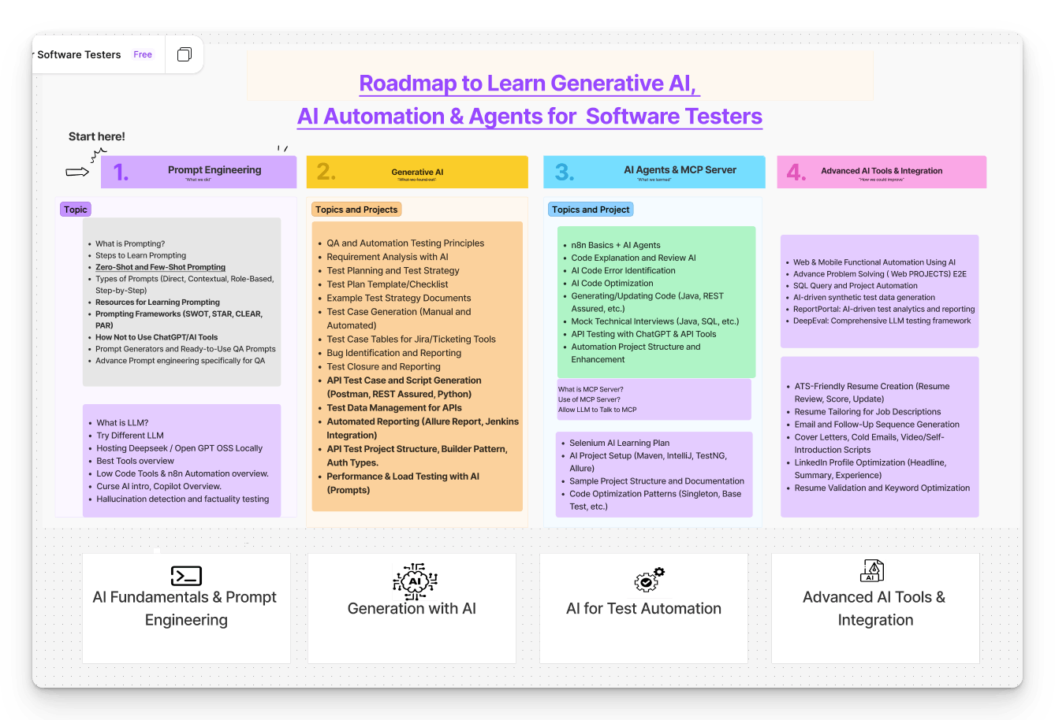
﻿﻿www.figma.com/board/0aAIi9aiWQDQJQ0rnTdkx0/Learn-Generative-AI---AI-Agents-for--Software-Testers?node-id=22-46&t=vnGZCA4abRpwPVXh-1

Task # 1 -
- Create an Account - ﻿app.thetestingacademy.com/
- (with Google Option)
﻿
What is the app.thetingacademy.com?
- Curriculum, Roadmap, AI Agent list, AI Testing Tools List, LIVE Test
- My progress.

﻿

How to access the courses ? (Recordings)
- Make sure that the you have a reset password -
﻿﻿courses.thetestingacademy.com/password/reset
﻿
- Access the all the courses here - ﻿courses.thetestingacademy.com/mycourses
- Bonus will be also available here in the ﻿course.thetestingacademy.com
- All Recordings 24x7 ->, Lifetime access
- AI Tester Blueorint 4x ( Date)
- PS. -> Finish all the videos within 4-5 months.
- You can do Binge Watchng - -Wathcing videos back to back.
﻿

﻿

How to Ask the Doubts, Get the Task and Discuss my problem?
- Private - ﻿www.sdetclub.com/c/ai-tester-4x-only - Invitation Based -
- Email from us - Invite you to SDETCLUB
- All the memebrs are for the same batch.
- Task , Doubts - Datewise
- LIVE Class - Sat/ Sun - 8.30 AM IST, 10.30 AM IST + 1 Extra (Bi Weekly) -> Friday/ Tue Evening - 8 PM IST or 9 PM IST (Optional, I would recommand), Extra AI concepts.
- LIVE Test - Wed at 9 am IST ( LIVE Test) Which you can give. - M ( Give the TEST -> EOD)
  - ﻿﻿app.thetestingacademy.com/student/live-test
- Email ID - ﻿contact@thetestingacademy.com - Max 1 hour
- Meeti, Dipak From my TEAM -

﻿

How to see the recording
﻿﻿https://www.loom.com/share/f52b39bc9095470ea0902075fe169e26?sid=564ed0c2-74ee-45c8-9acb-a6477b9669eb
- ﻿﻿courses.thetestingacademy.com/
- Today's AI Tester Blueprint 4x

﻿

Sequence to follow
- LLM Basics
- Prompt Eng
- Generative AI
  - Github Copilot
  - Claude Code
  - Command Code/ OpenCode AI
- AI Agents (RAG)
  - Vibe Code
  - n8n
  - Langflow
  - Crew AI / LangChain(Python Basics)
  - LangGraph - AI Agents(Multi Agents) QA
- RAG
  - 10 + TYPES
  - Langlfow
  - n8n
  - Vibe Code
- MCP
  - Use
  - Create Own MCP - FastMCP
  - Debug MCP
  - Automation + AI
- LLM Eval
  - Basic LLM Eval
  - DeepEval
  - PromptFoo
  - OpenEvAL, RAGAs
- AI Testing tools
  - 3-4 AI Testing
  - CI/CD + Automation via AI.
- Projects -
  - 35+ AI Projects( AI Agents, MCP, RAG, LLM EvaL)+. AI Testing Tool).

﻿

Required Access
﻿﻿https://forms.gle/L47EKJns4ZPobLUH6
﻿
- Bonus ✅ SDET Masterclass | Friday Master Class
- ✅ Gen AI Course
- ✅ n8n Basic → Advanced
- ✅ SDET Club (Doubts & Assignments)
- ✅ Job Assistance (QaJobBoard)

﻿
﻿
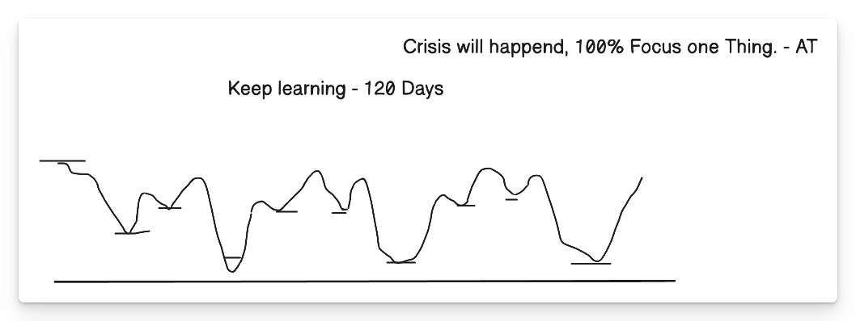
﻿

Rules of Life
- 100% Focus on One Thing -> AI Ready Tester -> All of the 100% efforts.
- 5% (Execution) and 95% (Plan) -> 5% Plan -> 95% -> Try and Fail -> Try Again ->Success.
- 50-70% is Perfect -> 100% is Failure - 25K + companies
  - 40-70% Ready -> Interviews
  - Unlimited Oppor. -> Delhi, NCR, Bangalore, Chennai, Pune, -> 25K companies.
  - ﻿
- New Actions -> Whatever worked in past, will not work in future. New Skills - G

﻿
- Discipline
- Consistnecy
- Focus
- Practice
5+ Week Per-month

﻿
the only reason right now I am learning is because if I do not learn, somebody is going to learn and implement, and I will leave behind I will get replace
﻿
Financial Knowledge
- Emergency Fund -> monthly - 50k x 6 months -> 3L ( FD, Bank) - Save Job Security.
- 20K per Month -> 1.2 L in your ACC, don't touch it, until emergency
- Health Insurance
- Term Insurance
- 4.SIP - MF - Investing (5-10%) per month, - without -> index Nifty
﻿
﻿

﻿
20-30 Pages per day
﻿

﻿

Task #2

Github Account Setup
﻿﻿github.com/signup
﻿

Task #3

NodeJS (latest version)
﻿﻿nodejs.org/en/download
﻿
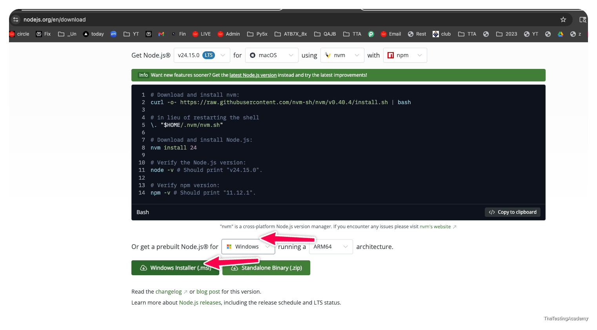

Visual Studio Code (Office Laptop)
﻿﻿code.visualstudio.com/download
﻿

Advance AI IDE ( Personal Laptop)
- Google Antrigravity -> ﻿antigravity.google/
- Cursor
- Windwruf
- KIRO /KILO
﻿

﻿
Person Laptop - PERSONAL
Office Laptop -> Office -> Personal If possible(invest 25-30k BUY OLD VERSION mac or windows)
﻿
﻿﻿🤖 4X Advanced AI Tester Blueprint |

﻿

🤖 AI Tester Blueprint
﻿

Foundation Models
🧠 What Changed After 2020 – The Era of Scale
Before 2020, AI models were like smart calculators – good at one thing. After 2020, AI models became like super interns – they can write, read, code, explain, summarize, and even reason.
2020-2022 - Playground ->. I had
2022 -> Sam Altman -> ChatGPT - on twitter.com
﻿

Real-World Example
- Old AI: A spam filter on
- New AI: Can read the email, explain why it is spam, rewrite it professionally, and suggest a reply.
﻿

Two Major Consequences of Scale
- Capability Explosion
  - Models can now perform many tasks well
  - New applications became possible (coding, writing, planning, vision)
- Model-as-a-Service Emergence
  - Training large models is expensive and centralized
  - A few organizations build models
  - Everyone else consumes them via APIs
﻿
➡️ Result: AI application demand increased while entry barriers dropped.
﻿
AI
- LLM
- llm Eval
- MCP
- RAG
- NLP
- Langchain
- n8n
- Prompt Eng.
- Gen AI
- Multi Agent
- RAGAS
- LangFlow
- Agentic AI
- DeepEval
- Github Copilot
- Context Eng
- Harness Eng
- Loop Enf
- Agent Orches
- VIBE Coding
- AI Testing Tools
- Claude
- Prompt Foo
- GauradRails
- Model Drift, Theft
- Cursor
- Skills
- Deep Learning
- MD Files
- Chuncking
- Sematic Search BM25
- Hallucinations
- KIRO, Amazon Q, Cursor,.
- Neutral Network.
- Tokemics
- Vector dB
- huGGINCE face
- Codex, Claude
﻿

🤖 What Is AI Engineering?
AI Engineering = Building applications on top of existing foundation models.
﻿
ML , DL , -> AI Eng
⚠️ Using powerful pre-built AI brains to solve real problems == AI Engineering.
﻿
You are not training the brain from scratch.
﻿
You are:
- Giving it instructions
- Giving it context
- Checking its answers
- Connecting it to real systems
﻿

Why AI Engineering Is Growing Fast
- Powerful models already exist
- APIs make usage simple
- Minimal infrastructure required
- Even non-engineers can build AI apps.

﻿
Traditional Machine Learner Engineer:
- Collects 1M records
- Labels data
- Trains a model
- Tunes hyperparameters
﻿
AI Engineer:
- Chooses GPT / Claude / Gemini - Brain
- Writes prompts
- Adds documents via RAG
- Evaluates responses
- Deploys fast
- Solve Real Problems
- LLM Eval
﻿
This is why AI Engineering feels faster and more creative.

﻿
LLM -> Brain
AI Agent -> Brain + Memory + Tools ( Workflows)

﻿
ChatGPT -> Chat application which is using a private LLM - GPT 5.6
Claude.ai -> chat application Sonu 4.6, Opus 4.6
Gemini - 3.1 ->. ﻿aistudio.google.com/prompts/new_chat
LLM -> Open source / Closed source
﻿

﻿
Claude Code, Kimi Code, Codex, Amazon Q, , - Github Copilot -> ? LLM? ( This is a AI Coding assistant) (AI Agent)
﻿
﻿
Notepad -> Program
IDE -> Integrated Development Environment -> IntelliJ
Eclipse
PyCharm
Sublime Text
Visual Studio Code

﻿
Antigravity, Cursor , Windsurf, KILO/kiro IDE, -> ADE -> agent-driven development environment (ADE), VS Code with GHCP (ADE) , GitHub Copilot (GHCP)
IDE + Agent
﻿
﻿
﻿
Perplexity ->. Curation of multiple models, it uses a algo(AI Agent). which select which model you can use for the which purpose. .
﻿

﻿
From Language Models to Large Language Models (LLMs)
﻿
﻿
What Is a Language Model?
A language model is like autocomplete on steroids.
the cat will sit on _
﻿

A language model:
- Learns statistical patterns of language.
- Predicts the next token given context
- Giving the Attention
﻿
Link to the Paper -> ﻿proceedings.neurips.cc/paper_files/paper/2017/file/3f5ee243547dee91fbd053c1c4a845aa-Paper.pdf
﻿
﻿﻿app.thetestingacademy.com/ai/llm-vs-aiagent
﻿
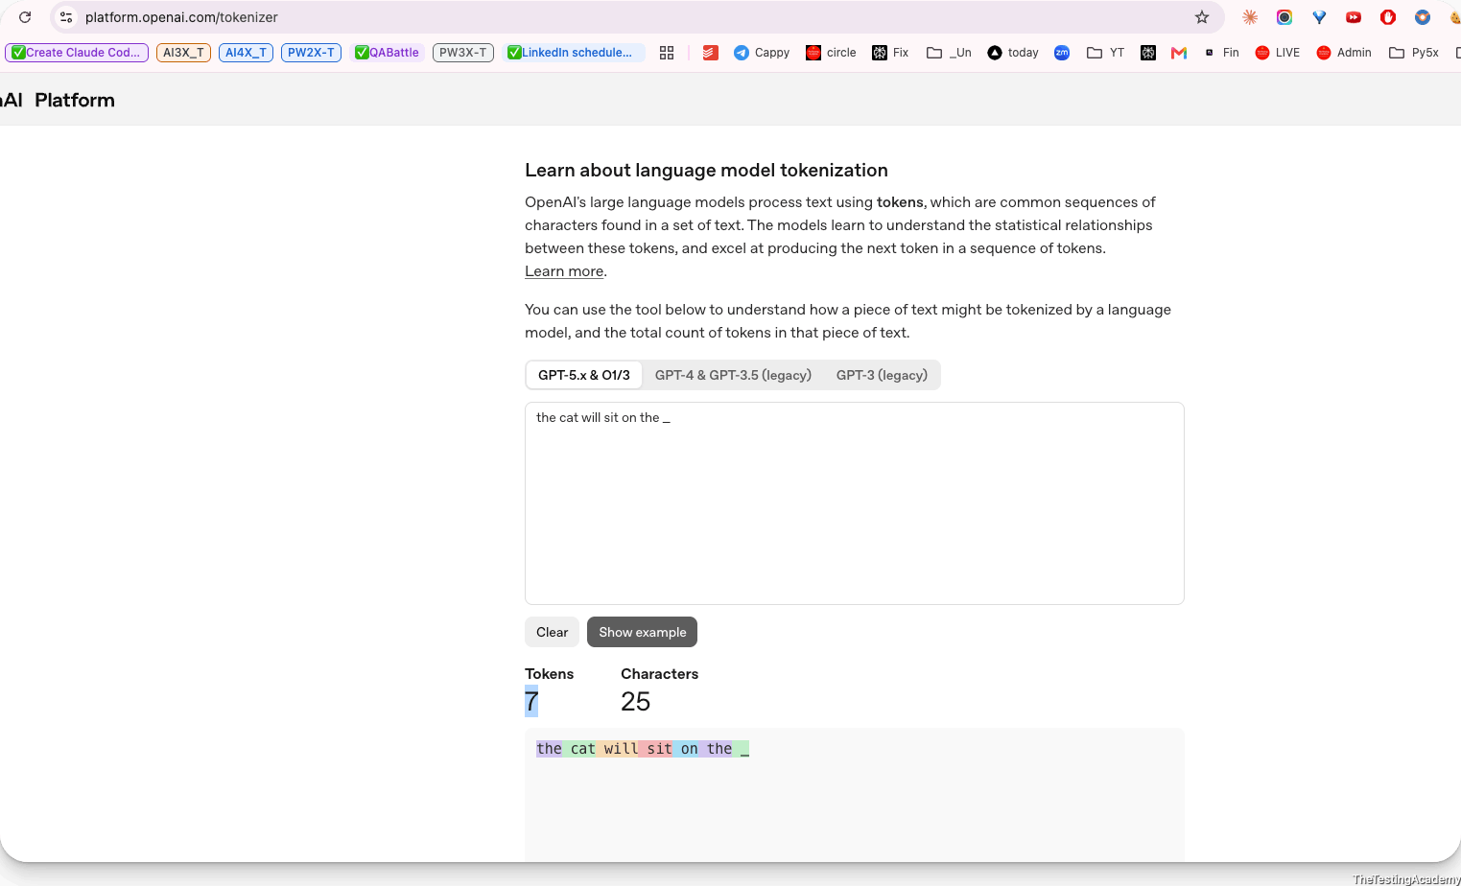

﻿

What is the Context?
- Information
- Reference, Objective.
- Some information what we are discussing
- background information
﻿
"My favorite color is ___"
﻿
Trained ->

﻿

Tokens (Very Important)
- Token = basic unit (word, sub-word, or character)
- Models don’t see words, they see tokens.
﻿
Why tokens?
- Capture meaning better than characters
- Smaller vocabulary than words
- Handle unknown/new words.
﻿
Ask - Give me the source code for the hello world in javascript.
﻿
Paper - ﻿arxiv.org/html/1706.03762v7
Attention is all you need ( ~2014)
﻿
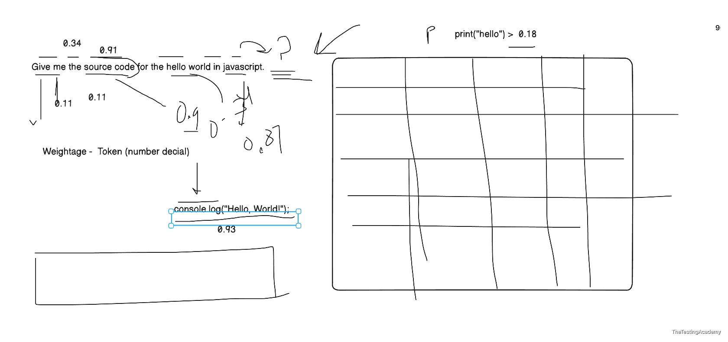
GPT 2 - Was trained - ﻿Reddit.com Forum where people discuss topics and problems.
﻿
Prompt
the cat will sit on the _, Can you please show me properly how exactly the transformer transforms it and how the large language model R is able to predict exactly in the tabular format? Explain to me step by step in a very simple manner so that I can know how the output is made in the end.
﻿
Text → Tokens → Token IDs → Vectors → Attention → Transformer layers → Vocabulary scores → Probabilities → Selected next token
﻿

Input sentence
“The cat will sit on the ___.”
The model’s job is to predict the next token after “the”.
A transformer does not directly understand the sentence like a human. It converts words into numbers, processes relationships between them, and produces probabilities for possible next words.
The numerical values below are simplified examples. Real language models use thousands of dimensions, billions of parameters, and many transformer layers.

﻿

Complete process at a glance
Step | Transformer operation | Simplified result
1 | Tokenization | ﻿The, cat, will, sit, on, the
2 | Token IDs | ﻿[791, 8415, 690, 2503, 389, 279]
3 | Embeddings | Each token becomes a vector of numbers
4 | Positional information | The model learns each token’s location
5 | Self-attention | Tokens examine other relevant tokens
6 | Feed-forward network | The model processes the combined meaning
7 | Repeat transformer layers | The representation becomes more contextual
8 | Generate logits | Every vocabulary token receives a raw score
9 | Softmax | Scores become probabilities
10 | Select a token | For example: mat
11 | Continue generation | “The cat will sit on the mat.”

﻿

Step 1: Tokenization
The tokenizer breaks the sentence into smaller units called tokens.
Position | Text | Token
1 | The | ﻿The
2 | cat | ﻿cat
3 | will | ﻿will
4 | sit | ﻿sit
5 | on | ﻿on
6 | the | ﻿the
7 | Missing | Model must predict this
The model receives:
[The] [cat] [will] [sit] [on] [the]
Tokens are not always complete words. For example, a tokenizer might split:
unbelievable → un + believ + able

﻿

Step 2: Tokens become token IDs
Every token has an integer ID in the model’s vocabulary.
Token | Example token ID
﻿The | 791
﻿cat | 8415
﻿will | 690
﻿sit | 2503
﻿on | 389
﻿the | 279
The sentence is now represented as:
[791, 8415, 690, 2503, 389, 279]
These IDs are only labels. The number 8415 does not itself contain the meaning of “cat”.

﻿

Step 3: Token IDs become embeddings
The model looks up an embedding for each token.
An embedding is a list of numbers representing learned features of a token.
Here is a highly simplified four-dimensional example:
Token | Animal-related | Action-related | Location-related | Grammar-related
﻿The | 0.05 | 0.02 | 0.04 | 0.92
﻿cat | 0.94 | 0.15 | 0.10 | 0.32
﻿will | 0.03 | 0.40 | 0.01 | 0.88
﻿sit | 0.15 | 0.96 | 0.35 | 0.25
﻿on | 0.02 | 0.08 | 0.95 | 0.61
﻿the | 0.05 | 0.02 | 0.04 | 0.92
In a real model, an embedding may contain thousands of numbers:
cat → [0.018, -0.246, 0.774, ..., -0.091]
These dimensions are learned during training. They do not normally have simple human-readable labels such as “animal-related”.

﻿

Step 4: Add positional information
A transformer must know the order of the tokens.
Compare:
The cat chased the dog.
The dog chased the cat.
The words are similar, but their positions change the meaning.
The model combines:
Token embedding + Position information
Position | Token | What position tells the model
1 | ﻿The | Beginning of the sentence
2 | ﻿cat | Subject position
3 | ﻿will | Comes after the subject
4 | ﻿sit | Main action
5 | ﻿on | Introduces a location or surface
6 | ﻿the | A noun probably comes next
After this step, the model knows both:
- what each token represents;
- where each token appears.

﻿

Step 5: Create Query, Key, and Value vectors
For every token, the transformer creates three new vectors:
Vector | Simple meaning
Query — Q | What information am I looking for?
Key — K | What type of information do I contain?
Value — V | What information should I pass forward?
They are calculated using learned matrices:
Q = Embedding × WQ
K = Embedding × WK
V = Embedding × WV
For the final token the, the query might behave conceptually like:
“I need information that will help identify the noun that should come next.”
The keys from previous words indicate what information they contain.
Previous token | Simplified information in its key
﻿The | Sentence beginning and grammar
﻿cat | Subject: an animal
﻿will | Future construction
﻿sit | Sitting action
﻿on | Surface/location relationship
﻿the | A noun phrase has started

﻿

Step 6: Self-attention calculates relevance
The final position examines earlier tokens and assigns attention weights.
The basic attention calculation is:
Attention(Q, K, V) =
softmax(QKᵀ / √d) × V
In simple language:
- Compare the current query with every key.
- Produce relevance scores.
- Convert those scores into percentages.
- Collect information from the corresponding value vectors.
For the last token, the attention might look like this:
Token being examined | Simplified attention weight | Why it matters
﻿The | 3% | Provides general sentence structure
﻿cat | 19% | Identifies who will sit
﻿will | 5% | Indicates future tense
﻿sit | 31% | Strongly defines the action
﻿on | 34% | Indicates that a surface/location follows
﻿the | 8% | Indicates that a noun should come next
Total | 100% | ﻿
This allows the model to form a contextual idea similar to:
An animal is going to sit on a particular surface or object.
The attention weights are not manually programmed. They are learned from training data.

﻿

Step 7: Multi-head attention
A transformer does not normally use just one attention calculation. It uses several attention heads.
Different heads may learn to examine different relationships.
Attention head | What it may focus on
Head 1 | ﻿cat is the subject
Head 2 | ﻿sit is the action
Head 3 | ﻿on expects a surface or location
Head 4 | ﻿the expects a noun
Head 5 | Common phrase patterns
Head 6 | Long-range grammatical relationships
A simplified view:
Head | Most important tokens | Information extracted
Grammar head | ﻿will, the | A noun should follow
Action head | ﻿sit | The noun should be compatible with sitting
Relationship head | ﻿on | The noun is likely a surface
Subject head | ﻿cat | The surface should be suitable for a cat
Phrase head | ﻿sit on the | Common continuation patterns
The outputs of the heads are combined into one richer representation.

﻿

Step 8: Feed-forward neural network
After attention, each token representation goes through a feed-forward neural network.
Its simplified job is to transform and refine the information:
Attention result
↓
Linear transformation
↓
Activation function
↓
Linear transformation
↓
Improved contextual representation
For the final position, the representation may now contain information similar to:
Learned condition | Strength
Next token should probably be a noun | Very high
Noun should describe a surface or place | High
Noun should be compatible with sitting | High
Noun should be plausible for a cat | High
Future tense is being used | Medium

﻿

Step 9: Residual connections and normalization
Transformers also use:
- Residual connections
- Layer normalization
A residual connection adds the earlier information back:
New representation = Old representation + Processed information
This helps prevent useful information from being lost.
Layer normalization keeps numerical values stable so that the network can process them effectively.
A simplified transformer block looks like:
Input
↓
Multi-head self-attention
↓
Add and normalize
↓
Feed-forward network
↓
Add and normalize
↓
Output

﻿

Step 10: Repeat through many transformer layers
This process happens repeatedly.
Layer stage | Simplified understanding
Early layers | Recognize tokens and basic grammar
Middle layers | Identify subject, action, and relationships
Later layers | Build sentence-level meaning and continuation possibilities
Final layer | Prepare scores for the next token
A model may have dozens or even hundreds of transformer layers.
By the final layer, the last-position representation approximately expresses:
Predict a noun describing something a cat can sit on.
It is important to understand that this meaning is stored as numbers, not as an English sentence inside the model.

﻿

Step 11: Convert the final representation into logits
The final vector is multiplied by an output matrix.
This produces one score for every token in the vocabulary.
These raw scores are called logits.
Suppose the model considers these candidate tokens:
Candidate token | Raw score or logit
﻿mat | 8.2
﻿floor | 7.6
﻿chair | 6.9
﻿sofa | 6.5
﻿bed | 6.1
﻿table | 4.8
﻿moon | 0.7
﻿banana | -0.5
﻿running | -1.2
A higher logit means the model considers that token more suitable.
Logits are not yet probabilities.

﻿

Step 12: Softmax converts logits into probabilities
The softmax function transforms the raw scores into probabilities that add up to 100%.
Probability(token i) =
e^(logit i) / sum of e^(all logits)
A simplified output may look like:
Candidate next token | Probability
﻿mat | 36%
﻿floor | 20%
﻿chair | 10%
﻿sofa | 7%
﻿bed | 5%
﻿table | 1%
Thousands of other tokens | 21%
Total | 100%
The model does not know with certainty that mat is correct.
It predicts:
“mat is the most probable next token based on this context.”

﻿

Step 13: Select the next token
The application chooses a token using a decoding strategy.

Greedy decoding
Always choose the highest-probability token:
mat → 36%
Output:
The cat will sit on the mat

Sampling
Randomly choose according to the probabilities.
Possible output:
The cat will sit on the sofa
Even though sofa has a lower probability, it is still plausible.

Temperature
Temperature changes how predictable or creative the selection is.
Temperature | Effect
0 or very low | Usually selects the highest-probability token
0.7 | Balanced output
1.0 | More variation
Above 1 | More randomness and less predictability

﻿

Step 14: Generate the following token
After selecting mat, the model receives a new input:
The cat will sit on the mat
It runs the complete process again to predict the next token.
For example:
Candidate | Probability
﻿. | 65%
﻿and | 9%
﻿near | 5%
﻿because | 2%
Other tokens | 19%
It may select the period:
The cat will sit on the mat.
Generation happens one token at a time.

﻿

Final simplified table
Stage | Input | Operation | Output
Tokenization | Sentence | Split text into tokens | ﻿The, cat, will, sit, on, the
Token IDs | Tokens | Vocabulary lookup | ﻿[791, 8415, 690, 2503, 389, 279]
Embeddings | Token IDs | Convert IDs to vectors | Numerical representations
Position encoding | Embeddings | Add token order | Position-aware vectors
Q, K, V | Position-aware vectors | Learned matrix multiplication | Query, key, value vectors
Attention | Q, K, V | Find relevant relationships | Focus on cat, sit, on, the
Multi-head attention | Attention outputs | Capture several relationships | Rich contextual representation
Feed-forward network | Contextual vectors | Refine learned features | Improved representation
Transformer layers | Previous layer output | Repeat processing | Deep contextual understanding
Output projection | Final vector | Score vocabulary tokens | Logits
Softmax | Logits | Convert scores to probabilities | ﻿mat: 36%, floor: 20%, etc.
Decoding | Probabilities | Select one token | ﻿mat
Next cycle | Updated sentence | Repeat everything | ﻿.

The key idea
Text
→ Tokens
→ Token IDs
→ Vectors
→ Attention
→ Transformer layers
→ Vocabulary scores
→ Probabilities
→ Selected next token
The transformer does not retrieve a fixed answer from a database. During training, it learned statistical and structural patterns such as:
“cat” + “sit on the” → mat, floor, chair, sofa, bed...
It then calculates which continuation is most probable for the current context.
﻿

﻿
4th Aug Tue - 8 PM IST -> Session - Doubts Class + CommandCode Part 2(Part 1 again)
7th Aug Friday 8 PM IST -> Mastering Claude Code (with Claude 101) ExamCo
﻿﻿anthropic.skilljar.com/claude-101
﻿
﻿
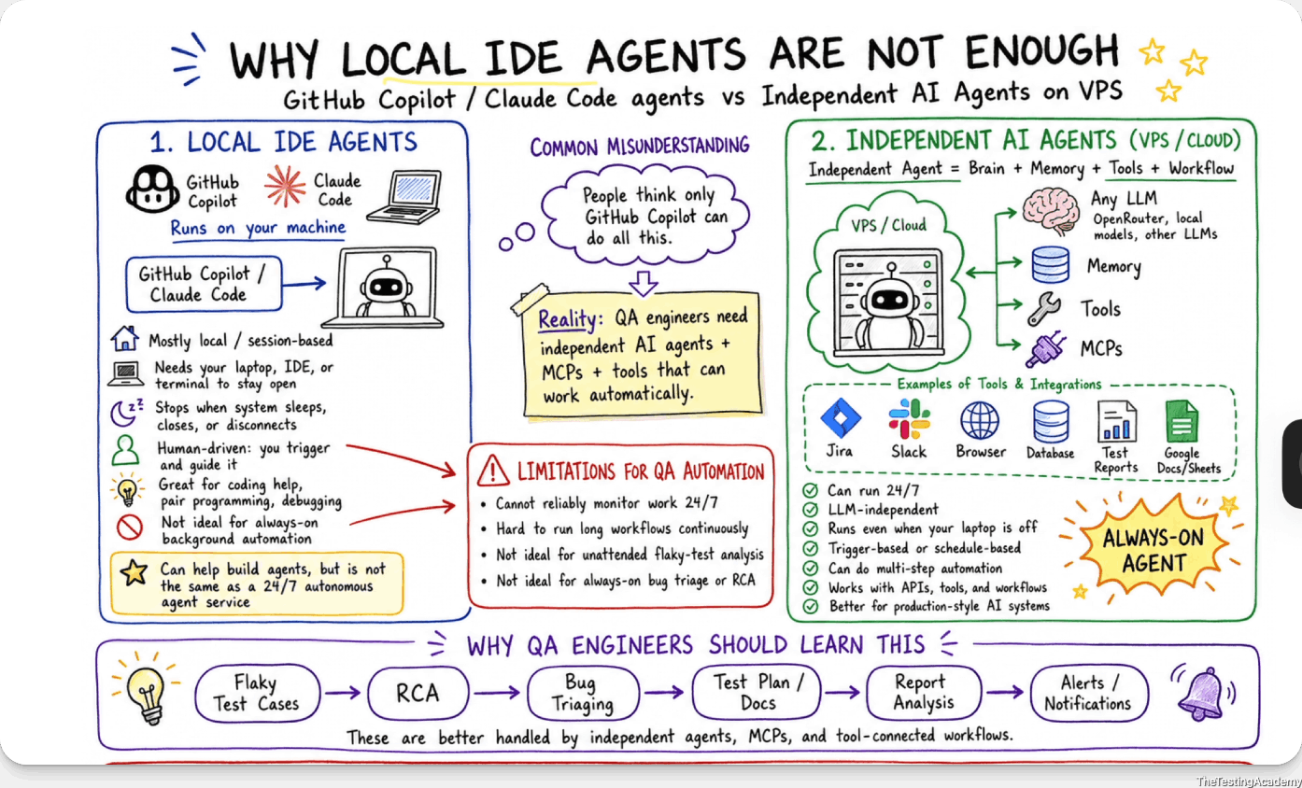
﻿
﻿
Office Laptop X - Try to use Personal If possible
﻿
Local TestCase

﻿
2th Aug 2026
﻿

What Is a Language Model? A language model is like autocomplete on steroids.
﻿

A language model:
- Learns statistical patterns of language.
- Predicts the next token given context
﻿
﻿
4th Aug -> Tue - 8 PM -> CommandCode AI revisit, Doubts (1.5 hour)
7th Aug Friday -> 8 PM -> MASTER Claude Code($20)( 25+ Commands) + Claude 101 Certification ((1.5 hour)
﻿

Two Types of Language Models
﻿

1. Masked Language Models (BERT-style) -> my - color is black
Bidirectional Encoder Representations from Transformers
Masked Model (BERT) = Fill in the blanks in an exam paper
- Predict missing tokens anywhere
- Uses left + right context
- Best for understanding tasks
Examples:
- Sentiment analysis
- Classification
- Code understanding
﻿﻿https://www.geeksforgeeks.org/nlp/masked-language-models/
my Fav color is black
﻿
“Playwright is a [MASK] automation tool.”
﻿
“Playwright is a browser/web automation tool.”
﻿

2. Autoregressive Language Models (GPT-style)
Autoregressive Model (GPT) = Write an essay one word at a time
Generative Pre-trained Transformer
- Predict next token only
- Generate text sequentially
- Best for generation
  - text
  - code
  - image
  - video
  - .....anythhing.
﻿
Examples:
- ChatGPT
- Code generation
- Writing, summarization
﻿
➡️ We mainly focuses on autoregressive models
My eye color is _Black, Brown ,Grey
﻿
GPT -> Generative Pre Trained Transformer.
﻿
Read It and Give a Task - ﻿app.thetestingacademy.com/ai/ml-ai-dl-engineer#tab1
﻿
- LLM -> large language model that predicts and generates text token-based
- Transformer -> It is an attention-based neural architecture used by most modern large language models
- Paramaters

﻿

Paramaters
Parameters in Large Language Models are the internal weights and biases that the model learns during training.
More Parameter have you better. LLM
﻿
﻿
﻿
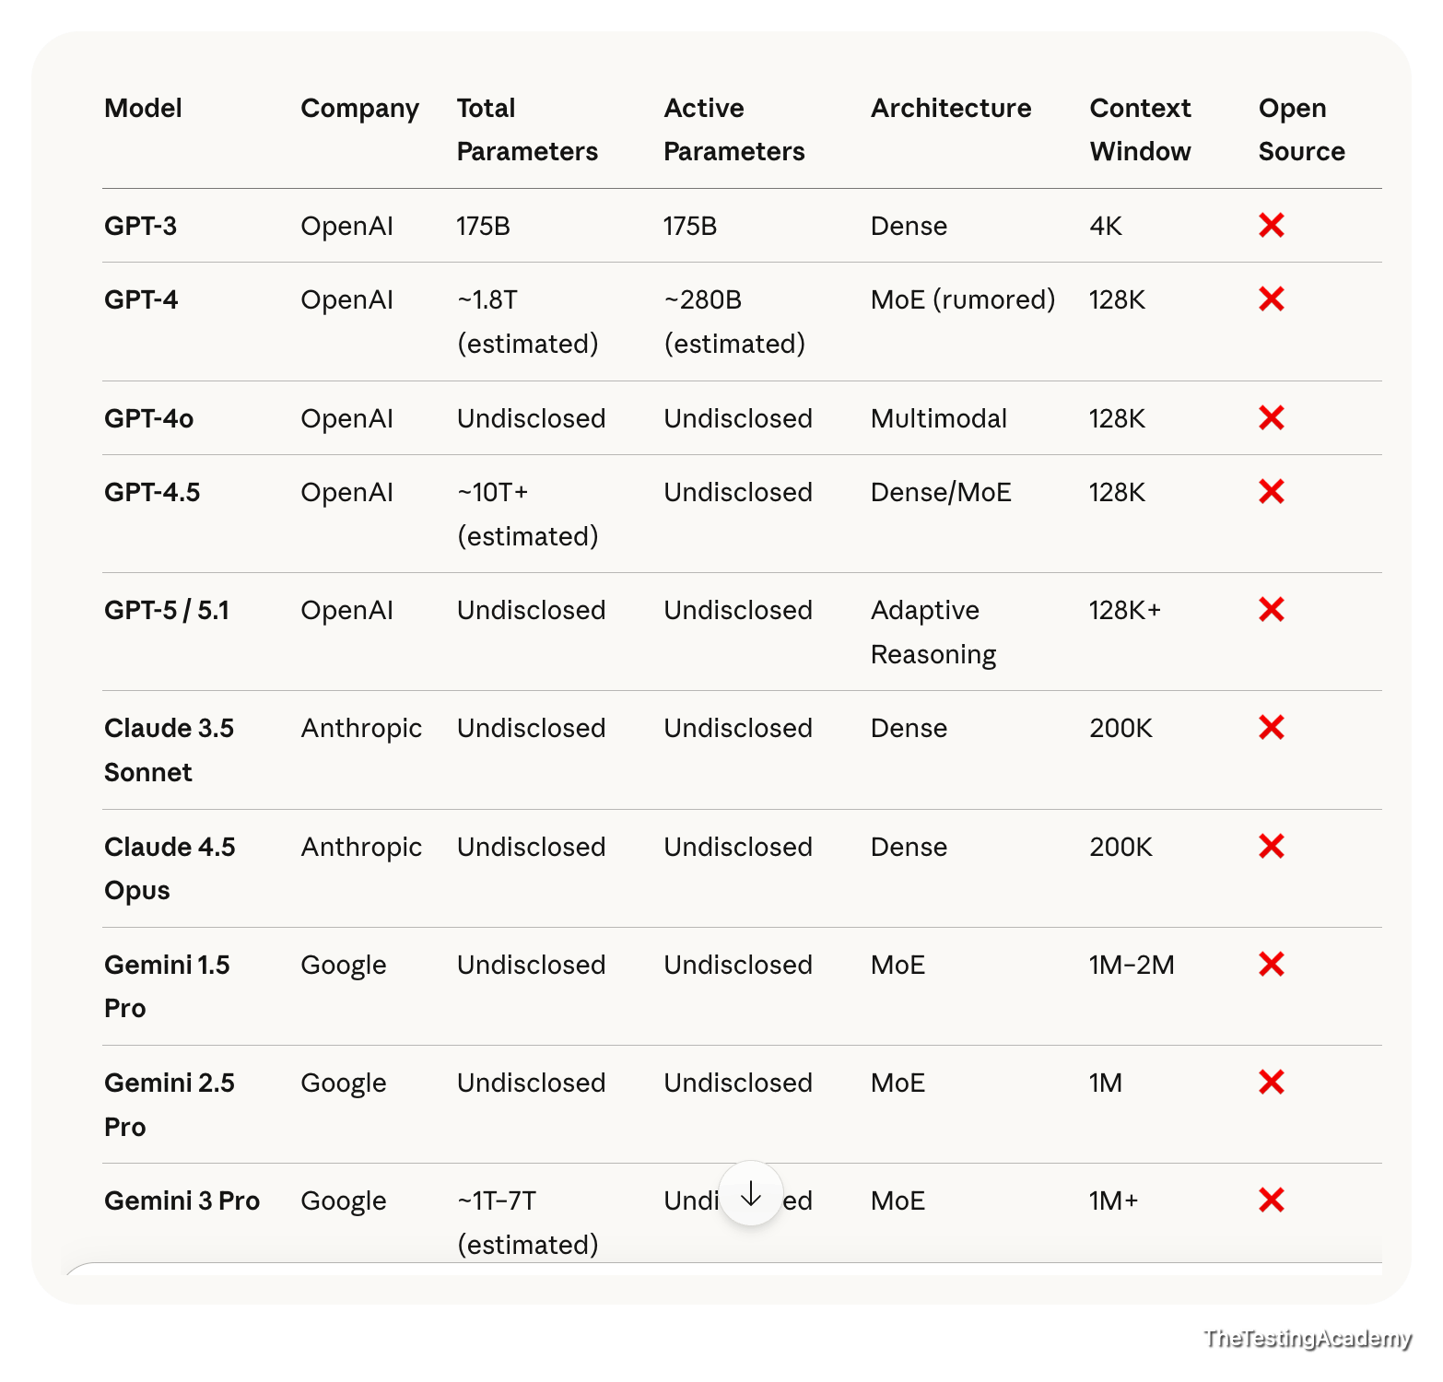
﻿
﻿
﻿
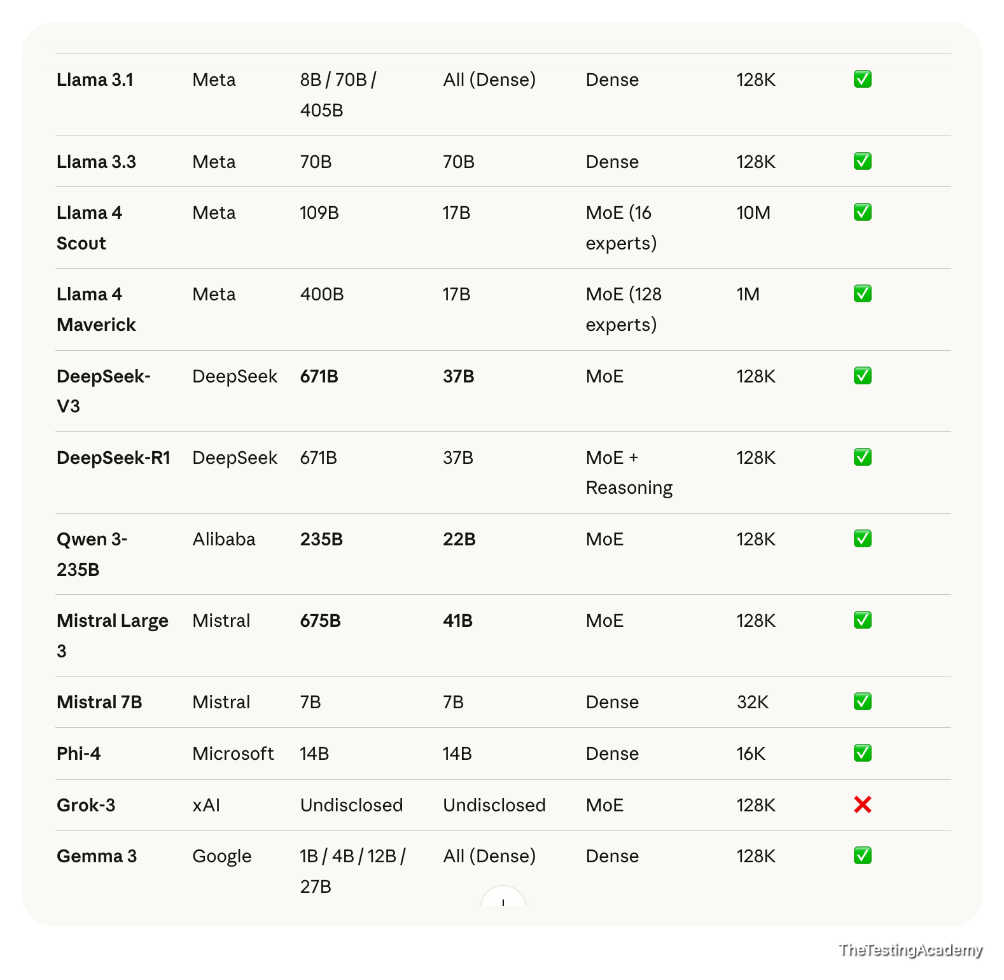
Large Language Model > 1B Large
Small Language Model < 1B (SLM)
﻿
Closed Source LLM
- GPT 5.6
﻿
Open Source LLM
- Mistral 4
- DeepSeek v4 Flash
﻿
﻿﻿huggingface.co/deepseek-ai/DeepSeek-V4-Flash-0731/tree/main
Hugging face is like a GitHub for the models, where you can host your model, you can download a model, and you can deploy and use it or test it also in this case.
﻿

﻿
- Office Laptop - Yes
- Personal. - P

﻿
Command Code | Command Code AI
- Visual Studio - ﻿code.visualstudio.com/download?_exp_download=fb315fc982
- Command Code AI -
  - ﻿﻿nodejs.org/en/download
  - ﻿﻿commandcode.ai/pricing
﻿
Rich -> $20 Claude / Codex
Budget - $1 CommandCode AI
Cursor, WindSurf - No
﻿

﻿
- Claude 101 - is optional to buy the - not mandatory to buy $20 (good to have)
﻿

﻿

Hallucinations (LLMs “Making Things Up”)

Definition
A hallucination occurs when an AI model produces confident but factually incorrect or completely fabricated output, even though the information does not exist in the system, logs, API, or requirements.
The key danger: the answer sounds correct.
﻿

QA Example 1 : Bug Report Hallucination
Prompt to AI
“Analyze this screenshot and generate a Jira bug report.”
AI Output (Hallucinated)
- Error Code: AUTH_403_INVALID_TOKEN
- Root Cause: Token expiry after 15 minutes
- Affected API: /auth/refresh
﻿
Reality
- Screenshot only shows “Something went wrong”
- No error code visible
- No token logic involved
﻿
Why this is a hallucination
- AI invented technical details
- No evidence in input
- Over-confident explanation
﻿

QA Example 2 – Test Case Hallucination
Prompt
“Generate test cases for VWO dashboard.”
AI Output
- Test case: Verify Dark Mode toggle
- Test case: Validate Export to CSV
﻿
Reality
- No Dark Mode
- No Export feature in product
﻿
﻿
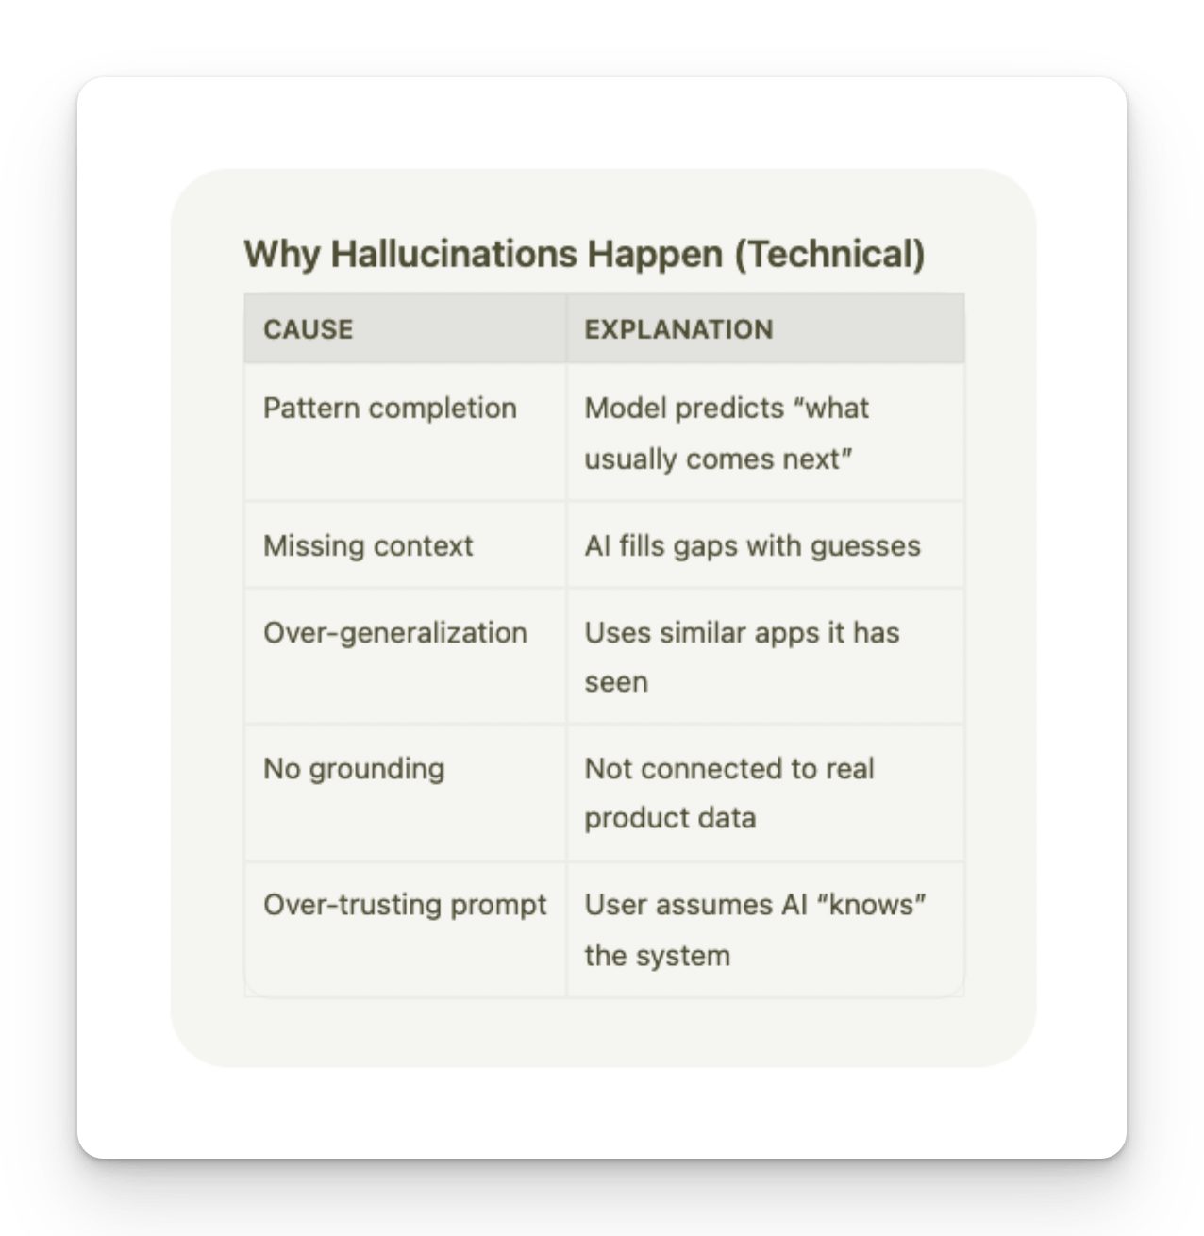

QA Red Flags for Hallucinations
- Mentions features not in PRD
- Invents error codes
- Claims logs show X (without logs)
- Gives exact numbers without evidence
Sounds too certain without sources

﻿
You never ask the AI. You always tell the AI what to do.
﻿

Anti-Hallucination Rules
ROLE: You are a QA assistant operating under strict verification rules. SCOPE OF KNOWLEDGE
You may ONLY use information explicitly provided in: PRD API documentation Logs Screenshots Test data User input
﻿
STRICT RULES (MANDATORY) DO NOT invent features, APIs, error codes, UI elements, or behavior. DO NOT assume default or "typical" system behavior. If information is missing or unclear, respond with: "Insufficient information to determine." Every assertion must be traceable to provided input. If a detail is inferred, label it explicitly as: "Inference (low confidence)". Output must be deterministic and repeatable.
PROCESS YOU MUST FOLLOW Step 1: Extract verifiable facts from the input. Step 2: List unknown or missing information. Step 3: Generate output ONLY from Step 1 facts. Step 4: Perform a self-check for hallucinations or contradictions. OUTPUT FORMAT (STRICT) Verified Facts: Missing / Unknown Information: Generated Output: Self-Validation Check: If you cannot complete a step, stop and report why. >> Instructions
﻿
﻿
﻿
﻿
﻿
﻿
﻿
- Local LLM with Ollama, LM Studio
- What is Prompt?, Skill?
- Prompt vs Skill File vs AI Agents
- Skill File (Office) - md -> that you can shared. (
  - Folder skill which can do many things.
﻿

﻿

Task 1. - Using the anti-hallucination rule to get the maximum output from the large language model
﻿
Req - ﻿docs.google.com/document/d/1GsT57ocl4HaUCxNhBGVmwvLYh7R24gjVB_RDteltkF4/edit?usp=sharing
﻿
Bad EXAMPLE
﻿﻿chatgpt.com/share/69a3c1a9-3ed0-8009-969c-9dd3a7cce824
﻿
Good Example
PRD - ﻿docs.google.com/document/d/1GsT57ocl4HaUCxNhBGVmwvLYh7R24gjVB_RDteltkF4/edit?usp=sharing
﻿﻿chatgpt.com/share/69a3c2d9-1f40-8009-98ed-6e04598199b4
﻿

﻿
Anti HALLCINATIONS Rule
﻿﻿github.com/PramodDutta/AI-Tester-Blueprint/blob/main/chapter_01_foundation_model/rules_checklists/ch_01_anti_hallucination.md
﻿

﻿
Prompt vs Skill
﻿
Prompt -> It is a set of instructions which are given.
Skill -> skill is nothing but a set of instructions which are properly structured to get a desired output
﻿
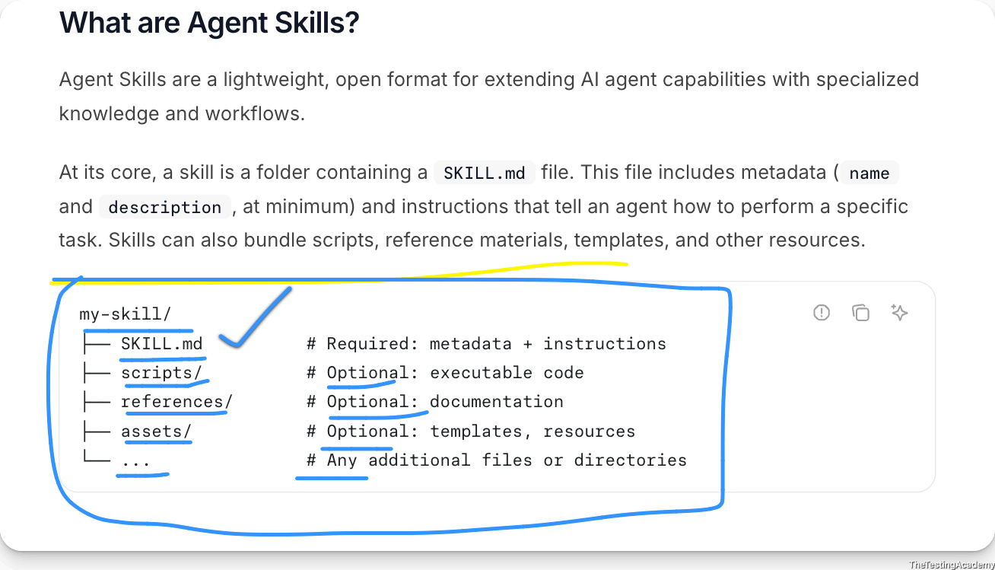
﻿
AI Agents - Brain + Memory + Tool (Workflow) -> They can do the studd 24x7, autononous
﻿

﻿
8th Aug 2026

Prompting Engineering
- What is Prompting
- Types of Prompts
- Advanced Prompting
  - QA-Specific Frameworks
    - Write your first QA-style prompt, Chain-of-Thought
    - Prompt frameworks: STAR, CLEAR, CRISP
    - Context creation via Templates (.md files)
    - RICE POT Framework (QA)
- What is Prompt Engineering and why we need to learn it
  - Steps to follow for Effective Prompt Engineering
  - Role-based prompting for QA, Zero Shot vs Precise Prompting

﻿

🧠 What is Prompting and how to learn?
﻿
- Better Mechanism to Ask from the LLM
- Ask -> Tell
﻿
Ask - you will get only 20% of things LLM
Tell - 80% ->
﻿
you will never ask from the LLM. You will always tell the LLM
Telling of the LLM, the right thing is called prompting.
﻿
LLM - (100%)
- Prompt Eng (Skill, AI Agents)
- RAG
- Fine tuning
﻿
- Prompting refers to the practice of providing specific instructions or input to an artificial intelligence (AI) model to obtain desired responses.
- In the context of AI and language models like GPT-4, prompting involves crafting queries or statements that guide the model to generate useful and relevant outputs.
﻿
Prompt Engineering is the practice of designing and refining inputs (prompts) to effectively communicate with Large Language Models (LLMs) to achieve desired outputs.
﻿
﻿
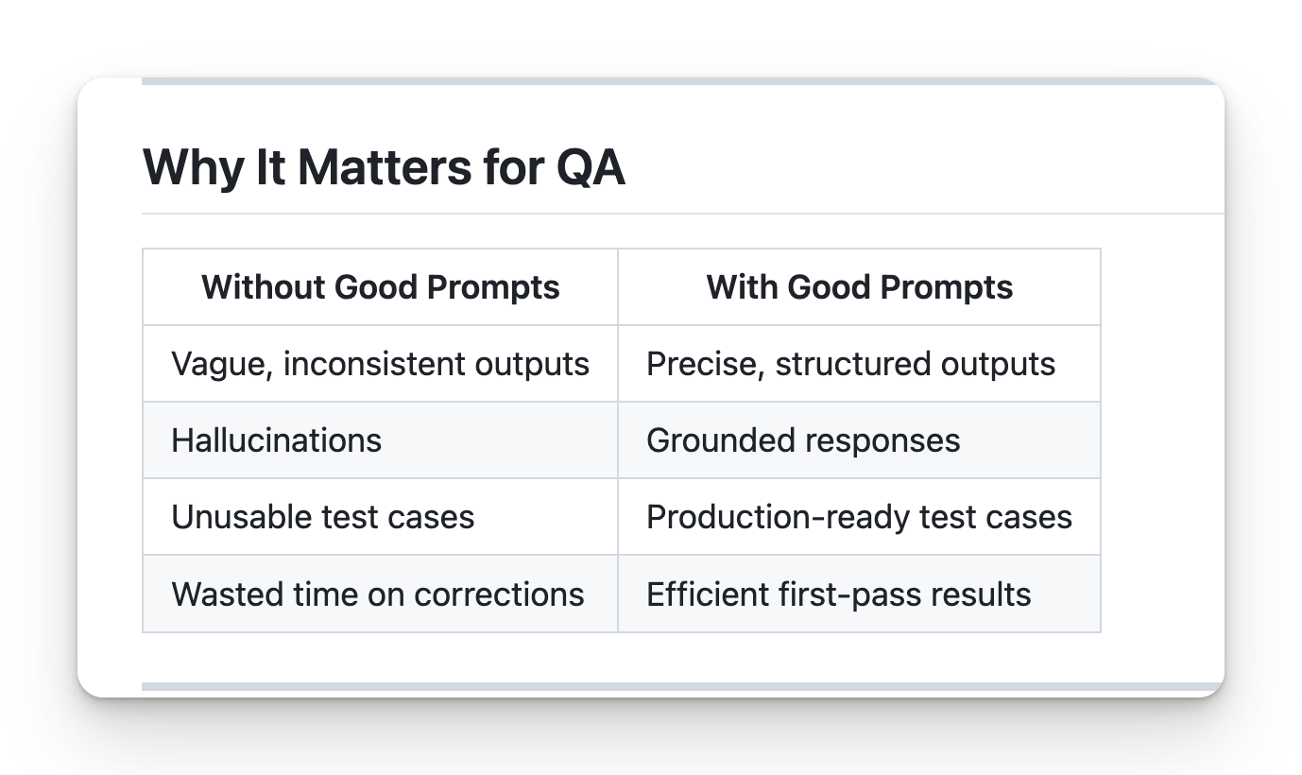
﻿
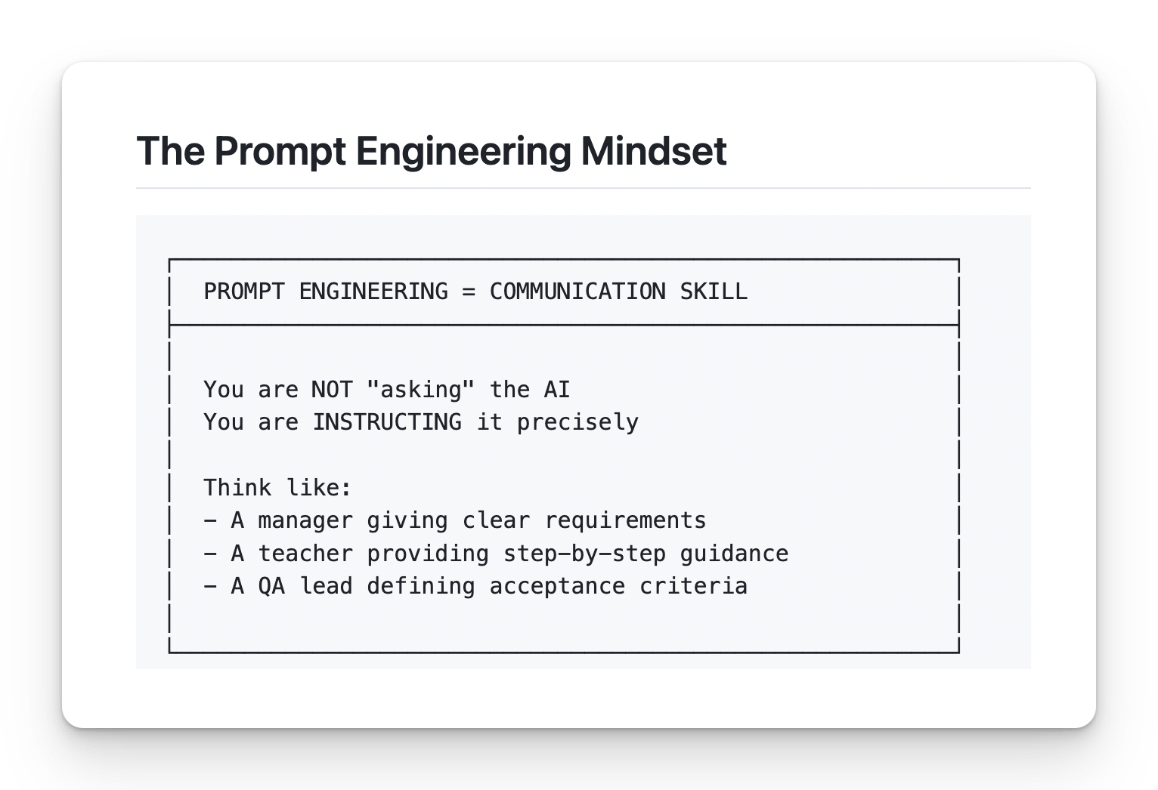
﻿

Core Principles
﻿

1. Be Specific
❌ Bad: "Write test cases for login"
﻿
✅ Good: "Write 5 functional test cases for email/password login, covering valid login, invalid email, invalid password, empty fields, and SQL injection attempt. Use the Proper JIRA format: Test ID, Description, Steps, Expected Result."
﻿
﻿

2. Provide Context
❌ Bad: "Test the API"
✅ Good: "Given this API endpoint documentation: [paste docs], write test cases covering happy path, error scenarios, and edge cases."
﻿

3. Define Output Format
❌ Bad: "Generate bug report"
✅ Good: "Generate a bug report using JIRA format: Title, Environment, Steps to Reproduce, Expected Result, Actual Result, Severity, Attachments."
﻿

4. Set Constraints
❌ Bad: "Help me test"
✅ Good: "Using ONLY the PRD provided, generate test cases. Do NOT assume any features not mentioned. If information is missing, state 'Not specified in PRD'."
﻿
﻿
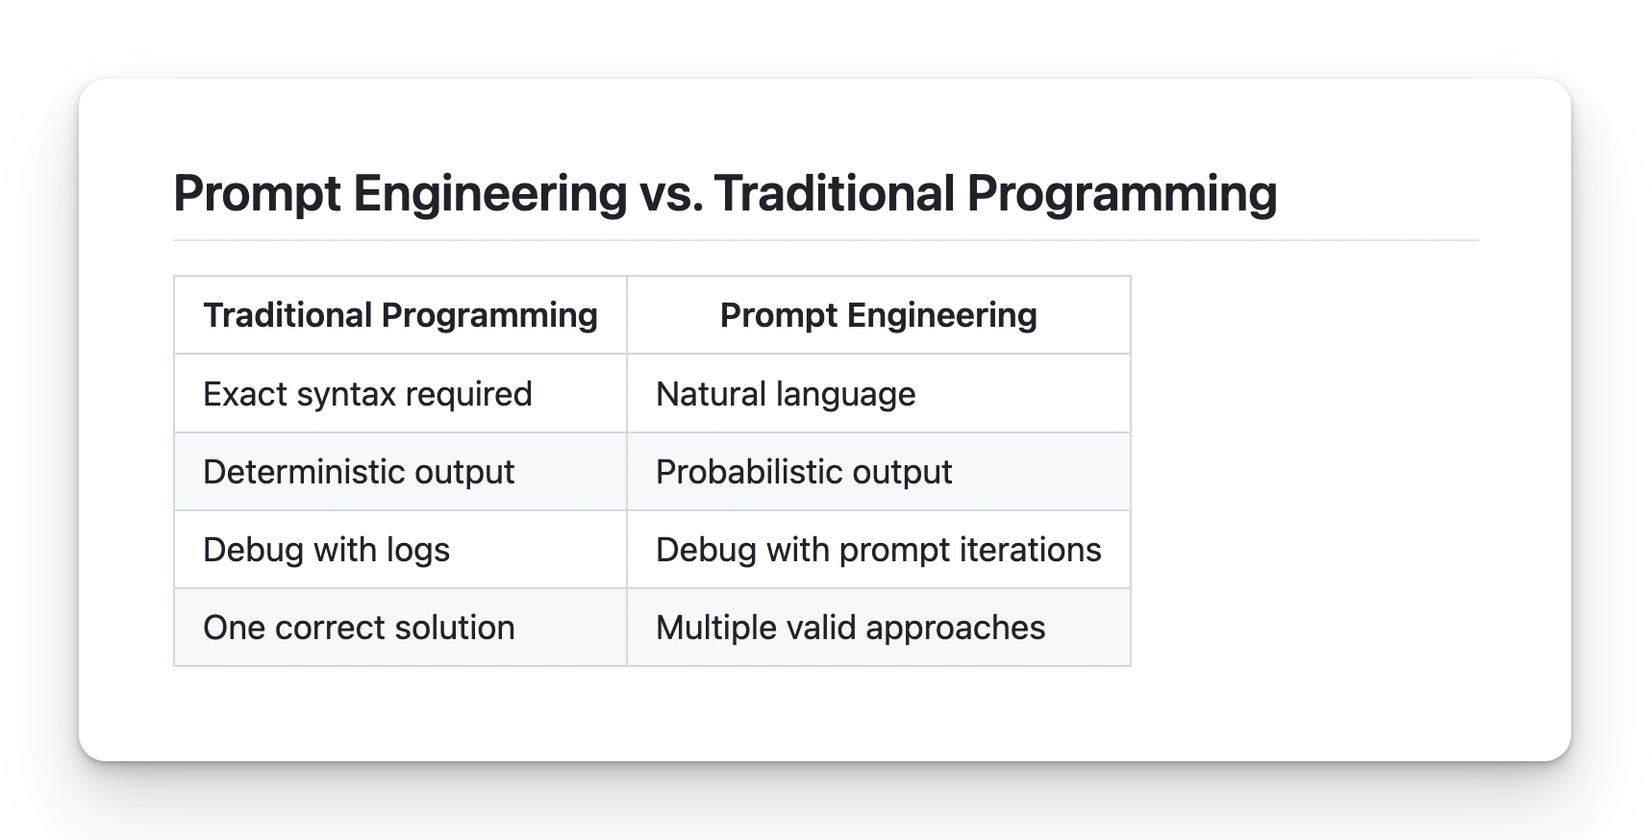

Steps to Follow for Effective Prompt Engineering
- │ Define the Goal │
- │ Gather Context │
- │ Choose Prompting Strategy │
- │ Structure the Prompt │
- │ Add Constraints │
- │ Test and Iterate │
- │ Document and Reuse │
﻿
Create testcase for app.vwo.com
﻿

Step 1: Define the Goal
Ask yourself:
- What exactly do I need?
- What will I do with the output?
- What does success look like?
❌ Vague: "Help me with testing" ✅ Clear: "Generate 10 test cases for login validation"
﻿
Objective : I want to generate only 10 test cases for the login on app.bw.com. I can see that on app.legend.com, there are:
- email ID
- password
- submit
- forget password
- a way to create a new account
I want to tell you that I have almost 15 years of experience, so please create the test case in such a way that it is production-ready and at an enterprise-grade level in this case
﻿
Plan -> Generate (AI) - - RULE 1- (95% Plan , 5% Action)
﻿
BLAST Framework > which will make sure that you know what you are building - AI
﻿
﻿

Step 2: Gather Context
Collect all relevant information:
- PRD / Requirements document
- API documentation
- Screenshots / UI mockups
- Error logs
- Previous test cases
- Constraints / Limitations
- JIRA ID, Stories , Epic, BRD, Conflueces, Wireframes, figma, Artch. Miro..
Rule: More context = Better output
﻿

Step 3: Choose Prompting Strategy
Zero-Shot -> No example
﻿
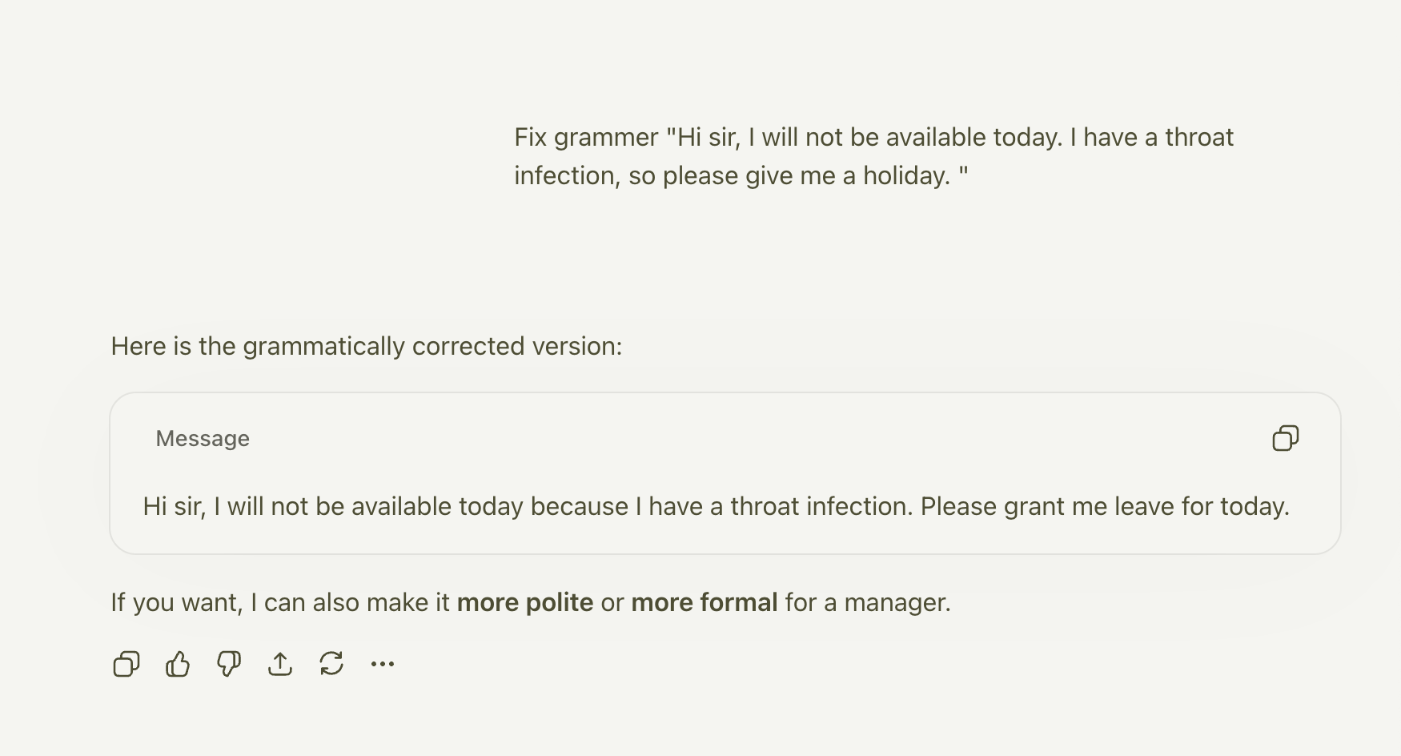
﻿
﻿

Few Shot : when you give one or more examples along with the prompt, what you wanted to achieve this
﻿
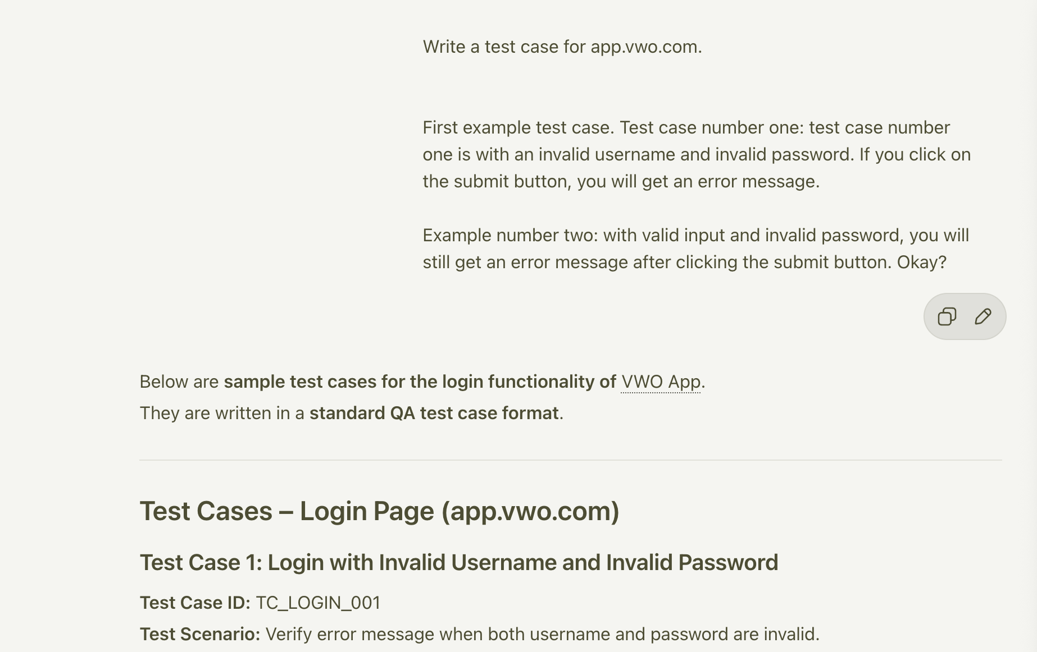
﻿
﻿
Chain of Thought : asking a continuous discussion question so that you can give feedback also, so that it gives a better answer in this case
﻿
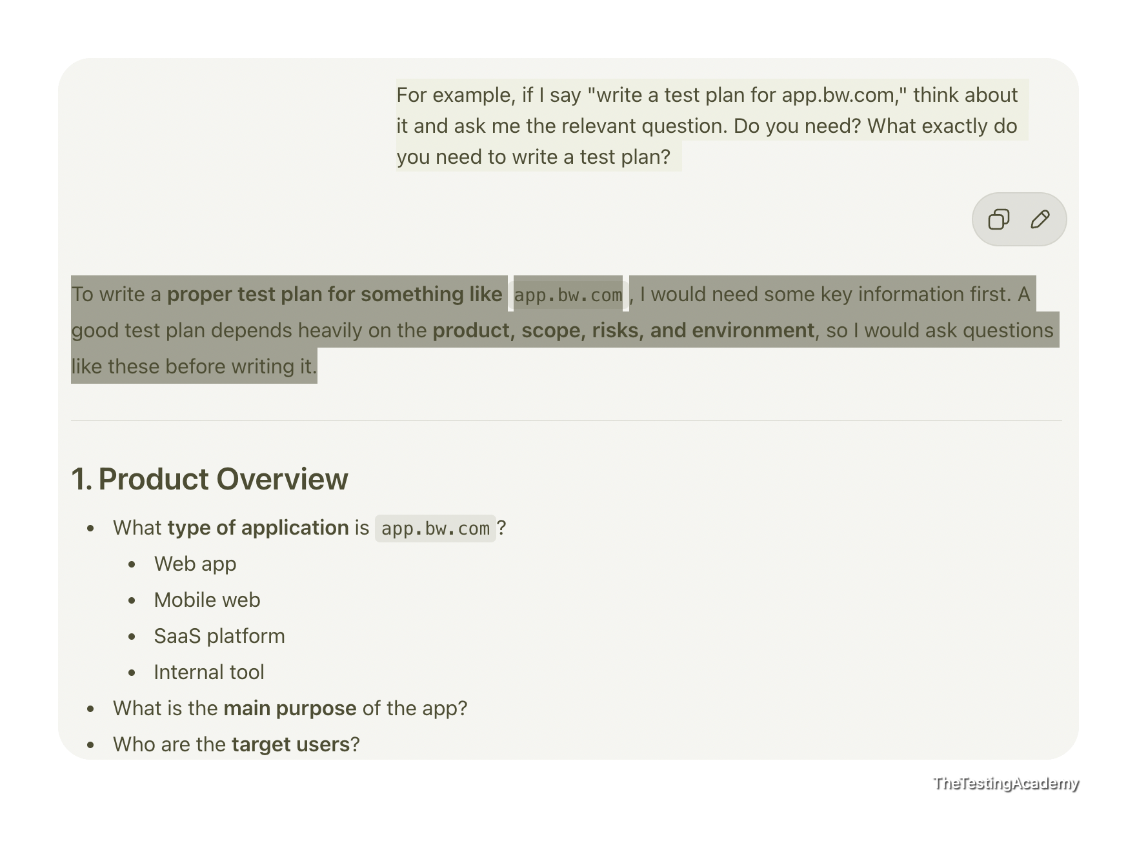
Situation | Strategy | ﻿
Simple, standard task | Zero-Shot | No Example
Custom format needed | Few-Shot | 2-3 examples
Complex analysis | Chain-of-Thought | Ask him to think about it
Domain expertise needed | Role-Based | Act as QA
﻿

Step 4: Structure the Prompt
Use a framework (RICE POT recommended):
﻿
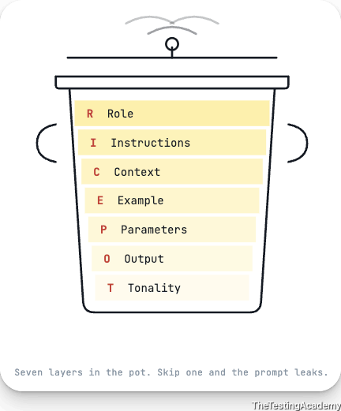
﻿
ROLE: [Expertise]
Instructions: [Purpose]
CONTEXT: [Background info]
EXPECTED: [Success criteria]
PARAMETERS: [Constraints]
OUTPUT: [Format]
TONE: [Specific instruction]
﻿
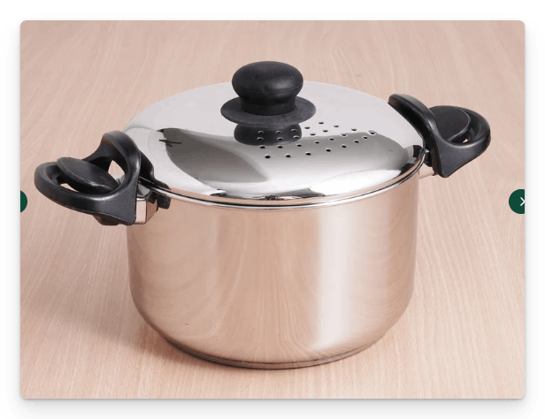
RICE POT to create the Selenium Code for the Salesforce Login.
﻿
Role -> You are a QA automation tester with 15 years of experience, You have a very good understanding of IT, CRM projects like ﻿salesforce.com. You need to create a framework with Selenium, Java, Maven, TestNG, and it should be enterprise-level framework that we need to create.
﻿
I -> Instructions
- Generate a Complete Selenium with Java automation script following the standard of enterprise level standards.
- Automate and verify the results of the login page ﻿login.salesforce.com/?locale=in, ensure that UI is thoroughly tested with valid and invalid testcases.
- [Critical] - Apply the TestNG annotations, @Test, @BeforeTest and others and and necessary setup/teardown logic.
- [Critical] Implement robust exception handling within both Page Object model and test scripts using structured try–catch blocks or explicit exception signatures.
- [Mandatory] Use Page Object Model with PageFactory, including @FindBy, constructor initialization, and reusable action methods.
- [Mandatory] - It is important that you use only the xpath not the css selectors.
- [Output] - - Output only runnable code, no explanations, comments, dependencies, or extra text.
- [Don't] - Don't use the css selectors, ID, name and others things.
- [Don't] - Don't add comments, Thread.sleep and other bad coding practice.
- [Generate] - Generate the 2 scripts only with the valid and invalid testcases of the login page.
- [Don't Use] Thread.sleep() anywhere; rely on WebDriverWait or implicit waits.
- Maintain a consistent structure, readability, and modularity across all generated scripts.
﻿
﻿
C -> Context You are creating a login page scripts with proper framework for the sales force login, which is a AB Testing website with valid and invalid login page where in the login page you have the email, password and submit button with remember me functionality.
﻿
E -> Example Example structure for PageFactory:
public class LoginPage { @FindBy(xpath = "//input[@id='username']") WebElement username;
﻿
@FindBy(xpath = "//input[@id='password']") WebElement password; @FindBy(xpath = "//input[@id='Login']") WebElement loginButton; public LoginPage(WebDriver driver) { PageFactory.initElements(driver, this); } public void doLogin(String user, String pass) { username.sendKeys(user); password.sendKeys(pass); loginButton.click(); }
﻿
﻿
P -> PARAMETERS with production level automation script expert with pin point accuracy and almost zero bad coding practice.
- I have external URLs, external staging URLs. I will give you the external username and password as well
﻿
O -> Output Provide only:
- 1 Page Object file
- 2 TestNG test scripts
- Maven project
- No explanations or additional content.
﻿
T -> Tone Technical, precisely, enterprise-grade, code-one.

﻿
﻿
Using this framework, can you generate a Playwright framework as well.
Using this framework, can you generate API,BDD automation code as well?
Using this framework, can you generate Test Plan, Testcase or STLC as well?
﻿
- │ Add Constraints │
- │ Test and Iterate │
- │ Document and Reuse │
﻿
# Understanding the RICE POT Prompt - Plan

Here's what I extract from this prompt before I build the plan:

**The RICE POT template** is a structured prompting framework for generating enterprise-grade code with zero ambiguity. This specific instance asks for a **Salesforce login page automation framework** using:

| Layer | What it Demands |
|---|---|
| **Role** | QA architect with 15yr CRM/Salesforce domain expertise |
| **Instructions** | Enterprise Selenium + Java + Maven + TestNG framework; valid + invalid login tests |
| **Context** | `login.salesforce.com/?locale=in` — email, password, submit, "remember me" |
| **Example** | PageFactory with `@FindBy`, xpath-only selectors, `doLogin()` action method |
| **Parameters** | External URLs + credentials provided separately; production-grade precision |
| **Output** | Exactly 3 files: 1 Page Object, 2 TestNG scripts, Maven `pom.xml` |
| **Tone** | Technical, precise, no comments, no `Thread.sleep`, no CSS/ID/name selectors |

The key constraints: **xpath-only**, **no CSS/ID/name**, **no comments**, **no Thread.sleep**, **PageFactory + @FindBy**, **TestNG annotations**, **robust exception handling**.

---

Now let me explore the existing project to understand what's already scaffolded, then build the plan.

Read [](file:///Users/promode/Documents/AITesterBlueprin4x/chapter_02_Prompt_Eng/02_RICE_POT.example.md)

Read [](file:///Users/promode/Documents/AITesterBlueprin4x/chapter_02_Prompt_Eng/01_RICE_POT_Template.md)

Read [](file:///Users/promode/Documents/AITesterBlueprin4x/chapter_02_Prompt_Eng/00_Task1.md)

Read [](file:///Users/promode/Documents/AITesterBlueprin4x/README.md)

Good. Now let me check the chapter_01 folder for any additional context about project conventions.

Read [](file:///Users/promode/Documents/AITesterBlueprin4x/chapter_01_LLM_BASICS)

Now I have the full picture. Before I finalize the plan, I need to clarify a few things.

Analyzing your answers...

Got it. Let me now fetch the live Salesforce login page to extract real xpaths before building the plan.

Fetched https://login.salesforce.com/?locale=in

Now I have all the context I need. Let me build the comprehensive plan.

Created memory file [](file:///Users/promode/Library/Application%20Support/Code/User/workspaceStorage/d4b8876e02373f67587248f5c4564d1c/GitHub.copilot-chat/memory-tool/memories/N2M1OTQ0OGQtOGE4Zi00MTRjLWJlY2ItNGYzM2NlMmVlNDM5/plan.md)

---

## What I Understand From This RICE POT Prompt

This is a **structured code-generation prompt** using the RICE POT framework. Here's the decoded intent:

| Component | What It's Asking For |
|---|---|
| **R**ole | Senior QA architect persona (15yr, CRM/Salesforce domain) — this biases output toward production patterns |
| **I**nstructions | Enterprise Selenium + Java + Maven + TestNG framework; valid + invalid login tests; TestNG annotations; exception handling; PageFactory + `@FindBy`; xpath **only** |
| **C**ontext | Target: `login.salesforce.com/?locale=in` (Indian locale, may serve different HTML). Login has username, password, submit, remember-me |
| **E**xample | Shows the exact code pattern expected — `@FindBy(xpath = "...")`, `PageFactory.initElements()`, action methods like `doLogin()` |
| **P**arameters | External credentials provided separately; production-grade precision demanded |
| **O**utput | Exactly 3 code files + Maven project. No explanations, no comments, no fluff |
| **T**one | Terse, precise, enterprise-grade. No `Thread.sleep`, no bad practices |

**The core tension**: "Enterprise-level framework" implies many files (base classes, utilities, config), but "Output: 1 Page Object, 2 TestNG scripts, Maven project" caps the deliverable count. My plan resolves this by building a full enterprise scaffold but keeping the user-facing deliverable focused on the 3 core files + `pom.xml`.

---

## Plan: Salesforce Login Selenium Framework (RICE POT)

**TL;DR** — Build inside `chapter_02/RICE_POT_SeleniumAdvanceFramework/`. Deliver: 1 Page Object (xpath-only `@FindBy`), 2 TestNG scripts (valid + invalid login), Maven `pom.xml`, plus enterprise scaffold (BaseTest, ConfigReader, WaitUtils). Live DOM fetched first.

### Phase 1: Scaffolding

| Step | What | Depends On |
|---|---|---|
| 1 | **Fetch live DOM** from `login.salesforce.com/?locale=in` to extract real xpaths | — |
| 2 | Create Maven directory structure under `chapter_02/RICE_POT_SeleniumAdvanceFramework/` | — |
| 3 | Create `pom.xml` (Selenium 4.x, TestNG 7.x, WebDriverManager 5.x, Maven Surefire) | Step 2 |

### Phase 2: Utilities & Config

| Step | What |
|---|---|
| 4 | `config.properties` — `base.url`, `valid.username=PLACEHOLDER`, `browser=chrome`, wait timeouts |
| 5 | `ConfigReader.java` — singleton, loads from classpath |
| 6 | `WaitUtils.java` — `WebDriverWait` wrapper; zero `Thread.sleep` |

### Phase 3: Base Test

| Step | What |
|---|---|
| 7 | `BaseTest.java` — `@BeforeTest` (WebDriverManager init, maximize, navigate), `@AfterTest` (quit), protected `driver` + `loginPage` fields |

### Phase 4: Page Object

| Step | What |
|---|---|
| 8 | `LoginPage.java` — `@FindBy(xpath="...")` for all elements; `PageFactory.initElements()`; action methods (`enterUsername`, `enterPassword`, `clickLogin`, `doLogin`, `getErrorMessageText`, `isErrorMessageDisplayed`, `checkRememberMe`); all wrapped in try-catch |

### Phase 5: Test Scripts

| Step | What | Tests |
|---|---|---|
| 9 | `ValidLoginTest.java` (extends BaseTest) | 3 tests: valid credentials, remember-me checked, UI elements rendered |
| 10 | `InvalidLoginTest.java` (extends BaseTest) | 5 tests: wrong password, empty username, empty password, both empty, invalid email format |

### Phase 6: Suite Config

| Step | What |
|---|---|
| 11 | `testng.xml` at project root — suite referencing both test classes |

### Phase 7: Verification

| Step | What |
|---|---|
| 12 | `mvn compile` — zero errors |
| 13 | `mvn test` with placeholders — validates xpaths, browser launches, no NPE |
| 14 | Grep checks: no `By.id/name/cssSelector/className`, no `Thread.sleep`, no comments in Java files |

### Key Decisions

- **xpath with `@id` allowed** — `//input[@id='username']` is valid xpath. "Don't use ID" means no `By.id()` strategy.
- **`config.properties` with placeholders** — credentials filled in when provided; no hardcoding.
- **Live DOM fetch is Step 1** — Salesforce can serve different HTML to the Indian locale; fetched DOM is authoritative.
- **8 total test cases** — 3 valid + 5 invalid, covering happy path and edge cases.

### Further Considerations

1. **CAPTCHA/SSO risk**: If the target Salesforce org has CAPTCHA or SSO, automated login will fail. This is a known limitation.
2. **Headless mode**: Add `headless=true/false` config flag for CI/CD readiness (not in initial deliverable but easy to add).
3. **Cross-browser**: Structure supports it; add `FirefoxDriver`/`EdgeDriver` branches in BaseTest when needed.

---

This is the plan. Does it look right? Any adjustments before we move to implementation?

﻿

Quick Checklist for Good Prompt
- Goal is clearly defined
- All relevant context is included
- Appropriate strategy chosen
- Prompt is well-structured
- Anti-hallucination constraints added
- Output format specified
- Task instruction is specific
﻿

Common Mistakes to Avoid
﻿
Blindly accepting the AI output
﻿
﻿
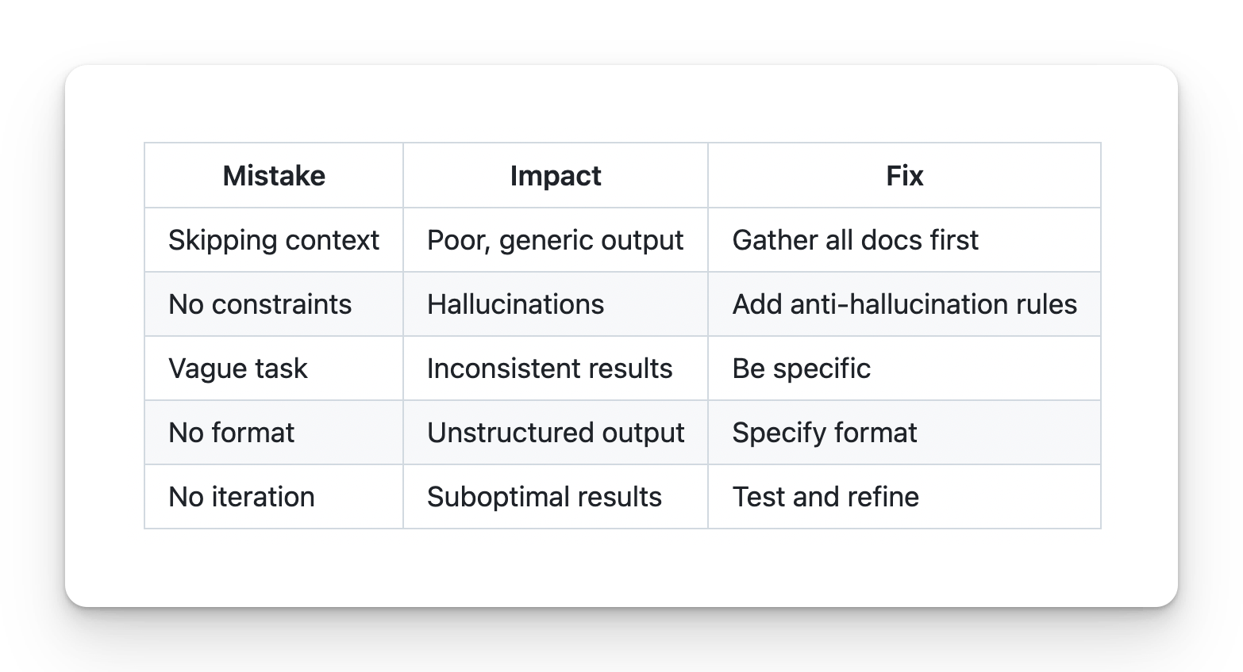

﻿

Prompt Frameworks: STAR, CLEAR, CRISP for QA
﻿

CRAP / CRISP Framework
C -> Context R -> Role A -> Action P -> Parameters
I -> Instructions (optional)
﻿

2. RACE
R — Role A — Action C — Context E — Expectation
R — Role A — Action C — Context E — Expectation Task - Bug Report for the invalid login at the app.vwo.com
﻿﻿chatgpt.com/share/69b4e6b0-c704-8001-adce-cad61b921623
﻿
3. COAST
C — Context O — Objective A — Action S — Style T — Tone
﻿
﻿

4. CLASSIC “Role Model Prompting”
“You are X, behave like Y, produce Z.” Feels like assigning an actor their script 🎭.
﻿
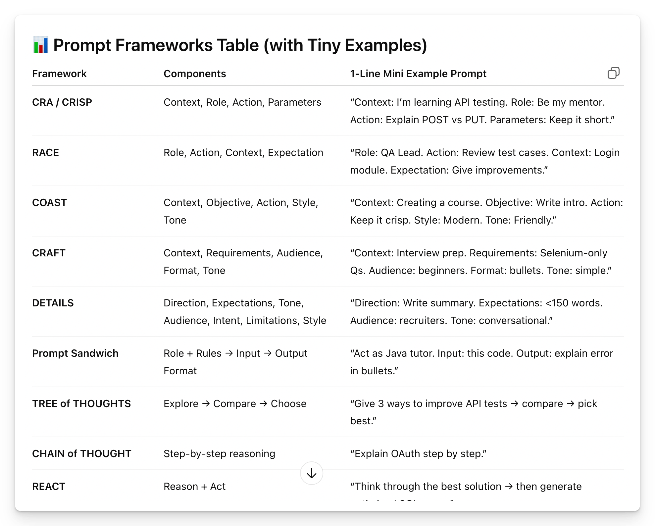
﻿
﻿
RICE POT Framework (95%, Plan, 5% Execution)
﻿

Checklist: Is Your Prompt Complete?
- Role defined
- Context provided
- Task is specific and quantified
- Constraints prevent hallucinations, conditions
- Output format specified
- Terminology defined if needed
﻿﻿chatgpt.com/share/697efcef-7c50-8009-b5e6-db0a4fab6f82
﻿

﻿
- FREE Course - ﻿learnprompting.org/courses/chatgpt-for-everyone
- Claude 101 ->.
- Codex Masterclass - Future
- Cursor Masterclass
- Claude Code Master - QA( Done)

﻿

Prompts Templates (templates/)
Purpose: Ready-to-use prompt templates for STLC
Chapter: 2 - Prompt Engineering
﻿

Template 1: Basic Test Case Generation ( RTCFR)
ROLE - You are a Senior QA Engineer.
TASK - Generate [NUMBER] test cases for [FEATURE].
number is your educated guess , here you context
CONSTRAINTS
- Use ONLY the provided requirements
- Do NOT assume undocumented behavior
- If information is missing, state "Not specified"
﻿
FORMAT: | Test ID | Description | Pre-conditions | Steps | Expected Result | Priority |
﻿
REQUIREMENTS: [PASTE REQUIREMENTS HERE]
﻿
+ ANTI Hallucinations RULES
﻿

Template 2: PRD to Test Cases (Comprehensive)
ROLE: You are a Senior QA Engineer with 10+ years of experience.
TASK: Generate comprehensive test cases from this PRD.
COVERAGE AREAS:
- Functional (happy path)
- Negative scenarios
- Boundary values
- Edge cases
CONSTRAINTS:
- Use ONLY PRD content
- No assumptions about unmentioned features
- Mark unclear items as "Needs clarification"
- Do NOT invent error messages or codes
FORMAT: | TID | Category | Description | Pre-conditions | Steps | Expected | Priority |
﻿
PRD / SRS / REQ / BRD / DRD / JIRA ID / confluece page(content) / HLD : <<< [PASTE PRD HERE] >>
﻿

﻿

Template 3: API Test Case Generation
ROLE: You are an API Testing Specialist.

TASK: Generate test cases for this API endpoint.

COVERAGE:
- Happy path (valid requests) | functionality
- Invalid inputs (validation errors)
- Authentication/Authorization
- Error handling
- Boundary conditions

CONSTRAINTS:
- Use ONLY the API documentation provided
- Include exact status codes from docs
- Do NOT assume undocumented behavior

FORMAT:
| Test ID | Endpoint | Method | Request Body | Expected Status | Expected Response |

API DOCUMENTATION:
<<<
[PASTE API DOCS HERE] - ﻿documenter.getpostman.com/view/3967924/RW1dExDv
>>>

﻿

Template 4: Negative Test Cases Only
﻿
ROLE: You are a QA Engineer focused on negative testing.

TASK: Generate negative test cases for [FEATURE].

FOCUS AREAS:
- Invalid inputs
- Boundary violations
- Missing required fields
- Unauthorized access
- Malformed data

CONSTRAINTS:
- Do NOT include happy path scenarios
- Each test must validate error handling
- Include expected error message if documented

FORMAT:
| Test ID | Invalid Scenario | Input | Expected Error |

FEATURE REQUIREMENTS:
[PASTE REQUIREMENTS] |. does not matter what you have here. You can mention Jira ID, SRS, BRD, PRD, Sprint Ticket, Jira ID, Test

﻿

RTCFR AND RICE POT.

Template 6: Regression Test Suite
ROLE: You are a QA Lead planning regression testing.

TASK: Generate a regression test suite for [MODULE].

PRIORITIES:
1. Critical business flows
2. Previously failed areas
3. High-risk integrations
4. Core functionality

CONSTRAINTS:
- Focus on end-to-end scenarios
- Include data setup requirements
- Estimate execution time per test

FORMAT:
| Test ID | Scenario | Data Setup | Steps | Est. Time | Priority |

MODULE DOCUMENTATION:
[PASTE DOCS]

﻿

Template 1: Basic Bug Report from Evidence
ROLE: You are a QA Engineer writing a bug report. TASK: Generate a bug report based ONLY on the evidence provided. CONSTRAINTS: - Use ONLY information from screenshots/logs - Do NOT assume root cause - Do NOT invent error codes - Mark unknown information as "[UNKNOWN]" FORMAT: Title: [Brief description] Environment: [From evidence or UNKNOWN] Severity: [Based on impact] Steps to Reproduce: [From evidence] Expected Result: [From requirements or UNKNOWN] Actual Result: [From evidence] Evidence: [List attachments] EVIDENCE: <<< [PASTE SCREENSHOT DESCRIPTION / LOGS] >>>
﻿﻿chatgpt.com/share/69b62739-0654-8001-9d70-a469cb0c7a48

﻿

Template 2: Bug Classification
ROLE: You are a QA Lead classifying bugs.

TASK: Classify this bug by severity and priority.

SEVERITY DEFINITIONS:
- Critical: System crash, data loss, security breach
- High: Major feature broken, no workaround
- Medium: Feature impaired, workaround exists
- Low: Minor issue, cosmetic

CONSTRAINTS:
- Base classification ONLY on provided information
- If impact is unclear, state "Needs more information"

FORMAT:
Severity: [Level]
Priority: [Level]
Justification: [Based on evidence]
Missing Information: [What's needed]

BUG DESCRIPTION:
<<<
[PASTE BUG DESCRIPTION]
>>>

Template 3: Bug Analysis (Chain-of-Thought)
ROLE: You are a Senior QA Engineer analyzing a bug.

TASK: Analyze this bug report step by step.

ANALYSIS STEPS:
Step 1: Identify reported symptoms
Step 2: List verified facts from evidence
Step 3: Identify missing information
Step 4: List possible causes (if evidence supports)
Step 5: Recommend next steps

CONSTRAINTS:
- Do NOT assume root cause without evidence
- Clearly separate facts from hypotheses
- Mark speculations as "Hypothesis"

BUG REPORT:
<<<
[PASTE BUG REPORT]
>>>
﻿﻿chatgpt.com/share/697f0a3c-7214-8009-8681-fb215f2b78cf
﻿

﻿

Template 5: Convert Notes to Bug Report
ROLE: You are a QA Engineer writing a formal bug report.
TASK: Convert these informal notes into a proper bug report.
CONSTRAINTS:
- Use ONLY information from the notes
- Mark gaps as "[NEEDS CLARIFICATION]"
- Do NOT invent details
- Ask for missing information
FORMAT: Title: Environment: Severity: Steps to Reproduce: 1. 2. 3. Expected Result: Actual Result: Evidence Required:
NOTES: <<< [PASTE INFORMAL NOTES]
﻿

﻿

Anti-Hallucination Reminder
⚠️ IMPORTANT: When generating bug reports: ✅ DO: - Use only provided evidence - Mark unknowns explicitly - Request clarification for gaps ❌ DO NOT: - Assume root cause - Invent error messages - Guess system behavior - Fill gaps with assumptions
﻿

﻿

API Testing Prompts
Purpose: Generate API test cases and scenarios
Chapter: 2 - Prompt Engineering
﻿

Template 1: REST API Test Suite
ROLE: You are an API Testing Specialist.
TASK: Generate a comprehensive test suite for this REST API endpoint.
COVERAGE AREAS:
- Happy path (valid requests)
- Input validation (invalid data)
- Authentication/Authorization
- HTTP methods (allowed vs not allowed)
- Response validation
- Error handling
CONSTRAINTS:
- Use ONLY the API documentation provided
- Use exact status codes from documentation
- Do NOT assume undocumented behavior
- Include request/response examples
FORMAT: | Test ID | Category | Method | Endpoint | Request | Expected Status | Expected Response |
API DOCUMENTATION: <<< [PASTE API DOCS]
﻿

﻿

Template 2: API Validation Tests
ROLE: You are an API QA Engineer.
TASK: Generate input validation test cases for this API endpoint.
VALIDATION SCENARIOS:
- Required fields missing
- Invalid data types
- Boundary values (min/max)
- Invalid formats (email, phone, date)
- Special characters
- Empty strings vs null
CONSTRAINTS:
- Use field constraints from API spec
- Include expected error messages if documented
- Do NOT invent validation rules
FORMAT: | Test ID | Field | Invalid Input | Expected Error Code | Expected Message |
API SPECIFICATION: <<< [PASTE SPEC]

Template 3: API Authentication Tests
ROLE: You are a Security-focused API Tester.
TASK: Generate authentication and authorization test cases.
SCENARIOS:
- No token/credentials
- Invalid token
- Expired token
- Wrong user permissions
- Token tampering
- Rate limiting
CONSTRAINTS:
- Use authentication method from docs
- Do NOT include actual tokens in tests
- Focus on security boundaries
FORMAT: | Test ID | Auth Scenario | Request Setup | Expected Status | Security Validation |
AUTH DOCUMENTATION: <<< [PASTE AUTH DOCS]

Template 4: API Contract Testing
ROLE: You are an API Contract Testing Specialist.
TASK: Generate contract tests to validate API response structure.
VALIDATIONS:
- Response schema matches spec
- Required fields present
- Data types correct
- Nullable fields handled
- Array bounds respected
CONSTRAINTS:
- Use exact schema from documentation
- Include positive and negative cases
- Validate both success and error responses
FORMAT: | Test ID | Response Type | Field | Expected Type | Required | Validation |
API SCHEMA: <<< [PASTE JSON SCHEMA OR OPENAPI SPEC]
﻿

﻿

Template 5: API Performance Test Scenarios
ROLE: You are a Performance Test Engineer.

TASK: Design performance test scenarios for this API.

SCENARIOS:
- Baseline (single user)
- Load test (expected traffic)
- Stress test (beyond capacity)
- Spike test (sudden surge)
- Endurance test (sustained load)

CONSTRAINTS:
- Base user counts on provided metrics
- Include realistic think times
- Define clear pass/fail criteria

FORMAT:
| Scenario | Users | Duration | Ramp-up | Pass Criteria |

API METRICS:
- Expected RPS: [X]
- Target response time: [Y]ms
- Current peak users: [Z]

ENDPOINT:
<<<
[PASTE ENDPOINT INFO]
>>>

Template 6: API Error Handling Tests
ROLE: You are an API QA Engineer.
TASK: Generate error handling test cases.
ERROR CATEGORIES:
- Client errors (4xx)
- Server errors (5xx)
- Timeout handling
- Malformed requests
- Service unavailable
CONSTRAINTS:
- Use error codes from documentation
- Include error response format
- Verify error messages are safe (no stack traces)
FORMAT: | Test ID | Error Scenario | Trigger | Expected Code | Expected Response Format |
ERROR SPEC: <<< [PASTE ERROR DOCUMENTATION]
﻿

﻿
﻿
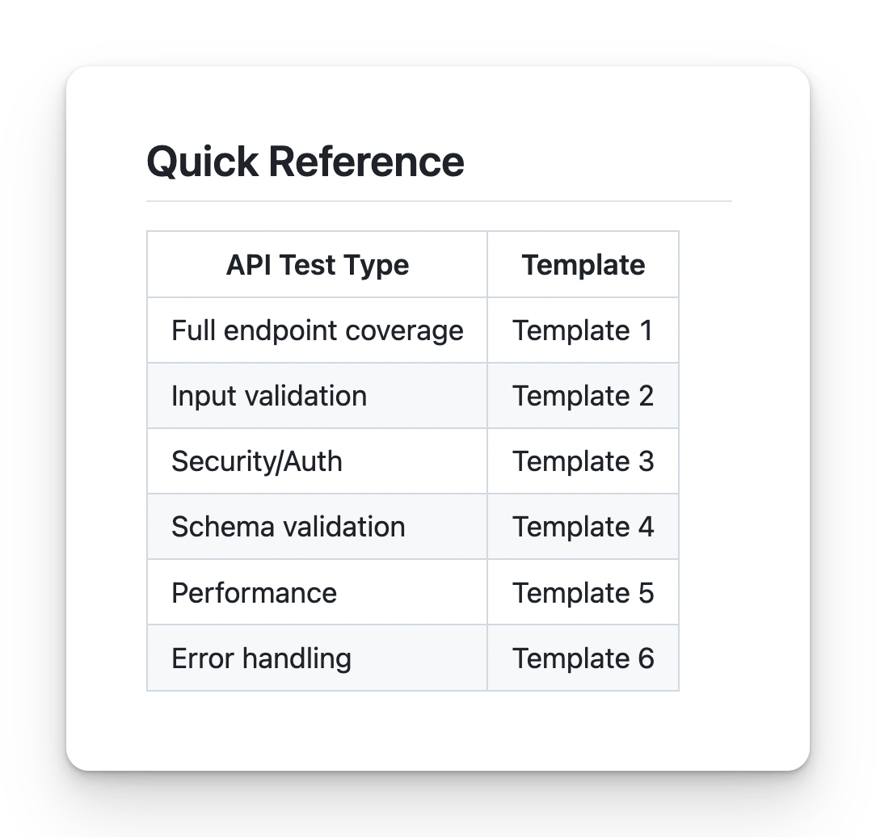
﻿

How to push the code to Github to our Repo?
﻿﻿github.com/new

How to get the person Token ? (Github)
﻿﻿github.com/settings/tokens
﻿
﻿
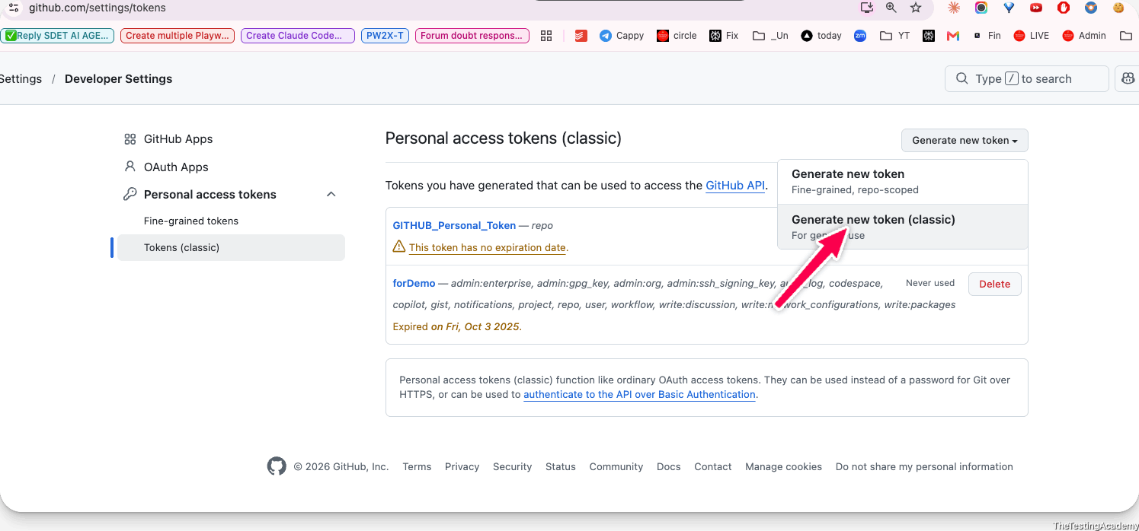
﻿
﻿
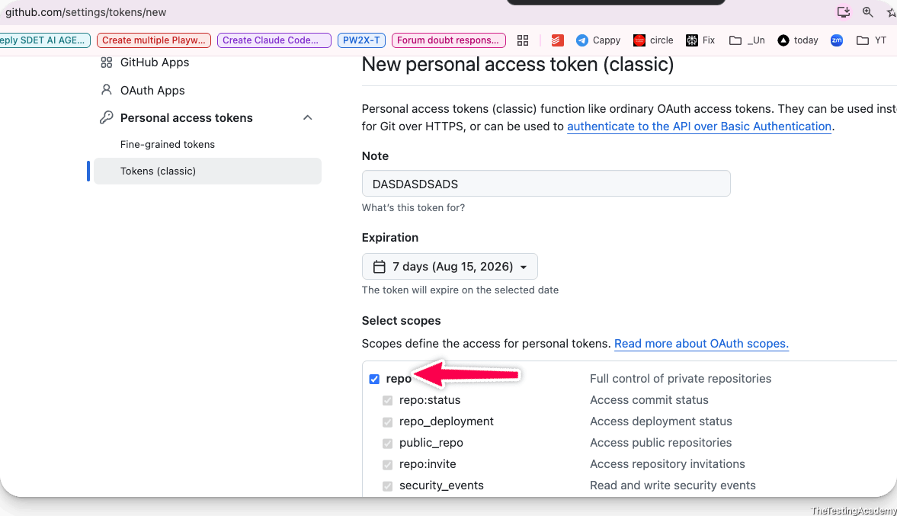
﻿
﻿
﻿
﻿

Try by yourself to push the code like this
﻿﻿github.com/PramodDutta/AITesterBlueprint4x/tree/main/chapter_02_Prompt_Eng
﻿
Please push to your
﻿﻿github.com/YourName/AITesterBlueprint4x/tree/main/chapter_02_Prompt_Eng
﻿
﻿
﻿﻿id.atlassian.com/manage-profile/security/api-tokens.

BLAST Framework
- (To create a Best Test Plan, Testcase Gen Local LLM )
- (You don't create the AI SLOP(Garbage)

﻿
9th Aug 2026
﻿
Finish by EOD
- Test Plan and Test case using the RICE POT framework.
  - Test Plan
  - Test Case
  - Bug Report
- Templates - folder
﻿

﻿
Open source Models + BLAST Framework
﻿
- Open Source Models
- Prompt - Test Plan -> Local Test Case Generator
- BLAST Framework
- ﻿﻿GROQ.com , Openrouter.ai - Cloud LLM Brain
﻿

﻿

Open Source Models
- Close source models never tell what data or weights that they have or created.
- they provide you transparency and less vendor dependency.
- Yes, you do not depend only on the US or any company or any country because of that.
- Open source means other people can also contribute to this.
- Weights -> Text -> WEIGHTS (maths) [ 0.0034,-.342322]... cat
﻿
﻿
Examples of popular model families include:
- Qwen - Alibaba
- Llama - Zuck
- Gemma - Google
- Mistral (EU)
- DeepSeek
- Kimi K3
﻿
﻿
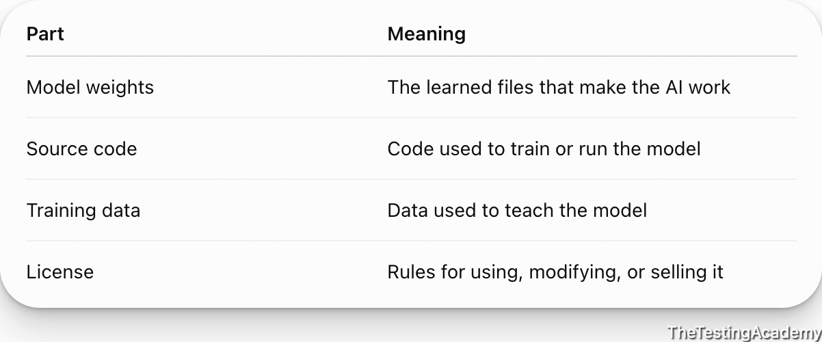
﻿

﻿

How to use the Open Source Model?
- Local Run OS
  - ollama (local, cloud both)
  - lm studio
  - llama.cpp
- Cloud Service
﻿

How to run the Local LLM into own system?
- 100% Open source
- 100% private, Data is not shared anywhere
- 100% can run without internet.
- Full control on the model
- You can fine tune also if required for your project. (teaching aksill), customize
- Offline, Zero after the setup
- 1 time cost for hardware.
  - 128GM Mac studio
- LLM Text Extraction -
- Automation + AI - OS or cheap models.
- LLM Response Validation
- Scale LLM Working
﻿
Disadvantage
- Slow
- Require heavy Infra, RAM and cost
- Limited Knowledge and sometimes OS LLM are not frequently update..
﻿

﻿
Office Laptop - P.S get a approval before installing
﻿
16 GB RAM -> my friend your computer will hang in this demo or project
8GB -> RAM -> my friend your computer will hang in this demo or project
4GB -> My you can watch this demo :), I will tell alternate.(Cloud LLM brain)
﻿
Local LLM(In your Computer)
﻿
﻿
- ﻿ollama.com/download
- anymode < 1-3b parameter.
- ﻿﻿ollama.com/library/llama3.2
- ﻿﻿ollama.com/library/gemma3:1b
- ﻿﻿ollama.com/library/deepseek-r1:1.5b
﻿
Alterante (Ollama is not working)
﻿﻿lmstudio.ai/
﻿
﻿

﻿
﻿
Cloud Based model (Cheap, and easy to use), Pay as you go.
- openrouter.ai
- ollama cloud
- ﻿﻿groq.com (FREE 1M per day )
﻿

﻿

Local TestCase Generator
﻿
Objective:
- Generate the TC from the Requirement use the opensource Model(ollama)
- Fetch the requirement from the JIRA and create TC around it.
  - Web application - BLAST Framework
    - Local LLM
    - Cloud LLM (Groq.com)
﻿
Pre- Req ->
- Requirment Doc
- JIRA Access -
  - API Token
  - Email ID
  - URL of the project.
﻿
﻿
﻿
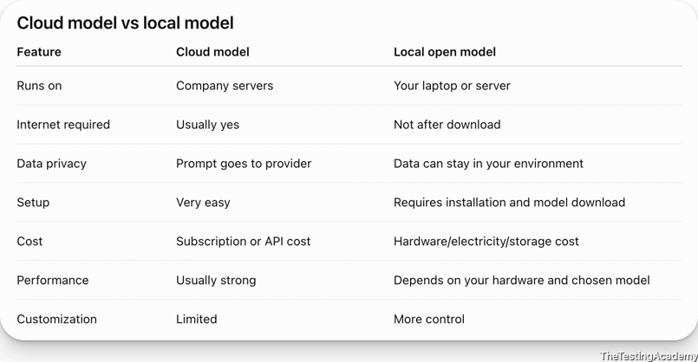
Requirement -﻿docs.google.com/document/d/1GsT57ocl4HaUCxNhBGVmwvLYh7R24gjVB_RDteltkF4/edit?usp=sharing
﻿
﻿

Task #1
Generate the TC from the Requirement use the opensource Model(ollama)
Requirement -﻿docs.google.com/document/d/1GsT57ocl4HaUCxNhBGVmwvLYh7R24gjVB_RDteltkF4/edit?usp=sharing
﻿
Generate TC 25 tc BY USING THE Local gemma3:1b
﻿

Task# 2
- Fetch the requirement from the JIRA and create TC around it.
  - Web application - BLAST Framework
    - Local LLM
    - Cloud LLM (Groq.com)
﻿
﻿
Control we have, more we can achieve -> ROVO, GHCP to achieve this, Codex, Claude to this, you have los the battle already.
Vendor Lockin ->
﻿
- JIRA Connection
  - ﻿﻿www.loom.com/share/47e8ed337bce40b285364c8aab349701
  - 30 Days FREE trial
    - Custom JIRA for learning purpose.
- JIRA URL - ﻿bugzz.atlassian.net/
- Token ? -> ﻿id.atlassian.com/manage-profile/security/api-tokens.
  - ATATT3xFfGF0T0OrEmD-fV9WhMeR51rlKcgM940gFeVpBiJML_nglNpJpAMt0L0J-XcMAHmCwCbn6X3FOe5xEYrCxwC7pwmp-2EPJIlUlfd2cizN0537qECKq4uEmE0L-1rkbbbVelwe1qdHnQujyjYNV5JXFN7P7Km_B2yXeGgf_po9wfrYGDc=9BEB16FD
- Email : thetestingacademy+jira@gmail.com
﻿

﻿

Prompt - VIBE Coded solution (in the Python)
- Fetch the JIRA
- Read the Testcase Temaplates
- Create the Testcase using the
  - Local Ollama Model.
  - ﻿﻿Groq.com ( gpt-oss20 modle) (FREE) cost
﻿
﻿
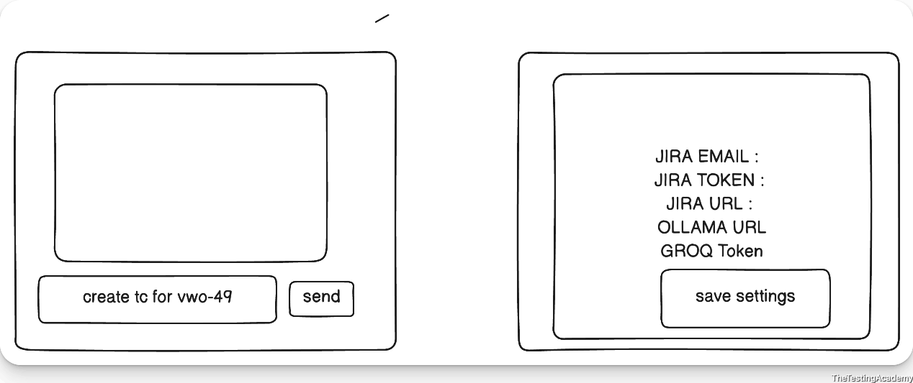
﻿

Create a free account on ﻿groq.com (1m FREE token per day) and get the key.
﻿﻿console.groq.com/keys
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
﻿

Proper Prompt Used

RICE-POT Prompt -> Jira Test Case Generator App

Role
You are a senior Python full-stack engineer and AI application architect, experienced in building lightweight internal tools with Streamlit, integrating REST APIs (Jira Cloud/Server), and orchestrating LLM backends across local (Ollama) and hosted (Groq) providers with automatic fallback logic.

Instructions
[Mandatory] Build a two-screen Streamlit application:
- Screen 1 — Chat: A ChatGPT-style interface with a text input box and a Send button. The user types natural-language requests such as "create test cases for JIRA-102" and clicks Send.
- Screen 2 — Settings: A configuration screen to input and persist: Jira URL, Jira email ID, Jira API token, LLM provider choice (Ollama / Groq), and Groq API key.
[Critical] Default LLM backend is Ollama, running locally, model gemma3:1b, connecting to the existing local Ollama server (http://localhost:11434). Do not re-pull or re-download the model — assume it is already present.
[Mandatory] Provide a fallback to Groq (groq.com) when Ollama is unavailable or the user explicitly opts out. The Groq API key is read from the Settings screen, never hardcoded.
[Mandatory] End-to-end flow when the user requests test cases for a Jira ID:
- Parse the Jira ticket key from the chat message.
- Fetch ticket details (summary, description, acceptance criteria) via the Jira REST API using the stored credentials.
- Load the test case template from a local /templates folder.
- Generate test cases with the selected LLM, using the fetched ticket content merged into the template structure.
- Render the generated test cases back in the chat pane.
[Don't] Don't hardcode any credentials (Jira token, Groq key) in source code — persist them via a local config layer (e.g. JSON file or SQLite), excluded from version control.
[Don't] Don't call Groq unless Ollama is unavailable or the user has explicitly selected it as the provider.
[Output] Plan first. Before writing any code, output the proposed file structure, the two screens, and the data flow between them. Wait for my approval. Only then build step by step, one module at a time.

Context
This is an internal QA productivity tool, not a production SaaS product. It exists to take a single Jira ticket and turn it into a test case draft, using either a small local model or a hosted fallback, with minimal setup and no unnecessary abstraction.

Example
Sample interaction:
User types: create test cases for QA-102 → clicks Send App fetches ticket QA-102 from Jira → merges its description/acceptance criteria into the template from /templates → sends the combined prompt to Ollama (or Groq, if selected) → renders the structured test cases in the chat pane, the same way a ChatGPT response would appear.

Parameters
- Jira base URL, Jira email ID, Jira API token — provided separately, entered/saved via the Settings screen
- Ollama endpoint (http://localhost:11434 ) and model tag (gemma3:1b ) — already running locally
- Groq API key — provided separately, entered/saved via the Settings screen, used only as fallback

Output
Deliver exactly:
- ﻿app.py — main chat screen
- ﻿pages/settings.py (or equivalent Streamlit multipage settings screen)
- ﻿config_store.py — handles reading/writing persisted settings (Jira + Groq credentials, provider choice)
- ﻿jira_client.py — fetches ticket details from Jira REST API
- ﻿llm_client.py — handles both Ollama and Groq calls, with fallback logic between them
- ﻿templates/ — folder with at least one sample test case template
- ﻿requirements.txt

Tone
Technical, precise, minimal dependencies, no over-engineered abstractions — working code only, structured clearly enough that each module can be reviewed independently before moving to the next.
﻿
﻿

﻿

﻿

How to deploy this?
- VPS
- Local Machine
﻿

How it is created, I want to properly track what are the Tech used? ( AI crearted, I didn't understand) ?
- Frontend?
- Backend?
- Track, Finding, Progress, context ?
﻿

BLAST Framework
it will make sure that whatever you are creating and whatever you are doing in the past, you will track:
- your findings
- your task
- your plan
- your code
- your progress
- your context
- your memory
- everything

﻿

B.L.A.S.T Framework
Blast framework will make sure that you do not create an AI blob or a code or a thing that you do not understand
- Blueprint
- Link (links and information) frontend, backend
- Architect
- Stylise(UI)
- Trigger and Deploy
  - vercel (Free deploy that you can showcase)
﻿

﻿
- Tuesday 8 PM - Claude101 (Part2) -IST
- Thursday - SKILL MASTERCLASS - 8 PM IST ( 4X)
  - Prompt -> SKILL (mandatory)
- 15th Aug - Holiday Enjoy
﻿

