Create multiple files and share everything with your team.
Sign Up Free
🎭 3x - Playwright + AI Mastery - Notes
Read Only
DocumentBothCanvas
CtrlK
Sign inDuplicateEraser AI
🎭 3x - Playwright + AI Mastery - Notes
- Action Plan for the 90 DAYS
- How to access the courses ? (Recordings)
- How to Ask the Doubts, Get the Task and Discuss my problem?
- Topics and Roadmap
- LIVE class Timing and Task
- How to see the recording
- Required Access
- Rules of Life
- Visual Studio Setup with Github copilot
  - default Claude Opus, GPT 5.5
  - With commandcode.ai ( $1)
  - Local LLM setup (if required)
  - Zcode.ai - (FREE 3M Token per day)
Question - ﻿forms.gle/Cj3zk3z4vq62vdmV9
﻿
﻿
Action Plan for the 90 DAYS | Topics and Roadmap
﻿
Roadmap 90-100 Days
﻿﻿www.figma.com/board/pkItIomNHwPzSdYrsWp1BT/90-Days-Roadmap-to-Playwright-with-JS-TS?node-id=1-13&t=yAXVWoruKX2fUmUP-1
﻿
Tracking Sheet | Playwright Sheet
﻿﻿https://sdet.live/playwright-sheet
﻿
﻿﻿app.thetestingacademy.com/
﻿

﻿
How to access the courses ? (Recordings)
- Make sure that the you have a reset password -
- ﻿﻿courses.thetestingacademy.com/password/reset
- Playwright
  - Access the all the courses here - ﻿courses.thetestingacademy.com/mycourses
﻿

﻿
How to Ask the Doubts, Get the Task and Discuss my problem?
Private Community
﻿﻿www.sdetclub.com/c/playwright-3x/
﻿
- Invite to SDETClub - ﻿contact@thetestingacademy.com ( Around 10 AM-5PM , IST)
- make sure this email does not go to spam
﻿

﻿
Jobs and Referral Group
﻿﻿www.sdetclub.com/c/jobs-and-referral/

﻿
when you have access to SDET club
- ﻿﻿www.sdetclub.com/c/playwright-3x/introduce-yourself

﻿
Links - Mobile Application
﻿apps.apple.com/us/app/circle-communities/id1509651625
﻿﻿play.google.com/store/apps/details?id=so.circle.circle&utm_source=community_nav

﻿
Branding (Day 1)
- Create the -> ﻿github.com/signup
- Linkedin.com
- ﻿﻿medium.com/ Blog
﻿

﻿
﻿
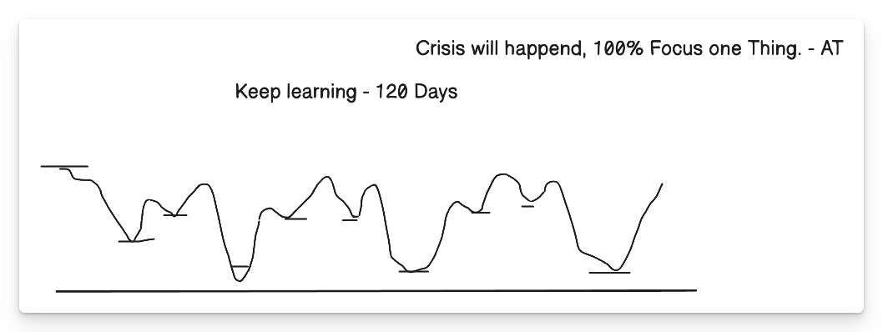
Shut up the Keep Learning
﻿
Rules of Life
- 100% Focus on One Thing -> AI Automation Tester -> All of the 100% efforts.
- 5% (Execution) and 95% (Plan) -> 5% Plan -> 95%(Test Execution) -> Try and Fail -> Try Again ->Success.
- 50-70% is Perfect -> 100% is Failure - 25K + companies
  - 40-70% Ready -> Interviews
  - Unlimited Oppor. -> Delhi, NCR, Bangalore, Chennai, Pune, -> 25K companies.
- New Actions -> -> Whatever worked in past, will not work in future. New Skills
  - Instagram, TikTok < 30 min per day Max.
  - ﻿﻿play.google.com/store/apps/details?id=bitpit.launcher&hl=en_IN
﻿

﻿
Consistency - Day 1 to 90 Days - Challenge
﻿
Financial Knowledge
﻿
- Emergency Fund -> monthly - 50k x 6 months -> 3L ( FD, Bank) - Save Job Security.
- 20K per Month -> 1.2 L in your ACC, don't touch it, until emergency
2.Health Insurance
3.Term Insurance
4.SIP - MF - Investing (5-10%) per month, - without -> index Nifty
﻿
﻿
LEARNING >> Struggling
﻿


﻿
- ﻿﻿code.visualstudio.com/
- AI
  - Ultra RICH -> Cursor, Windsurf -> 20$ per month, Claude Code -> 20$
  - RICH -> Github Copilot Company -> Yes
  - Middle Class -> Github Coplit (10$ per month)
    - Name: Command Code for VS Code
    - Don't use it in Company Laptops.
  - VVP -> (Personal Laptopn)
    - Ollama -> qwen3b:4
    - ﻿﻿ollama.com/download
    - 16 GB RAM ,
  - VVVP -> then, Don't buy ... 8 GB
﻿
﻿
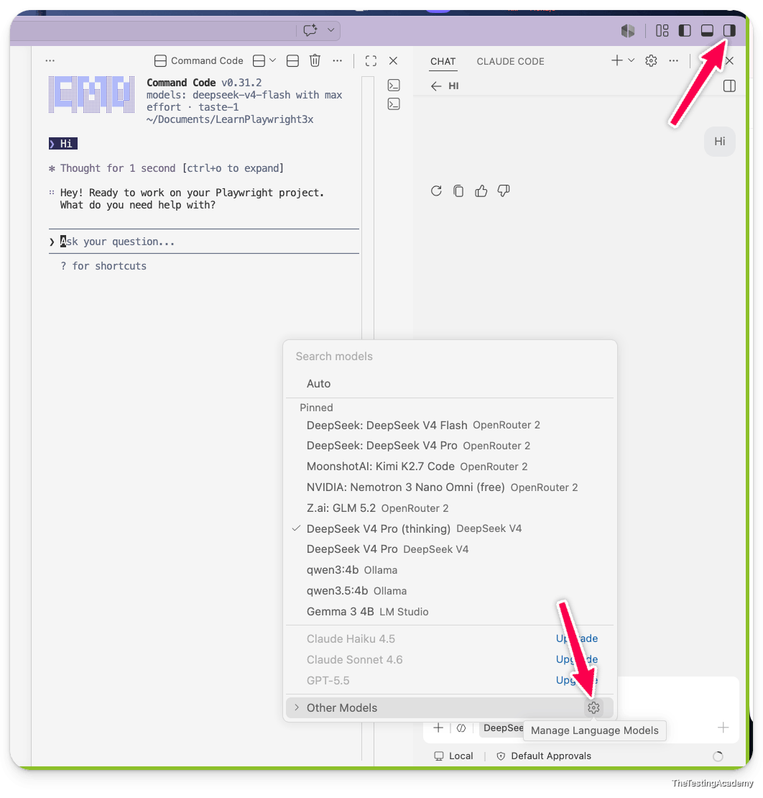
﻿
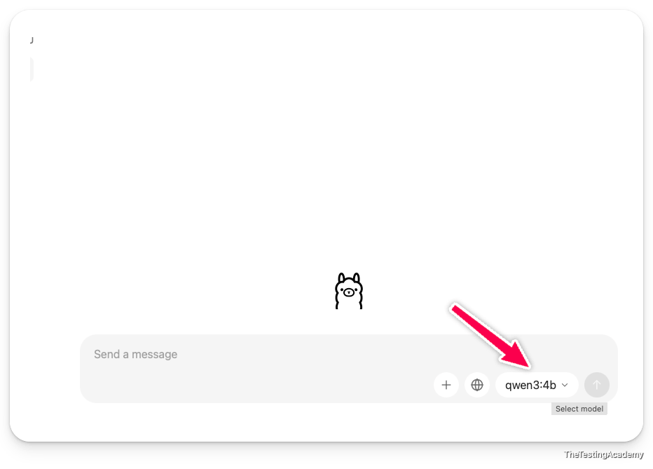
﻿

﻿
Required access Form - ﻿forms.gle/L47EKJns4ZPobLUH6
LIVE Class Timing
Tues, Thurs, Sat - 7 am to 8.15 AM IST
Tue, Friday -> Extra bi weekly)
Tomorrow - Wed -> Github Copilot Part 3 (Optional). 8 PM IST - ﻿https://sdet.live/clubclass (only work on the when we have class) ->
﻿

﻿
AI for QA | Playwright Installation
2th July 2026
- 90 Days Playwright + AI
- AI -> Important -> Learning Playwright ->
try to avoid using the AI to write the code until understand.
﻿
whichever you are comfortable with, use that
Cursor, Windsurf, Opencode, Claude Code, Codex, commandCode, Kiro, Amazon Q.
﻿
- Visual Studio Code. -> ﻿code.visualstudio.com/
- By Default VS - GHCP ->
  - 10$ per month -> Buy it. for 1-2 months
  - Officia - GHCP -> Access
  - CommandCode -. Cheaper Version( Personal Laptop)
    - please cancel your subscription if you don't want to use it
﻿
﻿﻿antigravity.google/product/antigravity-ide

﻿
90 Days
- 2 Gen AI + Playwright Setup
- JS
- TS
- PW
- PW + AI (got it)
﻿
Pramod is not learning. We are learning
﻿
Research, Practice and Upload to Github.com
﻿
🧠 What Changed After 2020 – The Era of Scale
AI models became like super interns – they can write, read, code, explain, summarize, and even reason.
AI after 2020 is defined by scale.
- Models like ChatGPT, Gemini, Midjourney are extremely large
- They consume massive compute, electricity, and data
- Public internet data is becoming a limiting factor
﻿
Model-as-a-Service Emergence
﻿
What Is AI Engineering?
AI Engineering = building applications on top of existing foundation models.
﻿
large-language model is a model which is trained on the data with more than 1 billion parameters
﻿
if the parameters are less than one billion, we call them a small language model, everyone. < 1B
﻿
What is Parameters?
- by using the parameters, a large language model will be able to predict the next token
﻿
Langauge Model
- Language model is like an autocomplete which predicts the next output based on the input asked. basically, do this by using the concept of transformer
﻿
What is a token ?
Token is not a word. It's the minimum amount of a kind of a string, or you can say that it's a bunch of characters which a large language model gives weight to while converting them to storing them in this case , weightages, everyone. What is a weightage
﻿
﻿﻿arxiv.org/pdf/1706.03762
﻿
0 to 1
King -> 0.45
Queen -> 0.34
Banana -> 0.11
﻿
Token - the language model is nothing but the smallest unit which the language model understands
token is not a word. It is not even a letter it is the smallest unit which language model can understand and by using the transformer or weights it can predict the next word
﻿
GPT 2 -> < 10 millions. (Parameters).
GPT 5.5 -> > 1 T ( 1000) ->. LLM > 10-50 T
﻿

﻿
open source models and closed source models
﻿
Closed source models
- GPT 5.5
- Claude Sonnet 5, Opus 4.8, Fable 5
- Gemini
﻿
Open source models - their whole source code as well as all the weights, param are public in nature
- DEEPSEEK
- Kimi K2.5
- Qwen
- Mistral - OS/Paid
﻿
AI Coding Assistant
- Codex
- GHCP
- CommandCode
- OpenCode
- Claude Code
- KIRO
﻿
What is a Hugging Face?
it is like a GitHub for models , list of opensoure models
﻿
we are not machine learning engineers. We will never create our foundation model. We are only going to use them. We are
﻿
LLMs do the same thing — but with:
- Entire internet-level knowledge
- Reasoning patterns
- Multiple languages
﻿
﻿
Base Model
A base model (also called a "foundation model" in some contexts, though there's a distinction) is a pre-trained model that has learned general patterns from large amounts of data but hasn't been fine-tuned for any specific task.
﻿
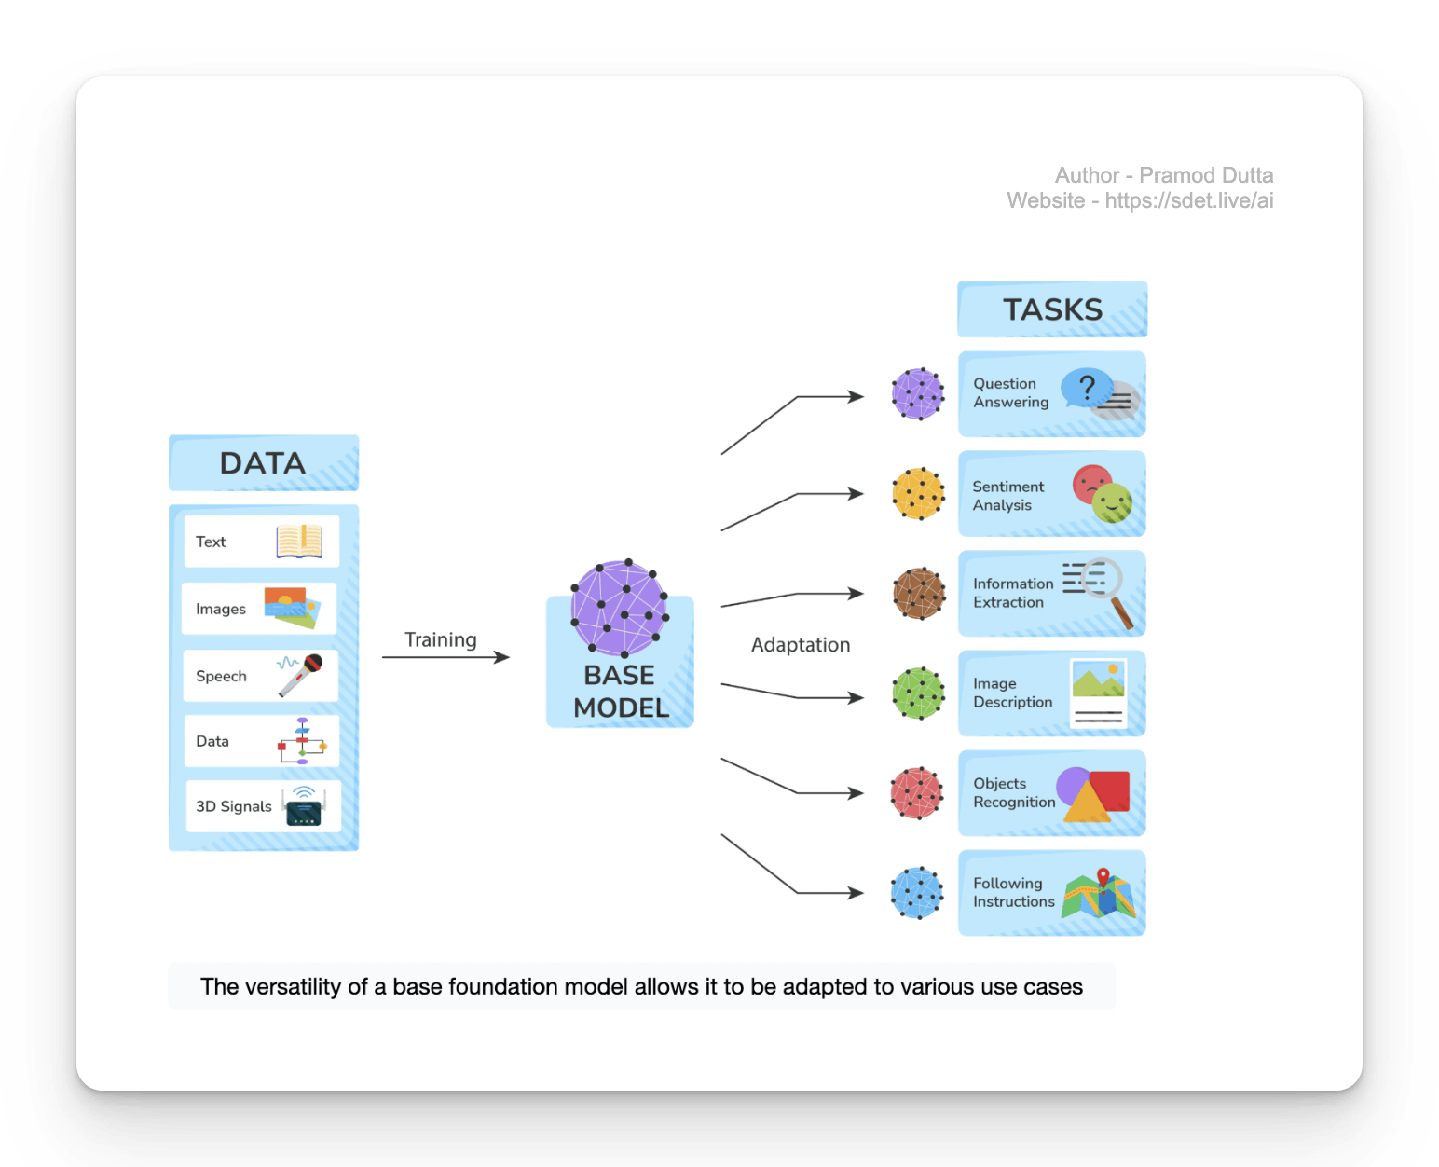
Foundation Models
- Handle multiple modalities:
  - Text
  - Images
  - Video
  - Audio
﻿
Github Copilot -> Coding AI Assitance Agent. (which uses the foundation model to help you)\
Perplexity AI -> Curation of the different Foundation modles
ChatGPT -> It. just a web chat with the foundation model GPT 5.5
﻿
Visual Studio Code
- Norma IDE - which can help you to generate a JavaScript code, Python code, or even the Java code
﻿
﻿
Cursor | Antigravity. | Windsurf | -> Agentic Coding IDE ( they help you to chat, agentic way to code and help you use the LLMs within the IDE to develop the code.
﻿
Closed-Source Models
(GPT, Claude, Gemini)
Pros
- Best reasoning quality
- Managed infra
- Fast iteration
﻿
Open-Source Models
(Mistral, LLaMA, DeepSeek, Phi, Qwen, kimi-k2)
﻿
﻿
What Is Google Antigravity?
Google Antigravity is an AI-powered integrated development environment - or IDE - that was released alongside Gemini 3 in November 2025.

﻿
How to install command code into your machine ?
Open the terminal or CMD or PowerShell and run these two commands.
Disclaimer: If you are using an office laptop, then please do not install command code until you have permission
- Install Node JS - ﻿nodejs.org/en/download
- Open the Terminal or Powershell
- npm i -g command-code@latest
- cmdc (for windows, cmd for mac)
﻿
Windows 11, 10
if you are facing any issue in the PowerShell or CMD related to error, just run this command in PowerShell
Set-ExecutionPolicy -Scope CurrentUser -ExecutionPolicy RemoteSigned
﻿
To run our JavaScript code, we will be using the Code Runner extension
﻿﻿marketplace.visualstudio.com/items?itemName=formulahendry.code-runner
﻿
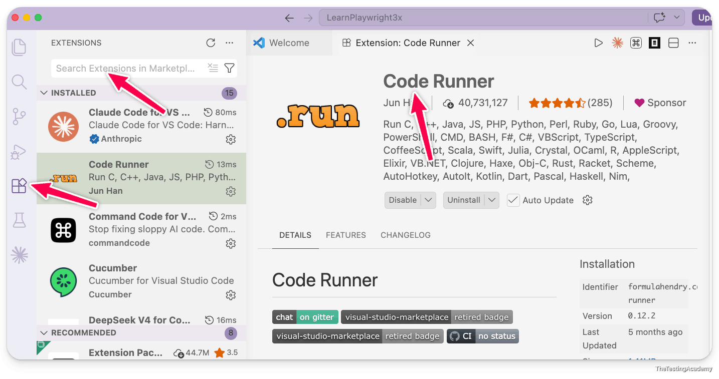

﻿
﻿
﻿
Problem with the large language model
- Hallucinations
- Knowledge cutoff
﻿
Hallucinations (LLMs “Making Things Up”)
﻿
A hallucination occurs when an AI model produces confident but factually incorrect or completely fabricated output, even though the information does not exist in the system, logs, API, or requirements.
The key danger: the answer sounds correct.
﻿
QA Example 1 – Bug Report Hallucination
﻿
Reality
- Screenshot only shows “Something went wrong”
- No error code visible
- No token logic involved
﻿
Why this is a hallucination
- AI invented technical details
- No evidence in input
- Over-confident explanation
﻿
QA Example 2 – Test Case Hallucination
Prompt
“Generate test cases for VWO dashboard.”
AI Output
- Test case: Verify Dark Mode toggle
- Test case: Validate Export to CSV
Reality
- No Dark Mode
- No Export feature in product
Failure Type
- Feature hallucination
﻿
﻿
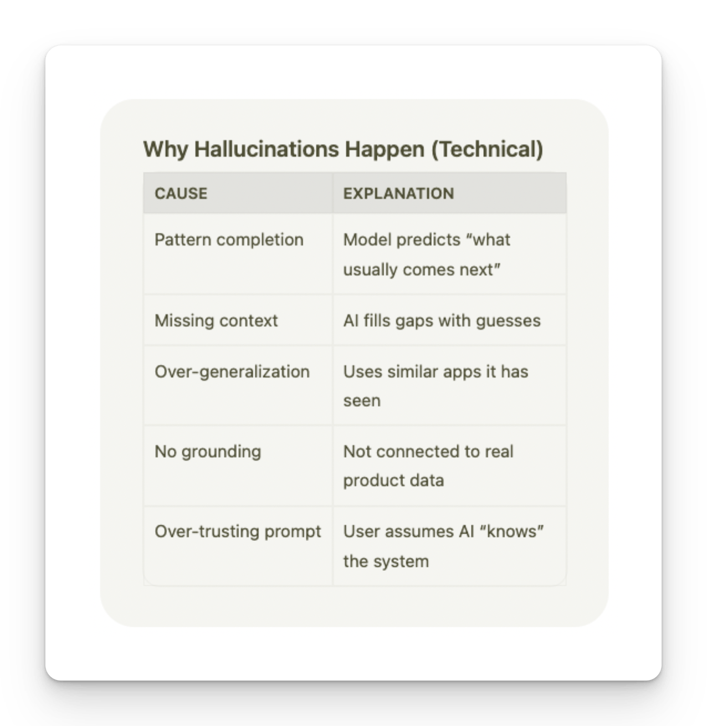

﻿
Anti-Hallucination Rules
﻿
ROLE: You are a QA assistant operating under strict verification rules.
SCOPE OF KNOWLEDGE You may ONLY use information explicitly provided in: PRD API documentation Logs Screenshots Test data User input
STRICT RULES (MANDATORY) DO NOT invent features, APIs, error codes, UI elements, or behavior. DO NOT assume default or "typical" system behavior. If information is missing or unclear, respond with: "Insufficient information to determine." Every assertion must be traceable to provided input. If a detail is inferred, label it explicitly as: "Inference (low confidence)".
﻿
Output must be deterministic and repeatable. PROCESS YOU MUST FOLLOW Step 1: Extract verifiable facts from the input. Step 2: List unknown or missing information. Step 3: Generate output ONLY from Step 1 facts. Step 4: Perform a self-check for hallucinations or contradictions. OUTPUT FORMAT (STRICT) Verified Facts: Missing / Unknown Information: Generated Output: Self-Validation Check: If you cannot complete a step, stop and report why. >> Instructions
﻿

﻿
Prompt with the Anti-Hallucination Rule
﻿﻿chatgpt.com/share/6a45cc4b-ba08-83e8-b7d5-a5635bcd44c6
﻿
Create the Test Plan for the app.vwo.com,
use these rules, ROLE: You are a QA assistant operating under strict verification rules.
SCOPE OF KNOWLEDGE You may ONLY use information explicitly provided in: PRD API documentation Logs Screenshots Test data User input
STRICT RULES (MANDATORY) DO NOT invent features, APIs, error codes, UI elements, or behavior. DO NOT assume default or "typical" system behavior. If information is missing or unclear, respond with: "Insufficient information to determine." Every assertion must be traceable to provided input. If a detail is inferred, label it explicitly as: "Inference (low confidence)".
Output must be deterministic and repeatable. PROCESS YOU MUST FOLLOW Step 1: Extract verifiable facts from the input. Step 2: List unknown or missing information. Step 3: Generate output ONLY from Step 1 facts. Step 4: Perform a self-check for hallucinations or contradictions. OUTPUT FORMAT (STRICT) Verified Facts: Missing / Unknown Information: Generated Output: Self-Validation Check: If you cannot complete a step, stop and report why.

﻿
Prevent Hallucinations (Best Practices)
- Proper prompts
- Rules
- Constraints (examples)
- RAG ? (discuss later) ->

﻿
Inconsistencies (AI Contradicting Itself)
An inconsistency occurs when the AI gives different or conflicting answers for the same requirement, test case, or scenario, either:
- In the same response
- Across multiple runs
- Across different prompts
QA Example 1 – Inconsistent Test Cases
Prompt 1
“Write test cases for login failure.”
AI Output
- Expected Result: Error message appears
Prompt 2 (Same input, new run)
- Expected Result: User redirected to forgot password
Problem
- Same scenario → different expected behavior
﻿
﻿
the only way to fix the inconsistency is by giving the proper context
Save the Context by PDF, Knowledge, Text File, JSON File, Output Format, Proper Images, Screenshots, Figma Designs, PRDs, Jira Tickets, Jira Descriptions, Jira Titles, What to Do, What Not to Do.
﻿
﻿

﻿
﻿
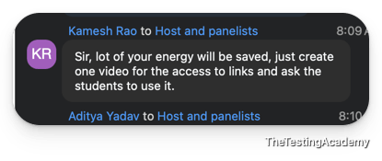
﻿

﻿
Temperature - Control your randomness in your answers.
1.Lower Temperature ( 0 to 1)
- Use temperature = 0–0.2 for QA tasks
2. Use Structured Output
- JSON schemas
- Tables with fixed fields
3. Single Source of Truth
- Always attach the same PRD / test data
4. Deterministic Prompts
- Avoid vague words like “analyze”, “suggest”
﻿﻿platform.openai.com/chat/edit?models=gpt-4.1-mini
﻿
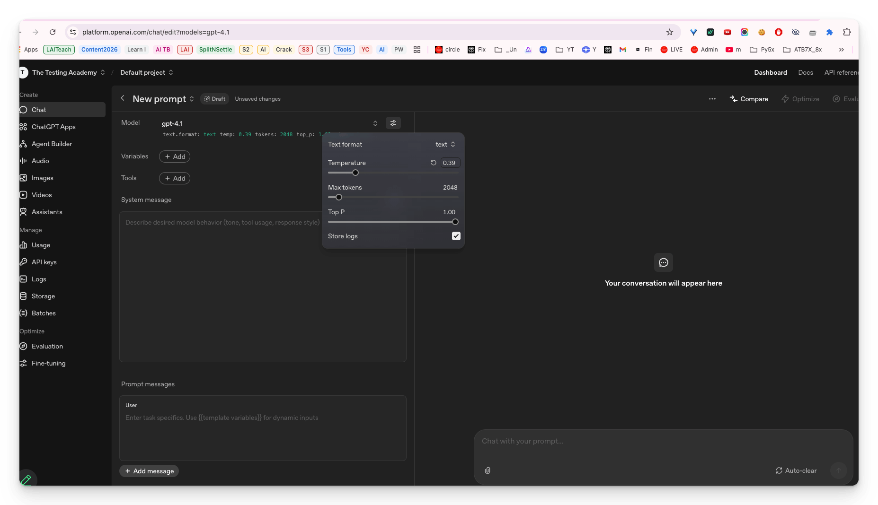
﻿
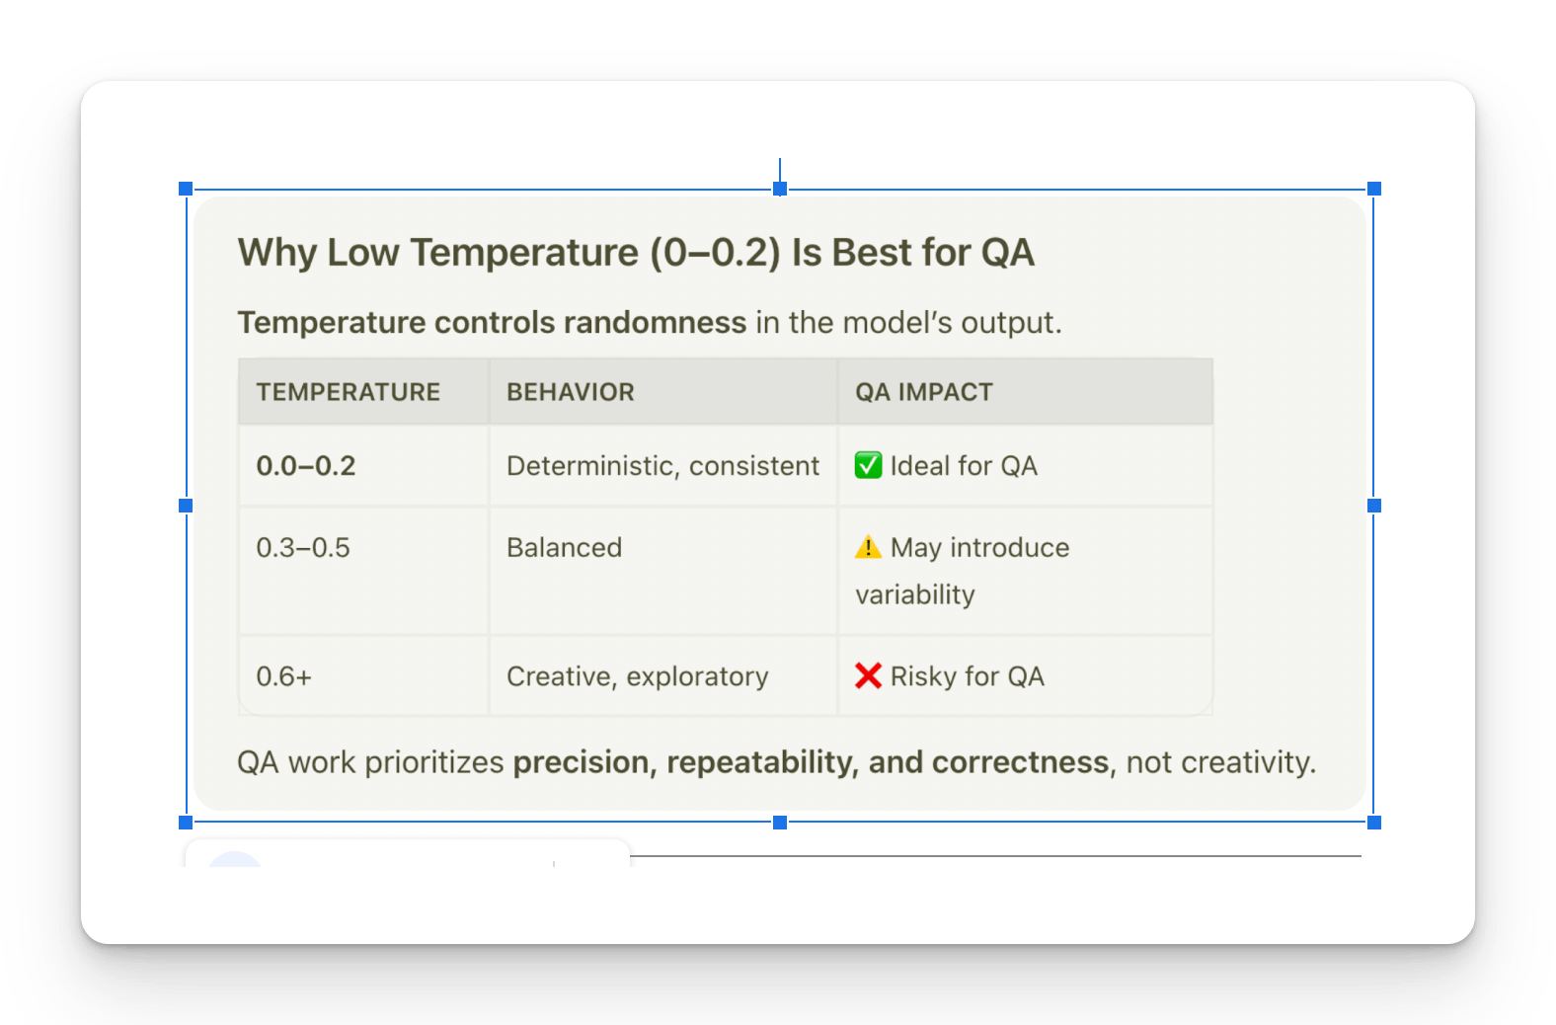
﻿
Supervised vs Un Supervised vs Self-Supervised Learning
- The first robot attended culinary school, carefully following labeled recipes with step-by-step instructions.
- The second robot never had formal instruction; instead, it studied countless cookbooks to find common cooking patterns.
- The third robot had no instructions. It experimented by cooking randomly, tasting the results, and learning what worked best.
﻿
﻿
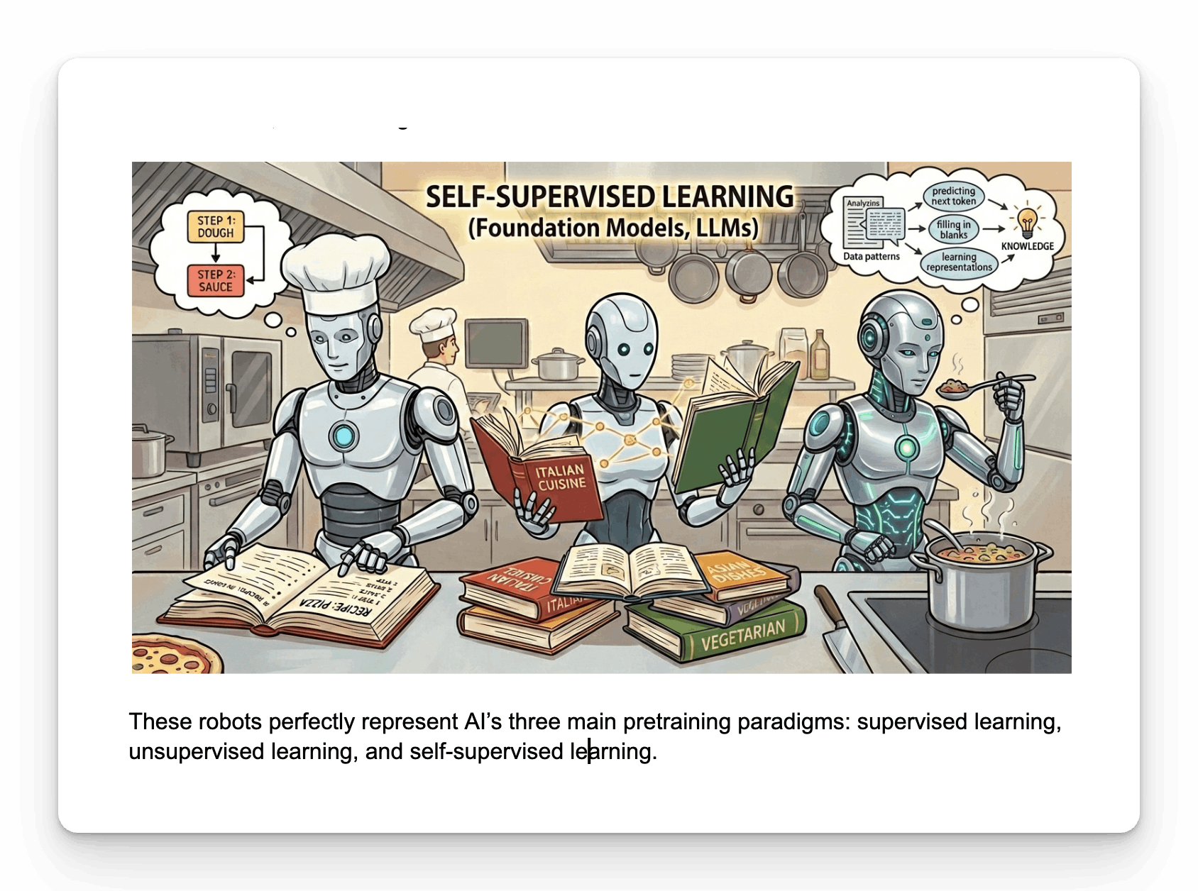
﻿
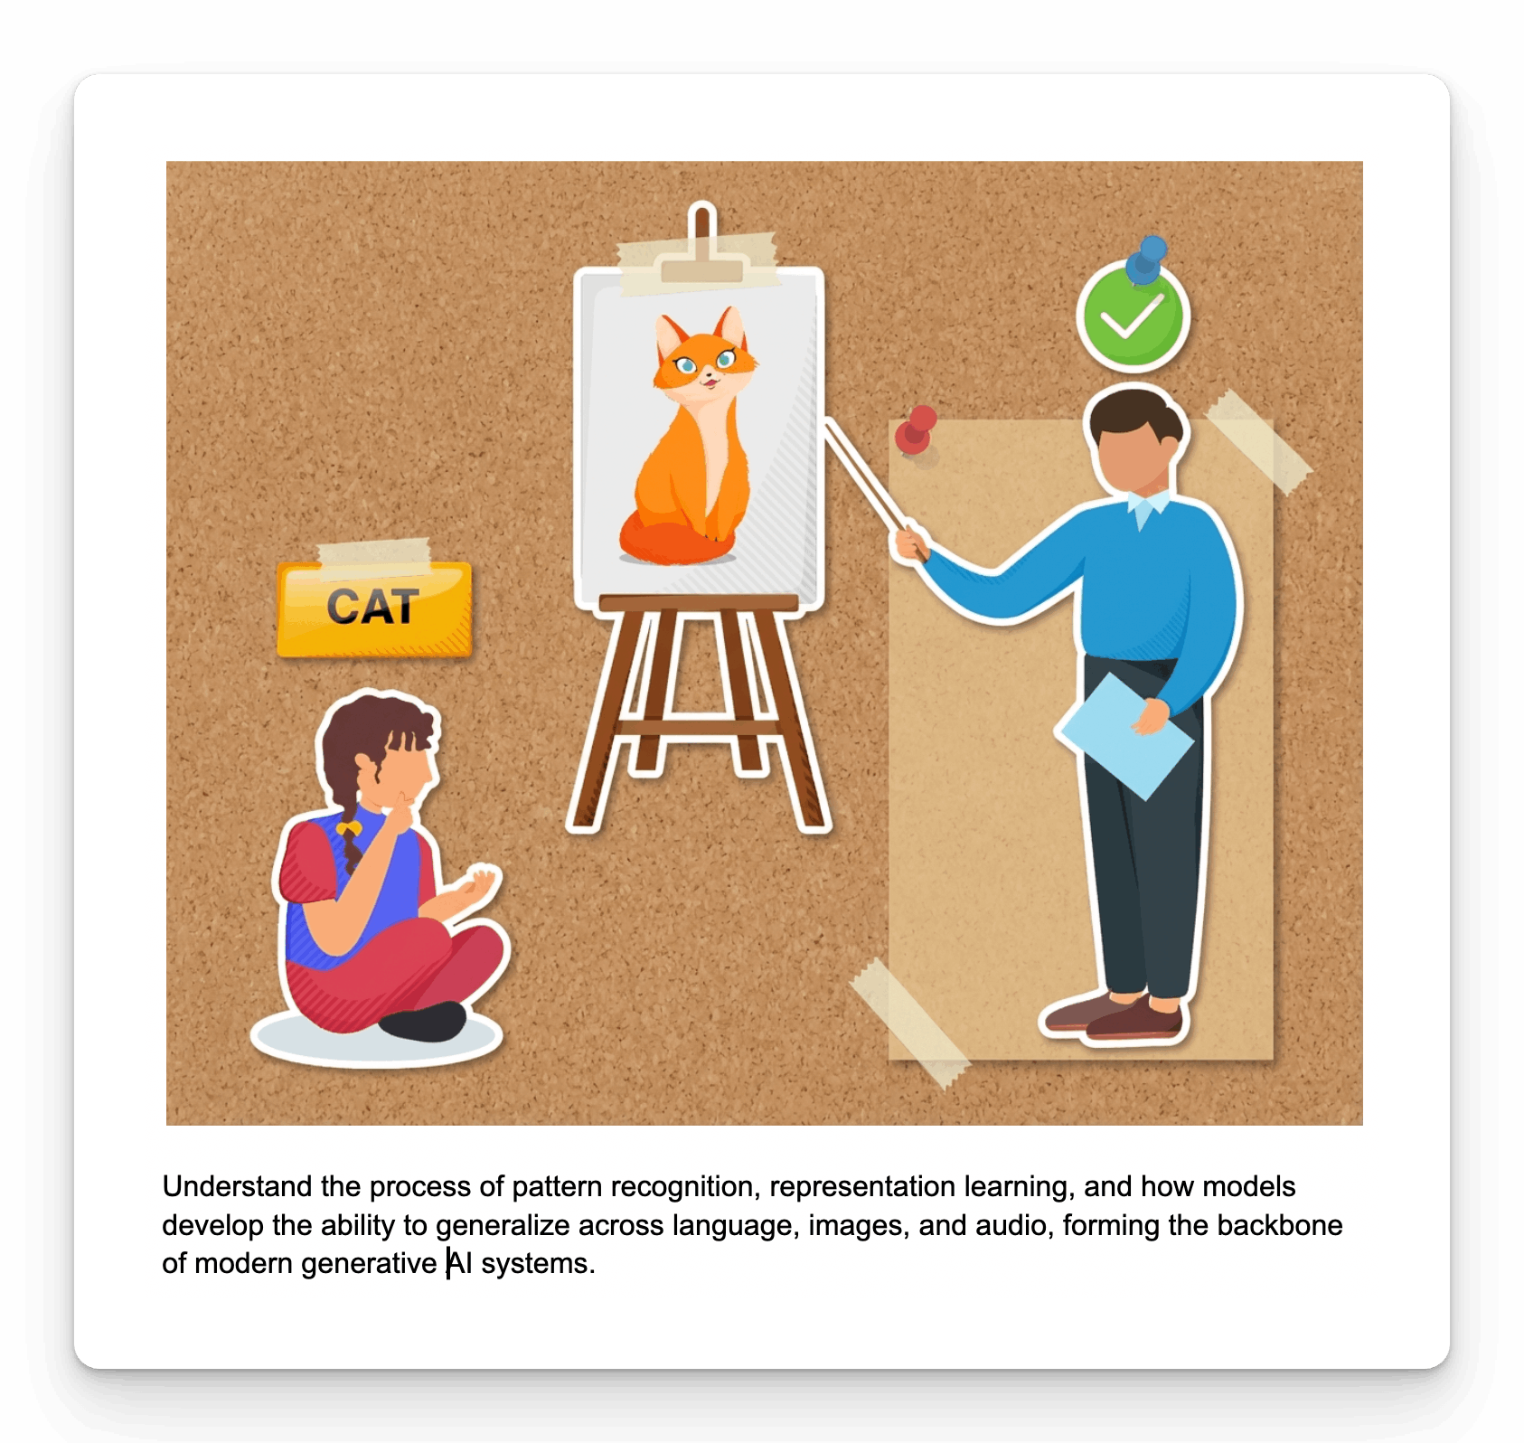
﻿
🧠 Difference Between ML, AI, Deep Learning
Machine Learning (ML)
What it is Machine Learning is a subset of AI where systems learn from data instead of being explicitly programmed.
Key idea ML = Learn patterns from data → make predictions
Examples
- Fine Tune LLM
﻿
Deep Learning (DL)
What it is Deep Learning is a subset of ML that uses neural networks with multiple layers to understand complex patterns.
Key idea DL = Learn like the human brain (neurons + layers)
Examples
- Image recognition
- Speech-to-text
- Large Language Models (GPT, Claude)

﻿
AI: Making machines intelligent -> we are going to use the large language models and build the application on the topic
﻿

﻿
Prompting Engineering
Prompt Engineering is the practice of designing and refining inputs (prompts) to effectively communicate with Large Language Models (LLMs) to achieve desired outputs.
﻿
Prompting refers to the practice of providing specific instructions or input to an artificial intelligence (AI) model to obtain desired responses.
﻿
Core Principles
1. Be Specific
❌ Bad: "Write test cases for login"
✅ Good: "Write 5 functional test cases for email/password login, covering valid login, invalid email, invalid password, empty fields, and SQL injection attempt. Use the Proper JIRA format: Test ID, Description, Steps, Expected Result."
﻿
2. Provide Context
❌ Bad: "Test the API"
✅ Good: "Given this API endpoint documentation: [paste docs], write test cases covering happy path, error scenarios, and edge cases."
﻿
3. Define Output Format
❌ Bad: "Generate bug report"
✅ Good: "Generate a bug report using JIRA format: Title, Environment, Steps to Reproduce, Expected Result, Actual Result, Severity, Attachments."
﻿
4. Set Constraints
❌ Bad: "Help me test"
✅ Good: "Using ONLY the PRD provided, generate test cases. Do NOT assume any features not mentioned. If information is missing, state 'Not specified in PRD'."
﻿

﻿
Steps to Follow for Effective Prompt Engineering
- Define the Goal │
- │ Gather Context │
- │ Choose Prompting Strategy │
- │ Structure the Prompt │
- │ Add Constraints │
- │ Test and Iterate │
- │ Document and Reuse
﻿
Step 1: Define the Goal
Ask yourself:
- What exactly do I need?
- What will I do with the output?
- What does success look like?
❌ Vague: "Help me with testing"
✅ Clear: "Generate 10 test cases for login validation"
Step 2: Gather Context
Collect all relevant information:
- PRD / Requirements document
- API documentation
- Screenshots / UI mockups
- Error logs
- Previous test cases
- Constraints / Limitations
Rule: More context = Better output
﻿
Step 3: Choose Prompting Strategy
Situation | Strategy | ﻿
Simple, standard task | Zero-Shot | No Example
Custom format needed | Few-Shot | 2-3 examples
Complex analysis | Chain-of-Thought | Ask him to think about it
Domain expertise needed | Role-Based | Act as QA
Few Shot
Create a bug report for ﻿app.vwo.com where the login page is not working.
example
A Jira bug report will contain:
- our scenario ID - 1
- scenario test case ID - 001
- test case title - verify this app.log in.com is working.
- test case description
- expected result
- output results
- comment severity
- priority
Result ->
Bug Title: Login page is not working on app.vwo.com
Scenario ID: 1
Scenario Test Case ID: 001
Test Case Title: Verify that the login page of app.vwo.com is working.
Test Case Description: Verify that a user is able to access the login page, enter valid login credentials, and successfully log in to app.vwo.com without any errors.
Steps to Reproduce:
- Open the browser.
- Navigate to ﻿https://app.vwo.com .
- Enter valid email ID and password.
- Click on the Login button.
- Observe the result.
Expected Result: The user should be successfully logged in and redirected to the VWO dashboard/home page.
Actual Result / Output Result: The login page is not working. The user is unable to log in to app.vwo.com. The page may not respond, show an error, or fail to redirect after clicking the Login button.
Severity: High
Priority: High
Comment: This issue blocks users from accessing the application. Since login is a critical functionality, it should be fixed as soon as possible.

﻿
Step 4: Structure the Prompt
Use a framework (RICE POT recommended):
﻿
The RICE-POT Prompt Framework
RICE-POT Breakdown
Letter | Component | Description
R | Role | Defines the persona the AI should adopt (e.g., Expert QA Automation Engineer).
I | Instructions | Specific, step-by-step commands and constraints (e.g., Mandatory rules, "Don't" lists).
C | Context | Background information to help the AI understand the  why  and  where  (e.g., Salesforce Login Page description).
E | Example | Providing a code snippet or format to guide the style (e.g., PageFactory example).
P | Parameters | Constraints on quality, accuracy, and style (e.g., Production-level code, zero bad practices).
O | Output | Defines exactly what artifacts to produce (e.g., Only code, no comments).
T | Tone | The style of communication (e.g., Technical, precise, code-only).

﻿
📝 The Exact Prompt Used
﻿
Role : You are a QA automation tester with 15+ years of experience. You have a very good understanding of IT, CRM projects like salesforce.com. You need to create a framework with Selenium, Java, Maven, TestNG, and it should be enterprise-level framework that we need to create.
﻿
I - Instructions
- Generate a Complete Selenium with Java automation script following the standard of enterprise level standards.
- Automate and verify the results of the login page login.salesforce.com/?locale=in, ensure that UI is thoroughly tested with valid and invalid testcases.
- ﻿[Critical] - Apply the TestNG annotations, @Test, @BeforeTest and others and and necessary setup/teardown logic.
- ﻿[Critical] Implement robust exception handling within both Page Object model and test scripts using structured try–catch blocks or explicit exception signatures.
- ﻿[Mandatory] Use Page Object Model with PageFactory, including @FindBy, constructor initialization, and reusable action methods.
- ﻿[Mandatory] - It is important that you use only the xpath not the css selectors.
- ﻿[Output] - - Output only runnable code—no explanations, comments, dependencies, or extra text.
- ﻿[Don't] - Don't use the css selectors, ID, name and others things.
- ﻿[Don't] - Don't add comments, Thread.sleep and other bad coding practice.
- ﻿[Generate] - Generate the 2 scritps only with the valid and invalid testcases of the login page.
- ﻿[DoNOTuse] Thread.sleep() anywhere; rely on WebDriverWait or implicit waits.
- ﻿Maintain a consistent structure, readability, and modularity across all generated scripts.
C : Context You are creating a login page scripts with proper framework for the sales force login, which is a AB Testing website with valid and invalid login page where in the login page you have the email, password and submit buttin with remember me fucntionality.
﻿
E — Example
Example structure for PageFactory:

public class LoginPage {
@FindBy(xpath = "//input[@id='username']") WebElement username;
@FindBy(xpath = "//input[@id='password']") WebElement password;
@FindBy(xpath = "//input[@id='Login']") WebElement loginButton;

public LoginPage(WebDriver driver) { PageFactory.initElements(driver, this); }

public void doLogin(String user, String pass) {
username.sendKeys(user);
password.sendKeys(pass);
loginButton.click();
}
}
P — PARAMETERS
with production level automation script expert with pin point accuracy and almost zero bad coding practice.

O — Output
Provide only:
1 Page Object file
2 TestNG test scripts
Maven project
No explanations or additional content.

T — Tone
Technical, precisly, enterprise-grade, code-one.

Please make the entire step by step process and ask me what you are doing and explain to me also what you are doing step by step. Make sure that you first plan everything and show me what exactly you are going to create. Then only you are going to create afterwards step by step.

﻿
Quick Checklist for Good Prompt
- Goal is clearly defined
- All relevant context is included
- Appropriate strategy chosen
- Prompt is well-structured
- Anti-hallucination constraints added
- Output format specified
- Task instruction is specific
﻿

﻿
Prompt Frameworks: STAR, CLEAR, CRISP
All EXAMPLES - ﻿chatgpt.com/share/692f98ea-86d8-8009-905a-e7f2ae5d8e9a
1. CRAIP Framework
C — Context R — Role A — Action
I - Instructions P — Parameters (optional)
﻿
﻿
2. RACE
R — Role A — Action C — Context E — Expectation Task - Bug Report for the invalid login at the app.vwo.com Role: QA Lead Action: Review test Plan. Context: This is a Test Plan by a another QA lead. Expectation: Give improvements
﻿
3. COAST
C — Context O — Objective A — Action S — Style T — Tone
﻿
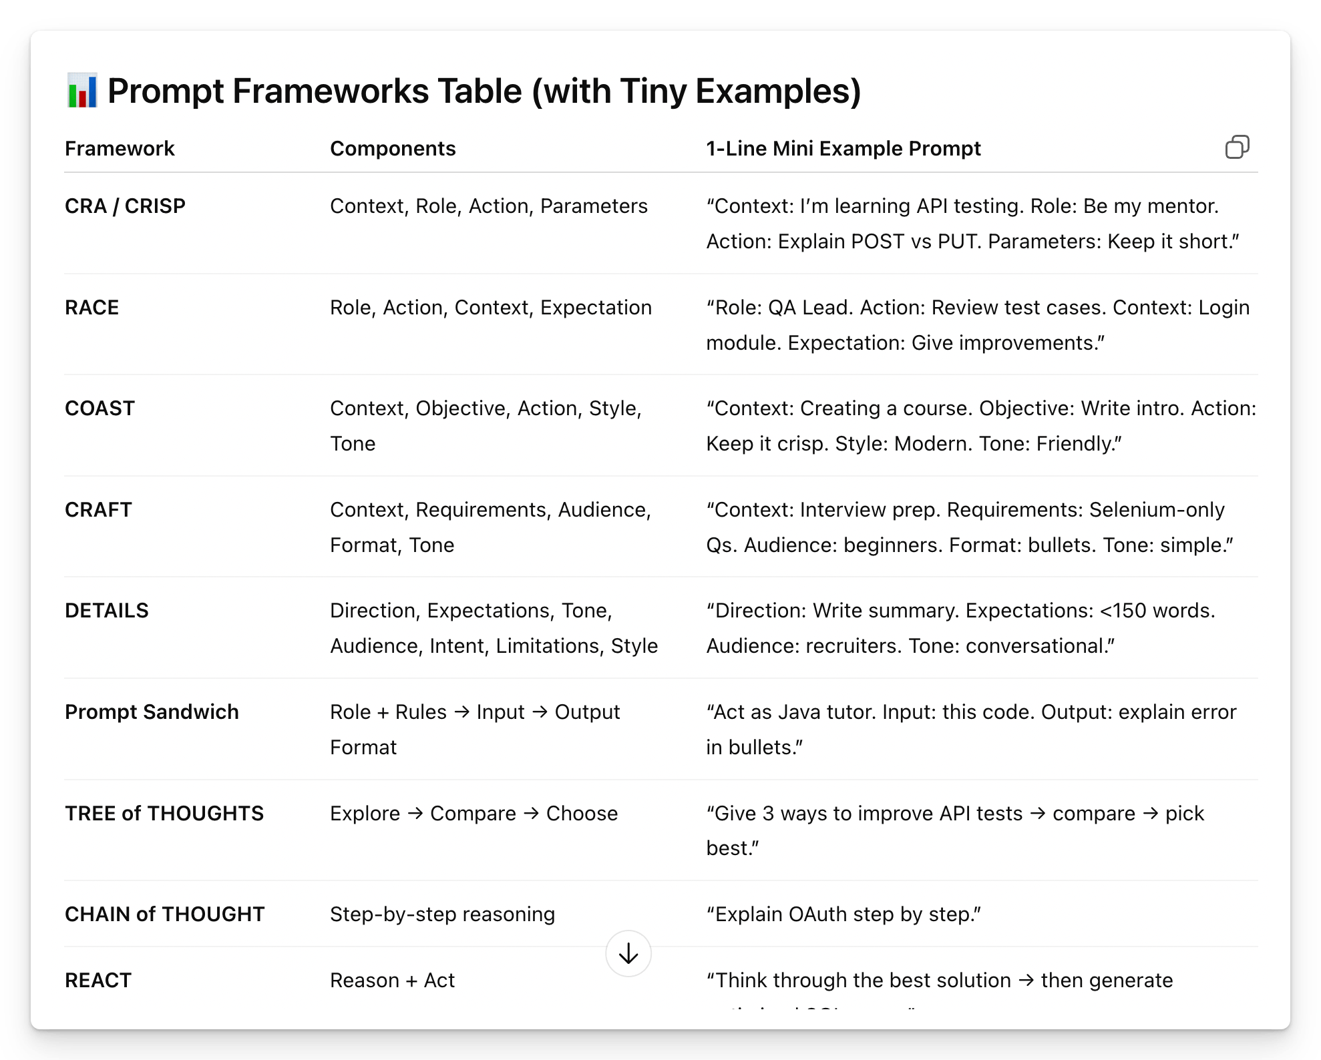

﻿
Further READ - ﻿github.com/PramodDutta/AITesterBlueprint/tree/main/Project_03_RICE_POT_PROMPT_SeleniumFramework
﻿
STAR Framework
Origin: Adapted from behavioral interview technique
┌─────────────────────────────────────────────────────────┐
│ STAR FRAMEWORK │
├─────────────────────────────────────────────────────────┤
│ S - Situation │ Background and context │
│ T - Task │ What needs to be done │
│ A - Action │ How to approach it │
│ R - Result │ Expected outcome │
└─────────────────────────────────────────────────────────┘
﻿﻿github.com/PramodDutta/AI-Tester-Blueprint/blob/main/chapter_01_foundation_model/rules_checklists/ch_01_anti_hallucination.md
﻿
Skill is something which will contain multiple things. It will contain scripts, it will contain assets, it will contain resources, templates, and clear instructions on what you want to use. In this skill, you will also use your MCP connections side by side.
﻿
Prompt is just plain English instructions on what to do to a direct LLM

﻿
7th July 2026
Javascript Basics
- What is Javascript?
- How JavaScript Engine Works
- How does a V8 engine Works?
- Setup Antigravity / VS code
- Github Account Create
- GHCP and CommandCode Setup
﻿
JS -> TS -> Playwright(with TS)
﻿
What is Javascript?
A website is built with three core technologies
- HTML — Structure / Content
- CSS — Styling / Appearance
- JavaScript — Behavior / Interactivity
﻿
- Where it runs: Originally designed to run in web browsers, JavaScript now also runs on servers (via Node.js), mobile apps, desktop applications, and even IoT devices.
- Core features: It supports object-oriented, functional, and event-driven programming styles. It's dynamically typed, meaning you don't need to declare variable types explicitly.
- The DOM: JavaScript can manipulate the Document Object Model (DOM), allowing it to dynamically change a webpage's content, structure, and styling in real time without reloading.
- Asynchronous programming: It supports asynchronous operations through callbacks, Promises, and `async/await`, making it efficient for tasks like API calls and file handling.
- Ecosystem: It has a massive ecosystem of libraries and frameworks such as React, Angular, Vue.js (frontend) and Express, Next.js (backend), supported by the npm package manager.
- Universal adoption: JavaScript is the most widely used programming language in the world, supported by all modern browsers and backed by a huge developer community.
﻿
Java. vs Javascript
- Java language has no relationship with JavaScript
- Java -> int a = 10; x -> no possitble a= "Pramod" // Data type 100%
- Javascript let a = 10; -> a= "Pramod"
﻿
Javascript vs Typescript
Javascript -> let a = 10;
TypeScript -> let a:number = 10;
﻿
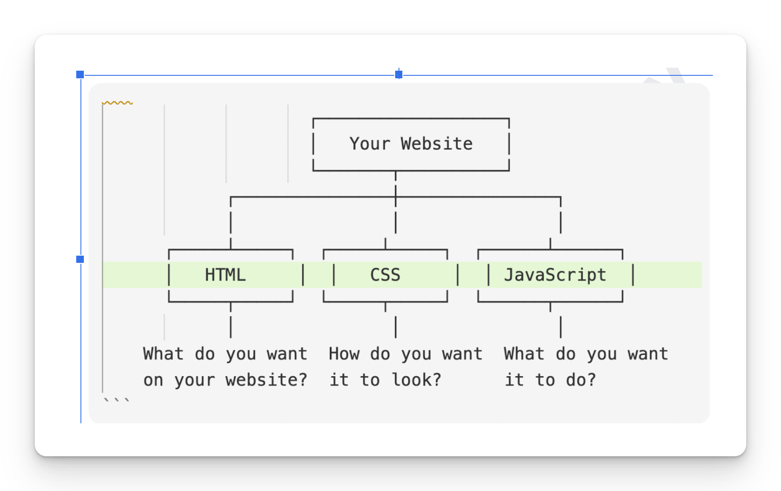
✅ Is JavaScript Compiled or Interpreted?
﻿
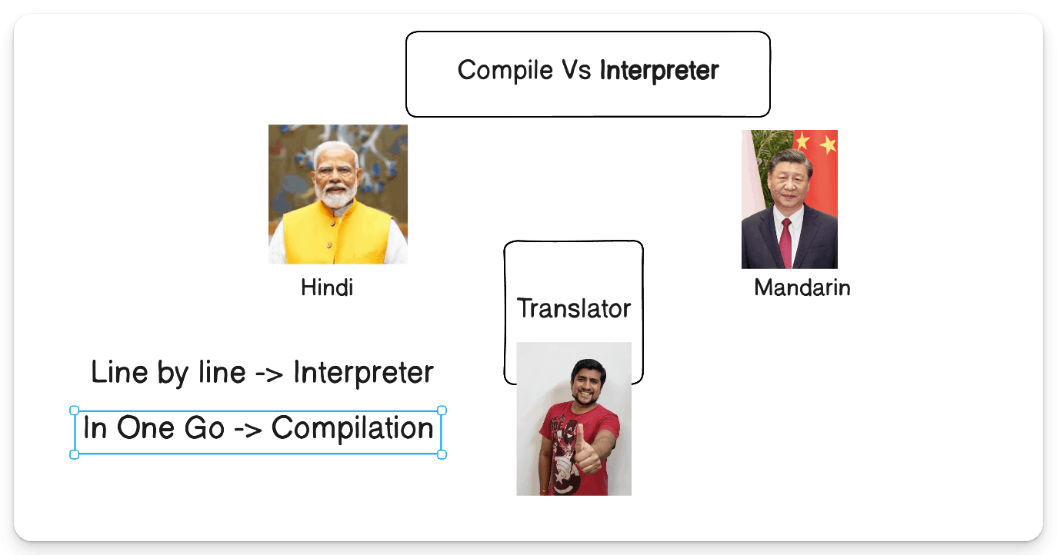
JavaScript is an interpreted language with JIT compilation at runtime.
﻿
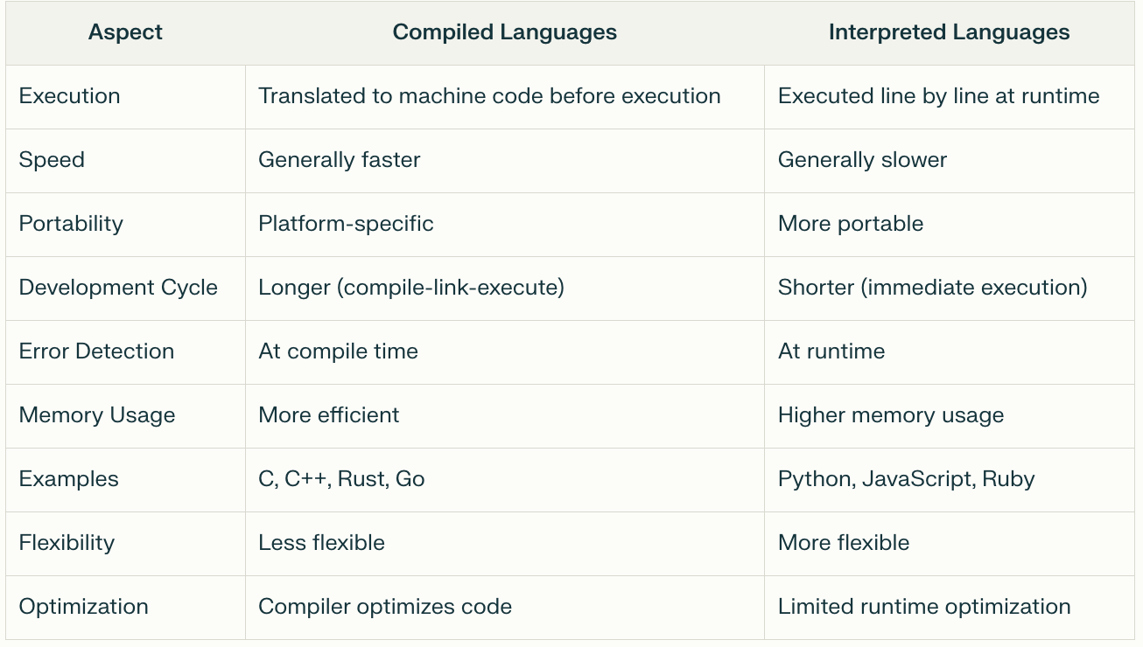
﻿
✅ JavaScript: Compile-Time & Runtime?
- JavaScript is Primarily a Runtime (Interpreted) Language Traditionally, JavaScript code is executed line by line at runtime by the browser's JS engine.
- Simple Terms - JavaScript is a runtime language that uses JIT compilation internally for performance.
﻿
﻿
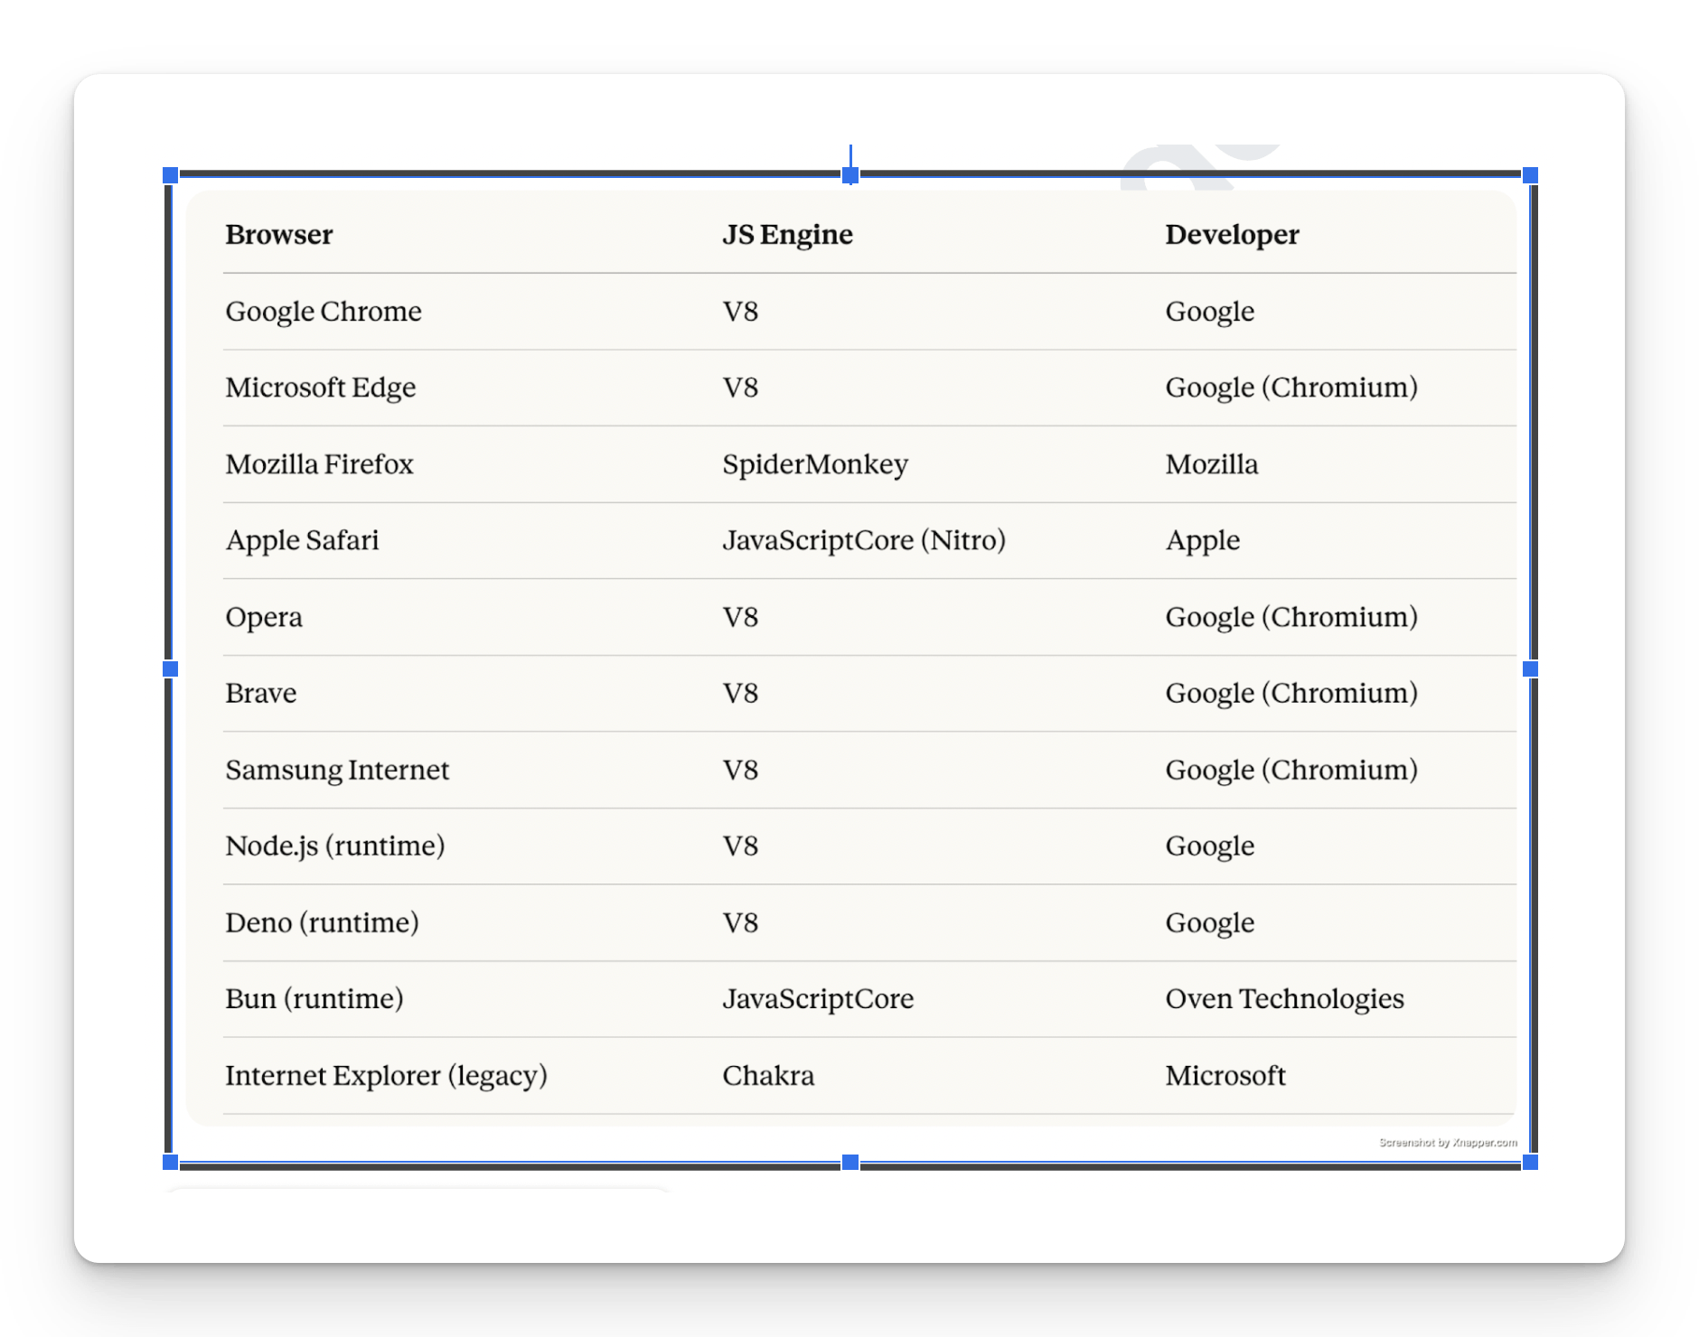
﻿
﻿
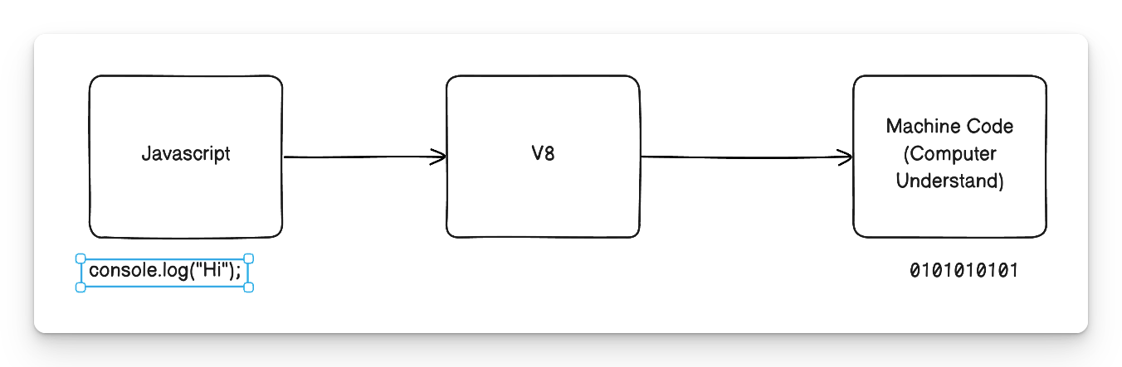
﻿
JavaScript was only available in the browser
✅ What is ﻿Node.js?
- Node.js is an open-source, cross-platform JavaScript runtime environment that allows you to run JavaScript code outside of a web browser primarily on servers.
- It was created by Ryan Dahl in 2009 and is built on Google Chrome's V8 JavaScript engine.
﻿
﻿
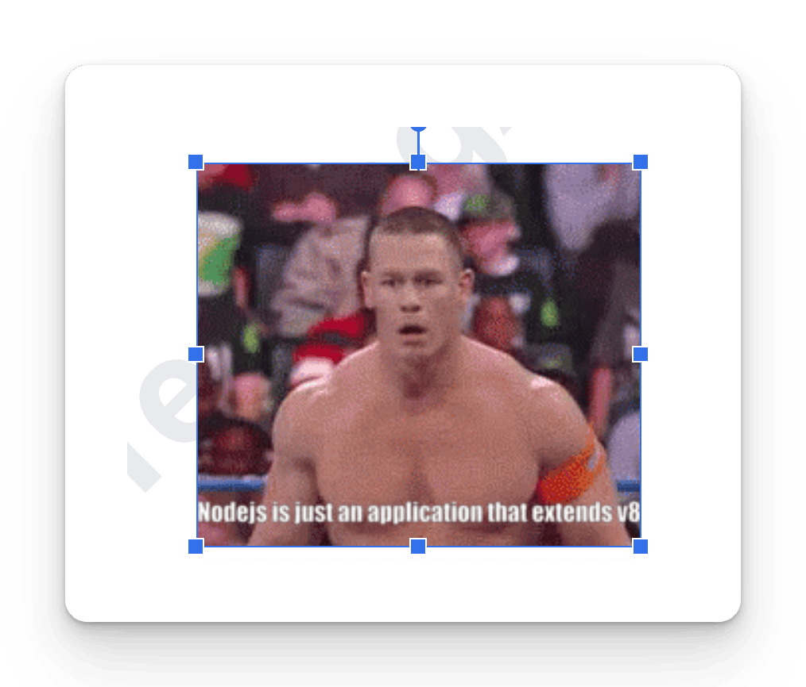
﻿
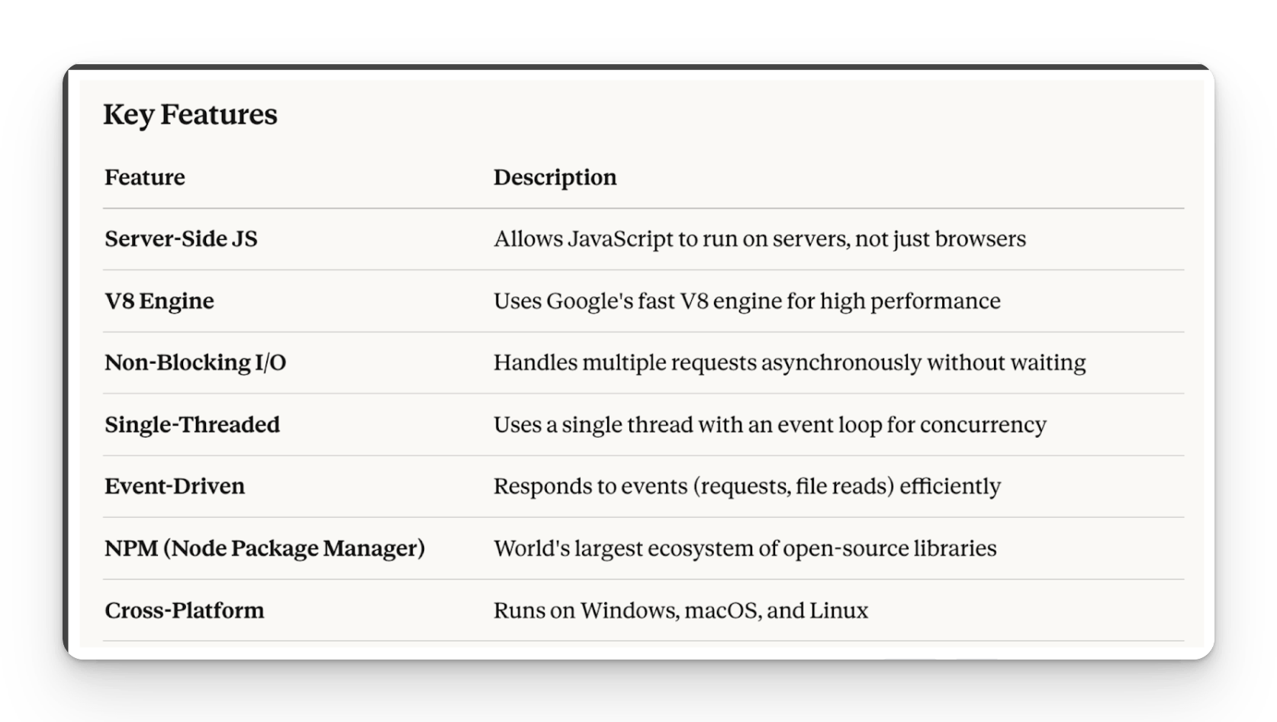
﻿
Install the Node.js
﻿﻿nodejs.org/en/download
﻿
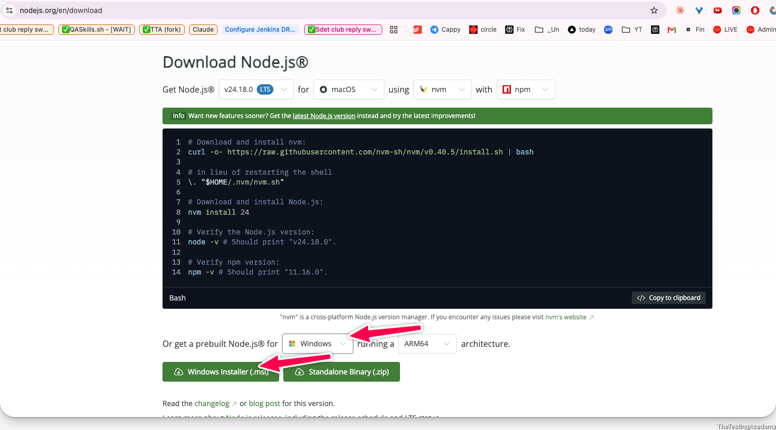
﻿
﻿
To write the Code
- Normal Dev Env - Notepad, Notepad++, Sublime 2
- Advance - IDE
  - Visual Studio Code
  - Jetstorm, Webstorum
  - Eclipse
- ADE ( Agentic Integrated Env)
  - VS code with CommandCode - ﻿commandcode.ai/pricing
    - Personal Laptop only
  - VS code with GHCP (10$)
  - Cursor
  - WindSurf
  - KIRO IDE
- Advance ADE(complete)
  - Claude Code
  - Codex
  - Antigravity
  - Gemini Studio
﻿
Install IDE
﻿
﻿﻿code.visualstudio.com/
﻿
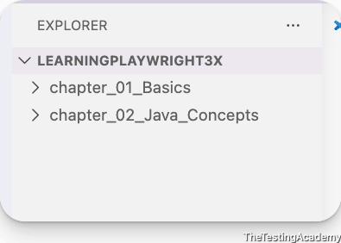

﻿
Common Use Cases
- Web Servers & APIs (REST, GraphQL)
- Real-Time Apps (Chat apps, live notifications)
- Microservices Architecture
- Command-Line Tools (CLI apps)
- Streaming Applications (Video/audio)
- IoT (Internet of Things)
﻿
﻿
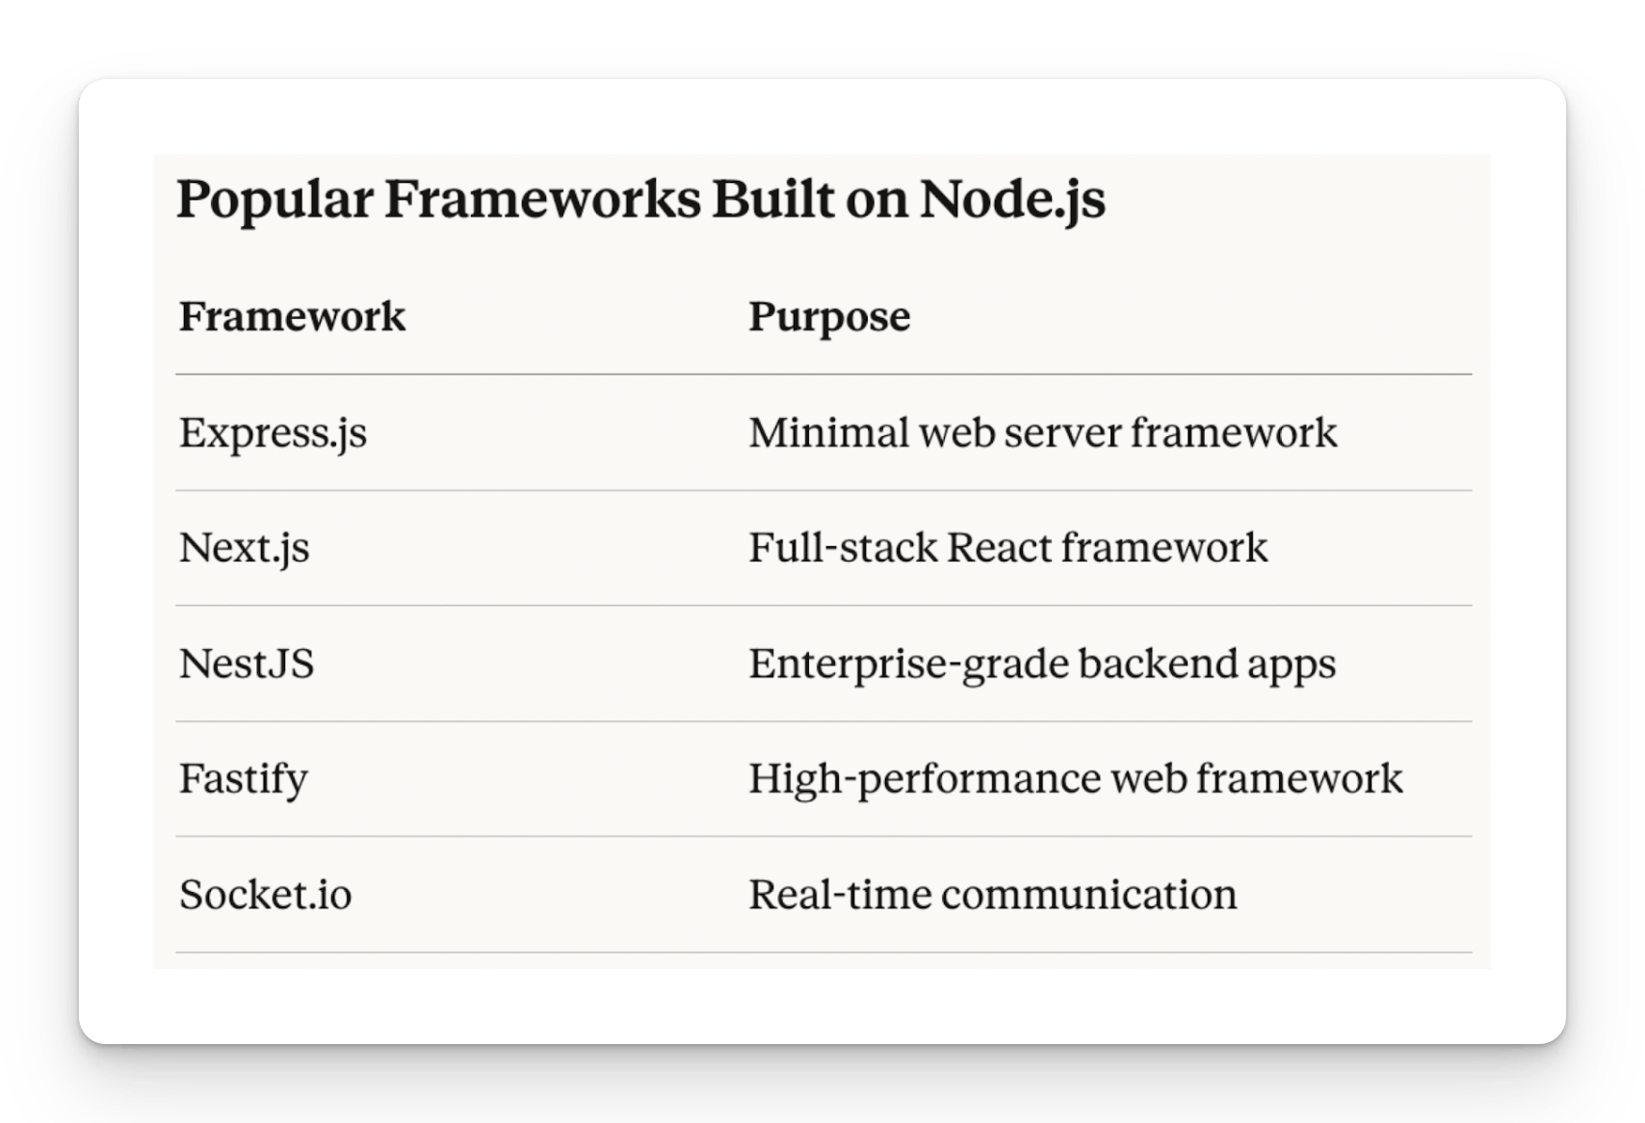
🟩 NODE js in simple terms
Node.js = JavaScript + V8 Engine + Server-Side Capabilities, enabling full-stack development using a single language.
﻿
NPM -> Node Package Manager
﻿﻿www.npmjs.com/
pnpm
﻿﻿pnpm.io/
Package Manger - Yarn
﻿﻿yarnpkg.com/
Bun
﻿﻿bun.com/package-manager
﻿
🟩 Install Google Antigravity
Disclaimer - Try to avoid to install in Company Laptop
﻿﻿antigravity.google/
﻿
Install Node.js
Windows:
1. Download the Windows installer from the [Node.js website](https://nodejs.org/).
2. Run the installer.
3. Follow the prompts in the installer (Accept the license agreement, click the NEXT button a bunch of times and finally install).
4. Restart your computer to ensure changes take effect.
﻿
MacOS:
1. Download the macOS installer from the [Node.js website](https://nodejs.org/).
2. Open the `.pkg` file you downloaded and follow the instructions.
3. You may need to enter your admin password.
4. To verify installation, open a terminal and type `node -v`.
﻿
- ﻿﻿nodejs.org/en/download
node --version
npm --version
(Windows) -> cmd
Mac /LINUX -> Terminalo
﻿
﻿
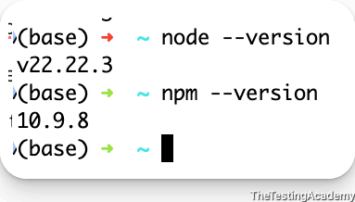
﻿
﻿
AS OF NOW it it not required.
﻿﻿github.com/nvm-sh/nvm
NVM will install NPM automatically when you use their command
﻿
How to set up command code in Visual Studio Code
npm i -g command-code@latest
cmd / cmdc(windows) login
﻿
Extension to install
- Command Code Extension - Github push the code, docs... explain a concept. (GHCP)
- Code Runner (JS, TS)
- Playwright (Not required)
﻿
﻿

﻿
9th July 2026
﻿
🟩 How JavaScript Engine Works
﻿
A JavaScript engine is a program that reads, interprets, and executes JavaScript code.
Here's a complete breakdown of how it works step by step.
﻿
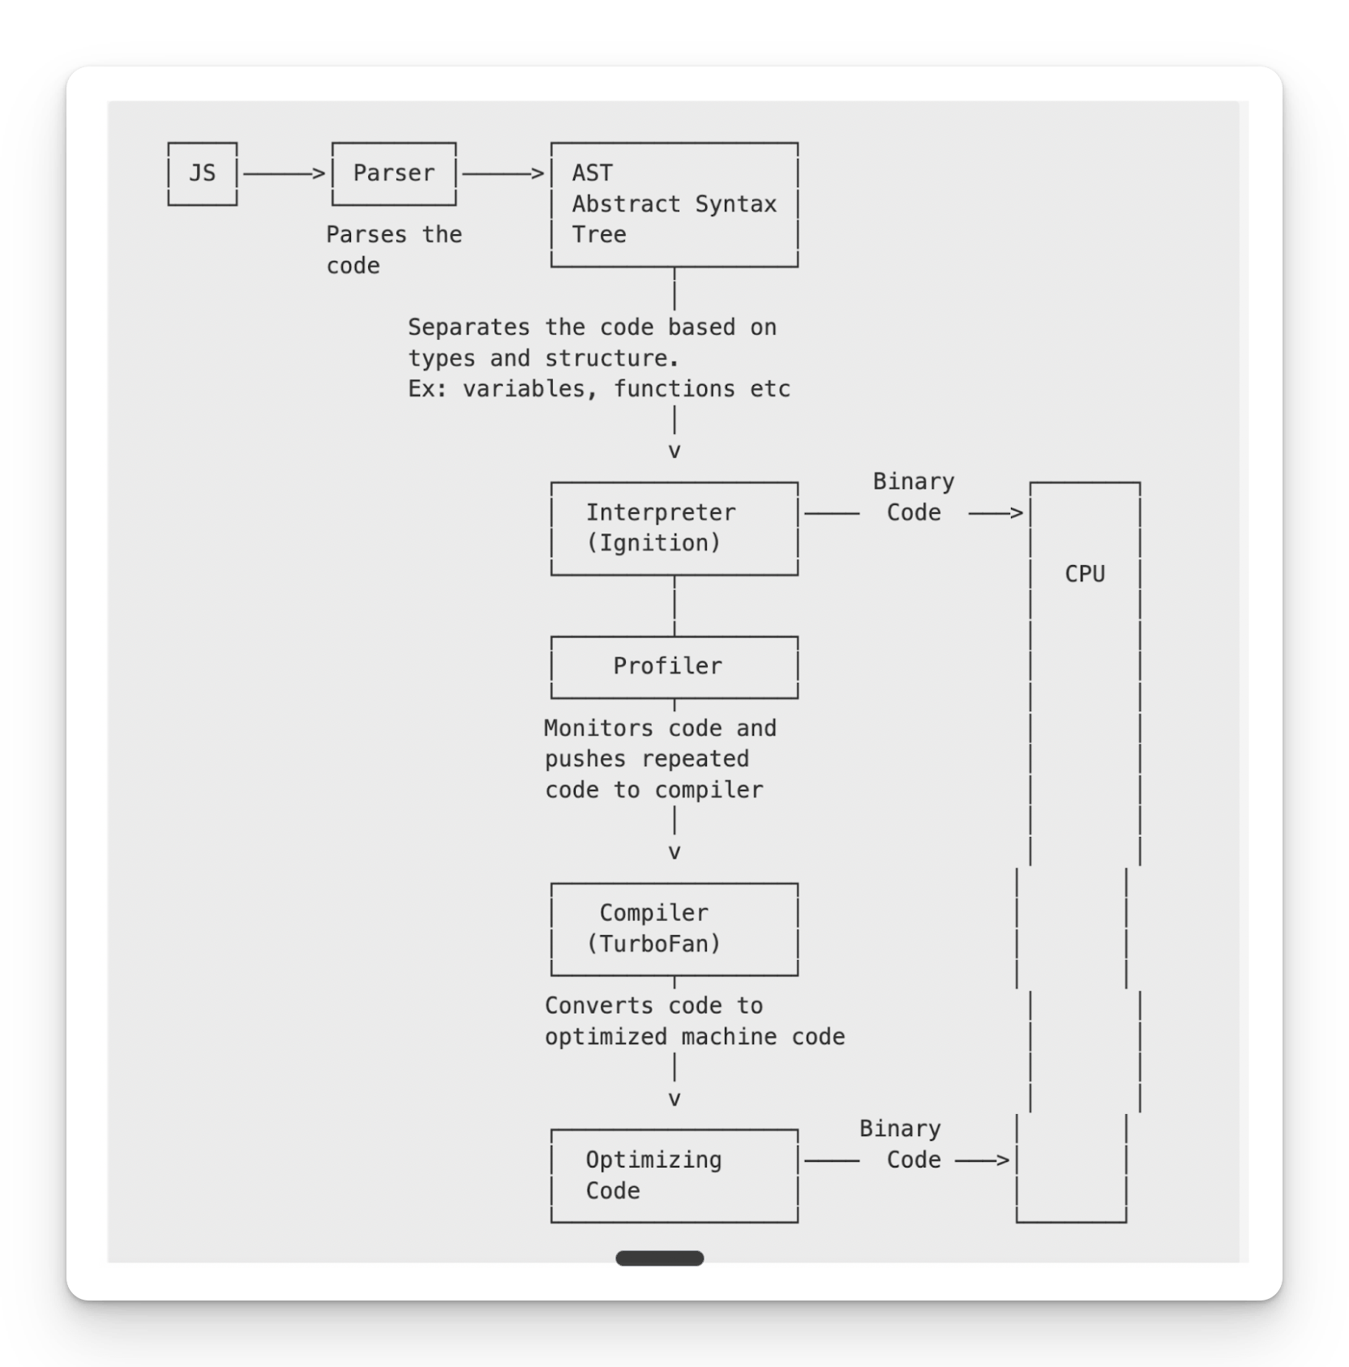
PS. Make sure that everyone download the Code Runner Extension.
﻿
let x = 10;
🟩 Step-by-Step Breakdown
The engine first breaks the raw code into small meaningful chunks called tokens.
﻿
1. Lexical Analysis | Tokenizing
Example: let x = 10;
Tokens → [let] [x] [=] [10] [;]
2. Parsing (Syntax Analysis)
This represents the grammatical structure of the code.
Program
|
VariableDeclaration
/ \
Identifier Literal
(x) (10)
If there's a syntax error, it gets caught at this stage.
﻿
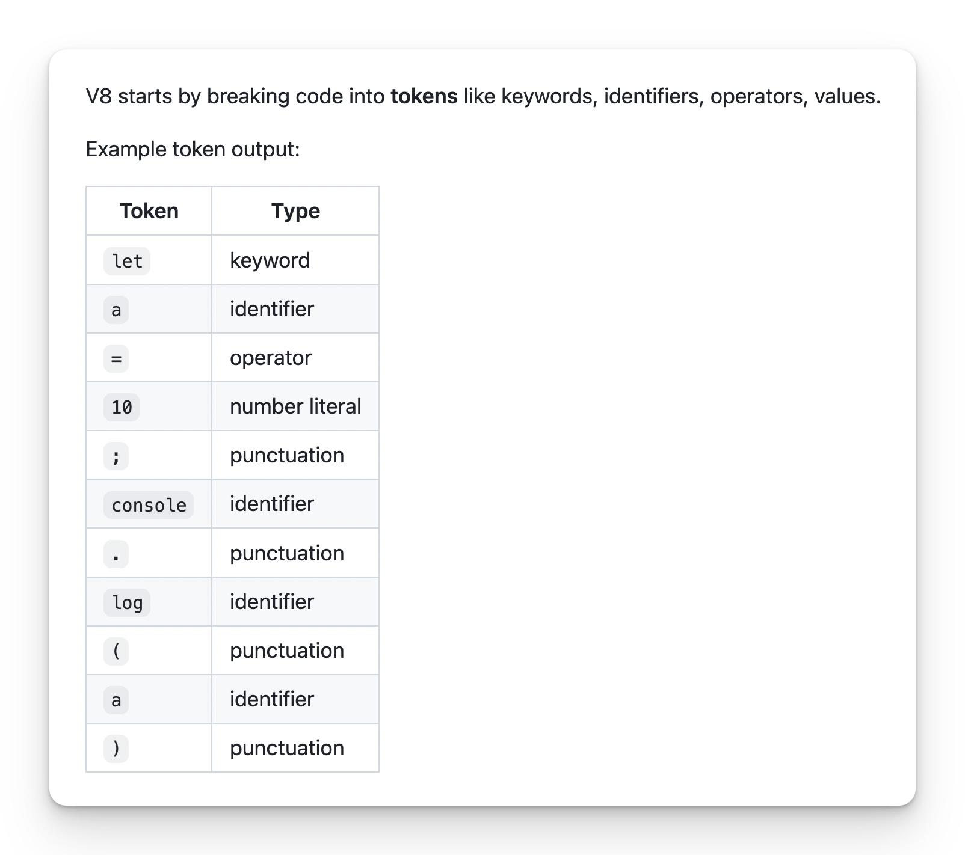
3. Create AST (Abstract Syntax Tree)
The tokens are converted into a structured tree representing the logic.
Simplified AST example:
Program
├── VariableDeclaration (let)
│ └── Identifier: a
│ └── Literal: 10
└── ExpressionStatement
└── CallExpression: console.log
└── Identifier: a
﻿
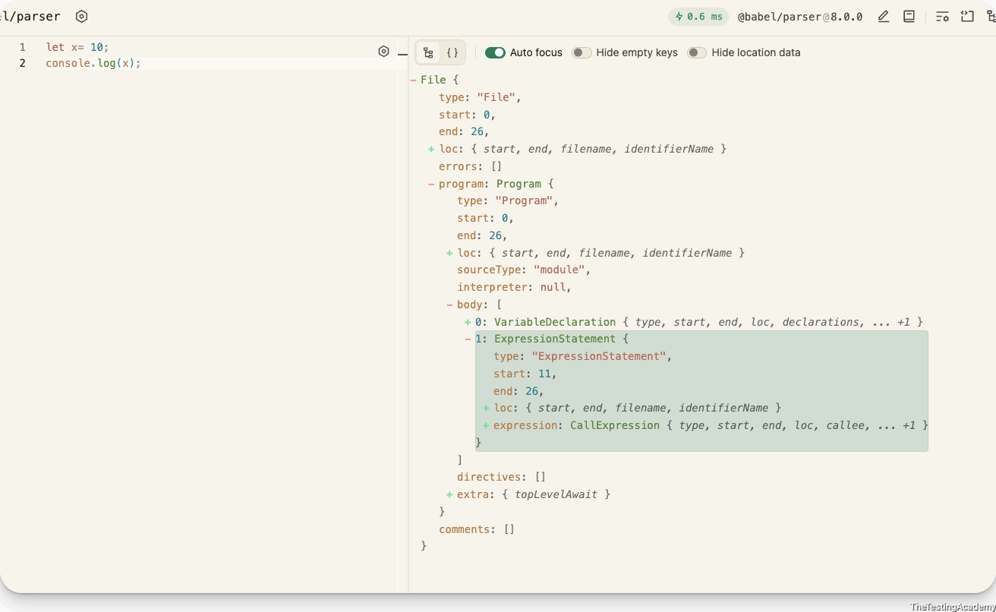
﻿﻿astexplorer.net/
﻿﻿ast-explorer.dev/
﻿
4. Interpreter (Ignition) Converts AST to Bytecode
Ignition creates lightweight bytecode from AST and starts executing immediately.
Bytecode might look like:
LdaSmi [10] // Load immediate small integer 10
Star <x> // Store into variable a
LdaGlobal console
LdaNamedProperty log
Lda <x> // Load value of a
CallProperty1 // Call log with 1 argument
﻿
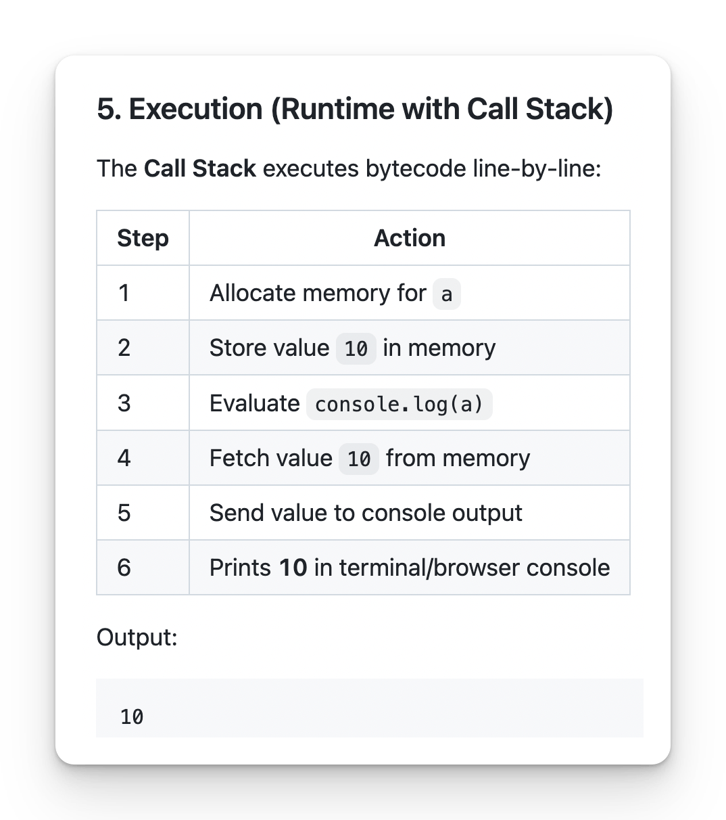
﻿
6. Profiler + JIT Optimization
JIT full form is Just In Time
Since this code is very small and not repeated, the Profiler sees no benefit, so TurboFan (JIT Compiler) does NOT optimize.
If we had a loop with thousands of executions, V8 would compile that part into machine code.
﻿
Hot Code -> Code which needs Optimization
Cold Code -> the code which does not require
TurboFan / Compiler -> Compiler convert or optimize the code of the Hot code. -> ByteCode.
﻿
7. Garbage Collector
Automatically frees memory by removing unused or unreachable objects. Prevents memory leaks and keeps performance efficient.
8. Machine Code Execution
The final optimized code is executed directly by the CPU. This gives the best performance at runtime.
﻿
How to See the Bytecode?
node --print-bytecode test.js

﻿
﻿
What is the Source Code?
Source code is something which is written by humans, and humans understand them very well in this case. They write source code into the IDE or integrated development environment.
﻿
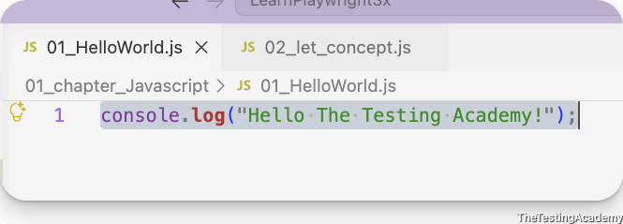
﻿
What is ByeCode?
Bytecode code is an intermediate code created by the JavaScript engine, which humans cannot understand, but it is going to be created into the binary code later
﻿
What is Binary Code?
010101010, binary code is also called 01010, switch off or switch on, which is actually understood by the real machines or our chips
﻿

﻿
Prompt
Explain [YOUR CONCEPT] in a table view with clear comparison columns. Use a simple code/file example to walk through each layer. Save it as a `.md` file inside the `IQ_Notes` folder. Follow the same visual style as `Source_Code_ByteCODE_Binary_IQ.md` — breakdown table, example walkthrough, pipeline diagram, and TL;DR.
﻿
﻿
how to create a personal token for git push ?
﻿﻿github.com/settings/tokens
﻿
﻿
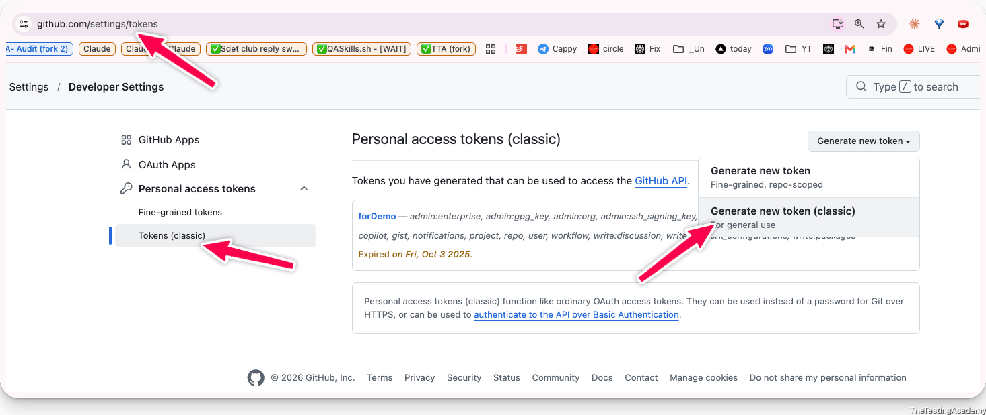
﻿
﻿
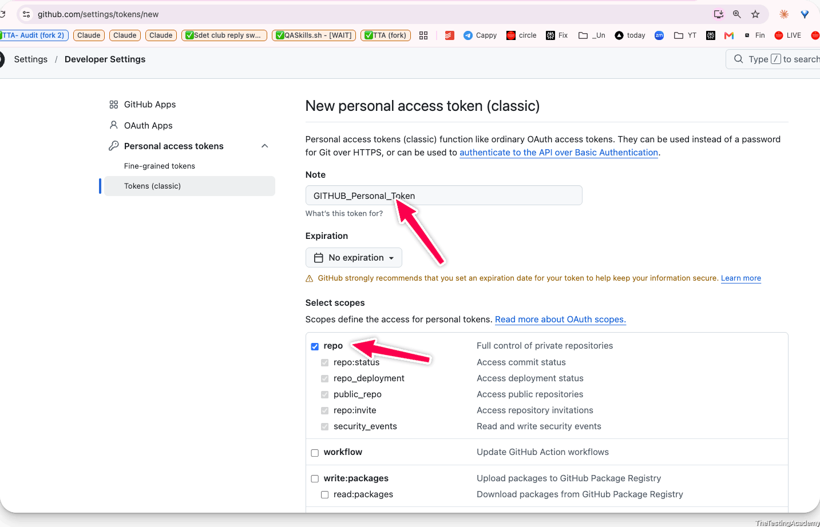
﻿
﻿
﻿﻿git-scm.com/
﻿
I want to Go Advance - i WANT TO know command which AI was running
Follow this course
﻿﻿courses.thetestingacademy.com/login?redirecturl=courses/sdet-club-masterclasses-1337/contents/65c724bfd930b
﻿
Two Rules
- become a very good listener
- do your own research first
﻿

﻿
🟩 How does a V8 engine Works?
V8 is Google's open-source high-performance JavaScript and WebAssembly engine, written in C++. It powers Google Chrome and ﻿Node.js.
﻿
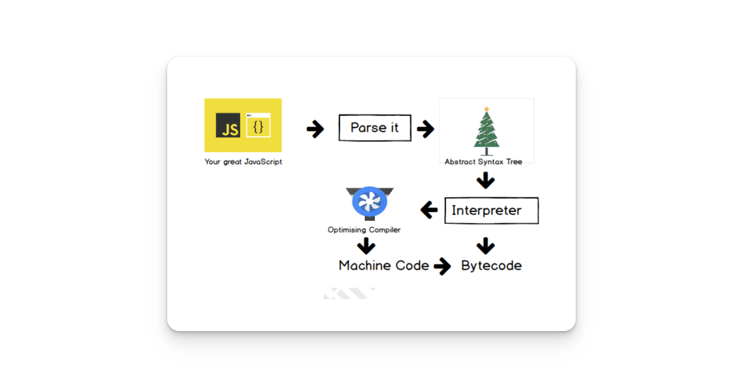
﻿
﻿
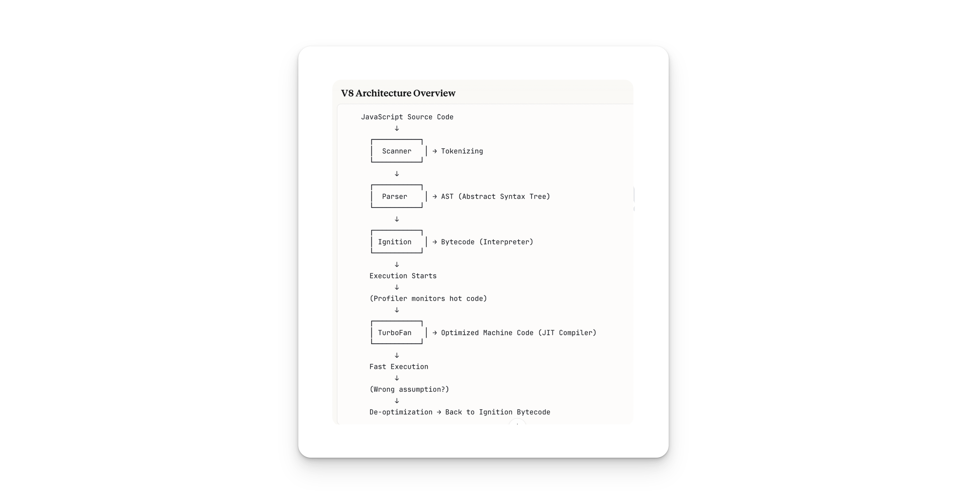
Step-by-Step Breakdown
Step 1: Scanner (Lexical Analysis / Tokenizing)
The scanner reads your raw JavaScript code character by character and breaks it into tokens.
Source: const sum = 10 + 20;
Tokens: [const] [sum] [=] [10] [+] [20] [;]
It also handles lazy parsing — meaning it skips parsing functions that aren't immediately needed to improve startup speed.
Step 2: Parser (Syntax Analysis)
The parser takes the tokens and builds an Abstract Syntax Tree (AST).
V8 uses two parsers for performance:
﻿
﻿
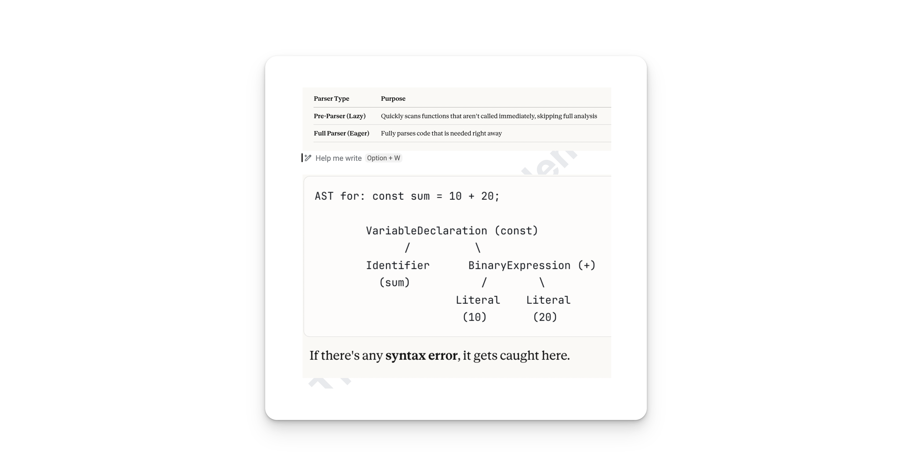
Step 3: Ignition (Interpreter)
Ignition is V8's interpreter. It takes the AST and converts it into bytecode.
﻿

﻿
Why bytecode? Bytecode is smaller than machine code, uses less memory, and allows faster startup compared to compiling everything upfront.
Ignition also collects feedback data (type information, frequency of execution) while executing bytecode. This data is critical for the next step.
Step 4 : Execution + Profiling
﻿
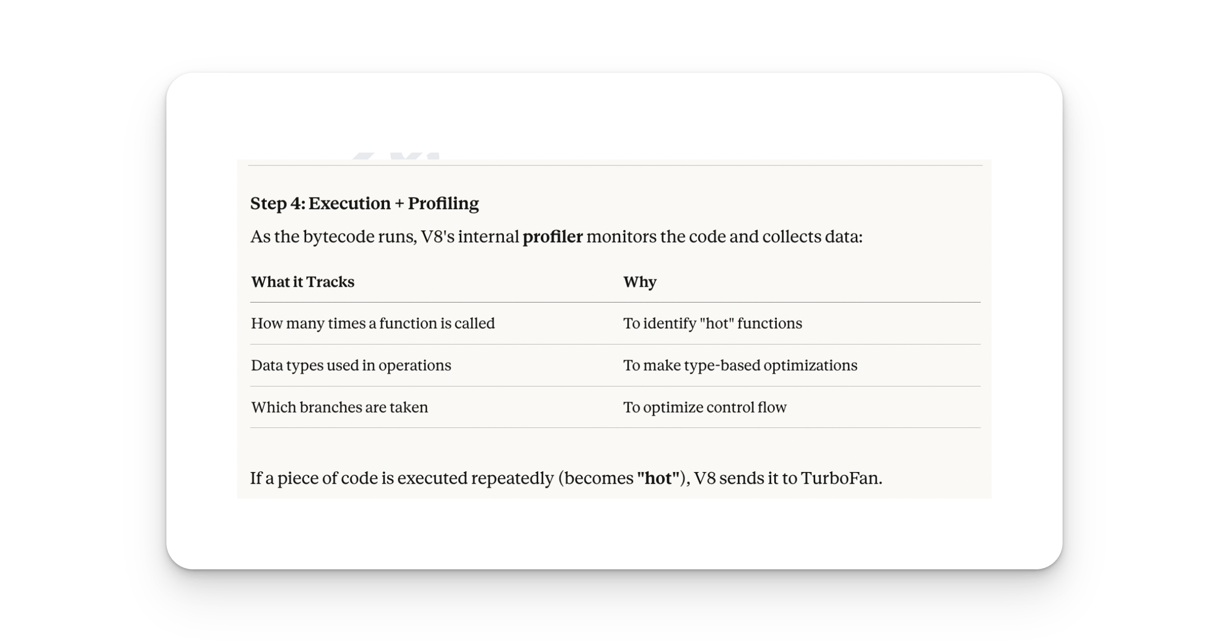
Step 5 : TurboFan (JIT)
﻿

Step 6: De-optimization (Bailout)
If TurboFan's assumptions turn out to be wrong, V8 throws away the optimized machine code and falls back to Ignition's bytecode.
﻿
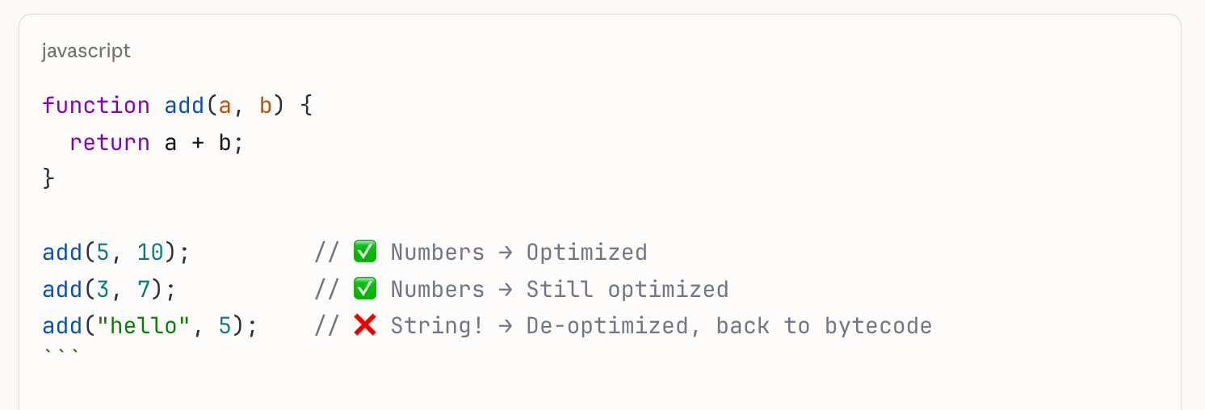
﻿
Doubt Thread
Step 7: Garbage Collection:
V8 takes your JavaScript, parses it into an AST, interprets it to bytecode via Ignition for fast startup, then JIT compiles hot code via TurboFan into optimized machine code, while managing memory through generational garbage collection and speeding up property access with hidden classes and inline caching.

﻿
What is Source Code?
Source code is the original human-readable code that you write as a developer. It's the raw JavaScript that you type in your editor.
﻿
What is Bytecode?
Bytecode is a lower-level, intermediate representation of your source code generated by the V8 engine's Ignition interpreter. It sits between human-readable source code and machine code.
﻿
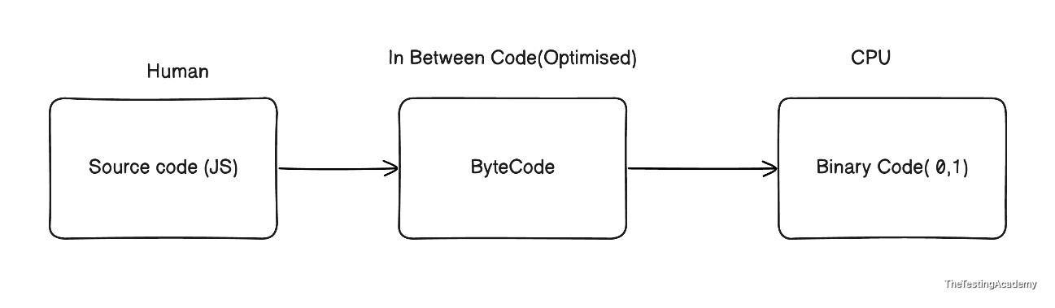
Bytecode is:
- Generated automatically by the JS engine
- Not human-readable (looks like assembly)
- Smaller and faster to execute than parsing source code every time
- Platform-independent — same bytecode runs on any OS
- Not machine code — still needs the engine to execute it
Full Journey: Source Code → Bytecode → Binary Code (MC)
﻿

﻿
Javascript Basics
﻿
- Keywords
- Identifiers
- Literals
- Operators
﻿
let x= 10;
﻿
let x= 10;
let - Keyword
x -> Identifier / Variable Name
= -> Operator
10 -> Literal / Variable Value
﻿
﻿
Keyword
These are nothing but a reserved word in the particular programming language.
﻿
﻿
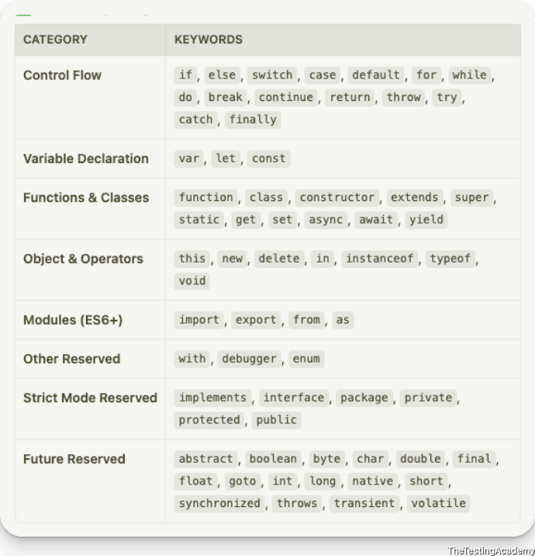
break, case, catch, class, const, continue, debugger, default, delete, do, else, export, extends, finally, for, function, if, import, in, instanceof, new, return, super, switch, this, throw, try, typeof, var, void, while, with, yield, implements, interface, let, package, private, protected, public, static, enum, await, as, async, from, get, of, set, target, true, false, null, undefined
﻿
Identifier / Variable name.
- identifier is the name given to the variable. It's a variable name.
- Identifier has certain rules that you need to follow
﻿
Rules that you have to follow for the identifier.
﻿
let x = 10;
﻿
Operator
(=) -> is the one of the type of operator. Operators work with the operands to perform a particular task. This time, the normal equal to operator is just used to assign the literal value to identifier.
let x = 10;
﻿
Variable
a variable is something which will store some value, it is like a container which can store some value, variables are used so that we can change their value later.
var v = 10;
v -> identifier ->variable name
= -> operator
10 -> Literal
; -> end of the statement or line terminator ( it is optional but advisable to add)
﻿

﻿
const
﻿
const c = 10;
const PI = 3.14;
PI = 10; not possible
const -> once the value is assigned, it cannot be changed , it has a fixed value in this case
﻿

﻿
var vs let vs const

﻿
Rules for the Identifier for the Javascript
• Must begin with a letter (a–z, A–Z), underscore (_), or dollar sign ($).
• Subsequent characters may also include digits (0–9).
• Cannot start with a digit.
• Cannot be a reserved keyword.
• Are case-sensitive.
• May contain Unicode letters and Unicode escape sequences.
• Cannot contain spaces, hyphens, or special characters (except _ and $).
let age = "pramod"; // String Lietal
let isStudent = true; // This is a boolean literal assigned to the variable 'isStudent'.
let pi = 3.14; // This is a numeric literal assigned to the variable 'pi'.
let name = 'Alice'; // This is a string literal assigned to the variable 'name'.
let nullValue = null; // This is a null literal assigned to the variable 'nullValue'.
let undefinedValue; // This variable is declared but not assigned, so it has the value 'undefined'.
let pi2 = 3; // numeric literal

// Numric Literal - Numeric
// 1. int
// 2. float

// typeof - operatr - It will tell you what is a data type that it has.
console.log(typeof age);
console.log(typeof pi);
console.log(typeof pi2);
console.log(typeof isStudent);
console.log(typeof nullValue);
console.log(typeof undefinedValue);

﻿
14th July 2026
﻿
How Create a variable in JavaScript ?
- var
- let
- const
﻿
﻿
Operator, Functions -> Hoisting, TDZ
﻿
﻿var -> the old way, var was the original keyword in JavaScript.
It is function-scoped, can be redeclared, can be reassigned, and gets hoisted to the top of its scope with an initial value of undefined.
- Function
- Hoisted
- TDZ
﻿
var v = 10;
var browser = "chrome";
browser = "edge"; // reassignment allowed
﻿

﻿
﻿let -> the modern way for changing values
﻿let is block-scoped (lives only inside { }), can be reassigned, but cannot be redeclared in the same scope. It is hoisted but not initialized, so accessing it before declaration throws a ReferenceError.
- Block Scoped
- hoisted
let x = 10;
﻿
let retryCount = 0;
retryCount = retryCount + 1;
﻿

﻿
﻿const -> for values that should not change
const pi = 3.14;
pi = 5; ❌
﻿

﻿
Primitive Data Type
﻿
﻿
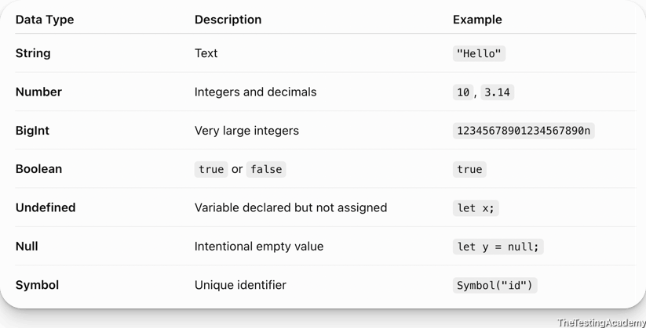
Non Primitive Data
- Array, Functions and Objects.
- ﻿
﻿
string -. collection of characters (h,e,l,l,o ) -> helllo

﻿
Operator
let result = 5+3;
﻿
Assignment Operators
- =
- to assign the right hand side value to the left side.
- let x = 10;
- x = 30;
- ﻿
Arithmetic Operators
// Arithmetic Operators

let sum = a + b;
let sub = a - b;
let mul = a * b;
let div = a / b;

console.log(sum);
console.log(sub);
console.log(mul);
console.log(div);
﻿
OR GATE
﻿
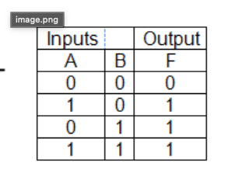
And Gate
﻿
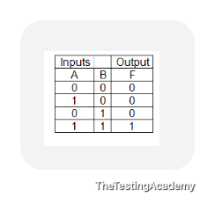
﻿
﻿
3. Comparison Operators
5 == "5" // true (loose equality - compares value only)
5 === "5" // false (strict equality - compares value + type)
5 != "5" // false
5 !== "5" // true
5 > 3 // true
5 < 3 // false
5 >= 5 // true
5 <= 4 // false
4. Logical Operators
﻿
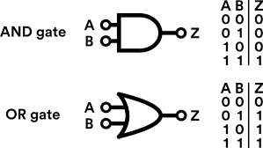
true && false // false (AND - both must be true)
true || false // true (OR - at least one true)
!true // false (NOT - flips the value)
The Core Difference
- === (strict equality) — checks both value AND datatype. No conversion.
- ﻿== (loose equality) — checks value only, after converting both sides to the same type (type coercion).

﻿
16th July 2026
﻿
Operators - Part 2
﻿
5. String Operators
"Hello" + " World"
﻿
6. Ternary (Conditional) Operator
// ## Ternary (Conditional) Operator
// condition, either this or either that.
let age = 20;
let is_pramod_will_go_to_goa = age > 18 ? "Yes" : "No";
console.log(is_pramod_will_go_to_goa);

// condition ? value(if true) : value (if false)
let responseTime = 850; // ms
let sla = 1000; // ms
let slaStatus = responseTime <= sla ? "Within SLA ✅" : "SLA breached ❌";
console.log(`Response: ${responseTime}ms — ${slaStatus}`);
// Template Literal
console.log(`What is the SLA time ? - ${sla}`);
﻿
Nested Ternary (Conditional) Operator
let temp = 35;
let feel = (temp >= 40) ? "Very Hot" :
(temp >= 30) ? "Hot" :
(temp >= 20) ? "Warm" :
(temp >= 10) ? "Cool" : "Cold";
console.log("7. Temperature:", temp, "| Feel:", feel);
﻿
Task Given to Student for Practice
﻿﻿app.thetestingacademy.com/student/coding-practice
﻿
7. Type Operators
console.log(typeof "hello"); console.log(typeof 123); // int -> number console.log(typeof 31.4); // float -> number // typeof true // typeof undefined -> undefined // typeof null -> object // typeof [] -> object console.log(typeof []); // -> object
﻿

﻿
8. Bitwise Operators
these operators are mostly used in electronics, if you have remembered. Anyone from electronics and communication
5 & 1 // 1 (AND)
5 | 1 // 5 (OR)
5 ^ 1 // 4 (XOR)
~5 // -6 (NOT)
5 << 1 // 10 (Left shift)
5 >> 1 // 2 (Right shift)
﻿www.rapidtables.com/
﻿
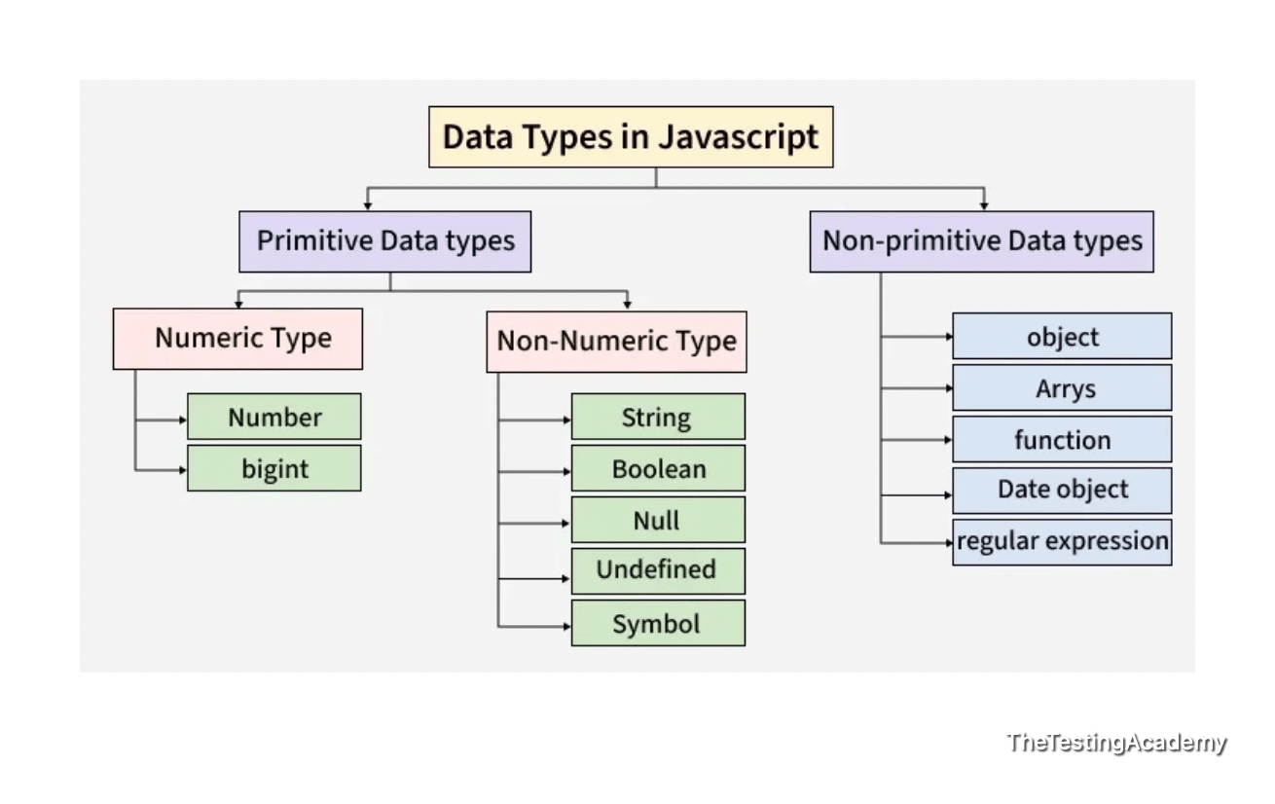
﻿
To run the JS Test
node 23_test.js
﻿
&& - || , Logical Operator
&&, || - Logical And gate,
true && true -> true
0 && "hello" // 0 (left is falsy, short-circuits, returns left)
1 && "hello" // "hello" (left is truthy, returns right)
true && false // false

false && sideEffect() // sideEffect() never runs — right side is skipped
&,| -> Bitwise And, Or
5 & 3 // 1

﻿
Operators
- Assignment
- Logical
- Arithemtic
- Comparsion
- String Concat
- Type
- Bitwise
- Ternary
- Increment and Decrement - Cover
﻿
If-Else, Switch, User INPUT, Loops, Arrays, Funtions, TDZ, Hoisting.
﻿
18th July 2026
Increment and Decrement - Cover
﻿
Increment
- Pre Increment -> ++a;
- Post Increment -> a++;
﻿
Decrement
- Pre Decrement -> --a;
- Post Decrement -> a--;
﻿
﻿
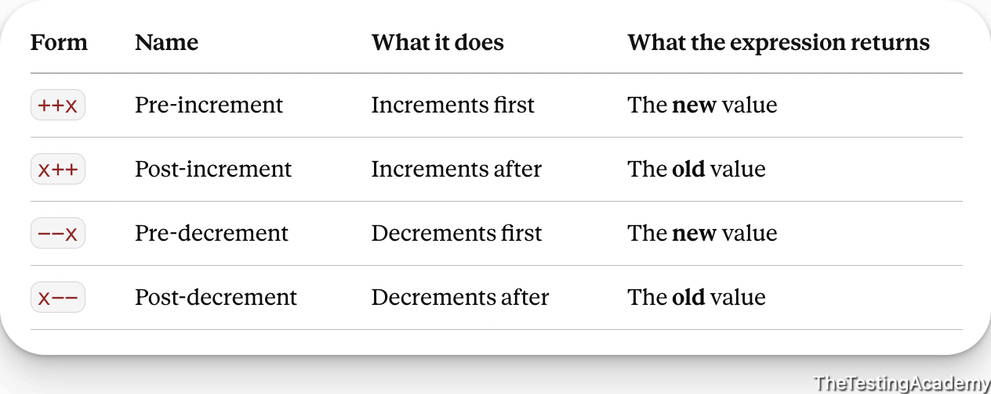

﻿
Statement
if and else
- The if/else statement is JavaScript's most fundamental decision-making tool.
- It executes a block of code if a condition evaluates to true, and optionally runs a different block if the condition is false.
- You can chain multiple conditions using else if.
- if (condition) { // runs if condition is true } else if (anotherCondition) { // runs if anotherCondition is true } else { // runs if ALL conditions are false }
﻿
﻿
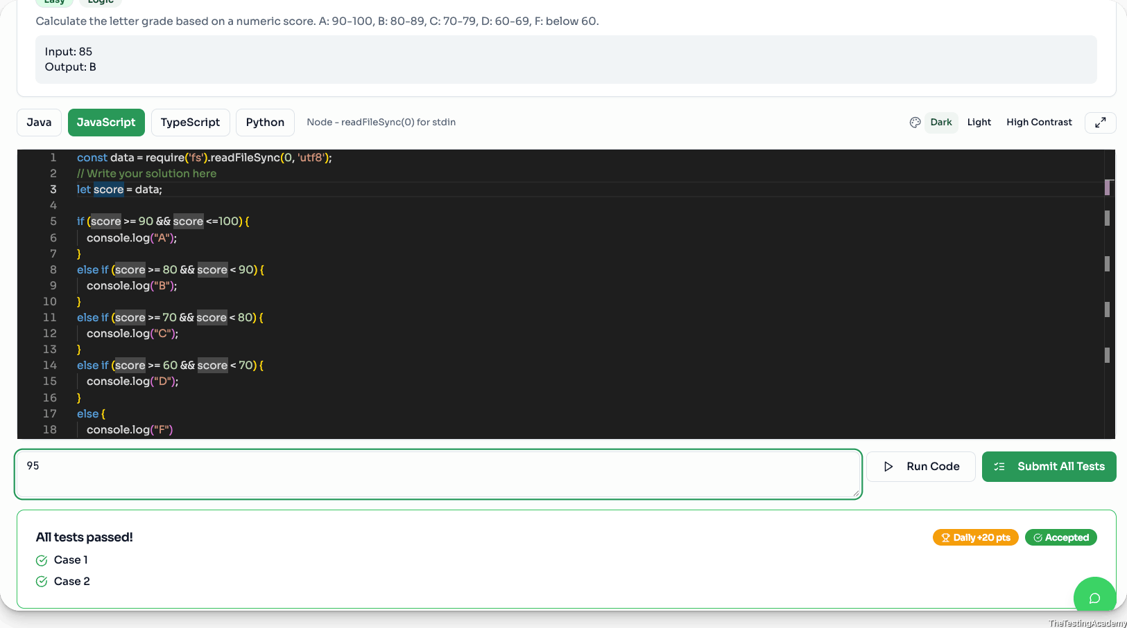
﻿
﻿
﻿﻿www.hackerrank.com/contests/7days-javascript/challenges
﻿

﻿
21th July 2026
﻿
Switch Statement in JavaScript
The switch statement evaluates an expression once and then compares it against multiple case values.
expression -> case 1, case 2, case 4..... default....
- When a match is found, the code for that case runs.
- It is cleaner than long if/else if chains when comparing a SINGLE value against many options.
- Switch uses strict comparison (===).
﻿
Q: What is the difference between if(x == 5) and if(x === 5) in testing?
Always use === (strict equality) in tests. == does type coercion: "5" == 5 is true but "5" === 5 is false. In QA, strict equality catches type bugs.
﻿
switch (expression) {
case value1:
// code block
break; // IMPORTANT: stops fall-through
case value2:
// code block
break;
default:
// runs if no case matches (optional)
}
Q: What happens if you forget the break statement?
A: The code "falls through" and executes ALL subsequent cases until it hits a break or the switch ends. This is the #1 switch bug. Always include break unless fall-through is intentional (and add a // fall-through comment).
﻿

﻿
Concepts covered
- ﻿switch (expr) — evaluates expr once, then matches against each case .
- ﻿case matching — comparison is strict (=== ), no type coercion.
- ﻿break — exits the switch. Without it, execution falls through to the next case.
- ﻿default — runs when no case matches. Position doesn't matter, but conventionally last.
- Grouped cases — stacking case labels with no body in between shares one block of code.
- ﻿switch (true) — idiom for range/boolean checks (each case becomes a condition).
- Duplicate case values — legal syntactically; the first match wins, the rest are dead code.
- Block scoping in cases — let / const inside a case need braces { } if reused across cases.
﻿
--
How to take the User Input?
- Normal JS -
  - prompt
﻿
﻿
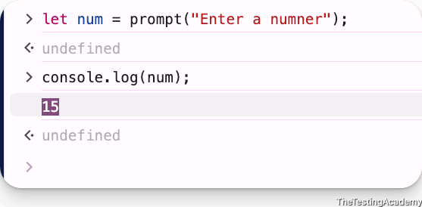
- JS in Browser or outside?
  - Node JS - Most used
    - ﻿const data = require('fs').readFileSync(0, 'utf8');
  - HackerRank
    - ﻿
﻿
﻿
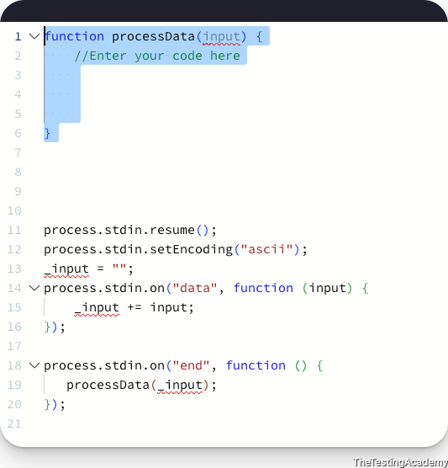
﻿
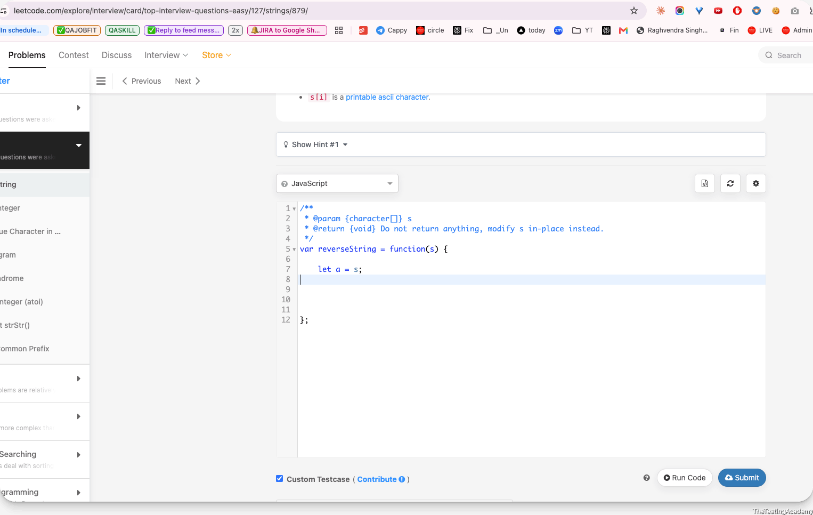

﻿
23th July 2026
Loops
Loop basically means a task that you want to do multiple times, or a simple task that you want to have repeated in.
﻿
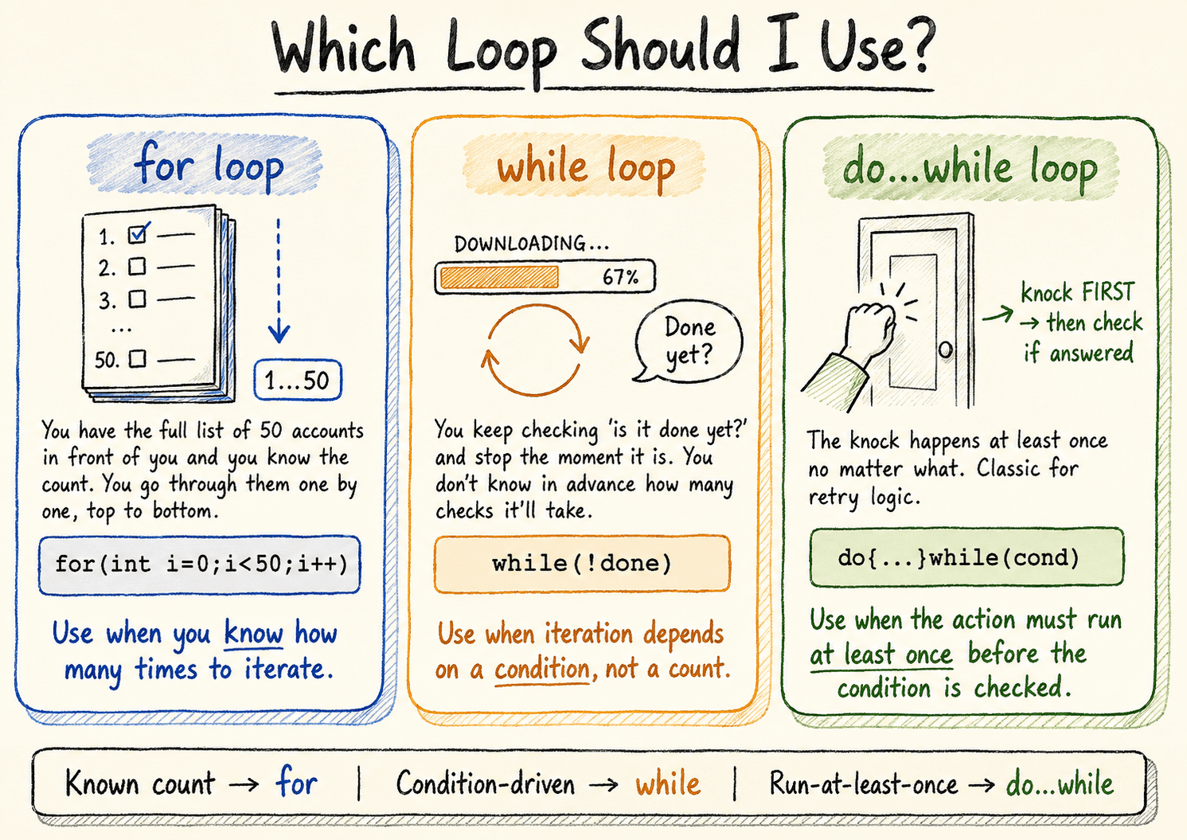

﻿
For Loop
﻿
For ( I, C, U)
I - Init / - initialization
C - Condition
U - Updation - You can use whichever you want pre or post, (we are using the the variable in the next) , // i++,++i
﻿
﻿﻿for(let i=0; i<10; i++){
console.log(i)
}
﻿

﻿
WHILE LOOP
while is generally used when you want to have a condition as the main
// While Loop - Sister (For) // I,C,U
﻿
let attempt = 0; // Init - 1

while(attempt < 3){ // Condition - 2
console.log(attempt);
attempt++; // UPDATION - 3

}

﻿
﻿
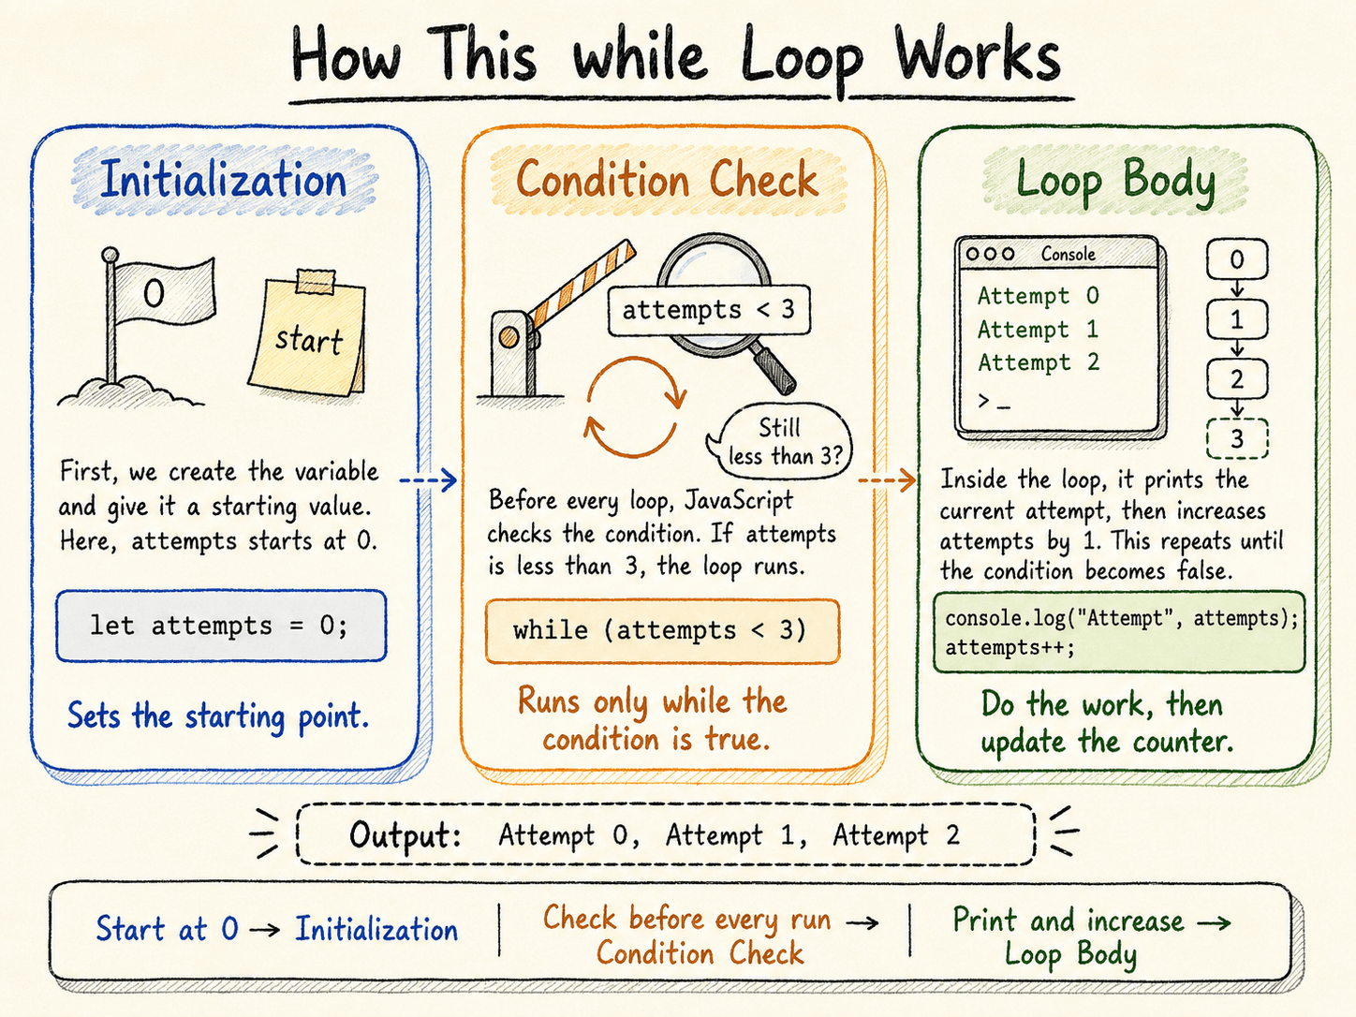
﻿

﻿
Big Sister
do while loop
retrying a flaky action at least once
will always execute at least one time

﻿
For ,
For of, For in, ForEach -> They will come when we use the Array!

﻿
For loop, with the For loop- Matrix
﻿

﻿
Q1. [Easy] Which loop is guaranteed to execute its body at least once, even when its condition is initially false?
- A) for
- B) while
- C) do…while
- D) All three
﻿
Q2. [Easy] What is the output?
for (let i = 0; i < 3; i++) {
console.log(i);
}
- A) 0 1 2
- B) 1 2 3
- C) 0 1 2 3
- D) 1 2
﻿
Q3. [Easy] What is the output?
let i = 0;
while (i < 5) {
i++;
}
console.log(i);
- A) 4
- B) 5
- C) 0
- D) Infinite loop
﻿

﻿
Q4. [Easy] What is the output?
let i = 10;
do {
console.log(i);
} while (i < 5);
- A) Prints 10
- B) Prints nothing
- C) Prints 10 five times
- D) Infinite loop
﻿
Q5. [Easy] What is the output?
let count = 0;
for (let i = 5; i < 5; i++) {
count++;
}
console.log(count);
- A) 0
- B) 5
- C) 1
- D) Infinite loop
﻿

﻿
25th July 2026
﻿
Agent Skill Master 1, 2 - Playwright - SKILL.md
﻿
Array & Functions
﻿
- Arrays are ordered collections of values.
- JavaScript arrays are dynamic and can hold mixed types.
- An ordered, zero-indexed, mutable collection.
- typeof [] is "object" -> use Array.isArray() to check.
const browsers = ["chrome", "firefox", "webkit"];
console.log(browsers[0]); // chrome
console.log(browsers.at(-1)); // webkit (negative index)
console.log(browsers.length); // 3
﻿
﻿
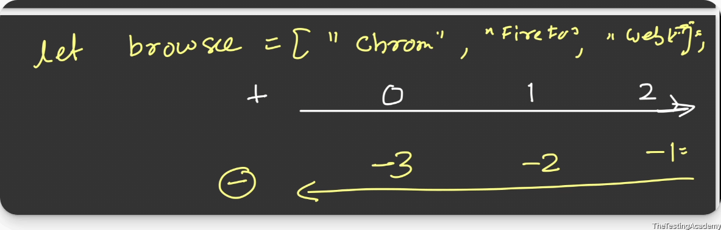
let fruit = [];
let browsers = ["chrome", "firefox", "webkit"];
console.log(browsers[0]);
console.log(browsers.at(-1));
console.log(browsers.length);
console.log(fruit.length);

// For the Negative indexed, use the at
console.log(browsers[-1]); // undefined

﻿
﻿
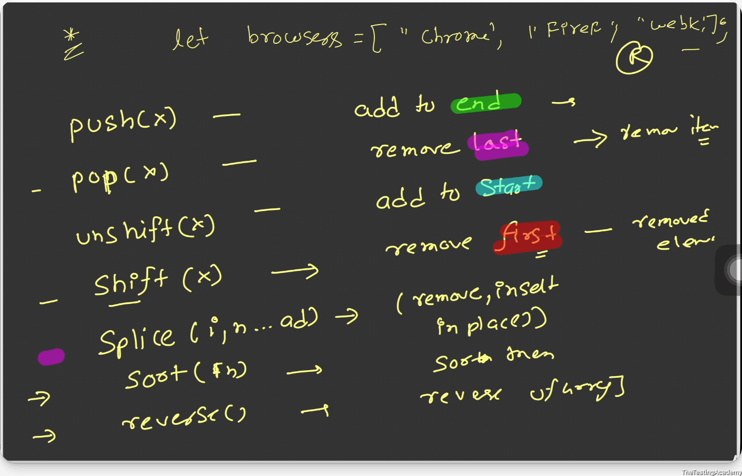
﻿
﻿
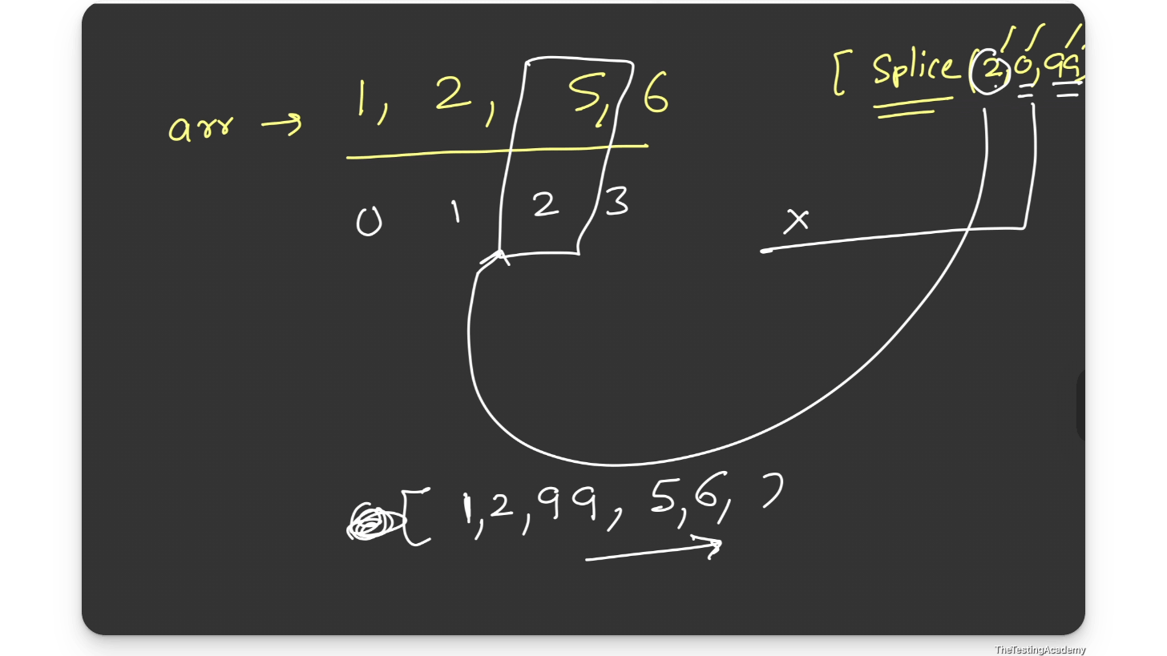
﻿
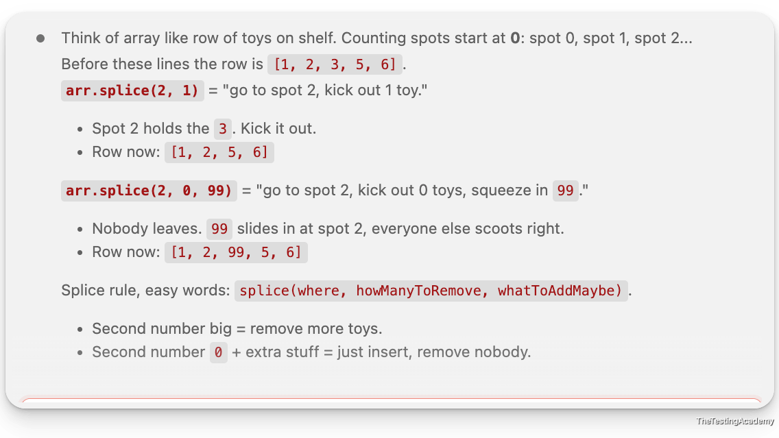
﻿
let arr = [1, 2, 3];
console.log(arr);

// Add to END
arr.push(4);
console.log(arr);

// Remove from END
arr.pop();
console.log(arr);

arr.push(5, 6);
console.log(arr);

// Add to BEGINNING
arr.unshift(0);
console.log(arr);

// Remove from BEGINNING
arr.shift();
console.log(arr);

// [ 1, 2, 3, 5, 6 ]

arr.splice(2, 1);
console.log(arr);

arr.splice(2, 0, 99);
console.log(arr);
﻿
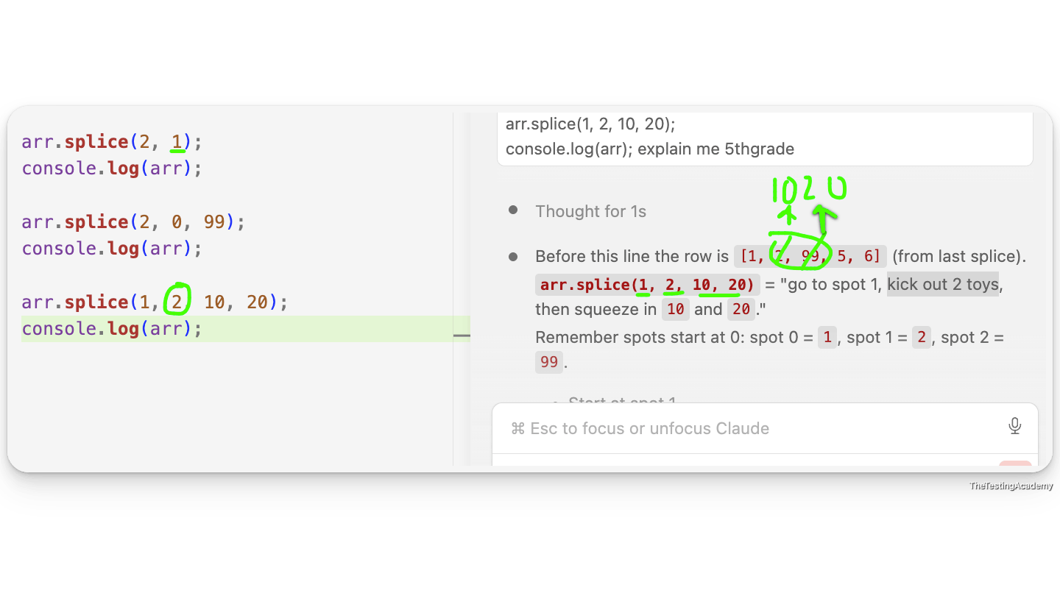
﻿
﻿
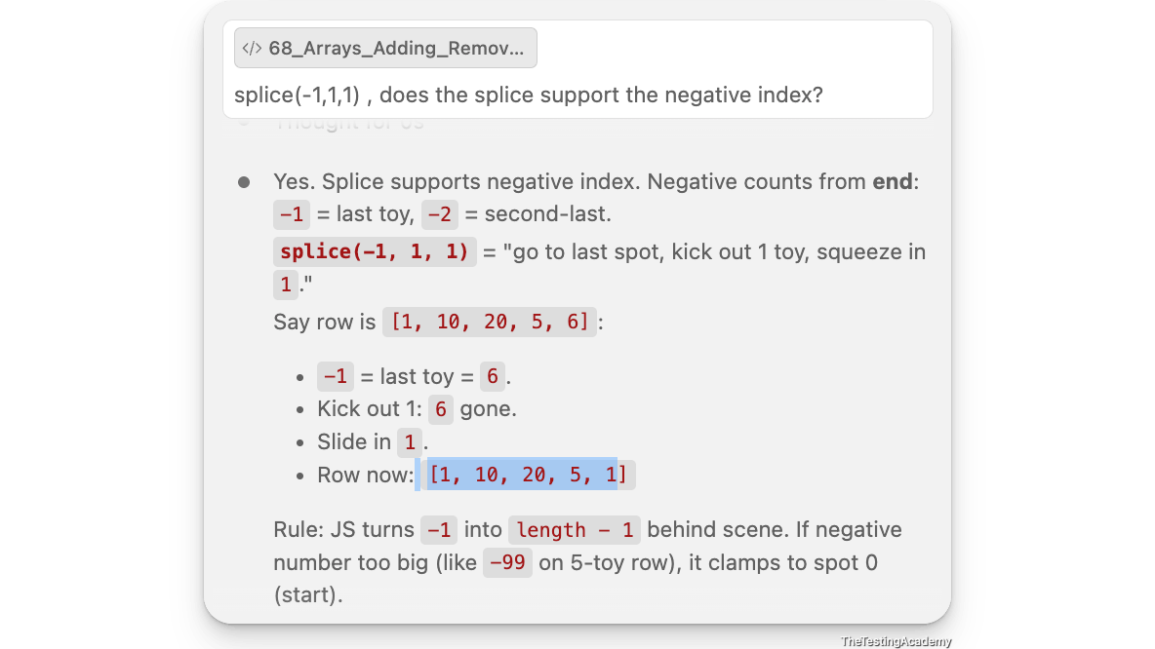

﻿
Q1. [Easy] What is the output?
const arr = [1, 2, 3];
console.log(arr.push(4));
- A) [1,2,3,4]
- B) 4
- C) 3
- D) undefined

﻿
Monday - MasterClass - Evening - 8 PM - Topic, After
﻿

﻿
Arrays Transform, Sort, Slicing, Checking, Copy, Shallow Copy, Deep Copy
Destructuring Arrays
﻿
Map
let scores = [45, 82, 91, 60, 73];

let grades = scores.map(item_score => item_score > 70 ? "Pass": "Fail");
console.log(grades);

// Map My app is generally used whenever we want to
// transform the array into a new array of the same size.
Filter
let passing = scores.filter(s => s >= 70);
console.log(passing);
﻿
Sorting
let fruits = ["banana", "apple", "cherry"];
fruits.sort();
console.log(fruits);
// alphabetical by default

let score = [4,3,2];
console.log(score.sort());

let nums = [10,1,21,2];
// nums.sort();
console.log(nums); // 1,2,10,21 -
// Natural Sorting - Lexicographic / string sort

// Proper Sorting, Asc , Desc
// nums.sort((a,b) => a-b);

nums.sort((a,b) => b-a); // Desc
console.log(nums);
// Slice & Combining

let arr = [1, 2, 3, 4, 5];
// slice(start, end) — returns new array, does NOT mutate actual -> ( start, end-1) . index = 0
//Don't give the end, it will automatically take from start to end.
let arr = [1, 2, 3, 4, 5];

// slice(start, end)
// ✔ Returns a NEW array.
// ✔ Does NOT modify (mutate) the original array.
// ✔ start index is included.
// ✔ end index is excluded.
// ✔ Array indexing starts from 0.
// ✔ If 'end' is omitted, it returns elements from 'start' to the end of the array.

console.log(arr.slice(1, 3)); // [2, 3]
console.log(arr);
// Checking Arrays

// Check if something IS an array

let result = Array.isArray([1, 2, 3]);
let result1 = Array.isArray("a");
console.log(result);
console.log(result1);

﻿
1st Aug 2026
What is a Function?
JavaScript, if you remember, is all about functions.
﻿
- A function is a reusable block of code that performs a specific task.
- Instead of repeating logic, you define it once and call it whenever needed.
﻿
- Define / Definition a Function.
- Calling of Functions
﻿
Definition
function name(param){
// code which is repeated that you execute.
}
﻿
Calling
name(90); // argument

﻿
There are four types of functions which exist (JS)
- no return type. No arguments
- with return type No arguments.
- with argument, no return
- with arguments and with return
﻿
﻿
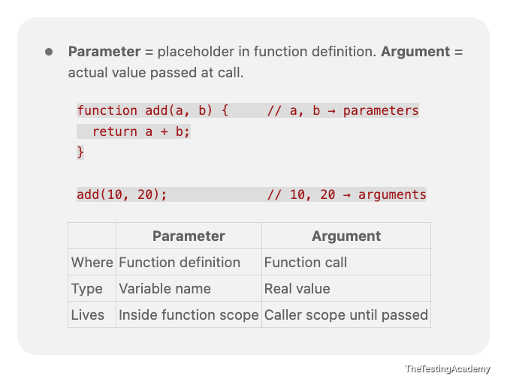
Console.log vs Return
﻿console.log = print to terminal/devtools (side effect, for humans).
﻿return = send value back to caller (data flow, for code).
﻿
function addLog(a, b) {
console.log(a + b); // prints, returns nothing
}
function addReturn(a, b) {
return a + b; // gives value back
}
let x = addLog(2, 3); // prints something, x = undefined
let y = addReturn(2, 3); // prints nothing, y = 5
Differences
﻿ | ﻿console.log | ﻿return
Purpose | Debug / display | Pass value out
Output goes to | Terminal / browser console | Caller variable
Function value | Still undefined | The returned value
Stops function? | No | Yes — exits immediately
Chainable? | No | Yes (addReturn(2,3) * 10)
// normal
function validateStatusCode(status) {
if (status >= 200 && status <= 300) {
console.log("Request is fine!")
}
}

// Fn as Expression
const validateStatusCode_Exp = function (status) {
if (status >= 200 && status <= 300) {
console.log("Request is fine!")
}
}

// Arrow Fn
const validateStatusCode_Arrow = (status) => {
if (status >= 200 && status <= 300) {
console.log("Request is fine!");
}
}

validateStatusCode(200);
validateStatusCode_Exp(200);
validateStatusCode_Arrow(200);
//Immediately Invoked Function Expression (IIFE)
//They don't need to be called.

function name1() {
console.log("Hi")
}
name1();

// IIFE
(function(){
console.log("Anonymous Fun");
})();

(function () {
console.log("Staging")
})();

//Arrow Crazy

(() => {
console.log("Setup complete");
})();

﻿
4th Aug 2026
Functions Part 2
Callbacks, Promise and Strings & 2D Array
﻿
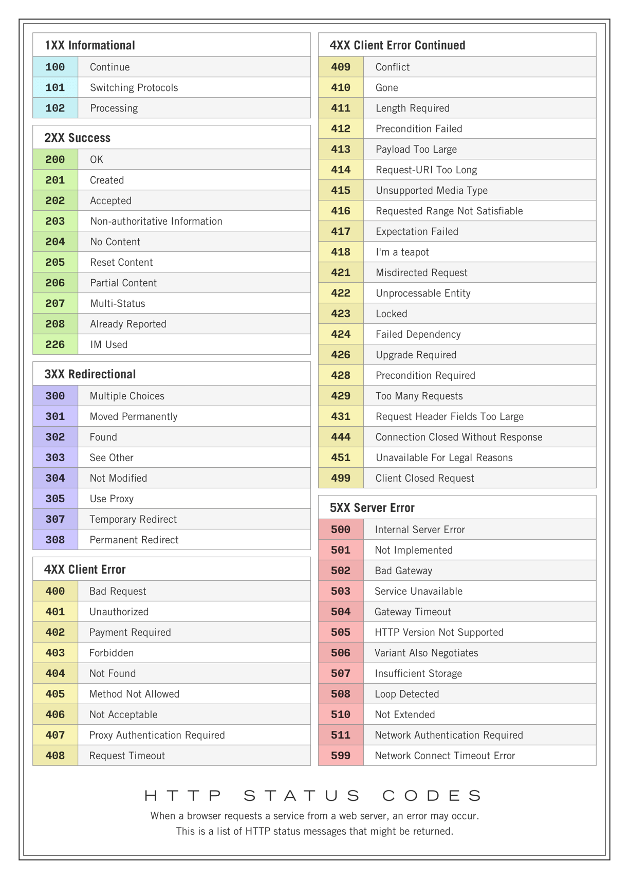
Hoisting and TDZ
﻿
console.log(greeting);
var greeting = "Hello!";
console.log(greeting);

// Behind the scenes:
// var greeting; <-- hoisted with undefined
// console.log(greeting); <-- undefined
// greeting = "Hello!"; <-- assignment stays in place
// console.log(greeting); <-- "Hello!"
TDZ (Temporal Dead Zone) is:
TDZ is the time when a variable exists but you are NOT allowed to use it yet.
﻿
TDZ is the time between entering a block and initializing a let or const variable. During this time, the variable exists but cannot be accessed.
{
console.log(a);
let a = 10;
}

// Enter Block
// ↓
// a is created ✅
// a has NO value yet ❌
// ↓
// console.log(a) ❌ Error (TDZ)
// ↓
// let a = 10;
// ↓
// a = 10 ✅
﻿
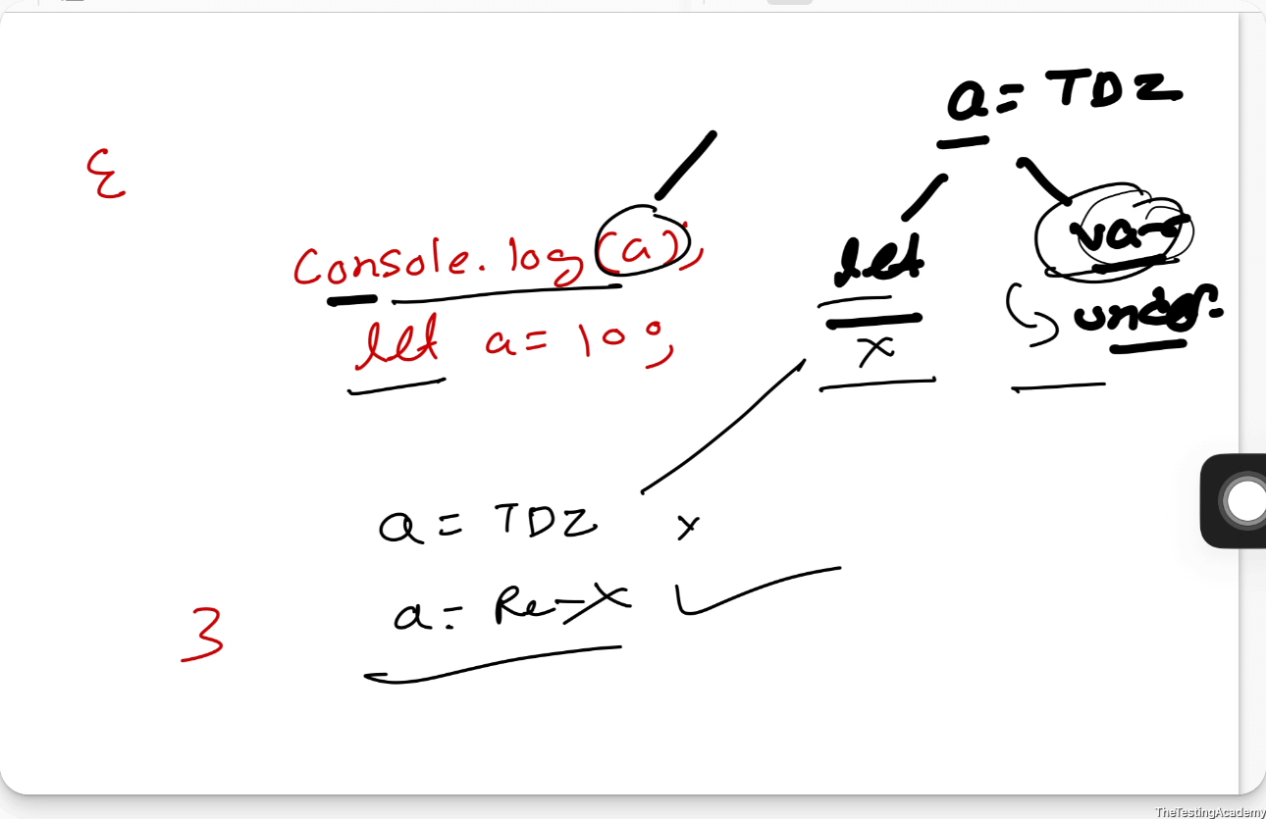
﻿
Hoisting in JavaScript — Complete Guide
TheTestingAcademy | var | let | const | Functions | Classes

﻿
🟢 SECTION 1: WHAT IS HOISTING?
Definition
Hoisting is JavaScript's default behavior of moving variable and function DECLARATIONS to the top of their containing scope during the compilation phase, BEFORE the code is actually executed.
Important: Only declarations are hoisted, NOT initializations or assignments. The variable exists in memory from the start of the scope, but its value is only assigned when execution reaches that line.
How JavaScript Engine Works (Behind the Scenes)
When JavaScript code runs, it goes through two phases:
- Phase 1 — Memory Creation (Compilation): The engine scans all code, finds all declarations (var, let, const, function, class), and allocates memory.
- Phase 2 — Code Execution: The engine runs code line by line, assigning values and executing logic.
Visual: How JS Engine Sees Your Code
What YOU write:
console.log(name); // Line 1
var name = "Dev"; // Line 2
console.log(name); // Line 3
What JS ENGINE does internally:
// ---- Phase 1: Memory Creation ----
var name = undefined; // Declaration hoisted, initialized as undefined

// ---- Phase 2: Execution ----
console.log(name); // undefined (name exists but value not assigned yet)
name = "Dev"; // NOW the assignment happens
console.log(name); // "Dev"
NOTE: Hoisting does NOT physically move your code. It is a mental model to understand how the JS engine handles declarations during compilation.

﻿
🟢 SECTION 2: HOISTING WITH var
How var Hoisting Works
Variables declared with var are hoisted to the top of their FUNCTION scope (or global scope if outside any function). During hoisting, they are automatically initialized with undefined.
You CAN access a var variable before its declaration line without error, but its value will be undefined.
Example 1: Basic var Hoisting
console.log(greeting); // Output: undefined
var greeting = "Hello!";
console.log(greeting); // Output: "Hello!"

// Behind the scenes:
// var greeting; <-- hoisted with undefined
// console.log(greeting); <-- undefined
// greeting = "Hello!"; <-- assignment stays in place
// console.log(greeting); <-- "Hello!"
Example 2: var Hoisting Inside a Function
function getUserStatus() {
console.log(status); // undefined (hoisted within function)
var status = "Active";
console.log(status); // "Active"
return status;
}
getUserStatus();

// Note: var is function-scoped, so status is hoisted to
// the top of getUserStatus(), NOT the global scope.
Example 3: var Hoisting with if Blocks (No Block Scope!)
function checkAccess(isAdmin) {
if (isAdmin) {
var accessLevel = "Full";
} else {
var accessLevel = "Limited";
}
console.log(accessLevel); // Works! var ignores block scope
}
checkAccess(true); // "Full"
checkAccess(false); // "Limited"

// Both var declarations are hoisted to function scope.
// This is a common source of bugs!
Example 4: var Leaks Out of for Loops
for (var i = 0; i < 5; i++) {
// do something
}
console.log(i); // 5 (var leaks out of the for block!)

// Compare with let:
for (let j = 0; j < 5; j++) {
// do something
}
// console.log(j); // ReferenceError: j is not defined
Example 5: Multiple var Declarations (Re-declaration Allowed)
var testName = "Login Test";
var testName = "Signup Test"; // No error! Re-declaration allowed with var
var testName = "Search Test"; // Still no error!
console.log(testName); // "Search Test" (last value wins)

// This is DANGEROUS in large codebases!
// You can accidentally overwrite variables.
⚠️ WARNING: var allows re-declaration which can silently overwrite variables. This is one of the biggest reasons to avoid var.
Example 6: var Hoisting with Functions (Classic Interview Question)
var x = 10;

function printX() {
console.log(x); // undefined (NOT 10!)
var x = 20;
console.log(x); // 20
}
printX();

// WHY? Inside printX, the local "var x" is hoisted to the
// top of the function. So the function has its own "x" that
// shadows the global "x". At the first console.log, the local
// "x" exists but has not been assigned yet = undefined.
Example 7: The Classic setTimeout + var Bug
for (var i = 0; i < 3; i++) {
setTimeout(function() {
console.log("var loop: " + i);
}, 100);
}
// Output: 3, 3, 3 (NOT 0, 1, 2!)

// WHY? var is function-scoped. There is only ONE "i" variable.
// By the time setTimeout callbacks execute, the loop has finished
// and i = 3 for all three callbacks.

// FIX with IIFE (old way):
for (var i = 0; i < 3; i++) {
(function(j) {
setTimeout(function() {
console.log("IIFE fix: " + j);
}, 100);
})(i);
}
// Output: 0, 1, 2
🔹 Q: In automation script, a variable declared with var inside a loop is accessible outside. Bug? 💡 A: No, expected behavior. var is function-scoped, not block-scoped. It leaks out of for/if/while blocks. Use let/const instead.
🔹 Q: Why does console.log(x) show undefined instead of ReferenceError with var? 💡 A: var declarations are hoisted and initialized with undefined. The variable exists from the start of scope, just without its value.

﻿
🟢 SECTION 3: HOISTING WITH let
How let Hoisting Works
Variables declared with let ARE hoisted, but are NOT initialized. They enter the Temporal Dead Zone (TDZ) from the start of their block until the declaration line.
Accessing a let variable in the TDZ throws: ReferenceError: Cannot access variable before initialization
What is the Temporal Dead Zone (TDZ)?
The TDZ is the period between when a scope starts and when the let/const declaration is encountered. During this zone, the variable EXISTS in memory but is marked as "uninitialized."
Visual: Temporal Dead Zone
{
// ---- TDZ for "score" starts here ----
// console.log(score); // ReferenceError!
// score = 50; // ReferenceError!
// typeof score; // ReferenceError!
// ---- TDZ for "score" ends here ----
let score = 100; // Declaration reached, TDZ ends
console.log(score); // 100 (safe to access now)
}
Example 1: Basic let Hoisting (TDZ Error)
// console.log(userName); // ReferenceError: Cannot access 'userName' before initialization
let userName = "Dev";
console.log(userName); // "Dev"

// Compare with var:
console.log(greeting); // undefined (var is initialized with undefined)
var greeting = "Hello";
Example 2: let is Block-Scoped
let x = "global";

if (true) {
// TDZ for block-scoped "x" starts here
// console.log(x); // ReferenceError (NOT "global"!)
let x = "block"; // TDZ ends
console.log(x); // "block"
}

console.log(x); // "global" (outer x unchanged)
NOTE: Even though there is a global 'x', the block-scoped let x creates a NEW variable that shadows it. The TDZ applies from the start of the block.
Example 3: let in for Loops (New Binding Per Iteration)
for (let i = 0; i < 3; i++) {
setTimeout(() => console.log(i), 100);
}
// Output: 0, 1, 2

// Each iteration creates a NEW "i" binding.
// Each setTimeout callback captures its own "i".

// Compare with var (prints 3, 3, 3):
for (var j = 0; j < 3; j++) {
setTimeout(() => console.log(j), 100);
}
// Output: 3, 3, 3 (all share same "j")
Example 4: let Cannot Be Re-declared in Same Scope
let testName = "Login";
// let testName = "Signup"; // SyntaxError: Identifier 'testName' has already been declared

// But you CAN re-declare in a nested block:
let score = 90;
if (true) {
let score = 100; // Different scope, this is fine!
console.log(score); // 100 (block-scoped)
}
console.log(score); // 90 (original unchanged)
Example 5: let in Switch Statement (Common Gotcha)
// This FAILS:
// switch (action) {
// case "a": let x = 1; break;
// case "b": let x = 2; break; // SyntaxError: x already declared
// }

// FIX: Use blocks inside cases
let action = "b";
switch (action) {
case "a": {
let x = 1;
console.log(x);
break;
}
case "b": {
let x = 2; // OK! Different block scope
console.log(x); // 2
break;
}
}
Example 6: TDZ with typeof (Surprising Behavior)
// typeof on an undeclared variable is safe:
console.log(typeof randomVar); // "undefined" (no error)

// But typeof in TDZ throws an error!
// console.log(typeof myLet); // ReferenceError!
let myLet = 42;

// The engine KNOWS about myLet (it's hoisted)
// but it's in the TDZ, so even typeof cannot access it.
Example 7: TDZ with Function Default Parameters
// This works:
function greet(name, greeting = "Hello " + name) {
console.log(greeting);
}
greet("Dev"); // "Hello Dev"

// This FAILS (TDZ):
// function broken(a = b, b = 10) {
// console.log(a, b);
// }
// broken(); // ReferenceError: Cannot access 'b' before initialization
// "b" is in TDZ when "a = b" is evaluated!
🔹 Q: Difference between 'not defined' and 'not initialized' errors? 💡 A: 'x is not defined' = variable doesn't exist anywhere. 'Cannot access x before initialization' = it IS declared (let/const) but you're in the TDZ.
🔹 Q: In Cypress, I get 'Cannot access variable before initialization'. Why? 💡 A: You're using a let/const variable before its declaration. It's in the TDZ. Move the declaration above first usage.

﻿
🟢 SECTION 4: HOISTING WITH const
How const Hoisting Works
﻿const behaves EXACTLY like let for hoisting: hoisted but not initialized (TDZ applies). Key differences: must be assigned at declaration, cannot be reassigned.
Example 1: const TDZ (Same as let)
// console.log(API_KEY); // ReferenceError: Cannot access before initialization
const API_KEY = "abc-123-xyz";
console.log(API_KEY); // "abc-123-xyz"
Example 2: const Must Be Initialized
// const myVar; // SyntaxError: Missing initializer in const declaration

// You MUST assign a value:
const MAX_RETRIES = 3;
const BASE_URL = "https://api.example.com";
Example 3: const Cannot Be Reassigned
const testName = "Login Test";
// testName = "Signup Test"; // TypeError: Assignment to constant variable

const score = 100;
// score++; // TypeError
// score += 10; // TypeError
Example 4: const with Objects (VERY IMPORTANT!)
const config = {
browser: "Chrome",
headless: true,
timeout: 3000
};

// Modifying properties is ALLOWED:
config.timeout = 5000; // ✅ OK!
config.retries = 3; // ✅ OK! (adding new property)
delete config.headless; // ✅ OK! (removing property)

// Reassigning the variable is NOT ALLOWED:
// config = {}; // ❌ TypeError: Assignment to constant variable
// config = { new: "obj" }; // ❌ TypeError
NOTE: const protects the BINDING (reference), not the VALUE. Object/array contents can change, but the variable cannot point to a different object/array.
Example 5: const with Arrays
const testCases = ["Login", "Signup", "Search"];

// Modifying contents is ALLOWED:
testCases.push("Checkout"); // ✅ OK!
testCases[0] = "OAuth Login"; // ✅ OK!
testCases.pop(); // ✅ OK!
testCases.splice(1, 1); // ✅ OK!

// Reassigning is NOT allowed:
// testCases = []; // ❌ TypeError
// testCases = ["New", "Array"]; // ❌ TypeError
Example 6: Making Objects Truly Immutable
// Object.freeze() makes properties read-only (SHALLOW):
const frozenConfig = Object.freeze({
browser: "Chrome",
timeout: 3000,
nested: { retries: 3 }
});

frozenConfig.timeout = 5000; // Silently fails
console.log(frozenConfig.timeout); // 3000 (unchanged!)

// WARNING: freeze is SHALLOW!
frozenConfig.nested.retries = 10; // This WORKS!
console.log(frozenConfig.nested.retries); // 10

// For deep freeze, you need a recursive function or library.
Example 7: const in Loops
// const in for loop — ERROR:
// for (const i = 0; i < 5; i++) { // TypeError at i++
// console.log(i);
// }

// const in for...of — WORKS (new binding each iteration):
const browsers = ["Chrome", "Firefox", "Safari"];
for (const browser of browsers) {
console.log(browser); // Chrome, Firefox, Safari ✅
}

// const in for...in — WORKS:
const obj = { a: 1, b: 2, c: 3 };
for (const key in obj) {
console.log(`${key}: ${obj[key]}`); // ✅
}
🔹 Q: If const objects can be modified, what's the point? 💡 A: const prevents accidental reassignment (config = {}). Combine with Object.freeze() for deep immutability.
🔹 Q: Should I use const for test data objects? 💡 A: Yes! const for test data, config, selectors, URLs. You modify properties, not the binding. const + Object.freeze() is safest.

﻿
🟢 SECTION 5: FUNCTION HOISTING
Function Declarations are FULLY Hoisted
Function declarations are completely hoisted — both name AND body. You can call them BEFORE they appear in code.
Example 1: Calling Function Before Declaration
sayHello(); // "Hello, World!" — works perfectly!

function sayHello() {
console.log("Hello, World!");
}
Example 2: Function Expression is NOT Hoisted
// greet(); // TypeError: greet is not a function

var greet = function() {
console.log("Hi there!");
};

greet(); // "Hi there!" — works here

// WHY? "var greet" is hoisted as undefined.
// Calling undefined() gives TypeError.
Example 3: Arrow Function Hoisting
// runTest(); // ReferenceError: Cannot access 'runTest' before initialization

const runTest = () => {
console.log("Running test...");
};

runTest(); // "Running test..."

// Arrow functions with const/let follow TDZ rules.
Example 4: Function Declaration vs var Expression
console.log(typeof myFunc); // "function" (function declaration wins)

var myFunc = "I am a string";

function myFunc() {
return "I am a function";
}

console.log(typeof myFunc); // "string" (var assignment overwrites)

// During hoisting:
// 1. var myFunc; (hoisted)
// 2. function myFunc() {...} (fully hoisted, takes priority)
// During execution:
// 3. myFunc = "I am a string"; (overwrites)
Example 5: Functions Inside Blocks (DON'T DO THIS)
// BAD (inconsistent behavior across browsers):
if (true) {
function test() { return "inside if"; }
}

// GOOD (use function expressions):
let test;
if (true) {
test = function() { return "inside if"; };
}
console.log(test()); // "inside if"
Example 6: Named Function Expression
const factorial = function fact(n) {
if (n <= 1) return 1;
return n * fact(n - 1); // "fact" works here (recursion)
};

console.log(factorial(5)); // 120
// console.log(fact(5)); // ReferenceError: fact is not defined
Example 7: IIFE (Immediately Invoked Function Expression)
(function() {
var secret = "hidden";
console.log("IIFE executed: " + secret);
})();

// console.log(secret); // ReferenceError (contained in IIFE scope)

// Arrow IIFE:
(() => {
console.log("Arrow IIFE executed!");
})();
🔹 Q: In test frameworks, why are setup functions callable before test blocks? 💡 A: Frameworks like Jest/Mocha collect all blocks during registration, then execute in order — similar to hoisting.
🔹 Q: Arrow function helper throws ReferenceError. Why? 💡 A: Arrow functions with const/let aren't hoisted like function declarations. Define them ABOVE where you call them.

﻿
🟢 SECTION 6: CLASS HOISTING
Classes are Hoisted but Stay in TDZ
// const user = new User("Dev"); // ReferenceError

class User {
constructor(name) { this.name = name; }
}

const user = new User("Dev"); // ✅ Works here
console.log(user.name); // "Dev"
Class Expression — Same TDZ Rules
// const t = new TestCase(); // ReferenceError

const TestCase = class {
constructor(name) { this.name = name; }
};

const t = new TestCase("Login"); // ✅
Class vs Function — Hoisting Comparison
// Function — fully hoisted:
const result = add(2, 3); // 5 ✅
function add(a, b) { return a + b; }

// Class — TDZ:
// const calc = new Calculator(); // ❌ ReferenceError
class Calculator {
add(a, b) { return a + b; }
}
const calc = new Calculator(); // ✅
🔹 Q: Why are classes in TDZ when functions are fully hoisted? 💡 A: Deliberate ES6 design. Classes can have inheritance (extends), and using a class before its parent is defined could cause errors. TDZ prevents this.

﻿
🟢 SECTION 7: COMPLETE HOISTING COMPARISON TABLE
Feature | var | let | const | function decl | class decl
Hoisted? | Yes | Yes | Yes | Yes (fully) | Yes
Initialized during hoist? | Yes (undefined) | No (TDZ) | No (TDZ) | Yes (full body) | No (TDZ)
Access before declaration? | undefined | ReferenceError | ReferenceError | Works normally | ReferenceError
Scope | Function | Block | Block | Function | Block
Re-declarable? | Yes | No | No | Yes | No
Re-assignable? | Yes | Yes | No | Yes | Yes
Must initialize? | No | No | Yes | N/A | N/A
TDZ? | No | Yes | Yes | No | Yes

﻿
🟢 SECTION 8: COMMON INTERVIEW & QA QUESTIONS
🔹 Q: What will output? console.log(a); var a = 1; console.log(a); 💡 A: undefined, then 1. var is hoisted with undefined.
🔹 Q: What will output? console.log(a); let a = 1; 💡 A: ReferenceError. let is in TDZ.
🔹 Q: Can you call a function before defining it? 💡 A: Only function declarations. Function expressions and arrow functions cannot.
🔹 Q: Output? var x = 1; function foo() { console.log(x); var x = 2; } foo(); 💡 A: undefined. Local var x is hoisted inside foo, shadowing global x.
🔹 Q: Should helper functions be at top or bottom of test file? 💡 A: Function declarations work anywhere (hoisted). const/arrow functions MUST be before use. Best practice: top.
🔹 Q: What happens with let x = x;? 💡 A: ReferenceError! Right-hand x evaluated first, but x is still in TDZ.
🔹 Q: Does hoisting work differently in strict mode? 💡 A: var/function hoisting is same. In strict mode, functions inside blocks are block-scoped (more predictable).
🔹 Q: Output? console.log(foo); var foo = function bar() { return 42; }; 💡 A: undefined. var foo hoisted as undefined. The function expression is NOT hoisted.
🔹 Q: Why should QA engineers care about hoisting? 💡 A: Causes subtle bugs: undefined variables, unavailable functions, shared loop state. Understanding hoisting helps debug flaky tests.
🔹 Q: Output? function test() { return 1; } var test = 2; console.log(typeof test); 💡 A: 'number'. Function hoisted first, then var assignment overwrites it to 2.

﻿
🟢 SECTION 9: BEST PRACTICES
The Golden Rules
- Use const by default -> Only switch to let when reassignment is needed. Never use var.
- Declare at top of scope — Even with TDZ protection, top declarations improve readability.
- Never use var — ESLint rule: "no-var": "error"
- Function declarations for hoisted utilities -> Arrow functions with const for everything else.
- Never declare functions inside blocks — Use function expressions instead.
- let in for loops, const in for...of/for...in
- Enable ESLint rules:
{
"rules": {
"no-var": "error",
"prefer-const": "error",
"no-use-before-define": "error",
"block-scoped-var": "error"
}
}
Quick Decision Flowchart
Question | Answer | Use
Will the value change? | No | const
Will the value change? | Yes | let
Need function hoisting? | Yes | function declaration
Need function as value? | Yes | const + arrow function
Old codebase with var? | Refactor! | Replace with let/const

﻿
TheTestingAcademy — JavaScript Hoisting Complete Guide
﻿
﻿

﻿
String, 2dArray, Callback, Promise, OOps
6th AUg 2026
﻿
Closure
A closure is when an inner function remembers and can access variables from its outer function, even after the outer function has finished executing.
function startBrowser() {
let name = "edge";

function installBrowser() {
console.log(name);
}

return installBrowser;
}

const runTc = startBrowser();
runTc();
﻿
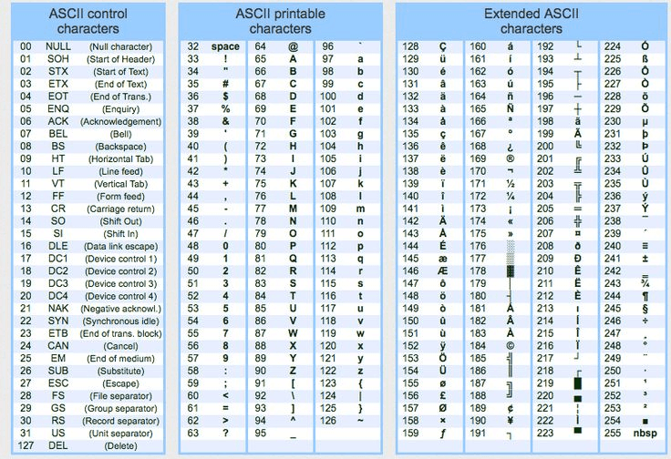
﻿
﻿
Unicode - the universal kind of codes which are available for other languages also.

﻿
8th Aug 2026
Strings
- Strings are sequences of characters.
- JavaScript provides many methods for string manipulation.
- A string is a sequence of characters used to represent text.
- In testing, strings are everywhere -> URLs, selectors, assertions, response messages, log parsing.
﻿
Creating Strings
let url = "https://app.vwo.com";
let status = 'pass';
let message = `Test completed in ${320}ms`; // template literal
﻿
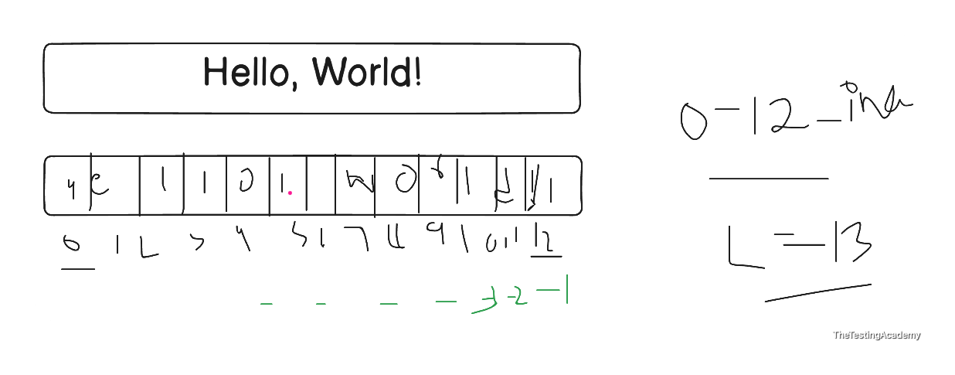
JavaScript Unicode/ASCII table for A-Z and a-z.
Character | Decimal | Hex | JavaScript
A | 65 | 0x41 | ﻿"A".charCodeAt(0)
B | 66 | 0x42 | ﻿"B".charCodeAt(0)
C | 67 | 0x43 | ﻿"C".charCodeAt(0)
D | 68 | 0x44 | ﻿"D".charCodeAt(0)
E | 69 | 0x45 | ﻿"E".charCodeAt(0)
F | 70 | 0x46 | ﻿"F".charCodeAt(0)
G | 71 | 0x47 | ﻿"G".charCodeAt(0)
H | 72 | 0x48 | ﻿"H".charCodeAt(0)
I | 73 | 0x49 | ﻿"I".charCodeAt(0)
J | 74 | 0x4A | ﻿"J".charCodeAt(0)
K | 75 | 0x4B | ﻿"K".charCodeAt(0)
L | 76 | 0x4C | ﻿"L".charCodeAt(0)
M | 77 | 0x4D | ﻿"M".charCodeAt(0)
N | 78 | 0x4E | ﻿"N".charCodeAt(0)
O | 79 | 0x4F | ﻿"O".charCodeAt(0)
P | 80 | 0x50 | ﻿"P".charCodeAt(0)
Q | 81 | 0x51 | ﻿"Q".charCodeAt(0)
R | 82 | 0x52 | ﻿"R".charCodeAt(0)
S | 83 | 0x53 | ﻿"S".charCodeAt(0)
T | 84 | 0x54 | ﻿"T".charCodeAt(0)
U | 85 | 0x55 | ﻿"U".charCodeAt(0)
V | 86 | 0x56 | ﻿"V".charCodeAt(0)
W | 87 | 0x57 | ﻿"W".charCodeAt(0)
X | 88 | 0x58 | ﻿"X".charCodeAt(0)
Y | 89 | 0x59 | ﻿"Y".charCodeAt(0)
Z | 90 | 0x5A | ﻿"Z".charCodeAt(0)
Character | Decimal | Hex | JavaScript
a | 97 | 0x61 | ﻿"a".charCodeAt(0)
b | 98 | 0x62 | ﻿"b".charCodeAt(0)
c | 99 | 0x63 | ﻿"c".charCodeAt(0)
d | 100 | 0x64 | ﻿"d".charCodeAt(0)
e | 101 | 0x65 | ﻿"e".charCodeAt(0)
f | 102 | 0x66 | ﻿"f".charCodeAt(0)
g | 103 | 0x67 | ﻿"g".charCodeAt(0)
h | 104 | 0x68 | ﻿"h".charCodeAt(0)
i | 105 | 0x69 | ﻿"i".charCodeAt(0)
j | 106 | 0x6A | ﻿"j".charCodeAt(0)
k | 107 | 0x6B | ﻿"k".charCodeAt(0)
l | 108 | 0x6C | ﻿"l".charCodeAt(0)
m | 109 | 0x6D | ﻿"m".charCodeAt(0)
n | 110 | 0x6E | ﻿"n".charCodeAt(0)
o | 111 | 0x6F | ﻿"o".charCodeAt(0)
p | 112 | 0x70 | ﻿"p".charCodeAt(0)
q | 113 | 0x71 | ﻿"q".charCodeAt(0)
r | 114 | 0x72 | ﻿"r".charCodeAt(0)
s | 115 | 0x73 | ﻿"s".charCodeAt(0)
t | 116 | 0x74 | ﻿"t".charCodeAt(0)
u | 117 | 0x75 | ﻿"u".charCodeAt(0)
v | 118 | 0x76 | ﻿"v".charCodeAt(0)
w | 119 | 0x77 | ﻿"w".charCodeAt(0)
x | 120 | 0x78 | ﻿"x".charCodeAt(0)
y | 121 | 0x79 | ﻿"y".charCodeAt(0)
z | 122 | 0x7A | ﻿"z".charCodeAt(0)
JavaScript example:
console.log("A".charCodeAt(0)); // 65
console.log("Z".charCodeAt(0)); // 90
console.log("a".charCodeAt(0)); // 97
console.log("z".charCodeAt(0)); // 122
﻿
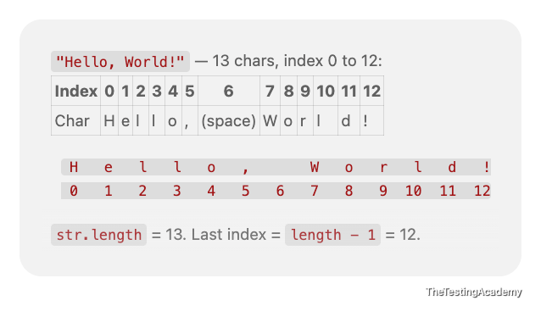
﻿
﻿
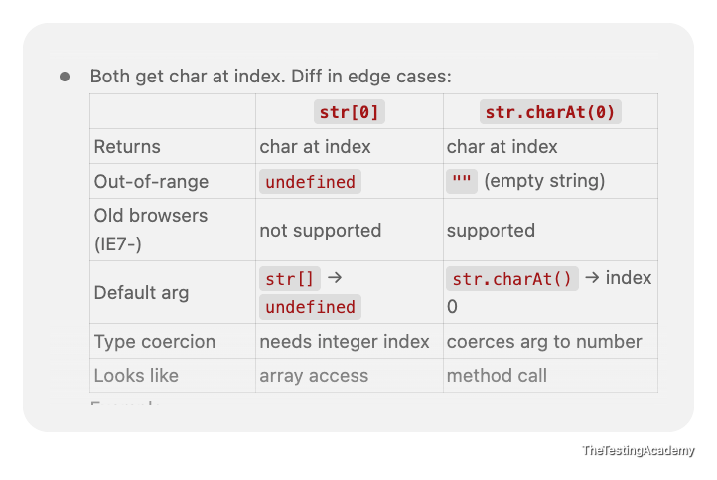
﻿
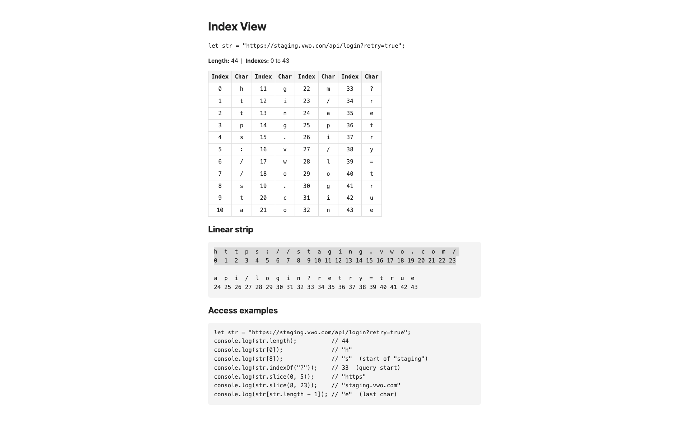
﻿
// Extracting Substrings
﻿
Regex - 101 - Extra - it is basically used to find a particular string in your own string in this case with the help of a pattern
﻿﻿prmaod@gmail.com ->. pramod or if it is valid @﻿gmail.com or not,.
﻿
JavaScript String Methods — Complete Cheatsheet (SDET)
All outputs verified on Node.js v22. Strings are immutable — every method returns a new string.
let s = "abc";
s[0] = "z";
console.log(s); // 'abc' ← silently unchanged

﻿
1. Length & Character Access
Method | Purpose | Example | Result
﻿.length | character count (property, not a method) | ﻿"Playwright".length | ﻿10
﻿.charAt(i) | char at index | ﻿"Playwright".charAt(4) | ﻿'w'
﻿[i] | char at index (bracket) | ﻿"Playwright"[4] | ﻿'w'
﻿.at(i) | char at index,  supports negative | ﻿"Playwright".at(-1) | ﻿'t'
﻿.charCodeAt(i) | UTF-16 code unit | ﻿"A".charCodeAt(0) | ﻿65
﻿.codePointAt(i) | full code point (emoji-safe) | ﻿"😀".codePointAt(0) | ﻿128512
Out-of-range difference: "abc".charAt(99) → '' (empty string) but "abc".at(99) → undefined.

﻿
2. Searching
Method | Returns | Example | Result
﻿.indexOf(sub, from?) | first index, -1 if absent | ﻿"Login Successful".indexOf("Success") | ﻿6
﻿.lastIndexOf(sub, from?) | last index | ﻿"a-b-a".lastIndexOf("a") | ﻿4
﻿.includes(sub, pos?) | ﻿true / false | ﻿"Login Successful".includes("Login") | ﻿true
﻿.startsWith(sub, pos?) | ﻿true / false | ﻿"https://qa.com".startsWith("https") | ﻿true
﻿.endsWith(sub, len?) | ﻿true / false | ﻿"report.pdf".endsWith(".pdf") | ﻿true
﻿.search(regex) | index of first regex match, -1 if none | ﻿"Order #10245".search(/\d+/) | ﻿7
﻿.match(regex) | array of matches, or null | ﻿"Order #10245".match(/#(\d+)/) | ﻿['#10245','10245']
﻿.matchAll(regex) | iterator of all matches (needs /g) | ﻿[..."a1b2".matchAll(/([a-z])(\d)/g)].map(m => m[0]) | ﻿['a1','b2']
⚠️ All of these are case-sensitive. "Login Successful".includes("login") → false. Lowercase both sides before comparing UI text.
⚠️ .match() returns null on no match — "abc".match(/\d/)?.[0] avoids the TypeError.
⚠️ .match(/\d/g) with the global flag returns only full matches, no capture groups: "a1b2c3".match(/\d/g) → ['1','2','3'].

﻿
3. Extracting Substrings
Method | Negative index? | Swaps args? | Example | Result
﻿.slice(start, end?) | ✅ counts from end | ❌ returns '' | ﻿"JavaScript".slice(-6) | ﻿'Script'
﻿.substring(start, end?) | ❌ clamps to 0 | ✅ auto-swaps | ﻿"JavaScript".substring(-6) | ﻿'JavaScript'
﻿.substr(start, length) | ✅ | — | ﻿"JavaScript".substr(4, 6) | ﻿'Script' (deprecated)
"JavaScript".slice(0, 4); // 'Java'
"JavaScript".slice(4, 0); // '' ← end < start
"JavaScript".substring(4, 0); // 'Java' ← args swapped silently
Use slice() by default. It's the only one with predictable negative-index behaviour.

﻿
4. Splitting & Joining
"a,b,c".split(","); // ['a', 'b', 'c']
"a,b,c".split(",", 2); // ['a', 'b'] ← limit
"abc".split(""); // ['a', 'b', 'c']
"abc".split(); // ['abc'] ← no separator = whole string
"a1b22c".split(/\d+/); // ['a', 'b', 'c'] ← regex separator
"a1b2".split(/(\d)/); // ['a','1','b','2',''] ← capture group is kept

[..."hey"]; // ['h','e','y'] ← emoji-safe, unlike split("")
Array.from("hey"); // ['h','e','y']
["a","b"].join(" | "); // 'a | b'
"abc".split("").reverse().join(""); // 'cba' ← reverse a string
⚠️ "😀".split("") breaks the emoji into two broken halves. Use [..."😀"] → ['😀'].

﻿
5. Case & Whitespace
Method | Example | Result
﻿.toUpperCase() | ﻿"qa".toUpperCase() | ﻿'QA'
﻿.toLowerCase() | ﻿"QA".toLowerCase() | ﻿'qa'
﻿.toLocaleUpperCase(locale) | ﻿"i".toLocaleUpperCase("tr-TR") | ﻿'İ' (vs 'I')
﻿.toLocaleLowerCase(locale) | locale-aware lowercase | —
﻿.trim() | ﻿" QA ".trim() | ﻿'QA'
﻿.trimStart() | ﻿" QA ".trimStart() | ﻿'QA '
﻿.trimEnd() | ﻿" QA ".trimEnd() | ﻿' QA'
﻿trimLeft / trimRight are legacy aliases — use trimStart / trimEnd.

﻿
6. Padding, Repeating, Concatenating
"7".padStart(3, "0"); // '007' ← zero-pad IDs
"Name".padEnd(10, "."); // 'Name......' ← align console output
"abcdef".padStart(3, "0"); // 'abcdef' ← no-op if already long enough
"ab".repeat(3); // 'ababab'
"ab".repeat(0); // ''
"a".concat("b", "c"); // 'abc' ← `+` is clearer

﻿
7. Replacing
Method | Replaces | Example | Result
﻿.replace(str, new) | first  occurrence only | ﻿"banana".replace("a","X") | ﻿'bXnana'
﻿.replace(/re/g, new) | all (with g flag) | ﻿"banana".replace(/a/g,"X") | ﻿'bXnXnX'
﻿.replaceAll(str, new) | all occurrences | ﻿"banana".replaceAll("a","X") | ﻿'bXnXnX'
Replacement patterns:
"abc".replace(/b/, "[$&]"); // 'a[b]c' ← $& = whole match
"2026-07-25".replace(/(\d+)-(\d+)-(\d+)/, "$3/$2/$1"); // '25/07/2026'
"a1b2".replace(/\d/g, d => d * 2); // 'a2b4' ← function replacer
⚠️ .replaceAll() with a regex requires the g flag or it throws a TypeError.

﻿
8. Comparing & Sorting
"abc" === "abc"; // true
"a" < "b"; // true
"10" < "9"; // true ← lexicographic, not numeric!

["b","a","C"].sort(); // ['C','a','b'] ← uppercase sorts first (code units)
["b","a","C"].sort((x, y) => x.localeCompare(y)); // ['a','b','C']

"a".localeCompare("b"); // -1 (negative = a before b, 0 = equal, positive = after)

// Natural / numeric sort — essential for IDs like item2 vs item10
["item10","item9"].sort((a, b) => a.localeCompare(b, undefined, { numeric: true }));
// ['item9', 'item10']

// Case-insensitive equality check
"ABC".localeCompare("abc", undefined, { sensitivity: "base" }); // 0
﻿.normalize("NFC") fixes accented characters that look identical but differ in bytes — worth adding before comparing text scraped from different sources.

﻿
9. Template Literals
const name = "Pramod", count = 3;
`User ${name} ran ${count} test${count > 1 ? "s" : ""}`;
// 'User Pramod ran 3 tests'

`line1
line2`; // multi-line, preserves the newline

// Tagged template
function tag(strings, ...vals) { return strings.raw.join("|") + " :: " + vals.join(","); }
tag`a${1}b${2}c`; // 'a|b|c :: 1,2'

﻿
10. Static Methods & Conversions
Call | Purpose | Result
﻿String.fromCharCode(72, 105) | code units → string | ﻿'Hi'
﻿String.fromCodePoint(128512) | code point → string | ﻿'😀'
﻿String.raw`C:\new\test` | ignore escape sequences | ﻿'C:\\new\\test'
﻿String(123) | any value → string | ﻿'123'
﻿(255).toString(16) | number → base-N string | ﻿'ff'
String → number:
Number("12"); // 12
Number("12px"); // NaN ← strict
Number(""); // 0 ← watch out
parseInt("12px", 10); // 12 ← stops at first invalid char
parseFloat("12.5px"); // 12.5
+"42"; // 42 ← unary plus, same rules as Number()
⚠️ "5" + 3 → '53' (concatenation) but "5" - 3 → 2. Only + is overloaded.

﻿
11. Rarely Needed
Method | Note
﻿.isWellFormed() | ﻿false if the string has lone surrogates
﻿.toWellFormed() | replaces lone surrogates with �
﻿.normalize(form) | Unicode normalization: NFC, NFD, NFKC, NFKD
﻿.valueOf() / .toString() | returns the primitive value
﻿.anchor(), .big(), .blink(), .bold(), .fixed(), .fontcolor(), .fontsize(), .italics(), .link(), .small(), .strike(), .sub(), .sup() | legacy HTML wrappers —  never use these

﻿
12. SDET Recipes
// Normalize UI text before asserting (kills stray \n and double spaces)
const normalize = s => s.replace(/\s+/g, " ").trim().toLowerCase();
normalize(" LOGIN Successful\n"); // 'login successful'

// Currency string → number
const money = s => parseFloat(s.replace(/[^0-9.]/g, ""));
money("₹1,299.50"); // 1299.5

// Extract an ID from a URL
"https://shop.com/order/10245?ref=x".match(/\/order\/(\d+)/)[1]; // '10245'

// Extract the first number from any label
"Order #10245".match(/\d+/)[0]; // '10245'

// Validate a format
/^\d{4}-\d{2}-\d{2}$/.test("2026-07-25"); // true

// Mask sensitive test data in logs
const mask = s => s.slice(0, 2) + "*".repeat(Math.max(0, s.length - 4)) + s.slice(-2);
mask("4111111111111111"); // '41************11'

// Slug for screenshot / test-artifact filenames
const slug = s => s.trim().toLowerCase().replace(/[^a-z0-9]+/g, "-").replace(/^-|-$/g, "");
slug(" Add to Cart! Test #3 "); // 'add-to-cart-test-3'

// Truncate long failure messages
const truncate = (s, n) => s.length > n ? s.slice(0, n - 1) + "…" : s;
truncate("Element not visible on page", 15); // 'Element not vi…'

// Clean a CSV-ish row
"a, b ,c".split(",").map(s => s.trim()); // ['a', 'b', 'c']

// Count occurrences
("a-b-a-c".match(/a/g) || []).length; // 2

// Title case
"login page".replace(/\b\w/g, c => c.toUpperCase()); // 'Login Page'

﻿
Gotcha Summary
Trap | Reality
﻿s[0] = "z" | silently does nothing — strings are immutable
﻿.replace("a", "X") | first match only; use replaceAll or /g
﻿.includes("Login") | case-sensitive
﻿.substring(-6) | clamps to 0; use .slice(-6)
﻿"10" < "9" | ﻿true — string comparison, not numeric
﻿["b","a","C"].sort() | ﻿['C','a','b'] — use localeCompare
﻿.match(/x/) with no match | returns null, not []
﻿Number("12px") | ﻿NaN; use parseInt
﻿Number("") | ﻿0, not NaN
﻿"5" + 3 | ﻿'53'; every other operator coerces to number
﻿.split("") on emoji | splits the surrogate pair; use [...str]
﻿.charAt(99) vs .at(99) | ﻿'' vs undefined

﻿
All snippets in this cheatsheet were executed on Node.js v22 and the outputs pasted verbatim.
﻿
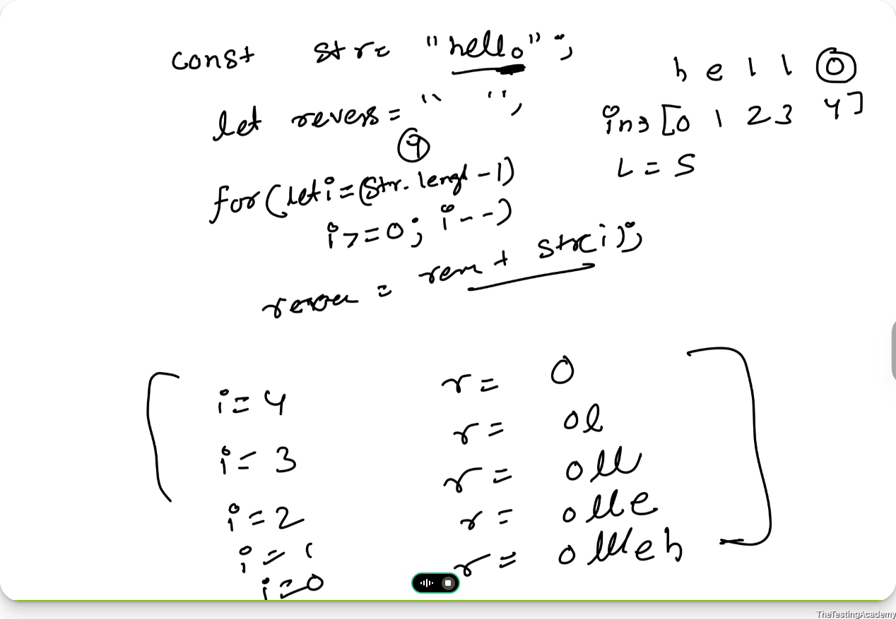

﻿
Objects in JS
- Key and value
﻿
let student1 = { name: "Amit", age: 65 };
let student2 = { name: "Pramod" };
let student3 = { name: "Pramod", age: 87, phone: 987654320 };
// Key will not be in the doubt quotes
// below key in doubt is actually JSON
let JSON_student4 = { "name": "Pramod", "age": 87, "phone": 987654320 };
let a = { status: "pass" };
console.log(a.status);
console.log(a["status"]);

﻿
11th Aug 2026
Multi-Dimensional Arrays in JavaScript
- 1D
- 2D
- 3D
﻿
1D -> array is a collection of similar elements
﻿
﻿
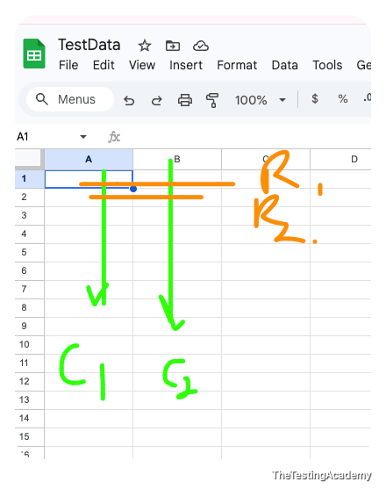
﻿
﻿
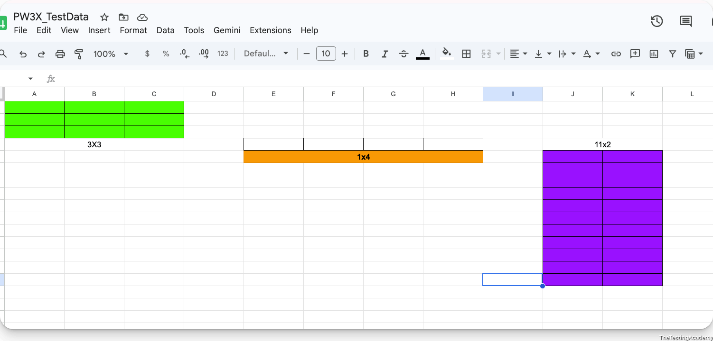
﻿﻿docs.google.com/spreadsheets/d/1o2QpjmOEMpX84SXhZEU-zq8NzBigSFbVu0QY31n8CcE/edit?usp=sharing
﻿

﻿
﻿
﻿process.stdout.write -> print raw, NO newline.
﻿console.log — print + auto-append \n (newline).
﻿
﻿
﻿
﻿
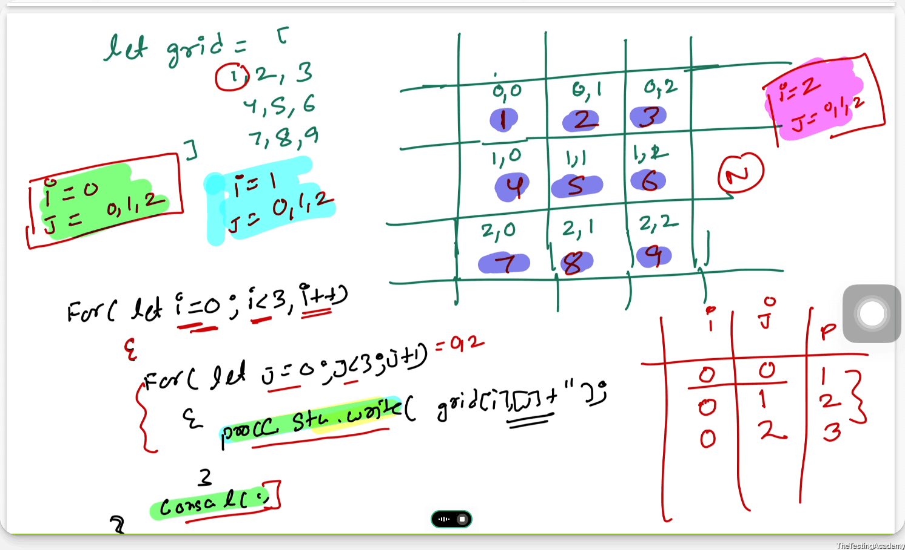
﻿
﻿
﻿
﻿
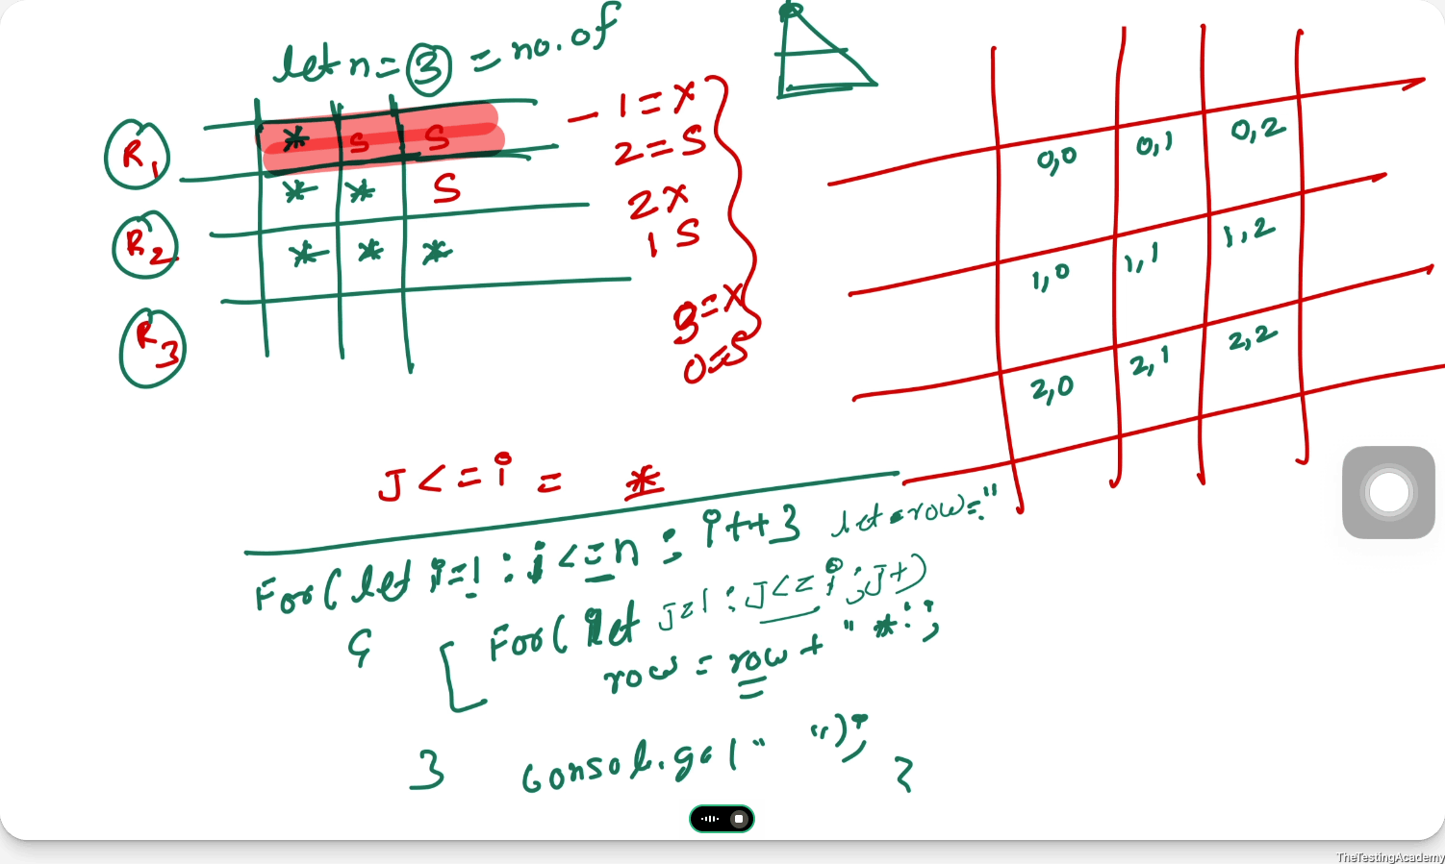
﻿
﻿
﻿
﻿
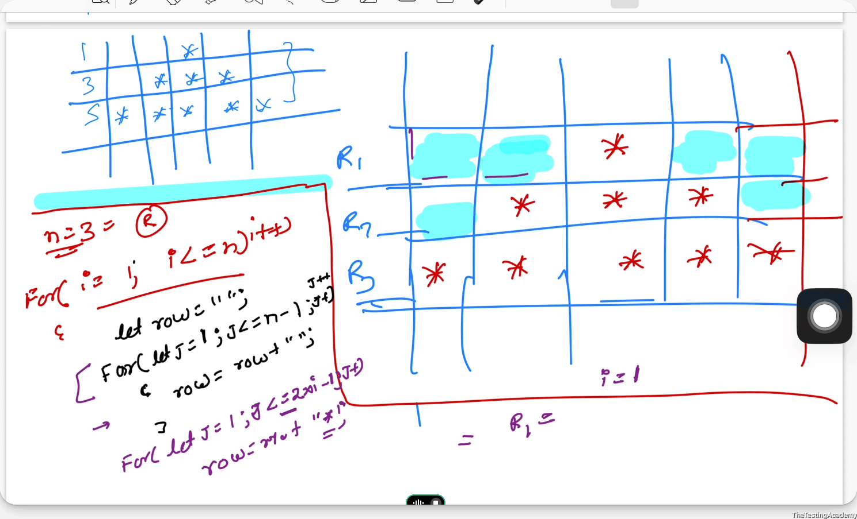
﻿
﻿
﻿
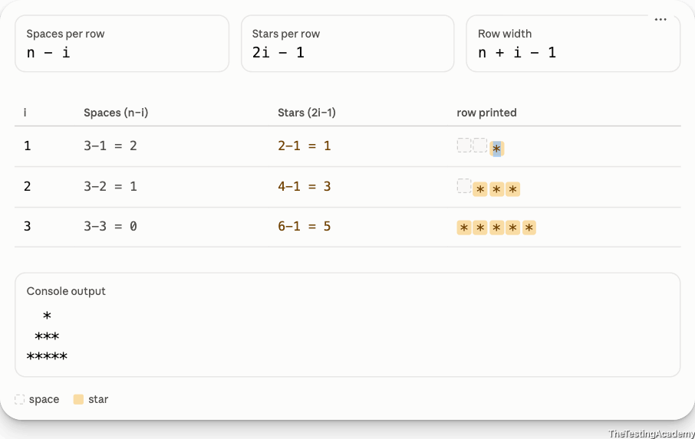
﻿
﻿
﻿
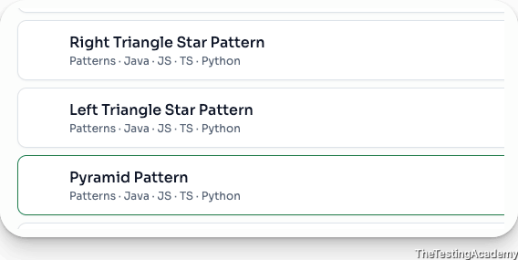
﻿
﻿
﻿
Claude 101 - Part - 2
Skill master - Full - Wed 8 PM IST
﻿
﻿
JavaScript Advanced Topics
- Callback Functions
- Callback Hell & Pyramid of Doom
- Dom Manipulation
- Promise
- Sync &. Async
﻿
﻿
﻿

