Extinction

Observed magnitude:

$$m_{e}=m_{0}+A_{x}$$

Where $m_{0}$ is the intrinsic magnitude and $A_{x}$ is the extinction in band $x$ which is defined as:

$$A_{x}=E\left(B-V\right).R_{x}$$

Where $E(B-V)$ is the reddening and $R_{x}$ is the extinction vector for band $x$.

The Fitzpatrick99 model in the python package extinction takes $A_{v}$ and $R_{v}$ as inputs.

We want to have a color vector for each band, but I don’t know how it is possible to have one vector per band since the extinction varies between sources. To see this we can rearrange expand and rearrange the previous equations to get:

$$R_{x}=\frac{m_{e}-m_{0}}{E(B-V)}$$

So for some spectrum and reddening factor this should give the vector. For example lets calculate the vector for the PS1 g band, $R_{g}$, for black body spectra at 7000K and 5000K. For simplicity we will use $E\left(B-V\right)=1$ and the conventional $R_{v}=3.1$.

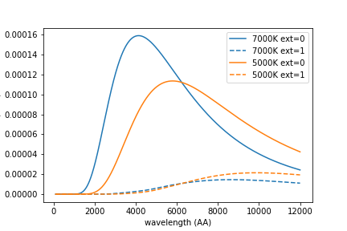

For both sources we calculate the magnitudes in the g band and get the vector with

$R_{g}=m_{e}-m_{0}$ to get:

* T = 7000K $$R_{g}=3.536$$
* T = 5000K $$R_{g}=3.490$$

The difference in the vector between these two sources is $0.046$ and grows with redder sources. Does this matter?

Converting Bayestar19 to a conventional unit

<http://argonaut.skymaps.info/usage> discusses how B19 can be converted to conventional extinction units, and provides extinction vectors for PS1 bands to directly map B19 output to extinction

$$b_{x}=B19.B_{x}$$

Where $B19$ is the output from B19 and $B_{x}$ is the extinction vector shown in table 1 for band $x$. As stated in the above link, to convert B19 to extinction in other bands we need to assume a relation, such as RV = 3.1 with the Fitzpatrick (1999) reddening law to a 7000 K sources. They state that $B19$ can be transformed with either of the following:

$$E\left(B-V\right)=0.884.B19$$

$$E\left(B-V\right)=0.996.B19$$

Since they both give the reddening on a source, we can set $b_{x}=A_{x}$, from which it follows that

$$B_{x}=\frac{m_{e}-m_{0}}{B19}$$

For the PS1 g band $R_{v}=3.1$ and a 7000K source the table lists $B_{g}=3.518$ we get:

* If $E\left(B-V\right)=0.884.B19$ $B_{g}=3.132$
* If $E\left(B-V\right)=0.996.B19$ $B_{g}=3.522$

In this case the second value is closest to the table value, however, it isn’t close for the PS1 r band which is calculated to be $B_{r}=2.541$ but listed as 2.617 in the table.

What am I missing?