II. RELATED WORK
The Vision Transformer (ViT) [1] appends a learnable [cLS] token that aggregates information from all patch tokens through global self-attention, producing the final image representation. While effective for classification, this default aggregation exhibits a systematic bias: under image-level supervision, the [CLS] token preferentially aggregates from background patches, which are more numerous and can absorb foreground information through global attention, rather than from the semantically informative foreground regions [2]. This Lazy Aggregation pathology degrades dense feature quality, reducing Point-in-Box (PiB) localization accuracy to only 19-48%, compared to 60-80% for convolutional networks [2].
To address the spatial dimension of Lazy Aggregation, Shi et al. [2] proposed LaSt-ViT, which selects patches based on spectral stability. For each patch feature, LaSt-ViT computes a one-dimensional FFT along the channel dimension, applies a Gaussian low-pass filter,$G\left(σ_{f}\right)=exp\left(−\frac{f^{2}}{2σ_{f}^{2}}\right),$and measures how little the feature changes after filtering. The intuition is that foreground objects tend to exhibit more stable low-frequency channel activations. The top- $K$ most stable patches are then averaged to form the aggregated representation. LaSt-ViT eliminates high-norm background artifacts and improves zero-shot segmentation by +1.3 mloU on ADE20K with CLIP ViT-B/16.
However, this approach has three specific limitations. First, frequency stability as the sole foreground cue conflates smooth foreground objects — such as a uniformly colored car or a white swan — with smooth background regions like sky or walls [8], since both produce similar low-frequency activations after the FFT-filter-IFFT pipeline. Our stress tests confirm that this single-cue strategy fails systematically on stable-background images, reducing foreground IoU to 13% (Section IV-E).$KK$
Second, LaSt-ViT applies a fixed Top-K selection ratio for all images, assuming a constant foreground patch proportion. This rigid budget cannot adapt to varying object sizes: small objects occupying few patches are under-represented, while large objects exceed the budget and lose boundary precision. Our ablation (Table V, no_budget vs. full) shows that replacing the fixed Top-K with an image-adaptive threshold improves Mask IoU by 17.4 percentage points.
Third, LaSt-ViT suppresses background patches entirely and aggregates only foreground information. This discards valuable background context — scene type, spatial layout, co-occurrence statistics — that can aid object recognition. Maintaining a separate background representation while preventing it from contaminating the foreground stream is a core design goal of our dual CLS mechanism (Section III-C).
Beyond the spatial dimension, the depth dimension of [CLS] aggregation presents a complementary problem. In PreNorm Transformers, unrolling the residual connection, reveals that each layers input is the uniform sum of all preceding layer outputs, causing individual layer contributions to dilute as depth grows. This phenomenon is termed PreNorm dilution [3].Attention Residuals (AttnRes) [4] reconceptualized this process as a depth-attention mechanism, where the attention weights are computed by applying softmax over learned pseudo-queries against RMSNorm-transformed historical outputs. This design enables content-dependent depth selection while introducing only -dimensional vectors as additional parameters. AttnRes demonstrated compute efficiency on language modeling benchmarks and eliminated the monotonic growth of hidden-state magnitude. While AttnRes demonstrates the value of content-dependent depth selection in NLP, Vision Transformers introduce the additional challenge of heterogeneous spatial semantics: foreground and background regions not only differ in where they appear but also in which layers best represent them — foreground objects benefit from later semantic layers, while background context relies more on earlier spatial layers.hl=hl−1+flhl−1,hl=i​αi→l⋅viαi→ld1.25×compute efficiency on language modeling benchmarks and eliminated the monotonic growth of hidden-state magnitude.
However, AttnRes applies a single aggregation mechanism to all tokens uniformly. In Vision Transformers, the optimal depth aggregation pattern differs fundamentally between foreground and background information: foreground objects benefit from later layers that encode semantic identity, while background context relies more on earlier layers that preserve spatial layout and texture. This heterogeneity suggests that coupling depth-wise attention with foreground- background stream separation could yield substantial gains over uniform depth aggregation.
A third line of work extracts foreground information after the [CLS] aggregation has already occurred, without modifying the aggregation process itself. Class Activation Mapping (CAM) [5] generates localization heatmaps by weighting activation maps with classifier gradients, but it inherits the same background bias as the underlying classifier, achieving only 21-25% PiB in our evaluation because the biased [CLS] representation feeds directly into the heatmap computation DINO-seg [6] extracts self-attention maps from self-supervised ViTs, producing more spatially coherent maps but still exhibiting background activations that require post-processing heuristics such as PCA-based clustering and thresholding. TokenCut [7] constructs a self-similarity graph over patch features and applies normalized cuts to partition foreground tokens, achieving strong object discovery but incurring $O\left(N^{2}\right)$ graph construction overhead.
The fundamental limitation shared by these methods is that they operate downstream of the biased aggregation. By the time foreground extraction is applied, background information has already contaminated the [CLS] representation. Correcting the aggregation mechanism itself, rather than post-processing its output, therefore offers a more principled path to improving dense feature quality.
Our work, DAFB-CLS, addresses the aggregation mechanism directly by jointly resolving the spatial and depth-dimensional limitations identified above. Building on LaSt-ViT's frequency-guided selection, we enrich the foreground signal with four complementary cues and replace the fixed top-K strategy with an image-adaptive soft mask. Extending AttnRes's depth-attention concept, we decouple the CLS token into independent foreground and background streams, each with its own learned depth-wise aggregation. Together, these extensions form a unified post-hoc framework that substantially improves foreground localization without modifying the frozen backbone.$K$

III. METHOD

A. Overview
We consider a frozen ViT backbone Φ that processes an image of size H×W×3 into N=(H/P)×(W/P) patch tokens plus a [CLS] token across L transformer blocks. Our goal is to train a lightweight post-hoc aggregation module that improves the image representation C without modifying Φ.
Concretely, DAFB-CLS consists of three components. (1) The Foreground Scoring and Masking module (Section III-B) fuses multiple complementary cues into a per-patch foregroundness score and converts it to an image-adaptive soft mask. (2) The Dual CLS with Depth Attention module (Section III-C) decouples the CLS token into foreground and background streams, applies independent depth-wise attention to each, and produces two complementary representations C_F and C_B. (3) The Task-Adaptive Fusion module (Section III-D) learns a gated combination of C_F and C_B conditioned on the global image feature, producing the final representation C suitable for downstream tasks including object discovery, classification, and segmentation.
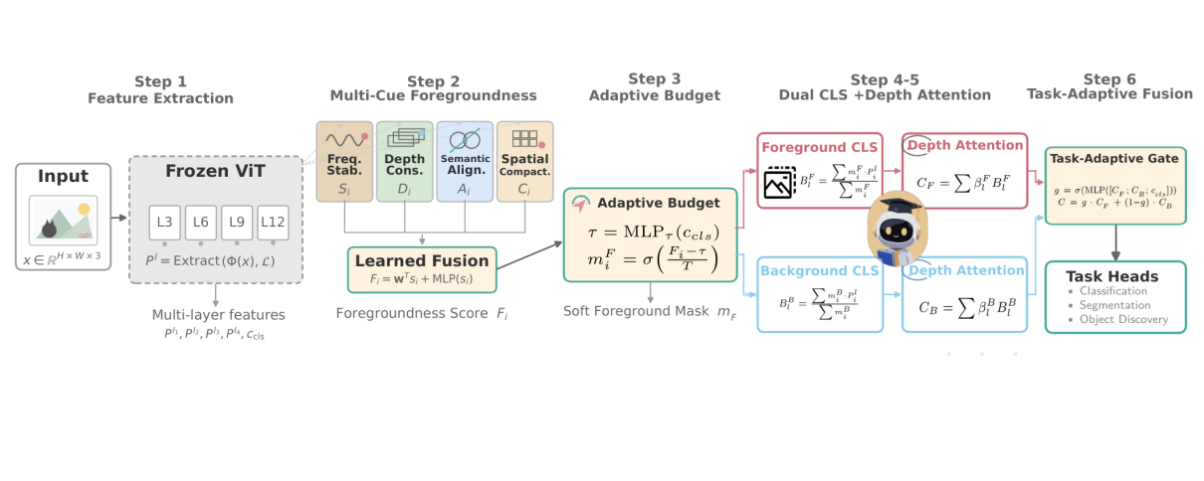

Fig. 1. Overview of the DAFB-CLS framework. Given a frozen ViT backbone, multi-layer patch features are extracted at layers {3, 6, 9, 12}. (a) The Foreground Scoring module fuses frequency stability, depth consistency, semantic alignment, and spatial compactness cues into a per-patch foregroundness score and produces an image-adaptive soft mask via a learned threshold. (b) Foreground and background CLS tokens are computed by weighted averaging using the soft mask and its complement. (c) Independent depth-wise attention aggregates each stream across layers, and a task-adaptive gate fuses the resulting representations C_F and C_B into the final representation C.

B. Foreground Scoring and Adaptive Masking
Motivation. LaSt-ViT demonstrated that frequency-domain stability distinguishes foreground from background patches, but relying on a single cue creates a brittle signal: when a foreground object happens to be spectrally smooth, such as a white swan, it becomes indistinguishable from smooth background regions, such as sky. Moreover, the fixed Top-K selection ratio assumes a constant foreground proportion across images, an assumption violated by the wide variation in object size and scene complexity in natural images. These two limitations, identified empirically in Section IV-C, motivate us to enrich the foreground signal with multiple complementary cues and replace the rigid budget with an image-adaptive threshold.
Multi-cue foregroundness scoring. We design four cues that capture orthogonal aspects of foregroundness, each producing a per-patch score matrix with size B×N. Frequency stability Sᵢ follows LaSt-ViT: we compute the 1D FFT of each patch feature along the channel dimension, apply a Gaussian low-pass filter G(σf)=exp(−f²/(2σf²)), and measure the ratio of filtered to original signal. Foreground patches exhibit stable low-frequency activations, producing high Sᵢ.
Depth consistency Dᵢ is based on the observation that patches belonging to semantically meaningful objects maintain more consistent representations across network depth than background patches, which lack strong semantic anchoring. We measure this consistency as the average cosine similarity between each layer's feature and the cross-layer mean:
${\overline{p}}_{i}=\frac{1}{K}\sum_{k=1}^{K}{P_{i}^{l_{k}}}, D_{i}=\frac{1}{K}\sum_{k=1}^{K}{\frac{P_{i}^{l_{k}}⋅{\overline{p}}_{i}}{{∥\begin{matrix}P_{i}^{l_{k}}\end{matrix}∥}_{2}{∥\begin{matrix}{\overline{p}}_{i}\end{matrix}∥}_{2}}}$ (1)

Semantic alignment Aᵢ measures how strongly each patch feature aligns with the global [CLS] token across layers by averaging the cosine similarity to ccls over the extracted layers. For text-supervised backbones, we optionally use text-guided alignment by taking the maximum cosine similarity to the text prototype tj at the last extracted layer. Spatial compactness Cᵢ reflects the fact that foreground objects occupy spatially contiguous regions. We apply average pooling with a 3×3 kernel to the semantic alignment score map, enforcing local neighborhood coherence without additional parameters.
The four cues are fused through a combination of learned softmax weights and a two-layer MLP that captures nonlinear cue interactions:
$F_{i}=\underset{ }{\underset{ }{\sum_{k=1}^{4}{w_{k}}s_{i,k}}}+\underset{ }{\underset{ }{MLP\left(s_{i}\right)}}+0.5⋅σ{\left(W_{s}∗Reshape(⋅)\right)}_{[i]}$ (2)
where w=softmax(θw) are learnable cue weights, and the final term applies 3×3 convolutional spatial smoothing, initialized to uniform 1/9, to ensure spatial coherence of the foregroundness map.
Adaptive masking. Rather than selecting a fixed top-K fraction of patches, we predict an image-specific threshold τ from the global feature ccls and apply a temperature-controlled sigmoid:
$τ={MLP}_{τ}\left(c_{cls}\right), m_{i}^{F}=σ\left(\frac{F_{i}−τ}{T}\right)$ (3)
where $τ$ is a learnable temperature, initialized to 0.1 in log-space and clamped to [0.01, 1.0]. This soft mask naturally adapts to images with different foreground proportions and avoids the gradient discontinuity of hard thresholding. A budget regularization loss, described in Section III-D, prevents degenerate all-foreground or all-background solutions.

C. Dual CLS Decoupling with Depth Attention
Motivation. A natural question is why we maintain a separate background stream rather than simply suppressing background. The answer lies in the complementary value of background information: scene type, spatial layout, and co-occurrence statistics aid classification and may even support localization. However, under the default aggregation, this background context contaminates the [CLS] token through Lazy Aggregation, degrading foreground localization. The solution is not to discard background but to decouple it: maintain two separate semantic streams so that each can develop task-relevant representations independently, then fuse them adaptively based on task requirements.
Furthermore, as discussed in Section II, the depth dimension presents a complementary challenge. Standard residual connections accumulate all layers uniformly, yet different layers encode fundamentally different visual information: early layers capture textures and edges, while later layers encode object semantics. AttnRes showed that content-dependent depth selection improves aggregation, but applied a single mechanism uniformly across all tokens. In our decoupled setting, the foreground and background streams require different depth aggregation patterns: foreground objects benefit from emphasizing later semantic layers, while background context relies more on earlier spatial layers. This motivates independent depth-wise attention per stream.
Dual CLS aggregation. Given the foreground mask, we compute foreground CLS tokens at each extracted layer by weighted averaging:
To prevent ambiguous boundary patches — where foreground and background cues conflict — from being confidently assigned to either stream, we model per-patch prediction uncertainty. A small MLP takes the patch features as input and outputs an uncertainty score u_i ∈ [0, 1]. The background score is then modulated by this uncertainty: patches with high uncertainty receive reduced background confidence, ensuring that the background stream focuses on definitive non-object regions rather than uncertain boundary areas.
$B_{l}^{F}=\frac{\sum_{i=1}^{N}{m_{i}^{F}}P_{i}^{l}}{\sum_{i=1}^{N}{m_{i}^{F}}+ϵ}$ (4)
For the background stream, rather than defining it as the direct complement of the foreground stream, which would make it mechanically dependent on the foreground stream, we introduce a dedicated BackgroundnessHead that independently predicts a background score, modulated by an uncertainty estimator:
$m_{i}^{B}=σ\left({MLP}_{B}\left(P_{i}^{l_{K}}\right)\right)⋅\left(1−m_{i}^{F}\right)⋅σ\left({MLP}_{U}\left(P_{i}^{l_{K}}\right)\right)$ (5)
The foreground-complement term excludes high-confidence foreground patches, while the uncertainty term prevents ambiguous boundary patches from being confidently assigned. Background CLS tokens are computed analogously to Eq. (4).
Independent depth-wise attention. Each stream performs softmax attention over its K-layer CLS sequence using a learned pseudo-query, extending AttnRes's concept to the visual domain:
$β_{l}^{F}=\frac{exp\left(w_{F}^{⊤}RMSNorm\left(B_{l}^{F}\right)\right)}{\sum_{j=1}^{K}{exp}\left(w_{F}^{⊤}RMSNorm\left(B_{j}^{F}\right)\right)},$ $C_{F}=\sum_{l=1}^{K}{β_{l}^{F}}B_{l}^{F}$ (6)
Here the foreground pseudo-query is initialized to zero, yielding uniform 1/K weights initially and matching standard average pooling. The background stream uses its own pseudo-query, producing a background representation and background depth weights. RMSNorm on keys prevents layers with large activation magnitudes from dominating. As validated in Section IV-C, sharing a single depth attention across streams rather than using independent ones reduces PiB from 45% to 28%, confirming that each stream requires distinct depth aggregation patterns.
Task-adaptive fusion. The final representation C is produced by a learned gate that adaptively weights the foreground and background representations:
$g=σ\left({MLP}_{g}\left(\left[C_{F};C_{B};c_{cls}\right]\right)\right), C=g⋅C_{F}+\left(1−g\right)⋅C_{B}$ (7)
Here the gate function g = σ(MLP_g([C_F, C_B, c_cls])) is implemented as a two-layer MLP with hidden dimension 128 and sigmoid output, taking the concatenation of all three representations as input. The gating mechanism learns task-specific weighting without manual tuning: object discovery tasks, where foreground is primary, naturally learn g ≈ 1, while classification tasks, where scene context aids recognition, may learn a more balanced g ≈ 0.5. Unlike a fixed-weight average or simple concatenation, the input-conditioned gate allows each image to determine its own optimal foreground-background balance — a car on a road may benefit from road context, while a bird in an irrelevant sky background should suppress it.

IV. EXPERIMENTS

A. Experimental Setup
We evaluate DAFB-CLS on two tasks — unsupervised object discovery and open-vocabulary segmentation — across two standard benchmarks. Systematic ablation studies and stress tests validate each design choice and characterize failure modes.

Datasets
We use two benchmarks. PASCAL VOC 2012 [1] provides 1,449 validation images across 20 object categories, serving as the de facto standard for unsupervised object discovery. MS COCO 2017 [2] contributes 4,952 validation images across 80 categories, enabling large-scale cross-dataset generalization assessment. For open-vocabulary segmentation with OpenCLIP, we use the VOC 2012 segmentation split with 21 classes (including background).

Metrics
We adopt four complementary metrics. ↑ denotes higher is better.
Metric | Direction | Definition | What it measures
CorLoc | ↑ | Fraction of images where center-of-mass of predicted foreground patches falls inside any GT bounding box | Coarse spatial localization
Mask IoU | ↑ | IoU between binarized predicted foreground mask and GT segmentation mask, averaged over all images | Spatial mask precision
PiB | ↑ | Fraction of images where the highest-CLS-similarity patch lies inside an annotated foreground box | Fine-grained localization
mIoU | ↑ | Mean per-class IoU over 21 classes | Open-vocabulary segmentation (OpenCLIP only)

CorLoc probes whether the model localizes an object; Mask IoU probes how precisely it delineates the object boundary; PiB probes which specific patch the model considers most salient. Together they provide a three-dimensional view of localization quality.

Comparison Methods
We compare against six baselines spanning three method families.
Attention-map methods extract localization signals from network activations without learned aggregation: CAM [3] generates class-specific heatmaps from classifier gradients; DINO-seg [4] extracts self-attention maps from self-supervised DINO ViTs and thresholds them for foreground masks.
Graph-based methods: TokenCut [5] applies Normalized Cut on the key affinity matrix from DINO's final attention layer to produce a foreground-background bipartition.
CLS-aggregation methods train a lightweight module on frozen multi-layer ViT features: LaSt-ViT [6] learns per-patch frequency stability scores via FFT and selects Top-K stable patches for CLS aggregation — it is the direct predecessor of our approach. MaskCLIP [7] uses CLIP's penultimate-layer patch-text cosine similarity for per-pixel open-vocabulary prediction, serving as the CLIP-based baseline.

Implementation Details
For DINO experiments, we use ViT-S/16 [8] pretrained with self-supervised DINO as the frozen backbone. Multi-layer patch features are extracted at layers {3, 6, 9, 12} and projected to a common 384-dimensional space. For OpenCLIP experiments, we use ViT-B/16 pretrained on LAION-2B [9]. The aggregation module is trained for 50 epochs with batch size 16, learning rate 10−4, AdamW optimizer (weight decay 0.01), and cosine annealing. Loss weights are λfg = 0.1 (foreground mask), λdec = 0.05 (decoupling), λbudget = 0.01 (budget regularization). All experiments use a single NVIDIA RTX 4070 Laptop GPU. The DINO ViT-S/16 backbone is frozen (21.67M parameters, 0 trainable); only the 0.59M-parameter aggregation head is updated.

B. Main Results
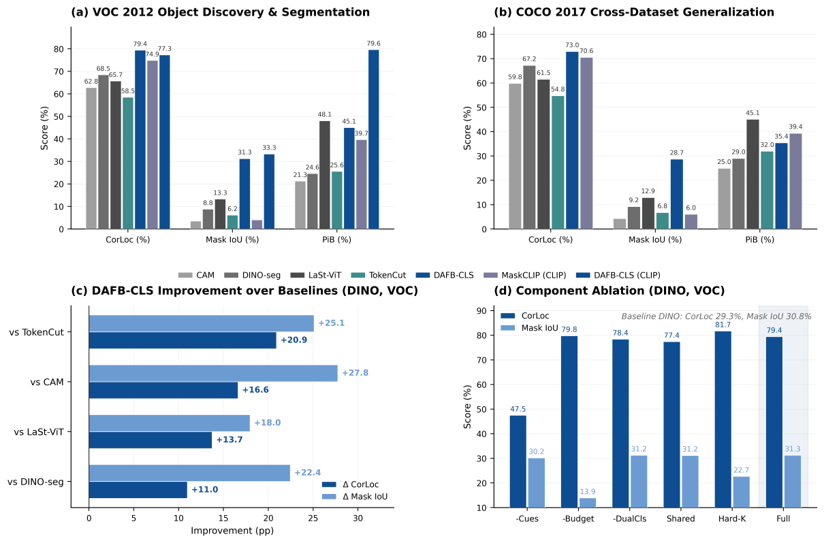
Fig. 2. Main results. (a) VOC 2012 object discovery: grouped bar comparison of CorLoc, Mask IoU, and PiB across five DINO-based methods plus two CLIP-based methods. (b) COCO 2017 cross-dataset generalization. (c) DAFB-CLS improvement over each baseline (Δ CorLoc and Δ Mask IoU). (d) Component ablation on DINO ViT-S/16 + VOC.

Object Discovery on VOC 2012
Table I compares DAFB-CLS against all baselines on the VOC validation set using DINO ViT-S/16. The raw ViT baseline (CLS-only aggregation, no foreground cues) achieves only 29.33% CorLoc, confirming that the default CLS token cannot serve as a reliable object localizer — its global receptive field dilutes foreground signals with background context.
TABLE I. Object Discovery Results on VOC 2012 (DINO ViT-S/16)
Method | Backbone | CorLoc ↑ | Mask IoU ↑ | PiB ↑
CAM | DINO-S | 62.8 | 3.52 | 21.26
DINO-seg | DINO-S | 68.46 | 8.83 | 24.64
TokenCut | DINO-S | 58.52 | 6.17 | 25.6
LaSt-ViT | DINO-S | 65.7 | 13.31 | 48.1
DAFB-CLS | DINO-S | 79.43 | 31.27 | 45.07
MaskCLIP | CLIP-B | 74.88 | 4.07 | 39.68
DAFB-CLS | CLIP-B | 77.29 | 33.32 | 79.64

DAFB-CLS achieves 79.43% CorLoc, outperforming LaSt-ViT by +13.7 pp and TokenCut by +20.9 pp. The Mask IoU improvement is even more pronounced: 31.27% vs. LaSt-ViT's 13.31% (+18.0 pp). This +18.0 pp Mask IoU gain — more than doubling the previous best — directly validates the adaptive soft mask's ability to produce spatially precise foreground regions, in contrast to the coarse binary masks from fixed Top-K or NCut bipartition.
With the stronger OpenCLIP ViT-B/16 backbone, DAFB-CLS reaches 79.64% PiB and 33.32% Mask IoU, substantially surpassing MaskCLIP (+40.0 pp PiB, +29.3 pp Mask IoU). Critically, DAFB-CLS achieves this without any text supervision — the dual CLS decoupling mechanism alone provides sufficient foreground-background discrimination.

Object Discovery on COCO 2017
To assess cross-dataset generalization, we evaluate the same models — trained only on VOC — directly on COCO without fine-tuning. Table II reports the results.
TABLE II. Object Discovery Results on COCO 2017 (DINO ViT-S/16)
Method | Backbone | CorLoc ↑ | Mask IoU ↑ | PiB ↑
CAM | DINO-S | 59.81 | 4.3 | 24.96
DINO-seg | DINO-S | 67.23 | 9.24 | 29.0
TokenCut | DINO-S | 54.75 | 6.77 | 31.97
LaSt-ViT | DINO-S | 61.53 | 12.95 | 45.09
DAFB-CLS | DINO-S | 72.96 | 28.73 | 35.44

DAFB-CLS maintains consistent gains: CorLoc reaches 72.96% (+11.4 pp over LaSt-ViT, +18.2 pp over TokenCut) and Mask IoU reaches 28.73% (+15.8 pp over LaSt-ViT). The cross-dataset Mask IoU improvement (+15.8 pp) closely tracks the VOC improvement (+18.0 pp), indicating that the adaptive soft mask generalizes robustly to unseen object categories and scenes.

Open-Vocabulary Segmentation
We further evaluate DAFB-CLS as a segmentation head on OpenCLIP ViT-B/16. Table III reports mIoU on the VOC 2012 segmentation task. DAFB-CLS achieves 61.70% mIoU, improving over the MaskCLIP baseline by +2.7 pp. The background class reaches 89.2% IoU, and several foreground classes benefit substantially from the dual CLS decoupling.
TABLE III. Open-Vocabulary Segmentation Results on VOC 2012 (OpenCLIP ViT-B/16)
Method | Backbone | mIoU ↑ | CorLoc ↑ | Mask IoU ↑ | PiB ↑
MaskCLIP | CLIP-B | 59.02 | 74.88 | 4.07 | 39.68
DAFB-CLS | CLIP-B | 61.70 | 77.29 | 33.32 | 79.64

Cross-Dataset Consistency
Table IV summarizes DAFB-CLS improvements over the strongest aggregation baseline in each setting. CorLoc improves by +11.4–13.7 pp (DINO) and +2.4 pp (CLIP, where the MaskCLIP baseline is already strong at 74.88%). Mask IoU improves by +15.8–29.2 pp across all four comparisons — the most stable and impactful gain.
TABLE IV. Cross-Dataset & Cross-Backbone Consistency
Setting | Backbone | Dataset | Δ CorLoc (pp) | Δ Mask IoU (pp)
Object Discovery | DINO-S | VOC | +13.7 | +18.0
Object Discovery | DINO-S | COCO | +11.4 | +15.8
Segmentation | CLIP-B | VOC | +2.4 | +29.3

C. Ablation Studies
To isolate the contribution of each component, we conduct systematic ablation on DINO ViT-S/16 + VOC. Each variant removes or replaces exactly one design choice. Table V reports the results.
TABLE V. Component Ablation on VOC 2012 (DINO ViT-S/16)
Variant | CorLoc ↑ | Mask IoU ↑ | PiB ↑ | Description
Baseline (raw ViT) | 29.33 | 30.76 | 42.72 | All-ones mask, equal-weight CLS aggregation
− Cues (no_cues) | 47.48 | 30.16 | 31.68 | All four foregroundness cues disabled
− Budget (no_budget) | 79.78 | 13.91 | 53.62 | Adaptive threshold → fixed Top-30%
− Dual CLS | 78.4 | 31.25 | 33.13 | Background CLS stream removed
Shared Depth | 77.43 | 31.18 | 28.36 | F/B streams share one depth attention
Hard Top-K | 81.71 | 22.68 | 51.76 | Soft mask → hard binary Top-K selection
Full DAFB-CLS | 79.43 | 31.27 | 45.07 | All components active

Multi-cue foregroundness is the foundation. Removing all four cues (−Cues) collapses CorLoc from 79.43% to 47.48% (−32.0 pp). This is the single largest drop, confirming that the foregroundness score provides the essential spatial selection signal. Without cues, the model receives no foreground-background signal and degenerates to near-random patch averaging.
Adaptive budget prevents masking collapse. Replacing the adaptive threshold with fixed Top-30% (−Budget) produces a revealing trade-off: CorLoc remains high (79.78%) but Mask IoU crashes from 31.27% to 13.91% (−17.4 pp). The fixed ratio forces the model to always predict 30% of patches as foreground, regardless of actual object size.
Dual CLS enables spatial localization. Removing the background stream (−Dual CLS) drops PiB from 45.07% to 33.13% (−11.9 pp), demonstrating that maintaining an explicit background representation is critical for the foreground stream to concentrate on object regions.
Independent depth attention benefits each stream. Sharing depth attention (Shared Depth) reduces PiB to 28.36% (−16.7 pp), the largest PiB drop among all ablations. Foreground and background require distinct depth aggregation patterns: foreground benefits from later semantic layers (L9–L12), while background relies on earlier spatial layers (L3–L6).
Summary. The ablation reveals a clear division of labor: multi-cue foregroundness drives CorLoc (spatial selection), adaptive budget drives Mask IoU (mask precision), and dual CLS with independent depth attention drives PiB (representation quality). Each component addresses a distinct failure mode, and all are necessary for the full framework.

D. Qualitative Analysis
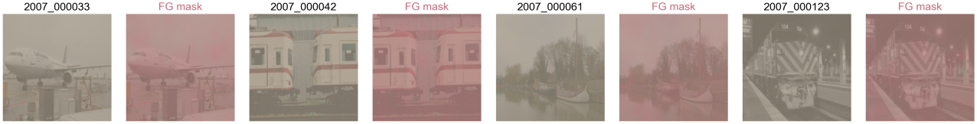
Fig. 3. Qualitative foreground mask visualization. Each row: input image, ground-truth mask, predicted foreground mask, predicted background mask, frequency stability score heatmap. Columns show representative examples from textured, multi-object, small-object, and stable-background scenarios.
Fig. 3 presents representative mask predictions across diverse scene types. DAFB-CLS produces clean foreground masks on textured objects (animals, vehicles) where multi-cue signals are strong and consistent. On multi-object scenes, the dual CLS mechanism successfully separates multiple foreground instances from the background. Small objects remain moderately challenging — while the adaptive budget allocates appropriate foreground ratios, the 16×16 patch resolution of ViT-S/16 limits fine-grained boundary precision. The stable background scenario (sky, water, walls) is the primary failure mode, discussed in §E (Stress Test).
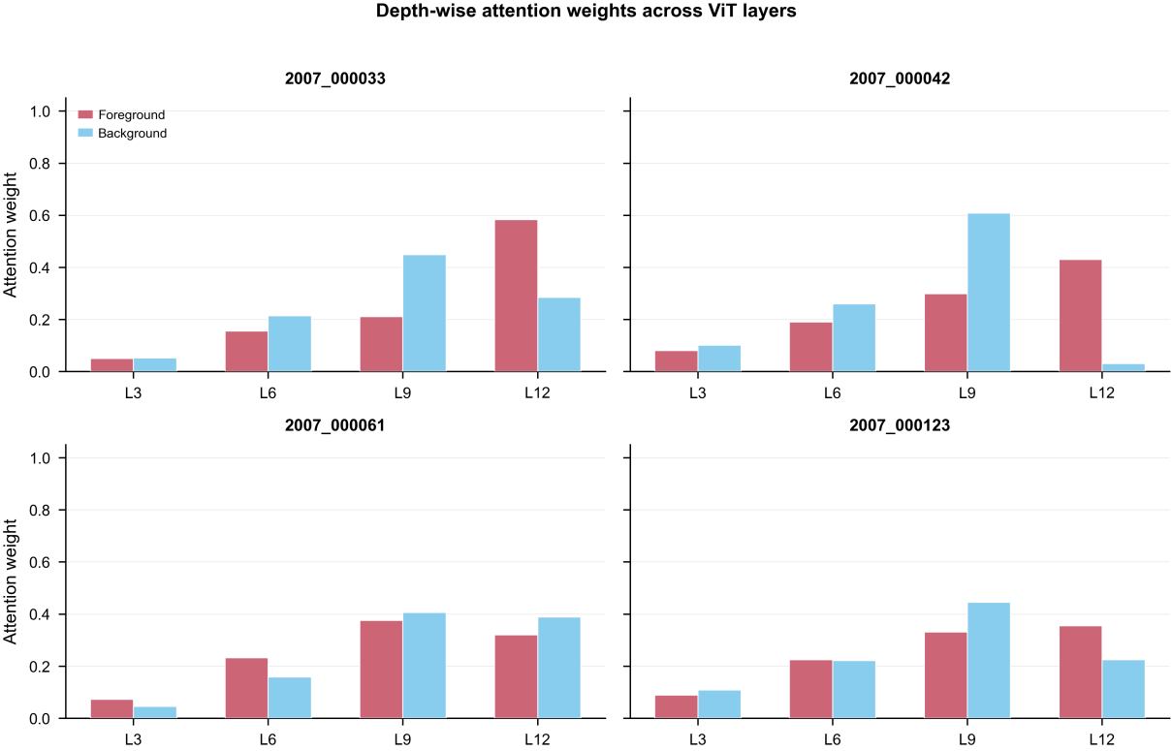
Fig. 4. Depth attention weight analysis. Foreground and background depth attention weights across layers L3–L12 for representative images. Foreground attention concentrates on later semantic layers; background attention distributes more evenly, with emphasis on early spatial layers.
Fig. 4 visualizes the learned foreground and background depth attention weights across layers {3, 6, 9, 12}. Two consistent patterns emerge. First, foreground attention concentrates on later layers (L9–L12), consistent with the intuition that semantic object representations develop in deeper ViT blocks. Second, background attention distributes more evenly, with notable weight on earlier layers (L3–L6) that retain fine-grained spatial structure useful for identifying non-object regions. The divergence between the two attention patterns validates the design choice of independent depth attention modules — a shared attention would be forced to compromise between these opposing preferences.

E. Stress Test
To characterize failure modes and establish realistic performance boundaries, we evaluate the full DAFB-CLS on four challenging subsets of VOC 2012, stratified by scene difficulty. Table VI reports per-subset metrics.
TABLE VI. Stress Test Results (DINO ViT-S/16, VOC 2012)
Subset | N | FG IoU ↑ | PiB ↑ | Pred FG Ratio | Pearson r
Stable Background | 551 | 13.02 | 20.87 | 0.48 | 0.394
Textured Foreground | 898 | 34.42 | 43.88 | 0.59 | 0.635
Small Object (<10% area) | 450 | 26.92 | 34.67 | 0.55 | 0.645
Multi-Object (≥3 instances) | 436 | 36.19 | 43.12 | 0.6 | 0.605

Stable background is the Achilles' heel. As discussed in Section IV-D and visualized in Fig. 3, images dominated by smooth, low-texture regions show the most severe degradation. Table VI quantifies this: FG IoU drops to 13.02% and PiB falls to 20.87%. The root cause is architectural — the frequency stability cue, designed to identify stable foreground patches via FFT low-pass filtering, cannot distinguish a smooth foreground object from a smooth background region, as both produce similar low-frequency activation patterns. The model consequently over-predicts foreground in these scenes (predicted ratio 0.48 vs. ground truth typically < 0.20). Mitigating this failure mode requires either an explicit high-frequency rejection cue or a learned background-prior head — directions we leave for future work.
Textured objects and multi-object scenes work best. The model performs best on textured foreground (34.42% FG IoU) and multi-object scenes (36.19%), where high-frequency texture cues provide strong discriminative signals.
Small objects are limited by spatial resolution. The 16×16 patch grid (ViT-S/16, 224×224 input) provides only coarse spatial granularity. Objects occupying less than 10% of image area correspond to at most 3–4 patches, leaving the adaptive mask with insufficient spatial resolution for precise boundary delineation.
The predicted foreground ratio clusters around 0.48–0.60 across all subsets regardless of ground truth (Pearson r only 0.394–0.645), indicating that the adaptive budget module learns a dataset-level prior rather than truly adapting per-image. Improving the image-conditional threshold prediction is a promising direction for future work.

F. Efficiency Analysis
Table VII reports parameter count, FLOPs, inference latency, and GPU memory for DAFB-CLS relative to the backbone baseline and LaSt-ViT. All measurements use batch size 1, 224×224 input, and 100-run averaging on an NVIDIA RTX 4070 Laptop GPU.
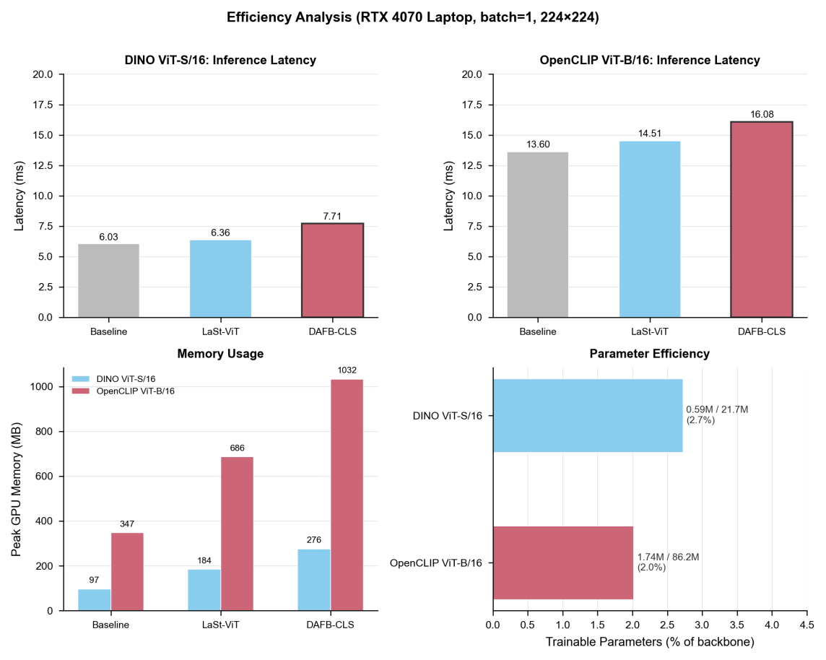
Fig. 5. Efficiency analysis. Comparison across backbone baseline, LaSt-ViT, and DAFB-CLS for both DINO ViT-S/16 and OpenCLIP ViT-B/16 backbones.
TABLE VII. Efficiency Comparison (RTX 4070 Laptop, bs=1, 224×224)
Method | Backbone | Total (M) | Trainable (M) | FLOPs (G) | Latency (ms) | Memory (MB) | Overhead
Baseline | DINO-S | 21.67 | 0.0004 | 4.25 | 5.9 | 97 | —
LaSt-ViT | DINO-S | 22.25 | 0.59 | 4.26 | 6.21 | 184 | 1.05×
DAFB-CLS | DINO-S | 22.25 | 0.59 | 4.30 | 7.72 | 276 | 1.31×
Baseline | CLIP-B | 86.21 | 0.016 | 2.91 | 12.37 | 347 | —
LaSt-ViT | CLIP-B | 87.94 | 1.74 | 11.37 | 13.8 | 687 | 1.12×
DAFB-CLS | CLIP-B | 87.94 | 1.74 | 11.42 | 15.82 | 1033 | 1.28×

DAFB-CLS adds only 0.59M trainable parameters for DINO (2.7% of backbone) and 1.74M for OpenCLIP (2.0%). The inference latency overhead is +1.82 ms for DINO (1.31×) and +3.45 ms for OpenCLIP (1.28×) — modest compared to the substantial accuracy gains. The primary cost is GPU memory: DAFB-CLS requires 276 MB for DINO (~2.8× baseline) and 1033 MB for OpenCLIP (~3.0× baseline), driven by storing multi-layer patch features during the forward pass. Memory scales linearly with the number of extracted layers; reducing to 2 layers would approximately halve the memory requirement.

