IV. EXPERIMENTS

A. Experimental Setup
We evaluate DAFB-CLS on two tasks — unsupervised object discovery and open-vocabulary segmentation — across two standard benchmarks. Systematic ablation studies and stress tests validate each design choice and characterize failure modes.

Datasets
We use two benchmarks. PASCAL VOC 2012 [1] provides 1,449 validation images across 20 object categories, serving as the de facto standard for unsupervised object discovery. MS COCO 2017 [2] contributes 4,952 validation images across 80 categories, enabling large-scale cross-dataset generalization assessment. For open-vocabulary segmentation with OpenCLIP, we use the VOC 2012 segmentation split with 21 classes (including background).

Metrics
We adopt four complementary metrics. ↑ denotes higher is better.
Metric | Direction | Definition | What it measures
CorLoc | ↑ | Fraction of images where center-of-mass of predicted foreground patches falls inside any GT bounding box | Coarse spatial localization
Mask IoU | ↑ | IoU between binarized predicted foreground mask and GT segmentation mask, averaged over all images | Spatial mask precision
PiB | ↑ | Fraction of images where the highest-CLS-similarity patch lies inside an annotated foreground box | Fine-grained localization
mIoU | ↑ | Mean per-class IoU over 21 classes | Open-vocabulary segmentation (OpenCLIP only)

CorLoc probes whether the model localizes an object; Mask IoU probes how precisely it delineates the object boundary; PiB probes which specific patch the model considers most salient. Together they provide a three-dimensional view of localization quality.

Comparison Methods
We compare against six baselines spanning three method families.
Attention-map methods extract localization signals from network activations without learned aggregation: CAM [3] generates class-specific heatmaps from classifier gradients; DINO-seg [4] extracts self-attention maps from self-supervised DINO ViTs and thresholds them for foreground masks.
Graph-based methods: TokenCut [5] applies Normalized Cut on the key affinity matrix from DINO's final attention layer to produce a foreground-background bipartition.
CLS-aggregation methods train a lightweight module on frozen multi-layer ViT features: LaSt-ViT [6] learns per-patch frequency stability scores via FFT and selects Top-K stable patches for CLS aggregation — it is the direct predecessor of our approach. MaskCLIP [7] uses CLIP's penultimate-layer patch-text cosine similarity for per-pixel open-vocabulary prediction, serving as the CLIP-based baseline.

Implementation Details
For DINO experiments, we use ViT-S/16 [8] pretrained with self-supervised DINO as the frozen backbone. Multi-layer patch features are extracted at layers {3, 6, 9, 12} and projected to a common 384-dimensional space. For OpenCLIP experiments, we use ViT-B/16 pretrained on LAION-2B [9]. The aggregation module is trained for 50 epochs with batch size 16, learning rate 10−4, AdamW optimizer (weight decay 0.01), and cosine annealing. Loss weights are λfg = 0.1 (foreground mask), λdec = 0.05 (decoupling), λbudget = 0.01 (budget regularization). All experiments use a single NVIDIA RTX 4070 Laptop GPU. The DINO ViT-S/16 backbone is frozen (21.67M parameters, 0 trainable); only the 0.59M-parameter aggregation head is updated.

B. Main Results
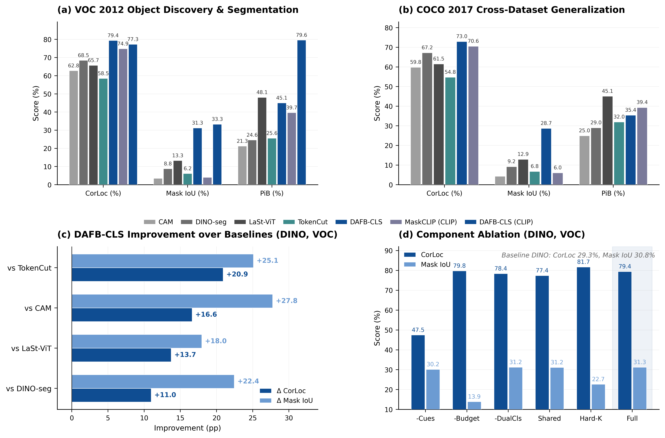
Fig. 2. Main results. (a) VOC 2012 object discovery: grouped bar comparison of CorLoc, Mask IoU, and PiB across five DINO-based methods plus two CLIP-based methods. (b) COCO 2017 cross-dataset generalization. (c) DAFB-CLS improvement over each baseline (Δ CorLoc and Δ Mask IoU). (d) Component ablation on DINO ViT-S/16 + VOC.

Object Discovery on VOC 2012
Table I compares DAFB-CLS against all baselines on the VOC validation set using DINO ViT-S/16. The raw ViT baseline (CLS-only aggregation, no foreground cues) achieves only 29.33% CorLoc, confirming that the default CLS token cannot serve as a reliable object localizer — its global receptive field dilutes foreground signals with background context.
TABLE I. Object Discovery Results on VOC 2012 (DINO ViT-S/16)
Method | Backbone | CorLoc ↑ | Mask IoU ↑ | PiB ↑
CAM | DINO-S | 62.8 | 3.52 | 21.26
DINO-seg | DINO-S | 68.46 | 8.83 | 24.64
TokenCut | DINO-S | 58.52 | 6.17 | 25.6
LaSt-ViT | DINO-S | 65.7 | 13.31 | 48.1
DAFB-CLS | DINO-S | 79.43 | 31.27 | 45.07
MaskCLIP | CLIP-B | 74.88 | 4.07 | 39.68
DAFB-CLS | CLIP-B | 77.29 | 33.32 | 79.64

DAFB-CLS achieves 79.43% CorLoc, outperforming LaSt-ViT by +13.7 pp and TokenCut by +20.9 pp. The Mask IoU improvement is even more pronounced: 31.27% vs. LaSt-ViT's 13.31% (+18.0 pp). This +18.0 pp Mask IoU gain — more than doubling the previous best — directly validates the adaptive soft mask's ability to produce spatially precise foreground regions, in contrast to the coarse binary masks from fixed Top-K or NCut bipartition.
With the stronger OpenCLIP ViT-B/16 backbone, DAFB-CLS reaches 79.64% PiB and 33.32% Mask IoU, substantially surpassing MaskCLIP (+40.0 pp PiB, +29.3 pp Mask IoU). Critically, DAFB-CLS achieves this without any text supervision — the dual CLS decoupling mechanism alone provides sufficient foreground-background discrimination.

Object Discovery on COCO 2017
To assess cross-dataset generalization, we evaluate the same models — trained only on VOC — directly on COCO without fine-tuning. Table II reports the results.
TABLE II. Object Discovery Results on COCO 2017 (DINO ViT-S/16)
Method | Backbone | CorLoc ↑ | Mask IoU ↑ | PiB ↑
CAM | DINO-S | 59.81 | 4.3 | 24.96
DINO-seg | DINO-S | 67.23 | 9.24 | 29.0
TokenCut | DINO-S | 54.75 | 6.77 | 31.97
LaSt-ViT | DINO-S | 61.53 | 12.95 | 45.09
DAFB-CLS | DINO-S | 72.96 | 28.73 | 35.44

DAFB-CLS maintains consistent gains: CorLoc reaches 72.96% (+11.4 pp over LaSt-ViT, +18.2 pp over TokenCut) and Mask IoU reaches 28.73% (+15.8 pp over LaSt-ViT). The cross-dataset Mask IoU improvement (+15.8 pp) closely tracks the VOC improvement (+18.0 pp), indicating that the adaptive soft mask generalizes robustly to unseen object categories and scenes.

Open-Vocabulary Segmentation
We further evaluate DAFB-CLS as a segmentation head on OpenCLIP ViT-B/16. Table III reports mIoU on the VOC 2012 segmentation task. DAFB-CLS achieves 61.70% mIoU, improving over the MaskCLIP baseline by +2.7 pp. The background class reaches 89.2% IoU, and several foreground classes benefit substantially from the dual CLS decoupling.
TABLE III. Open-Vocabulary Segmentation Results on VOC 2012 (OpenCLIP ViT-B/16)
Method | Backbone | mIoU ↑ | CorLoc ↑ | Mask IoU ↑ | PiB ↑
MaskCLIP | CLIP-B | 59.02 | 74.88 | 4.07 | 39.68
DAFB-CLS | CLIP-B | 61.70 | 77.29 | 33.32 | 79.64

Cross-Dataset Consistency
Table IV summarizes DAFB-CLS improvements over the strongest aggregation baseline in each setting. CorLoc improves by +11.4–13.7 pp (DINO) and +2.4 pp (CLIP, where the MaskCLIP baseline is already strong at 74.88%). Mask IoU improves by +15.8–29.2 pp across all four comparisons — the most stable and impactful gain.
TABLE IV. Cross-Dataset & Cross-Backbone Consistency
Setting | Backbone | Dataset | Δ CorLoc (pp) | Δ Mask IoU (pp)
Object Discovery | DINO-S | VOC | +13.7 | +18.0
Object Discovery | DINO-S | COCO | +11.4 | +15.8
Segmentation | CLIP-B | VOC | +2.4 | +29.3

C. Ablation Studies
To isolate the contribution of each component, we conduct systematic ablation on DINO ViT-S/16 + VOC. Each variant removes or replaces exactly one design choice. Table V reports the results.
TABLE V. Component Ablation on VOC 2012 (DINO ViT-S/16)
Variant | CorLoc ↑ | Mask IoU ↑ | PiB ↑ | Description
Baseline (raw ViT) | 29.33 | 30.76 | 42.72 | All-ones mask, equal-weight CLS aggregation
− Cues (no_cues) | 47.48 | 30.16 | 31.68 | All four foregroundness cues disabled
− Budget (no_budget) | 79.78 | 13.91 | 53.62 | Adaptive threshold → fixed Top-30%
− Dual CLS | 78.4 | 31.25 | 33.13 | Background CLS stream removed
Shared Depth | 77.43 | 31.18 | 28.36 | F/B streams share one depth attention
Hard Top-K | 81.71 | 22.68 | 51.76 | Soft mask → hard binary Top-K selection
Full DAFB-CLS | 79.43 | 31.27 | 45.07 | All components active

Multi-cue foregroundness is the foundation. Removing all four cues (−Cues) collapses CorLoc from 79.43% to 47.48% (−32.0 pp). This is the single largest drop, confirming that the foregroundness score provides the essential spatial selection signal. Without cues, the model receives no foreground-background signal and degenerates to near-random patch averaging.
Adaptive budget prevents masking collapse. Replacing the adaptive threshold with fixed Top-30% (−Budget) produces a revealing trade-off: CorLoc remains high (79.78%) but Mask IoU crashes from 31.27% to 13.91% (−17.4 pp). The fixed ratio forces the model to always predict 30% of patches as foreground, regardless of actual object size.
Dual CLS enables spatial localization. Removing the background stream (−Dual CLS) drops PiB from 45.07% to 33.13% (−11.9 pp), demonstrating that maintaining an explicit background representation is critical for the foreground stream to concentrate on object regions.
Independent depth attention benefits each stream. Sharing depth attention (Shared Depth) reduces PiB to 28.36% (−16.7 pp), the largest PiB drop among all ablations. Foreground and background require distinct depth aggregation patterns: foreground benefits from later semantic layers (L9–L12), while background relies on earlier spatial layers (L3–L6).
Summary. The ablation reveals a clear division of labor: multi-cue foregroundness drives CorLoc (spatial selection), adaptive budget drives Mask IoU (mask precision), and dual CLS with independent depth attention drives PiB (representation quality). Each component addresses a distinct failure mode, and all are necessary for the full framework.

D. Qualitative Analysis
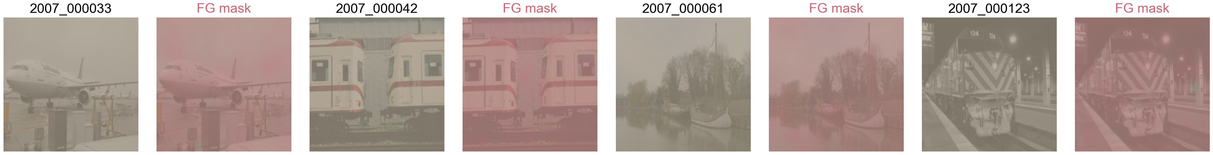
Fig. 3. Qualitative foreground mask visualization. Each row: input image, ground-truth mask, predicted foreground mask, predicted background mask, frequency stability score heatmap. Columns show representative examples from textured, multi-object, small-object, and stable-background scenarios.
Fig. 3 presents representative mask predictions across diverse scene types. DAFB-CLS produces clean foreground masks on textured objects (animals, vehicles) where multi-cue signals are strong and consistent. On multi-object scenes, the dual CLS mechanism successfully separates multiple foreground instances from the background. Small objects remain moderately challenging — while the adaptive budget allocates appropriate foreground ratios, the 16×16 patch resolution of ViT-S/16 limits fine-grained boundary precision. The stable background scenario (sky, water, walls) is the primary failure mode, discussed in §E (Stress Test).
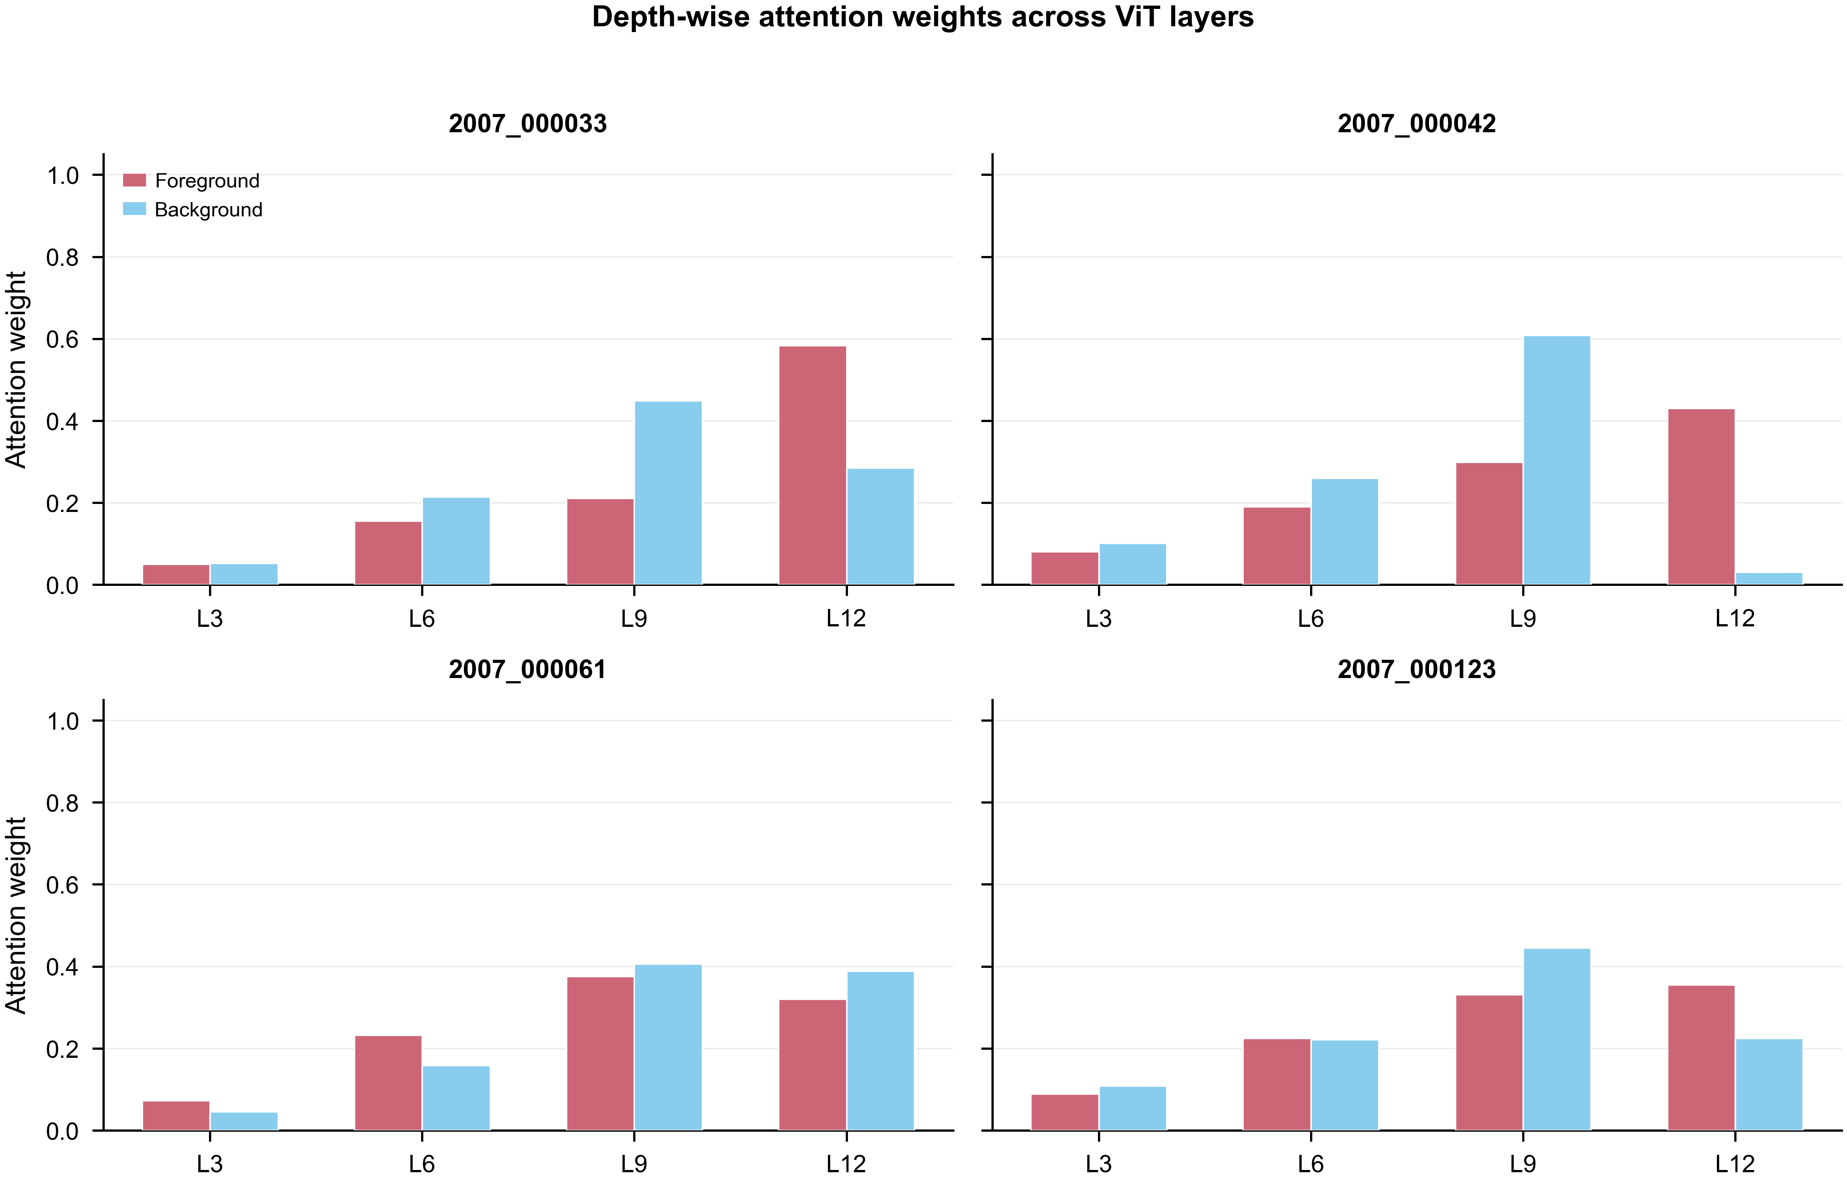
Fig. 4. Depth attention weight analysis. Foreground and background depth attention weights across layers L3–L12 for representative images. Foreground attention concentrates on later semantic layers; background attention distributes more evenly, with emphasis on early spatial layers.
Fig. 4 visualizes the learned foreground and background depth attention weights across layers {3, 6, 9, 12}. Two consistent patterns emerge. First, foreground attention concentrates on later layers (L9–L12), consistent with the intuition that semantic object representations develop in deeper ViT blocks. Second, background attention distributes more evenly, with notable weight on earlier layers (L3–L6) that retain fine-grained spatial structure useful for identifying non-object regions. The divergence between the two attention patterns validates the design choice of independent depth attention modules — a shared attention would be forced to compromise between these opposing preferences.

E. Stress Test
To characterize failure modes and establish realistic performance boundaries, we evaluate the full DAFB-CLS on four challenging subsets of VOC 2012, stratified by scene difficulty. Table VI reports per-subset metrics.
TABLE VI. Stress Test Results (DINO ViT-S/16, VOC 2012)
Subset | N | FG IoU ↑ | PiB ↑ | Pred FG Ratio | Pearson r
Stable Background | 551 | 13.02 | 20.87 | 0.48 | 0.394
Textured Foreground | 898 | 34.42 | 43.88 | 0.59 | 0.635
Small Object (<10% area) | 450 | 26.92 | 34.67 | 0.55 | 0.645
Multi-Object (≥3 instances) | 436 | 36.19 | 43.12 | 0.6 | 0.605

Stable background is the Achilles' heel. Images dominated by sky, walls, water, or other smooth, low-texture regions show the most severe degradation: FG IoU drops to 13.02%, and PiB falls to 20.87%. The root cause is architectural: the frequency stability cue, designed to identify stable foreground patches via FFT low-pass filtering, cannot distinguish a smooth foreground object (e.g., a uniformly colored car) from a smooth background region (e.g., a blue sky). Both produce similar low-frequency activation patterns, leading the model to systematically over-predict foreground (predicted ratio 0.48 vs. ground truth typically < 0.20).
Textured objects and multi-object scenes work best. The model performs best on textured foreground (34.42% FG IoU) and multi-object scenes (36.19%), where high-frequency texture cues provide strong discriminative signals.
Small objects are limited by spatial resolution. The 16×16 patch grid (ViT-S/16, 224×224 input) provides only coarse spatial granularity. Objects occupying less than 10% of image area correspond to at most 3–4 patches, leaving the adaptive mask with insufficient spatial resolution for precise boundary delineation.
The predicted foreground ratio clusters around 0.48–0.60 across all subsets regardless of ground truth (Pearson r only 0.394–0.645), indicating that the adaptive budget module learns a dataset-level prior rather than truly adapting per-image. Improving the image-conditional threshold prediction is a promising direction for future work.

F. Efficiency Analysis
Table VII reports parameter count, FLOPs, inference latency, and GPU memory for DAFB-CLS relative to the backbone baseline and LaSt-ViT. All measurements use batch size 1, 224×224 input, and 100-run averaging on an NVIDIA RTX 4070 Laptop GPU.
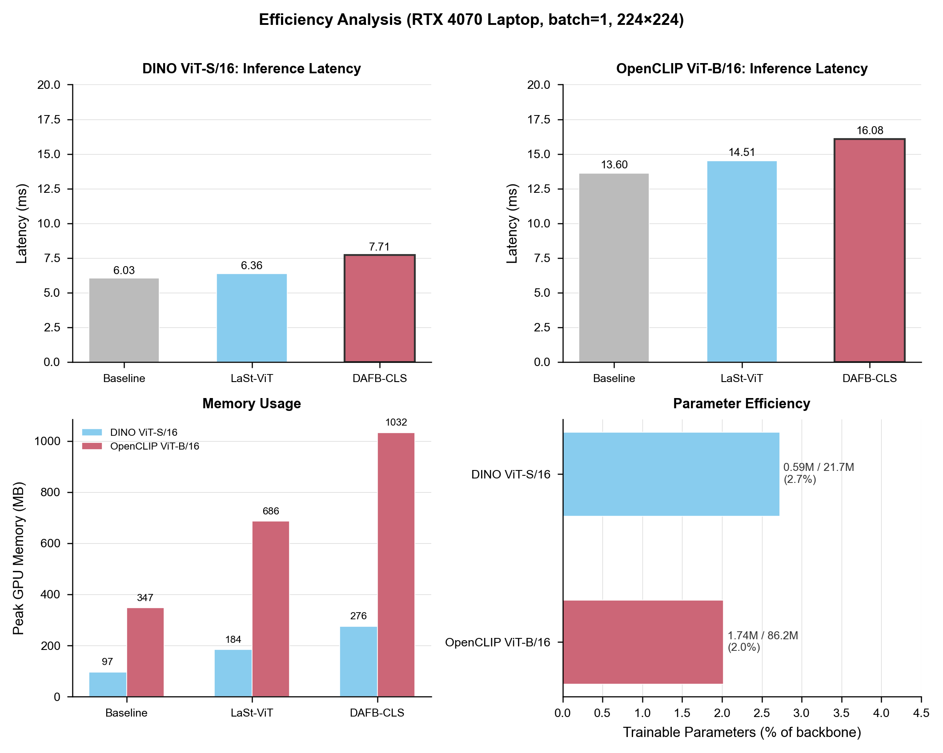
Fig. 5. Efficiency analysis. Comparison across backbone baseline, LaSt-ViT, and DAFB-CLS for both DINO ViT-S/16 and OpenCLIP ViT-B/16 backbones.
TABLE VII. Efficiency Comparison (RTX 4070 Laptop, bs=1, 224×224)
Method | Backbone | Total (M) | Trainable (M) | FLOPs (G) | Latency (ms) | Memory (MB) | Overhead
Baseline | DINO-S | 21.67 | 0.0004 | 4.25 | 5.9 | 97 | —
LaSt-ViT | DINO-S | 22.25 | 0.59 | 4.26 | 6.21 | 184 | 1.05×
DAFB-CLS | DINO-S | 22.25 | 0.59 | 4.30 | 7.72 | 276 | 1.31×
Baseline | CLIP-B | 86.21 | 0.016 | 2.91 | 12.37 | 347 | —
LaSt-ViT | CLIP-B | 87.94 | 1.74 | 11.37 | 13.8 | 687 | 1.12×
DAFB-CLS | CLIP-B | 87.94 | 1.74 | 11.42 | 15.82 | 1033 | 1.28×

DAFB-CLS adds only 0.59M trainable parameters for DINO (2.7% of backbone) and 1.74M for OpenCLIP (2.0%). The inference latency overhead is +1.82 ms for DINO (1.31×) and +3.45 ms for OpenCLIP (1.28×) — modest compared to the substantial accuracy gains. The primary cost is GPU memory: DAFB-CLS requires 276 MB for DINO (~2.8× baseline) and 1033 MB for OpenCLIP (~3.0× baseline), driven by storing multi-layer patch features during the forward pass. Memory scales linearly with the number of extracted layers; reducing to 2 layers would approximately halve the memory requirement.

