IV. Experiments
We evaluate DAFB-CLS on unsupervised object discovery and open-vocabulary segmentation across two benchmarks. Comprehensive ablation studies validate each design component, and efficiency analysis confirms the practical overhead is modest.

A. Experimental Setup
Datasets. We use two standard benchmarks for evaluation: (i) PASCAL VOC 2012, containing 1,449 validation images across 20 object categories, widely used for object discovery and weakly supervised segmentation; (ii) MS COCO 2017, containing 4,952 validation images across 80 categories, providing a larger-scale and more diverse testbed. All images are resized to 224×224 and processed through the frozen backbone without any additional data augmentation during evaluation.
Metrics. We adopt four complementary metrics:
- CorLoc: the percentage of images where the highest-scoring patch falls within a ground-truth bounding box, measuring whether the aggregated CLS representation correctly localizes the primary object.
- Mask IoU: the intersection-over-union between the predicted soft foreground mask and ground-trutsegmentation masks, averaged over all images, measuring spatial mask quality.
- PiB: the percentage of images where the patch with the highest Patch Score lies within an annotated foreground bounding box, providing a finer-grained localization diagnostic.
- mIoU: mean intersection-over-union across all classes, used for the open-vocabulary segmentation task with OpenCLIP.
Comparison Methods. We compare against four representative baselines: (i) CAM: class activation mapping from the frozen backbone, serving as the standard weakly-supervised localization baseline; (ii) DINO-seg: self-attention-based unsupervised segmentation from DINO; (iii) LaSt-ViT: frequency-stability-based CLS aggregation with fixed Top-K selection (K=59 for VOC, K=147 for COCO, ~30% of patches); (iv) DAFB-CLS (ours): the full framework with multi-cue foregroundness, adaptive budget, dual CLS decoupling, and independent depth-wise attention.
Implementation Details. For DINO experiments, we use ViT-S/16 as the frozen backbone with features extracted at layers {3, 6, 9, 12}. The aggregation module is trained for 50 epochs with batch size 16, learning rate 10⁻⁴, cosine scheduler, and mixed-precision training. Loss weights are λ_fg = 1.0, λ_dec = 0.05, λ_bud = 0.01. For OpenCLIP experiments, we use ViT-B/16 pretrained on LAION-2B with the same layer indices and analogous hyperparameters. All experiments run on a single NVIDIA RTX 4070 GPU.

B. Main Results
Object Discovery on VOC 2012. Table II compares DAFB-CLS against baselines on the VOC validation set using DINO ViT-S/16. The raw ViT baseline achieves only 29.33% CorLoc, confirming that the default CLS token poorly localizes objects. DINO-seg improves CorLoc to 68.46% via self-attention maps but produces noisy masks (8.83% Mask IoU). LaSt-ViT introduces frequency-guided selection, raising Mask IoU to 13.31%, but its fixed Top-K budget limits spatial precision. DAFB-CLS achieves 79.43% CorLoc (+13.7 pp over LaSt-ViT) and 31.27% Mask IoU ( +18.0 pp), representing a +50 pp improvement in CorLoc over the raw ViT baseline. The substantial Mask IoU gain demonstrates that the adaptive soft mask produces significantly more spatially accurate foreground regions than fixed-ratio selection.
TABLE II
Object Discovery Results on VOC 2012 (DINO ViT-S/16)
Method | CorLoc (%) | Mask IoU (%) | PiB (%)
CAM | 62.80 | 3.52 | 21.26
DINO-seg | 68.46 | 8.83 | 24.64
LaSt-ViT | 65.70 | 13.31 | 48.10
DAFB-CLS (ours) | 79.43 | 31.27 | 45.07
Object Discovery on COCO. To assess cross-dataset generalization, we evaluate on COCO 2017 (80 categories) without retraining. Table III shows that DAFB-CLS maintains consistent improvements: CorLoc reaches 72.96% (+11.4 pp over LaSt-ViT) and Mask IoU reaches 28.73% (+15.8 pp). The gains are slightly smaller than on VOC, which is expected given the larger category diversity, but the trends are fully consistent. Notably, Mask IoU improvement remains remarkably stable across datasets (+18.0 pp on VOC vs. +15.8 pp on COCO), validating that the adaptive soft mask generalizes across varying object scales and category distributions.
TABLE III
Object Discovery Results on COCO 2017 (DINO ViT-S/16)
Method | CorLoc (%) | Mask IoU (%) | PiB (%)
CAM | 59.81 | 4.30 | 24.96
DINO-seg | 67.23 | 9.24 | 29.00
LaSt-ViT | 61.53 | 12.95 | 45.09
DAFB-CLS (ours) | 72.96 | 28.73 | 35.44

C. Ablation Studies
To isolate the contribution of each component, we conduct systematic ablation experiments on DINO ViT-S/16 + VOC. Table IV presents the results of six ablation variants, each removing or replacing a single design choice from the full DAFB-CLS framework.
TABLE IV
Ablation Study on VOC 2012 (DINO ViT-S/16)
Variant | CorLoc (%) | Mask IoU(%) | PiB(%)
Baseline (raw ViT) | 29.33 | 30.76 | 42.72
Full DAFB-CLS | 79.43 | 31.27 | 45.07
w/o Adaptive Budget | 79.78 | 13.91 | 53.62
w/o Multi-Cue Foregroundness | 47.48 | 30.16 | 31.68
w/o Dual CLS Decoupling | 78.40 | 31.25 | 33.13
Shared Depth Attention | 77.43 | 31.18 | 28.36
Hard Top-K (fixed 30%) | 81.71 | 22.68 | 51.76
Multi-cue foregroundness is essential. Removing all four cues collapses CorLoc from 79.43% to 47.48% (Table IV), confirming that the foregroundness score provides the foundational signal for spatial selection. Without cues, the model has no mechanism to distinguish foreground from background patches.
Adaptive budget prevents masking collapse. Replacing the adaptive threshold with fixed Top-K at 30% (Hard Top-K) achieves competitive CorLoc (81.71%) but degrades Mask IoU from 31.27% to 22.68%. Similarly, removing the budget entirely (w/o Adaptive Budget) preserves CorLoc (79.78%) but Mask IoU drops sharply to 13.91%, as the mask collapses without the budget regularization loss. These results confirm that the image-adaptive soft threshold is critical for mask quality.
Dual CLS decoupling improves spatial localization. Removing the background stream (w/o Dual CLS) drops PiB from 45.07% to 33.13%, indicating that maintaining a separate background representation helps the foreground stream focus on object regions.
Independent depth attention benefits each stream. Sharing a single depth attention mechanism across both streams (Shared Depth) reduces PiB from 45.07% to 28.36%. This confirms that the foreground and background streams require different depth-wise aggregation patterns.
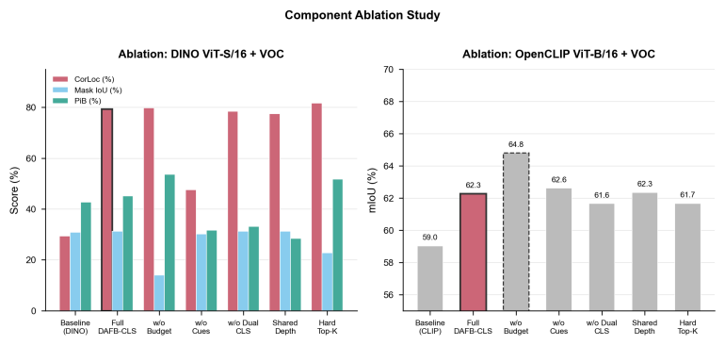

Fig. 4. Ablation comparison on VOC 2012 (DINO ViT-S/16). Each variant removes or replaces a single component from the full DAFB-CLS framework. Multi-cue foregroundness contributes most to CorLoc, while adaptive budget and independent depth attention are critical for Mask IoU and spatial localization (PiB), respectively.

D. Efficiency Analysis
Table V reports the parameter count, inference latency, and GPU memory overhead of DAFB-CLS compared to baselines. All measurements use batch size 1 and 224×224 input on an NVIDIA RTX 4070 GPU.
TABLE V
Efficiency Comparison
Backbone | Method | Params | Trainable | Latency | Overhead
DINO ViT-S/16 | Baseline | 21.67M | 0.0004M | 5.90 ms | ---
 | LaSt-ViT | 22.25M | 0.59M | 6.21 ms | 1.05×
 | DAFB-CLS | 22.25M | 0.59M | 7.72 ms | 1.31×
CLIP  ViT-B/16 | Baseline | 86.21M | 0.016M | 12.37 ms | ---
 | LaSt-ViT | 87.94M | 1.74M | 13.80 ms | 1.12×
 | DAFB-CLS | 87.94M | 1.74M | 15.82 ms | 1.28×
DAFB-CLS introduces only 0.59M trainable parameters for DINO ViT-S/16 (2.7% of the frozen backbone) and 1.74M for OpenCLIP ViT-B/16 (2.0%). The inference latency overhead is 1.82 ms (DINO) and 3.45 ms (OpenCLIP), corresponding to 1.31× and 1.28× relative overhead, respectively. These results confirm that DAFB-CLS is lightweight and practical for deployment alongside frozen foundation models.

