Main Camera:

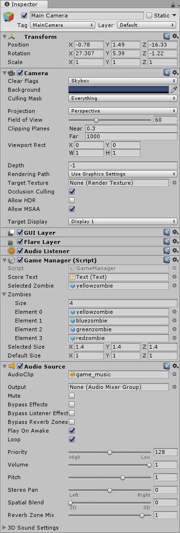

Directional Light:

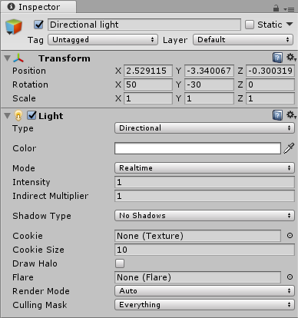

Floor:

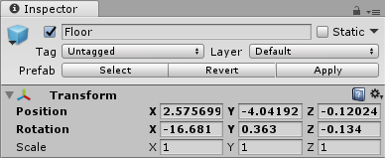

Floor – Cubes:

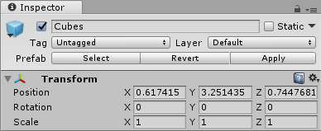

Floor – Cubes – YellowCube:

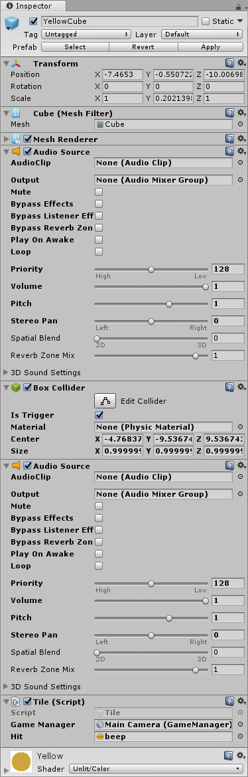

Floor – Cubes – BlueCube:

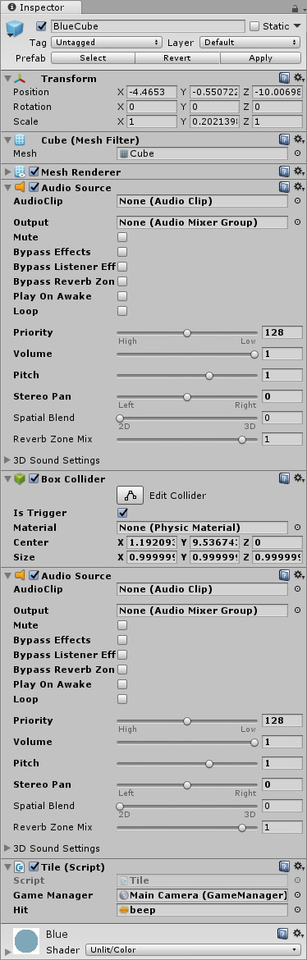

Floor – Cubes – GreenCube:

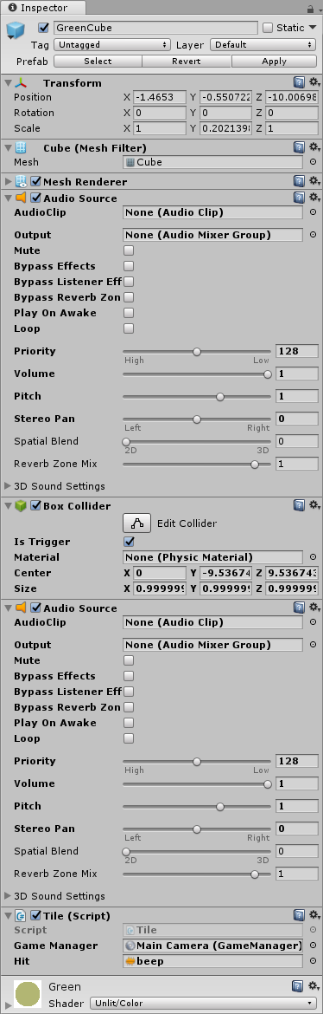

Floor – Cubes – RedCube:

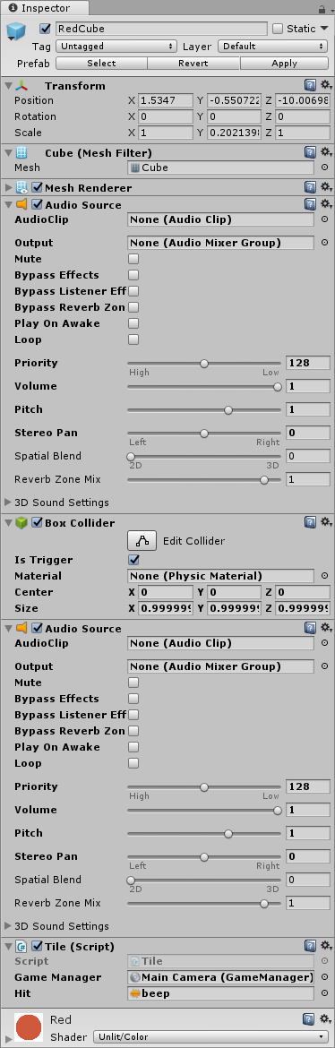

Floor – Floor:

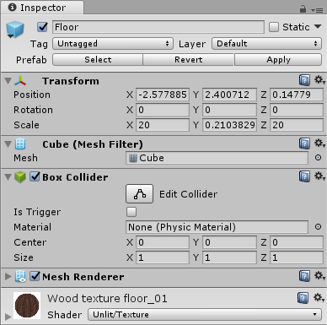

BlueZombie:

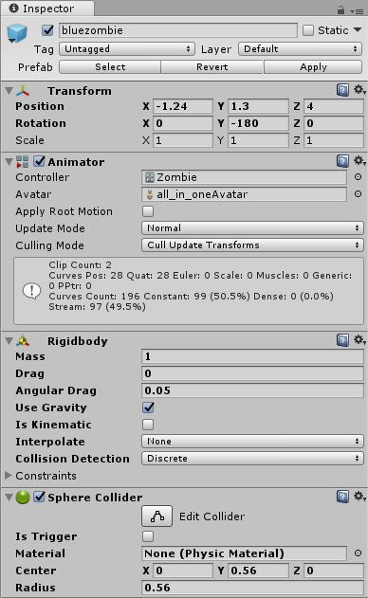

GreenZombie:

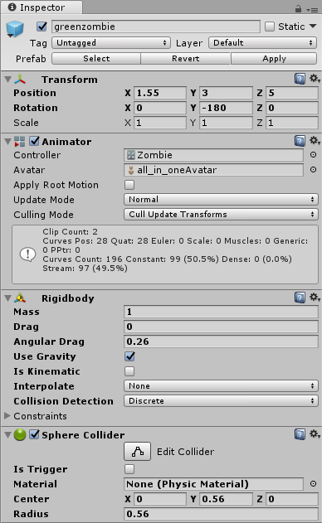

RedZombie:

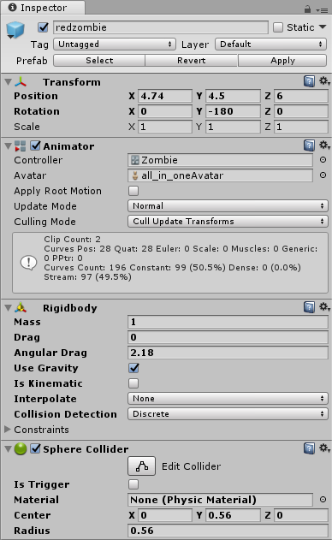

YellowZombie:

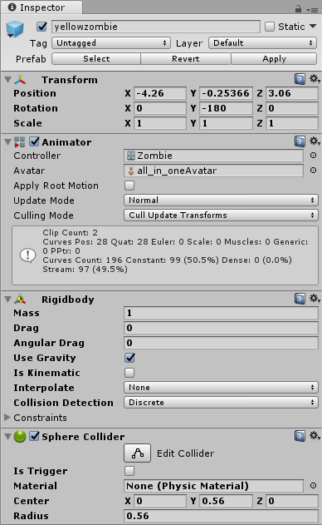

Canvas:

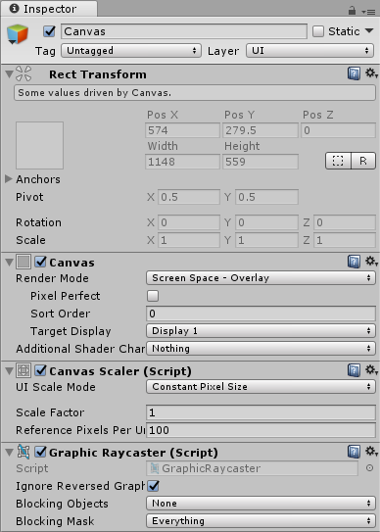

Canvas – Text:

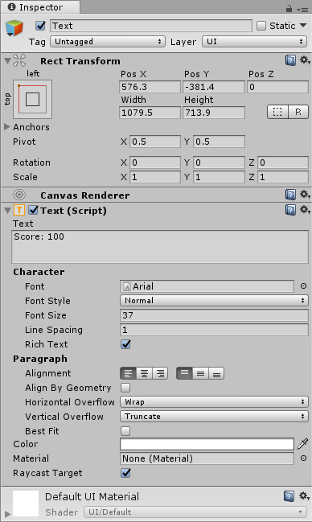

EventSystem:

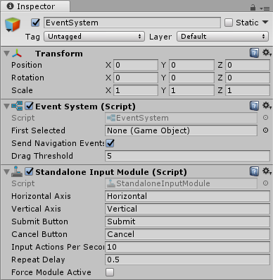

Kode til «Tile»:

using UnityEngine;

using System.Collections;

public class Tile : MonoBehaviour {

public GameManager gameManager;

public AudioClip hit;

AudioSource source;

// Use this for initialization

void Start () {

source = GetComponent<AudioSource> ();

}

// Update is called once per frame

void Update () {

}

void OnTriggerEnter(Collider other){

gameManager.AddPoint ();

source.PlayOneShot (hit);

}

}

Kode til «GameManager»:

using UnityEngine;

using System.Collections;

using System.Collections.Generic;

using UnityEngine.UI;

public class GameManager : MonoBehaviour {

private int selectedZombiePosition = 0;

public Text scoreText;

private int score = 0;

public GameObject selectedZombie;

public List<GameObject> zombies;

public Vector3 selectedSize;

public Vector3 defaultSize;

// Use this for initialization

void Start () {

SelectZombie (selectedZombie);

scoreText.text = "Score: " + score;

}

// Update is called once per frame

void Update () {

if (Input.GetKeyDown ("left")) {

GetZombieLeft ();

}

if (Input.GetKeyDown ("right")) {

GetZombieRight ();

}

if (Input.GetKeyDown ("up")) {

PushUp ();

}

}

void GetZombieLeft () {

if (selectedZombiePosition == 0) {

selectedZombiePosition = 3;

SelectZombie (zombies [3]);

} else {

selectedZombiePosition = selectedZombiePosition - 1;

GameObject newZombie = zombies [selectedZombiePosition];

SelectZombie (newZombie);

}

}

void GetZombieRight () {

if (selectedZombiePosition == 3) {

selectedZombiePosition = 0;

SelectZombie (zombies [0]);

} else {

selectedZombiePosition = selectedZombiePosition + 1;

SelectZombie(zombies[selectedZombiePosition]);

}

}

void SelectZombie(GameObject newZombie) {

selectedZombie.transform.localScale = defaultSize;

selectedZombie = newZombie;

newZombie.transform.localScale = selectedSize;

}

void PushUp() {

Rigidbody rb = selectedZombie.GetComponent<Rigidbody> ();

rb.AddForce(0, 0, 10, ForceMode.Impulse);

}

public void AddPoint() {

score = score + 1;

scoreText.text = "Score: " + score;

}

}