Name:
Section:
University ID:

Lab 3 Report

Summary:
10pts
In this lab we learned about pthreads and how they work. We created different pthreads and saw how they call a given function by pointer. We used p_thread_cond to implement waits in our code to make a certain process wait for a condition to be met. We also learned about Mutex and how we can use it to limit data access within threads so we don’t have multiple threads accessing the same chunk of data. Overall, this lab was a great lab for learning about pthread and how it works.
Lab Questions:

3.1:
6pts To make sure the main terminates before the threads finish,
add a sleep(5) statement in the beginning of the thread functions.
Can you see the threads' output? Why?
2pts Add the two pthread_join statements just before the printf statement in
No it still does not work. This is because the main thread gets done executing while the threads are still in sleep so the main the other threads get closed once the main function closes.
main. Pass a value of NULL for the second argument. Recompile and rerun the program. What is the output? Why?

2pts Include your commented code.
We get all of the output of the threads. This is because the join function makes the current process wait until the execution of the targeted thread is done executing.

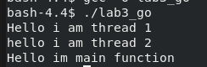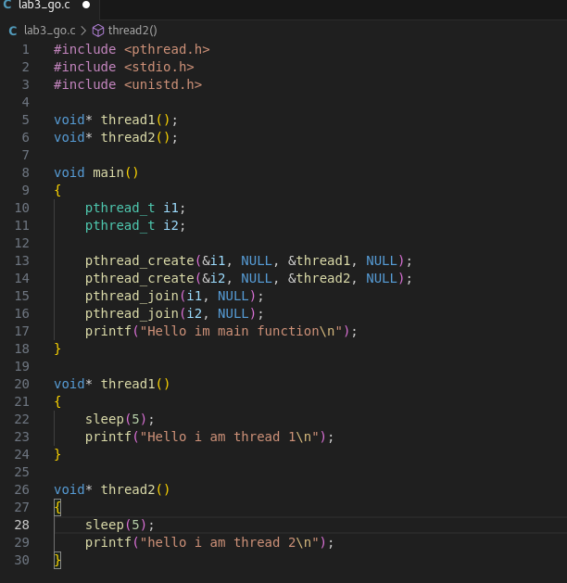
3.2:
3.2.1:
2pts Compile and run t1.c, what is the output value of v?
v=0

8pts Delete the pthread_mutex_lock and pthread_mutex_unlock statement in both increment and decrement threads. Recompile and rerun t1.c, what is the output value of v? Explain why the output is the same, or different.
3.2.2:
v=-990
It is different because the pthread_mutex_lock makes it so that only one thread can have access to the the proceeding code. Any other threads have to wait until it becomes unlocked to access it. When we remove the lock and unlock functions the two threads are in a race condition where they are both adding and subtracting to v whenever they can.
10pts Include your modified code with your lab submission and comment
on what you added or changed.
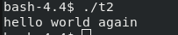
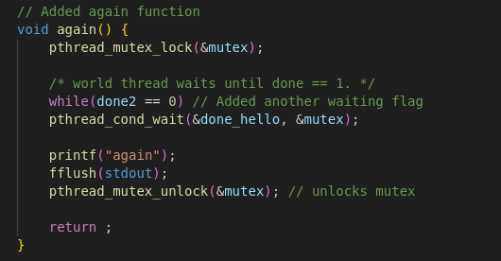

3.3:
20pts Include your modified code with your lab submission and comment on what you added or changed.
