­­Revision System Coursework

Table of Contents

Analysis 5

Justification of the program 5

Justification of how the problem can be solved using computational methods 6

Thinking abstractly 6

Thinking Ahead 7

Thinking Procedurally 8

Thinking Logically 9

Thinking concurrently 10

Stakeholders 11

Overview 11

Didier Vincent 12

Questions: 12

Analysis: 14

Henry Sullivan-Porteous 15

Questions 15

Analysis of Interview 17

Research 20

Active Learn: 20

Navbar: 20

While logged out of Active Learn: 20

While logged in to Active Learn: 20

Library Page: 21

Login Page: 22

Essential Features 23

Limitations 25

Requirements 26

Hardware 26

Software 26

Success criteria 27

Design 29

Breaking the problem down 29

Enitity Relationship Diagram 33

TblUsers 34

TblUserClassInter 34

TblClasses 35

TblTeachers 35

TblAssignments 36

TblSets 36

TblQuestions 36

TblAnswers 37

Development 38

Back end 38

Connection.php 38

Install.php 39

TblUsers 39

TblUserClassInter 39

TblClasses 40

TblTeachers 40

TblAssignments 40

TblSets 41

TblQuestions 41

TblAnswers 41

Adding Users 43

addUsers.php 43

users.php 44

Adding a Class: 45

addClass.php 45

class.php 46

Login.php 47

Loginprocess.php 48

AddClass.php 49

Class.php 50

Front end 52

The Navbar 52

Iteration 1: 52

Iteration 2: 52

The Final Result: 53

Set Page: 54

Iteration 1: 54

# Analysis

## Justification of the program

The goal for this project is to create a website which allows for quick and simple revision for students and teachers alike, it would act as a way to not only help students revise better but also share and use other students already

created revision resources to enhance the revision of the student. I also hope for it to be easily used by teachers to set assignments and to record how their students are doing, therefore removing the middleman of handing out documents and then relying on the students to make their own revision. It will be orientated in such a way that everyone in the class and beyond can get revision resources in the exact way that teacher teaches their subject which would give a better revision resource for the students in their class. My main stakeholder for this is a Design engineering and technology teacher that wants to have access to a revision resource that has been made with the difficulties of DET, such as revising sketches in mind. For this it will need to be a place which allows students to track their journey of revision throughout the year and see that increase which can only serve to motivate the student that they are doing well. This project lends itself to a website design as once logged on it will be easy to traverse, and the website design allows for the storage of large quantities of data which will be required for a revision resource.

This project lends itself to a computational approach as it will need to store vast quantities of revision materials that cannot only be used at a moment’s notice but also can be moved without much effort or the forethought to bring the revision materials as modern day classes use computers and so it would take less effort from a teacher to make sure the whole class can excel at what they are doing. It also lends itself as it allows for the teachers to more easily manage the work set for students and see their progression making assessment of the student a much faster process. It also lends itself as it allows for randomisation of the revision material and therefore it would make the students remember rather than simply remember the order of terms that come up ensuring that the material is stored in long term memory.

## Justification of how the problem can be solved using computational methods

### Thinking abstractly

My final solution will simplify the process of revision, by allowing a student to more easily see the time spent revising one set, their accuracy on the set and their speed in which they completed the set which can all serve to not only create a way in which the students then look at revising with a more competitive nature and show progression. It will also reduce the time taken for a student or teacher to not only create the set but also learn the set as they can now do any time they have some free time as they could simply use the website on a phone and revise quickly possibly in the car going to exam or after lessons in which they did not completely understand what they were taught.

It will simplify the teachers as they can not only create sets faster than they could using other processes but it also allows for easier distribution as they only have to send their students a link to a set they have created rather than having to physically print out and distribute the pages which can not only take time as it has to be given in person but also uses up resources from printing the same sets of paper for each member which could be up to around 30 members.

### Thinking Ahead

The register page will mostly only need to take in simple information such as the users name, email and gender for future reference, but it will also mostly likely need to take in a subject preference which would need probably need to be taken in via a drop down system, but it would need an option to add subjects as students who do A-levels would only need to input around 4 subjects but students doing GCSE would be doing closer to 11. For the set creation page, the inputs would be more extensive as they could input any question with an unknown number of answers as it could be a simple question with one answer, or it could be an exam style question in which there is multiple answers possible which are all correct but answer the questions in a different way, as these answer boxes would be custom made they will be relatively easy to implement, but there would also need to be a button to add another answer box (up to a certain limit, current prediction is that I will have the option to add up to 20 input boxes) as having the limit of answer boxes immediately shown would not look appealing but only having the one answer box would not suffice for many of the questions that could be inputted.

The input method for each revision type will need to be different as each type aims to help the user revise in a different way. The first type of revision will be Flash Cards which will not need a particular input method except from the use of space to flip the card and possibly left and right to switch flashcard. However, this will not be the same for multiple choice as there will be up to 4 buttons for the user to press, only one of them will be correct, which will mean that the page will need to tell you when you have inputted the wrong option and possibly highlight the correct one, although another option for this would be to tell the user their answer is wrong and give them another try which may further solidify the revision or it could mean the user gets lazy and does not fully read the question when answering. The final answer type will be a written answer which will have an input box under the question. All of these pages will have to have a button to skip if they do not know the answer so they don’t get stuck midway through a revision set and get frustrated which would reduce the net revision time.

Another page that will have to have a different input method is the settings page in which you can switch on and off certain revision methods, these will most likely be on and off button with the option to change how many choices you get for the multiple choice question if the user is struggling, this could also be automated as well so that if a set number of multiple choice question are answered falsely it would go down from four or if it is already below four it will increase if they get a certain amount of questions correct it gives another option.

### Thinking Procedurally

For longer and more complex problems I could break down the problem into easier and smaller steps until it turns into manageable step that can be easily understood and written in code and then at the end of the testing for each step they can then be recombined into a larger more complex page of code which will answer the problem and work as each step has been tested and therefore each step can be troubleshooted while in small chunks that can be easily fixed.

For example, the breakdown of the process to creating a set is shown below:

* The teacher log into their account.
* They go to their home page.
* They click the button to create a new set.
* They click the add question button.
* They write the question into the box.
* They click the “add answer” button below.
* They write the answer to the question in the box that appears.
* They can repeat the last step for however many correct answers there are.
* They repeat the last few steps until all the questions and answers are written in.
* They click the finish button at the bottom right of the page.

### Thinking Logically

The final product will have many cases of branching and looping such as giving questions to the user. Because of this fact I have decided to show a flow chart of what a process like this might look like in the case of adding names of students who have not done their work to a teacher.

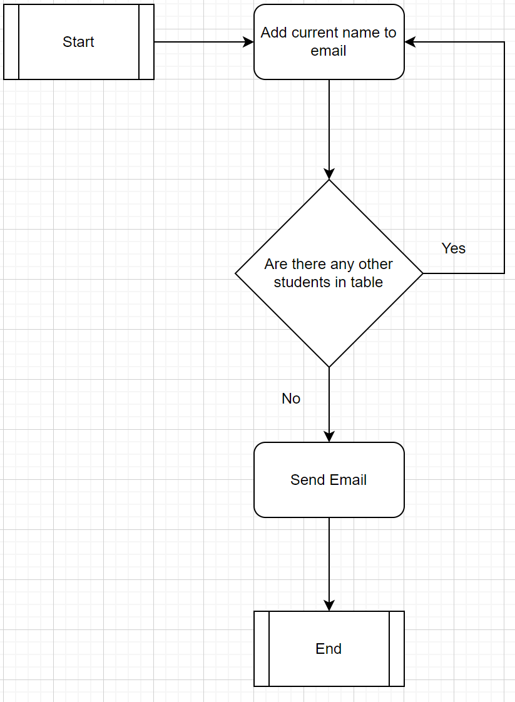

### Thinking concurrently

Many of the features of the revision will require the website to do multiple tasks simultaneously:

* Many of the users will likely be revising at the same time and so the website will have to handle the load of having separate instances running at the same time
* Answers will have to be deemed incorrect or correct and the auto forward timer will have to start simultaneously.
* Many users will likely need to either login to the website or register to the website at any one time.
* It will need to deem if an answer is right or wrong and add the result to the database for later viewing once the set is complete
* It will have to access multiple tables at the same time to retrieve data on the set that has just been completed so that the user can deem how they did on that set and if they want can restart based on the result

## Stakeholders

### Overview

I will use my stakeholders to deem how the development of the website is going and what section of it needs either improvement for better efficiency or a complete overhaul if it is not working as they expected or wanted. My main stakeholder for this project is Didier Vincent as he wants a revision website that can suit his needs as a DET teacher, but I will also need to take in the viewpoints of the students who will also be using it to revise.

Didier Vincent is the main stakeholder of the project as he will be a teacher who aims to use it often and will benefit to the creation of a revision website that specifically has the ability to take a DET teachers needs in to account. He will make use of this to see and manage his student’s revision as well as create sets that he can distribute to his sets and view their individual scores and average result for each. He will need a teachers account so that he can have the option to create a class and manage the students that have the code to join that class. This website will benefit him as he will not have to spend in class time which he could be teaching them managing their revision while still helping their revision progress to ensure a good result for the student in their exam.

Henry Sullivan-Porteous is a student who is hoping to use a revision resource that considers the student’s viewpoint and that he has a hand in the creation of it which will allow him to have a revision website that will allow him to maximise his time revising. The website will have to be easy to use as he does not want to spend much time managing his sets as he wants to maximise his time revising.

### Didier Vincent

Design and engineering GCSE and A-level teacher.

#### Questions:

1)What are some problems with previous revision websites you have used?

They have not been made with a way to revise sketching for DET which is a crucial part of the exam

2)What age group do you use revision systems most for?

I would use it for a range of age groups but probably most prominently in the classroom with lower years and more so recommend one to upper years.

3)Would you like to have a forced login, or would you like there to be an option for logged out access?

I would like for there to be an option for logged out access so I can quickly check if there is a set available for what I want and so that a new student will not have to sign up and join the class which could take time out of my lesson.

4)Do you want to be notified if a student doesn’t do the work set for them?

Yes, as that would mean that I myself don’t have to go through it and it is shown to me at the deadline.

5.1) Would you like to have a leaderboard for class activities?

yes, as that would mean it would be possible to see how each person in the class is doing and who needs more individual support.

5.2) In that case would you like it to be public so everyone in the class can see it so it’s more competitive or private so only you can see it and so it’s only a judge of skill

I would like for it to be an option whether it is private or public because I think I would use both depending on the class.

6)Do you have any suggestions?

Stakeholder: As a Design Technology teacher, it would be useful to have a sketch revision option

Me: I understand the thought process but how exactly do you want it to work

Stakeholder: I would like it so that originally you draw the sketch, and then when the question comes up, the student draws it again and based on the similarity it gives a percentage score on how close it is to the original sketch

7) Do have an idea for the colour scheme would you like?

I would like it to have a quite neutral colours scheme as to not take the attention of the revision itself, but I would still like it to have a level of colours so that it looks visually appealing.

#### Analysis:

1) To fix this issue I would constantly consult Mr Vincent to make sure that the revision website has some type of method for him to use as a DET teacher and that he is happy with the final product.

2)This means that I will need to make some design choices in the eyes of a younger audience so that it appeals to the students who use it and can therefore be a website that will stay in use of the student even if they are not required to do work.

3)This would require the need for them instead to be redirected to the websites home page rather than the users individual home page as that will not exist, this will also mean that the statistics that would be saved cannot be saved after the completion of a set

4)This means that after the deadline the system will automatically compile the list of names that have not done the threshold amount of work, write them onto an email and send it to them, this will have to be made to be quite fast after the deadline so that the students it says did the work is accurate.

5.1) This mean that I would need to take two sets of data, the time taken to answer a set number of questions, say 20, and the accuracy of the answers and show the top ten in descending order of accuracy and if there is a tie in accuracy the person who did it faster would place higher

5.2) This would mean that I will have to create a button which can switch between the two modes, this will most likely have an automatic setting in the class settings but also an individual set setting where you can alter it if one set Is particularly hard.

6) This will be a challenging side of the website as to make it so that the users draw a sketch, and it compares it to the one given at the start will have to have a kind of machine learning to determine if the two sketches are alike. Most likely however the user will be asked to input four sketches at the start and one design brief, and this type of question will be multiple choice only.

7) This would give a smoother appearance to the eye, and I will most likely go with a light shade of blue, which both my stakeholders like which will ensure they are happy with final appearance while still not subtracting from the fact that it is geared towards not attracting attention.

### Henry Sullivan-Porteous

#### Questions

1) How often do you use a revision system?

On average 2-3 times a week and 5 times a week during exam periods.

2) What are some of the problems you have encountered?

Too convoluted and not streamlined enough.

3) Would you like to have the option to create folders for your set?

Yes, as that would allow me to sort the different parts of the syllabus and years and would allow me to see section of a course made by other people.

4) Do you want a centralised place to see your sets?

Yes, as this would streamline the process.

5.1) Would you like to be able to see other people’s sets?

Yes, as that would mean I could use notes from other students and teachers.

5.2) Would you like to be able to search for other people?

Yes, as that would allow me and someone else, say a classmate, to work on making notes and revise the notes that we have made together even though we are not in the same place for example revising before an exam.

6) Would you like a forced login?

No as that would take time out of revision sessions.

7.1) Do you want a leaderboard for in class sets?

Yes, as that would allow me to see how much revision I am doing compared to others and pace my revision.

7.2) Where would you like the leaderboard to be located?

I would like the leader to be displayed on the page for the set so that anyone doing that set could see the leaderboard, I also think it would be useful for a class specific leaderboard to be displayed on an assignment.

7.3) What would you like shown on the leaderboard?

I would like for there to be the number of questions answered, time taken and accuracy on there.

8) Do you want a history of revision done?

Yes, as that would allow me to see my progress of work.

9.1) Would you like a time shown on your sets?

Yes, that would allow me to pace myself.

9.2) How would you like it shown?

I would like it to be shown in minutes and then at one hour it will change to show the time in hours.

10.1) Would you like an option to access recently revised sets?

Yes, as that would allow me to pick where I left off after a break.

10.2) How would you like it shown?

In the search bar when clicked on would show recently done sets and in a box on the left showing the 5 most recently revised.

11) Have you got any suggestions you would make?

I would like for there to be an option to input for example a list of subjects you do so that when you search the options at the top are tailored to you.

12)Would you like to be able to see the sets you have made on the home page?

Yes as that would mean that I can quickly go to the sets that I have created to revise, and it would also reduce the time faffing about before revision

#### Analysis of Interview

Q1) As he said that he uses it reasonably often it means that the website would need to handle high traffic and therefore when choosing the hosting service high traffic compatibility will need to play an important role in the decision making.

Q2) Because of Henry’s want for a streamlined and non-convoluted website a high emphasis will be put on the usability of the website while still ensuring that it has enough depth to fulfil the number of capabilities that have been requested.

Q3) The desire of folders would require a table with a foreign key so that one set could be accessed from a centralised location and therefore could slim down and therefore give a more streamlined appearance for the front page as the stakeholder has requested earlier in the interview.

Q4) His need for a centralised place to find his sets fulfils henrys needs for a streamlined website as it allows less need to go through multiple pages to find the sets that have been created while still allowing for the creation of set folders.

Q5) This would create the need for a more extensive search as you would need to search not only your own sets but also other peoples which may take longer to search but would give a more streamlined search system which would fulfil the need of the stakeholder.

Q5.2) The ability to search for a person on the platform would allow for multiple people to use the same revision resource and for central resources, this however would add a layer of complexity, while not large it would still take time as I would need to add the ability for a second search parameter and therefore each search would take a small amount of time more as it would need to consult more than 1 list of contents as it would need to search the list of users.

Q6) the option of not being logged in creates a small problem as the pages that would normally direct you to your home page where your sets are located, such as the logo button in the top left, would need to instead direct you to another page, for example the home page of the website itself or the search page.

Q7) This would create the need for the data of the set revised all to be exported beyond just the table that would record recent history as it would need to be sent to a centralised table where it can then be sent to anyone who access the table, whether they are a student or teacher.

Q7.2) This while a simple request could be hard to incorporate as the request for it to be streamlined would need to be taken into consideration and with the several things wishing to be added to the main page of the set it could become more difficult, because of this the leaderboard or another feature will probably have to be hidden until a button is pressed for it to appear so as to minimise how cluttered the main set page will be.

Q7.3) Since this is only a relatively short list of items the time to create a table when requested will likely be quite small while still giving the student an idea of how each student is doing which achieves the streamlined design request by the stakeholder.

Q8) This would not be too problematic to incorporate into the design as it would only need to retrieve data from a table such as time revising and questions answered, as this page would most likely be used quite a lot it would most likely go on the task bar to minimise the time taken to start revising.

Q9.1) This would likely be very easy to implement as it is just a timer and would most likely be displayed when you are in the middle of revising in a corner and pause when you either another tab or stop revising.

9.2) This will be very simple as it is a simple check and should not be hard to implement.

10.1) This would most likely be in the history tab previously mentioned and would act as a form of link so that if you see the time on a set is low or you wish to spend more time on it you don’t have to exit out and search for it you can simply click on the set directly.

10.2) This would give faster access to previously done sets and so would mean that faster access is given but a consequence of this being done on the home page is it would have to be a slimmed down version and therefore not show the details that the history page would, this is another feature that would have to be excluded for logged out access.

11) This would be a more complex part of this as it would need to be able to be taken at the creation of an account and so would extend the time taken to create an account which could reduce the number of people willing to sign up but could make the people who do stay longer, however it would also have a layer of complexity as it would not only need to have the ability to be changed but also to be accessed quickly as it would be used for every search possibly taking up the time of the use.

12) To do this the solution would be relatively simple as I would only have to consult the table of sets

## Research

### Active Learn:

#### Navbar:

##### While logged out of Active Learn:



Features:

* Has a login page at the top so no matter where you are on the page you can immediately go to the login page. The login button is also green which stands in contrast to the black and acts as an accessibility feature as it draws your eye.
* Has a register page so that there is no need to redirect from the login page would take time.
* Has a help button so that the user can talk to an admin of Active Learn if their device won’t allow them to login or if they have forgotten their password.
* Has a features button so before creating an account you can see what you’re getting into and therefore determine if you want to create an account on the website.
* Has a products page which allows you to see what you can access once logged in which prevents people from signing up because they are uninformed.

On top of that they have their logo on the top left of the Navbar which directs the user to the menu that they can currently access. While logged out you can also see if you want to pay for the service as they have a product page so you can see the topics accessible and the features page so you can see how the website interacts with the websites.

##### While logged in to Active Learn:



Features:

* Has a library button so no matter what you are doing at the time you can instantly return to where all of your books are located.
* Has a courses button so that you can not only look at the books in your own library by the courses they are registered under but look for specific books you can buy sorted into the course they are registered for.
* Has a tasks page that allows for a student to more easily see the work that has been assigned to them and therefore manage their time more effectively and allows for the teacher student relationship to be more effective.
* Has an admin page which allows you to manage the settings of your account which allows for a simple and streamlined way to look at all your settings which has been requested by the stakeholder.
* Has a help button so that the user can talk to an admin of Active Learn if their device won’t allow them to login or if they have forgotten their password.
* Has an award and mailing button which allow for student teacher interactions to be more accessible and done so that they can communicate about work while not being in a lesson or going through an external service such as email.

#### Library Page:

The library page while used in a different manner in Active Learn could be used in a similar way in a revision website to order sets that either the user has created, or the user has added to it. The top left button to add activate new access code would then be adapted to show create a new set or folder which would allow easy organisation of your own sets or other peoples. The top right drop down button would allow for easy search through the topics of sets that you have set up which would then allow you to more easily revise for say an exam. The actual book series buttons are shown just below the activate new access code button, this once clicked redirects you to another page (shown below) which then shows you the books in that book series, if this setup is adopted the folder system would likely follow a similar set up as it allows for sets to more easily be organised.

As you can see this would also be a place to not only see the books inside the series but also the task and exercises which could be set by your teacher, this means that a teacher could create a folder with sets it and send it to their students and then set an assignment to say do the first three pages of the folder and then at a later date update it so that they now have to do say the next 3.

#### Login Page:

The login page is reasonably minimalistic as this page is not designed to be appealing as the user is not meant to spend long on it.

Features:

* Has a help button in the top right which is shown to be a usability feature as the brain naturally goes to the top right.
* If a field which is required (username and password in this case) is not filled in the colour of the box will change colour into a high contrast colour which means that eyes of the user naturally are attracted to it meaning that they fill it in without having to scan the whole page which is a usability feature
* Has the option to show the password once it has been typed in which means that if the user has made an error, they can change it without having to rewrite the entire password.
* Link directly under the password to a page in which the user can recover their password which means that the user does not need to spend time finding the link as it is located close to the place I which the event can occur which acts as a usability feature.
* Sign in button is high contrast

## Essential Features

The essential components of the website will most likely contain the following:

* A logged in home page
  + This will be where you can see your most recent sets including the results for them
  + How long you have spent revising in the last week
  + How many sets you have revised today
  + A streak of how many days you have revised a set
  + This page will mostly be statistics with an option to view some of the sets you have made or viewed
* A logged out home page
  + This will be mostly text and look professional to make sure that the people who do visit the website see it as a website to use
  + This will be mostly text and images to show what the website can do
* A set creation page
  + Allowing a user to create a new set with multiple words or questions
* Individual set pages
  + Button to redirect to terms pages
  + Show personal statistics of that set
  + If in teacher mode show students’ stats in that set
  + Show set specific settings
* Terms page
  + Show all terms in that specific set, both questions and answers
* Login user page
  + Simple way for the user to login to their account
* Register user page
  + Will take in preferences
  + Will take in name
  + Will take in email
  + Will take in age
  + Will take in if they are a teacher or a student
* Search page
  + Will show most recent searches
  + Search box at the top
* Search results page
  + Shows sets in box format
  + Search box at top
* A settings page
  + Can change any of the data that they have input when registering for the website
  + Change name shown and profile picture
  + See all their data including user code
* A statistics page
  + Allows for one page that shows all the data that a student could need
  + Teacher variant in which they can choose the students statistics they see
* A create class page
  + Will have input for name of set
  + Will have a user code input box so that they can add students which will allow for students to be added remotely
* A view class page
  + Will allow you to see all students
  + Will allow you to access individual assignments which you can view each student’s progress in that set
  + Will allow you to view students’ progress in all sets if clicked on the student
  + Show class code so that someone can join
* A view student page
  + Will allow you to see student statistics
  + See when they joined the class
  + What assignments they have done in percentages
* A view assignments page
  + Both student and teacher versions
  + Student view will show the contents of the assignment and when it is due
  + Teacher version will allow you to see and edit what the assignment says
  + Teacher version will also allow you to see in a tab who has completed and who hasn’t
  + In teacher mode if a student has handed late work in it will say when they handed it in and how late it was handed in
* An opinions page which would allow for students to give their opinion on a set to a teacher
  + Will have a scale for usefulness
  + Will have an input box for how long it took them

## Limitations

The website is in a very competitive field where many websites have already tried to stake a claim with websites such as Active Learn, Quizlet and Seneca to name a few. With such a competitive field the website will most likely not attain much traffic as most of the other websites have a team that works tirelessly to maintain and improve the website on a constant basis where as I am just an A-level student that will not be able to dedicate much time to maintaining the final product once it is done as I will have work to do for my A-level exams.

Because of the fact that the throughput of my website is most likely going to be quite low I will most likely opt to not go for a custom domain name which can cost money to buy in most cases, instead I will probably go for a free domain name as that will still achieve the goal of creating a revision website while not spending unnecessary money in the creation of a website that will not be able to rival companies with far more resources that can have the ability to constantly improve their website.

A large problem is the fact of mobile availability which can come in many forms, one of which is an app which will be extremely hard to create as I will not only have to write a completely different set of code for each platform, apple and android, but will also have to go through the process of getting them verified by the host which can take several days if not weeks. As a ix to this problem I will most likely opt to make the website be available in a resized option for the size of an iPhone and android phone which will mean that a phone user can still use the website even though it is not a physical app which would solve the compatibility issue, while not in the most elegant way it is the most time efficient and time saving method which would allow me to create the website faster which would mean that the stakeholders get there investment back.

## Requirements

### Hardware

For the hardware of this project, I will be using my Microsoft surface during development to code on. The website once loaded on will not use much RAM at all to run on a user’s computer as it is more the fact that there is a tab rather than what the tab is that takes up the RAM.

### Software

For the Hardware requirements of the final solution, I will use XAMPP as I need a local hosting app for use in development and updating of iterations which will allow me to make iterations faster and more improved as I have more time to create better ones which will allow me to make a better final product. I have chosen XAMPP as it is the local hosting app that I am most familiar with and so will reduce the time I need to start making iterations. XAMPP also allows for an easy creation and viewing of tables, so that I can easily see the data within them. Eventually once my final iteration is tested and has been proven to be reliable, I will need to find a free hosting service which allow me to make the website available for anyone with the link. I will use a free hosting service as there is no need to get the perfect domain name as even with the perfect domain name there is likely to not be much through put, if there then proves to be a larger throughput I will then change it so that it is on a better domain name with easier availability.

I will use visual studio code to code the software behind the website as it is the IDE that I am most comfortable with and have used for the longest meaning I can get the most out of the time I am given to write it which will ensure a better finished product rather than if I was forced to use an IDE that I was not familiar with.

## Success criteria

* My main success criteria is that is easy to use.
  + Justification – this will ensure that it will be used more as it will be easier to revise and will make the introduction to the website a slow learning curve which will make it more appealing to new user. To measure this, I will give a questionnaire to my stakeholder which will be on a scale of 1-10 how easy is each page to use, I will see it as a success once it is 7 or above.
* The sign up should take no more than 5 minutes.
  + Justification – as this would ensure all the people who did choose to sign up do not get disinterested once they are in the process and to reduce time wastage.
* The creation of a class should take no more than 5 minutes.
  + Justification – so that a teacher can easily add their class to it and follow their progress and reduce time wastage that will inevitably happen.
* The login process should take less than 1 minute.
  + Justification – So that a user who wants to login does not have to waste time they have set aside for revising to login.
* The users must not be able to see any user data if they are not logged in.
  + Justification – This is to give certain perks to create an account and therefore encourage the use of signing up for an account.
* Teachers must be able to see student progression in an easy way.
  + Justification – So that a teacher can quickly check the status of students in a lesson to determine what they will do next or in the decision process if giving more work.
* Teachers should have an email compiled and sent to them about who has not done the assignment within 5 minutes of it being overdue.
  + Justification – This will make sure that the teacher gets accurate emails on who has and hasn’t done the work.
* Ensure the flashcard system works well, sending you either back to the start of the flashcards or to the set home page upon completion.
  + Justification – so that the initial learning of the question is a fast and easy process rather than one that is dreaded and so postponed.
* Ensure that the different revision types work well and output the right answer if a wrong one is inputted.
  + Justification – To make sure that the site reaches its intended state and that if a mistake is made it can be easily remedied.
* The process of joining a class and to show that they are in that class should take no more than five minutes.
  + Justification – so that a student doesn’t accidently sign-up multiple time which could cause an issue, it will also mean that they can access an assignment made by the teacher faster
* The creation and deletion of a new assignment should take less than 5 minutes.
  + Justification – So that teachers could quickly do at the end of lesson, so it does not stretch into either another lesson or the teacher’s personal hours.
* The questionnaire at the end of an assignment should take no more than a minute.
  + Justification – This is to ensure that the feedback by the student is given and that time out of revising is kept as minimal as possible.
* A teacher must be able to see every student’s progression in an assignment in an easy way.
  + Justification – to mean that at the beginning of an assignment a teacher can quickly look over the results of the assignment to determine what the class is going to do that day.
* A user should be able to add a set that someone else made and is public to their home page in less than a minute.
  + Justification – This is to ensure that the revision of that set could be possible as soon in a short time and that it is then saved for later use on their home screen.

# Design

## Breaking the problem down

In the diagram above I have broken the problem of making the website down into its composite problems which are of a suitable size for computational methods to be effective which I have then explained and justified below.

I am breaking the problem down as it will make the problem of writing the code a much simpler and streamlined process which will hopefully give a sleeker result and a longer time at the end of the coding process to perfect the code to the stakeholders’ views.

The navbar will always be visible and therefore people will be able to easily access any page they want to and will make navigation an easier process, the access level of the user will also change what items appear on the navbar.

The general public will be able to see:

* A home page
  + This is a page that will show general statistics and show suggested sets based on the previous sets done
* An individual set page
  + This will be a simplified version of the logged in access as you will not be able to see past history but you will still be able to see every question that has been made in that set and the answers to them, you will also be able to see the rating and the reviews on each set as that could influence what set you would like to practice
* Login/Signup
  + The Login Function allows existing users to login into the site, to access their own data, purchase new programs or to book sessions with Jack. It Also allows Jack to login which allows him to manage sessions and clients
  + The Signup Function allows new users to create an account by providing some basic data; First name, Last name, Gender, Email and the user can create a Password

The Login Function will create a session variable in order to make sure any access is for a legitimate use of the site, once a customer is logged in, the site will recognise a higher access level and allow more pages to be available to them. Once a customer is logged in, they have access to:

* User information page
  + This will give information on the user including the date they joined and various different statistics such as the number of sets done and the time spent revising
  + This will also show you the sets that you have created, the privacy status of each set, the number of terms in each set and the date and time you created or last edited the set
* Progress page
  + The progress page will take in the sets done and the statistics of each time the set is done and will show every time you have done that set from the first time to the last time to give an accurate feeling of progress
  + The data of each set will be stored in a tap down table which will be able to sorted by either time done or percentage correct
* User settings page
  + This will show more confidential information that the user has stored such as the email address that is used to access the site and your name
  + From here you will also be able to reset your password by being sent an email to ensure confidentiality
* Student view class page
  + This page will be used as a way to see all the class you are linked to either from using a private code that you have been given in your real life class or by joining a public class set up by another person
  + Frojm here you will be able to add new classes either using the individual page search bar or by using a code in a pop up menu
  + You will also be able to see each assignment that has been set to you by clicking on a drop down menu that will be attached to each set
* Assignment page
  + This page will allow you to see every assignment that has been set to you in one of two formats, the time and date they are due in on from earliest at the top and latest at the bottom or by the class that has assigned it
* Set search
  + This will show you the currently most popular sets and then as you add search parameters it will show you the most popular sets according to that which will mean you will be able to have a more refined set easier to access but also enable you to search for quite specific subject and give you a multitude of sets that could help you
* Logged in individual set page
  + This page will show you the sets questions and answers, and as you have user data stored on your profile you will also be able to see your past history with that set including data such as the time spent revising it, the date that it was done at and the percentage of the questions that you got right
* FAQ page
  + On here you will be able to submit question that you have about the function of the website or potential improvements which will then be answered by admins that will manage the site, you will also to be able to see past questions which may answer the questions you have come to have answered, the past questions will not have associated usernames for the public to see but will be stored for admins to see

In the case that the login access you have been given yourself is that of a teacher you will be able to see some pages that a regular view wouldn’t:

* Class management
  + This will be on the class page and will give you an option to create a class, here you will be able to specify certain users that will be invited if you have their user code which also give you a private class code or opt to have a public class which will mean that anyone who searches for classes with that title will be able to join
  + This page will give you access to either upload a premade set or give you the option to create a set that you will assign to the class
  + From here you will also be able to manage each individual user that is part of the set which include managing their progress on the current assignment or to see how many assignments they have done on time or late.

The admin view will be quite different to both the student and teacher views as they have higher permissions, they will be able to toggle a switch which will allow them to see the student or teacher view, but their main view will be as follows:

* FAQ page
  + While this page can also be seen from a general public view it’s not in the same format as only the admins will be able to see who has posted what questions as to keep the confidentiality of the site, they will also be able to respond to any questions that have been asked which the general user will not be able to do
* User page
  + They will be able to view different user pages including everything that user has done in that past on the site to make sure there is good enough monitoring to make sure there is no words or phrases used that could be deemed harmful for children to see
  + They will also have the option to take down a user page if they have repeated actions that have been deemed not okay by the admins, this will delete any data that user has such as the time they have on the site the sets they have created and will permanently ban the email as to make sure that the same user does not return, however the ban can be lifted if it was deemed that the user does not aim to repeat their offence
* User data table
* This will include data such as the data of joining and the status of each user on a large table from here the admin will be able to see if anyone has tried to reset their password and grant them a reset password which will mean that the admins will have a high level of monitoring to make sure that every user’s data is secure

### Enitity Relationship Diagram

### TblUsers

|  |  |  |  |  |  |
| --- | --- | --- | --- | --- | --- |
| **Field Name** | **Data Type** | **Validation** | **Justification for validation** | **Typical Data** | **Justification** |
| UserID | Int (4) Primary Key | auto generated | Means there are no duplicates | 0001 | Unique identifier for each user |
| AccessLvl | Int (1) | Auto-generated | Will automatically give as to ensure no false admins | 1 | Shows what pages the user should be able to access |
| Gender | Varchar (1) | Required |  | M | User Information |
| Forename | Varchar (20) | Required, max 20 characters, |  | John | User Information |
| Surname | Varchar (20) | Required, max 20 characters |  | Doe | User information |
| Email | Varchar (50) | Required, max 20 characters |  | exaple@gmail.com | Allows for contact such as emails about set usage |
| Password | Varchar (100) | Required, Max 20 characters |  | $2y$15$Xt3VZc.6pVJ3Mw8wuqGJLegl9h94q6TR5DEOVx7RZQK | Password for login, stored in hashed form for security |

### TblUserClassInter

|  |  |  |  |  |  |
| --- | --- | --- | --- | --- | --- |
| **Field Name** | **Data Type** | **Validation** | **Justification for validation** | **Typical Data** | **Justification** |
| UserID | Int (4)  Primary Key | Taken from other tables  Auto-generated | Allows for easy differentiation between users | 0001 | Unique identifier for each user |
| ClassID | Int (4)  Foreign Key | Taken from other tables  Auto-generated | Allows for easy differentiation between classes | 0001 | Unique identifier for each class |

### TblClasses

|  |  |  |  |  |  |
| --- | --- | --- | --- | --- | --- |
| **Field Name** | **Data Type** | **Validation** | **Justification for validation** | **Typical Data** | **Justification** |
| ClassID | Int (4)  Primary Key | auto generated | Means there are no duplicates | 0001 | Unique identifier for each class |
| Subject | Varchar (20) | Required, max 20 characters |  | History | Class information |
| ClassName | Varchar (50) | Required, max 50 characters |  | HistoryYear5 | Class Information |
| Email | Varchar (50) | Required, max 50 characters |  | exaple@gmail.com | Allows contact of the class teacher/creator |
| TeacherName | Varchar (20) | Required, Max 20 characters |  | Hugh Laurie | Allows for easy identification as there will be many repeats of set names |
| Open | INT (1) | Required, max 1 letter |  | 1/0 | To see if class can be accessed by anyone |
| ClassTeacherID | Int (4)  Foreign Key | auto generated | Means there are no duplicates | 0001 | Unique identifier for each class’s teachers |
| Password | VARCHAR (100) | Required, Max 20 characters |  | $2y$15$Xt3VZc.6pVJ3Mw8wuqGJLegl9h94q6TR5DEOVx7RZQK | Password to join class, stored in hash |

### TblTeachers

|  |  |  |  |  |  |
| --- | --- | --- | --- | --- | --- |
| **Field Name** | **Data Type** | **Validation** | **Justification for validation** | **Typical Data** | **Justification** |
| ClassTeacherID | Int (4)  Primary Key | auto generated | Means there are no duplicates | 0001 | Unique identifier for each teacher |
| UserID | Int (4)  Foreign Key | auto generated | Means there are no duplicates | 0001 | Unique identifier for each user |

### TblAssignments

|  |  |  |  |  |  |
| --- | --- | --- | --- | --- | --- |
| **Field Name** | **Data Type** | **Validation** | **Justification for validation** | **Typical Data** | **Justification** |
| AssignmentID | Int (4)  Primary Key | auto generated | Means there are no duplicates | 0001 | Unique identifier for each assignment |
| ClassID | Int (4)  Foreign Key | Auto-generated | Means there are no duplicates | 0001 | Unique identifier for each class |
| SetID | Int (4)  Foreign Key | Auto-generated | Means there are no duplicates | 0001 | Unique identifier for each set |
| Due Date | DATE | Input box that takes only the given format | Makes sure a date is input | 20/10/2006 | Allows for assignment deadlines |
| Description | Varchar (250) | Max 250 characters | Means that storage space required is minimised | The assignment is due tomorrow | Allows for teachers to send students a message |

### TblSets

|  |  |  |  |  |  |
| --- | --- | --- | --- | --- | --- |
| **Field Name** | **Data Type** | **Validation** | **Justification for validation** | **Typical Data** | **Justification** |
| SetID | Int (4)  Primary Key  Foreign key | auto generated | Means there are no duplicates | 0001 | Unique identifier for each set |
| Subject | Varchar (20) | Required, max 40 characters |  | History | Set information |
| SetName | Varchar (20) | Required, max 20 characters |  | Cold war dates | Set information |
| Open | INT (1) | Required, max 3 letters |  | Yes/no | To see if class can be accessed by anyone |
| UserID | Int (4)  Foreign Key | auto generated | Means there are no duplicates | 0001 | Unique identifier for each user |

### TblQuestions

|  |  |  |  |  |  |
| --- | --- | --- | --- | --- | --- |
| **Field Name** | **Data Type** | **Validation** | **Justification for validation** | **Typical Data** | **Justification** |
| QuestionID | Int (4)  Primary Key  Foreign Key | auto generated | Means there are no duplicates | 0001 | Unique identifier for each question |
| Question | Varchar (100) | Required, max 100 characters |  | When did the berlin wall fall? | Written question |
| SetID | Int (4) | auto generated | Means there are no duplicates | 0001 | Unique identifier for each set |

### TblAnswers

|  |  |  |  |  |  |
| --- | --- | --- | --- | --- | --- |
| **Field Name** | **Data Type** | **Validation** | **Justification for validation** | **Typical Data** | **Justification** |
| AnswerID | Int (4)  Primary Key | auto generated | Means there are no duplicates | 0001 | Unique identifier for each class |
| Answer | Varchar (100) | Required, max 100 characters |  | 1989 | Answer information |
| QuestionID | Int (4) | auto generated | Means there are no duplicates | 0001 | Unique identifier for each class’s assignments |

# Development

## Back end

## Connection.php

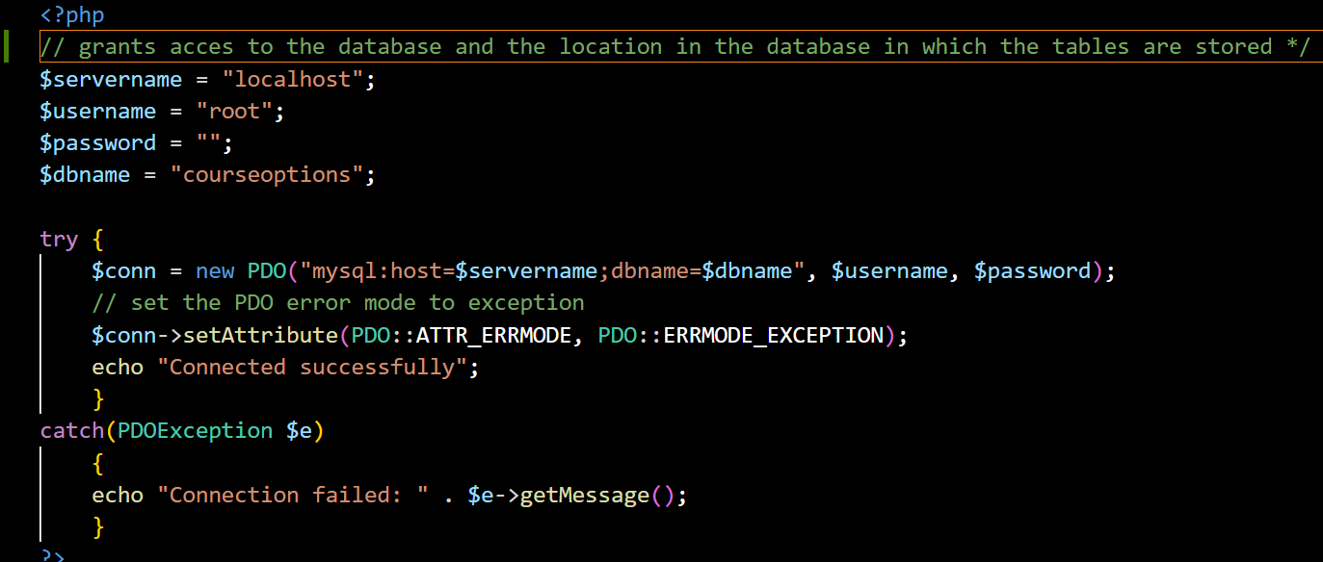

This is the page that will be able to connect the database to any of the purposes that the website will need which will be rapid communciation for retrieving information for the pages such as the revision terms and user information which will be securly stored in the database. This will not ask for any data but will set up for the transfer of data during the current session set up when the user contacts the website.

The first our lines our st up so that the code is able to access the database that I have set up using the password, username and name of the server to access, In this case it is accessing the server localhost which is a sever set up by xampp to develop code, this will later be changed to a full time sever. The name of the database to be accesed by the code is also included as to makie sure that it access the corrct tables.

### Install.php

This is the code that upon first launch will delete the current tables under the names of the tables to be created then once that has been completed it will then create the tables with a completely blank list of entries as to allow it to be used for the use of the website without accidently adding to a previously made table potentially causing problems with adding to the table later down the line.

#### TblUsers

#### TblUserClassInter

#### TblClasses

#### TblTeachers

#### TblAssignments

#### TblSets

#### TblQuestions

#### TblAnswers

After running this for the first time it creates all of the tables required for the website, running the command “show tables;” in the MySQL console should then give the output of: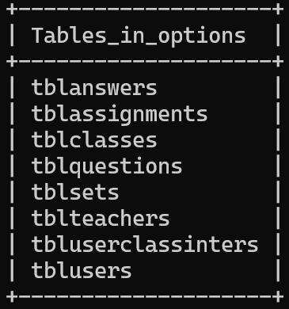

Which shows that not only has each table been created but the tables are correctly formatted as it has not given an error.

### Adding Users

#### addUsers.php

This page is made for the purpose of adding users which will be referred to later during the process and will also be used for adding test users as to make sure all the features of the website which are added can be tested and made sure they work before more is added making sure that the development process does not have any mistakes and errors backed up into the process. This will take in the data from users.php make sure all the values are formatted correctly and then add them to the database. After it has determined that the everything has been done correctly it will then forward the user to the home page to make navigation easier and faster for the user.

#### users.php

This creates a form in which the user inputs all the necessary information for the database into textboxes appropriately marked for each field, this includes the user’s first name, last name, password, email address, gender and access level on the website, the last of which will only be changeable to admin level if the access level of the current user is admin as we do not want the users to be able to gain admin privileges as this could result in people either changing, adding or deleting data of other users which is an extremely unsafe actions.

The outcome of this code along with the stylesheet parameters imported with navbar.php gives the result of:

### Adding a Class:

#### addClass.php

This takes in the data from class.php and hashes the password for the entry to the set to make sure that even if the table is somehow opened from a device that is not meant to, they will not see the password and therefore not be able to gain access to the class, this is a security measure to ensure the security of the entire website. It then bind the rest of the data taken from class.php and then executes the command in the database which then adds the data which can then be read when either the title is searched, or a member views the page. Once the data has been added to the database the user which created the class is then auto forwarded t the classesHome.php page in which they will be able to see the class they have just added.

#### class.php

This creates a page in which the user will see a series of textboxes in which the data field title expected will be displayed to the left. The form will take in the Subject of the class, the title of the class, the email address of the teacher, the name of the teacher( this is input by the user rather than taken from the system as in different classes the user may want to be referred to by different name for example their first or last name), the password that will be used to access the class and whether or not the user wants the class to be open or private. In future iterations I hope to be able to make the answer to whether the class is open or private make the input box for password to be visible or not as currently even if the class is open it will still ask for a password even though it will not be used. The user will view the form as show below:

### Login.php

This is the code that provides the user with an interface in which they can input their user details, the data which is taken using the code above is then forwarded to the loginprocess.php.

### Loginprocess.php

This code takes the values input from the login.php page and checks to see if the password, once hashed, corresponds with the hashed password in the database in which it will then allow access for the user, if the password does not correspond with the password in the database, it will then resend the user to the login page so they can try again.

### AddClass.php

This page takes in the data from class.php and formats it so that the data that is input matches the data type of the table in the database

### Class.php

This page gives the input side of the process to creating a new class, it takes in the Subject, Class Name, Email, Teacher Name, Password and if the class is open or not from the user. This will then be passed on to AddClass.php which will then add it to the database

## Front end

### The Navbar

#### Iteration 1:

The navbar is designed so that the navigation of the entire websites and even different parts of each page are easier to navigate and so make the website easier to use and therefore bring in greater audience as it caters to a larger audience. I have chosen to use the primary colour of the website that has been requested by the primary stakeholders. The navbar that is shown in the image above had minor things changed but was largely based on a project that I have done before so the design is quite basic to begin with.

Code:

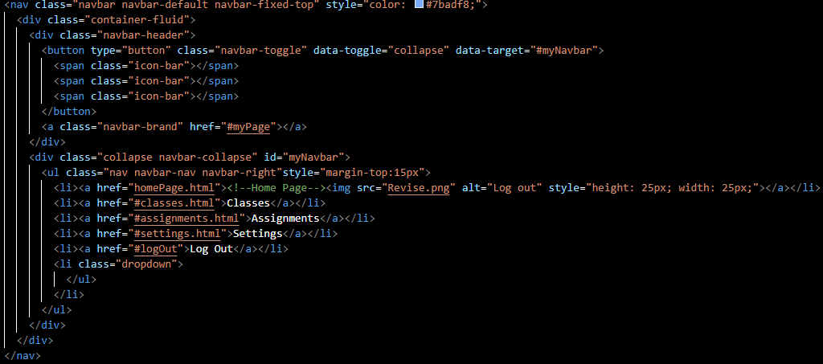

#### Iteration 2:



The settings button has been changed to show an icon that is commonly used for settings as this is considered a usability feature as when you are thinking of settings the image of gear instantly pops up in your mind and so you are also looking for an image of a gear and an image is easier to find than a word.

The same has been done to the log out button as to ensure that the website’s usability is high which in turn will mean that the users will come back to the website more often and in turn advertise the website to their friends as an easy tool to revise for.

Code:

It also links the stylesheet so that not only is the navbar formatted correctly but also any page that links to the navbar instantly gains access to the stylesheet and can therefore be formatted the same as the rest of the pages

#### The Final Result:

This page is then put into its own page called “navbar.php” as a result of this it can then be called by the other pages which means it does not have to be copied into each page which minimises the lines of code for each page, which reduces the visual complexity and makes it easier to understand as well as meaning that the memory taken up by the final product is minimised and therefore if it moves to a paid page it will then cost less to store.

“navbar.php” can then be called with the single line below and as the stylesheet is used for formatting navbar it will then also be incorporated into each page that navbar is incorporated into.



### Set Page:

#### Iteration 1:

The carousel has been placed in the centre which means that the users eyes will see it first upon entering the page which means less time is spent trying to find where they are, it has also been placed into a light grey box as to attract attention to the where the terms in each set will be located which means that as soon as they look at the page they will know where all the buttons relating to the management of the set are. The double placement of the placeholder “Set Name” is not a mistake but is implemented so that the stakeholders can see it and decide which they prefer, the set name being outside the box in which the carousel of terms will be or on the outside of the box. As it is the first iteration there were going to be problems and in this case there are a couple, first of all the carousel does not have an appropriate height attribute and so expands out of the box that is supposed to be containing it, The height between the where the Set term is and the top of the carousel is also too small and makes it look cramped.