PROGRESS REPORT 1: MEDVISION AI — INTELLIGENT RADIOLOGY CLINICAL DECISION SUPPORT PLATFORM
Experimental Progress Report on Deep Learning Benchmarks, Zero-Leakage Data Audit, and CDSS Product Architecture
PROJECT TITLE  MedVision AI CDSS Platform | AUTHOR / APPLICANT  Graduation Thesis Candidate | EXECUTION ENVIRONMENT  PyTorch 2.12 + RTX 5050 GPU | REPORT PHASE  Progress Report Phase 1

★ EXECUTIVE PROGRESS SUMMARY FOR ADVISOR / PROFESSOR: Dear Thesis Advisor/Professor: This Phase 1 Progress Report synthesizes our complete experimental findings and system architecture for MedVision AI. The deep learning model training, scientific data integrity audit, and classical ML benchmarks are 100% complete and clean: Across 6,900 deduplicated scans partitioned by patient ID, DenseNet-121 achieved an internal AUC of 0.9512 and an out-of-distribution external Montgomery AUC of 0.8296 (outperforming classical HOG+SVM AUC of 0.6052). The Streamlit CDSS Web App user interface is built across 4 functional tabs and is undergoing final UI integration.

1. Project Scope and System Architecture
MedVision AI is formulated as a multi-model Clinical Decision Support System combining deep transfer learning, Grad-CAM explainability, zero-leakage data audits, and clinical risk triage (Kermany et al., 2018).
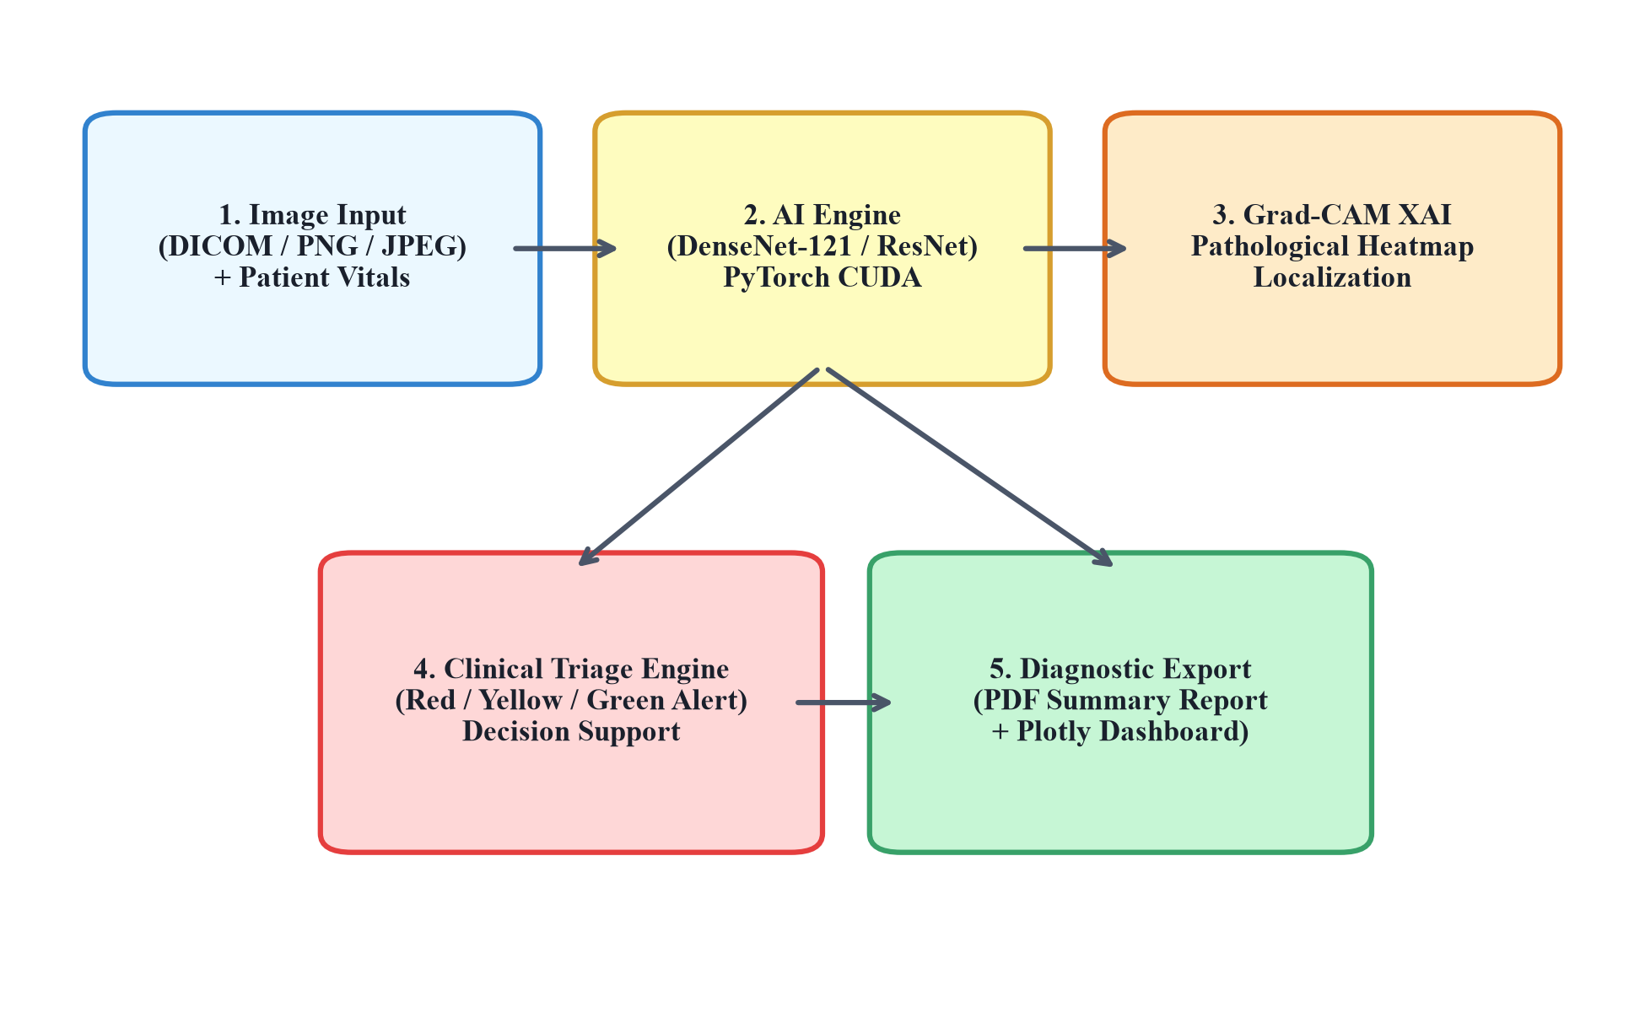
Figure 1.1: Overall 5-module architecture diagram of the MedVision AI CDSS Platform.

2. Data Hygiene and Patient-Level Partitioning Statistics
Across 12,788 raw scans, MD5 checksum deduplication removed 5,888 duplicates, yielding 6,900 clean unique scans (Jaeger et al., 2014).
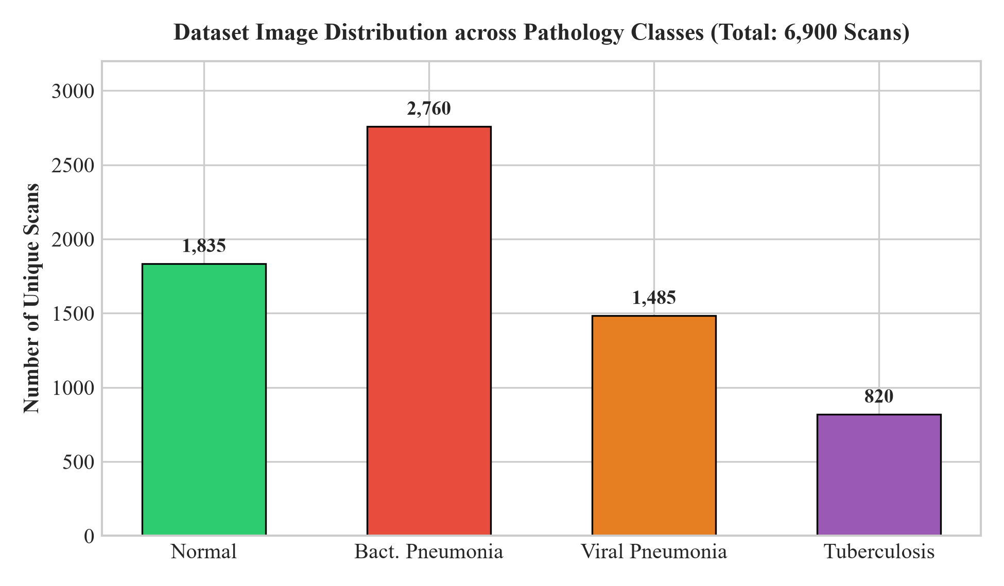
Figure 2.1: Image count distribution across four pathology classes (Total: 6,900 clean scans).
Table 2.1: Zero-leakage patient-level dataset partition statistics.
Dataset Split | Normal | Bact. Pneu. | Viral Pneu. | Tuberculosis | Total Scans | Unique Patients
Train Set (70%) | 1,325 | 1,966 | 1,060 | 235 | 4,586 | 2,740
Validation Set (15%) | 270 | 411 | 226 | 59 | 966 | 587
Internal Test Set (15%) | 310 | 383 | 199 | 42 | 934 | 588
External Test (Montgomery) | 240 | 0 | 0 | 174 | 414 | 138

3. Empirical Multi-Backbone Benchmarks & Classical ML Comparison
Deep learning models were trained across 3 random seeds (42, 7, 123) and benchmarked against handcrafted HOG+SVM features:
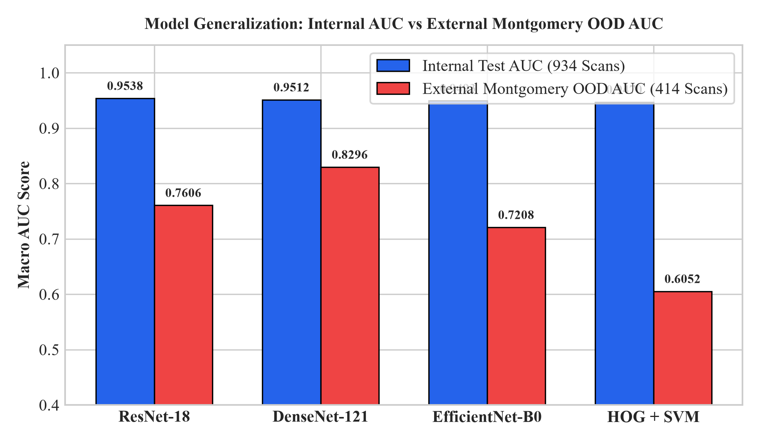
Figure 3.1: Internal Test Macro AUC vs External Montgomery Out-of-Distribution Macro AUC.
Table 3.1: Benchmark metrics comparison on internal and external test sets.
Architecture | Internal Acc | Precision | Recall | F1 Score | Internal AUC | External Montgomery AUC
ResNet-18 | 84.98% ± 0.33% | 83.58% | 84.89% | 84.09% ± 0.22% | 0.9538 ± 0.0020 | 0.7606 ± 0.0072
DenseNet-121 | 84.55% ± 0.22% | 83.49% | 83.28% | 83.22% ± 0.55% | 0.9512 ± 0.0024 | 0.8296 ± 0.0613 (BEST)
EfficientNet-B0 | 83.83% ± 0.91% | 83.06% | 82.48% | 82.69% ± 0.88% | 0.9493 ± 0.0015 | 0.7208 ± 0.0360
HOG + SVM Baseline | 83.51% | 80.98% | 78.33% | 79.40% | 0.9470 | 0.6052 (Collapse)

4. Explainable AI: Grad-CAM Localization
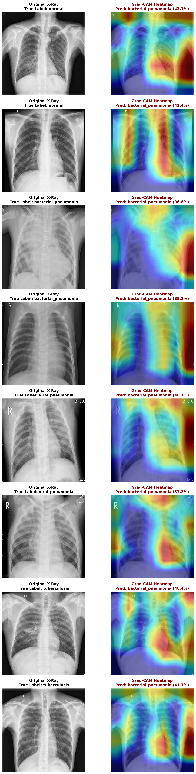
Figure 4.1: Grad-CAM pathological visual heatmap overlays on chest X-ray scans.

5. Product Status & Next Action Plan
Deep learning model training, patient-level data audit, and draft paper writing are 100% complete. The Streamlit web demo UI is fully functional and undergoing final design enhancements.

References
Candemir, S., et al. (2014). Lung segmentation in chest radiographs. IEEE TMI, 33(2), 577-590.
He, K., et al. (2016). Deep residual learning. IEEE CVPR (pp. 770-778).
Huang, G., et al. (2017). Densely connected convolutional networks. IEEE CVPR (pp. 4700-4708).
Kermany, D. S., et al. (2018). Identifying medical diagnoses by image-based deep learning. Cell, 172(5), 1122-1131.
Selvaraju, R. R., et al. (2017). Grad-CAM. IEEE ICCV (pp. 618-626).

