Author: Jacob Abts

Submission Date: 8/29/2024

CSU Global - CSC500-1

Link: <https://github.com/CheesyKiller/School/tree/956ae436701c052a2609c17785ddce111b84227b/CSC500-1>

Execution Photo:

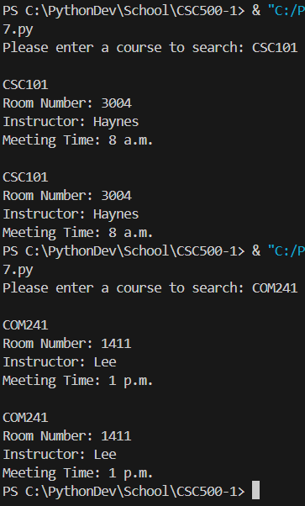

Note:

I got upset we didn’t just use a tuple, so I made a segment of code that implements a tuple.