Weather Prediction Using Machine Learning

ABSTRACT
Weather forecasting is important since it directly or indirectly affects the farming, flights and our daily activities. This paper studies how Machine Learning (ML) can be used to predict weather conditions. We compared many models to find which one is better to use.
The dataset we used contains 96,000 records of atmospheric data. Since some weather type occurs much more often than others, we used multiple models to balance and improve learning. We achieved the highest accuracy of 89.66%, which means it predicts weather correctly most of the times. It works very well for predicting clear, cloudy and foggy weather
Overall, the research shows that ensembles machine learning methods like random forest are effective for weather prediction using well- structured and clean data.
Keywords: Machine Learning, Weather Prediction, Random Forest, Ensemble Learning, Classification, Imbalanced Dataset, Atmospheric Data.
- INTRODUCTION
Weather conditions play an important role in many crucial aspects of life, including transport, farming, business, and planning of activities by governments [1]. However, forecasting of weather has always proved to be an extremely challenging activity, given the complexity and unpredictability of the behavior of the atmosphere. Conventionally, forecasting of weather has involved the use of complicated physical equations and powerful supercomputers for simulating atmospheric behavior. prediction accuracy. However, in recent years, machine learning has become a promising alternative for predicting weather in simpler and more computational efficient way [2].
The key problem being solved in this study is predicting various kinds of the weather using historical data on the atmosphere. The objective of the research is to classify the weather into four different kinds. This is achieved by using various environmental factors such as temperature, humidity, pressure, and wind speed in the predictions. This way, the complex problem of predicting the weather is reduced to a classification problem in machine learning.
Even though many methods exist for weather prediction, there are still some important challenges. First traditional Numeric Weather Prediction (NWP) models require very powerful computers and large network to collect data and also needs modern parallel computing, which makes them expensive and difficult to use for small scale or local forecasting systems [7]. Secondly, the models also face the challenge of imbalance data. When the models are trained without addressing the imbalance data challenge, the models tend to favor the weather types that are more frequent and tend to fail when the events are rare.
In order to solve the above challenges, the researcher suggests the use of the machine learning approach that can be used to solve the imbalance weather dataset. Instead of using complex weather simulations, the researcher relies on historic data to train the models with good accuracy.
The main contributions of the research are:
- Developing and improving the multiple models and find out which one is best to use
- Performing feature analysis to understand which atmospheric factors have the most influence on predicting weather conditions, helping to explain how environmental variables affect weather outcome.

- Problem Statement
Accurate weather prediction is challenging due to atmospheric complexity and data imbalance. Traditional models require high computational power. This project aims to develop a machine learning-based system. that can efficiently predict weather conditions using historical data.
- Objectives

• To develop ML models for weather prediction
• To compare multiple algorithms
• To handle imbalanced dataset
• To achieve high prediction accuracy

- Literature Review
The research on automated weather forecasting covers many areas of computer science. Here, previous studies are grouped into categories to understand existing approaches and how this research is different.
Traditional and Deep Learning Weather Models:
Many weather prediction systems use either physical weather equation or advanced deep learning models to predict weather patterns. some large deep learning models use complex neural network to improve predictions accuracy and reduce errors on global scale [2]. These models are powerful and can capture atmospheric patterns. However, they require very high computational power and large resources for training and prediction. In contrast this research proposes a lightweight models that focuses on localized weather prediction and can effectively work on normal mid-level computers.
Spatio-Temporal Data Processing:
Weather data usually changes over time and location, which makes it spatio-temporal in nature. Some model approaches process continuous environmental data using special models like transformers or sensors [3]. These systems continuously update their prediction by adding updated data and removing outdated information, enabling real time forecasting [8]. While these approaches are fast they often do not work well with traditional datasets. In this research, we focus on the historic data and extract important time related features to capture patterns without using complex real time data systems.
Model Evaluation and Interpretability:
Evaluating machine learning models is not only about measuring accuracy. Some studies use advanced methods to understand how model make decisions [4]. These approaches try to analyze the internal logic of models, that is by studying features influence or how the model minimizes error during training [5]. although these techniques help improve trust in machine learning systems, they can sometimes be too complex for simple classification tasks. In this study, we use more practical methods to understand how the model predicts different weather categories. In addition to that, we need to ensure that there is no imbalance in data while training the model since the machine learning models are heavily dependent on the quality of data and consistency of data sources, thus it is important to take consideration of data source and structure since it can lead to the unreliable predictions [6].
- METHODOLOGY
The methods used in this study follows machine learning process to convert raw, tabular weather data into useful predictions.
Collect data
The first step is collecting the weather dataset .for this research we used dataset that contains more than 96,000 historical weather records .The dataset include atmospheric features such as temperature, humidity, wind speed, pressure, visibility etc.
Clean and Prepare data
Raw weather data may contain missing values and duplicate data. That’s why it is important to perform data preprocessing, handling missing values by using a simple imputer.
Duplicate data is removed, as it may cause repetition of data. also converted the categorical variables such as precipitation type and weather category labels are converted into numerical values using labels encoding, so that machine learning algorithm can process them.
Training Machine Learning model
In this research we are gonna train multiple models and gonna compare them to find out which one perform best to use it.
Test and Evaluate Models
After training the model, the dataset is divided into 80:20 split 80% for training and 20% for testing. Stratified sampling is used to maintain the same distribution of weather classes in both datasets.
Use the best model
Once the models are trained and evaluated, we can compare them and then find out which one performs best. Once done it can be used to predict weather conditions for atmospheric data.
- MODELING AND ANALYSIS
In this study four ML models were trained, tested and compared to find out which one provides best results.
1.Gradient Boosting
Gradient boosting is an ensemble learning method that builds multiple decision trees sequentially. Each new tree tries correct the errors made by the previous one. Improving performance by gradually reducing mistakes during training. In this study the GBoost model gave us accuracy of 74.49%
2.XGBoost
XGBoost is advanced version of the GBoost algorithm that is optimized for speed and performance. It uses computation techniques and regulations to improve model accuracy also preventing overfitting. In our case XGBoost model achieved an accuracy of 80.77%, which is better than basic GBoost.
3.Extra Trees
Extra Trees is another ensemble learning algorithm similar to Random Forest. This helps improve model diversity and minimizes overfitting. In this study the Extra tree achieved accuracy of 88.23 %. showing the strong performance in predicting weather conditions
4.Random forest
Random forest is an ensemble learning model that combines multiple decision trees to make predictions. This method reduces overfitting and improves prediction stability. In this research the random forest achieved highest accuracy of 89.67% making the best performing model for this dataset.

- RESULTS AND DISCUSSION
Table 1. Comparison of Machine Learning Models for Weather Prediction
Sr. No. | Model | Accuracy (%) | Advantages | Disadvantages
1 | Gradient Boosting | 74.49% | Good at reducing bias, improves performance step-by-step | Slower training, sensitive to noise and overfitting
2 | XGBoost | 80.77% | Optimized for speed and performance, handles overfitting better than GB | Complex to tune, requires more computational resources
3 | Extra Trees | 88.23% | Fast training, reduces variance, good for large datasets | Can be less interpretable, slightly lower accuracy than RF
4 | Random Forest | 89.67% | High accuracy, reduces overfitting, robust to noisy and imbalanced data | Larger model size, slower prediction compared to simpler models

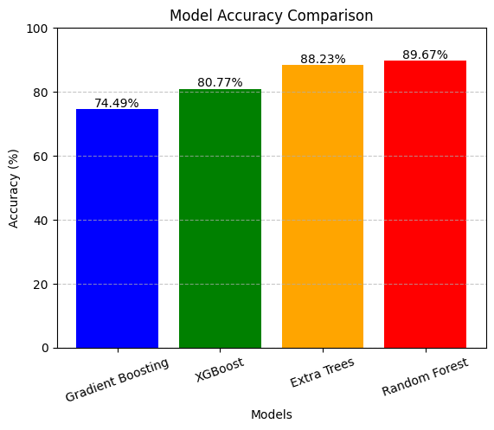
Figure 1: Histogram Showing Accuracy Comparison of Machine Learning Models

VIII. SYSTEM IMPLEMENTATION
The developed system is implemented as a web-based application that allows users to input weather parameters and obtain predictions easily through an interactive interface.
Frontend Design
The frontend of the application is developed using the Streamlit framework, which provides a simple and interactive web interface. The application is deployed as a website where users can access it through a browser.
The interface allows users to either manually enter atmospheric parameters or fetch real-time data using an online weather API. The parameters include:
- Temperature
- Humidity
- Wind Speed
- Pressure
- Visibility

API Integration
The system integrates an online weather API to fetch real-time weather data based on user-selected location. This allows the model to make predictions using current atmospheric conditions instead of only manual inputs.

User Interface of the System
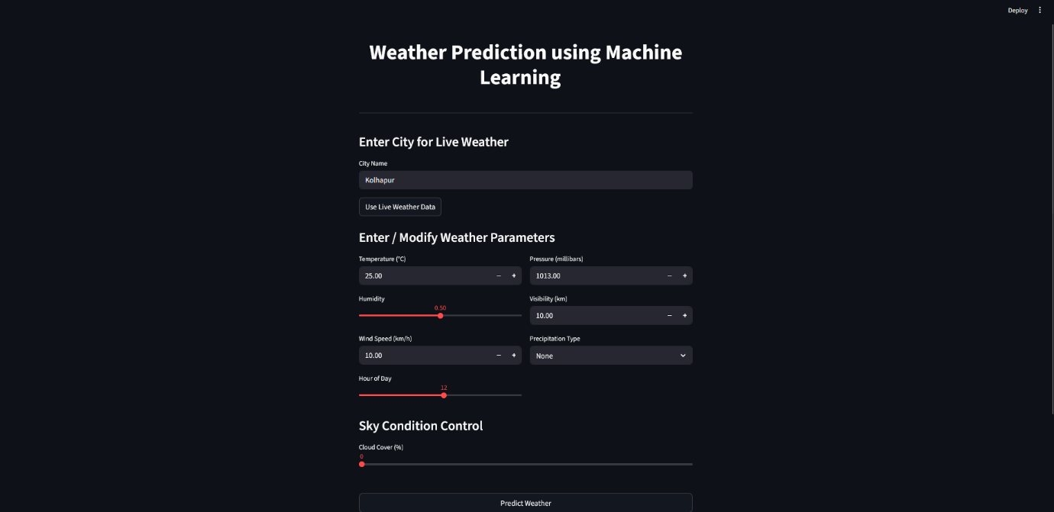
Figure 2: Web Application Interface for Weather Prediction

The above figure shows the web-based interface developed using Streamlit. Users can enter a city name or weather parameters, and the system displays predicted weather conditions using the trained machine learning model.

- CONCLUSION
We trained and tested multiple models to predict weather conditions using past weather data. Instead of using complex physical equations we treated weather prediction as classification problem and trained different models on data set with more than 96 thousand records. Out of them the Random Forest performed best with accuracy of 89.67%.
Compared to traditional weather prediction methods Machine learning approach is much simple and does not require powerful computer, Making it useful for smaller or local weather prediction systems. But there are some limitations, since the models uses past data, they may not fully capture how weather changes over time and across different locations Also, rare weather condition are harder to predict due to less appearance in the dataset.
In the future, this work can be improved by using real time data and more advanced models that can better understand changes over time and location. It would also be useful to improve how model explains it's predictions and focus more on predicting extreme weather events. Overall, the study shows that ML methods can be simple and effective to predict weather.
- REFERENCES

[1] “Weather Forecasting – Practical Applications,” Encyclopaedia Britannica. Available: https://www.britannica.com/science/weather-forecasting/Practical-applications
[2] Winkler, Jens, Denhard, Michael, "Arnoldi Singular Vector perturbations for machine learning weather prediction," 2025. https://arxiv.org/pdf/2506.22450v1
[3] Martin-Turrero, Carmen, Bouvier, Maxence, Breitenstein, Manuel, Zanuttigh, Pietro, Parret, Vincent, "ALERT-Transformer: Bridging Asynchronous and Synchronous Machine Learning for Real-Time Event-based Spatio-Temporal Data," Proceedings of the 41st International Conference on Machine Learning (2024), in Proceedings of Machine Learning Research 235:48837-48854, 2024. https://arxiv.org/pdf/2402.01393v3
[4] Cherednichenko, Olga, Chernyshov, Dmytro, Sytnikov, Dmytro, Sytnikova, Polina, "Generalizing Machine Learning Evaluation through the Integration of Shannon Entropy and Rough Set Theory," Proceedings of the 8th International Conference on Computational Linguistics and Intelligent Systems. Volume I: Machine Learning Workshop, April 2024, 2024. https://arxiv.org/pdf/2404.12511v1
[5] Niroomand, Maximilian P, Wales, David J, "Physics-Inspired Interpretability Of Machine Learning Models," ICLR 2023 Workshop on Physics for Machine Learning, 2023. https://arxiv.org/pdf/2304.02381v2
[6] Boom, Cedric De, Reusens, Michael, "Changing Data Sources in the Age of Machine Learning for Official Statistics," UNECE Machine Learning for Official Statistics Workshop 2023, 2023. https://arxiv.org/pdf/2306.04338v1
[7] M. A. Tolstykh and A. V. Frolov, “Some Current Problems in Numerical Weather Prediction,” Institute of Numerical Mathematics, Russian Academy of Sciences, Moscow, Russia,Jun.8,2004.https://www.researchgate.net/profile/Mikhail-Tolstykh3/publication/282027587_Some_Current_Problems_in_Numerical_Weather_Prediction/links/5601a72d08aecb0ce881acf6/Some-Current-Problems-in-Numerical-Weather-Prediction.pdf
[8] Chattopadhyay, A., Mustafa, M., Hassanzadeh, P., Bach, E., and Kashinath, K., "Towards physics-inspired data-driven weather forecasting: integrating data assimilation with a deep spatial-transformer-based U-NET in a case study with ERA5," Geoscientific Model Development, vol. 15, pp. 2221–2237, 2022. https://gmd.copernicus.org/articles/15/2221/2022/index.html

