**BUS334 Business Analytics**

**Data Collection and Preliminary Data Analysis**

Koh Kian Wei

Murdoch University

10th July, 2023

Page Count: 5 Pages



**Part 1 – Summary**

Tabula rasa, the idea that people are born as a “white sheet of paper”, and obtain knowledge through absorbing “colour (information)” from life experience would suggest that learning key information early is vital for a good life journey. One of the way parents can ensure their child have an edge is through utilising childcare centre, or other such services that helps in early child development.

A survey targeting parents with children who are eligible for childcare centres or, adults who are pregnant or intending to adopt soon were utilised in this analysis. Due to time constraints and that participants requiring to meet specific criteria to be eligible for participation, google form was chosen for its ability to reach out to more people as compared to other conventional tools to collect date. Questions asked were originally crafted that would help in achieving the main goal of this analysis, and the survey was sent directly to targeted participants, as well as word of mouth from those participants to individual whom they know fits the criteria as well. This resulted in reaching the desired number of participants, with a surprising 100% submission of data.

Key data, such as important aspects of childcare centre, were collected and analysed to determine the feasibility of opening “Life Treasure Childcare”, a childcare centre that operates in the parent’s workplace, with its main selling point the accessibility and benefit the location bring to the parent.

**Part 2 – Results**

The questions asked were split into three separate categories; Demographics, Childcare Arrangements, and Receptivity of Childcare Centre at Workplace. Survey sent via link through social media within a 1-week time frame resulted in 15 respondents, with a 100% of the participants fitting the specific criteria required to take part in the survey.

**Demographics**

Age, job field, monthly household income range, number of child(ren), and age group of the child(ren) was collected in this portion of the survey to better understand the background characteristics of the participants, and helps the business idea proposed to reach the right clients. With reference to Figure 1. below, the data collected showed that the majority of response comes from individuals aged between 25 to 34 years old and 35 to 44 years old, who made up 47% and 27% of the respondents respectively. Most of the participants are also either in white collar jobs (40%) or unemployed (27%). This suggest most answers to subsequent questions were made potentially by individual with family planning in mind, and have limited interaction with their child during morning to evening.

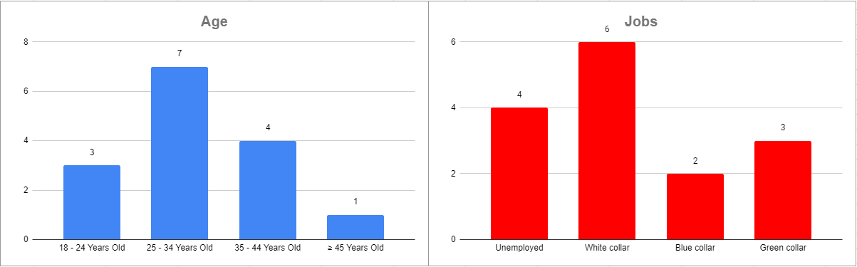

Figure . Age and Job Field of Participants

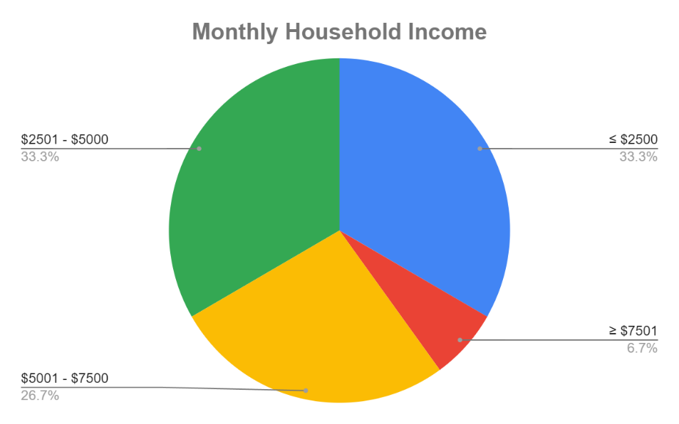Monthly household income of respondents was evenly spread, with $5000 and below making up 66% of the respondents and anything above $5000 making up the remaining 34%. This information suggests that any subsequent answers given are not skewed by imbalance in spending power of respondents, deriving from the even spread between household income of the individual responding to this survey. With reference to Figure 3. Below, data collected also shows the majority of participants to have at least a child, and the only participant who reported having no child is either pregnant or intending to adopt one. 85% of respondent with child(ren) within the range of age group eligible for childcare services imply that the majority of the respondent are potentially interested in childcare services, increasing the reliability of data collected by the survey.

Figure . Monthly Household Income of Participants

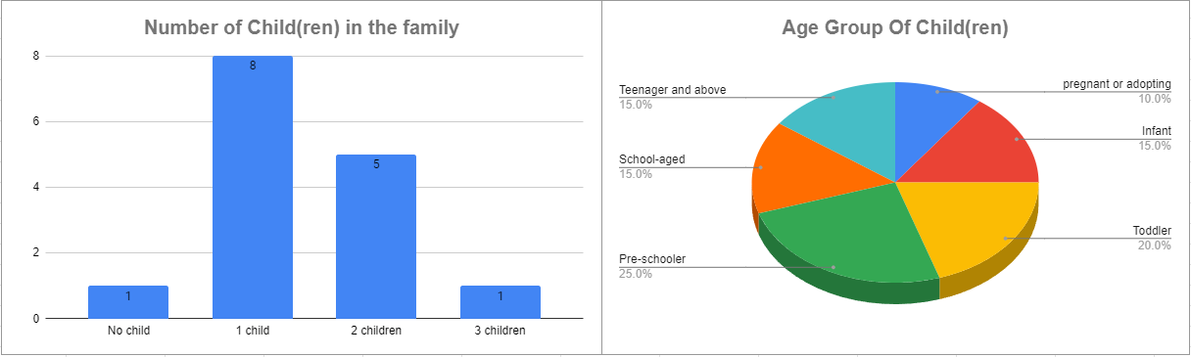

Figure . Participant's Number of Child(ren) and Their Age Group

**Childcare Arrangement**

Understanding an individual’s current and preferred childcare arrangement, as well as reason for the difference between the two will help provide an insight on what aspect of childcare services do the public deem more important.

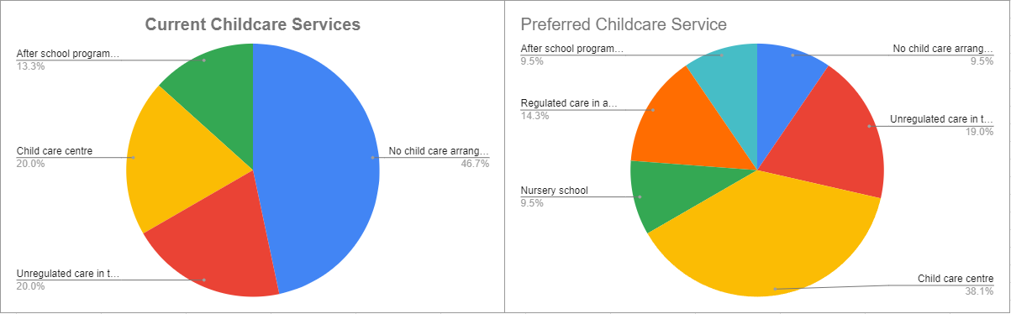

Figure . Comparison Between Current and Preferred Childcare Services of Participants

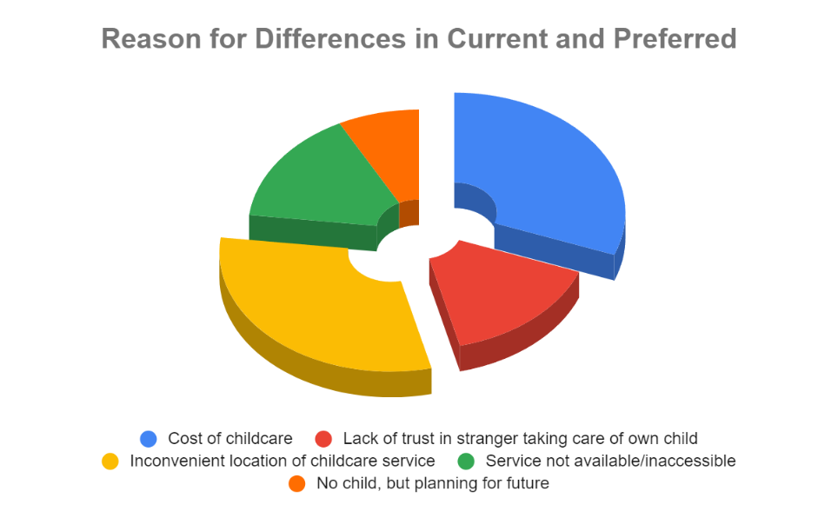Based on the information gathered, no childcare arrangement makes up half of the services they have (or do not have) currently, with the other half closely split between other childcare services. However, it was found that when given a choice, participants would prefer some form of childcare arrangement, with child care centre making up 38.1%, making it the dominant choice among other services. Figure 5. Shows the reason behind these differences. Cost of childcare and inconvenient location of childcare services were the two main reason participants gave, making up 30.8% each of the overall reasons given. This suggest that a prime location can help in attracting potential audience and make up for pricing disadvantages. Further analysis revealed that skills of the childcare personnel was vital in childcare centres, with location of childcare worth noting to be reported in most important aspect, but not in least important aspect. Figure 6. below shows a more complete explanation of data collected.

Figure . Reasons for Differences in Current and Preferred Childcare Service

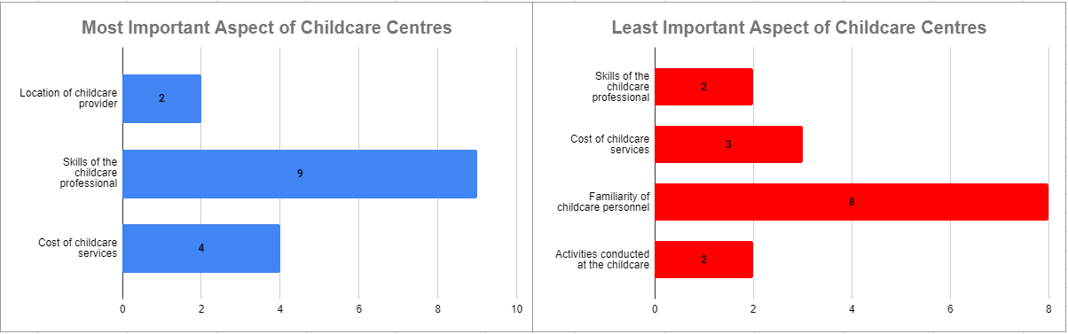

Figure . Most and Least Important Aspect of Childcare Centres Provided by Participants

To obtain an edge over other competitors, skills deemed important by parents were also explored to increase receptivity of the business, with results obtained supporting that parents seeks childcare personnel with knowledge in children’s development, ability to create a safe and healthy environment, and implementing developmentally appropriate programs.

Figure . Perceived Top 3 Most Important Skills of Childcare Personnel

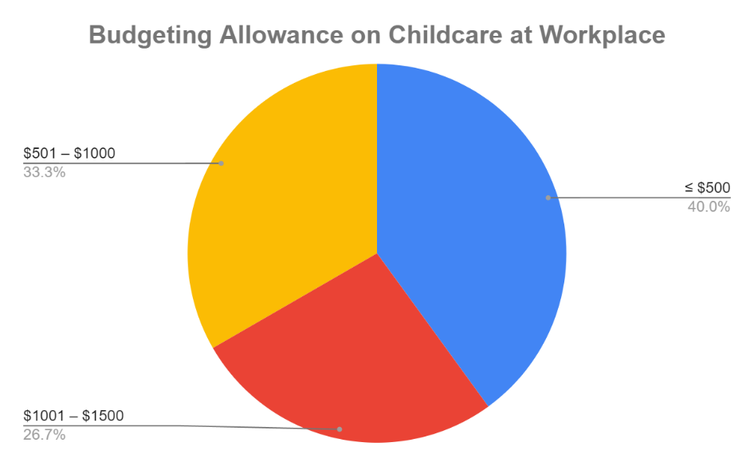**Receptivity of Childcare Centre at Workplace**

With prior data suggesting the importance of cost, appropriate pricing for childcare centre at workplace were investigated as well to trounce other competitors. Results shows majority who makes up 40% of total response prefers the cost to be under $500. However, data shows an even spread between the other price range as well, hinting that an increment in budgeting allowance is possible with the appropriate marketing and strategy.

Figure . Budgeting Allowance on Childcare at Workplace by Participants

Data on feasibility of business idea shows collaborating with their employer and raising awareness of the benefits a childcare centre at a parent’s workplace can potentially increase revenue. 14 out of 15 (93.33%) participants also supports the business idea after answering previous questions.

**Part 3 – Preliminary Conclusions, Next Steps & Recommendations**

Preliminary findings reported majority of participants to be between 25 to 34 years old with white collar jobs. Most household income was found to be $5000 and below, with many having either 1 or 2 children, and every participant having child(ren) eligible for childcare services. Consumer need for childcare services was identified, with majority reporting currently not having any childcare arrangement, but preferred childcare centre when given a choice. The cost and location of childcare centre was found to be the main reason for disparity between the two. Knowledge in children’s development, ability to create a safe and healthy environment, and implementing developmentally appropriate programs were key skills identified to attract targeted audience. Potential steps to increasing revenue was highlighted, and 93.33% of participants supported the business idea. In conclusion, the business idea was found to be feasable.

Limitations of this survey includes supsceptability to survey fraud. External validity might also be an issues, where due to time constrain, the sample size collected was too small to be able to confidently reflect the general populace. Internal validity might also be questioned as this is only the first round of data analysis, and it is still not known if the data acquired will necessarily support the business idea. Although time consuming, a real life interview could be done to promote honesty. Data collection done next time should also be given a longer time stamp to increase the sample size. Scrutinize the effectiveness of strategies used (in this case, collaboration and raising awareness of benefits of childcare centre in workpalce), and then using available information to refine data collection and data analysis. After every implementation of new strategy, data analysis should be conducted again to ensure the business stays competitive and remain relevant.

**Appendix**

Link to survey used for data analysis: <https://docs.google.com/forms/d/1lZXNEpP87IaV45nv2OIWsQjWUzS4Y0KseSj6vWIfu2Q/edit>

Link to document used to plot graphs: <https://docs.google.com/spreadsheets/d/1KKt2tMUuoGOhSAwUv1pmeYjbqOXRekzJXq1PxeBWZZU/edit?resourcekey#gid=2062050886>