Radview: An Agentic Early-Warning System that Turns Restaurant Reviews into Verified Action Plans
Yeo Zhang Han, Daniel Leong, Peh Xue Ying, Yang Jiajun Joven, Wong Wei Xuen, Vijayanand Jeeva
DSA2111 Cloud-based Data Science and Programming — Group 10
National University of Singapore · Code: github.com/Chef2121/dsa2111_project
Author order to be confirmed by the group

Abstract—Online ratings drive restaurant revenue, yet owners usually discover a reputation problem only after their average rating has already fallen, and the aggregate score never says what to fix. Existing research predicts permanent business failure from rating sequences, and commercial review analytics report overall sentiment; both describe the past and stop at diagnosis. We present Radview, a cloud-native system that warns owners of an impending rating decline and tells them, with cited review evidence, which operational problem to address first. Radview streams the Yelp Open Dataset, labels every review's sentiment toward food, service, cleanliness, price and ambience with a DistilBERT model fine-tuned by weak supervision, tracks aspect-level complaint rates with robust control charts, and forecasts a statistically significant 0.3-star decline over the next three months with a calibrated PyTorch GRU over twelve-month feature sequences. Forecasts are explained twice, by SHAP and by a counterfactual intervention, and an agent built with LangGraph turns them into a ranked action plan whose every claim is checked by a mechanical five-axis verifier before an owner sees it. The system runs as Docker containers on Kubernetes in AWS behind a REST API and an owner dashboard. On 152,649 reviews of 397 Philadelphia restaurants (2016–2021), the aspect model reaches macro-F1 0.737 and complaint-F1 0.567 on human-labelled SemEval-2014 sentences, ahead of TF-IDF and lexicon baselines; all 265 claims in 53 real action plans pass verification while 100% of claims from an adversarial planner are rejected, and a free open model (Qwen 2.5 7B) acting as the agent gets only 69% of its claims verified. On an out-of-time, COVID-era test period the GRU (AUROC 0.727) is the best learned multi-signal model, but a rating-trend logistic regression is marginally better (0.738), and complaint spikes do not anticipate declines at monthly granularity. We report these negative results and discuss why.
Index Terms—aspect-based sentiment analysis, early warning, rating forecasting, agentic AI, LLM grounding, explainable AI, Kubernetes.
I. Introduction
A single star on Yelp is worth real money: a one-star increase in a restaurant's rating has been associated with a 5–9% increase in revenue, with the effect concentrated in independent restaurants rather than chains [1], and rounding thresholds in displayed ratings measurably change how often diners choose a venue [2]. At the same time, restaurants operate on thin margins and fail at high rates, often for operational reasons the owner could in principle have fixed [3]. Reviews therefore carry an early, free and detailed signal about what customers are unhappy with — but an independent restaurant has neither the analyst to read hundreds of reviews nor the budget for enterprise reputation software.
The tools available today leave a gap in three places. First, the star rating is a lagging, aggregate indicator: it accumulates over years, moves slowly, and treats a three-star review that praises the food but complains about service identically to one that complains about hygiene. Second, research on review-based risk prediction stops at diagnosis. The strongest work we found, a variable-duration hidden Markov model of rating sequences, predicts restaurant failure with an out-of-sample AUC of 85.2% but, as its authors note, does not tell managers how to reach a better state and uses review text only as one aggregate sentiment score [4]. A hybrid CNN–DNN that adds aspect-wise topic sentiment predicts permanent closure with about 90% accuracy, but again outputs a single open/closed label at a fixed horizon [5]. Third, systems that do generate recommendations with large language models can hallucinate, and an owner cannot easily tell a grounded recommendation from an invented one.
Radview addresses these gaps with one end-to-end pipeline. We formulate the task as follows. For restaurant i and calendar month t, let x_{i,≤t} be the sequence of monthly signals derived only from reviews, check-ins and tips up to and including month t. The target y_{i,t} = 1 if the mean star rating over months t+1…t+3 falls at least 0.3 stars below the mean over months t−5…t and the drop is statistically significant (one-sided z ≥ 1.645). Radview must (i) estimate P(y_{i,t} = 1 | x_{i,≤t}) without using any future data, (ii) attribute the risk to five operational aspects, and (iii) produce a short, ranked action plan in which every claim is traceable to the analytics or to a verbatim review.
Our approach is to decompose reviews into aspect-level complaints with a transformer, monitor those complaints the way a quality engineer monitors a production line, forecast decline with a sequence model, and let an agent write the plan under a strict, mechanical verifier. Targeting a rating decline rather than closure gives owners an earlier, milder signal with room to intervene. The main contributions are:
• An aspect-to-action pipeline on real data. Weakly supervised aspect-level sentiment read from review text (the star rating only fills in polarity for opinion-less sentences in the training labels) feeds complaint monitoring, a calibrated decline forecaster with two independent explanations, and an action planner — evaluated on 152,649 real Yelp reviews and on human-labelled SemEval-2014 sentences.
• A grounded agent with a five-axis verifier. A LangGraph agent in which an LLM — Claude, or a free open-weight model served on our own GPU — chooses which analytics tools to call, with a deterministic planner as fallback and baseline; every claim is checked for citation, verbatim quotation, aspect relevance, numeric fidelity and substance, and an adversarial planner demonstrates that fabrications are rejected.
• A reproducible cloud-native deployment with honest evaluation. Docker images gated by tests, Kubernetes jobs and services, a REST API and an owner dashboard; and an evaluation against six forecasting baselines that reports where the proposal's hypotheses did not hold.
II. Related Work
A. Online Reviews and Business Outcomes
Luca [1] combined Yelp ratings with Washington State revenue data and a regression-discontinuity design to show that ratings causally affect demand for independent restaurants. Anderson and Magruder [2] used the same rounding discontinuities to show that an extra half-star raises the chance of a restaurant selling out at peak times. Parsa et al. [3] interviewed owners of failed and surviving restaurants and found that failure is usually operational and gradual rather than sudden. Together these studies motivate monitoring reviews continuously and acting early — but they are explanatory studies and do not build a predictive tool.
B. Predicting Decline and Failure from Reviews
Naumzik et al. [4] model each restaurant's rating sequence with a variable-duration hidden Markov model and detect an at-risk latent state long before closure, achieving an out-of-sample AUC of 85.2%; text enters only as one sentiment score per review, so the model cannot say which aspect drives risk. Thazhackal and Devi [5] combine aspect-wise sentiment from a sentiment-aligned topic model with business attributes in a hybrid CNN–DNN and report around 90% cross-validated accuracy for restaurant closure, but predict a single binary outcome at a fixed horizon and evaluate with a random rather than chronological split. Earlier work showed that review text improves rating prediction over stars alone: Ganu et al. [8] used sentence-level topics and sentiment in restaurant reviews, and McAuley and Leskovec [9] aligned latent rating dimensions with review topics. These methods predict a rating, not a future change in rating, and none produce recommendations.
C. Aspect-Based Sentiment Analysis
Hu and Liu [6] introduced feature-based opinion mining with frequent nouns and opinion lexicons — the lexicon-plus-rules approach our weak labeller descends from. The SemEval-2014 Task 4 benchmark [7] standardised aspect-category sentiment for restaurant reviews with human annotations for food, service, price, ambience and a miscellaneous category; we use its test set as an external, human-labelled evaluation. Transformer models dominate the task: BERT [10] fine-tuned with auxiliary sentences [12] or with review-domain post-training [13] gives large gains when trained on SemEval's own labels. DistilBERT [11] retains most of BERT's accuracy at 40% fewer parameters, which matters for CPU-only serving. Because Yelp has no aspect labels, we follow the weak-supervision paradigm popularised by Snorkel [14], in which noisy heuristic labels train a model that generalises beyond the heuristics; unlike [12], [13], our model never sees SemEval training labels.
D. Monitoring, Forecasting and Evaluation
Exponentially weighted moving-average control charts [15] are a standard tool for detecting gradual drift in process quality; we apply them to complaint rates, and replace the mean/standard-deviation scale with the median absolute deviation, which Leys et al. [16] recommend for outlier detection under skew. For forecasting from monthly sequences we use gated recurrent units [17], and gradient-boosted trees in the LightGBM implementation [18] as a strong tabular baseline. Because declines are rare, we follow Saito and Rehmsmeier [19] in treating precision–recall rather than ROC analysis as the primary view, report the Brier score [20] for probability quality, calibrate scores with Platt scaling [21], and guard against temporal leakage, a pervasive source of over-optimistic results [22].
E. Explainability
SHAP [23] attributes a prediction to its inputs using Shapley values; for differentiable models, the expected gradients estimator [24] approximates SHAP by integrating gradients from background samples. Counterfactual explanations [25] instead ask how the input would have to change for the outcome to change. We report both and measure how often they agree on the most important aspect.
F. LLM Agents and Grounded Generation
ReAct [26] interleaves reasoning with tool calls so that a language model can gather information before answering, and retrieval-augmented generation [27] conditions generation on retrieved documents. Both reduce, but do not eliminate, hallucination, which Ji et al. [28] survey as a central risk of natural-language generation. Gao et al. [29] evaluate whether generated statements are supported by their cited passages. Radview's verifier adopts that idea in a deliberately mechanical form: it checks citations, quotations and numbers against the agent's own tool outputs rather than asking another model to judge them.
G. Cloud-Native Deployment and Summary of Gaps
Container orchestration lets data pipelines and services be scheduled, restarted and scaled declaratively [30]. Table I summarises how Radview differs from the closest work: it predicts an earlier, milder outcome, decomposes risk into aspects using text-based polarity, explains its forecasts two ways, and converts them into verified actions inside a deployable system.
TABLE I
Comparison with closest related systems
 | [4] | [5] | Review dashboards | Radview
Outcome predicted | Closure | Closure | None | Rating decline
Aspect decomposition | No | Topics | Sometimes | 5 aspects
Aspect polarity from text | No | Yes | Varies | Yes (DistilBERT)
Leak-free time split | Yes | No | n/a | Yes
Explanation of risk | Latent state | No | No | SHAP + counterfactual
Actionable plan | No | No | No | Yes, verified
Deployed system | No | No | Yes | Docker + Kubernetes

III. Proposed System Design
A. Overview
Fig. 1 shows Radview's six modules. Raw Yelp files enter M1, which writes cleaned columnar tables to a shared volume. M2 labels every review with aspect-level sentiment; M3 aggregates those labels into monthly complaint rates and flags spikes; M4 forecasts decline risk and explains it; M5 turns the forecast, the trends and the underlying reviews into a verified action plan; and M6 serves everything through a REST API and a dashboard. Each module is a plain Python package that reads the previous module's output, so the same code runs in a notebook, in a container, or as a Kubernetes job, and a weekly job re-ingests and re-scores without retraining.

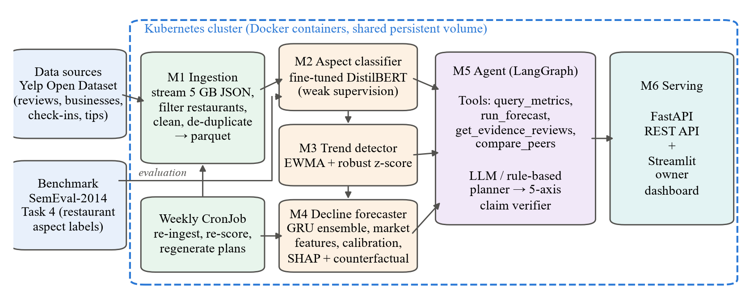
Fig. 1. System architecture. Arrows show data flow; all modules run as containers built from one image and share a persistent volume. SemEval-2014 is used only for evaluating M2.

B. M1 — Data Ingestion and Storage
The Yelp Open Dataset review file is 5.3 GB of JSON lines (6,990,280 reviews). M1 never loads it whole: it first selects restaurants from the business file (categories containing Restaurants), restricts to one market — the 400 most-reviewed restaurants in Philadelphia, the city with the most restaurant reviews — and then streams the review file, using a regular-expression pre-filter on the business identifier before paying for JSON parsing. Text is normalised, empty or invalid records removed, duplicates dropped both by review ID and by (user, business, text), and the final partial calendar month discarded because a half-observed month would look like a collapse in review volume. Check-ins and tips are aggregated to business-months. Outputs are Parquet tables plus a data-quality report. A preflight command summarises restaurants and reviews per city from the business file in seconds, so a user can choose a slice before ingesting. Table II gives the resulting dataset; a Yelp-format simulator with injected deterioration episodes provides a second, controlled dataset.
TABLE II
Dataset after ingestion (Yelp, Philadelphia)
Quantity | Value
Restaurants (top 400 by reviews; with 2016+ reviews) | 397
Reviews streamed / kept for these restaurants | 6,990,280 / 312,317
Reviews after date filter, cleaning, de-duplication | 152,649
Period | Jan 2016 – Dec 2021
Mean star rating / median review length | 4.01 / 75 words
Business-months with check-ins / tips | 44,515 / 20,232

C. M2 — Aspect-Level Sentiment Classification
Each review receives one of three labels — not mentioned, positive or negative — for each of five aspects. Because Yelp provides no aspect labels, we generate them by weak supervision. Each sentence is assigned to the aspects whose seed terms it contains (e.g. waiter, waited → service; sticky, restroom → cleanliness); its polarity comes from positive and negative opinion words with a three-token negation window (not clean is a complaint). Only when a sentence carries no opinion word do we fall back on the review's star rating. Generic words such as ordered or dinner are excluded from the seed lists after we found they copied the star rating onto neutral sentences. On 40,000 weakly labelled reviews, food is mentioned in 85% of reviews and cleanliness in only 7%, so the label distribution is highly imbalanced.
Three models are trained on these labels. The lexicon rule is the labeller itself. The TF-IDF baseline fits one class-balanced logistic regression per aspect on word uni- and bigrams. The proposed model fine-tunes DistilBERT [11]: the [CLS] representation feeds a linear layer with 5 × 3 outputs, one softmax head per aspect, trained with class-weighted cross-entropy (weights ∝ inverse class frequency^0.5) for two epochs on 6,000 reviews (sequence length 128, AdamW, learning rate 3×10⁻⁵, warm-up and linear decay). For serving on CPU the encoder's linear layers are dynamically quantised to int8, which cut inference time by about 30% in our measurements. The model with the best macro-F1 on the benchmark is selected automatically and scores every review.
D. M3 — Emerging Complaint Detection
For restaurant i, aspect a and month t, the complaint rate is the share of reviews labelled negative on a. Monthly counts are sparse, so we smooth the numerator and denominator separately with an EWMA (span 3) and take their ratio, then compute a robust z-score against the restaurant's own previous twelve months:
z_{t} = (r_{t} − median(r_{t−12}, …, r_{t−1})) / max(1.4826·MAD, binomial s.e., 0.04).
The floor stops a perfectly stable history from producing an infinite score, and the binomial term widens the scale for low-volume restaurants. An aspect is flagged when z > 2.5 and at least two negative mentions occurred in the last two months, so that "100% of two reviews" cannot fire an alert. For comparison, the same detector is applied to the smoothed star rating itself (a rating alarm).
E. M4 — Rating-Decline Forecasting
M4 builds one row per restaurant-month (including months without reviews, so windows are true calendar windows) with 47 features in three groups: rating trend and volume (1-, 3- and 6-month and cumulative ratings, slope, review velocity, check-ins, tips, months active, and the 3-month rating minus the city median that month); overall sentiment (share of low-star reviews and of reviews with any complaint); and aspect signals for each of the five aspects (complaint rate, its change, its gap to the market median, praise rate, M3 z-score and recent spike). Every feature uses data up to month t only; a unit test verifies that changing future months changes the label but no feature. The label requires both a 0.3-star drop and a significant one-sided z-test, because without the test small samples produced many "declines" that were regression to the mean after a lucky month. Formally, with n reviews, mean rating μ and variance s² in the past window p (months t−5…t) and the future window f (months t+1…t+3):
y_{i,t} = 1 ⇔ μ_{p} − μ_{f} ≥ 0.3 and (μ_{p} − μ_{f}) / √(s_{p}²/n_{p} + s_{f}²/n_{f}) ≥ 1.645,
At least six past and three future reviews are required; otherwise the month is left unlabelled.
The proposed forecaster is a GRU [17] that reads the last twelve months of standardised features (left-padded with a padding flag): a 64-unit projection with GELU and dropout, a 64-unit GRU, and a small head on the final hidden state. Three networks with different seeds are trained with class-weighted binary cross-entropy and early stopping on validation PR-AUC, averaged, and Platt-calibrated on the validation months [21]. Risk tiers are defined as lift over the training base rate (≥1.5× medium, ≥2× high) because calibrated probabilities for a 6% event rarely exceed 15%. Forecasts are explained in two ways: SHAP values from the expected-gradients estimator [23], [24], summed over time and grouped by aspect, and a counterfactual that resets one aspect's features to the market median for the whole window and re-runs the network [25]. A ridge regression of monthly mean stars on aspect complaint rates converts "how far above the market" into an estimated star cost.
F. M5 — Grounded Agentic Prioritisation
M5 is a LangGraph state machine (Fig. 2). It first calls four tools — query_metrics, run_forecast, get_evidence_reviews and compare_peers — each a thin, read-only function over the M2–M4 outputs scoped to one restaurant. Aspects are ranked by priority = (0.7·impact + 0.3·urgency) / effort, where impact averages each aspect's share of positive SHAP and counterfactual attribution, urgency combines the M3 z-score and complaint growth, and effort is a stated assumption (cleanliness fixes are cheap; ambience needs capital). Evidence retrieval re-scores every sentence of candidate reviews with M2 and keeps a review only if its most negative sentence on its own is classified as a complaint about that aspect.
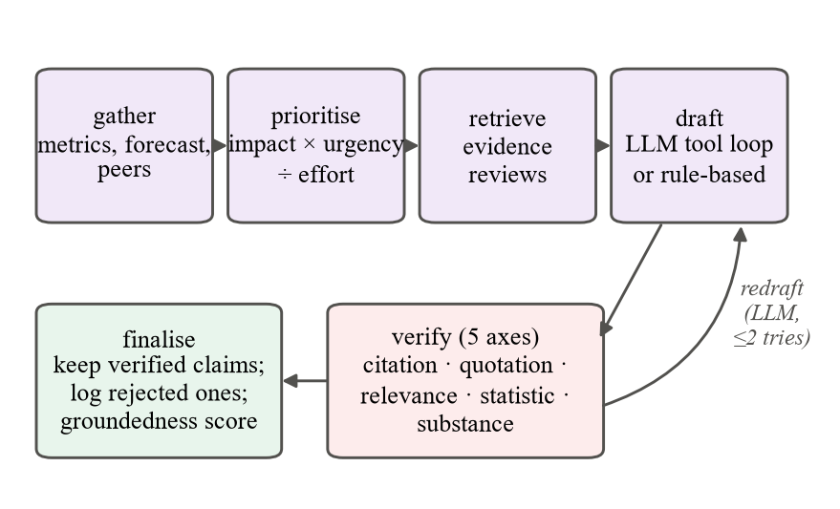
Fig. 2. M5 agent workflow. An LLM planner (Claude or the open model) may redraft once when claims fail verification; unverified claims never reach the owner but are logged.
Three planners sit behind the draft node. The Claude planner receives the pre-ranked priorities and the tool definitions and runs its own tool-calling loop — for instance fetching evidence for an aspect the analytics did not rank first — then submits the plan through a strict JSON-schema tool; every evidence ID it sees is recorded. The open-model planner runs the same prompt, tools and loop against a free open-weight model (Qwen 2.5 7B) served by Ollama through an OpenAI-compatible API, so it needs no API key, has no per-token cost and keeps reviews on the group's own server; it repairs only output-format slips (e.g. tool arguments sent as strings) and, when greedy decoding falls into a repetition loop that the server aborts, retries that turn once at temperature 0.4. The rule-based planner fills templates from the same tool outputs and the action playbook; it is both the offline fallback and the baseline. The verifier then checks every claim on five axes: citation (the review exists, belongs to this restaurant and was retrieved in this run), quotation (the quote appears verbatim), relevance (M2 labels the review negative on the aspect and the quoted sentence alone is a complaint about it), statistic (every percentage is within two points, and every star figure within 0.05, of a tool output) and substance (a metric claim must state a checkable figure). Failing claims are removed, and the share that passes is the plan's groundedness. A hallucinating planner that fabricates one claim per failure mode is part of the test suite.
G. M6 — Serving, Containers and Orchestration
A FastAPI service exposes ranked restaurants, per-restaurant metrics and timelines, action plans, live alerts, on-the-fly analysis of raw review text, evaluation results, and an endpoint for owners to rate a plan's usefulness. The Streamlit dashboard (Fig. 3) follows the order of an owner's questions — am I in trouble, is my rating moving, what are people complaining about compared with the market, is it getting worse, and what do I do first — and every chart has a table view and light and dark palettes. One CPU-only Docker image serves all three roles; its build includes a test stage, so an image cannot be produced from code that fails its tests. Kubernetes manifests define a namespace, a persistent volume claim, a training Job, a weekly re-scoring CronJob and health-checked Deployments for the API and the dashboard (two replicas). The system is deployed on the group's cloud machine, an AWS EC2 t3.large (2 vCPU, 8 GB) provisioned through NUS RONIN in the Singapore region: a single-node k3s Kubernetes cluster runs the API Deployment and the two dashboard replicas from the same manifests, using the host's Docker runtime so the test-gated image is not stored twice, with the trained models on a persistent volume. The dashboard Service is reachable only through an SSH tunnel, because it has no login and serves Yelp review text; the pods restart automatically whenever the machine is started, so it can be stopped between uses to stay within the $100 budget. The training Job is not run there: models are trained once and shipped as a bundle. For the open-model experiment the same machine was temporarily switched to a g4dn.xlarge with one NVIDIA T4 GPU running Ollama. One command (scripts/deploy_ronin_k3s.sh) reproduces the deployment. Table III lists the main frameworks.
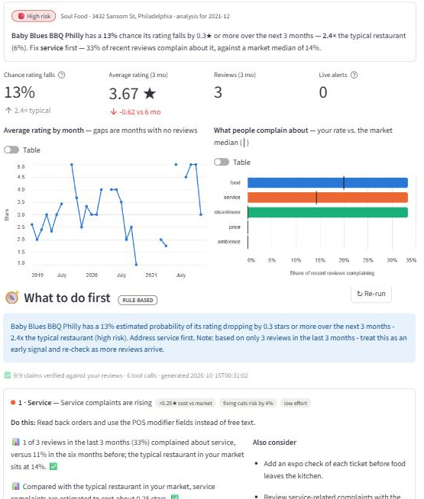
Fig. 3. Owner dashboard on real data: plain-English verdict, KPI tiles, monthly rating (gaps where no reviews), complaint rates against the market median (ticks), and the top of the verified action plan with its small-sample caveat.
TABLE III
Implementation stack
Layer | Technology
Data processing | pandas, PyArrow (Parquet)
Aspect models | PyTorch, Hugging Face Transformers, scikit-learn
Forecasting | PyTorch (GRU), LightGBM, scikit-learn
Explanation | SHAP (Gradient & Tree explainers)
Agent | LangGraph, Anthropic SDK (Claude), Ollama (Qwen 2.5 7B)
Serving | FastAPI, Uvicorn, Streamlit, Altair
Deployment | Docker (multi-stage), Kubernetes (k3s), AWS EC2 via NUS RONIN, pytest

IV. Experiment Evaluations and Performance Comparisons
A. Experimental Setup
All experiments ran on a 16-thread laptop CPU without a GPU. Forecasting uses a strict chronological split: training months 2016-01–2019-09, validation 2019-10–2020-03 and test 2020-04–2021-09 (16,442, 1,761 and 4,214 labelled restaurant-months; 5.6% and 7.0% positive in training and test). The test window coincides with the COVID-19 pandemic, a regime the models never saw in training. Metrics follow Section II: macro-F1 and complaint-F1 for M2; precision, lift and lead time for M3; AUROC, PR-AUC, Brier score, precision and recall in the riskiest 10% of restaurant-months, and early warning at a fixed 15% alert budget for M4; and groundedness for M5. Fixed random seeds make all reported numbers reproducible.
B. Aspect Classification (M2)
TABLE IV
Aspect sentiment on SemEval-2014 restaurant test set
Model | Macro-F1 | Compl.-F1 | ms/sent.
Lexicon rule (weak labeller) | 0.660 | 0.414 | 0.21
TF-IDF + logistic regression | 0.727 | 0.512 | 0.06
DistilBERT, fine-tuned (ours) | 0.737 | 0.567 | 6.49
800 human-labelled sentences; food, service, price, ambience (SemEval has no cleanliness category). No model saw SemEval training data.

Table IV and Fig. 4 compare the three aspect models on 800 human-labelled SemEval-2014 sentences that none of them was trained on. Both learned models improve substantially on the lexicon rule that produced their training labels (macro-F1 0.737 and 0.727 versus 0.660), which confirms that weak supervision generalises beyond its own heuristics. DistilBERT is the best model overall, and its advantage is concentrated where Radview needs it: complaint-F1 rises from 0.512 to 0.567 (+11% relative), with the largest gains on service (0.689 → 0.746) and ambience (0.227 → 0.348). TF-IDF remains slightly better on price (0.773 vs 0.748 macro-F1), where complaints use a small, distinctive vocabulary (overpriced, expensive). Ambience is hardest for every model: it is mentioned in only 28% of reviews and its complaints are lexically diverse. Fully supervised BERT models trained on SemEval's own training set report higher scores [12], [13]; ours is a transfer result from noisy Yelp labels, and DistilBERT costs about 6 ms per sentence on CPU against 0.06 ms for TF-IDF.
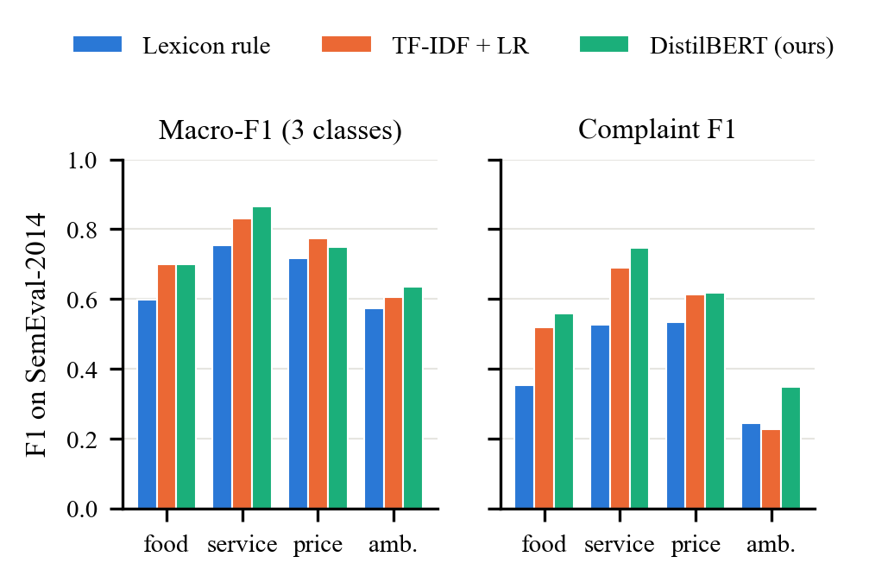
Fig. 4. Per-aspect F1 on SemEval-2014 for the lexicon rule, TF-IDF and fine-tuned DistilBERT. Left: three-class macro-F1. Right: F1 for detecting complaints (negative class).
C. Emerging Complaint Detection (M3)
TABLE V
Do alerts anticipate a decline in the next three months?
Detector | Flagged | Precision | Lift | Onsets warned | Lead (mo)
Complaint spike | 8.3% | 3.7% | 0.63 | 18.0% | 4
Rating alarm | 4.5% | 1.9% | 0.32 | 6.4% | 5
Base rate 5.8%; 827 decline onsets; lift = precision / base rate.

Table V tests the proposal's central hypothesis: that aspect complaint spikes are a leading indicator. On real data they are not. Restaurant-months with a complaint spike are followed by a decline only 3.7% of the time, below the 5.8% base rate (lift 0.63), and only 18.0% of decline onsets are preceded by a spike in the previous six months. The rating alarm is worse still (lift 0.32). We believe the main reason is regression to the mean: a spike typically arrives when the rating has already dropped, and because the label compares the next three months with the past six, the months after a spike tend to recover rather than fall further. M3 is therefore more useful as a diagnostic — it tells the owner which aspect broke — than as a forecaster, which is how the agent uses it.
D. Rating-Decline Forecasting (M4)
TABLE VI
Decline forecasting on the out-of-time test period
Model | AUROC | PR-AUC | Brier | P@10% | Warned
Majority (base rate) | 0.500 | 0.070 | 0.0657 | 0.057 | –
Current negativity (no model) | 0.598 | 0.094 | 0.0655 | 0.119 | 63.0%
Rating trend, LogReg | 0.738 | 0.205 | 0.0615 | 0.237 | 65.5%
Rating trend, LightGBM | 0.693 | 0.144 | 0.0641 | 0.180 | 60.0%
+ overall sentiment, LightGBM | 0.717 | 0.152 | 0.0635 | 0.192 | 57.6%
All features, LightGBM | 0.707 | 0.146 | 0.0641 | 0.180 | 61.8%
All features, GRU (ours) | 0.727 | 0.171 | 0.0632 | 0.207 | 55.2%
All models Platt-calibrated on validation. P@10% = precision in the riskiest 10% of restaurant-months; Warned = decline onsets flagged within 6 months at a 15% alert budget.

Table VI and Fig. 5 compare seven forecasters, from a constant base rate to the full GRU. Every learned model beats the trivial baselines, and the GRU is the strongest model that uses all signals: AUROC 0.727 and PR-AUC 0.171, ahead of every LightGBM variant (at most 0.717 and 0.152), with precision 20.7% in its riskiest decile — about three times the 7.0% base rate. However, the simplest learned model, a logistic regression on rating-trend features, is marginally better on every ranking metric (AUROC 0.738, PR-AUC 0.205, and the most decline onsets warned). Fig. 5 shows why: its precision is higher at low recall, where an owner would set an alert threshold. Adding aspect features to LightGBM does not help either (AUROC 0.707 vs 0.693 without them). Consistent with M3, on this data what customers complain about does not improve a three-month decline forecast beyond the rating trend itself; the most important LightGBM features by mean |SHAP| are the 6-month and cumulative ratings. The COVID-era test window — review volume fell by more than half in 2020 — penalises the higher-capacity models most; Section IV-E therefore repeats the comparison on a pre-pandemic test window.
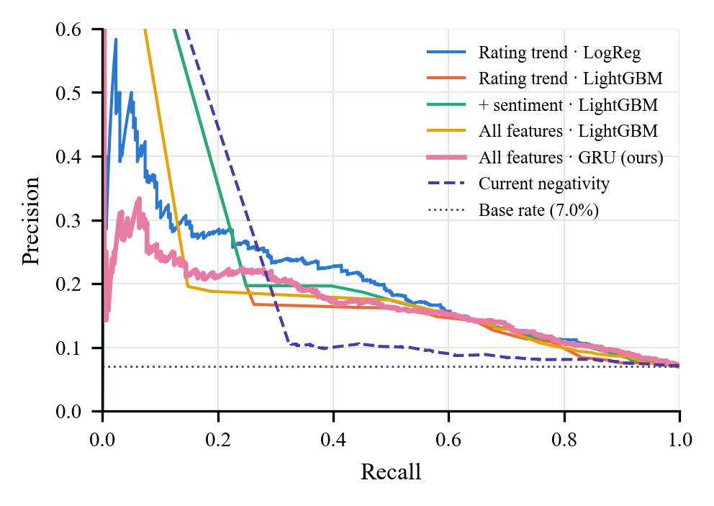
Fig. 5. Precision–recall curves on the test period. The dotted line is the 7.0% base rate. The rating-trend logistic regression dominates at low recall; the GRU is the strongest of the multi-signal models.
On the simulator, where the timing of injected deterioration episodes is known, the GRU caught 65.7% of 67 episodes and 22.4% before the drop was visible in the three-month rating — close to the rating-trend logistic regression (23.9%) and ahead of the LightGBM models (13.4–17.9%). The two explanation methods agree on the top aspect for 64% of the 397 restaurants (mean Spearman correlation 0.64), which suggests the aspect ranking shown to owners is not an artefact of one method. The star-impact model assigns the largest costs to food (-1.53 stars per unit complaint rate), service (-1.32) and cleanliness (-1.09); ambience receives a small positive coefficient, a correlation artefact, so star costs are clipped at zero.
E. Robustness: A Pre-Pandemic Test Window
TABLE VII
AUROC / PR-AUC in two test windows
Model | 2020-04 – 2021-09 | 2018-07 – 2019-12
Current negativity (no model) | 0.598 / 0.094 | 0.562 / 0.079
Rating trend, LogReg | 0.738 / 0.205 | 0.711 / 0.163
Rating trend, LightGBM | 0.693 / 0.144 | 0.622 / 0.090
+ overall sentiment, LightGBM | 0.717 / 0.152 | 0.608 / 0.087
All features, LightGBM | 0.707 / 0.146 | 0.632 / 0.090
All features, GRU (ours) | 0.727 / 0.171 | 0.686 / 0.147
Pre-pandemic run: training 2016-01–2017-12, validation 2018-01–2018-06, 6,524 test restaurant-months (6.0% positive). Evaluation only.

Because the main test window overlaps the pandemic, we repeated the comparison with all labels after December 2019 hidden, which moves the test window to July 2018 – December 2019 and leaves two years for training (Table VII). Absolute scores fall for every model — there is half as much training data — but the ordering is unchanged: the rating-trend logistic regression remains best (AUROC 0.711, PR-AUC 0.163), the GRU second (0.686, 0.147), and the LightGBM models degrade most (AUROC 0.608–0.632). The advantage of the simple model is therefore not a COVID artefact. It is better explained by sample size: with about 6% positives, a few hundred decline events per year are too few for high-capacity models to learn interactions that a linear model on well-chosen trend features does not already capture. The sequence model's inductive bias — reading the trajectory rather than hand-made windows — narrows but does not close that gap.
F. Discussion and Threats to Validity
Construct validity. Our decline label is a statistical construct; a restaurant owner may care about a smaller but persistent drop, or about review volume falling. The significance test makes positives more meaningful but also rarer, which limits what any model can learn. Internal validity. All features are computed from past data and the split is chronological (both enforced by tests), but the aspect labels come from a model trained on reviews spanning the whole period; because M2 is trained on weak labels rather than on outcomes, we judge the resulting leakage negligible, and a stricter design would retrain M2 on training-period reviews only. External validity. The data cover one city and its 400 busiest restaurants, which are larger and better reviewed than the typical independent restaurant Radview targets; a quieter restaurant produces exactly the sparse, noisy signals that our small-sample caveat warns about. Measurement. SemEval sentences are shorter and cleaner than Yelp reviews and have no cleanliness category, so M2's in-domain accuracy is unknown until the exported Yelp sample is hand-labelled. Finally, the verifier proves traceability, not truth: a plan that faithfully cites a miscalibrated forecast still passes.
G. Grounded Action Plans (M5)
TABLE VIII
Planner comparison on the 20 riskiest restaurants
Planner | Grounded | Claims | Cit. | Quo. | Rel. | Stat. | Sub.
Rule-based | 100% | 95 | 0 | 0 | 0 | 0 | 0
Qwen 2.5 7B | 69% | 48 | 8 | 8 | 0 | 1 | 6
Adversarial | 0% | 160 | 100 | 40 | 75 | 40 | 20
Last five columns: claims rejected on each verifier axis (a claim can fail several). Qwen 2.5 7B ran through Ollama on one NVIDIA T4 GPU (AWS g4dn.xlarge via NUS RONIN). The Claude planner could not be run: no API key was available.

Across all 53 at-risk restaurants, the rule-based planner produced 265 claims and all of them passed the verifier, with a median latency of 0.27 s per plan. This is expected by construction — the planner only restates tool outputs — so the verifier's value is shown by the adversarial planner (Table VIII): every one of its 160 fabricated claims was rejected, and every axis fired, from invented review IDs (citation) to quoted praise passed off as complaints (relevance). Inspecting real plans exposed two issues we then fixed: rates such as "33% of reviews" can mean one of three reviews in the sparse late-2021 data, so plans now state counts and add a small-sample caveat below ten reviews; and generic keywords led some actions to default to generic advice.
The open-model planner shows why the verifier is needed. Qwen 2.5 7B behaved as an agent — beyond the fixed analytics calls it chose 4.4 further tool calls per plan, mostly to fetch more review evidence or compare peers — but only 33 of its 48 final claims (68.8%) passed verification. Of the 20 plans, 12 were fully grounded and 8 needed a redraft after verifier feedback, but 4 ended with no verified claim. The rejected claims were mainly paraphrases presented as quotations (8), metric claims with no checkable figure (6; e.g. "Our cleanliness score is currently at the market median.") and citations of reviews that were never retrieved, including invented identifiers such as "r123"; one stated a statistic the tools never returned ("Our food quality is below the market median, with a 24.8% lower complaint rate compared to peers."). Owners therefore saw 11 action items backed by a verified quotation, against 24 from the rule-based planner. A plan took a median of 14.5 s and about 5,980 tokens on one T4 GPU, at no per-token cost, and its actions were largely adapted from the playbook. On this evidence a 7-billion-parameter open model adds investigative flexibility but not more specific advice, and is only safe to show owners behind the verifier; the Claude planner is implemented and tested but could not be measured without an API key.
H. Comparison with Existing Methods and System Performance
Direct numerical comparison with [4] and [5] would be misleading: both predict permanent closure, an outcome with a much stronger and longer-lasting signal than a three-month rating decline, and [5] uses a random rather than chronological split, which can inflate results through temporal leakage [22]. Qualitatively, Radview adds what both papers leave as future work — aspect-level causes and recommendations — at the cost of a harder, noisier target, and our AUROC of 0.73–0.74 on that target is consistent with the gap between the tasks. Operationally, fine-tuning DistilBERT took 54 minutes and scoring all 152,649 reviews 52 minutes on CPU; training and evaluating all seven forecasters takes under two minutes; a rule-based plan takes a quarter of a second and an open-model plan about 15 s on a T4 GPU. The test-gated Docker image is 3.6 GB; the full stack runs on the RONIN t3.large (8 GB) under k3s with about 1 GB of memory in use, and was first sized on Docker Desktop's single-node cluster (6.8 GiB allocatable); the 27-test suite passes against the real outputs.
V. Conclusions
Radview is an end-to-end, containerised system that turns raw restaurant reviews into aspect-level complaint signals, a calibrated decline forecast with two independent explanations, and a ranked action plan in which every claim is mechanically verified. On real Yelp data its fine-tuned DistilBERT is the most accurate aspect model on human-labelled SemEval sentences, especially for detecting complaints; its agent produced 53 fully grounded plans while rejecting every fabricated claim, and kept a free open model's unsupported claims (31% of its drafts) away from owners; and its GRU is the best multi-signal forecaster. Our main contributions are the aspect-to-action pipeline evaluated on real data, the five-axis verifier with an adversarial test, and a reproducible cloud-native deployment.
The evaluation also contradicted two of our expectations, and we consider reporting this part of the contribution: a rating-trend logistic regression forecasts decline marginally better than any model that uses aspect signals, and complaint spikes do not anticipate declines at monthly granularity. Open limitations are the COVID-era test window; weak labels and an evaluation set without a cleanliness category; low review volumes that make individual rates noisy; attributions and star costs that are associational rather than causal; a verifier that checks traceability, not truth; and a small open LLM planner whose claims pass verification only 69% of the time. Future work: redefine the spike target as lasting damage relative to the pre-spike baseline; hand-label the exported 300-review Yelp sample; extend to several cities; compare a frontier LLM planner such as Claude with the open model, and collect owner usefulness ratings, which the dashboard already records.
References
[1] M. Luca, "Reviews, reputation, and revenue: The case of Yelp.com," Harvard Business School, Working Paper 12-016, 2016.
[2] M. Anderson and J. Magruder, "Learning from the crowd: Regression discontinuity estimates of the effects of an online review database," Econ. J., vol. 122, no. 563, pp. 957–989, 2012.
[3] H. G. Parsa, J. T. Self, D. Njite, and T. King, "Why restaurants fail," Cornell Hotel Restaurant Admin. Quart., vol. 46, no. 3, pp. 304–322, 2005.
[4] C. Naumzik, S. Feuerriegel, and M. Weinmann, "I will survive: Predicting business failures from customer ratings," Marketing Sci., vol. 41, no. 1, pp. 188–207, 2022, doi: 10.1287/mksc.2021.1317.
[5] S. S. Thazhackal and V. S. Devi, "A hybrid deep learning model to predict business closure from reviews and user attributes using sentiment aligned topic model," in Proc. IEEE Symp. Ser. Comput. Intell. (SSCI), 2018, pp. 397–404, doi: 10.1109/SSCI.2018.8628823.
[6] M. Hu and B. Liu, "Mining and summarizing customer reviews," in Proc. 10th ACM SIGKDD Int. Conf. Knowl. Discov. Data Mining, 2004, pp. 168–177.
[7] M. Pontiki, D. Galanis, J. Pavlopoulos, H. Papageorgiou, I. Androutsopoulos, and S. Manandhar, "SemEval-2014 Task 4: Aspect based sentiment analysis," in Proc. 8th Int. Workshop Semantic Eval. (SemEval), 2014, pp. 27–35.
[8] G. Ganu, N. Elhadad, and A. Marian, "Beyond the stars: Improving rating predictions using review text content," in Proc. 12th Int. Workshop Web Databases (WebDB), Providence, RI, USA, 2009.
[9] J. McAuley and J. Leskovec, "Hidden factors and hidden topics: Understanding rating dimensions with review text," in Proc. 7th ACM Conf. Recommender Syst. (RecSys), 2013, pp. 165–172.
[10] J. Devlin, M.-W. Chang, K. Lee, and K. Toutanova, "BERT: Pre-training of deep bidirectional transformers for language understanding," in Proc. NAACL-HLT, 2019, pp. 4171–4186.
[11] V. Sanh, L. Debut, J. Chaumond, and T. Wolf, "DistilBERT, a distilled version of BERT: Smaller, faster, cheaper and lighter," arXiv:1910.01108, 2019.
[12] C. Sun, L. Huang, and X. Qiu, "Utilizing BERT for aspect-based sentiment analysis via constructing auxiliary sentence," in Proc. NAACL-HLT, 2019, pp. 380–385.
[13] H. Xu, B. Liu, L. Shu, and P. S. Yu, "BERT post-training for review reading comprehension and aspect-based sentiment analysis," in Proc. NAACL-HLT, 2019, pp. 2324–2335.
[14] A. Ratner, S. H. Bach, H. Ehrenberg, J. Fries, S. Wu, and C. Ré, "Snorkel: Rapid training data creation with weak supervision," Proc. VLDB Endowment, vol. 11, no. 3, pp. 269–282, 2017.
[15] S. W. Roberts, "Control chart tests based on geometric moving averages," Technometrics, vol. 1, no. 3, pp. 239–250, 1959.
[16] C. Leys, C. Ley, O. Klein, P. Bernard, and L. Licata, "Detecting outliers: Do not use standard deviation around the mean, use absolute deviation around the median," J. Exp. Social Psychol., vol. 49, no. 4, pp. 764–766, 2013.
[17] K. Cho, B. van Merriënboer, C. Gulcehre, D. Bahdanau, F. Bougares, H. Schwenk, and Y. Bengio, "Learning phrase representations using RNN encoder–decoder for statistical machine translation," in Proc. EMNLP, 2014, pp. 1724–1734.
[18] G. Ke, Q. Meng, T. Finley, T. Wang, W. Chen, W. Ma, Q. Ye, and T.-Y. Liu, "LightGBM: A highly efficient gradient boosting decision tree," in Adv. Neural Inf. Process. Syst. (NeurIPS), vol. 30, 2017, pp. 3146–3154.
[19] T. Saito and M. Rehmsmeier, "The precision-recall plot is more informative than the ROC plot when evaluating binary classifiers on imbalanced datasets," PLoS ONE, vol. 10, no. 3, e0118432, 2015.
[20] G. W. Brier, "Verification of forecasts expressed in terms of probability," Monthly Weather Rev., vol. 78, no. 1, pp. 1–3, 1950.
[21] J. Platt, "Probabilistic outputs for support vector machines and comparisons to regularized likelihood methods," in Advances in Large Margin Classifiers, A. Smola et al., Eds. Cambridge, MA, USA: MIT Press, 1999, pp. 61–74.
[22] S. Kaufman, S. Rosset, C. Perlich, and O. Stitelman, "Leakage in data mining: Formulation, detection, and avoidance," ACM Trans. Knowl. Discov. Data, vol. 6, no. 4, Art. 15, 2012.
[23] S. M. Lundberg and S.-I. Lee, "A unified approach to interpreting model predictions," in Adv. Neural Inf. Process. Syst. (NeurIPS), vol. 30, 2017, pp. 4765–4774.
[24] G. Erion, J. D. Janizek, P. Sturmfels, S. M. Lundberg, and S.-I. Lee, "Improving performance of deep learning models with axiomatic attribution priors and expected gradients," Nature Mach. Intell., vol. 3, no. 7, pp. 620–631, 2021.
[25] S. Wachter, B. Mittelstadt, and C. Russell, "Counterfactual explanations without opening the black box: Automated decisions and the GDPR," Harvard J. Law Technol., vol. 31, no. 2, pp. 841–887, 2018.
[26] S. Yao, J. Zhao, D. Yu, N. Du, I. Shafran, K. Narasimhan, and Y. Cao, "ReAct: Synergizing reasoning and acting in language models," in Proc. Int. Conf. Learn. Represent. (ICLR), 2023.
[27] P. Lewis et al., "Retrieval-augmented generation for knowledge-intensive NLP tasks," in Adv. Neural Inf. Process. Syst. (NeurIPS), vol. 33, 2020, pp. 9459–9474.
[28] Z. Ji et al., "Survey of hallucination in natural language generation," ACM Comput. Surv., vol. 55, no. 12, Art. 248, 2023.
[29] T. Gao, H. Yen, J. Yu, and D. Chen, "Enabling large language models to generate text with citations," in Proc. EMNLP, 2023, pp. 6465–6488.
[30] B. Burns, B. Grant, D. Oppenheimer, E. Brewer, and J. Wilkes, "Borg, Omega, and Kubernetes," Commun. ACM, vol. 59, no. 5, pp. 50–57, 2016.

Individual Workloads and Contributions
To be completed and agreed by the group. The module split below follows the proposal's six modules as a suggestion only — replace it with what each member actually did, including report sections and the part of the presentation each member delivers.
TABLE IX
Individual contributions
Member | Main technical contribution | Report sections | Presentation part
Yeo Zhang Han | e.g. M1–M6 module / dashboard / deployment | e.g. Sec. III-B | e.g. demo of …
Daniel Leong | e.g. M1–M6 module / dashboard / deployment | e.g. Sec. III-B | e.g. demo of …
Peh Xue Ying | e.g. M1–M6 module / dashboard / deployment | e.g. Sec. III-B | e.g. demo of …
Yang Jiajun Joven | e.g. M1–M6 module / dashboard / deployment | e.g. Sec. III-B | e.g. demo of …
Wong Wei Xuen | e.g. M1–M6 module / dashboard / deployment | e.g. Sec. III-B | e.g. demo of …
Vijayanand Jeeva | e.g. M1–M6 module / dashboard / deployment | e.g. Sec. III-B | e.g. demo of …

Use of AI tools. Declare as required by the module's academic-integrity policy, e.g.: "Parts of the implementation, documentation and figures were developed with the assistance of an AI coding assistant (Claude Code). All design decisions, results and text were reviewed, verified and are owned by the group." — adjust to reflect actual use.
Reflections
Yeo Zhang Han. Personal reflection on the learning journey (≈100–150 words): what you worked on, what you learned about cloud-based data science, AI and teamwork, what was hardest, and what you would do differently.
Daniel Leong. Personal reflection on the learning journey (≈100–150 words): what you worked on, what you learned about cloud-based data science, AI and teamwork, what was hardest, and what you would do differently.
Peh Xue Ying. Personal reflection on the learning journey (≈100–150 words): what you worked on, what you learned about cloud-based data science, AI and teamwork, what was hardest, and what you would do differently.
Yang Jiajun Joven. Personal reflection on the learning journey (≈100–150 words): what you worked on, what you learned about cloud-based data science, AI and teamwork, what was hardest, and what you would do differently.
Wong Wei Xuen. Personal reflection on the learning journey (≈100–150 words): what you worked on, what you learned about cloud-based data science, AI and teamwork, what was hardest, and what you would do differently.
Vijayanand Jeeva. Personal reflection on the learning journey (≈100–150 words): what you worked on, what you learned about cloud-based data science, AI and teamwork, what was hardest, and what you would do differently.

