Azure Hands-On Lab Application Insights with Node JS Web App

Create New the Node.JS

1. Go to Azure Portal
2. Add New Web App with Windows App Service Plan.
3. Keep Application Insights to OFF, we will add this shortly.

Pull the Sample Node.JS Code from GitHub

1. Select Above App in the Azure Portal.
2. Select Deployment Options Tab
3. Select External Repository
4. Enter <https://github.com/adventworks/nodejs-sample.git> and press Save.
5. Select the Overview Tab and Browse the App

Configure Node Runtime

1. Select above App in the Azure Portal.
2. Select Application Settings
3. Add “WEBSITE_NODE_DEFAULT_VERSION” and value “6.5.9” and Save.
4. Restart the App
5. Browse the App using Overview tab.

Add New Application Insights Instance

1. Add New Application Insights Instance and note down the instrumentation key.  
   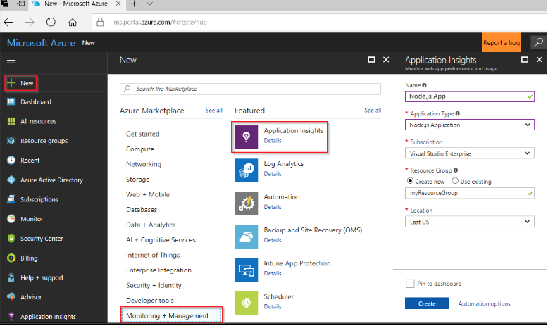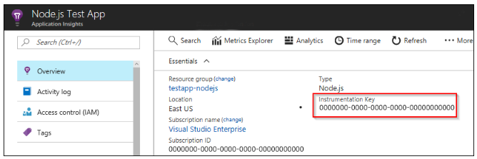
2. Select the new Node App Created and Select New App Insights Instance.
3. Select K and Kudu Interface.
4. Using CMD console run *npm install applicationinsights –save*

const appInsights = require('applicationinsights');  
 appInsights.setup('<instrumentation_key>').start();

1. Restart the App.
2. Open and Browse the App couple of times.
3. Select the App >> Application Insights and observe the traffic.