Azure Hands-On Lab, Setup CI and CD Pipeline for Node.JS App

Create New Node.JS App Service

1. Go to Azure Portal
2. Add New Web App with Windows App Service Plan.
3. Keep Application Insights to OFF, we will add this shortly.
4. Select Application Settings
5. Add “WEBSITE_NODE_DEFAULT_VERSION” and value “6.5.9” and Save.
6. Restart the App
7. Browse the App using Overview tab.

Create VSTS Account and Project

1. Go to VisualStudio.com and Login using Microsoft Account.
2. Create new Team System account.  
   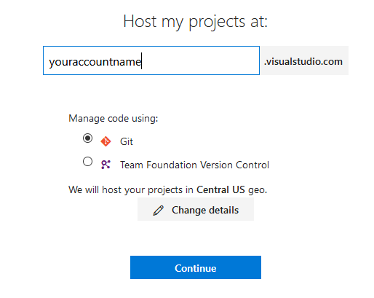
3. A new project by name MyFirstProject will automatically be created.
4. You can create new project or rename the existing project if required.

Import Sample Code into VSTS Git Repo

1. Select Project and Select CODE from top menu bar.
2. Select Import Repository by clicking the default code repo.  
   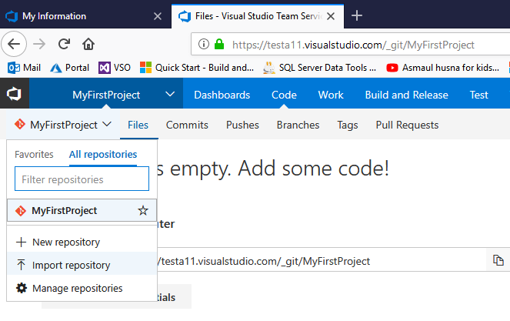
3. For Clone URL field add ‘ <https://github.com/adventworks/nodejs-sample.git> ‘ and Click Import.

Setup Build Definition

1. Click Build and Release on top menu bar and create new build definition.
2. Search for NODE and select Node with Gulp template.  
   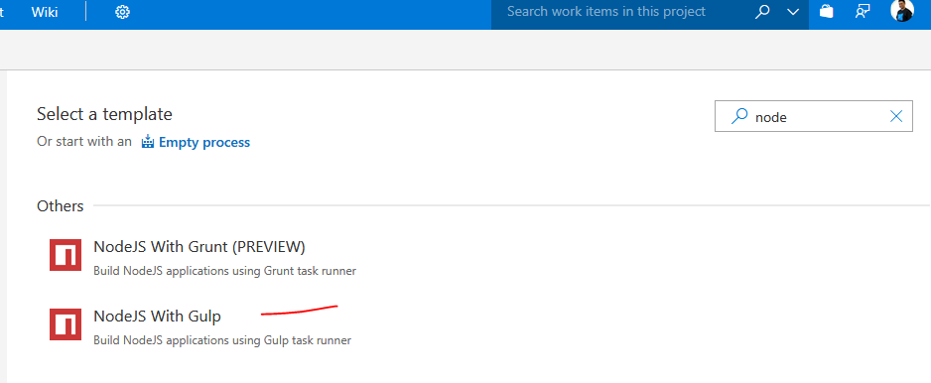
3. For Process task set the Build Agent Type as Hosted 2017.  
   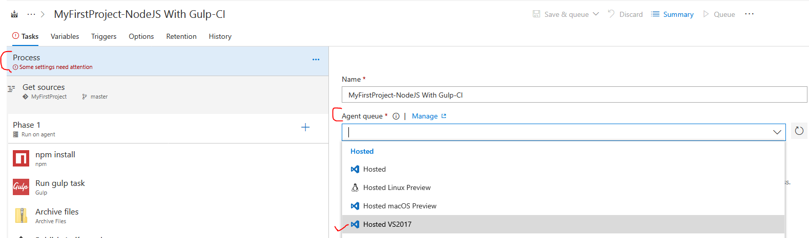
4. For Get Sources set NodeJS-Sample as repository.  
   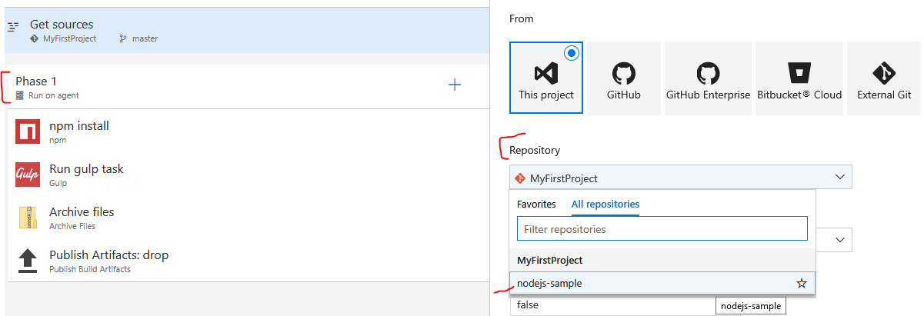
5. Enable CI trigger  
   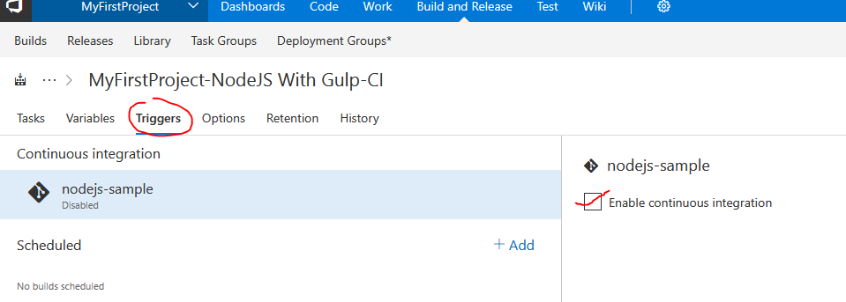
6. Press Save and Queue which will save and queue the new build.

Setup VSTS to Azure Subscription Account

1. Select Services option from settings menu.  
   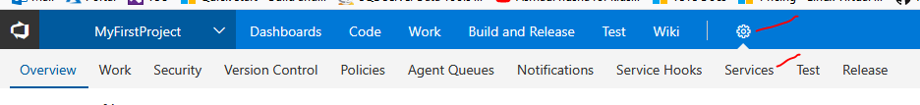
2. Add new Service End Point  
   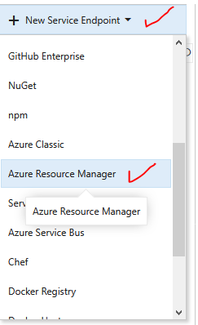
3. Select Full Version of config dialog box and fill the form, select Connection Name as AzureConn1  
   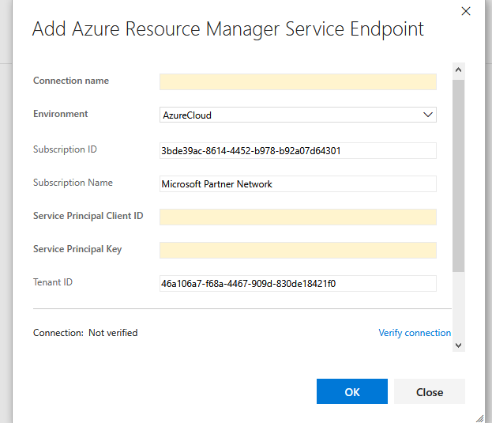
4. Verify connection to Azure subscription.

Setup Release Definition

1. Select Build and Release and Create new Release Definition.
2. Select Azure Web App as template.  
   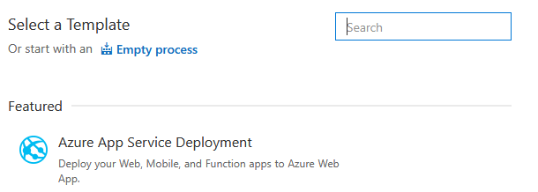
3. Name environment as DEV.
4. Select Build Definition from previous section to add as artifact.  
   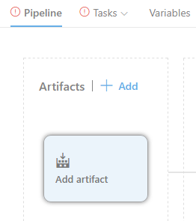
5. Select 1 Phase 1 Task button and configure  
   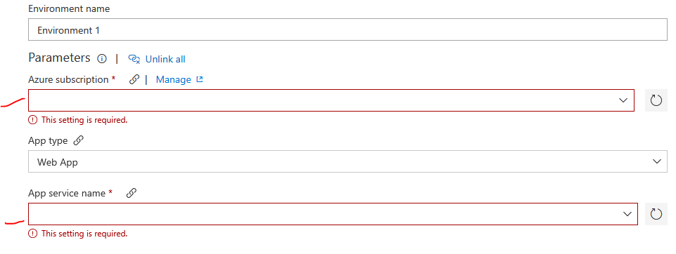
6. Press Save then Release.