Azure Hands-On Lab – Experience Cosmos DB

Create New Cosmos DB – SQL Model Account

1. Go to Azure Portal and Create Cosmos DB Account with SQL Model option.  
   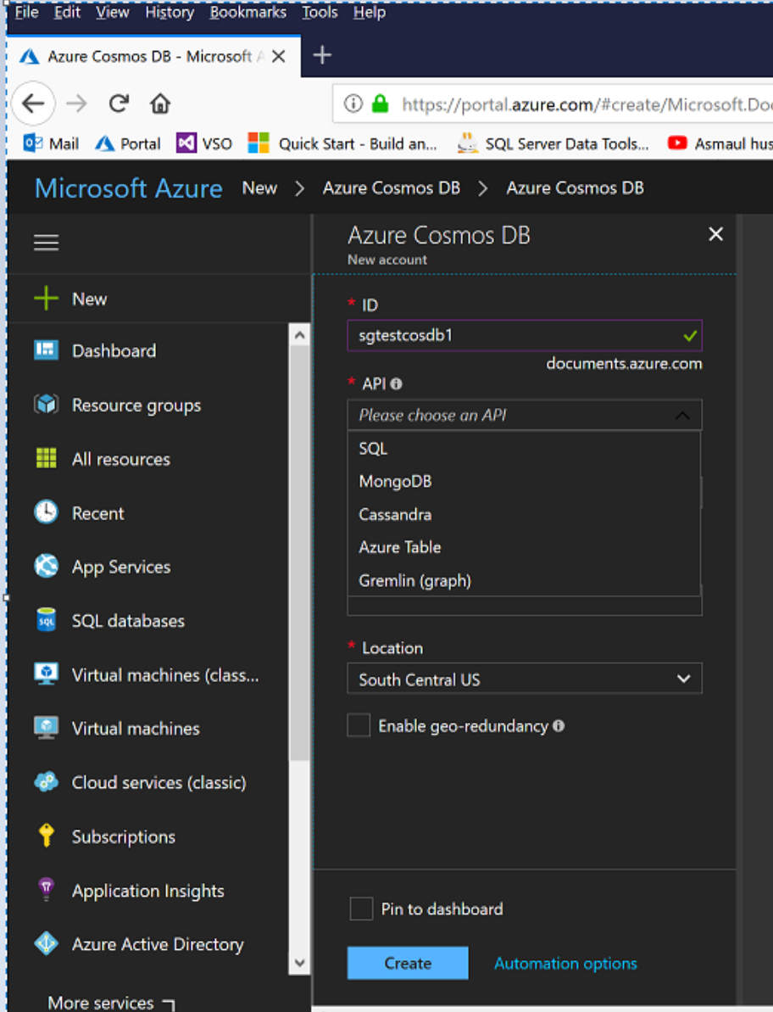

Add new DB Collection

1. Select Cosmos DB and add new DB and Collection.  
   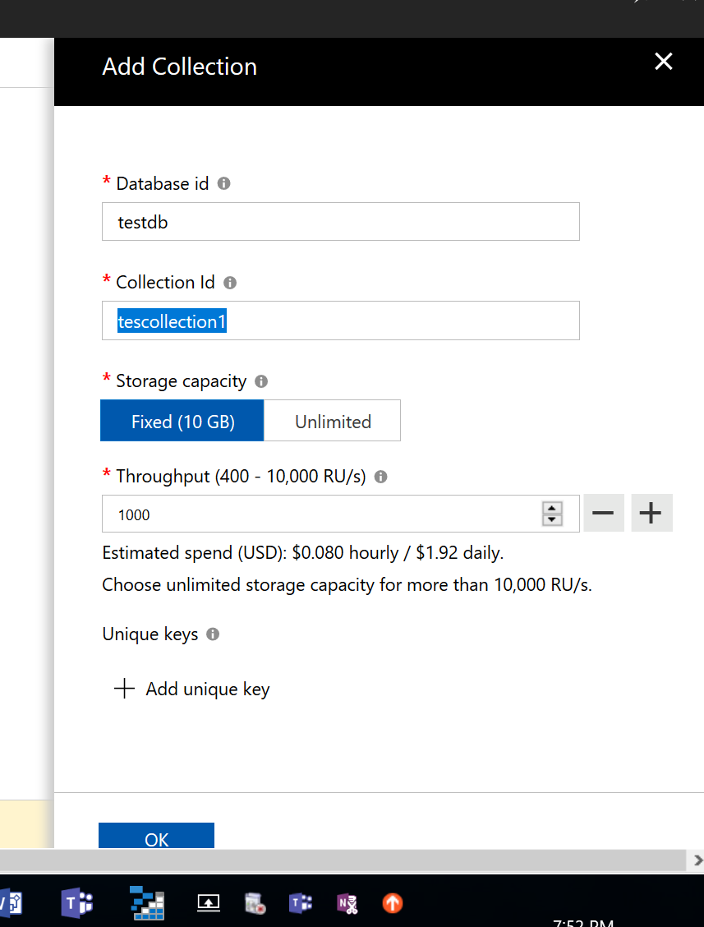

Add Variable Schema JSON Documents

1. Go to Document Explorer and Add Following Document  
   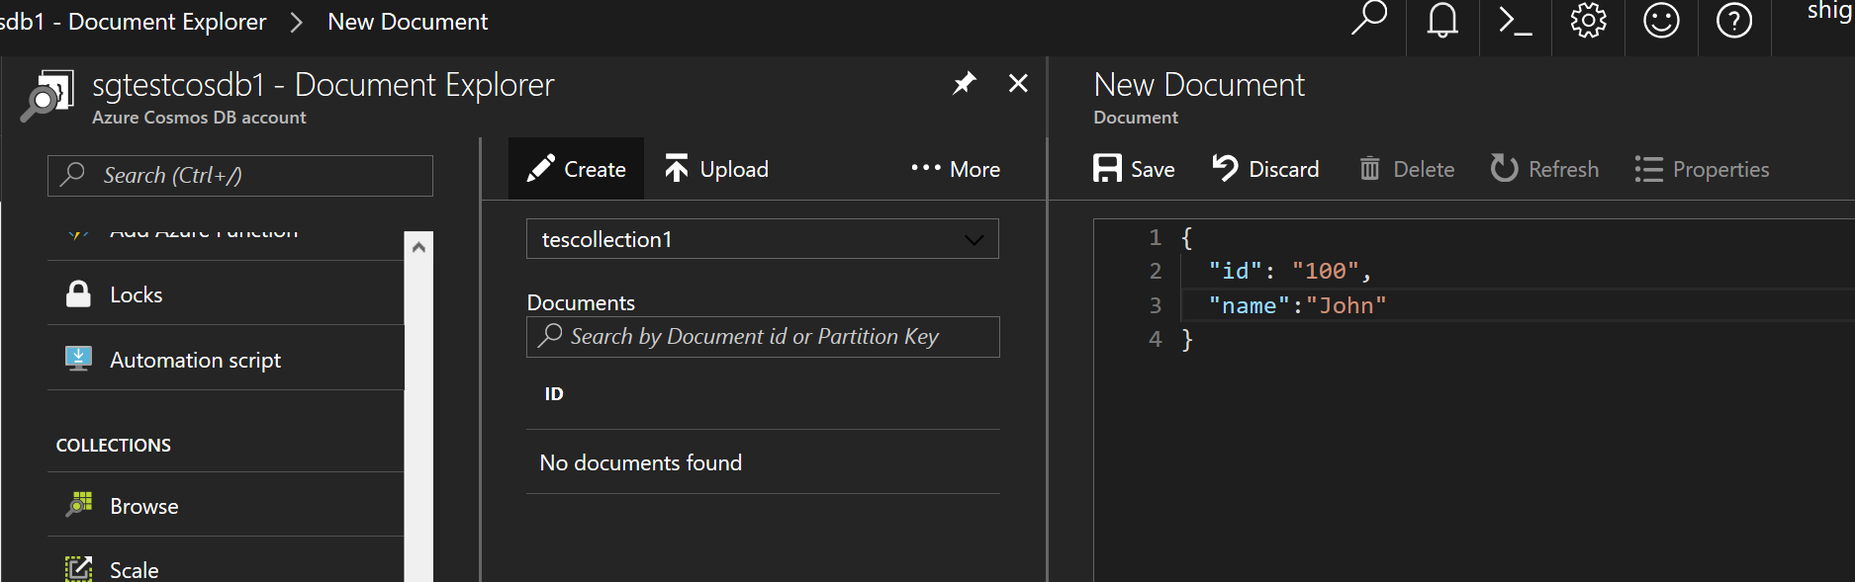

Query Your JSON Documents

1. Go to Query Explorer and Query Your Documents  
   