#Part 1  
  
class CalUtils: #To create an object  
 def calAveHeight(totalStudentHeight, totalStudentCount): #Function  
 calAveHeight = totalStudentHeight/totalStudentCount #Formula of area  
 print("Student average height is " + str(round(calAveHeight, 2)) + " m for " + str(totalStudentCount) + " students.") #Result  
 #Student average height is 1.72 m for 7 students.  
#Variables  
totalStudentHeight = float(0)  
totalStudentCount = int(0)  
names = []  
heights = []  
newTotalStudentHeight = float(0)  
newTotalStudentCount = int(0)  
  
file = open("listOfStudentHeight.txt", "r")  
for line in file: #To seperate the areas and names  
 name, height = line.split()  
 names.append(name)  
 heights.append(float(height))  
file.close()  
print(names, heights)  
#['Thomas', 'Peter', 'William', 'Patrick', 'May', 'June', 'Linda']  
  
file = open ("listOfStudentHeight.txt", "r")  
for height in heights:  
 totalStudentHeight += height  
 totalStudentCount += 1  
  
CalUtils.calAveHeight(newTotalStudentCount,totalStudentCount)  
  
#Part 2  
  
Squarename = input("Enter new student name: ")  
names.append(Squarename)  
print(names)  
  
while True: #while loop for inputing the new height, if the height input contains anything but string then it will have error  
 try:  
 Heightened = float(input("Enter student height (in meters): ")) #Enter student height (in meters): 1.9  
 heights.append(Heightened)  
 print(heights)  
 break  
 except ValueError: #Enter student height (in meters): alan  
 print("You have not correctly entered the height, please re-enter in number only.") #You have not correctly entered the height, please re-enter in number only.  
 continue  
  
#Part 3  
  
def calAvgHeight(newTotalStudentHeight, newTotalStudentCount): #For new inputs  
 calAvgHeight = newTotalStudentHeight / newTotalStudentCount  
 print("Student average height is " + str(round(calAvgHeight, 2)) + "for" + str(newTotalStudentCount) + " students.")  
 #Student average height is 1.74 m for 8 students.  
  
for height in heights:  
 newTotalStudentHeight += height  
 newTotalStudentCount += 1  
  
CalUtils.calAveHeight(newTotalStudentHeight, newTotalStudentCount)

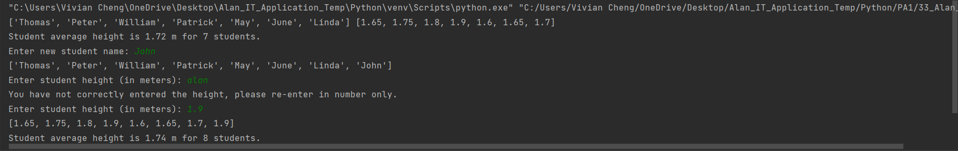Result: