BIT 4107 – Mobile Application Development
ENHANCED PROFESSIONAL STUDENT LOGBOOK
Student Name: James Chege
Admission Number: BIT/2024/5646
School/Faculty: COMPUTING AND INFORMATICS
Programme: BIT
Academic Year: THIRD
Semester: SECOND
Lecturer: MR. NYORO
Phone Number:0794063659

Instructions
This logbook is used to document weekly learning activities, practical exercises, skills acquired, challenges encountered, solutions applied, and reflections. Students should complete all sections every week.
Each week to follow remarks in week 1 section.

Autogenerated Table of content

Week 1: Introduction to Mobile Application Development

Practical Activities Undertaken
only screenshots needed and labeling
Screenshots/Evidence Attached (Yes/No)

Tools/Software Used
I used android studio, GitHub, personal phone, git to make my app

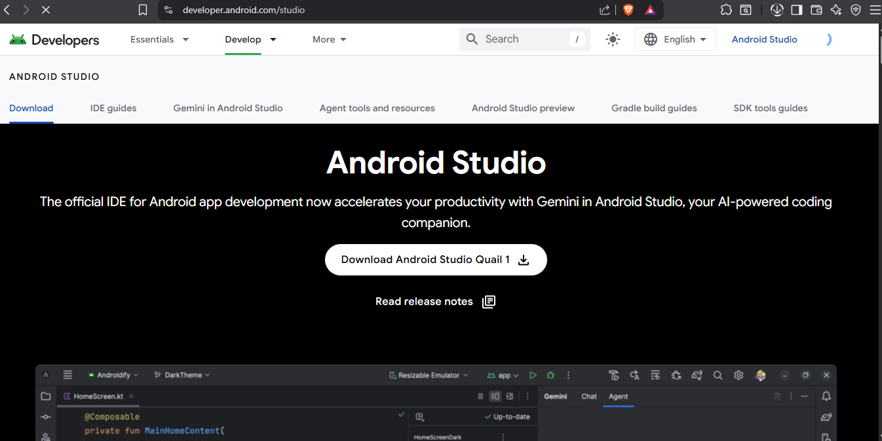

Personal Reflection
not more than 50 words
I was curious to learn from start the requirement and needs to develop an app and to know whether I would consider it later as my niche in I.T. I was open minded to learn the different needs to make a working app.

Week 2: Mobile Development Environment

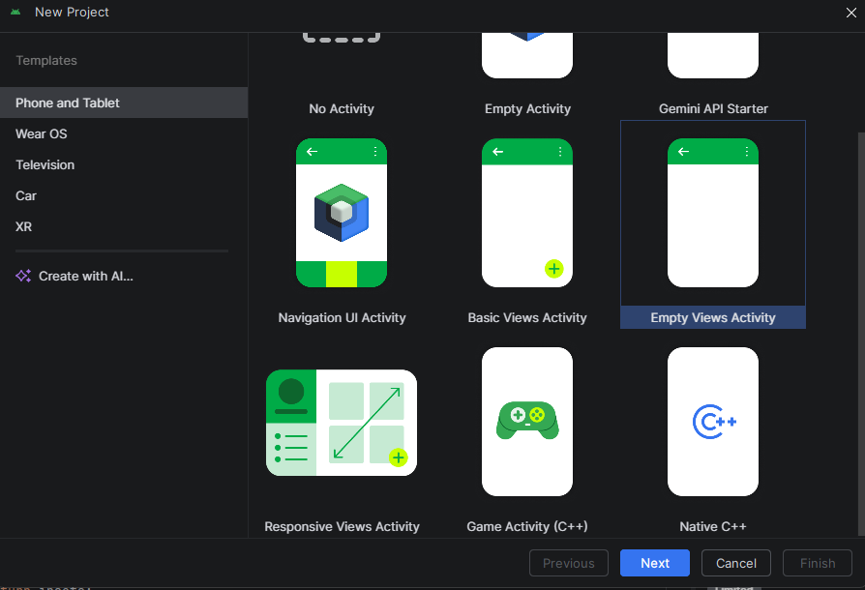

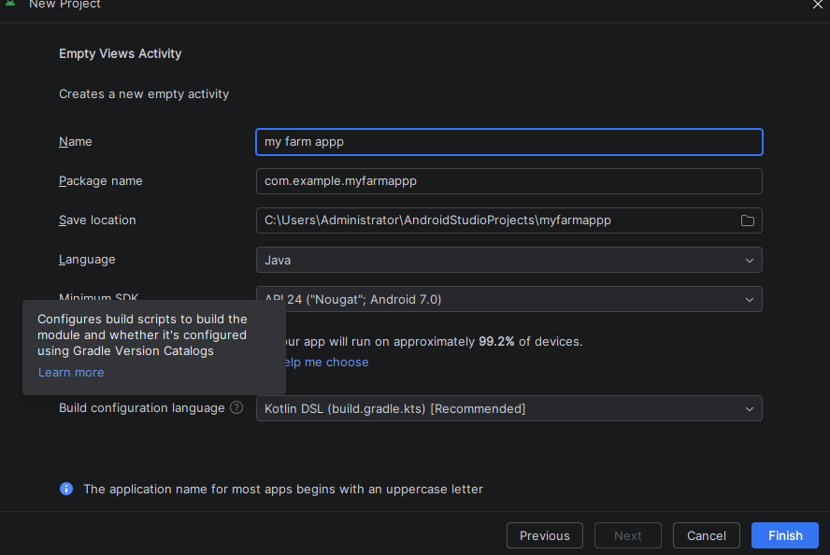

Tools/Software Used
I was still using android studio and phone as my emulator
Personal Reflection
I was still learning new things about android studio and how to use it, relatively new experience but still fine. Designing the app was fun but the amount of new things on the screen at once were a bit challenging to understand

Week 3: User Interface Design

I designed the user interface for the Farm Management App using Android Studio’s XML Layout Editor. I created the main dashboard screen using a Constraint Layout containing Card Views. Designed the main login page interface.
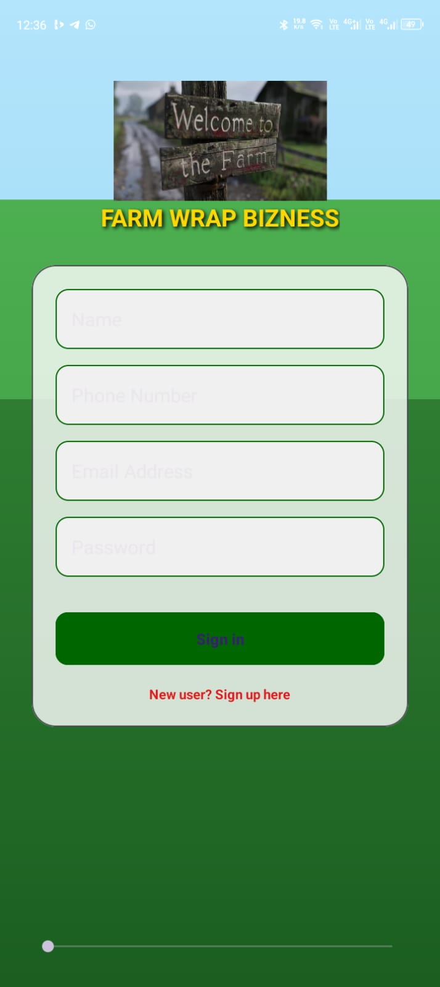

Personal Reflection
I was able to design the main first page and also add color to it plus a few other details to it. I later run the app on my phone and it was okay. Good feeling to achieve first page after long hours listening to few YouTube videos

Week 4: Event Handling and User Interaction

Practical Activities Undertaken
Handling first event of signing in users and saving the users details using the sign in button that I had designed earlier. I also put in validations to ensure fields are not submitted empty
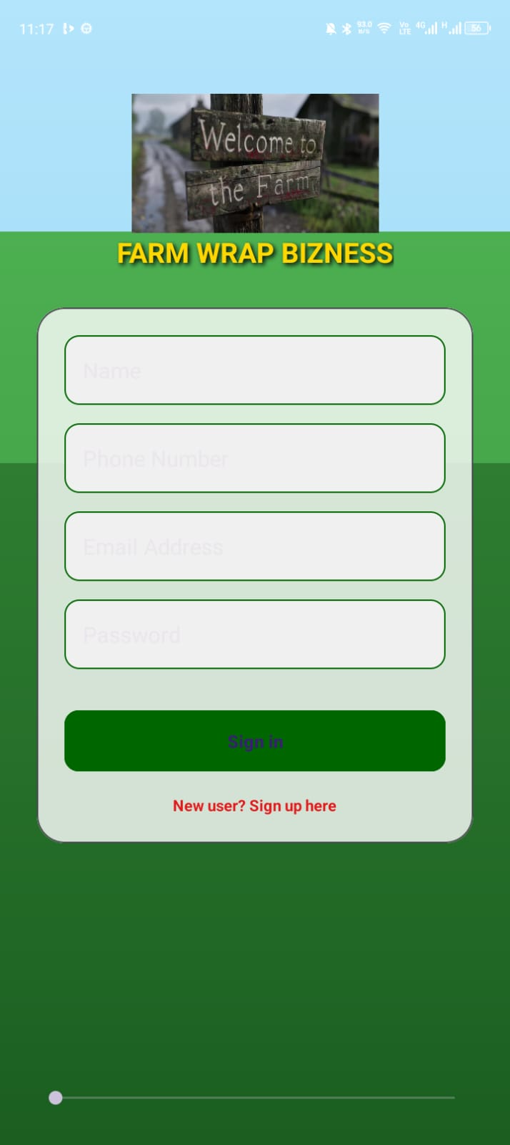
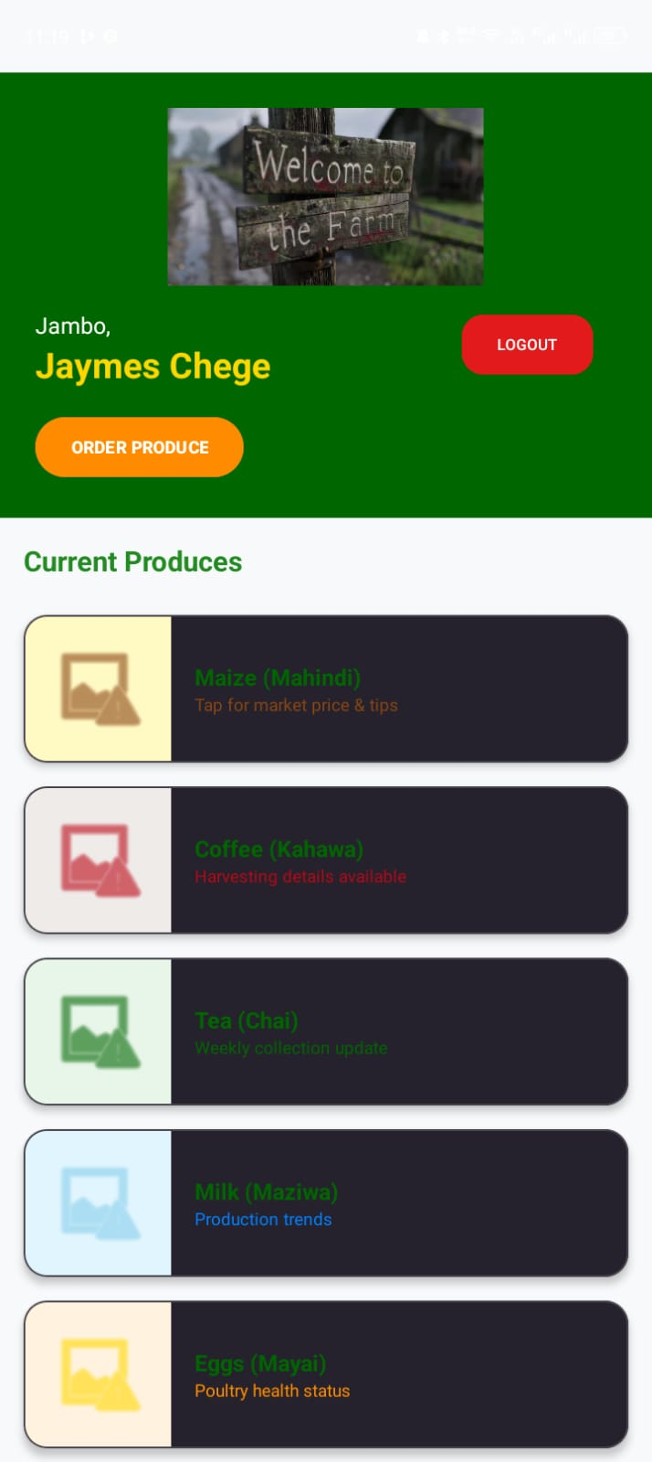

Week 5: Data Management

Practical Activities Undertaken
integration of the farm app into firebase as my data storage area.
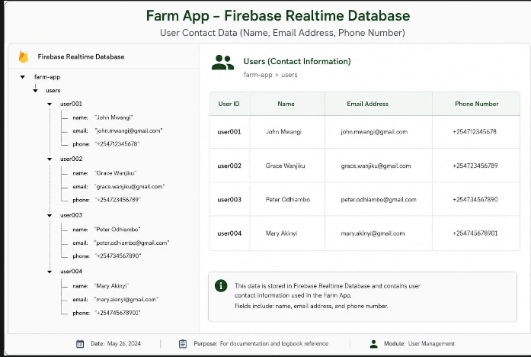

Tools/Software Used
Android studio and firebase

Personal Reflection
The work became a bit harder than expected due to challenges in connecting firebase and android studio. Was also frustrated by multiple repetition but finally managed it

Week 6: Networking and APIs

Practical Activities Undertaken
integration of a payment and an SMS notification API

Week 7: Application Architecture

Same as week 1

Week 8: Project Planning

Week 9: Device Features and Sensors

Same as week 1

Week 10: Notifications and Background Services

Same as week 1

Week 11: Mobile Security

Same as week 1

Week 12: Testing and Debugging

Same as week 1

Week 13: Application Deployment

Same as week 1

Week 14: Final Project Presentation

Same as week 1

Semester Project Tracking

Project Title

Project Objectives

Project Requirements

Development Milestones

Testing Results

Lessons Learned

Future Improvements

End of Semester Reflection

Summary of Skills Acquired

Most Interesting Topic

Major Challenges Faced

How Challenges Were Overcome

Professional Growth Achieved

Overall Course Experience

Final Approval
Student Name: __________________________
Student Signature: ______________________
Date: _________________________________
Lecturer Name: _________________________
Lecturer Remarks: _____________________
Date: _________________________________

