**Microprocessor Lab**

Laboratory Activity No. 2

**Binary Representation of 8 LEDs in TinkerCad**

**And Arduino Programming**

|  |
| --- |
|  |

Score

*Submitted by:*

**Isidro, Cheilo Marie P.**

**Sat 10:00-1:00 / CPE 0412.1-1**

*Date Submitted*

**11-10-2023**

*Submitted to:*

**Engr. Maria Rizette H. Sayo**

**I. Objectives**

The objective of this laboratory acitivity is to investigate and demonstrate the binary representation of 8 Light Emitting Diodes (LEDs) in TinkerCad through the utilization of Arduino programming. This experiment aims to provide a comprehensive understanding of binary numbering systems and their application in controlling multiple LEDs, fostering proficiency in Arduino programming, and gaining practical experience with TinkerCad for virtual circuit simulation.

**II. Method/s**

- Write a code and perform an Arduino circuit diagram of a Binary representation (decimal 0-255 using 8 LEDs)

*Materials Needed:*

1. Arduino Uno
2. 8 LEDs
3. 8 220 Ohms Resistors
4. Breadboard
5. Jumper / Connecting Wires
6. Computer with TinkerCad and Arduino IDE Installed

***TinkerCad Simulation Link:***[*https://www.tinkercad.com/things/cDmxS4mSppM-tremendous-maimu-uusam/editel?sharecode=daYChWtQPK0_dReiMEn4fDOkatGQ9LFKMuEN3MdYHJY*](https://www.tinkercad.com/things/cDmxS4mSppM-tremendous-maimu-uusam/editel?sharecode=daYChWtQPK0_dReiMEn4fDOkatGQ9LFKMuEN3MdYHJY)

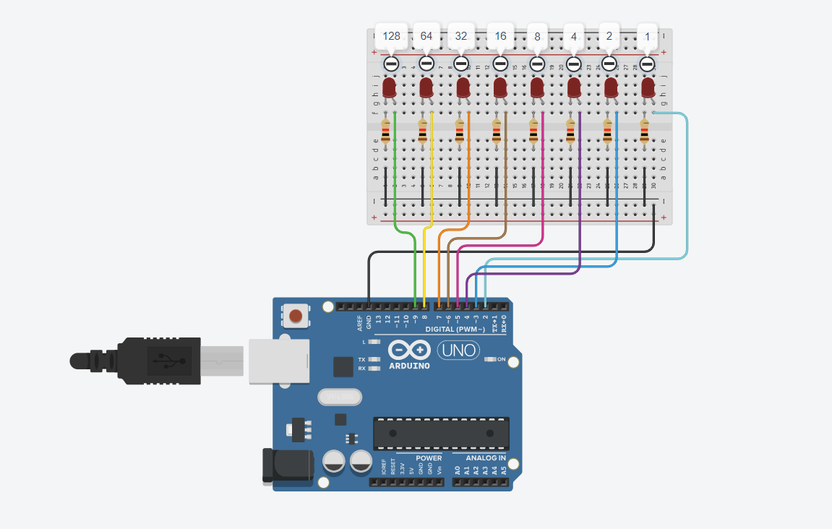

*Figure 1: Simulation in TinkerCad of Binary Representation of 8 LEDS*

*Written Code:*

*// C++ code*

*//*

*int num;*

*void setup()*

*{*

*for (int pin = 2; pin <= 9; pin++) {*

*pinMode(pin, OUTPUT);*

*}*

*Serial.begin(9600);*

*Serial.println("Enter The Number Which You Wanna Show In Binary:");*

*}*

*void loop()*

*{*

*if (Serial.available() > 0) {*

*num = Serial.parseInt();*

*Serial.println(num);*

*}*

*for (int pin = 2; pin <= 9; pin++) {*

*digitalWrite(pin, (num & (1 << (pin - 2))) ? HIGH : LOW);*

*}*

*}*

**III. Results**

*TinkerCad Simulation*

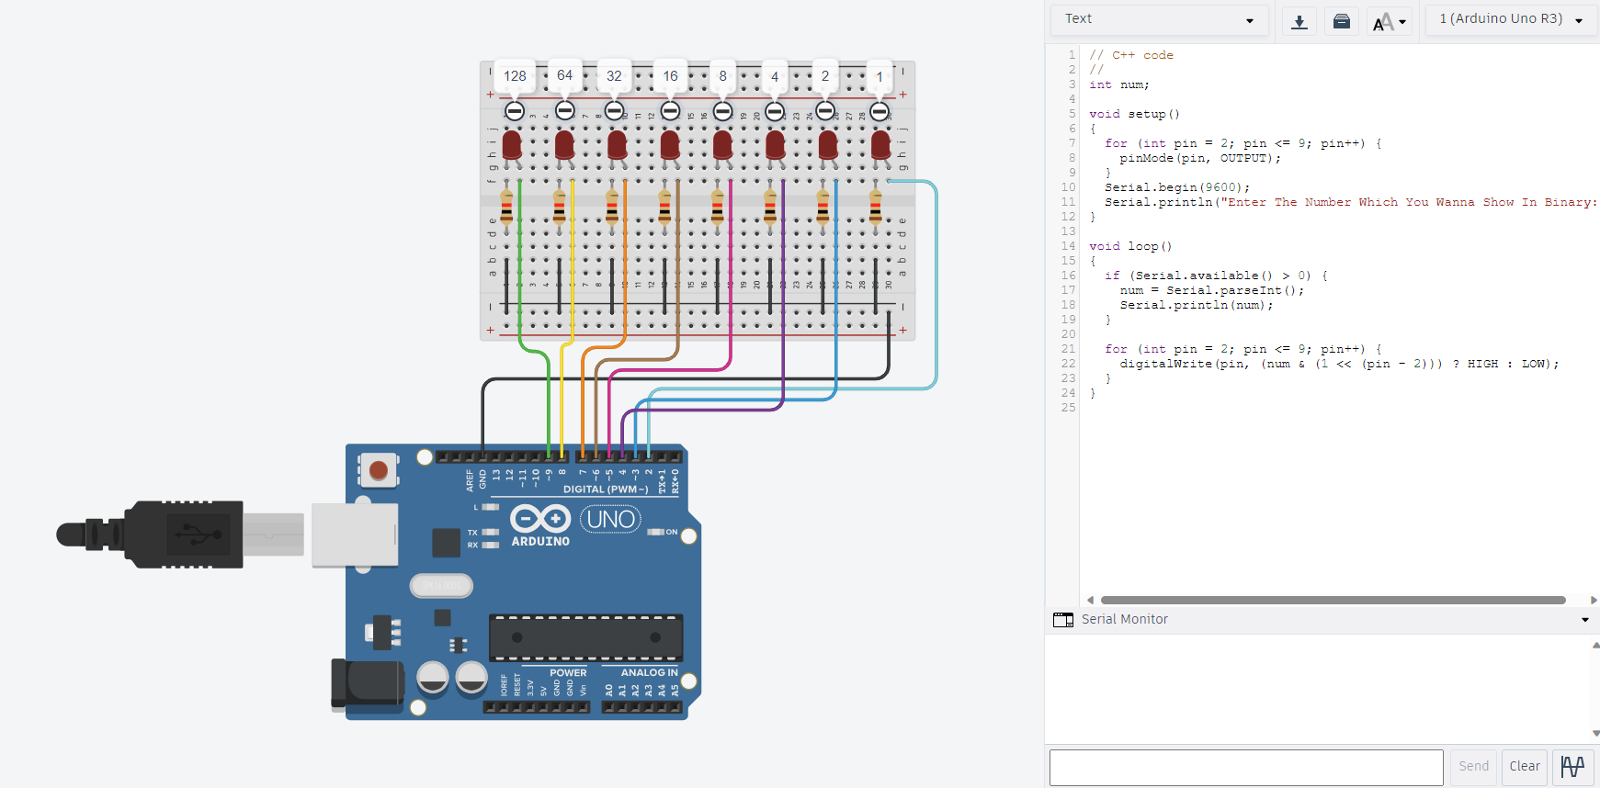

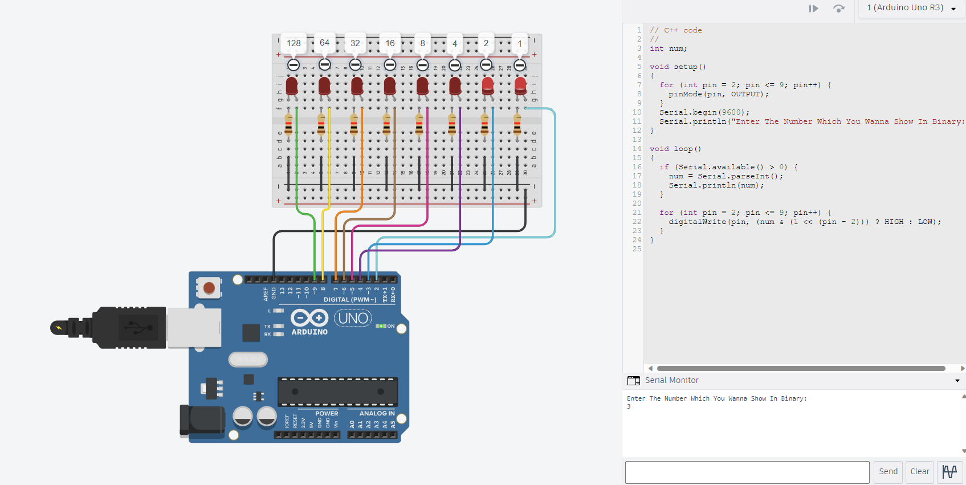

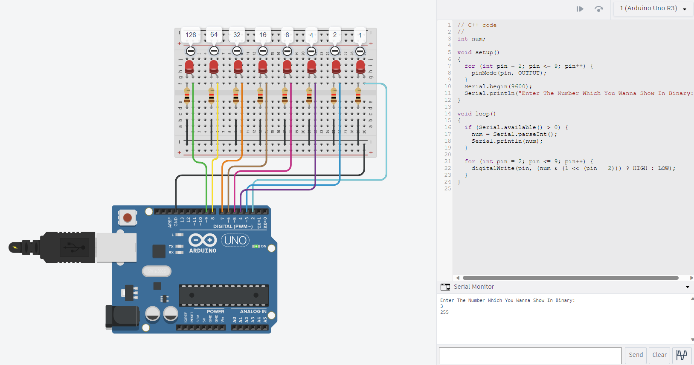

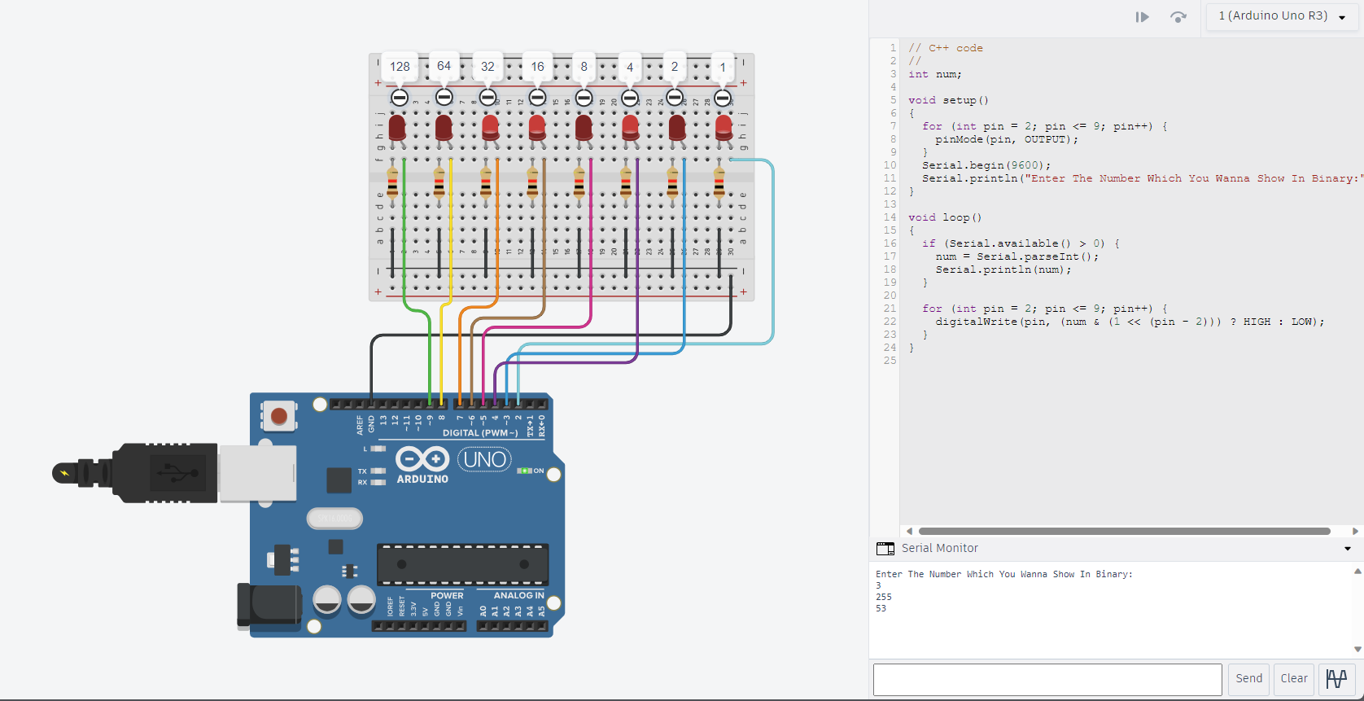

*Actual Simulation (Arduino IDE and Arduino UNO)*

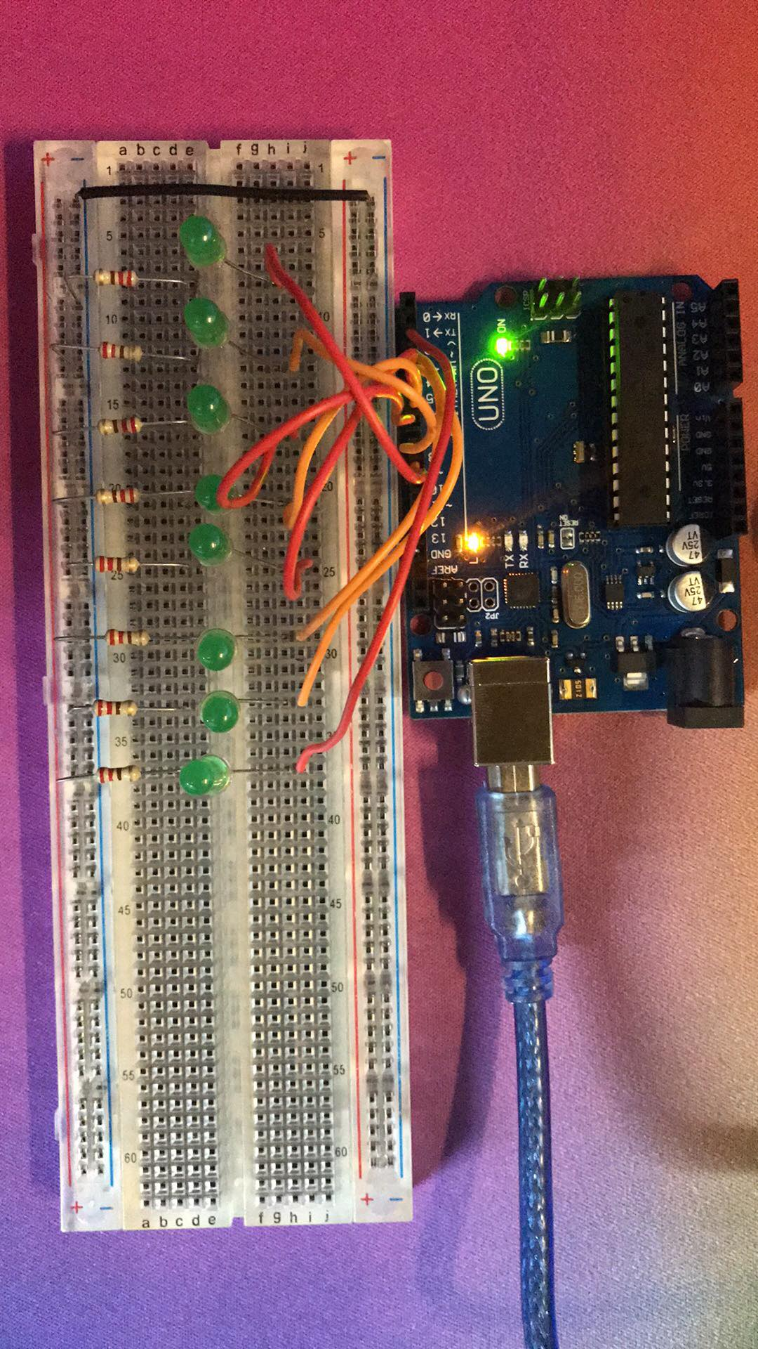

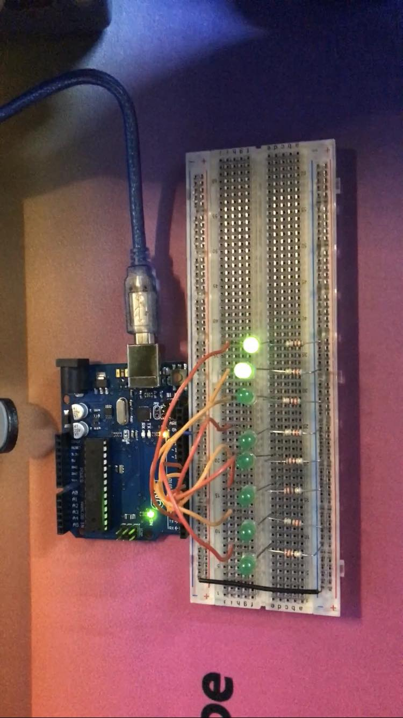

**IV. Conclusion**

In conclusion, the code effectively demonstrates how to control 8 LEDs using Arduino and binary representation. By inputting a number through the serial monitor, we can see a visual binary representation, where each LED corresponds to a binary bit. This experiment not only provides a clear understanding of binary encoding but also showcases how Arduino programming can be used to control hardware components. It's a fundamental step in understanding the relationship between digital numbers and the physical world, opening the door to more complex applications in electronics and programming.

**References**

*Login | TinkerCad*. (n.d.). Tinkercad. https://www.tinkercad.com/things/f8h8YCQuJGg-copy-of-binary-representation-by-leds/editel?tenant=circuits