­­МІНІСТЕРСТВО ОСВІТИ ТА НАУКИ УКРАЇНИ

НАЦІОНАЛЬНИЙ УНІВЕРСИТЕТ “ЛЬВІВСЬКА ПОЛІТЕХНІКА”

­­­

Контрольна робота №1-2

з курсу «Теорія Алгоритмів»

для студентів базового напрямку 6.08.04 "Комп’ютерні науки"

(заочна форма навчання)

Варіант 14

Виконав студент гр. КНз-2

Чалий Михайло

­­

Львів 2014

# Завдання №1

Здійснити розпізнавання образів із застосуванням евристичного алгоритму порогової величини. Порогова величина Т=2.

X1(1,2), X2(1,3), X3(1,4), X4(1,5), X5(2,2), X6(2,3), X7(2,4), X8(3,7), X9(3,8), X10(3,9)

## Рішення

import sys, math, random

class Thresold(object):

def __init__(self, points):

self._points = Points.from_tuples(points)

self._centers = []

self._clusters = []

self._t = 0;

def cluster(self, t):

self._t = t

for next in self._points:

next_handled = False

print("Process " + str(next))

for cluster_index in range(len(self._clusters)):

center = self._centers[cluster_index]

distance = center.distanceTo(next)

print("Distance from " + str(center) + ": " + str(distance))

if distance <= t:

print("Added to cluster " + str(cluster_index))

# Create new cluster

self._clusters[cluster_index].append(next)

next_handled = True;

if next_handled == False:

# Create new cluster

print("New cluster " + str(next))

self._centers.append(next)

self._clusters.append(Points([next]))

s = Thresold([

(1,2),

(1,3),

(1,4),

(1,5),

(2,2),

(2,3),

(2,4),

(3,7),

(3,8),

(3,9)

])

s.dump_points()

s.cluster(2)

s.dump_cluster()

s.plot_cluster('k1_1_14');

## Результат

[(1; 2), (1; 3), (1; 4), (1; 5), (2; 2), (2; 3), (2; 4), (3; 7), (3; 8), (3; 9)]

Clusted with T=2 :

#1: (1; 2) [(1; 2), (1; 3), (1; 4), (2; 2), (2; 3)]

#2: (1; 5) [(1; 5), (2; 4)]

#3: (3; 7) [(3; 7), (3; 8), (3; 9)]

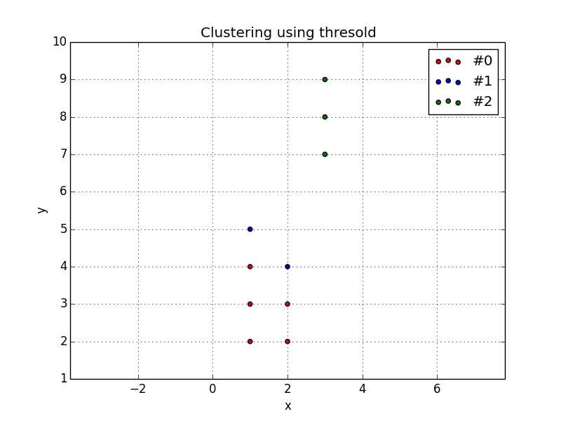

# Завдання №2

Здійснити розпізнавання образів із застосуванням максимінного алгоритму.

## Рішення

import sys, math, random

from point import *

from pylab import *

class MinMax(object):

def __init__(self, points):

self._points = [ Point(p[0], p[1]) for p in points ]

self._centers = []

def cluster(self):

self._centers = [self._points[0]]

max_distances = []

while True:

other_points = filter(lambda x: x not in self._centers, self._points)

def row_min_distance(other_point):

min_distance = 10000 # Should be max int

min_point = None

for z_point in self._centers:

item_distance = other_point.distanceTo(z_point)

if item_distance < min_distance:

min_distance = item_distance

min_point = other_point

return (min_point, min_distance)

def col_max_distance(other_points):

max_distance = 0

max_point = None

for other_point in other_points:

row_distance = row_min_distance(other_point)

item_distance = row_distance[1]

if item_distance > max_distance:

max_distance = item_distance

max_point = row_distance[0]

return (max_point, max_distance)

result = col_max_distance(other_points)

max_distance = result[1]

max_point = result[0]

if len(max_distances) == 0 or (max_distance > min(max_distances) / 2):

max_distances.append(max_distance)

self._centers.append(max_point)

else:

return

s = MinMax([

(1,2),

(1,3),

(1,4),

(1,5),

(2,2),

(2,3),

(2,4),

(3,7),

(3,8),

(3,9)

])

s.dump_points()

s.cluster()

s.dump_cluster()

s.plot_cluster('k1_2_14');

## Результат

[(1; 2), (1; 3), (1; 4), (1; 5), (2; 2), (2; 3), (2; 4), (3; 7), (3; 8), (3; 9)]

Cluster centers with 0.5 thresold:

[(1; 2), (3; 9)]

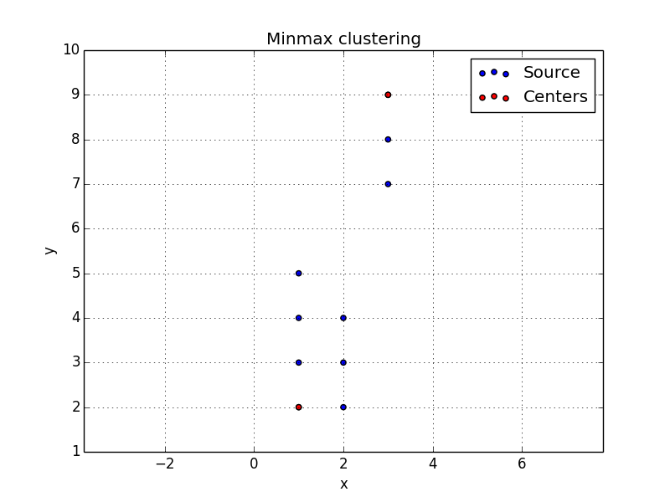

# Завдання №3

Здійснити розпізнавання образів із застосуванням алгоритму К-внутрішніх групових середніх. K= вибрати за кількістю кластерів отриманих 1м алгоритмом.

X1(1,2), X2(1,3), X3(1,4), X4(1,5), X5(2,2), X6(2,3), X7(2,4), X8(3,7), X9(3,8), X10(3,9)

## Рішення

import sys, math, random

from pylab import *

from point import *

INT_MAX = 100000

class KMeans(object):

def __init__(self, points):

self._points = points

self._centers = []

self._clusters = []

self._k = 0

def cluster(self, K):

self._k = K

# Put first points as centers

self._centers = [self._points[i] for i in range(0, K)]

while True:

# Recluster against centers

self._clusters = [[] for i in range(0, K)]

for other_point in self._points:

min_z_point_index = 0

min_distance = INT_MAX

for z_point_index in range(len(self._centers)):

z_point = self._centers[z_point_index]

item_distance = other_point.distanceTo(z_point)

if item_distance < min_distance:

min_distance = item_distance

min_z_point_index = z_point_index

self._clusters[min_z_point_index].append(other_point)

# New cluster centers

centers_moved = False

for z_point_index in range(len(self._centers)):

prev_center = self._centers[z_point_index]

cluster_points = self._clusters[z_point_index]

new_center = Point.find_center(cluster_points)

centers_moved = centers_moved or new_center.distanceTo(prev_center) > 0.01

self._centers[z_point_index] = new_center

if not centers_moved:

return

s = KMeans([

Point(1,2),

Point(1,3),

Point(1,4),

Point(1,5),

Point(2,2),

Point(2,3),

Point(2,4),

Point(3,7),

Point(3,8),

Point(3,9)

])

s.dump_points()

s.cluster(3)

s.dump_cluster()

s.plot_cluster('k2_1_14');

## Результат

[(1; 2), (1; 3), (1; 4), (1; 5), (2; 2), (2; 3), (2; 4), (3; 7), (3; 8), (3; 9)]

Cluster with k-means. K=3:

#1: (1; 2) [(1; 2), (2; 2)]

#2: (1; 3) [(1; 3), (1; 4), (1; 5), (2; 3), (2; 4)]

#3: (3; 8) [(3; 7), (3; 8), (3; 9)]

