MONOLITH

steps -

1. Perform Ubuntu 22.04 update

2. Install Apache & PHP for WordPress

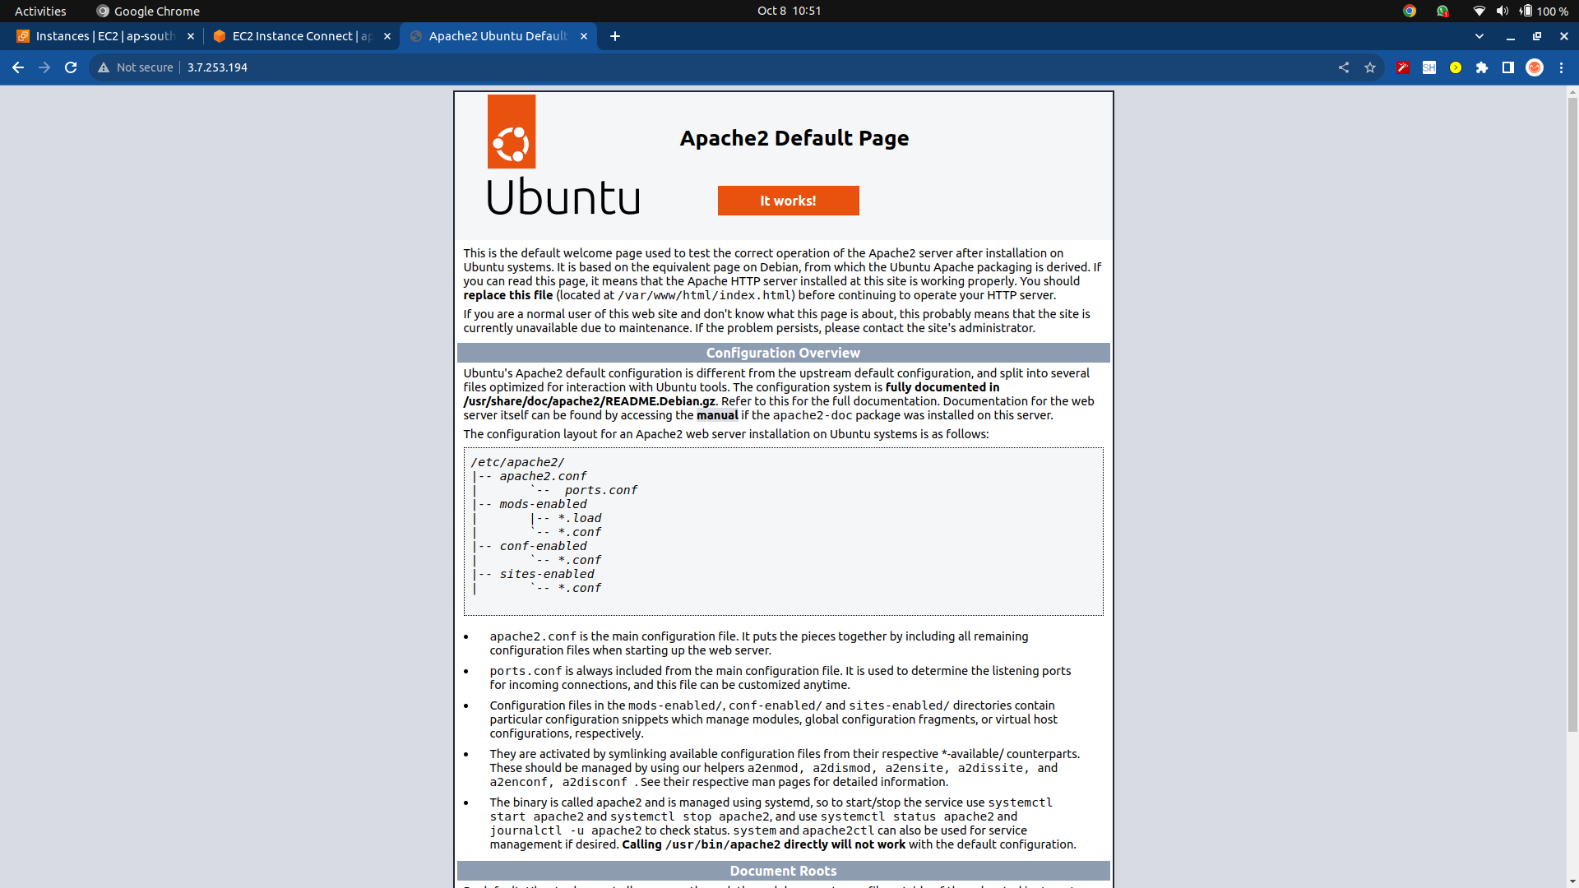

3. Install MariaDB or MySQL

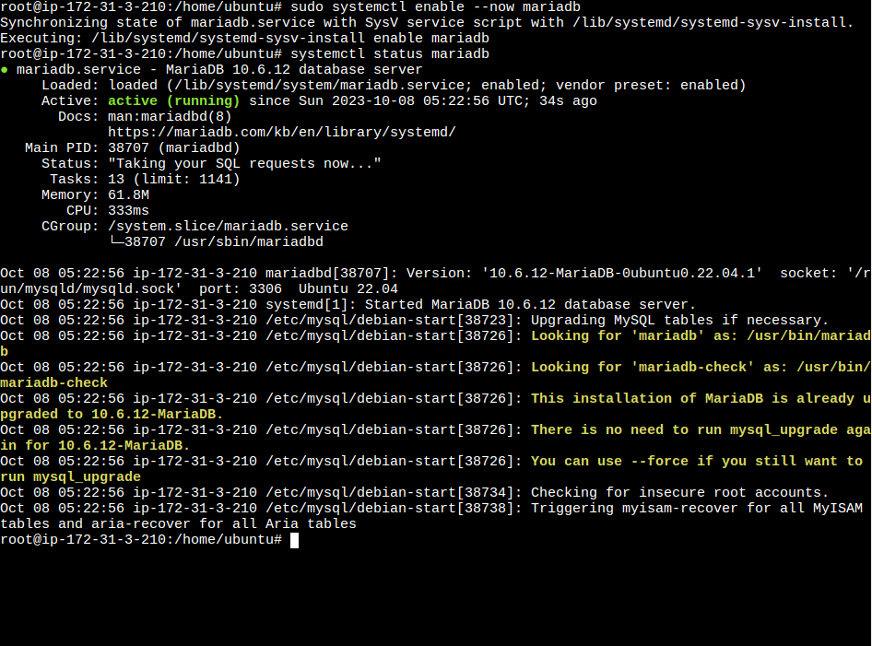

4. Create Database for WordPress

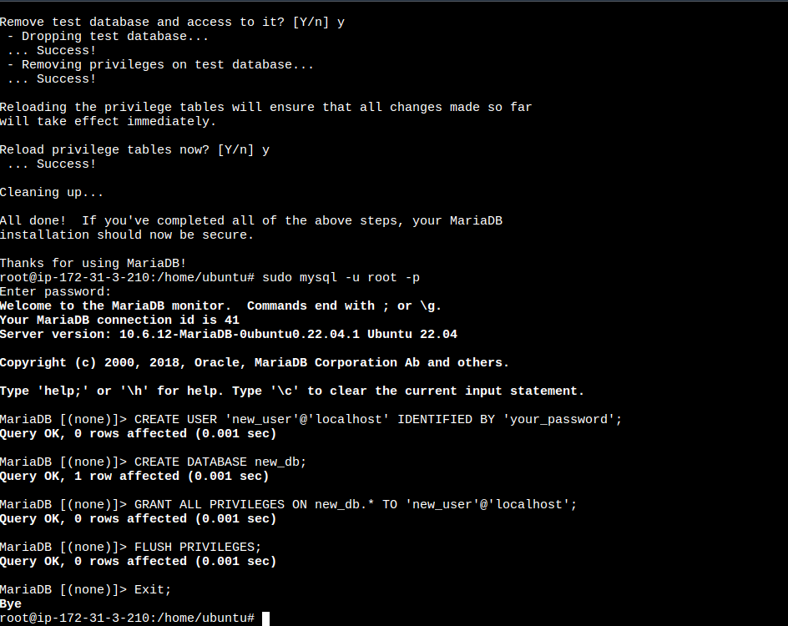

5. Install WordPress on Ubuntu 22.04

6. Configure Apache on Ubuntu 22.04

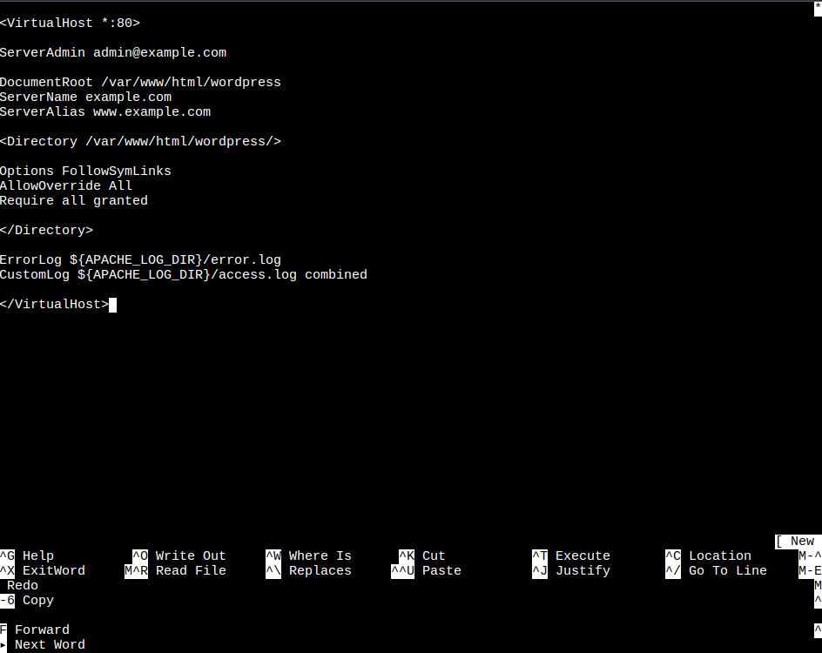

7. WordPress CMS web interface setup

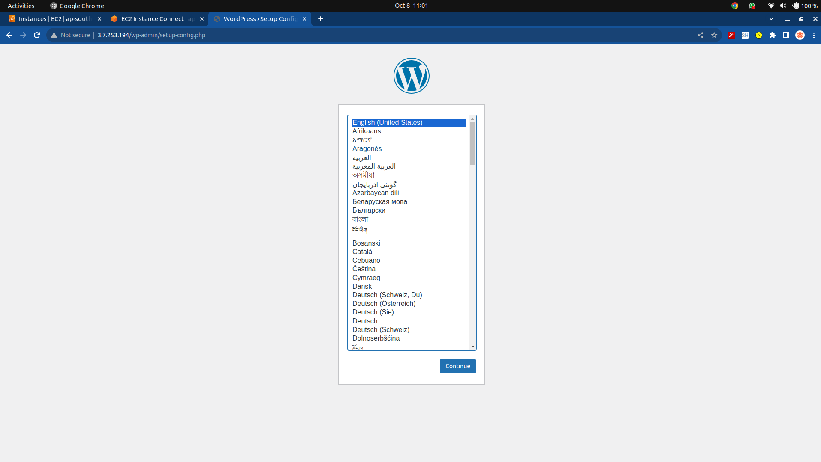
8. Add Database information

9. Create Admin user and password

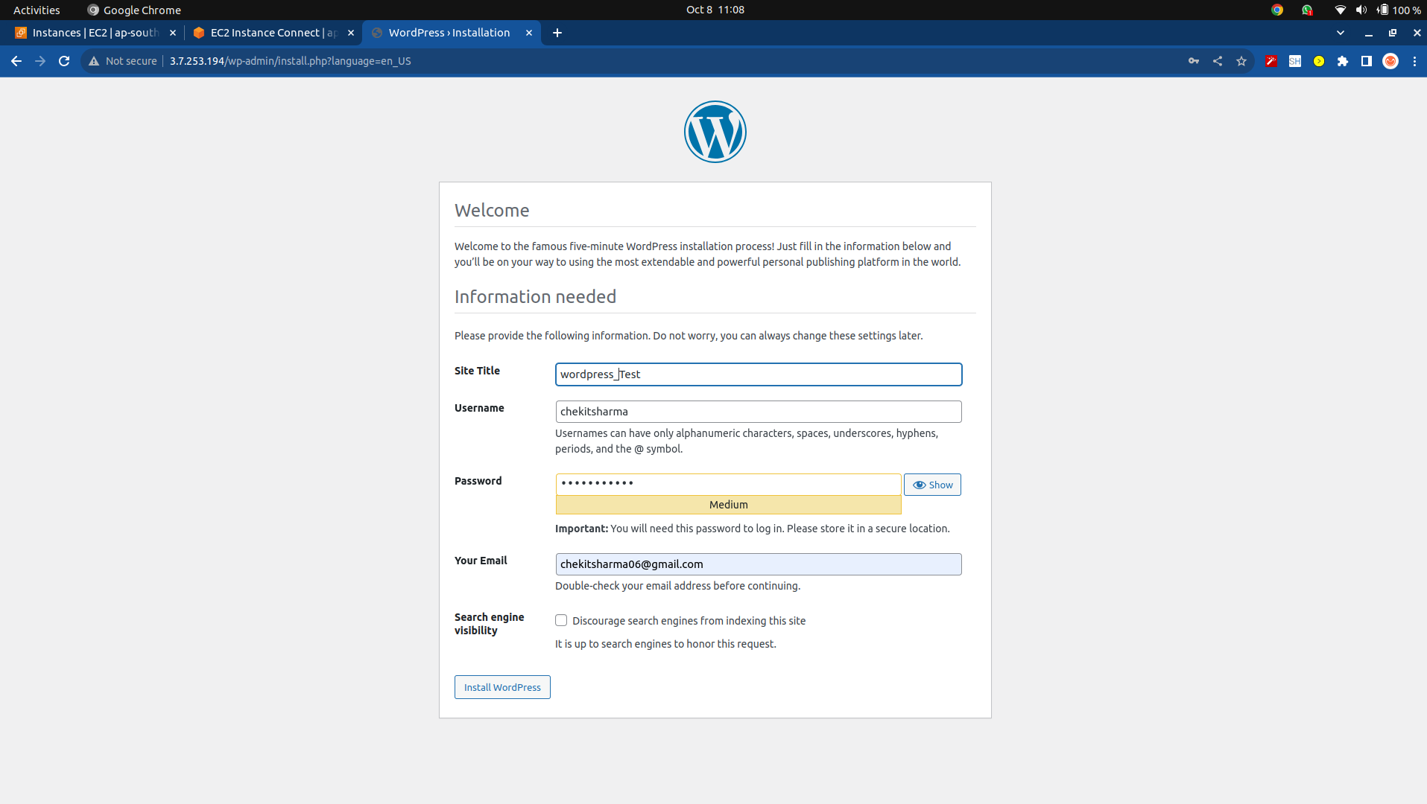
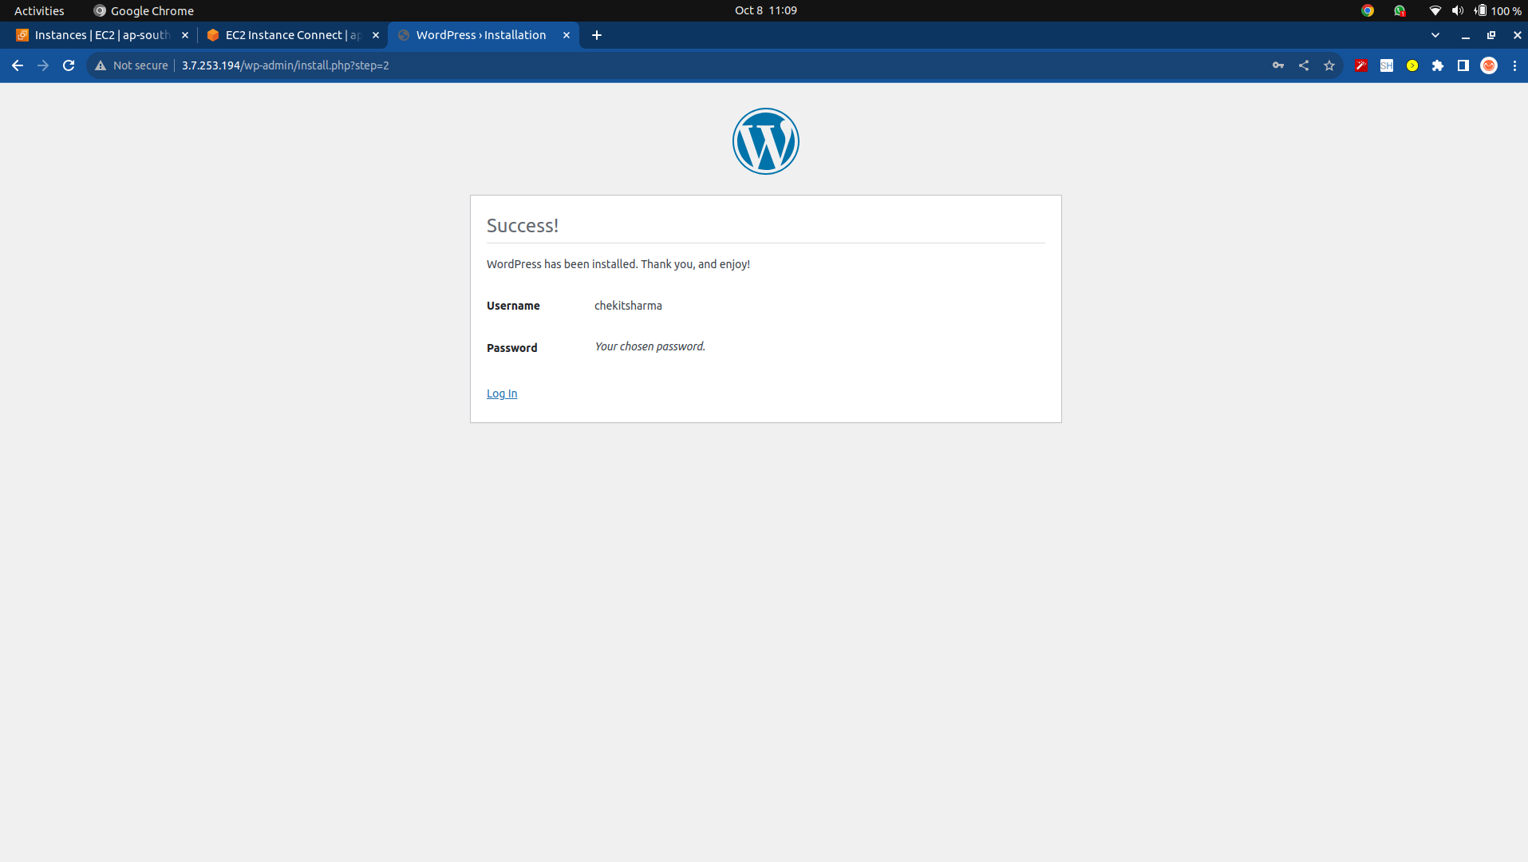

10. Login to the backend

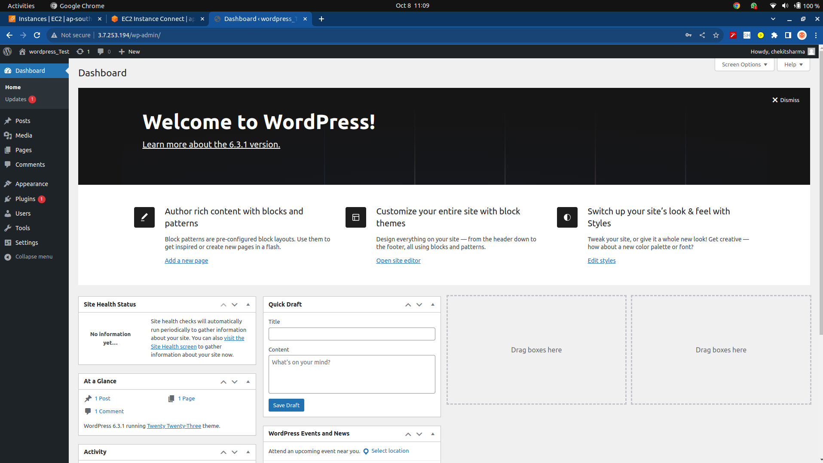

11. Create Welcome Page

