RESUME

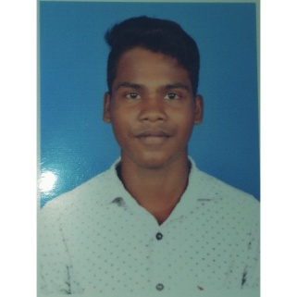

S.CHELLAPANDI

IT STUDENT

### MY PROFILE

* I am chellapandi,
* Information technology student,
* And I want to explore my experience level

CONTACT

**Phn** : 7904964200

**E-mail** : [pandichella841@gmail.com](mailto:pandichella841@gmail.com)

**Place** : thiruppathur

EDUCATION QUALIFICATIONS

ALAGAPPA UNIVERSITY

**B.sc Information technology**

**Arumugam pillai seethai ammal collage**

**NATIVE LANGUAGE**

* TAMIL(Native)
* Advanced English

**COMPUTER SKILLS**

* HTML & PHP
* JAVASCRIPT
* This language are using create and make up decoration of websites.
* Html is learn to easy