# [Ubuntu12.04配置NVIDIA cuda5.5经验帖](http://blog.csdn.net/abcjennifer/article/details/23016583)

分类： [Computer System](http://blog.csdn.net/abcjennifer/article/category/680229) [Linux & MAC](http://blog.csdn.net/abcjennifer/article/category/1148648) [Python](http://blog.csdn.net/abcjennifer/article/category/1205981)2014-04-06 08:58 13053人阅读 [评论](http://blog.csdn.net/abcjennifer/article/details/23016583#comments)(17) [收藏](javascript:void(0);) [举报](http://blog.csdn.net/abcjennifer/article/details/23016583#report)

之前配过一遍都忘光了，现在要重新配一遍真是好难过。。。特此记录参考网站以便查阅。

=============

环境：Ubuntu 12.04+Cuda5.5

1. 判断安装环境：

The setup of CUDA development tools on a system running the appropriate version of Linux consists of a few simple steps:

* Verify the system has a CUDA-capable GPU.
* Verify the system has a supported version of Linux.
* Verify the system has gcc installed.

见官方配置手册：http://docs.nvidia.com/cuda/cuda-getting-started-guide-for-linux/index.html

2. 下载镜像：

https://developer.nvidia.com/cuda-downloads

下run好了

3. 安装必要的库

**[plain]** [view plaincopy](http://blog.csdn.net/abcjennifer/article/details/23016583)[在CODE上查看代码片](https://code.csdn.net/snippets/277235)

1. sudo apt-get install freeglut3-dev build-essential libx11-dev libxmu-dev
2. libxi-dev libgl1-mesa-glx libglu1-mesa libglu1-mesa-dev

4. 删除已有nvidia，拉黑名单

**[plain]** [view plaincopy](http://blog.csdn.net/abcjennifer/article/details/23016583)[在CODE上查看代码片](https://code.csdn.net/snippets/277235)

1. sudo apt-get remove --purge nvidia*
2. sudo nano /etc/modprobe.d/blacklist.conf

blacklist.conf加入

**[plain]** [view plaincopy](http://blog.csdn.net/abcjennifer/article/details/23016583)[在CODE上查看代码片](https://code.csdn.net/snippets/277235)

1. lacklist amd76x_edac
2. blacklist vga16fb
3. blacklist nouveau
4. blacklist rivafb
5. blacklist nvidiafb
6. blacklist rivatv

5. Ctrl+Alt+F1, 登陆后安装

**[plain]** [view plaincopy](http://blog.csdn.net/abcjennifer/article/details/23016583)[在CODE上查看代码片](https://code.csdn.net/snippets/277235)

1. sudo service lightdm stop
2. chmod +x cuda_5.5.22_linux_64.run
3. sudo ./cuda_5.5.22_linux_64.run

Cuda5.5集成了toolkit，sdk和driver, 所以安装的时候一路同意下来就好了

6. 得到以下安装结果

    Driver:   Installed  
    Toolkit:  Installed In /Usr/Local/Cuda-5.0  
    Samples:  Installation Failed. Missing Required Libraries.

也就是SDK安装失败，这个官方手册上也提到了解决方案。

7. 单独安装SDK

解压sdk：

**[plain]** [view plaincopy](http://blog.csdn.net/abcjennifer/article/details/23016583)[在CODE上查看代码片](https://code.csdn.net/snippets/277235)

1. sh cuda_5.5.22_linux_64.run -extract=/path/to/extract/dir/

到根目录下的/path/to/extract/dir/去找cuda-samples_5.5.22_*******.run, 安装

**[plain]** [view plaincopy](http://blog.csdn.net/abcjennifer/article/details/23016583)[在CODE上查看代码片](https://code.csdn.net/snippets/277235)

1. sh cuda-samples_5.5.22_*******.run

8. Path配置：

$sudo gedit etc/profile或~/.bashrc

**[plain]** [view plaincopy](http://blog.csdn.net/abcjennifer/article/details/23016583)[在CODE上查看代码片](https://code.csdn.net/snippets/277235)

1. export PATH=$PATH:/usr/local/cuda-5.5/bin
2. export LD_LIBRARY_PATH=/usr/local/cuda-5.5/lib64:/lib

使之生效：

source /etc/profile（对应profile）或sudo ldconfig（对应bashrc）

还有一种装sdk的方法见http://askubuntu.com/questions/338907/how-to-install-cuda-5-5-under-ubuntu-12-04-lts-64-bit

9. 验证

见官网http://docs.nvidia.com/cuda/cuda-getting-started-guide-for-linux/index.html#verify-installation

nvcc-V:

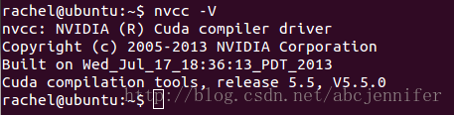

deviceQuery:

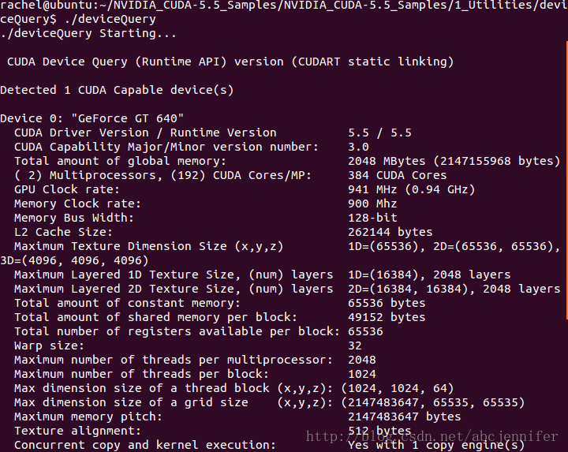

10. Cuda Hello World:

https://devtalk.nvidia.com/default/topic/486692/cuda-programming-and-performance/guide-installing-cuda-sdk-on-linux-walkthrough-on-how-to-install-the-cuda-sdk-and-build-the-example/

正文最下方

11. 装好theano的前提下配置~/.theanorc配置GPU

sudo vim ~/.theanorc

写入

[global]

floatX = float32

device = gpu

进行测试：http://deeplearning.net/software/theano/tutorial/using_gpu.html#testing-theano-with-gpu

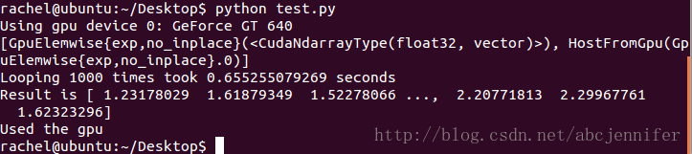

=============

此外附上其他配置参考：

1. theano+python模块

（Ubuntu 12.04自带python不用装，但要注意系统里很多模块依赖python，没事不要随便删！！！）

http://www.cnblogs.com/Ponys/p/3438491.html