UNO+WiFi R3 ATmega328P+ESP8266, 32Mb flash, USB-TTL CH340G, Micro-USB

Details:

It is a customized version of the classic ARDUINO UNO R3 board. Full integration of microcontroller Atmel ATmega328 and IC Wi-Fi ESP8266 with 32 MB flash memory, and USB-TTL converter CH340G on one board. All modules can work together or independently.

On the board where the switch of mode of operation with 8 position

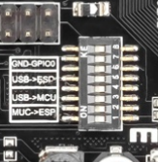

Switch status and mode selection:

|  |  |  |  |  |  |  |  |  |
| --- | --- | --- | --- | --- | --- | --- | --- | --- |
|  | 1 | 2 | 3 | 4 | 5 | 6 | 7 | 8 |
| CH340 connect to ESP8266 (upload sketch) | OFF | OFF | OFF | OFF | ON | ON | ON | NoUSE |
| CH340 connect to ESP8266 (connect) | OFF | OFF | OFF | OFF | ON | ON | OFF | NoUSE |
| CH340 connect to ATmega328 (upload sketch) | OFF | OFF | ON | ON | OFF | OFF | OFF | NoUSE |
| Mega328+ESP8266 | ON | ON | OFF | OFF | OFF | OFF | OFF | NoUSE |
| All modules work independent | OFF | OFF | OFF | OFF | OFF | OFF | OFF | NoUSE |

After choosing the mode of the board can proceed to setting up the IDE

It is important that when the ESP8266 module is programming, it is necessary to press the button “Mode”

To begin open the Arduino IDE programming environment and go to settings

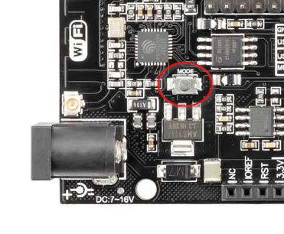

To begin open the Arduino IDE programming environment and go to settings

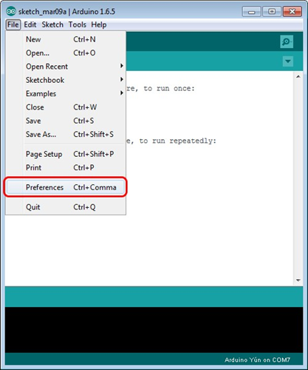

Then in the window that appears in the row Additional Boards Manager URLs (marked in red) insert <http://arduino.esp8266.com/stable/package_esp8266com_index.json> link for installation in Arduino IDE additional scripts that would work with the modules ESP8266, and click OK

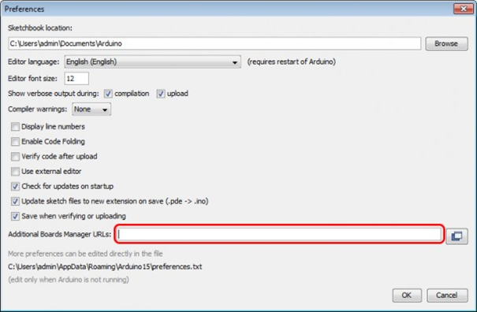

Then go to the Tools> Board> Boards Manager

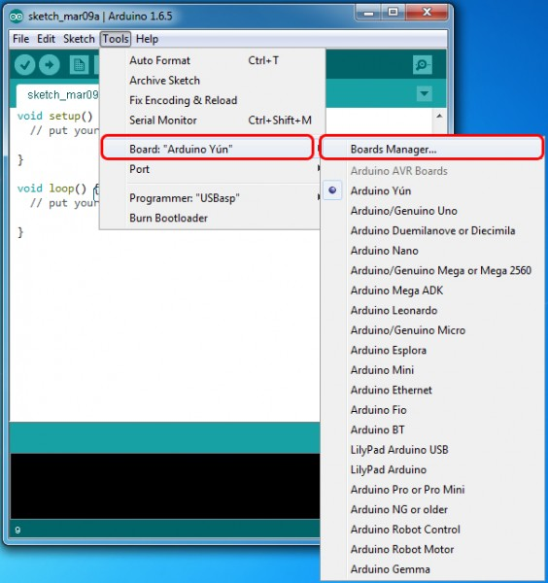

In the window that appears, scroll through the list down to the script esp8266 by ESP8266 Community and click.

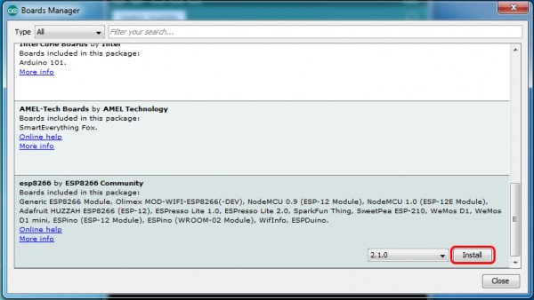

In the lower right corner will be able to select the version of the software, select the version 2.1.0 (the newest) and click the Install button

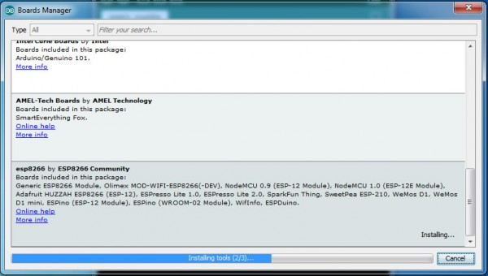

After installation, close the window and go to Tools> Board and see the list of available devices on the chip programming ESP8266

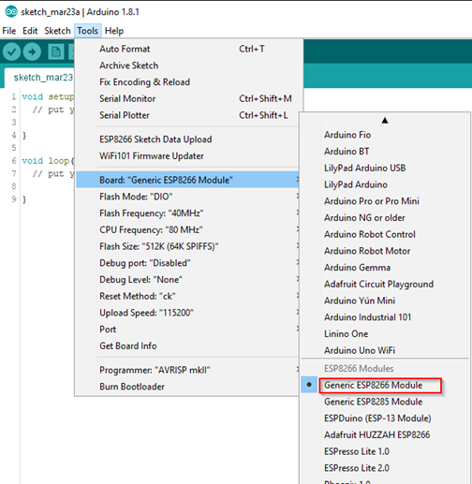

Next, you need to select the card as shown in the picture (Generic ESP8266 module)

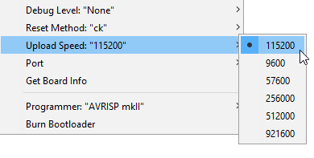

Select the upload speed - 115200

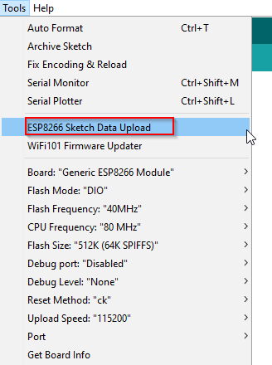

==========test sketch===========

void setup()

{ Serial.begin(115200);

pinMode(14,OUTPUT);

delay(500);

Serial.println("AT+CIPMUX=1");

delay(2000);

Serial.println("AT+CIPSERVER=1,5000");

delay(2000);

Serial.println("AT+CIPSTO=3600");

delay(2000); }

void loop()

{ while(Serial.available())

{ char Rdata;

Rdata=Serial.read();

if(Rdata=='A'|Rdata=='a')

{ digitalWrite(14,HIGH);

delay(50); }

else if(Rdata=='B'|Rdata=='b')

{ digitalWrite(14,LOW);

delay(10);

digitalWrite(14,HIGH);

delay(10);

digitalWrite(14,LOW); }

else

{ digitalWrite(14,LOW); } } }