World Demographics

Chelsea S.A. Mason
Student ID: 003123892
Howard University
MATH 014, Intro to Data Science
Dr. Nerolu
November 17, 2025

Objective
The purpose behind this assignment was to examine death in different ways. This was achieved by looking at the Death Rate, Infant Mortality Rate, and Median Age. This project also includes the use of the Total Fertility Rate. By examining the Median Age, it gave better insight into how long people tend to live globally. The Death Rate was used to explore how many people were dying. The Infant Mortality Rate showed how many babies did not reach the age of one. These three categories all made the study of Death richer.

Introduction
This dataset is taken from the CIA's records of Global demographics, which specifically focuses on the demographics of different countries. It includes categories such as population growth, infant mortality, sex ratio, etc. The information in the dataset can be used to have an inside look into the bigger picture for different countries. The dataset was found on the website Kaggle, it is titled “demographics_data.csv”. (Arya, 2025).

Method
For the wrangling stage the columns with missing values were checked. Almost all of the columns had missing values except the Country column. Due to this it was better to not delete columns with missing values because that would lead to deleting practically all of the dataset. In order to fix the dataset, the missing spaces in the columns were replaced with the median of that column. This worked for the numerical based columns. The categorical columns were left the same. This newly cleaned dataset was saved as “cleansed_demographics_data.csv”.

Storytelling

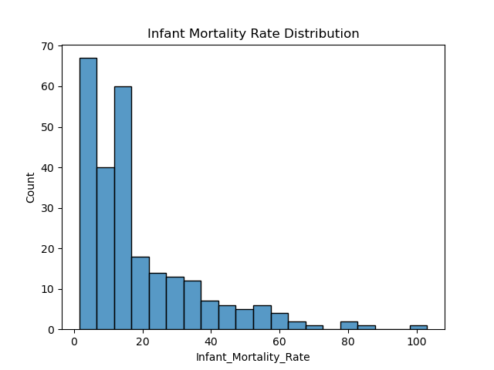Histogram
The histogram is based on the Infant Mortality Rate. The x-axis displays the actual Infant Mortality Rate. The y-axis shows the number of times that rate is used. The point of a histogram is to count the frequency of things. This histogram shows that most countries' Infant Mortality Rate is below 20. Infant Mortality Rate is the percentage of babies that died under the age of one per every 1,000 live births. This means that most countries do not have a high rate of babies dying. This is a very good statistic to have. Although there are still countries that have high infant mortality rates. There is one outlier that is all the way at 100, which means an extreme number of babies are dying. But on a lighter note, there is a decline for the frequency after the Infant Mortality Rate of 20.

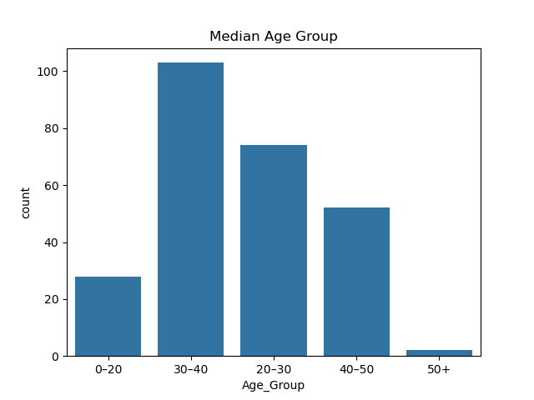Count Plot
The count plot is based on the Median Age. Originally, when the count plot was created it was unreadable. Due to there being so many countries. In order to make the plot readable, the Median Age was sorted into different ranges. The ranges were 0-20, 20-30, 30-40, 40-50, and 50+. This count plot measured the frequency of categories. The majority of countries Median Age were in between the 30-40 range. The third highest range was 40-50. This seems like good news because forty is middle age, which means a good number of countries have long lives. The second highest category was 20-30. That seems kind of young to be the Median Age being the second highest means a good portion of countries do not have long life expectancy. But it is not as bad as falling under the 0-20 range. The count for this category is just under 30, but that is still very concerning. It means those countries probably have extremely short life spans if the median age is so young. There are very few countries with a 50+ Median Age.

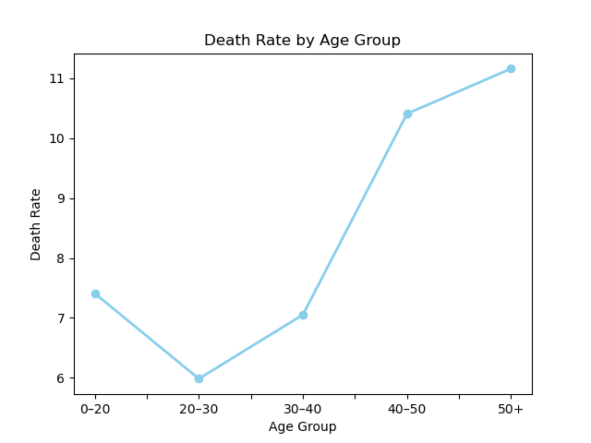Line Plot
The Line Plot was created to compare the Death Rate to the Median Age. The line plot was initially incredibly skewed due to extreme outliers. To get a more accurate graph I had to remove those values. Also, in order to have a more concrete plot the same ranges that were created for the count plot were used for the line plot. Each range took the average for their group for the Death Rate. The countries in the 50+ range had the highest Death Rate. This makes sense because they probably have a bigger aging population, which leads to more inevitable death. The second highest Death Rate was the 40-50 range, which gives this theory some credence. The third highest was the 0-20 range. It makes sense because if their Median Age is extremely young, it makes sense that the death rate would be higher because people do not live as long. The lowest Death Rate was the 20-30 group.

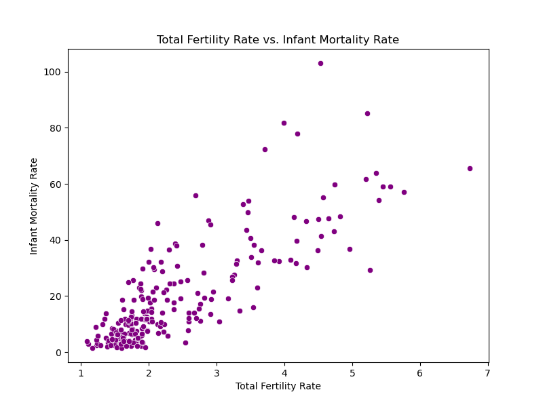Scatter Plot
Scatter Plots show the different points in the data. The Scatter Plot compared the Infant Mortality Rate to the Total Fertility Rate. This scatter plot was skewed due to an outlier, it had to be removed. The Total Fertility Rate shows the average number of children a woman would have. Looking at the scatter plot, there is a cluster below 2 for Total Fertility and under 20 for Infant Mortality Rate. This implies that there is a connection between lower death rates and lower fertility rates. The higher the Total Fertility Rate becomes also leads to the rising of the Infant Mortality Rate. This raises the question; do they have more children because the babies are more likely to die under the age of one? There are two interesting outliers one is close to 7 for Total Fertility Rate and the Infant Mortality Rate is just above 60. The other one is just under 5 for Total Fertility Rate and the Infant Mortality Rate is near 100. That outlier is terrifying because that means a good majority of babies are dying in one country.

Conclusion
The graphs for this assignment all tend to examine death in some way. The histogram looked at the frequency of Infant Mortality Rates. It concluded that most countries have an Infant Mortality Rate that is under 20. The count plot looked at the frequency of Median Age Groups. Most countries had a Median Age between 30-40. The line plot compared the Death Rate to the Median Age. The countries in the 50+ range had the highest Death Rate. The scatter plot compared Infant Mortality Rate to the Total Fertility Rate. There is a cluster below 2 for Total Fertility and under 20 for Infant Mortality Rate. All of this together implies that a good majority of countries have long or average life spans. Although there was a smaller number of countries that had higher Infant Mortality Rate and Death Rate. Overall, this data suggests that a close to majority of people globally are living nice lives. But there is still much work to be done because some places have a concerning Death Rate.

Acknowledgements
I would like to thank my mother, because she told me not to procrastinate on this assignment. It took me longer than initially anticipated. If she had not warned me, I might’ve been late at submitting this project. I thank my father, because he was the supportive voice that told me to keep going even when I wanted to quit. There were several low points throughout this semester. If it were not for his encouraging words I do not know where I would be. Finally, I would like to thank my professor, Dr. Nerholu, because this Intro to Data Science class definitely pushed me to go way beyond what I thought I could do when it comes to coding. Last year if someone told me I was doing all of this I would not have believed them. Although I struggled when it came to this assignment and class I am definitely growing in my knowledge and skills.

References
Arya, K. (2025). “demographics_data.csv”. CIA Global Statistical Database [Dataset]. https://www.kaggle.com/datasets/kushagraarya10/cia-global-statistical-database?select=demographics_data.csv

