Chelsea Gantt

Project 4 – Proof of Work

CS 5158/6058

1. Target Generation Function



1. Solution Generation Function

1. Verification Function

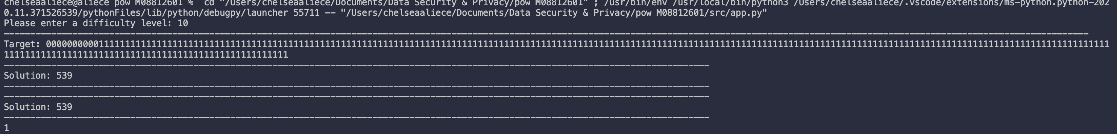

1. Performance of POW

In each image there is a output in the terminal. It reads “Runtime of the program is:” then a time in seconds is directly next to it.

The longest of the 6 was 26 and it ran for 62 seconds.

