**Instructions for Running the Program**

Written by: Chelsea De Bellis, reach me at [Chelsea.debellis@mail.mcgill.ca](mailto:Chelsea.debellis@mail.mcgill.ca) for any questions

**Introduction**

Analyzing large amounts of data can be quite time consuming, to aid in this process a series of scripts was created that would allow for information to be automatically sequestered and formatted for easy legibility. When given a list of UniProt IDs from a mass spectrometry experiment these scripts will construct a searchable and sortable table, with additional information, such as OrthoDB IDs, InterPro ID, amino acid number, protein name, and gene name. These scripts were created in the hope of aiding researchers to interpret data by displaying all information of importance in one place and gathering additional data automatically.

**Instructions**

Installation

To run the code, you must first open terminal on your computer. The folder should contain

Running the code

1. Open terminal
2. Navigate to the directory that hold the code
3. Ensure that the ./RunningScript.sh is executable. To do this type ls -l then press enter. Search for the file RunningScript.sh, check if the file has an x in the space encircled in the image.



If not type chmod u+x RunningScript.sh then press enter. And proceed to the next step.

Chm



1. Run the RunningScript.sh by typing ./RunningScript.sh then press enter. Image below illustrating what should be printed out

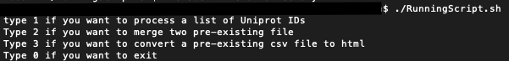

1. There should be a prompt that explains the task that is possible. Type the corresponding number for the task you wish to do then press enter.
2. Follow the instructions for the corresponding task.

**Running the code to process UniProt IDs from**

Proteins.csv (default file)

Non-default file

