**“The Bridge to Resilience”**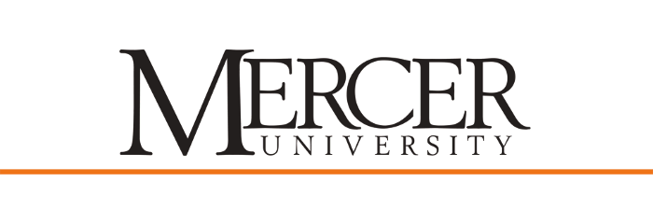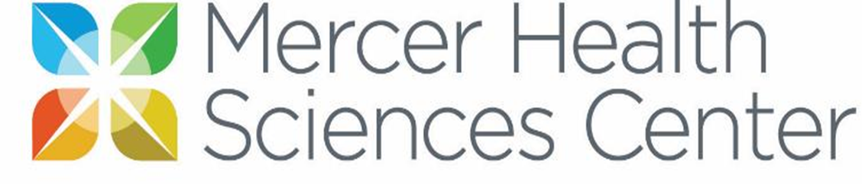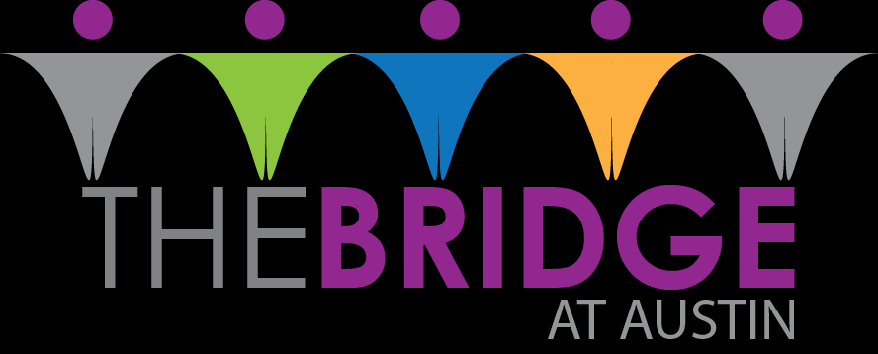

Researchers: Chelsea Gould, MPH-S, Rebecca Mortensen, PA-S, Dr. Thomas, DrPH, MSPH, Erin Lepp, MMSc, PA-C, Dr. May, PhD

**Statement of Purpose:**

To teach the target population, children ages 11 and 12 in Dekalb County, coping mechanisms and resilience skills in 5 sessions.

**Public Health Issue:**

Around the world things have changed drastically in the past year. Most children have not been in school and getting the academic and social support they need. When schools in DeKalb county opened up classrooms in March, two-thirds of the students continued online learning (Dixon, 2021). For the kids going back to school in the fall many of them have not been in class, face-to-face with peers and teachers, in almost a year and a half. These children have missed out on certain skills because of this. Stress, anxiety, and anger may stem from the online relationships, lack of skills and home dependence that they have grown into. Resilience to these emotions and building coping skills will be crucial for the success of these children in terms of school, family and other relationships. Building on the abilities that are lacking can help these children adapt and grow during whatever comes next for our world.

The purpose of this proposal is to introduce a population-based health education program to address the resilience skills in children ages eleven and twelve. Our goal is to help build the abilities that are lacking, to help these children adapt and grow for their futures.

**Intervention Program:**

This community-based project focuses on the mental health of children and the impact of COVID-19. We have conducted key informant interviews to assess the needs of children ages 11 and 12 in terms of stress, anxiety, anger, relationship conflicts, life skills, independence, and resiliency. The information obtained from these interviews will help us guide the content for this program. We have also held focus groups with kids from the community to gain their perspective.

The implementation sessions will focus on building the coping skills and life skills that are seen to be in need based on the information from the key informant interviews and focus groups. To assess effectiveness of this quasi-experimental field trial, the researchers will use The Resilience Scale (RS-10). The content will be taught at a camp over the summer in-person.

**Impact on the Community:**

This program will support children in their growth and teach skills for adaptation, especially in regards to COVID-19. These skills that are taught may be used for years to come. Kids will affect others in their lives who may end up learning these skills from them. In the future, this program can be used in classrooms, after school sessions, community center courses, and other camp sessions.

**Partnerships:**

The saying goes, “two heads are better than one.” It can be extremely helpful to have advice and opinions of others, especially those in different areas of expertise. Public Health students will work together with Physician Assistant students, and community members, including past teachers and parents. These collaborations will serve the program well in creating something that is evidence-based and community driven.

**Reference**

Dixon, K. (2021). Thow-thirds of DeKalb Students Continue with Remote Learning Option. *The Atlanta Journal-Constitution*. Retrieved on April 14, 2021 from https://www.ajc.com/news/atlanta-news/two-thirds-of-dekalb-students-continue-with-remote-learning-option/FWR5ACROQBEYZIJRDHVF34YCJQ/