QBUS3350 – Topic 5 (Weeks 8-9)

1. **How does risk level vary with project life cycle stages? Where is the period of highest risk impact? Why?**

Risk is highest during defining and planning, and decreases gradually during executing stage. Finally risk drops dramatically during delivering stage. This is because we have a lot of uncertainties at the defining and planing stage, for example, when the manager has a clear vision of what customers want but it is far from realisation, as such the uncertainty is high. In the executing stage, questions and problems are answered and resolved when project is processed therefore risk keep decreases until finish..

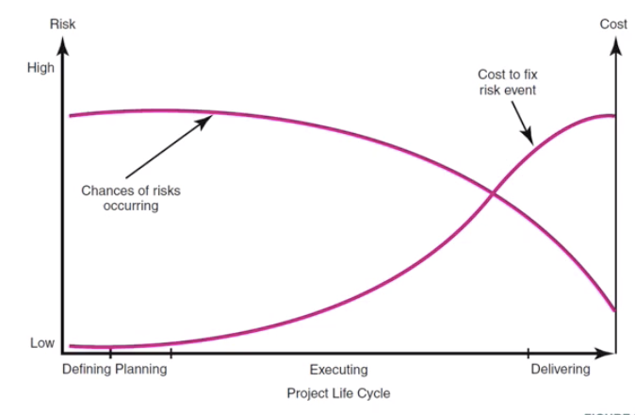

1. **Consider the following statement: “The problem with risk analysis is that it is possible to imagine virtually anything going wrong on a project. Where do you draw the line? In other words, how far do you take risk analysis before it becomes overkill?” How would you respond?**

We can use different methods to identify the risks, such as brainstoming and asking opinions from experts. Managers can use quantitative and qualitative tools to figure out the scores to identify what task would need more concern. When the significant risk variable has been identified, we need to come up with contingency plan to response to the risk. This process doesn’t ensure that all risks will be identified or that the right contingency plan will be created. However, the benefits of taking part of risk management is worthwhile as it avoids danger of no preparing for potential problems. In other words, it’s important to perform risk management and if we perform well in the risk management, we are able to avoid many potential issues in the future but it is impossible to imagine all the risks. So it is important to know the prioritisation and the final goals of project.

1. The Manchester United Soccer Tournament project team (Review Manchester United case at the end of Chapter 4) has identified the following potential risks to their project: How would you recommend that they respond (i.e., avoid, accept, …) to these risks and why?
2. Referees failing to show up at designated games.
   * 1. Response: mitigate risk
     2. Action points: contact referees before the games
     3. Contingency plan: contact more than one referees and call the second one to fill in.
3. Fighting between teams.
   * 1. Response: mitigate risk
     2. Action points:
        1. provide a training session to referees on how to diffuse potentially violent situations.
        2. Let teams know there would be stiff penalties for fighting between teams.
     3. Contingency plan: request referees game officials and coaches to intervene.
4. Pivotal error committed by a referee that determines the outcome of a game.
   * 1. Response: Mitigate risk
     2. Action points:
        1. Provide training session to referees on how to assign points.
        2. Recruit experienced/ seasoned referees and assign the best referees to the most important games
     3. Contingency plan: have a tournament czar who adjudicates appeals.
5. Abusive behavior along the sidelines by parents.
   * 1. Response: Mitigate / transfer risk
     2. Action points:
        1. Mitigate risk: let parents know there would be stiff penalties for being abusive
        2. Transfer risk: assign the responsibility to coaches to manage.
     3. Contingency plan: referees empowered to penalize team and dismiss parents group / hire security staffs.
6. Inadequate parking.
   * 1. Response: mitigate risk
     2. Action points:
        1. level the game schedule (i.e. don’t’ put many games on one day)
        2. organize games in different locations
     3. Contingency plan: provide shuttle services
7. Not enough teams sign up for different age brackets.
   * 1. Response: mitigate risk
     2. Action points: PR Campaign contributes to marketing strategies.
     3. Contingency plan: collapse age groups
8. Serious injury.
   * 1. Response: accept risk
     2. Contingency plan: contact ER in advance, setup field communication systems
9. A small project needs to complete two parallel activities A and B. The activity time of A and B are identically and independently distributed. With probability 0.5, A takes 1 unit of time and with probability 0.5, A takes 2 units of time. Determine the expected project duration and quantify how much PERT method underestimates the expected project duration.

|  |  |  |  |  |
| --- | --- | --- | --- | --- |
|  | | Duration | | |
|  | | 1 unit | 2 units | |
| Project A | | 0.5 | 0.5 | |
| Preject B | | 0.5 | 0.5 | |
| Expected duration: | | | |  |
|  | A=1 | | | A=2 |
| B=1 | 0.25 (T=1) | | | 0.25 (T=2) |
| B=2 | 0.25 (T=2) | | | 0.25 (T=2) |

E(T) = 1*0.25+2*0.25+2*0.25+2*0.25 = 1.75

The expected duration for the project is 1.75 units of time.

PERT Method:

E(T) = max(E(A), E(B))

E(A) = 0.5*1+0.5*2=1.5 units of time

E(B) = 0.5*1+0.5*2=1.5 units of time

E(T) = 1.5 units

Difference between expected duration and PERT duration = 0.25 unit

Conclusion: PERT method has underestimated the project duration by 0.25 unit of time.