Codebook for baseline

Autogenerated data summary from dataReporter

2022-03-24 12:16:43

# Data report overview

The dataset examined has the following dimensions:

|  |  |
| --- | --- |
| Feature | Result |
| Number of observations | 5059 |
| Number of variables | 16 |

# Codebook summary table

|  |  |  |  |  |  |
| --- | --- | --- | --- | --- | --- |
| Label | Variable | Class | # unique values | Missing | Description |
|  | **prim_key** | AsIs | 5059 | 0.00 % |  |
|  | **alc_consumption** | factor | 3 | 55.43 % |  |
|  | **alc_freq** | factor | 6 | 76.87 % |  |
|  | **alc_amount** | factor | 4 | 96.92 % |  |
|  | **sex_risk** | factor | 3 | 4.74 % |  |
|  | **sex_work** | factor | 3 | 3.70 % |  |
|  | **sex_work_condom** | factor | 3 | 99.58 % |  |
|  | **sex_hiv** | factor | 3 | 5.04 % |  |
|  | **sex_partners** | integer | 48 | 11.17 % |  |
|  | **sex_partners_24** | integer | 12 | 3.48 % |  |
|  | **hiv_positive** | factor | 3 | 0.67 % |  |
|  | **age** | integer | 69 | 0.83 % |  |
|  | **marital_status** | factor | 3 | 0.08 % |  |
|  | **c_bd_country** | factor | 3 | 0.10 % |  |
|  | **c_bd_educ4** | ordered | 5 | 0.34 % |  |
|  | **sex** | factor | 2 | 0.00 % |  |

# Variable list

## prim_key

* The variable is a key (distinct values for each observation).
* The variable has class AsIs which is not supported by dataReporter.

## alc_consumption

|  |  |
| --- | --- |
| Feature | Result |
| Variable type | factor |
| Number of missing obs. | 2804 (55.43 %) |
| Number of unique values | 2 |
| Mode | “1” |
| Reference category | 0 |

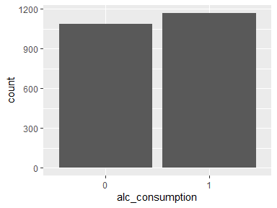

* Observed factor levels: "0", "1".

## alc_freq

|  |  |
| --- | --- |
| Feature | Result |
| Variable type | factor |
| Number of missing obs. | 3889 (76.87 %) |
| Number of unique values | 5 |
| Mode | “2” |
| Reference category | 1 |

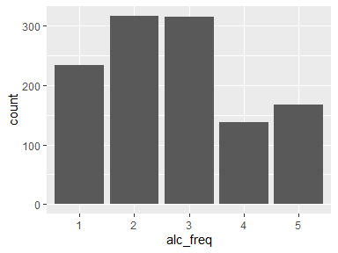

* Observed factor levels: "1", "2", "3", "4", "5".

## alc_amount

|  |  |
| --- | --- |
| Feature | Result |
| Variable type | factor |
| Number of missing obs. | 4903 (96.92 %) |
| Number of unique values | 3 |
| Mode | “3” |
| Reference category | 2 |

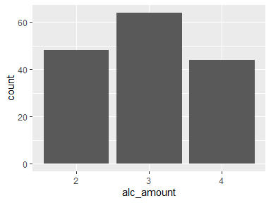

* Observed factor levels: "2", "3", "4".

## sex_risk

|  |  |
| --- | --- |
| Feature | Result |
| Variable type | factor |
| Number of missing obs. | 240 (4.74 %) |
| Number of unique values | 2 |
| Mode | “0” |
| Reference category | 0 |

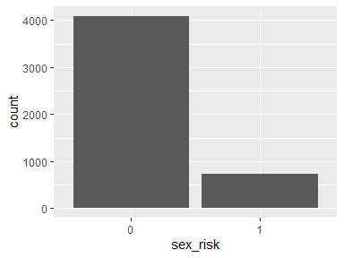

* Observed factor levels: "0", "1".

## sex_work

|  |  |
| --- | --- |
| Feature | Result |
| Variable type | factor |
| Number of missing obs. | 187 (3.7 %) |
| Number of unique values | 2 |
| Mode | “0” |
| Reference category | 0 |

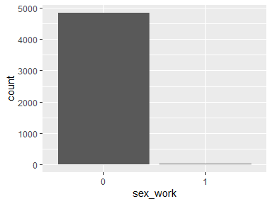

* Observed factor levels: "0", "1".

## sex_work_condom

|  |  |
| --- | --- |
| Feature | Result |
| Variable type | factor |
| Number of missing obs. | 5038 (99.58 %) |
| Number of unique values | 2 |
| Mode | “0” |
| Reference category | 0 |

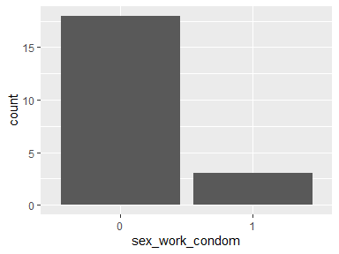

* Observed factor levels: "0", "1".

## sex_hiv

|  |  |
| --- | --- |
| Feature | Result |
| Variable type | factor |
| Number of missing obs. | 255 (5.04 %) |
| Number of unique values | 2 |
| Mode | “0” |
| Reference category | 0 |

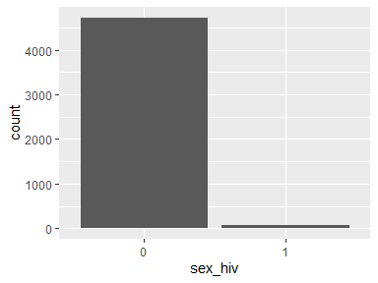

* Observed factor levels: "0", "1".

## sex_partners

|  |  |
| --- | --- |
| Feature | Result |
| Variable type | integer |
| Number of missing obs. | 565 (11.17 %) |
| Number of unique values | 47 |
| Median | 2 |
| 1st and 3rd quartiles | 1; 5 |
| Min. and max. | 0; 120 |

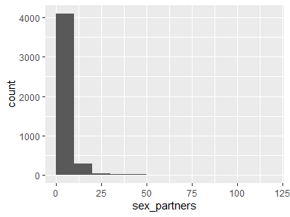

## sex_partners_24

|  |  |
| --- | --- |
| Feature | Result |
| Variable type | integer |
| Number of missing obs. | 176 (3.48 %) |
| Number of unique values | 11 |
| Median | 1 |
| 1st and 3rd quartiles | 0; 1 |
| Min. and max. | 0; 20 |

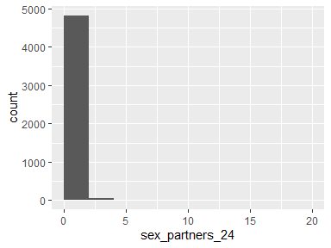

## hiv_positive

|  |  |
| --- | --- |
| Feature | Result |
| Variable type | factor |
| Number of missing obs. | 34 (0.67 %) |
| Number of unique values | 2 |
| Mode | “0” |
| Reference category | 0 |

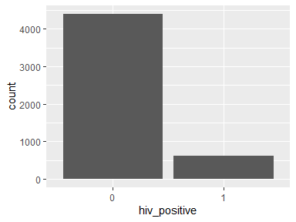

* Observed factor levels: "0", "1".

## age

|  |  |
| --- | --- |
| Feature | Result |
| Variable type | integer |
| Number of missing obs. | 42 (0.83 %) |
| Number of unique values | 68 |
| Median | 62 |
| 1st and 3rd quartiles | 52; 72 |
| Min. and max. | 2; 105 |

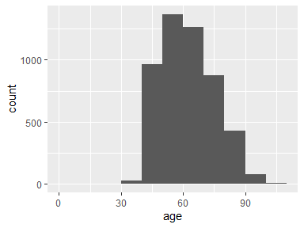

## marital_status

|  |  |
| --- | --- |
| Feature | Result |
| Variable type | factor |
| Number of missing obs. | 4 (0.08 %) |
| Number of unique values | 2 |
| Mode | “1” |
| Reference category | 0 |

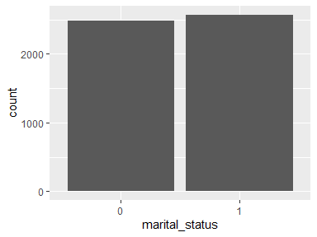

* Observed factor levels: "0", "1".

## c_bd_country

|  |  |
| --- | --- |
| Feature | Result |
| Variable type | factor |
| Number of missing obs. | 5 (0.1 %) |
| Number of unique values | 2 |
| Mode | “South Africa” |
| Reference category | South Africa |

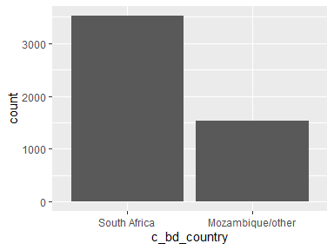

* Observed factor levels: "Mozambique/other", "South Africa".

## c_bd_educ4

|  |  |
| --- | --- |
| Feature | Result |
| Variable type | ordered |
| Number of missing obs. | 17 (0.34 %) |
| Number of unique values | 4 |
| Mode | “No formal education” |
| Reference category | No formal education |

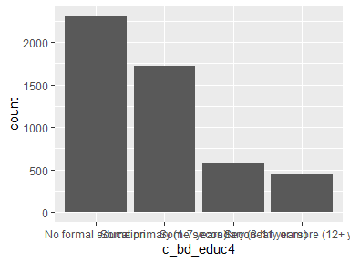

* Observed factor levels: "No formal education", "Secondary or more (12+ years)", "Some primary (1-7 years)", "Some secondary (8-11 years)".

## sex

|  |  |
| --- | --- |
| Feature | Result |
| Variable type | factor |
| Number of missing obs. | 0 (0 %) |
| Number of unique values | 2 |
| Mode | “2” |
| Reference category | 1 |

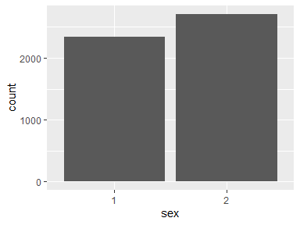

* Observed factor levels: "1", "2".

Report generation information:

* Created by: Could not determine from system (username: Unknown)
* Report creation time: Thu Mar 24 2022 12:16:43
* Report was run from directory: C:/Users/XinYQ/Documents/Duke/glhlth562/final/proposal
* dataReporter v1.0.2 [Pkg: 2021-11-11 from CRAN (R 4.1.2)]
* R version 4.1.1 (2021-08-10).
* Platform: x86_64-w64-mingw32/x64 (64-bit)(Windows 10 x64 (build 19044)).
* Function call: dataReporter::makeDataReport(data = baseline, mode = c("summarize", "visualize", "check"), smartNum = FALSE, file = "codebook_baseline.Rmd", replace = TRUE, checks = list(character = "showAllFactorLevels", factor = "showAllFactorLevels", labelled = "showAllFactorLevels", haven_labelled = "showAllFactorLevels", numeric = NULL, integer = NULL, logical = NULL, Date = NULL), listChecks = FALSE, maxProbVals = Inf, codebook = TRUE, reportTitle = "Codebook for baseline")